Bibliometric Study and Network Analysis of the

Phenomenon of Self Publishing

ABSTRACT

Mangas Vega, Almudena Universidad de Salamanca

C/ Francisco de Vitoria, 6

37008 Salamanca +34 923294580

almumvega@usal.es

Self-publishing is becoming increasingly prevalent as a form of editing. This article is a bibliometric and network analysis study on the phenomenon of publishing to determine which aspects are being more scientifically investigated and to check if the relevance of this issue is reflected in current scientific studies on the topic. Moreover, this report will present an example of what bibliometrics and network analysis can bring to this type of research.

Categories and Subject Descriptors

Applied computing → Computers in other Publishing

General Terms Documentation

Keywords

Self-Publishing; Bibliometrics; Network Analysis.

1. INTRODUCTION

domains

Without a doubt, self-publishing is an upward trend. [1].

→

Self-publishing has advantages, such as ease, cost reduction and publishing speed [2]. However, the absence of quality revision and editing, no final pre-publication assessment and the inability to publish such articles in scientific papers are often cited as disadvantages. [3]

All experts agree on the first claim, but not all agree on the latter.

Since other publishing transitions have been extensively studied, can the same be said for self-publishing? When trying to answer

Permission to make digital or hard copies of all or part of this work for personal or classroom use is granted without fee provided that copies are not made or distributed for profit or commercial advantage and that copies bear this notice and the full citation on the first page. Copyrights for components of this work owned by others than the author(s) must be honored. Abstracting with credit is permitted. To copy otherwise, or republish, to post on servers or to redistribute to lists, requires prior specific permission and/or a fee. Request permissions from Permissions@acm.org. TEEM '15, October 07 - 09, 2015, Porto, Portugal Copyright is held by the owner/author(s). Publication rights licensed to ACM. ACM 978-1-4503-3442-6/15/10…$15.00 DOI: http://dx.doi.org/10.1145/2808580.2808646

this question, a problem almost immediately arises with regard to the terminology which inevitably changes as advances appear: we find (in Spanish) the term "autopublicación" as a synonym for "autoedición", and in English, two synonymous are used with important implications; "vanity publish" or "self publish." [4]

As it is not the purpose of this article to discuss the terminology issue, we will aim instead to briefly define the object of our study: self-publishing. Its origins date back to "vanity publishing", when authors published their own works which publishers had rejected as not being up to par for publication. Today, perhaps as a result of a mistranslation from English, we confuse the term “auto-publicación” (publishing something for oneself without going through any type of control, external evaluation or editing apart from the author´s own reviewing), the phenomenon itself, from the scientific point of view, what is being studied about it, how, from what points of view, etc. Therefore, knowing and using all possible terms allows us to refine the analysis.

Bibliometrics is part of the so-called metric information studies [6], used to analyze scientific activity around a particular topic based on the application of mathematical and statistical indicators regarding bibliographic production and its authors [7].

This will give us an idea of how an in depth study of this matter is increasingly present also in scientific literature.

It will also enable us to check whether the data relating to the scientific literature based on the phenomenon of "self-publishing" does indeed show that it reached its peak in 2011, as some authors claim, or whether on the contrary, as Furtado [8] indicated, it "is not a bubble nor will sales of the work thus produced disappear".

Social network analysis is a technique that is increasingly proving to be more effective in all types of subjects as shown by numerous studies in which it is applied, as well as in different aspects of Information Science and Documentation [9], [10], [11], [12], [13], [14].

2. OBJECTIVES

The aim of this paper is to analyze the highlights of the study and research that has been done on self-publishing over the years, with particular attention being given to recent times, in which self-publishing appears to have undergone a resurgence.

Another topic which will be analysed in this paper is the matter of whether self-publishing is presently being addressed from a scientific point of view as deeply and thoroughly as you might expect for such a current issue.

439

Third International Conference on Technological Ecosystems for Enhancing Multiculturality - TEEM’15

To develop this goal, we will first study all the technical terminology and cultural traits that have transformed the landscape of publishing, and that may encourage a more complete analysis of the situation, to define the most appropriate methodology in order to achieve the objective.

3. METODOLOGY

For the purposes of the preparation of this paper, firstly a literature review was conducted taking into account the terms coined over the years to refer to the phenomenon now known as "self-publishing". This was done in order to determine the best search terms for our objective.

At the same time, different databases that could serve as sources of information were reviewed, such as WOS, SCOPUS, LISA and LISTA; the various data provided by them and the possibilities for a rigorous bibliometric study were analyzed in each case1.

After this initial stage, the search terms "vanity publishing", "vanity press" and "self publishing" were decided on and WOS was determined as a research resource.

The data collection date was March, 2015 for the bibliometric study, with an update in June, 2015 for network analysis.

First, a new verification of the search terms was conducted in the database Web of Science to decide if any changes were needed and to determine all the search parameters. Finally, the terms and search parameters were "self publishing" (in the fields of subject and title), "vanity publishing" (in the fields of subject and title) and "vanity press" (in the fields of topic and title).

Then, two searches were conducted to define the WOS database:

- In the first, we searched all databases

- In the second, only the main WOS databases were reviewed.

The reason for these two search strategies has to do with the data provided by WOS: for all database records, citation analysis is offered; but with regard to its main databases, additional data is added which is of great help in making a more comprehensive bibliometric analysis.

The question, then, was to ascertain whether the difference in records located in both strategies was large enough to consider it necessary to opt for the latter, despite offering more data to facilitate a bibliometric analysis, as reliability was lost in the study due to the absence of a significant number of records.

The result was as follows: In the investigation of all databases, 107 were logs, which, after being treated with the reference manager RefWorks and filter duplicates, were reduced to 106.

In the search performed only on the major WOS databases, 95 results appeared, which, again, after being further analysed using RefWorks and having eliminated duplicates, ended up as 85.

After checking the records analyzed and confirming that trends in both cases are similar and that the differences between them do not particularly affect the graphics, most notably the graphics related to evolution, it was decided to opt for the second search. The bibliometric analysis would therefore be more comprehensive.

1

As bibliometric studies require a set of concrete data, it was decided first database that best fulfilled this demand. Later these data would be adapted to the analysis of social networks

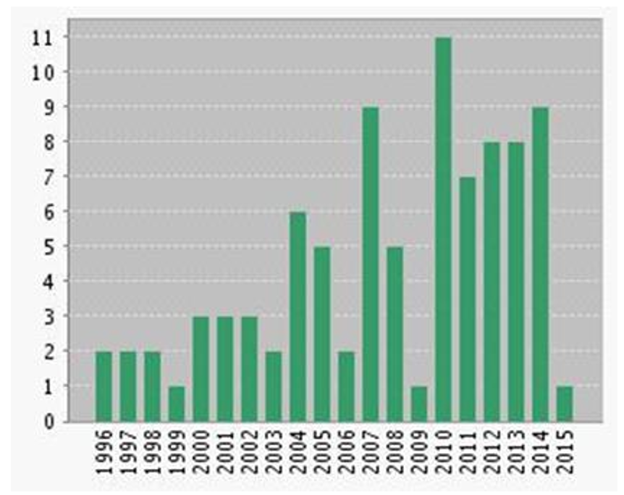

Figure 1. Evolution graph search in all databases

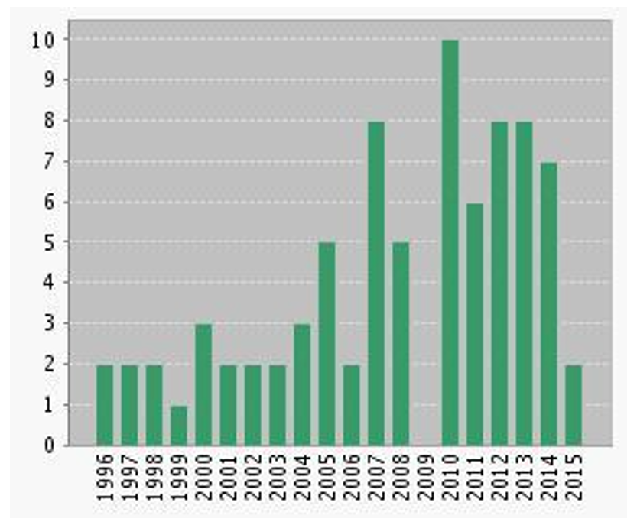

Figure 2. Graph of the evolution of the major search databases

WOS

After making the different searches and combining them, an analysis of the data was begun:

Using as a basis the hypothesis put forward by authors such as Furtado or Charman [15], which indicates that self-publishing is a very current and fashionable topic, but with a history deeply rooted in the past, it was decided not to limit the study by year of publication in order to confirm whether these theories are true or not.

4. RESULTS AND DISCUSSION

First of all, it should be advised that the data used in the analysis of networks belongs to an extremely small sample. Therefore, the results should be considered with great caution. Nonetheless, it serves to demonstrate the usefulness of this type of analysis, and, after comparing some results, we can verify its success even in such small samples.

An analysis shall now be done using the data based on the laws and indicators that bibliometrics provide us:

Evolution (growth / decline) over time, with reference to both the appearance of the publications and the citation of them.

To study the time evolution of our subject, a complete analysis will be carried out using the graphics provided by the database.

440

Bibliometric Study and Network Analysis of the Phenomenon of Self Publishing

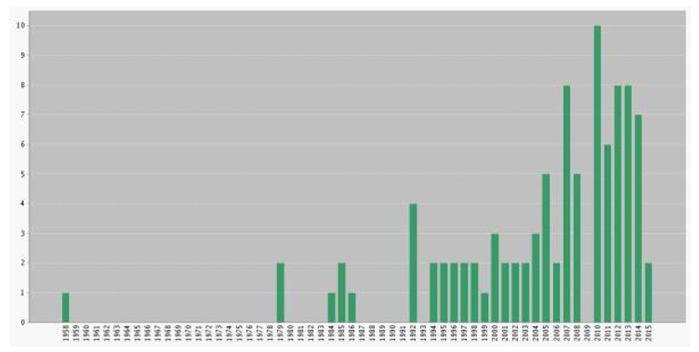

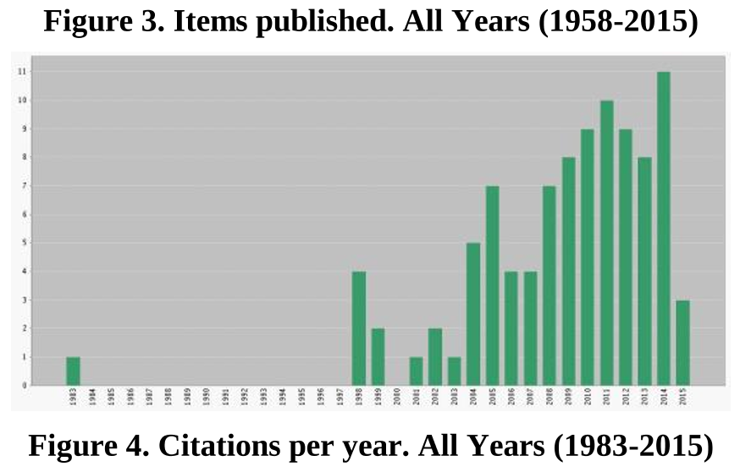

Arguably, the emergence of a "sustained" study on self-publishing began in 1996. While some articles have been discovered from previous years (1958 (1 article), 1979 (2 articles), 1984 (1 article) 1985 (2 articles) and 1986 (1 article), they have very little significance (only one article exists from 1983). It is only from the 90s on when research on the issue begins to appear in greater quantity.

According to the Law of exponential growth of scientific information, an indefinitely, constant and exponential growth is not sustainable. At some point it reaches a saturation limit, after which it begins to decrease.[16]. In this case, it seems that growth has not yet reached that limit, since the increase remains progressive. This is true, not only with regard to publications on the subject, but also to citations.

A noteworthy fact is that although data publications do not appear in 2009, citations were ceaseless, both in that year and in the following, thus indicating that it was an issue which was gaining relevance.

Contemporary science: However, not only is scientific literature growing exponentially, but also the number of researchers. Therefore, the first conclusion which Price reached regarding exponential growth was the contemporaneity of science, an expression that reflects the phenomenon. Price´s conclusion was that on assessing the number of scientists who have studied the phenomenon, adding all of those who have existed in the past to the sum of the present, it can be observed that the number of scientists from the past is so small that it is almost irrelevant in proportion to the current number of scientists working on the issue.

Figure 5. Increased authors

Total authors: 140; Total years: 55;

Authors in the last 13 years (25% of total): 118 (84%)

The theory is fully proven. The growing number of authors who have studied this issue in recent years has grown exponentially. This represents up to 84% of the authors found in the final quarter of the progress of the phenomenon through time. From this data it can be concluded that a limit on this growth has not yet been reached.

Dispersion of scientific literature (core journals): Bradford´s Law (formulated in 1948) states that "if scientific journals according to the declining production of articles on a given topic are available, they can be divided into core publications more specifically devoted to the subject, and several groups or zones, each containing the same number of items as the core, so that the amounts of magazines of the core and subsequent zones represent the relation 1: n: n ²". That is, each zone contains a similar number (in theory, an equal number) of items, while the number of magazines grows from one zone to another.

Publishing Research Quarterly

3 3.158%

Gl Conference Series

2 2.105%

Jour. Of South. African Studies

2 2.105%

Library Journal

2 2.105%

Library Quarterly

2 2.105%

|  |  |  |  |  |  |
| --- | --- | --- | --- | --- | --- |
|  |  | Of Spie  3 3.158% |  |  |  |
| Technical Communication  4 4.211% |  |  |  |  |  |
| Econtent  4 4.211% |  |  |  |  |  |
| Learned Publishing 6 |  |  |  |  |  |
|  |  |  | Nº.  arts. |  |  |
|  |  |  |  |  |  |
| is usual to set 3 groups or levels. If we have a list of 80 journals descending order of number of articles on the subject and have  -33% of the articles, we find that the 11 journals have the total of 80 journals. Thus the core is 11 magazines; 11 journals are the most requested by the authors to publish work; they tend to be more specialized. Perhaps, one might say that we have many items concentrated in a few  among the first 5 (only 5.88% of total magazines) for 21% of the articles on this topic. According to this  zone, the core is, in particular, the 11 magazines: |  |  |  |  | of 80 11  to in |
|  |  |  |  |  |  |
|  |  |  |  |  |  |

2

This calculation shows 84 items and not 85 because sometimes there is usually some variation regarding items that have failed the journal data and therefore do not appear in this analysis of WOS

441

Third International Conference on Technological Ecosystems for Enhancing Multiculturality - TEEM’15

At first glance, the distribution is not at all in proportion to Bradford`s 1: n: n2 (it would be closer to 1: n: 8 / 3n: 4 / 3n), so a progression to confirm the trend of clear dispersion cannot be observed in this case.

In some cases, a Bradford k multiplier (ratio of the number of magazines in an area to the number of the previous zone) is calculated and the necessary parameters are calculated to apply a distribution equation and see if it mathematically corresponds to Bradford´s. If the k multiplier is similar in all zones it indicates that it fits Bradford´s distribution. (This methodology was proposed Egghe in 1990). In our case:

K1 = 29/11 = 2.63 K2 = 40/29 = 1.37

Once again, it does not seem to fit at all.

Today it is common to adapt the Bradford formula: 50% of all items is calculated and the result is taken as the core. The rest are considered dispersed.

In our case: to obtain 50% of the articles, that is, 42 articles, 18 magazines needed to be consulted, thus confirming that this is a fairly dispersed topic.

The conclusion we draw from applying Bradford's Law is that, although the core is highly concentrated, there are really only a few top producing magazines. The rest, even in that nucleus, are spread out, as well as the following zones. It seems clear that there is a group of magazines that have opted for this topic and encourage the publication of related articles. On the other hand, the research groups taking the lead in investigating "self publishing" may be highly concentrated and usually publish articles only in those particular journals.

What does seem to be observed is a trend where the number of subjects increase, while the categories do not vary.

In order to confirm this information, the theory of social network analysis can be applied to draw a map for areas with Pajek3 and VOSViewer4 programs. The data for this network analysis has been updated in June 2015:

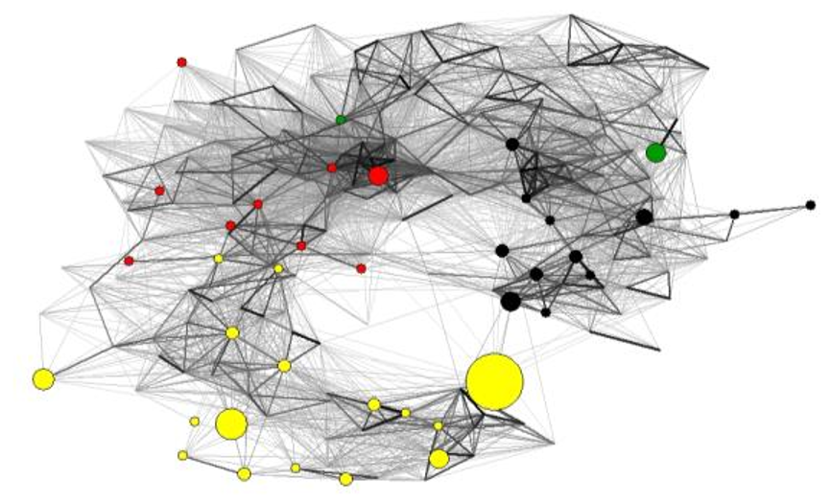

Figure 6. Overlay Sample Map

3

Program that facilitates the analysis and visualization of social networks. It was developed by the University of Ljubljana (Slovenia). Free download is allowed for non-commercial use

4

VOSViewer is a software tool to build and visualize bibliometric networks

To make the density of each of the materials clearer, VOSViewer has been used, employing specific tools [17]:

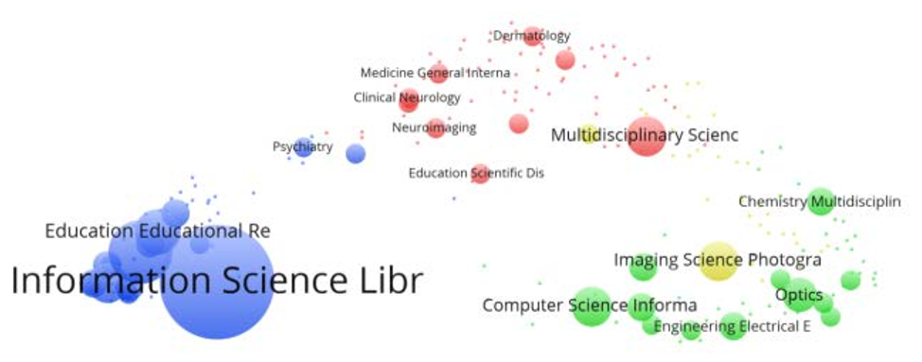

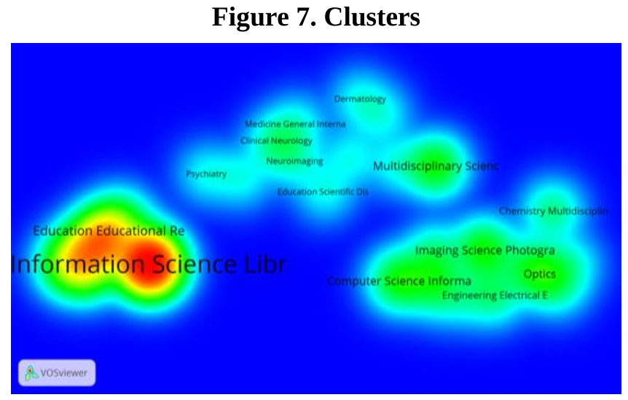

Figure 8. Clusters density map

As can be observed, self-publishing is an issue that is under consideration, mainly in the area of Information Science / Library Science (area given by Isi Web of Science). It is in this area where the foundations of this phenomenon are laid from a scientific point of view and where we will obtain (or should obtain) results that confirm its profile as a tool, method, subarea, etc ...

It is noteworthy that if the top 10 results are taken and contrasted with the ANEP5 areas, 70% of the areas where this phenomenon is being studied are within the formerly called "Social Sciences". This result may be obvious given that self-publishing is a way to communicate something that falls within the more "social" nature of knowledge, but it could also indicate a very interesting trend for the community of social sciences in general, since its implementation could fill important gaps in the channels of dissemination of scientific knowledge in this area, and more specifically, in the areas of evaluation and metrics of Social Science.

5

Classification of human knowledge in 26 areas by the spanish Agencia Nacional de Evaluación y Prospectiva (ANEP). It is available

at:http://www.idi.mineco.gob.es/portal/site/MICINN/menuitem. 8ce192e94ba842bea3bc811001432ea0/?vgnextoid=d2bbe7c85a b4d210VgnVCM1000001d04140aRCRD

442

Bibliometric Study and Network Analysis of the Phenomenon of Self Publishing

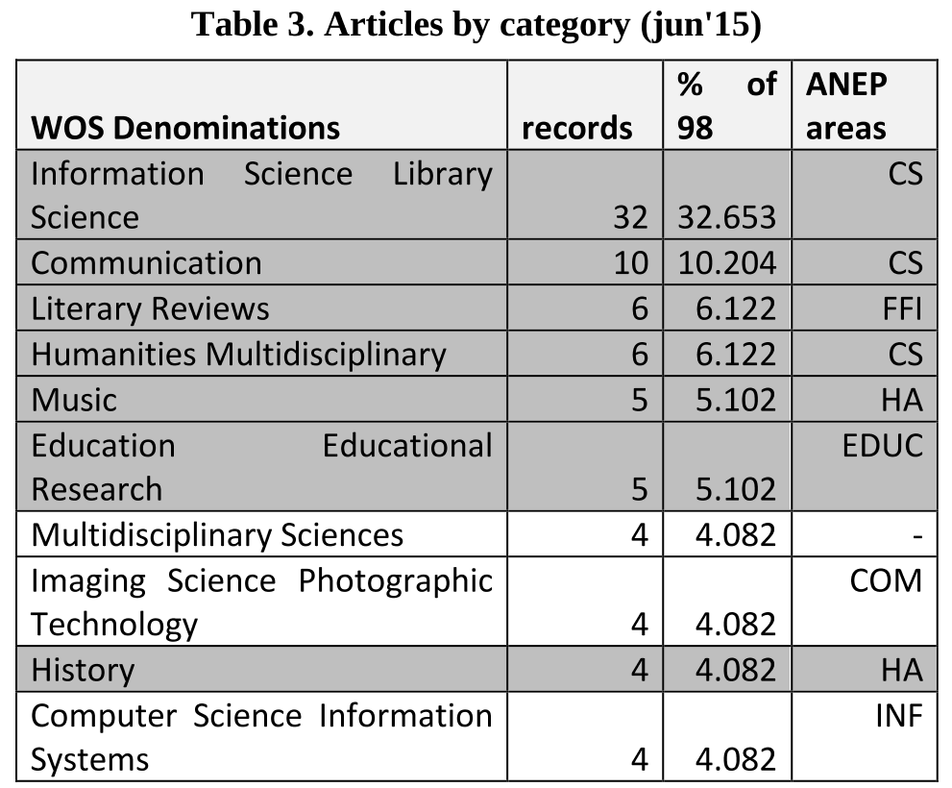

To ensure that the data has not changed in the June update, it can be compared with the March 2015 results:

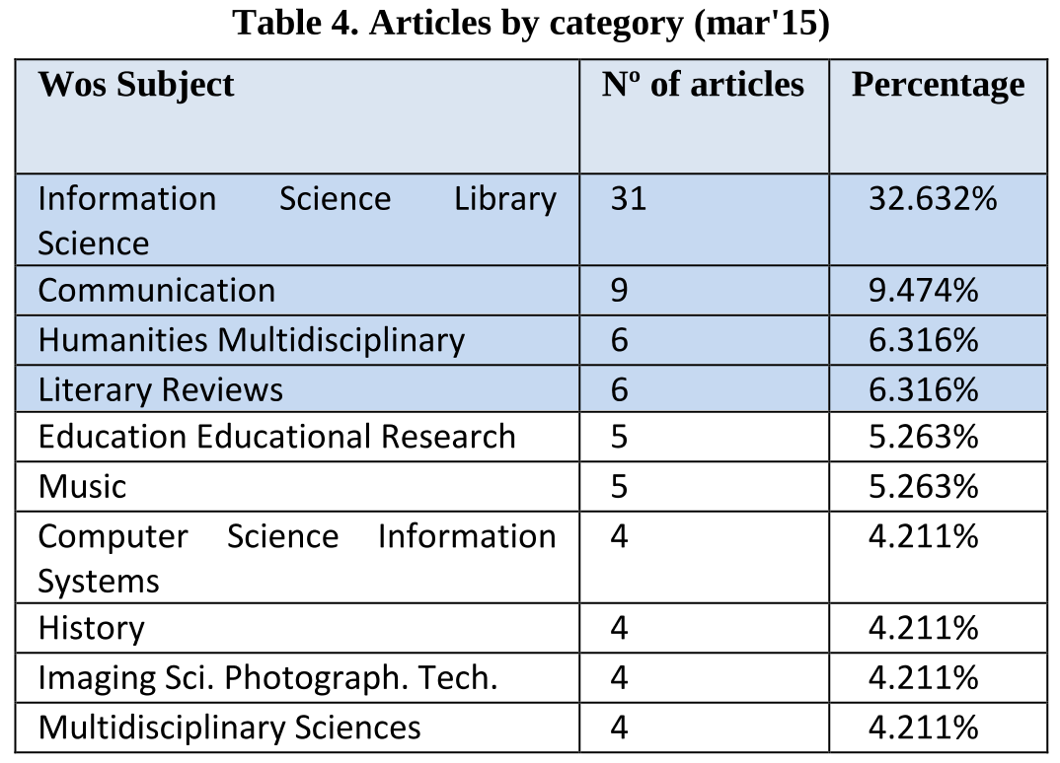

Again it is emphasized that only the first four areas now cover 55% of all items, as displayed in the above density map. This is a topic with very concentrated scientific literature.

Law of productivity of authors: For this calculation, the data was organized by authors and their scientific production.

Lotka's Law (1926) refers to the productivity of authors. The law proposes that regardless of the scientific discipline and with the sole condition that the literature collection is as complete and comprehensive as possible and covers an extended period of time, the number of authors who published n papers is inversely proportional to n². Therefore, few authors publish most of the relevant literature on the subject.

Their calculation can be done in two ways:

The first way is based on the idea that using the number of authors with one job on a particular topic it is possible to predict the number of authors with n projects, using the following formula: = A¹ Aⁿ / n² being A¹ that number of authors with a single job.

In our case: A3 = 109 / (3) 2 = 12 or A2 = 109 / (2) 2 = 27

In this case, the bibliography of our subject does not comply with the Lotka´s Law.

The second method is based on the contribution made by Price to Lotka´s law. Price said that for a particular period in a given scientific field, the number of prolific authors is approximately the square root of all authors in said field.

[number of prolific authors = set of authors who have published half of the work]

In order to test this further, calculations will be made following this second formula.

So, we made the calculations: Total authors: 117 authors6,

Lotka´s Law of: square root of 117 = 10.81

It is checked to see if the first 10 or 11 authors have 50% of the articles:

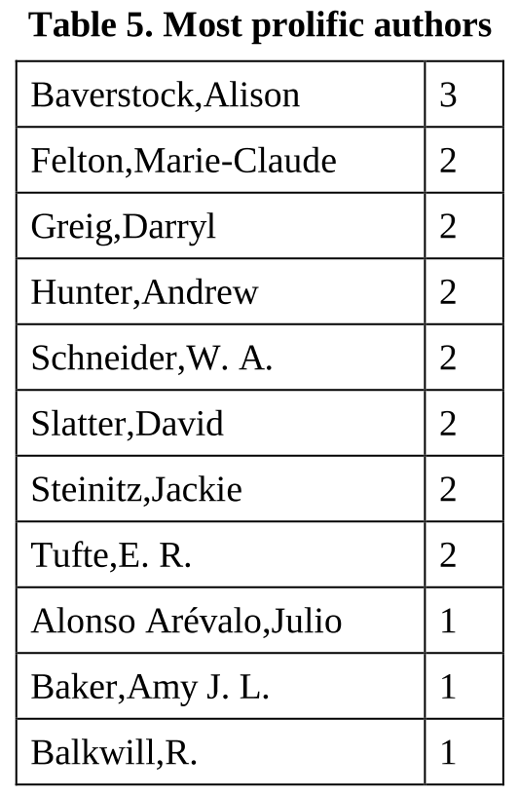

The first 10 authors have 20 articles, or 18.88%, far from the 50% which Lotka indicates. Therefore, the law is not fulfilled in this case.

This low productivity figure indicates that this is an issue of which several authors are skimming the surface, but very few are going any deeper. Such low figures perhaps indicate a single research group. This assumption perhaps could be confirmed in a new line of inquiry by reviewing institutional affiliations or research groups of authors.

Co-authorship index: Mathematically, the rate of co-authorship (including patents) is: Total number of authors / total number of items = 117/106 = 1.10.

To calculate the index of authorship simply divide:

Total number of authors / total number of items

Total number of authors: 117

Total number of items: 107

Authorship index = 1.09

6

To simplify this calculation only articles have been taken into account (not patents, etc ...).

443

Third International Conference on Technological Ecosystems for Enhancing Multiculturality - TEEM’15

It is strange to find such a low rate of co-authorship on a topic that is a worldwide occurring phenomenon. It is not a small issue geographically or socially, it is too broad a subject for such a low co-authorship coefficient. This does raise the issue as to whether current projects are taking into account all the factors involved in the phenomenon of self-publishing ... .This data could mean that little collaboration exists.

Here again we find a fact that lends itself to further research of great interest. Why this overwhelming lack of cooperation? Studying collaborations in the area of science always provides an additional and interesting point of view [18].

With regard to network citations, the case in recent months has caught our attention, which we wish to show in this article:

After carrying out a study with Pajek, using journal articles listed in the ISI Web of Science in 2015 and displaying it with the Kamada-Kawai layout, this is the appearance of the citation network / countries:

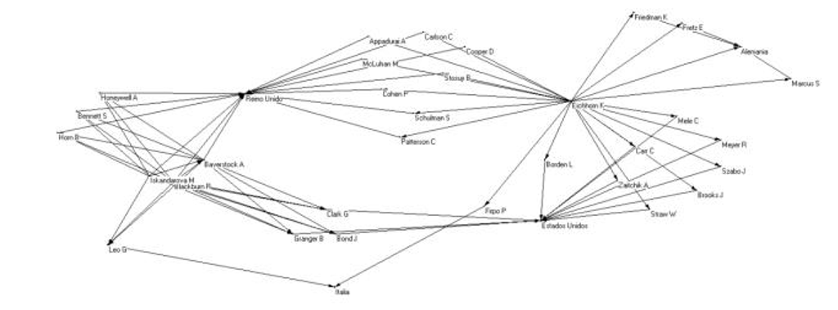

Figure 9. Citations / countries net

At first glance, some points can be observed where many sides converge: UK, USA and Eichhorn.

After making calculations, some interesting facts are: - Size: 35 nodes. - Total of lines (links): 75

- Number of links whose weight is different from 1 = 3. That is in 3 cases, the author cites another author more than once.

- Number of loops: 1 (There is an author who quotes himself)

- This is a network of mode 2 Two different relationships (citation and country) are studied at the same time.

- Average degree: 4.28. This also seems rather excessive, therefore it will be analyzed after separating relationships.

We extract relationships separately and look at the data which indicates the authors´ country of affiliation.

- Density: 0.32. For such a small network, the density is high. This data is not assessable, since it would be very unusual for an author to be affiliated with institutions of two countries at once.

- Average Degree = 1.77142857. This indicates that there is not a great diversity of authors´ countries of affiliation. Otherwise, this figure would be lower.

- Input Degree: The country which produces the most authors is United Kingdom, (14) followed by the USA (11), Germany (4) and Italy (2).

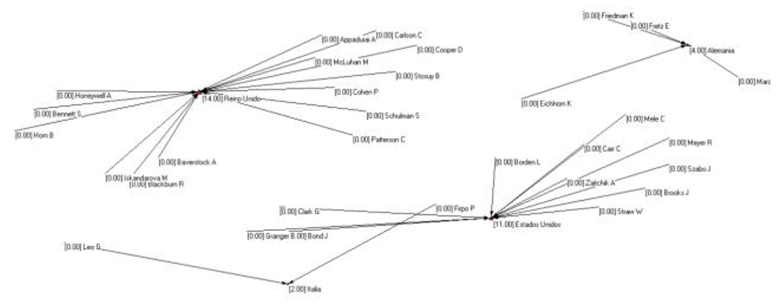

Figure 10. Input degree of the relationship "countries"

This fact is curious, since the United States of America is still a pioneering power on the phenomenon of self-publishing, with a large number of platforms including Amazon and an emerging ¨do it yourself¨ culture. Interestingly, in the past year it is in the United Kingdom where this phenomenon has been most widely investigated. Data regarding the language of the articles is not available, since all of the articles were in English, but this calculation does assume that a large majority in the coming months will also be in English.

In this relationship it does not make sense to calculate the other figures, since they will all come out in the same order.

The second relationship, citations, will now be analyzed:

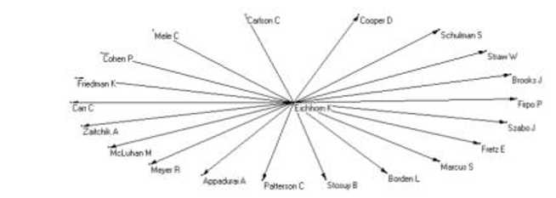

Figure 11. Relationship network "citations"

Average Degree: 2.5 This data is worthy of attention. If, as shown in the picture, there are only a few authors cited, the average degree should be close to 1. There must be some remarkable factor which is not perceivable in this representation.

Input degree: there are 3 distinct groups: one, authors with 0 posts (nobody cites them), another, which has more nodes, authors with one incoming link (cited once), and another with one single node, "Baverstock A ", which has 3 inputs (the heavy arrows indicate the weights of the lines).

Figure 12. Input degree, relationship "citations"

What is even more interesting is the centrality of degree weight (who is better positioned in terms of links received/

444

Bibliometric Study and Network Analysis of the Phenomenon of Self Publishing

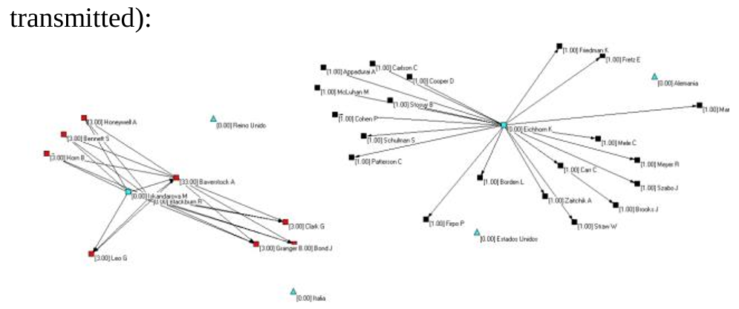

Figure 13. Degree centrality with weights

With this data we see clearly that the author with the most citations received is Baverstock. With this fact it can be assumed that Baverstock is the author investigating the topic of self-publication the most.

And if we compare with the bibliometric analysis covering every year, not only the last, this fact can be confirmed. She is the most prolific author.

Degree of closeness: what node is the best connected. In this case several authors have the same measure (0.11), the authors are: Leo, Bennet, Granger,…

Loops: The author quoted himself, and in a high percentage calculation based on the value (11.0) is "Baverstock, A."

Time Graph: They have defined time intervals indicating the dates of the cited articles.

[1] - [2002-2006] [2] - [2007-2010] [3] - [2011-2015]

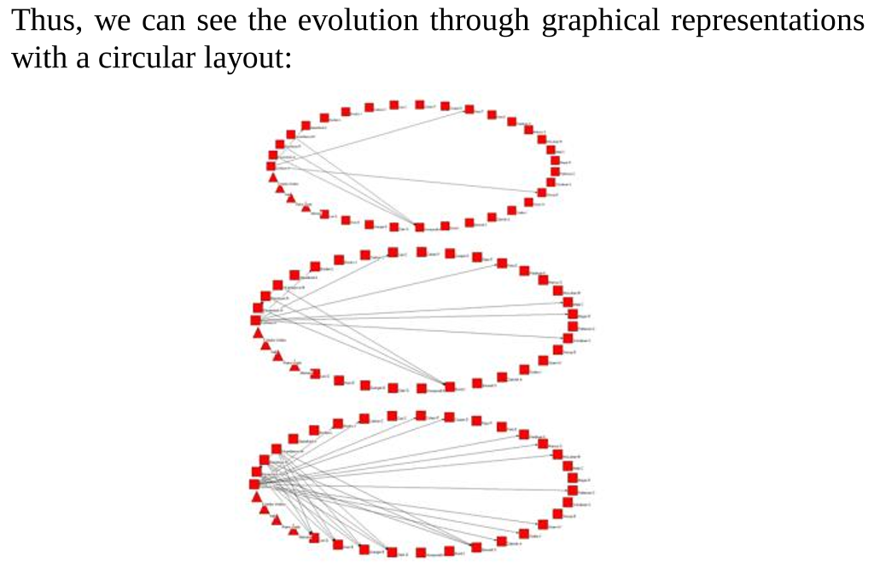

Figure 14. Evolution of the date of cited works

As we can see, there has been a progressive increase in the number of citations in the work of self-publishing. This may indicate an increase in works on the subject, in the number of authors investigating it, or different approaches that have been taken to the research.

It has thus been conclusively determined that there is an author who is working continuously. This author is also the one with the most citations received in 2015. These quotes came from the nodes shown closest to the author, who have cited the same authors as she has, including herself. It may be that this author is working on various research projects, all to do with self-publishing, hence the explanation for these "self-citations". Alternatively, a closed group of research may be involved. What is certain is that this author is the most prominent this year with regard to this topic.

The majority of authors appear to be from the UK, contrary to our perception prior to carrying out this study which led to believe that the United States would have the monopoly in the field of research on "self-publishing".

Finally, although this study obviously has serious shortcomings due to the extremely short data collection period, a progressive increase in the dates of the articles cited has been observed, indicating an increase in projects and / or increase in the number of authors working on this topic or an increase in the approaches and applications regarding self-publishing.

If we make the same analysis with Gephi7:

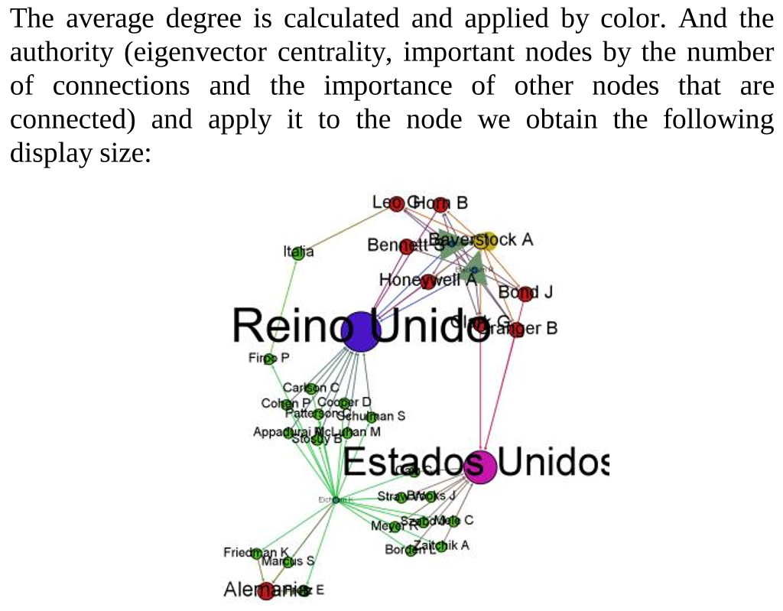

Figure 15. Average degree and eigenvector centrality

As can be seen, regarding countries, the United Kingdom and United States are indisputable. Furthermore, in the case of UK, those authors who are related, on the one hand with this country (important node) and moreover with Baverstock (node-author important) quickly gain in authority.

As a side note, to discover that Spain is not among the four countries that are studying self-publishing is not surprising, but to discover Italy in the top four certainly is. One of the hypotheses which is being considered in other current research focuses on the relationship between the Mediterranean and Latin American countries and the terminological problems which in turn create problems of legal loopholes in relation to digital books (the supports, devices, formats, …). This could be one of the causes of the relatively minor influence of the phenomenon of self-publishing on digital books, due to the minor effect that this area has had on users. To discover Italy in the top four (given the time and data restrictions that we have had for analysis) could turn the rest of data upside down and force us to review our assumptions and try to find new lines of action.

If the same calculations are made but authority is changed with intermediation (to seek the nodes that mediate, a bridge between subgroups within the network and therefore very relevant in the flow of information, and that is one of the measures of centrality most commonly used by different authors in their analysis [19]):

7

Gephi is an open source software for analysis and network visualization code. It was initially developed by students at the University of Technology of Compiègne (UTC) in France

445

Third International Conference on Technological Ecosystems for Enhancing Multiculturality - TEEM’15

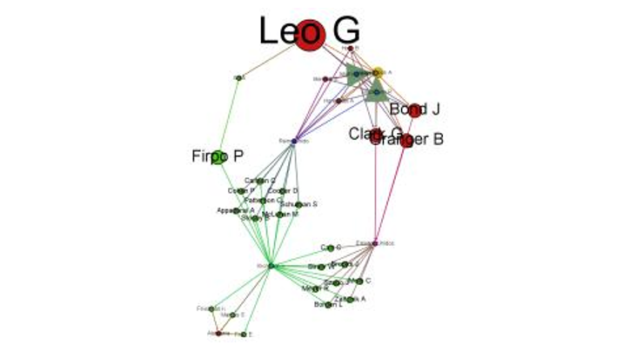

Figure 16. Average degree and betweenness

A name suddenly catches our attention which had not stood out before...Leo, and others who are bridges between different parts of the network appear. Leo is not widely connected, he is not a widely cited author, but he is connected to very important nodes, which makes him powerful.

Now for the network of citation connections:

- Average degree: 1.25. Average grade with weights: 2.11. It can again be observed that the author node receiving many citations raises the average. Without it, in general, we are talking about a network with very few connections (citations).

- Modularity: modularity groups in nodes in communities (node groups closely interrelated and less related to the outside). In this case, six communities are detected. Colours are applied to modularity in order to highlight the 6 communities located and with the size of the nodes the centrality of eigenvector is applied (to mark authority):

Figure 17. Comunnities

Of the 6 detected communities, 2 are of concern: the authors and citations. The other 4 communities are countries.

As can be seen, the most important elements are the group where the most cited author is, and greater interaction is clearly shown among authors in the group.

The other community has a totally egocentric shape: a new player in the game, Erichhorn, is quoting everyone else yet is referred to by no-one. A guess could be hazarded that this is the only author of one or two articles in which the other authors are cited. If this data is repeated when we expand the years of analysis, the fact that there are few mutual citations, and that in this community the network is completely egocentric, suggest that he does not usually work on self-publishing or perhaps has begun to do so only recently. It will also be interesting to analyze more closely why he has chosen to reference authors whom others do not cite, perhaps because they concentrate on other topics to which the self-publishing phenomenon can also be applied.

Similarly, the other group, with higher density, shows a research group, it is not known whether formed or invisible, which is addressing this issue. Either everyone is doing it from complementary approaches, hence the citations, or it is a group of authors who sign a common article or several articles where quotes of their own works appear (quite common) to a much

greater extent than quoting other authors (something not so common). In this group an author stands out: Baverstock, author who in the bibliometric study from 1958 appears to be more relevant and has produced the most work on the subject. So, we might suppose that this large number of quotations in just a few months indicates that a line of work is followed based on previous research.

Other indices and calculations could be used to expand the study of this phenomenon, but in this particular report only brief and approximate references are intended to be made. Consequently, the most striking data only has been analysed.

5. CONCLUSIONS

Those who study today's world of e-books, their formats, their devices, their delivery systems and new platforms that arise every day know that it is necessary to consider the other form of publishing, self-publishing.

Originally it used to mean a lack of quality in the finished product, but current changes have caused a transition in thinking and much progress is being made in terms of tools and resources. As a result, authors can edit jobs with certain editorial quality, although there is still doubt regarding its scientific rigor, the quality of content which has not undergone the supervision of an external editor.

A subject that raises many questions and so many possibilities and should be being thoroughly investigated by the scientific community. It that the case? The study indicates that it is. Perhaps we have not found high figures in our analysis, yet as we have seen this is a topic of only recent relevance. Even so, the area of library and information science has been clearly defined as the field where the most abundant studies are being done. It has also been observed that important and influential authors are currently working on this topic, and they all belong to research groups with years of experience behind them.

However, the rate of co-authorship is still low, which can mean a lack of multidisciplinary approach to research projects when the subject lends itself to it, as evidenced by the fact that there are many other areas in which the authors are slowly discovering the phenomenon of self-publishing.

Moreover, network analysis proved to be very useful in this type of study because it has allowed us, even working within a very small time frame, to discover patterns and emerging elements, to visualize community related nodes and to study different perspectives.

The combination of these analyses of applied social networks and traditional bibliometrics are a great combination when it comes to studying specific phenomena, such as self-publishing.

The possibilities that different software tools offer us should also be kept in mind and combined to get better test results.

Based on this analysis and almost parallel to it, new research has emerged which will be addressed in the future: comparing the results of this analysis with those arising from the same study of all ages gathered, analysing different approaches that are being taken to publishing research, studying whether the terminological problems affect the penetration of this phenomenon in society (and scientifically), among others.

6. REFERENCES

446

[1] Alonso Arévalo, J; Cordón García, J.A.; Gómez Díaz,

R. 2014. La autopublicación, un nuevo paradigma en la

creación digital del libro. Rev. cuba. inf. cienc. salud [online], vol.25, n.1, pp. 126-142.

[2] Cordón García, J. A.; Alonso Arévalo, J. 2010. Los

libros electrónicos: nuevas formas de edición y nuevos modos de lectura. En Revista UNE n.20, 21-23.

[3] Mangas Vega, A. 2014. Approach to the Evaluation of

Electronic Scientific Monographs IN García Peñalvo, F. J. TEEM '14 2nd International Conference on

Technological Ecosystems for Enhancing

Multiculturality Salamanca, Spain — October 01 - 03. ACM New York, NY, USA pp 537-540

[8] colaboración y consumo de la información en artículos originales de la revista Universitas Médicas, período

2002 a 2006. En: Universitas Médica 2007 vol. 48 nº 4 Disponible en:

http://med.javeriana.edu.co/publi/vniversitas/serial/v48n 4/2ESTUDIO%20BIBLIOMETRICO.pdf[Fecha de

consulta: 02/04/2015]

[9] Furtado, J. A. 2012. Self-publishing: ¿tsunami o "business as usual"? En: Libros electrónicos y

contenidos digitales en la sociedad del conocimiento: Mercado, servicios y derechos (1st ed., pp. 69-92)

Madrid: Pirámide, 2012.

[10] Kim, H.; Barnett, G.A. 2008. "Social Network Analysis Using Author Co-Citation Data". AMCIS Proceedings.

Paper 172.

[11] Miguel, S., Caprile, L., Jorquera-Vidal, I. 2008.

Análisis de co-términos y de redes sociales para la

generación de mapas temáticos. El Profesional De La Información, 17(6), 637-646.

[12] Jalalimanesh, A., Yaghoubi, S. M. 2013. Application of social network analysis in interlibrary loan services.

Webology, 10(1), 1-9.

[13] Ardanuy, J., Urbano, C., Quintana, L. 2009. "The evolution of recent research on Catalan literature

through the production of PhD theses: a bibliometric and social network analysis" Information Research,

14(2) paper 404. [Disponible en:

http://InformationR.net/ir/14-2/paper404.html]

[4] Sullivan, H. 1958. Vanity press publishing. Library Trends, 7(1), 105-115

[5] Cordón García, J.A.; Gómez Díaz, R.; Alonso Arévalo, J.; Alonso Berrocal, J.L. 2013. El Ecosistema del Libro

Electrónico Universitario. Madrid, Unión de Editoriales Universitarias Españolas.

[6] Gorbea Portal, S. 2005. Modelo teórico para la el

estudio métrico de la Información documental. España: TREA. p. 171.

[7] Camps, D. (2007). Estudio bibliométrico general de

[14] Carroll, N., Whelan, E., Richardson, I. 2010. The

Discovery of Agile Service Networks through the Use

of Social Network Analysis International Conference of Service Science (ICSS2010) , 13-14 may.

[15] Chang, Y. 2011. A comparative study of the research

literature on information needs and information seeking: A bibliometric and social network analysis. Journal of

Educational Media and Library Science, 48(3), 347-380.

[16] Charman-Anderson, Suw, <<Self-Publishing’s Place On The Hype Cycle>>, Forbes, 2/29/2012.

http://www.forbes.com/sites/suwcharmananderson/2012 /02/29/self-publishing-place-on-the-hype [Fecha de

consulta: 26/03/2015]

[17] Price, D. J. S. 1963. Little science, big science. New York: Columbia University Press.

[18] Leydesdorff, L. 1989. Words and Co-Words as

Indicators of Intellectual Organization. Research Policy, 18, 209-223.

[19] Maltrás, B. 2003. Los indicadores bibliométricos:

Fundamentos y aplicación al análisis de la ciencia. Gijón: Trea.

[20] Soheili, F., Khademi, R., Mansoori, A. 2015.

Correlation between impact factor and productivity with centrality measures in journals of information science:

A social network analysis. International Journal of Information Science and Management, 13(1), 21-38