1. The first step, you need to create an excel file, and the first column must be named ID. Then, you should copy the Excel file to your project's Assets directory.
2. Then open the ‘Tools / SQLite3 Window’ menu. You will see this window

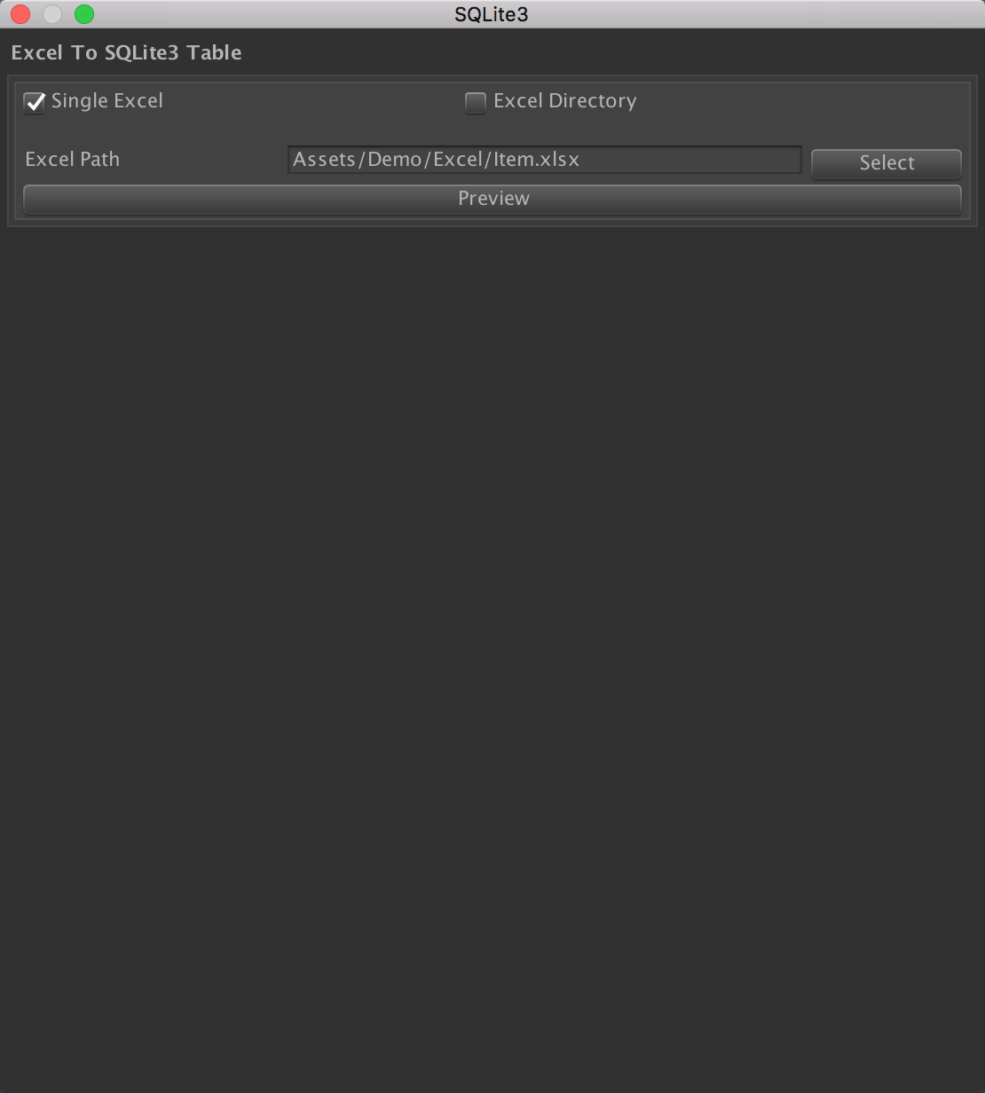

1. You can click the "Single Excel" check box to open a single Excel file or click the "Excel directory" check box to open all Excel files in the directory.
2. When you select the Single Excel option, you can enter the excel file storage path in the input box, or you can click the Select button, which will open a window where you can choose the path where your file is located. Like this:

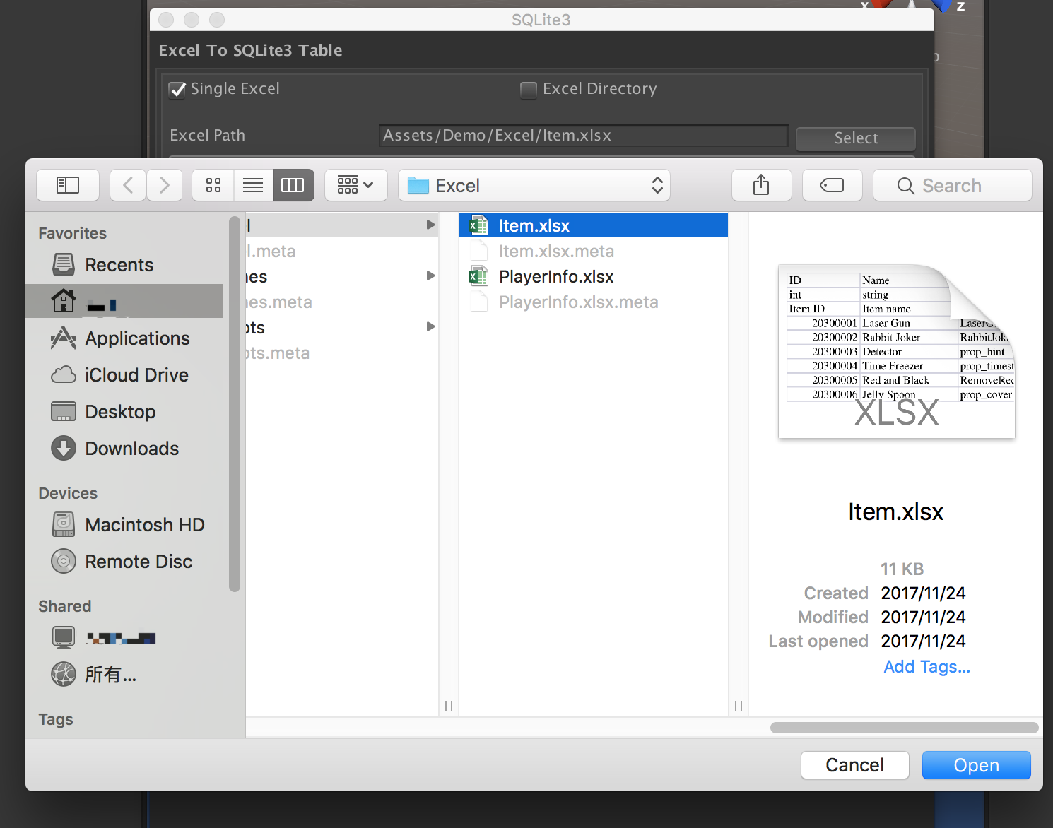

Choose you excel file then click Open button. The file path will show at the input box, and the path will store at the EditorPrefs, next time you open the SQLite3 Window