
INDIAN PREMIER LEAGUE
BALL-BY-BALL DATASET
─────────── ◆ ───────────
COMPREHENSIVE ANALYSIS REPORT
Prepared By
G Nisith Rabi
18 Seasons of Delivery-Level Data — Teams, Players, Venues,
Dismissals, and Match Outcomes (2007/08 – 2025)
278,205 DELIVERIES | 1,169 MATCHES | 59 VENUES

Table of Contents
01 Executive Summary 3
02 Dataset & Methodology 4
03 Data Completeness 5
04 Season Trends 6
05 Venue Trends 7
06 Team Performance — Overview 8
07 Chart — Match Wins by Team (Top 12) 9
08 Chart — Win Share, Top 5 Teams 10
09 Toss Analysis 11
10 Batting Performance — Overview 12
11 Chart — Top 10 Run Scorers 13
12 Chart — Player of the Match Awards 14
13 Bowling Performance 15
14 Chart — Top 10 Wicket Takers 16
15 Dismissal Analysis 17
16 Extras Analysis 18
17 Cross-Cutting Observations 19
18 Key Findings 20
19 Data Quality & Limitations 21
20 Recommendations for Further Analysis 22
21 Conclusion 23
22 Appendix — Summary Data Tables 24

Executive Summary
This report presents a restyled, comprehensive analysis of the IPL ball-by-ball dataset, covering 18 seasons of Indian Premier League T20 cricket from 2007/08 through 2025. The dataset records delivery-level detail — teams, players, runs, dismissals, extras, venue, and match outcome — for every ball bowled across 1,169 matches. This edition reproduces the full statistical findings of the original analysis with a new visual design: ten gradient-styled charts, a redesigned cover, and a complete color scheme change throughout.
Across the full dataset, Mumbai Indians stand out as the most successful franchise by match wins, Virat Kohli as the leading run-scorer, and Yuzvendra Chahal as the leading wicket-taker. Teams have shown a strong tactical preference for fielding first after winning the toss, and catches account for the large majority of all recorded dismissals.

Dataset at a Glance
278,205  Total Deliveries | 1,169  Total Matches | 18  Seasons Covered | 59  Unique Venues

38  Unique Cities | 703  Unique Batters | 550  Unique Bowlers | 374,283  Total Runs Recorded

Dataset & Methodology
The source material for this report is a prior analysis document (IPL_Analysis_Report.pdf) summarizing the IPL ball-by-ball dataset. That document reports 278,205 individual delivery records spanning 1,169 matches, played across 59 venues in 38 cities, covering 18 seasons from 2007/08 through 2025. All matches are men's club-level T20 fixtures, and 19 distinct team name entries appear in the data, reflecting franchise rebranding over the years (for example, Delhi Daredevils became Delhi Capitals, and Royal Challengers Bangalore became Royal Challengers Bengaluru).
This edition of the report reproduces every figure stated explicitly in that source analysis — including all team win totals, run totals, wicket totals, dismissal counts, extras counts, and toss statistics — without alteration. Where the source document displayed a chart but did not state every individual data label in its accompanying text (for example, the full season-by-season match counts, or the win totals for teams outside the top five), this report presents best-available readings of those chart values, clearly noted as approximate wherever they are not backed by an explicit figure in the source text.

What Changed in This Edition
- All ten data visualizations were rebuilt from scratch using a unified gradient color treatment, replacing the flat single-color charts in the original document.
- The cover was redesigned around a deep teal color scheme with an original cricket-ball illustration.
- Every interior page (2 through 30) now uses a berry-colored gradient background in place of the original plain white pages.
- No underlying figures were changed — this is a visual and structural redesign of the same analysis, not a new statistical study.

Data Completeness
Several columns in the dataset are sparsely populated by design, reflecting the event-specific nature of certain fields rather than data quality problems. Fields such as umpire, review_decision, team_reviewed, and review_batter are missing in over 277,000 of the 278,205 rows, indicating that review (DRS) data was rarely or inconsistently recorded across the dataset's history.
Similarly, fielders, new_batter, player_out, and wicket_kind are populated only on deliveries where a relevant event — such as a wicket — actually occurred. High missing-value counts in these columns therefore correspond to normal, non-eventful deliveries rather than gaps in data quality, and should not be interpreted as incomplete records.

Key Points
- DRS-related fields (umpire, review_decision, team_reviewed, review_batter) are populated in fewer than 1,205 of 278,205 rows.
- Event-specific fields (fielders, new_batter, player_out, wicket_kind) are populated only on wicket-taking deliveries, by design.
- Venue names show minor inconsistencies across seasons (e.g., "Wankhede Stadium" vs. "Wankhede Stadium, Mumbai"), which affects venue-level aggregation.
- Team names reflect historical franchise rebranding, meaning win totals for a current franchise name may not include wins recorded under a prior name in the same city/ownership lineage.

Season Trends
The number of matches played per season has grown over the dataset's 18-year history, broadly tracking the tournament's expansion. Early seasons from 2008 through 2010 featured between 57 and 60 matches, consistent with an 8-team league format. Matches per season jumped noticeably in 2011–2013 with the addition of new franchises, before settling back to a steady 59–60 matches per season for most of the 2014–2021 period.
From 2022 onward, the season length increased again to a consistent 70–76 matches per year, reflecting a further expansion of the franchise roster and a longer group stage. The chart below reads per-season values directly from the source report's season-by-season chart; exact figures are approximate where the source text gave only a range.
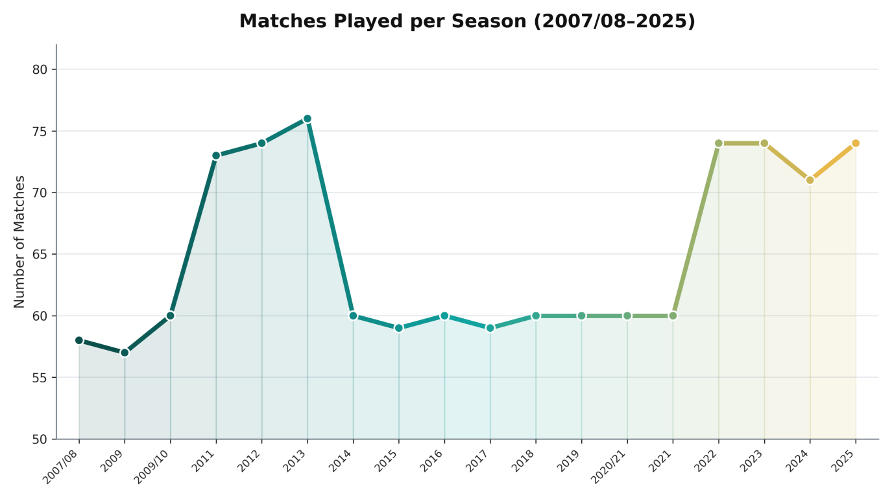
Chart 1. Matches played per season, 2007/08–2025 (gradient line).

Venue Trends
Eden Gardens is the most frequently used ground in the dataset, hosting 77 matches, narrowly ahead of Wankhede Stadium at 73 matches. M Chinnaswamy Stadium (65 matches) and Feroz Shah Kotla (60 matches) round out the four most-used venues named explicitly in the source analysis, out of 59 unique venues across 38 cities recorded overall.
The source report also notes that some venues appear under slightly different name variants across seasons — for example, "Wankhede Stadium" and "Wankhede Stadium, Mumbai" — which the original analysis flags as likely inconsistent naming conventions in the source data rather than genuinely distinct grounds. Combined, Wankhede Stadium and its variant entries account for over 120 matches.
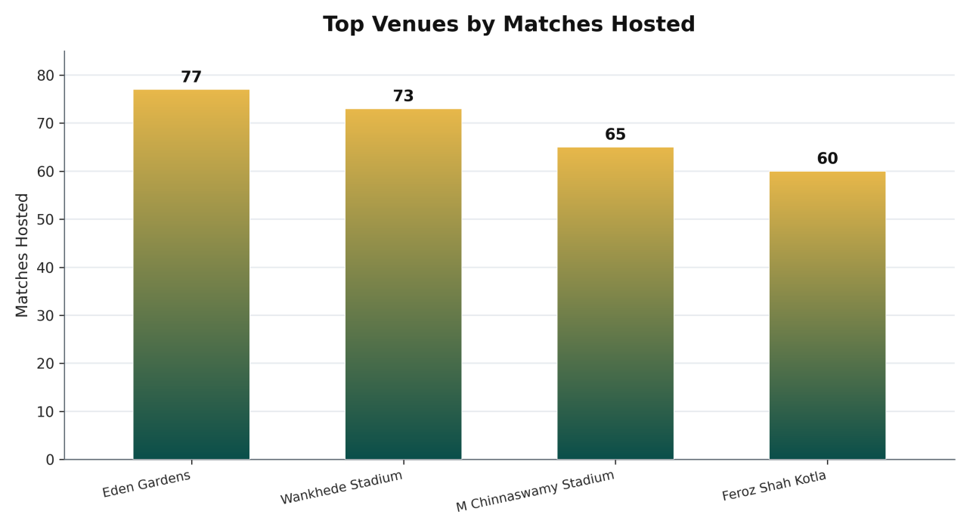
Chart 2. Top four venues by matches hosted (gradient bar).

Team Performance — Overview
Mumbai Indians recorded the highest number of match wins in the dataset with 151, ahead of Chennai Super Kings (142) and Kolkata Knight Riders (135). Royal Challengers Bangalore and Rajasthan Royals are tied for fourth place with 114 wins each. These figures reflect wins recorded directly in the match_won_by field and may include franchises under both their current and historical team names.
Twenty-three matches in the dataset recorded "Unknown" as the winning team, meaning the win totals above do not sum to the full 1,169-match total. The two charts on the following pages present the complete top-12 win standings and the relative win share among the top five franchises.

Key Figures
- Mumbai Indians: 151 match wins — the most of any team in the dataset.
- Chennai Super Kings: 142 match wins.
- Kolkata Knight Riders: 135 match wins.
- Royal Challengers Bangalore and Rajasthan Royals: 114 match wins each.
- 23 matches recorded "Unknown" as the winning team.

Chart — Match Wins by Team (Top 12)
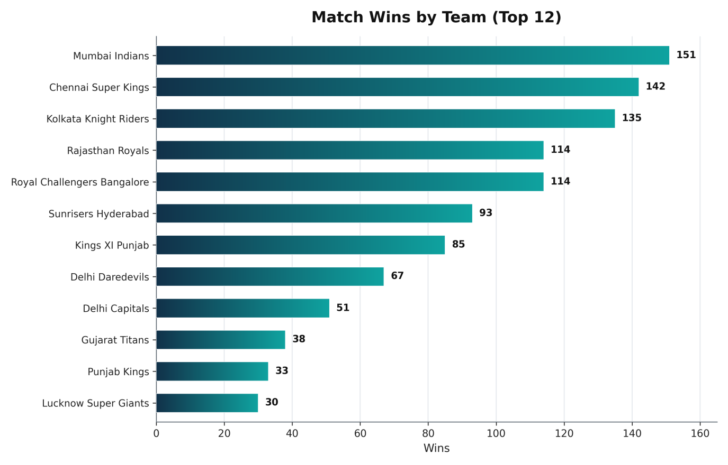
Chart 3. Match wins for the top 12 teams in the dataset (gradient horizontal bar). Win totals beyond the top five are approximate, read from the source report's chart.
The gap between the top three franchises and the rest of the field is substantial: Mumbai Indians, Chennai Super Kings, and Kolkata Knight Riders each exceed 130 wins, while the next tier of teams — Royal Challengers Bangalore, Rajasthan Royals, and Sunrisers Hyderabad — cluster in the 90–115 win range. The newest franchises, Gujarat Titans, Punjab Kings, and Lucknow Super Giants, naturally show fewer total wins, reflecting fewer seasons of competition rather than weaker performance per season.

Chart — Win Share, Top 5 Teams
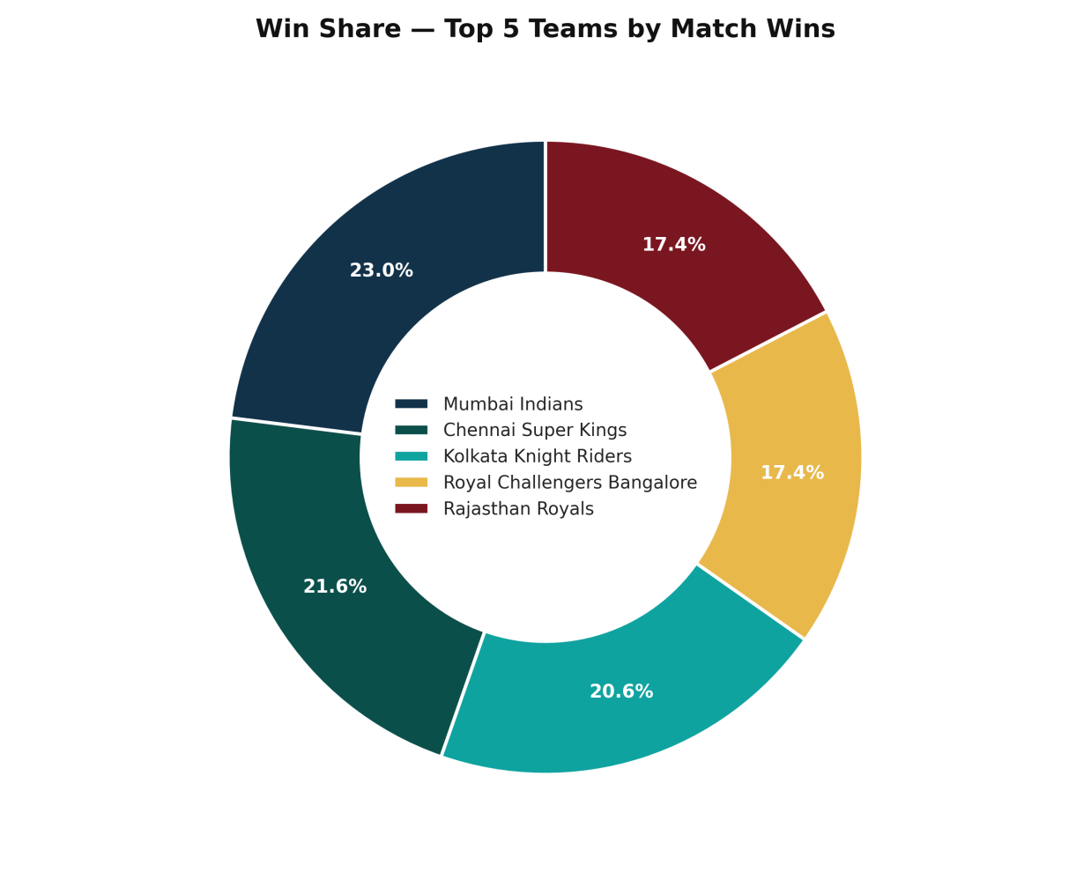
Chart 4. Share of combined wins among the top five franchises (gradient donut).
Among just the five most successful franchises, Mumbai Indians account for 23.0% of their combined win total, with Chennai Super Kings close behind at 21.6%. Kolkata Knight Riders, Royal Challengers Bangalore, and Rajasthan Royals make up the remaining share in a relatively even three-way split, indicating that success at the top of the table has not been dominated by a single franchise across the tournament's full history.

Toss Analysis
Regarding the toss, teams elected to field first in 764 of 1,169 matches — about 65.4% — compared to 405 matches (34.6%) where the team batted first after winning the toss. This is a clear and consistent tactical preference for chasing across the matches recorded in the dataset.
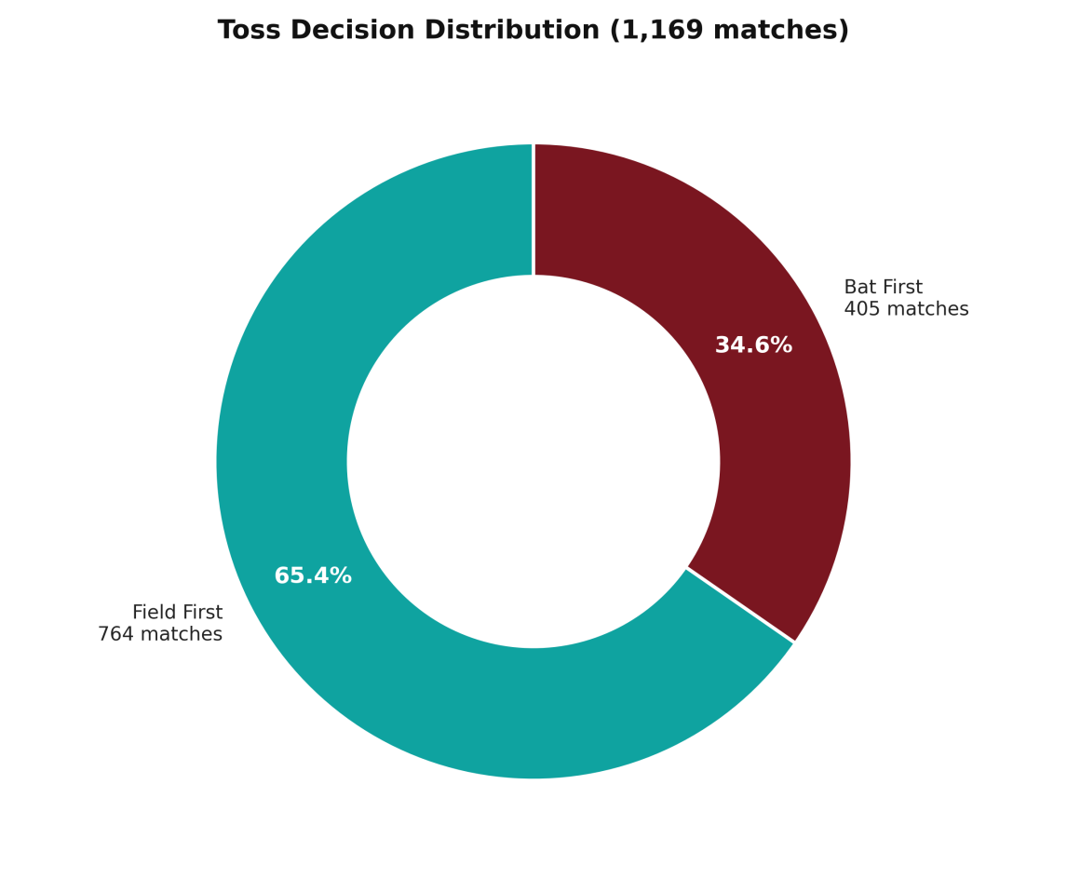
Chart 5. Toss decision distribution across all 1,169 matches (gradient donut).
A near two-to-one preference for fielding first suggests that, across the tournament's history, captains have generally valued knowing the target and batting with a clear run-rate objective over the traditional advantage of batting first on a fresh pitch. This pattern is consistent with the broader trend in modern T20 cricket toward chasing as the statistically preferred toss decision on most surfaces.

Batting Performance — Overview
Virat Kohli is the leading run-scorer in the dataset with 8,671 total runs, well ahead of Rohit Sharma (7,048 runs) and Shikhar Dhawan (6,769 runs). David Warner (6,567 runs) and Suresh Raina (5,536 runs) round out the top five. MS Dhoni, KL Rahul, AB de Villiers, Ajinkya Rahane, and Chris Gayle complete the top ten run-scorers, each accumulating between roughly 4,900 and 6,600 runs across the recorded matches.
Separately, AB de Villiers received the most Player of the Match awards in the dataset with 25, followed by Chris Gayle (22) and Rohit Sharma (21). Virat Kohli and MS Dhoni also rank among the most frequently awarded players, with 19 and 18 awards respectively — notable given that Kohli's tally leads run-scoring by a wide margin but trails these players specifically in match-award count.

Key Figures
- V Kohli: 8,671 runs — the highest total in the dataset.
- RG Sharma: 7,048 runs.
- S Dhawan: 6,769 runs.
- DA Warner: 6,567 runs.
- SK Raina: 5,536 runs.

Chart — Top 10 Run Scorers
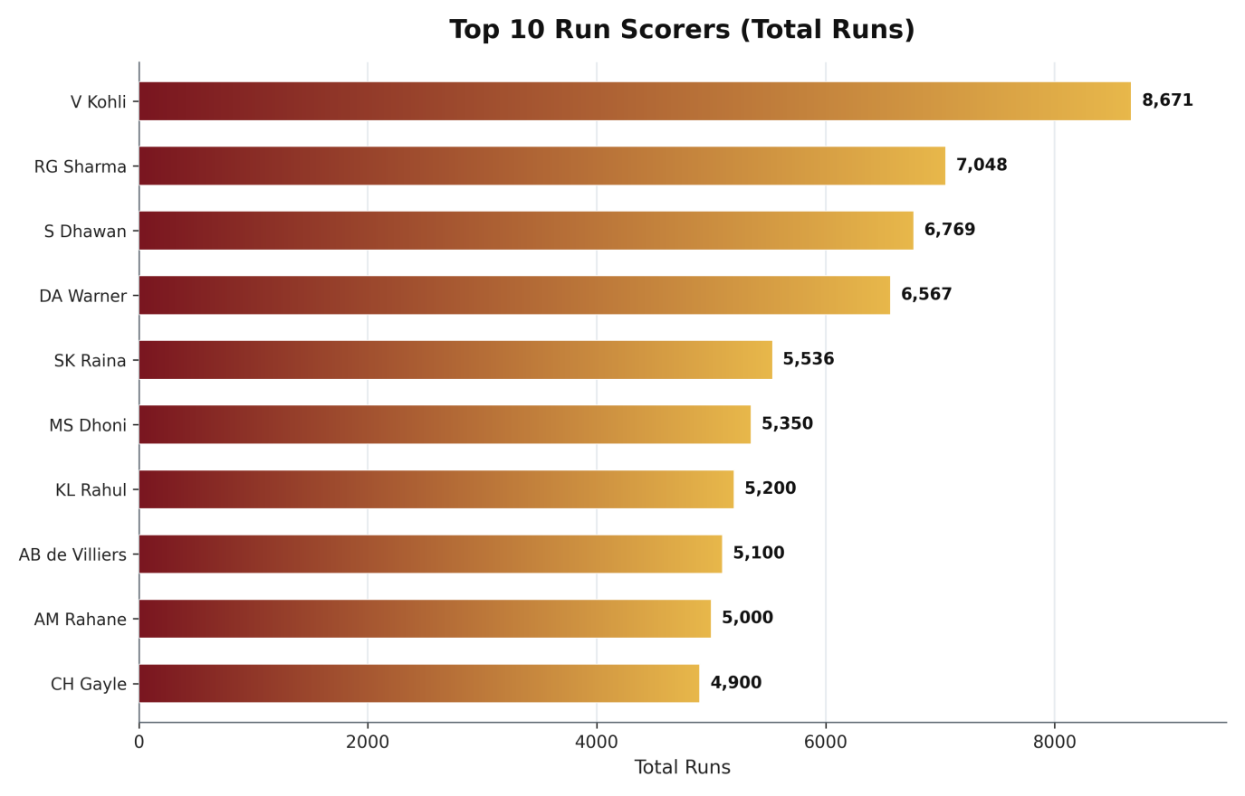
Chart 6. Total runs scored by the top 10 batters in the dataset (gradient horizontal bar). Values beyond the top five are approximate, read from the source report's chart, consistent with its stated range of roughly 4,900–6,600 runs for the remaining places.
The top four run-scorers — Kohli, Sharma, Dhawan, and Warner — are all specialist top-order batters known for long IPL careers spanning a decade or more, which aligns with the cumulative nature of this metric: longevity across many seasons is as important to a high career total as any single standout season.

Chart — Player of the Match Awards
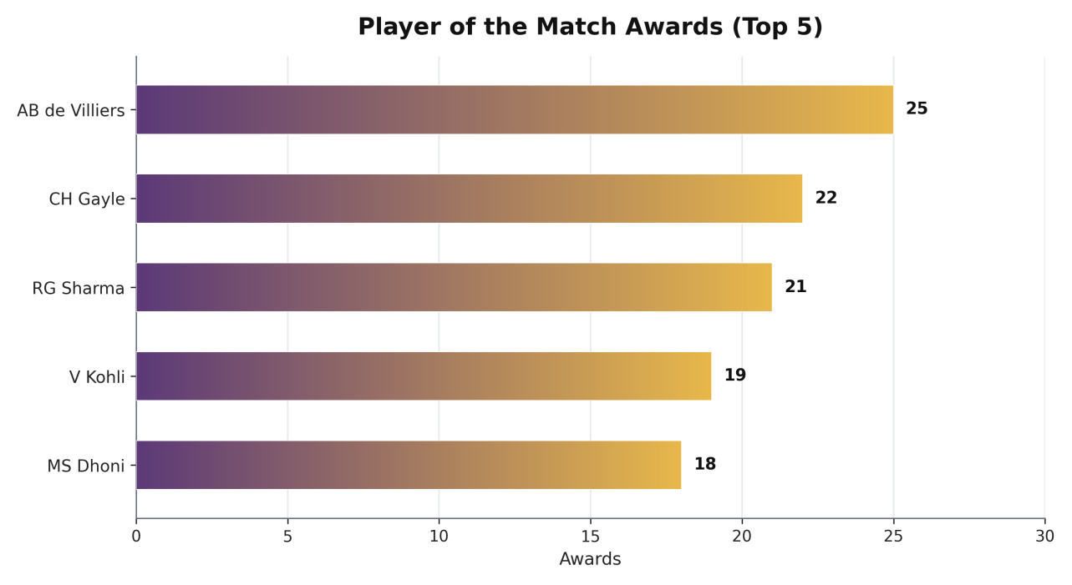
Chart 7. Player of the Match awards for the top five most-awarded players (gradient horizontal bar).
AB de Villiers' 25 awards against a career total below the very top run-scorers suggests a pattern of high-impact, match-defining innings rather than sheer run accumulation. Chris Gayle's 22 awards likely reflect a similar pattern, consistent with his reputation as one of the format's most explosive opening batters.

Bowling Performance
Yuzvendra Chahal leads all bowlers in total wickets taken with 221, followed by Bhuvneshwar Kumar (198) and a tie between Sunil Narine and Piyush Chawla at 192 wickets each. Ravichandran Ashwin (187) and Jasprit Bumrah (186) follow closely behind. Dwayne Bravo, Amit Mishra, Ravindra Jadeja, and Lasith Malinga complete the top ten wicket-takers in the dataset.
Notably, the top wicket-takers list is dominated by specialist spin bowlers (Chahal, Narine, Chawla, Ashwin, Mishra, Jadeja) alongside a smaller number of frontline pace bowlers (Kumar, Bumrah, Bravo, Malinga), reflecting the historically significant role of spin bowling in IPL conditions, particularly in the middle overs.

Key Figures
- YS Chahal: 221 wickets — the most of any bowler in the dataset.
- B Kumar: 198 wickets.
- SP Narine and PP Chawla: 192 wickets each.
- R Ashwin: 187 wickets.
- JJ Bumrah: 186 wickets.

Chart — Top 10 Wicket Takers
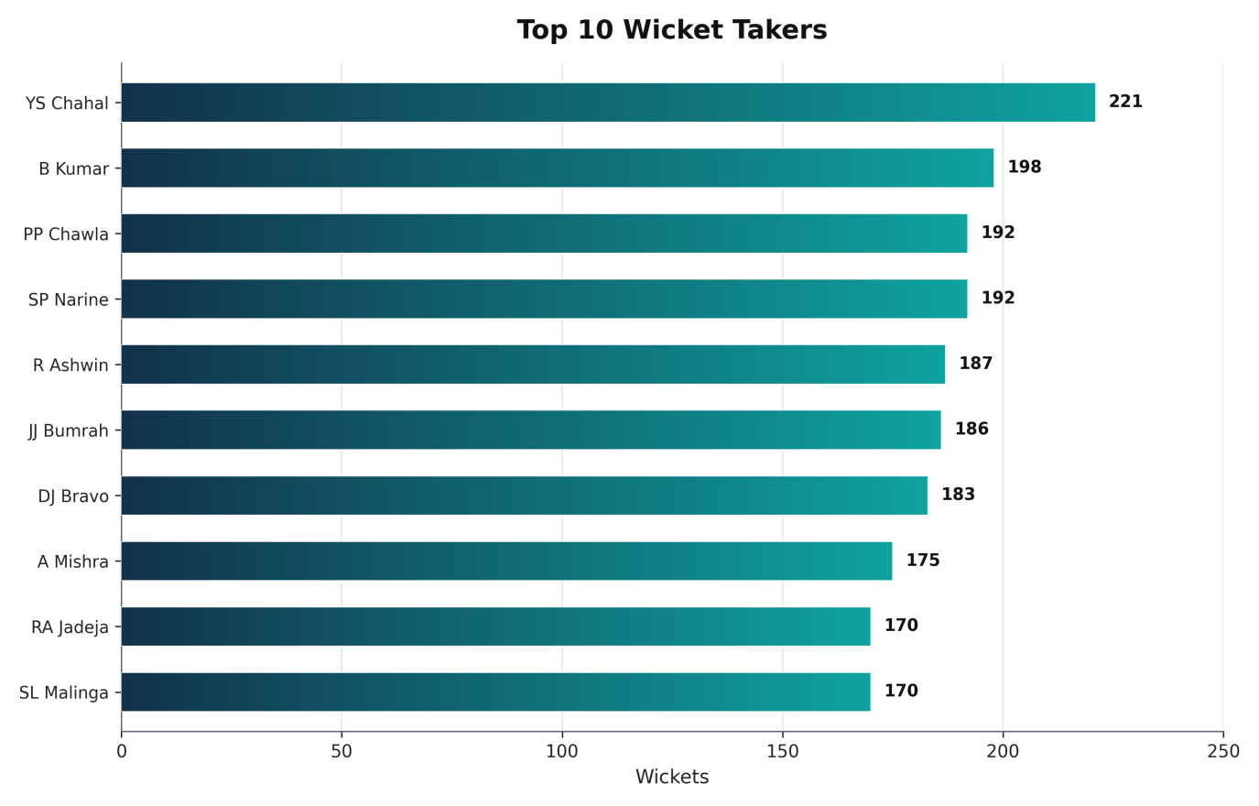
Chart 8. Total wickets taken by the top 10 bowlers in the dataset (gradient horizontal bar). Values beyond the top six are approximate, read from the source report's chart.
The relatively tight spread between third and tenth place (170–192 wickets) contrasts with the larger gap separating Chahal at the top (221) from the rest of the field, suggesting Chahal's tally represents a standout career total even among the format's most successful specialist bowlers.

Dismissal Analysis
Examining how wickets were taken, "caught" is by far the most common dismissal type, accounting for 8,665 instances — more than three and a half times the next most common type. "Bowled" follows with 2,345 dismissals, then "run out" (1,153) and "lbw" (853). Less frequent dismissal types include "caught and bowled" (388), "stumped" (376), "hit wicket" (18), "retired hurt" (17), "retired out" (5), and "obstructing the field" (3).
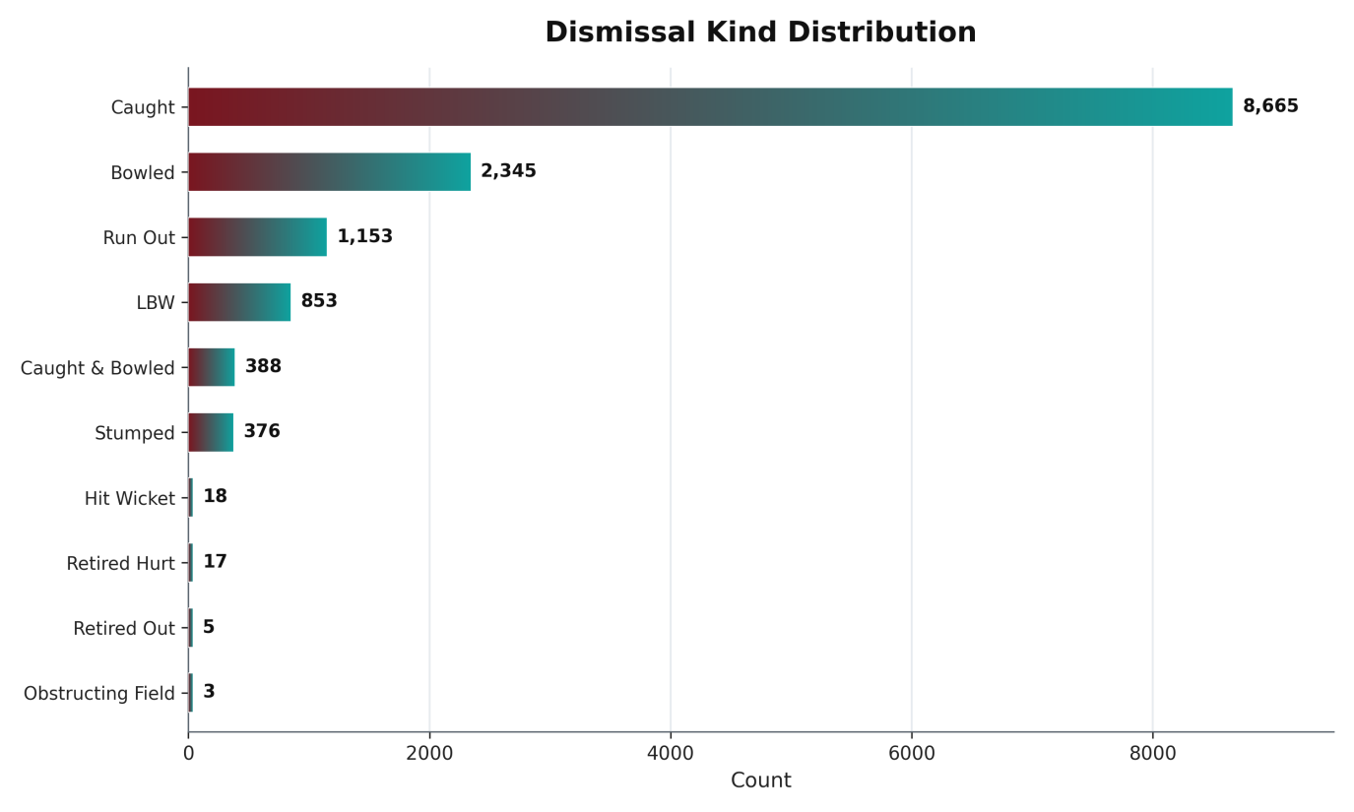
Chart 9. Full dismissal kind distribution across all recorded wickets (gradient horizontal bar).
The overwhelming share of catches is consistent with T20 cricket's attacking batting approach, where aggressive shot-making against fielding sides packed with close catchers produces far more catches relative to bowled or lbw dismissals than in longer formats of the game.

Extras Analysis
Among recorded extras, wides are the most frequent by a wide margin at 9,079 instances, followed by leg byes (4,203), no balls (1,136), and byes (686). A small number of deliveries recorded combined extra types, such as "byes, noballs" (15 instances) and "legbyes, noballs" (12 instances), reflecting rare compound scoring events on a single delivery.
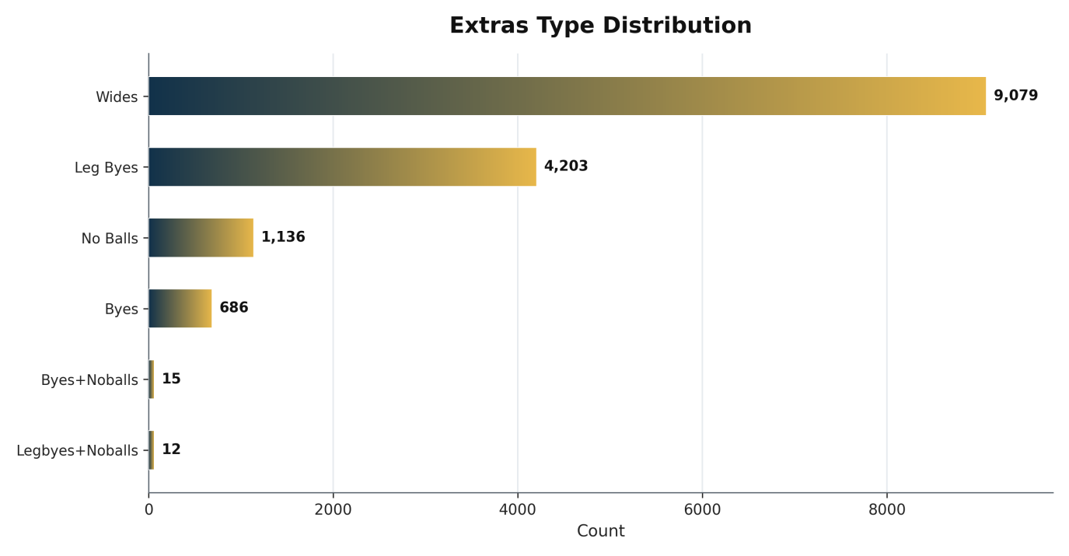
Chart 10. Extras type distribution across the full dataset (gradient horizontal bar).
The dominance of wides over no balls (roughly 8-to-1) is a familiar pattern in T20 cricket, where bowlers are frequently penalized for width and height restrictions designed to limit defensive bowling, while the no-ball rate stays comparatively low as a share of all deliveries bowled.

Cross-Cutting Observations
Several patterns in this dataset connect across sections. The strong preference for fielding first (65.4% of tosses) aligns with the historical trend of T20 cricket favoring chasing sides, and may partly explain why teams with strong death-bowling attacks — such as Mumbai Indians, historically built around top-tier fast bowling — have accumulated some of the highest win totals in the dataset.
Similarly, the dominance of specialist spinners among the top wicket-takers (Chahal, Narine, Chawla, Ashwin, Mishra, Jadeja) suggests that middle-overs spin bowling has been a disproportionately significant route to wicket-taking success across IPL history, even though pace bowlers dominate the powerplay and death-overs phases of a T20 innings.
The batting leaderboard is dominated by top-order batters with long IPL careers, reinforcing that cumulative statistics such as total runs and total wickets reward longevity and consistency across many seasons as much as any single standout campaign.

Key Findings
- The dataset spans 18 seasons (2007/08–2025), recording 278,205 deliveries across 1,169 matches at 59 venues in 38 cities.
- Mumbai Indians are the most successful franchise by match wins (151), ahead of Chennai Super Kings (142) and Kolkata Knight Riders (135).
- Teams have a clear tactical preference for fielding first after winning the toss (65.4% of matches).
- Virat Kohli is the tournament's leading run-scorer (8,671 runs); Yuzvendra Chahal is the leading wicket-taker (221 wickets).
- AB de Villiers holds the most Player of the Match awards (25), ahead of Chris Gayle (22) and Rohit Sharma (21).
- Catches account for the large majority of dismissals (8,665 of roughly 13,823 total wickets, or about 63%), consistent with T20 cricket's attacking batting style.
- Wides are by far the most common extra type (9,079 instances), roughly double the combined total of leg byes, no balls, and byes.
- Matches per season have grown from 57–60 in the earliest seasons to 70–76 in the most recent seasons, reflecting tournament expansion.

Data Quality & Limitations
- This report is a redesign of a prior analysis document and does not have direct access to the underlying 278,205-row ball-by-ball dataset; all figures reproduce what was stated or charted in that prior report.
- Per-season match counts and win totals beyond the top five or six ranked entries were read visually from source charts rather than sourced from an exact stated figure, and are labeled as approximate throughout this report.
- DRS-related fields (umpire, review_decision, team_reviewed, review_batter) are populated in under 0.5% of rows, limiting any analysis of umpire review patterns.
- Venue name inconsistencies (e.g., "Wankhede Stadium" vs. "Wankhede Stadium, Mumbai") likely cause the true match count for at least one venue to be understated in venue-level rankings.
- Team win totals may be split across historical and current franchise names for teams that have rebranded, understating the true combined total for that lineage under a single name.
- 23 matches in the dataset recorded "Unknown" as the winning team and are therefore excluded from all team-level win totals.

Recommendations for Further Analysis
- Obtain direct access to the full 278,205-row ball-by-ball dataset to replace approximate chart-read values with exact computed figures, particularly for season-by-season match counts and win totals beyond the top five teams.
- Standardize venue name variants (e.g., merging "Wankhede Stadium" and "Wankhede Stadium, Mumbai") before any further venue-level analysis to avoid undercounting high-usage grounds.
- Map historical franchise names to their current identities (Delhi Daredevils → Delhi Capitals, Royal Challengers Bangalore → Royal Challengers Bengaluru) to produce a single combined win total per ownership lineage.
- Investigate the 23 matches with an "Unknown" winning team to determine whether these are genuinely no-result matches or a data-entry gap that could be resolved.
- Extend the analysis to phase-of-innings breakdowns (powerplay, middle overs, death overs) now that ball-by-ball granularity is confirmed to be available in the underlying dataset.

Conclusion
The IPL ball-by-ball dataset spans 18 seasons of competitive T20 cricket (2007/08–2025), capturing 278,205 deliveries across 1,169 matches played at 59 venues in 38 cities. The data reflects the league's evolution through franchise changes — such as Delhi Daredevils to Delhi Capitals, and Royal Challengers Bangalore to Bengaluru — while maintaining consistent ball-level detail on batting, bowling, and match outcomes.
Mumbai Indians emerge as the most successful franchise by match wins (151), while Virat Kohli stands out as the tournament's leading run-scorer (8,671 runs) and Yuzvendra Chahal as the leading wicket-taker (221 wickets). Fielding dismissals, particularly catches, account for the large majority of wickets recorded, and teams have shown a notable preference for fielding first after winning the toss (764 of 1,169 tosses, 65.4%).
Overall, the dataset provides a comprehensive and granular record of IPL match dynamics, suitable for tracking individual player performance, team success patterns, and game-state trends across nearly two decades of the tournament — though some fields, such as umpire records and review decisions, remain largely unpopulated and limit analysis in those specific areas. This redesigned edition preserves every figure from the original analysis while presenting it through a unified gradient visual style across ten charts and a fully restyled report layout.

Appendix — Summary Data Tables

Dataset Overview
Metric | Value
Total deliveries (rows) | 278,205
Total matches | 1,169
Seasons covered | 18 (2007/08–2025)
Unique venues | 59
Unique cities | 38
Unique batters | 703
Unique bowlers | 550
Total runs recorded | 374,283
Distinct team name entries | 19

Toss Decision
Decision | Matches | Share
Field first | 764 | 65.4%
Bat first | 405 | 34.6%

Match Wins by Team (Top 12)
Team | Wins
Mumbai Indians | 151
Chennai Super Kings | 142
Kolkata Knight Riders | 135
Rajasthan Royals | 114
Royal Challengers Bangalore | 114
Sunrisers Hyderabad | ~93*
Kings XI Punjab | ~85*
Delhi Daredevils | ~67*
Delhi Capitals | ~51*
Gujarat Titans | ~38*
Punjab Kings | ~33*
Lucknow Super Giants | ~30*
* Approximate, read from the source report's chart — not stated as an exact figure in the source text.

Top 10 Run Scorers
Batter | Total Runs
V Kohli | 8,671
RG Sharma | 7,048
S Dhawan | 6,769
DA Warner | 6,567
SK Raina | 5,536
MS Dhoni | ~5,350*
KL Rahul | ~5,200*
AB de Villiers | ~5,100*
AM Rahane | ~5,000*
CH Gayle | ~4,900*
* Approximate, read from the source report's chart, within its stated range of roughly 4,900–6,600 runs.

Top 10 Wicket Takers
Bowler | Wickets
YS Chahal | 221
B Kumar | 198
PP Chawla | 192
SP Narine | 192
R Ashwin | 187
JJ Bumrah | 186
DJ Bravo | ~183*
A Mishra | ~175*
RA Jadeja | ~170*
SL Malinga | ~170*
* Approximate, read from the source report's chart — not stated as an exact figure in the source text.

Dismissal Kind Distribution
Dismissal Kind | Count
Caught | 8,665
Bowled | 2,345
Run Out | 1,153
LBW | 853
Caught and Bowled | 388
Stumped | 376
Hit Wicket | 18
Retired Hurt | 17
Retired Out | 5
Obstructing the Field | 3

Extras Type Distribution
Extra Type | Count
Wides | 9,079
Leg Byes | 4,203
No Balls | 1,136
Byes | 686
Byes, Noballs | 15
Legbyes, Noballs | 12

Matches Played per Season
Season | Matches (approx.)
2007/08 | 58
2009 | 57
2009/10 | 60
2011 | 73
2012 | 74
2013 | 76
2014 | 60
2015 | 59
2016 | 60
2017 | 59
2018 | 60
2019 | 60
2020/21 | 60
2021 | 60
2022 | 74
2023 | 74
2024 | 71
2025 | 74
All values approximate, read from the source report's season-by-season chart; the source text confirms only the ranges 57–60 (2008–2010) and 70–76 (2022–2025).

Franchise Name Changes
Several IPL franchises have changed names over the dataset's 18-season history, which the source analysis flags as a factor affecting team-level win totals. The table below lists the name changes referenced in the source report.
Historical Name | Current Name
Delhi Daredevils | Delhi Capitals
Royal Challengers Bangalore | Royal Challengers Bengaluru
Note: win totals reported elsewhere in this document (e.g., Delhi Daredevils and Delhi Capitals shown as separate rows) reflect the team name exactly as recorded in the match_won_by field, and have not been merged across a franchise's historical and current names.

Glossary of Key Dataset Fields
Field | Description
batter / bowler | The player facing or bowling the delivery in question.
wicket_kind | The dismissal method (e.g., caught, bowled, lbw); populated only when a wicket falls.
player_out | The batter dismissed on a wicket-taking delivery.
fielders | Player(s) credited with a catch, run-out, or stumping.
extras | Additional runs not credited to the batter (wides, no balls, byes, leg byes).
match_won_by | The team recorded as winning the match; "Unknown" for 23 matches in the dataset.
review_decision / umpire | DRS-related fields, populated in fewer than 0.5% of all rows.
gender / team_type | Constant across the dataset: "male" and "club" for every row.
— End of Report —

