Rossmann Store Sales: Exploratory Data Analysis Report
Prepared on 2026-06-04. This report presents dataset characteristics, preprocessing steps, exploratory findings, anomaly diagnostics, and proposed modeling methods.

1. Data Description
The analysis uses the merged Rossmann store-level daily sales data. The dataset contains calendar features, operational flags, promotional indicators, store metadata, and competition context variables.
Table 1. Data Column Descriptions
column | description | dtype
StoreID | Unique store identifier. | int64
Date | Calendar date of observation. | datetime64[us]
DayOfWeek | Numeric day of week. | int64
DayName | Day name label. | str
IsOpen | Derived or source column used in analysis. | int64
Open_Flag | Derived or source column used in analysis. | int64
StoreClosed_Flag | Derived or source column used in analysis. | int64
Sales | Total daily sales for the store. | int64
CustomerCount | Total daily customers for the store. | int64
DailyPromo | Indicator for whether daily promo is active. | int64
StateHoliday | State holiday type/category. | str
SchoolHoliday_Flag | Indicator for school holiday. | int64
StoreType | Store format/classification. | str
StoreType_Code | Derived or source column used in analysis. | str
Assortment | Product assortment class. | str
Assortment_Code | Derived or source column used in analysis. | str
CompetitorDistance_m | Distance to nearest competitor (meters). | int64
CompetitorDistance_Imputed | Derived or source column used in analysis. | int64
CompetitorOpenMonth | Derived or source column used in analysis. | float64
CompetitorOpenYear | Derived or source column used in analysis. | float64
RecurringPromo | Indicator for recurring promo participation. | int64
RecurringPromoStartWeek | Promo2 start week. | float64
RecurringPromoStartYear | Promo2 start year. | float64
RecurringPromoMonths | Months with recurring promotion. | str
Year | Derived or source column used in analysis. | int32
Month | Derived or source column used in analysis. | int32
MonthName | Derived or source column used in analysis. | str
Quarter | Derived or source column used in analysis. | int32
Week | Derived or source column used in analysis. | Int64
SalesPerCustomer | Derived or source column used in analysis. | float64
As shown in Table 1, the dataset includes core demand variables (Sales, CustomerCount), time indicators, and potential explanatory factors such as promotions, holidays, and store type.
Table 2. Data Types, Ranges, and Notes
column | dtype | range_or_cardinality | notes
StoreID | int64 | 1.00 to 1,115.00 | No missing values
Date | datetime64[us] | 2013-01-01 00:00:00 to 2015-07-31 00:00:00 | No missing values
DayOfWeek | int64 | 1.00 to 7.00 | No missing values
DayName | str | 7 unique values | No missing values
IsOpen | int64 | 0.00 to 1.00 | No missing values
Open_Flag | int64 | 0.00 to 1.00 | No missing values
StoreClosed_Flag | int64 | 0.00 to 1.00 | No missing values
Sales | int64 | 0.00 to 41,551.00 | No missing values
CustomerCount | int64 | 0.00 to 7,388.00 | No missing values
DailyPromo | int64 | 0.00 to 1.00 | No missing values
StateHoliday | str | 3 unique values | Has missing values
SchoolHoliday_Flag | int64 | 0.00 to 1.00 | No missing values
StoreType | str | 4 unique values | No missing values
StoreType_Code | str | 4 unique values | No missing values
Assortment | str | 3 unique values | No missing values
Assortment_Code | str | 3 unique values | No missing values
CompetitorDistance_m | int64 | 20.00 to 75,860.00 | No missing values
CompetitorDistance_Imputed | int64 | 0.00 to 1.00 | No missing values
CompetitorOpenMonth | float64 | 1.00 to 12.00 | Has missing values
CompetitorOpenYear | float64 | 1,990.00 to 2,015.00 | Has missing values
RecurringPromo | int64 | 0.00 to 1.00 | No missing values
RecurringPromoStartWeek | float64 | 1.00 to 50.00 | Has missing values
RecurringPromoStartYear | float64 | 2,009.00 to 2,015.00 | Has missing values
RecurringPromoMonths | str | 4 unique values | No missing values
Year | int32 | 2,013.00 to 2,015.00 | No missing values
Month | int32 | 1.00 to 12.00 | No missing values
MonthName | str | 12 unique values | No missing values
Quarter | int32 | 1.00 to 4.00 | No missing values
Week | Int64 | 1.00 to 52.00 | No missing values
SalesPerCustomer | float64 | 2.75 to 64.96 | Has missing values
As shown in Table 2, several operational fields contain structured missingness, which is important for feature engineering decisions.
Table 3. Descriptive Statistics of Numeric Variables
count | mean | median | std | min | 25% | 50% | 75% | max
1,017,209.00 | 558.43 | 558.00 | 321.91 | 1.0000 | 280.00 | 558.00 | 838.00 | 1,115.00
1,017,209.00 | 3.9983 | 4.0000 | 1.9974 | 1.0000 | 2.0000 | 4.0000 | 6.0000 | 7.0000
1,017,209.00 | 0.8301 | 1.0000 | 0.3755 | 0.0000 | 1.0000 | 1.0000 | 1.0000 | 1.0000
1,017,209.00 | 0.8301 | 1.0000 | 0.3755 | 0.0000 | 1.0000 | 1.0000 | 1.0000 | 1.0000
1,017,209.00 | 0.1699 | 0.0000 | 0.3755 | 0.0000 | 0.0000 | 0.0000 | 0.0000 | 1.0000
1,017,209.00 | 5,773.82 | 5,744.00 | 3,849.93 | 0.0000 | 3,727.00 | 5,744.00 | 7,856.00 | 41,551.00
1,017,209.00 | 633.15 | 609.00 | 464.41 | 0.0000 | 405.00 | 609.00 | 837.00 | 7,388.00
1,017,209.00 | 0.3815 | 0.0000 | 0.4858 | 0.0000 | 0.0000 | 0.0000 | 1.0000 | 1.0000
1,017,209.00 | 0.1786 | 0.0000 | 0.3831 | 0.0000 | 0.0000 | 0.0000 | 0.0000 | 1.0000
1,017,209.00 | 5,422.02 | 2,325.00 | 7,706.92 | 20.0000 | 710.00 | 2,325.00 | 6,880.00 | 75,860.00
1,017,209.00 | 0.0026 | 0.0000 | 0.0509 | 0.0000 | 0.0000 | 0.0000 | 0.0000 | 1.0000
692,161.00 | 7.2259 | 8.0000 | 3.2075 | 1.0000 | 4.0000 | 8.0000 | 10.0000 | 12.0000
692,161.00 | 2,008.87 | 2,010.00 | 4.4647 | 1,990.00 | 2,006.00 | 2,010.00 | 2,013.00 | 2,015.00
1,017,209.00 | 0.5006 | 1.0000 | 0.5000 | 0.0000 | 0.0000 | 1.0000 | 1.0000 | 1.0000
509,178.00 | 23.2691 | 22.0000 | 14.0960 | 1.0000 | 13.0000 | 22.0000 | 37.0000 | 50.0000
509,178.00 | 2,011.75 | 2,012.00 | 1.6629 | 2,009.00 | 2,011.00 | 2,012.00 | 2,013.00 | 2,015.00
1,017,209.00 | 2,013.83 | 2,014.00 | 0.7774 | 2,013.00 | 2,013.00 | 2,014.00 | 2,014.00 | 2,015.00
1,017,209.00 | 5.8468 | 6.0000 | 3.3261 | 1.0000 | 3.0000 | 6.0000 | 8.0000 | 12.0000
1,017,209.00 | 2.2943 | 2.0000 | 1.0818 | 1.0000 | 1.0000 | 2.0000 | 3.0000 | 4.0000
1,017,209.00 | 23.6155 | 22.0000 | 14.4334 | 1.0000 | 11.0000 | 22.0000 | 35.0000 | 52.0000
844,338.00 | 9.4936 | 9.2500 | 2.1974 | 2.7491 | 7.8956 | 9.2500 | 10.8997 | 64.9579
Table 3 summarizes mean, median, dispersion, and quantiles, supporting baseline understanding of skewness and outlier potential.

2. Key Findings from Exploratory Data Analysis

Figure 1. Missingness by Column
Figure 1 shows concentrated missingness in a subset of fields, indicating non-random, structural missingness. This supports indicator-aware imputation for selected variables.
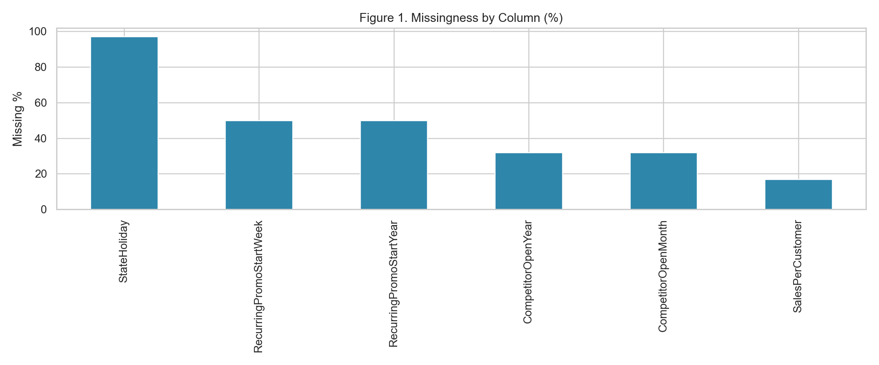

Figure 2. Sales Distribution
Figure 2 shows right-skewed sales distributions. The log transformation reduces skewness and improves stability for downstream models.
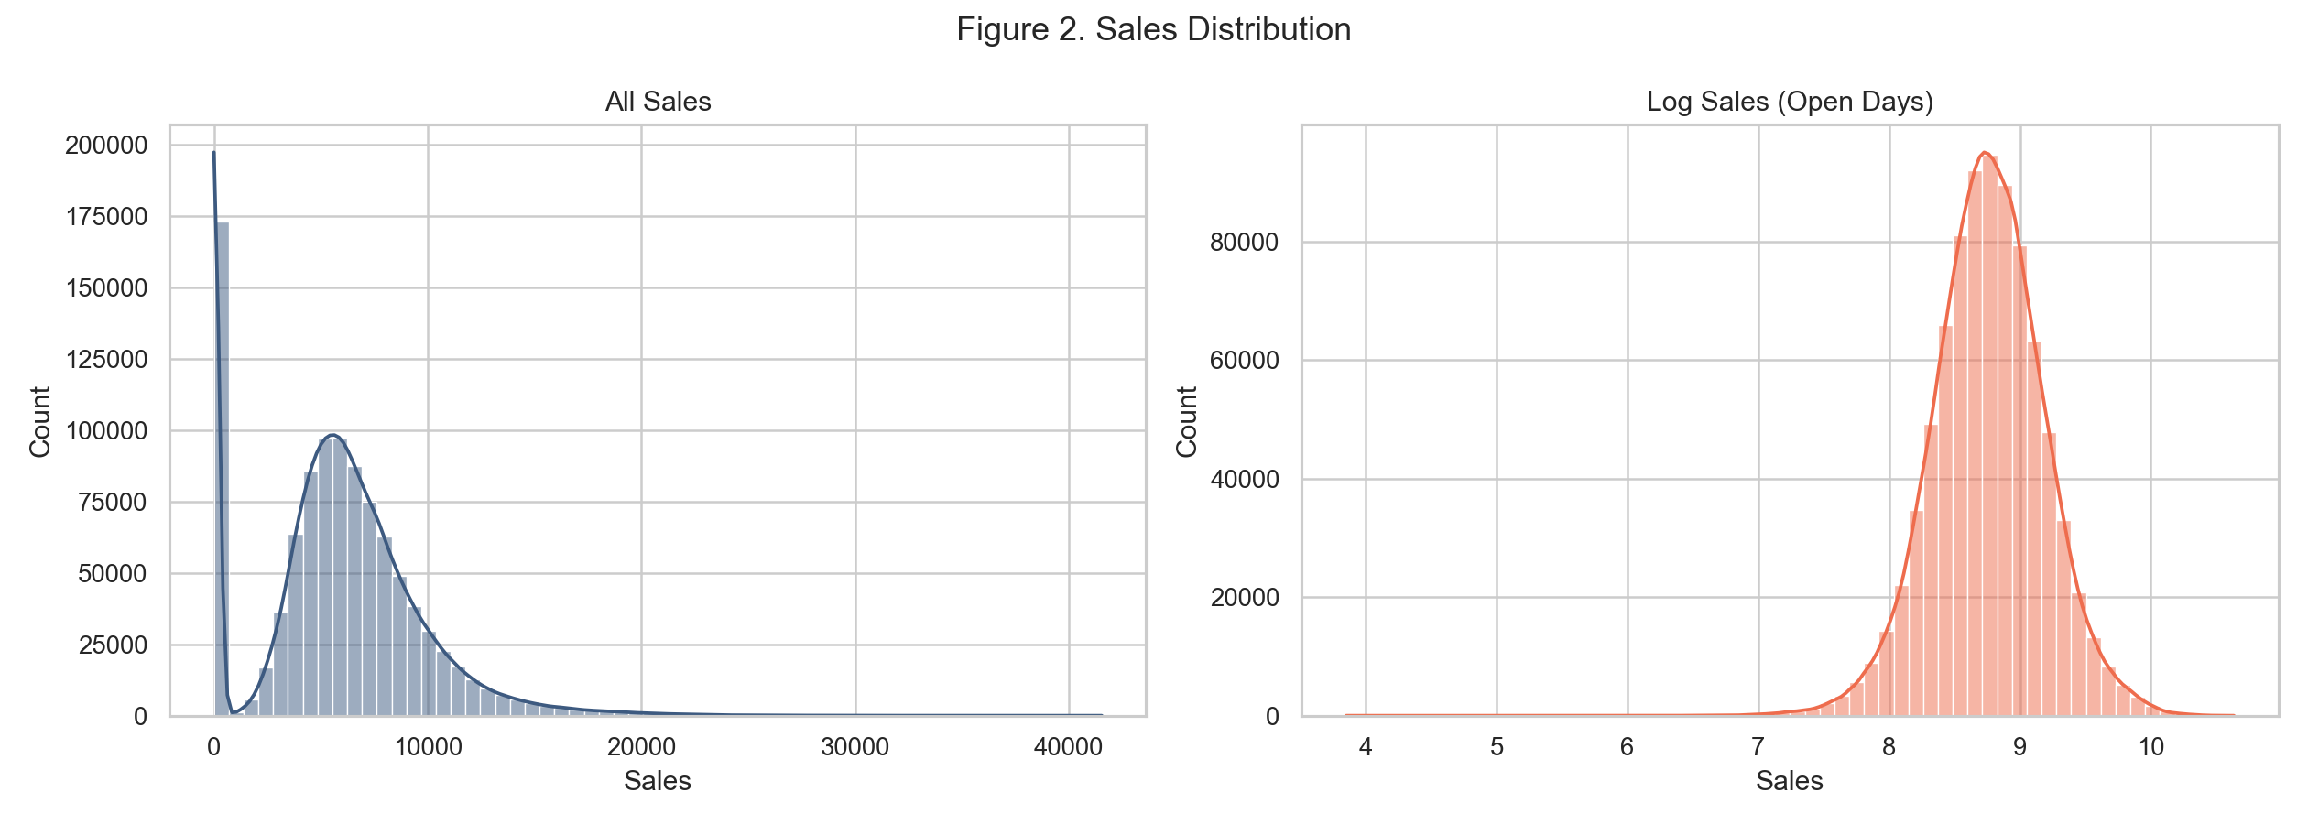

Figure 3. Sales vs CustomerCount
Figure 3 indicates a strong positive relationship between customer traffic and sales, suggesting traffic is a dominant short-term sales driver.
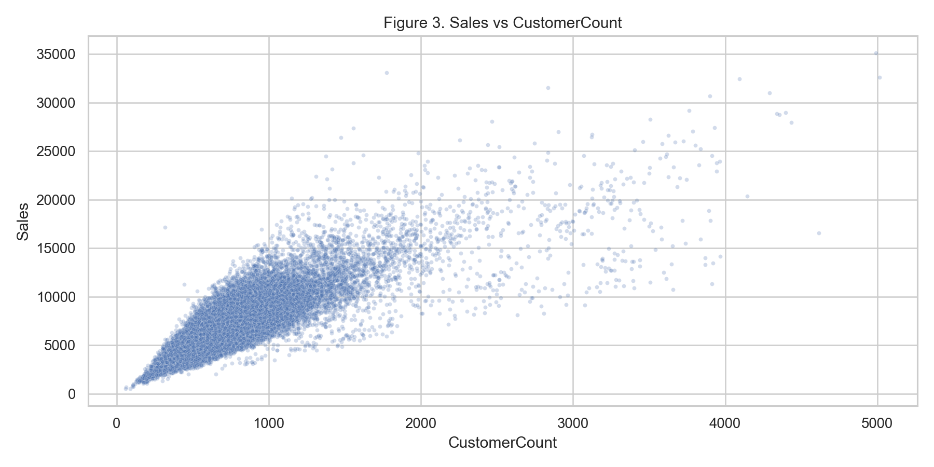

Figure 4. Daily and Monthly Time Trends
Figure 4 highlights nonstationary demand patterns and seasonality. Aggregate monthly trends are smoother and show systematic cyclical behavior.
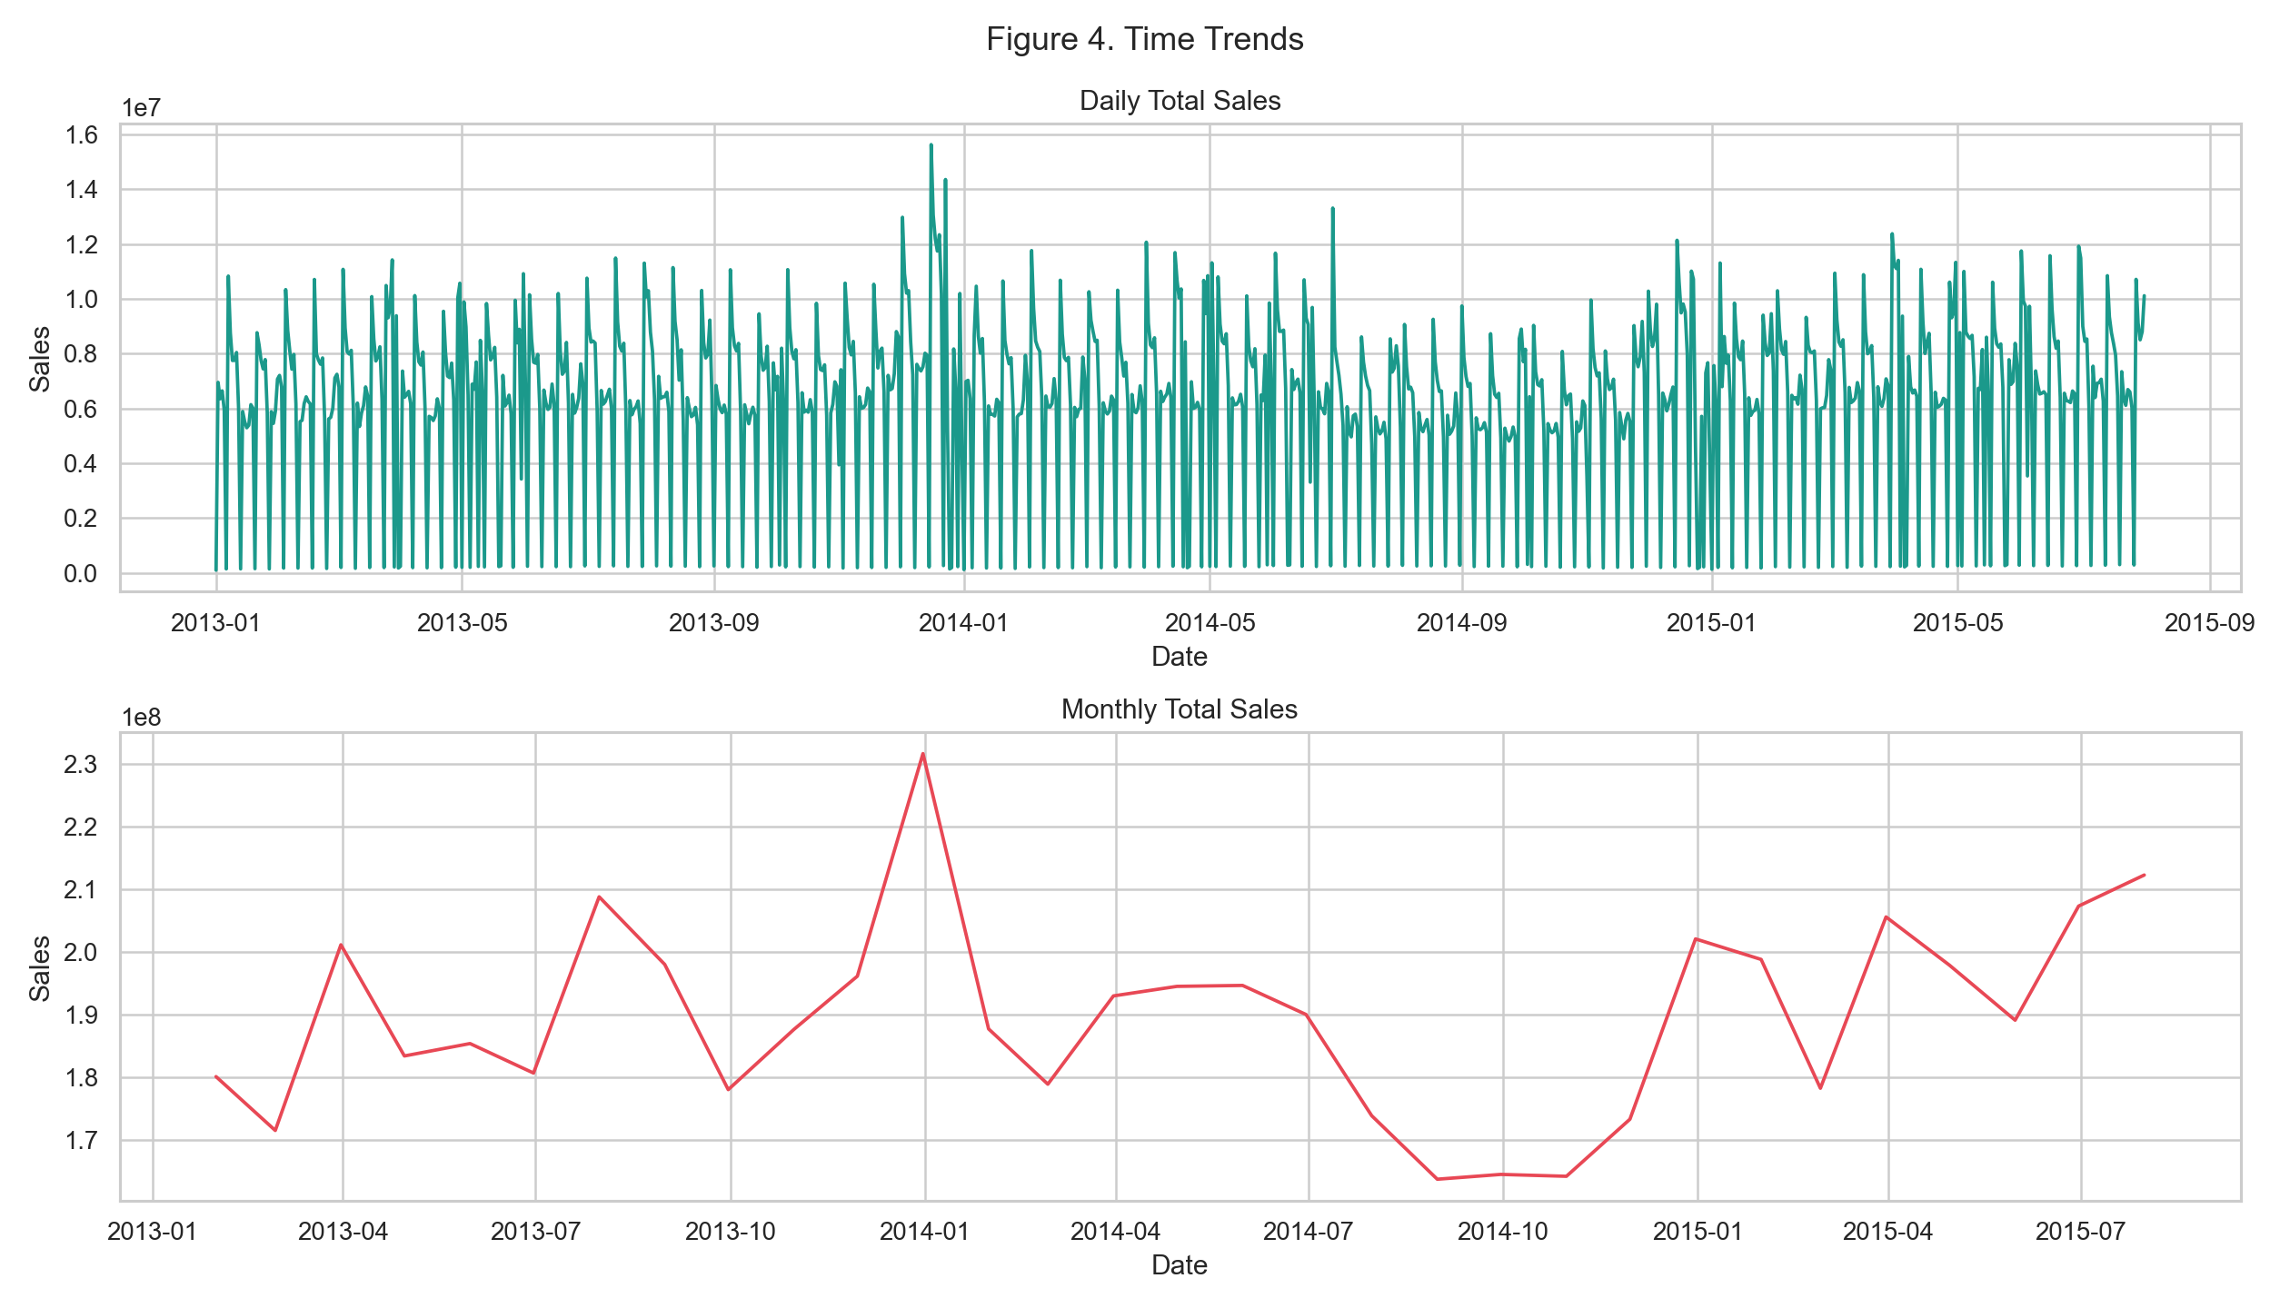

Figure 5. Promo Effect by StoreType
Figure 5 shows promotions raise average sales across store types, but effect size differs by segment, motivating interaction terms.
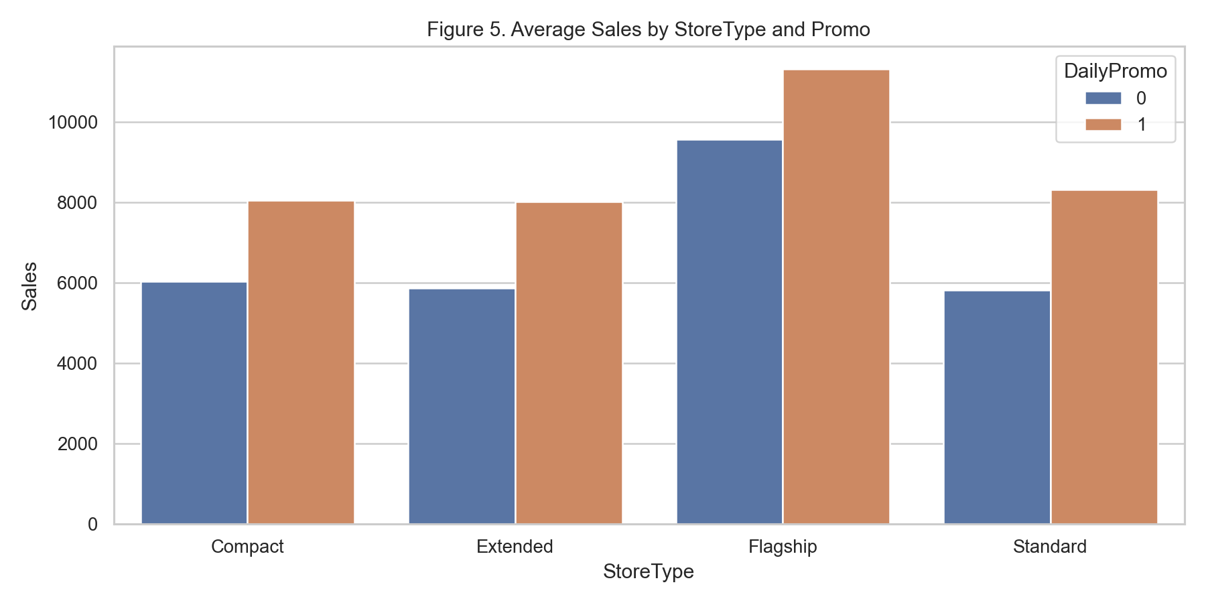

Figure 6. Correlation Matrix
Figure 6 summarizes linear relationships. Sales and CustomerCount exhibit strong positive correlation, while promotion and temporal features provide additional explanatory signal.
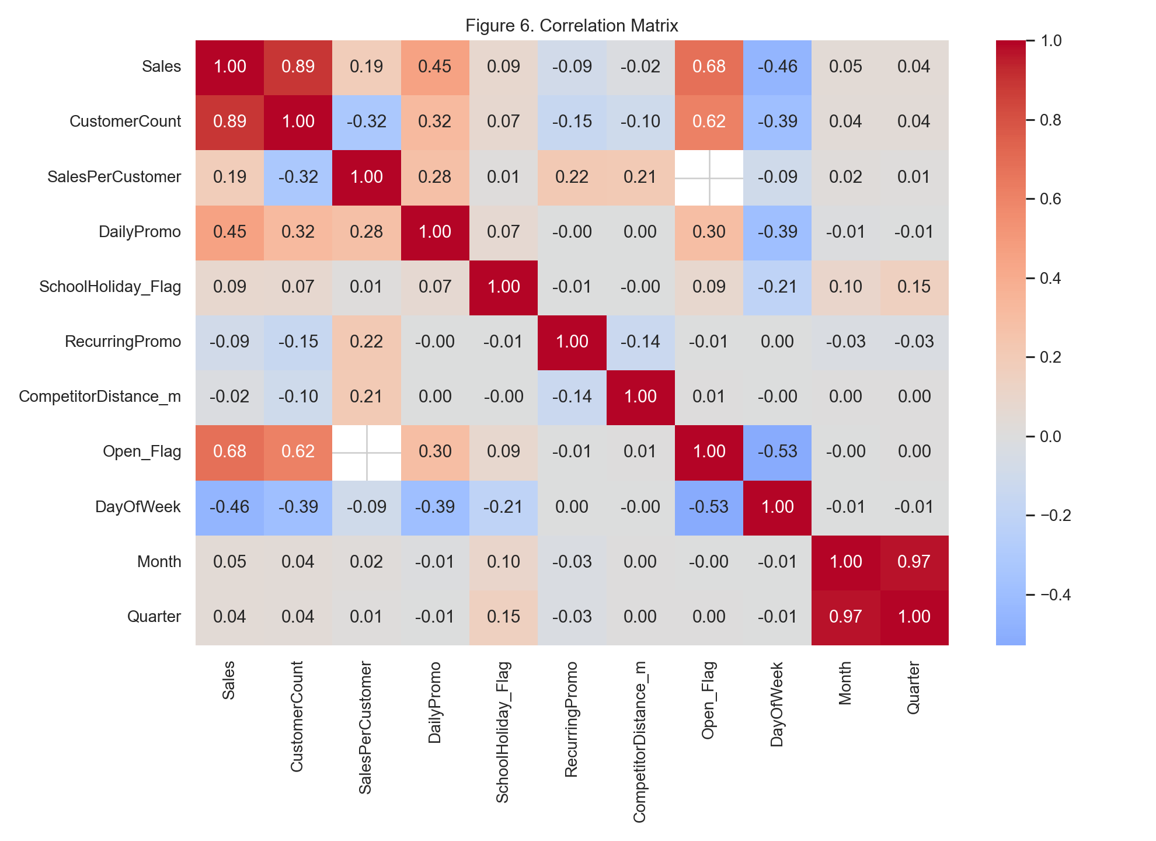

Figure 7. Anomaly Sensitivity
Figure 7 demonstrates anomaly detection sensitivity to threshold choice. Lower thresholds capture more events and are appropriate for monitoring workflows.
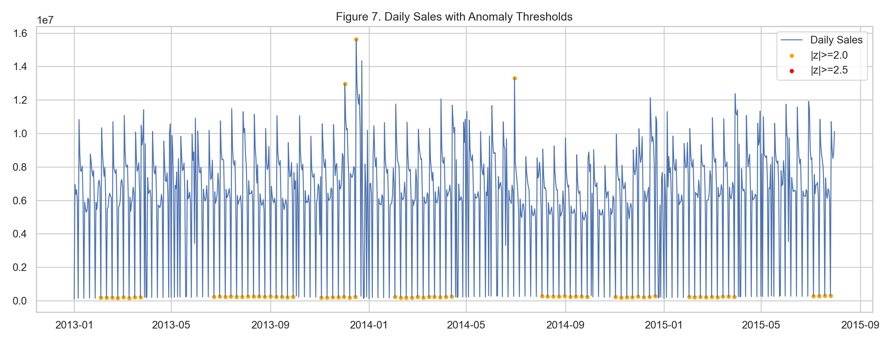
EDA Summary: As shown across Figures 2-6, sales are driven primarily by customer traffic, with significant contribution from promotional activity and store segmentation factors. Estimated promo uplift is 38.77% on open days, and Sales-Customer correlation is 0.824. Seasonality is meaningful: month 12 has the highest average sales while month 9 has the lowest.

3. Proposed Methods or Models for Next Analysis
Based on the exploratory findings, the next stage should combine interpretable baselines and nonlinear methods:
1) Regularized Linear Regression (on log-sales): provides transparent coefficient-level interpretation and strong baseline stability.
2) Gradient-Boosted Trees / Random Forests: captures nonlinear effects and interactions such as promo by store type, and customer traffic saturation effects.
3) Time-aware validation and rolling-window backtesting: ensures realistic forecast evaluation and avoids temporal leakage.
4) Feature strategy: include lagged sales, calendar indicators, promo flags, store metadata, and missingness indicators for structurally absent fields.
As shown in Figure 5 and Figure 6, segment-specific and interaction-aware models are justified. As shown in Figure 7, anomaly-aware preprocessing should be incorporated into model training pipelines.

References
Hyndman, R. J., & Athanasopoulos, G. (2021). Forecasting: Principles and Practice (3rd ed.). OTexts.
James, G., Witten, D., Hastie, T., & Tibshirani, R. (2021). An Introduction to Statistical Learning (2nd ed.). Springer.
Lundberg, S. M., & Lee, S.-I. (2017). A Unified Approach to Interpreting Model Predictions. NeurIPS.
Biecek, P., & Burzykowski, T. (2021). Explanatory Model Analysis. Chapman and Hall/CRC.

