Predicting Daily Store Sales for Rossmann
From Exploratory Analysis to a Working Sales-Forecasting Model
Caleb Ashitey-Amarh · John Darnell · Ashley Robbins
CEN6940 — Computing Practicum
Milestone Report 2 — Data, Exploratory Analysis, and Modeling
June 2026

Executive Summary
For this project our group worked with the Rossmann drug-store sales data, which has 1,017,209 rows of daily sales covering 1,115 stores from January 2013 to July 2015. We wanted to build a model that can predict how much a store will sell on a given day using only information that would actually be known ahead of time. A good forecast like this would help the company plan staffing and inventory instead of relying on a manager's guess.
We went through the whole process: cleaning the data, exploring what drives sales, building features, and then training and testing several models. We made sure to test the models on a later time period than they were trained on, since that is the only fair way to check a forecast. Our best model was a gradient-boosted tree ensemble. It reached a root-mean-square percentage error (RMSPE) of 0.131 and an R² of 0.896 on data it had never seen, which is about 73% better than a simple baseline that just guesses last week's sales. We also ran a rolling backtest, and the model held up across different seasons, so the result is not just luck from one split.
One thing we paid close attention to was data leakage. Even though sales and customer count are highly correlated, we did not let the model use the same day's customer count, because you would not actually know that number when making the forecast. Using it would make the model look great in testing but useless in real life, so we left it out and used past customer traffic instead.
Headline results (held-out final six weeks):
Model | RMSPE | MAE (€) | MAPE (%) | R²
HistGradient Boosting (best) | 0.131 | 647 | 9.66 | 0.896
Random Forest | 0.146 | 706 | 10.43 | 0.864
Ridge (log-sales) | 0.203 | 918 | 14.06 | 0.789
Lasso (log-sales) | 0.206 | 914 | 14.07 | 0.788
Seasonal-naive baseline | 0.483 | 2,364 | 37.46 | -0.11

1. Problem Statement and Objective
Rossmann runs more than a thousand stores, and how much each one sells on a given day changes a lot depending on promotions, holidays, the day of the week, the season, and nearby competition. Right now managers mostly forecast sales based on experience, which makes planning staff and inventory hit or miss. Our goal was to build a model that does this prediction more consistently using the data.
This is a supervised learning problem. The thing we are predicting is the daily Sales (in euros) for a store that is open, and the inputs are the things we would know about that store and date beforehand: recent sales history, recent customer traffic, the promotion schedule, holidays, the store type and assortment, and how close the nearest competitor is. We judge the model by how well it predicts sales for a time period it was not trained on.

2. The Data
The dataset is a merged version of the Rossmann data that puts the daily sales together with store information, the promotion schedule, and competitor details. Each of the 1,017,209 rows is one store on one day. Sales is what we are trying to predict, and the other columns are the features we can use. Table 1 lists the main columns.
Table 1. Key columns in the merged dataset.
Column | Description | Type
StoreID | Unique store identifier (1–1,115) | int
Date | Calendar date of the observation | date
DayOfWeek | Day of week (1 = Mon … 7 = Sun) | int
Sales | Daily turnover — the target variable | int
CustomerCount | Daily customers entering the store | int
Open_Flag | Store was open on the day (1/0) | int
DailyPromo | A day-level promotion was active | int
StateHoliday | State holiday type (else missing) | str
SchoolHoliday_Flag | Store-date affected by a school holiday | int
StoreType | Store format (Compact/Standard/Extended/Flagship) | str
Assortment | Product assortment (Basic/Extended/Extra) | str
CompetitorDistance_m | Distance to nearest competitor (m) | int
RecurringPromo | Participation in recurring promotion program | int
RecurringPromoMonths | Months the recurring promo refreshes | str

Three things from the summary statistics ended up shaping our later decisions:
- Right skew: the mean daily sales (€5,774) are above the median (€5,744) and the biggest value (€41,551) is more than seven times the mean. That points to a right-skewed distribution, which is why we later take the log of sales.
- Closed days: about 17% of the store-days are closed stores with zero sales. These are not really about demand, so we handle them separately.
- Big spread: competitor distance is spread out a lot (median 2,325 m, max 75,860 m), so taking the log of it works better than using the raw meters.

3. Exploratory Data Analysis — Key Findings
Before building anything, we spent time looking at the data to understand its shape and what actually drives sales. The seven figures below cover what we found, and most of our feature choices later come straight out of these.
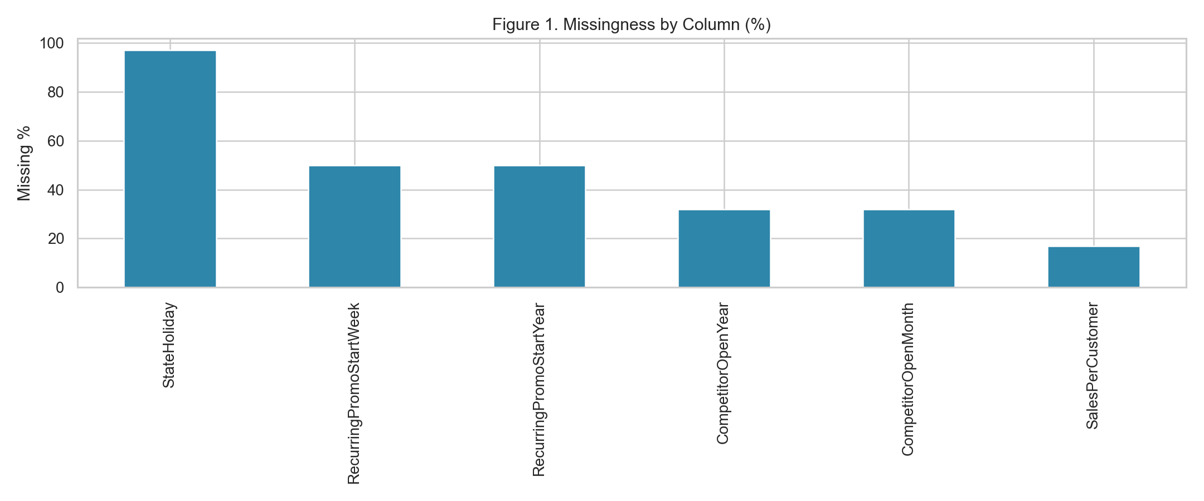
Figure 1. Missingness by column. Missing values are concentrated in a few fields (competitor-open dates, recurring-promo start), indicating structural — not random — missingness. This justifies indicator-aware handling rather than naive deletion.
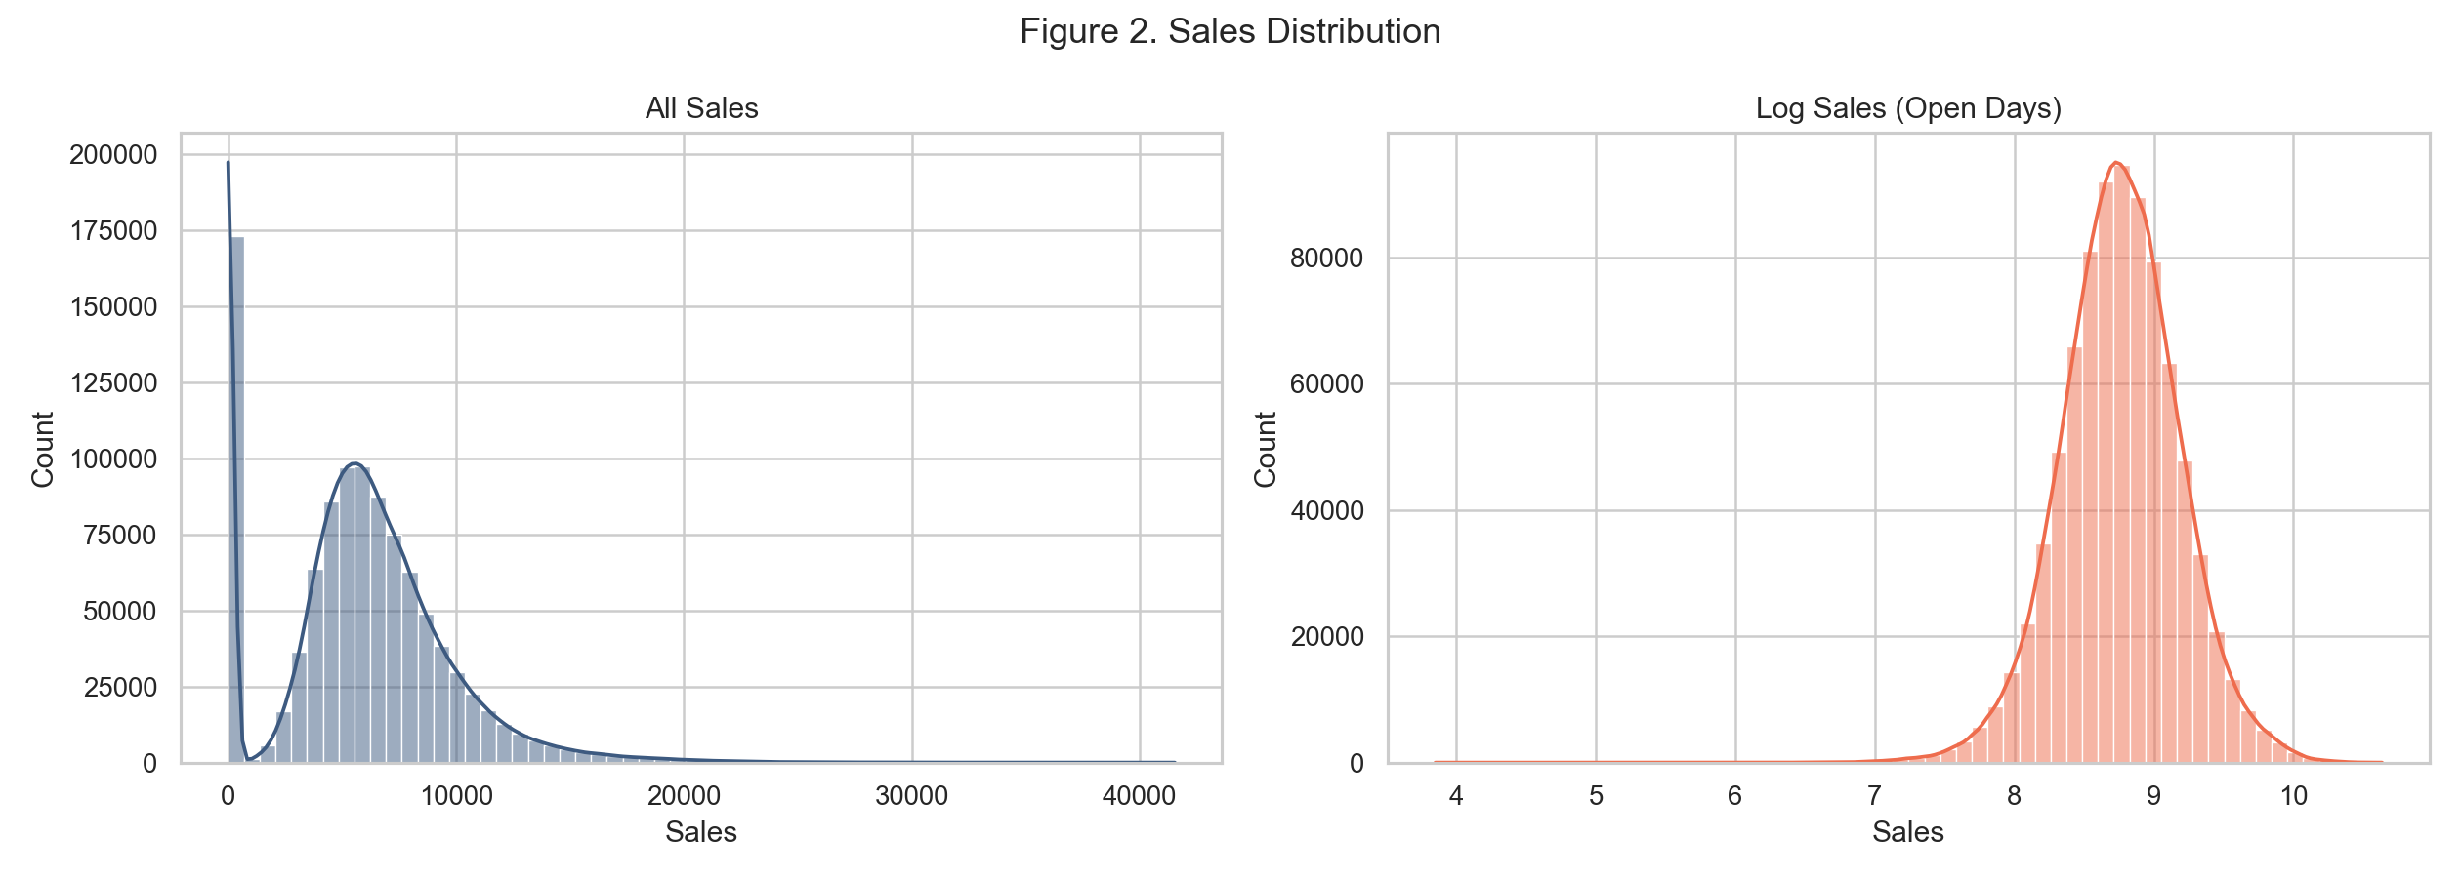
Figure 2. The raw sales distribution is strongly right-skewed; a log transform compresses the tail and stabilizes variance for downstream models.
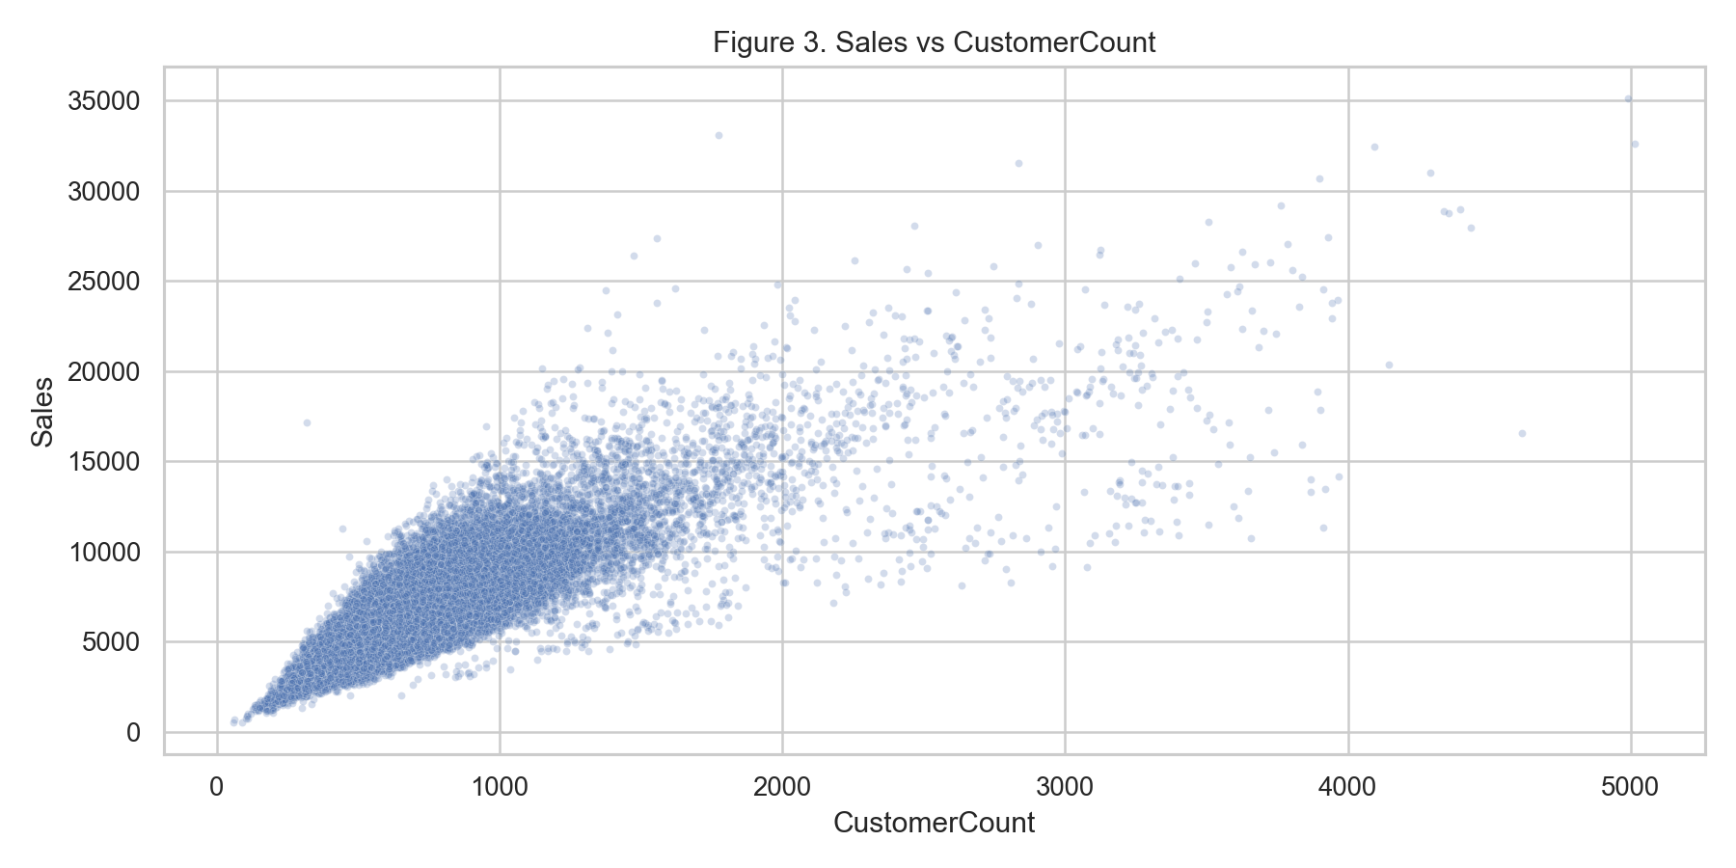
Figure 3. Sales rise strongly with customer traffic (correlation 0.89), confirming foot traffic as the dominant short-term sales driver.
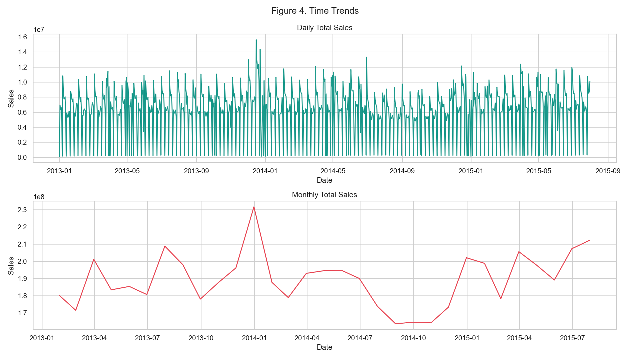
Figure 4. Daily and monthly trends reveal nonstationary demand with strong calendar seasonality — a December peak and clear day-of-week structure — which mandates a time-aware validation scheme.
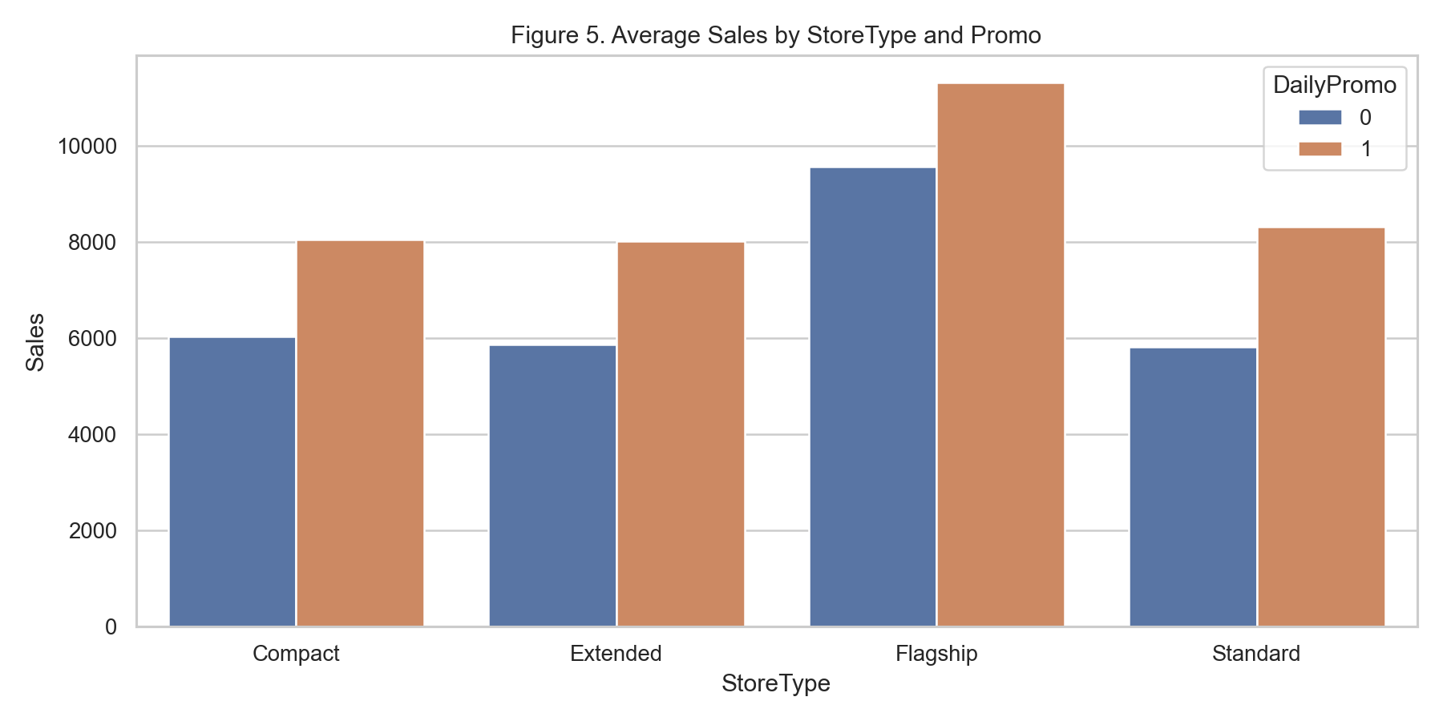
Figure 5. Promotions lift average sales across all store types, but the size of the lift differs by segment, motivating Promo × StoreType interaction effects.
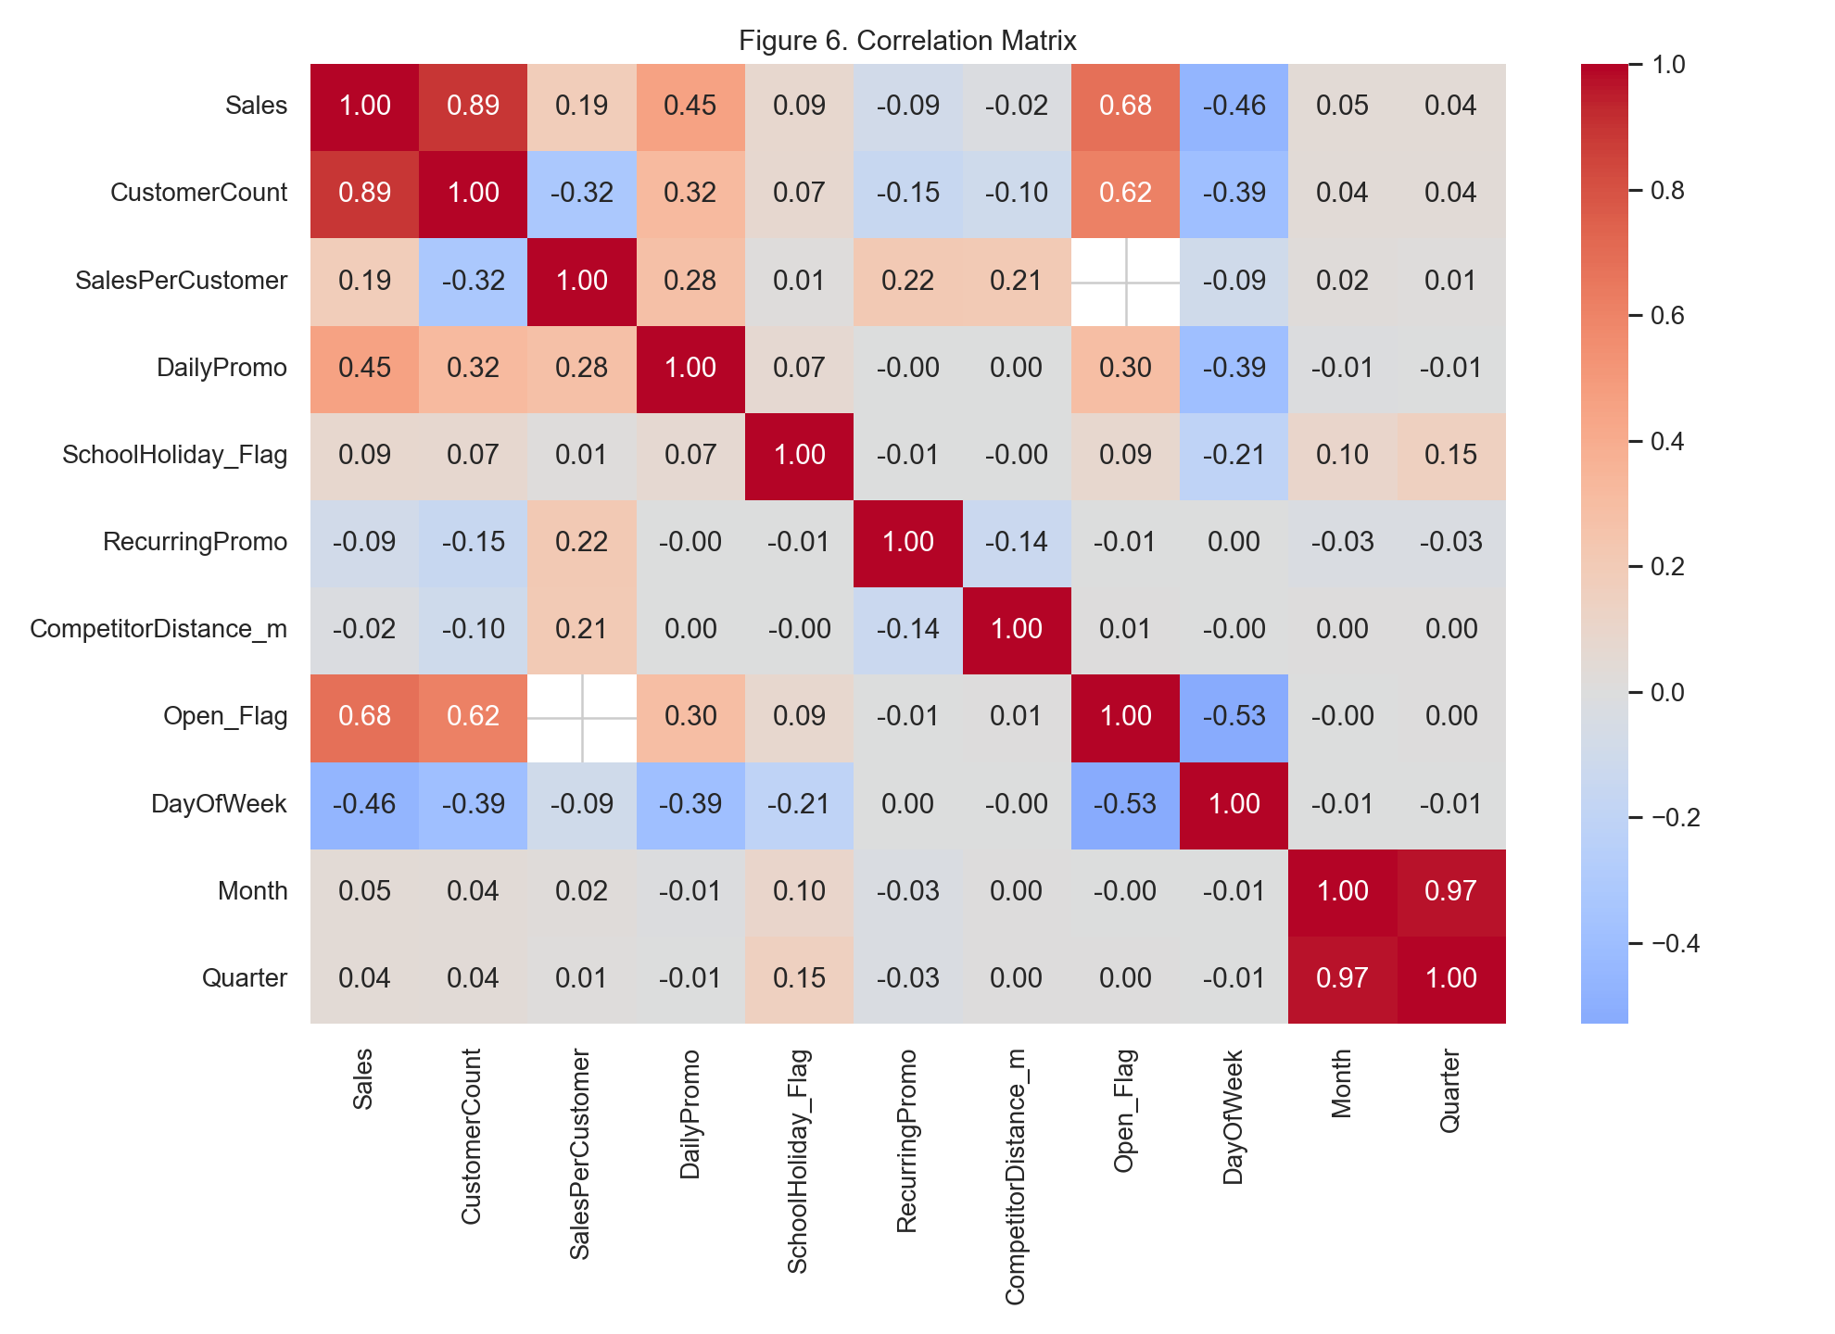
Figure 6. Pairwise correlations. Sales–CustomerCount dominates (0.89); the open/closed flags are mechanically redundant, so only one may enter a linear model.
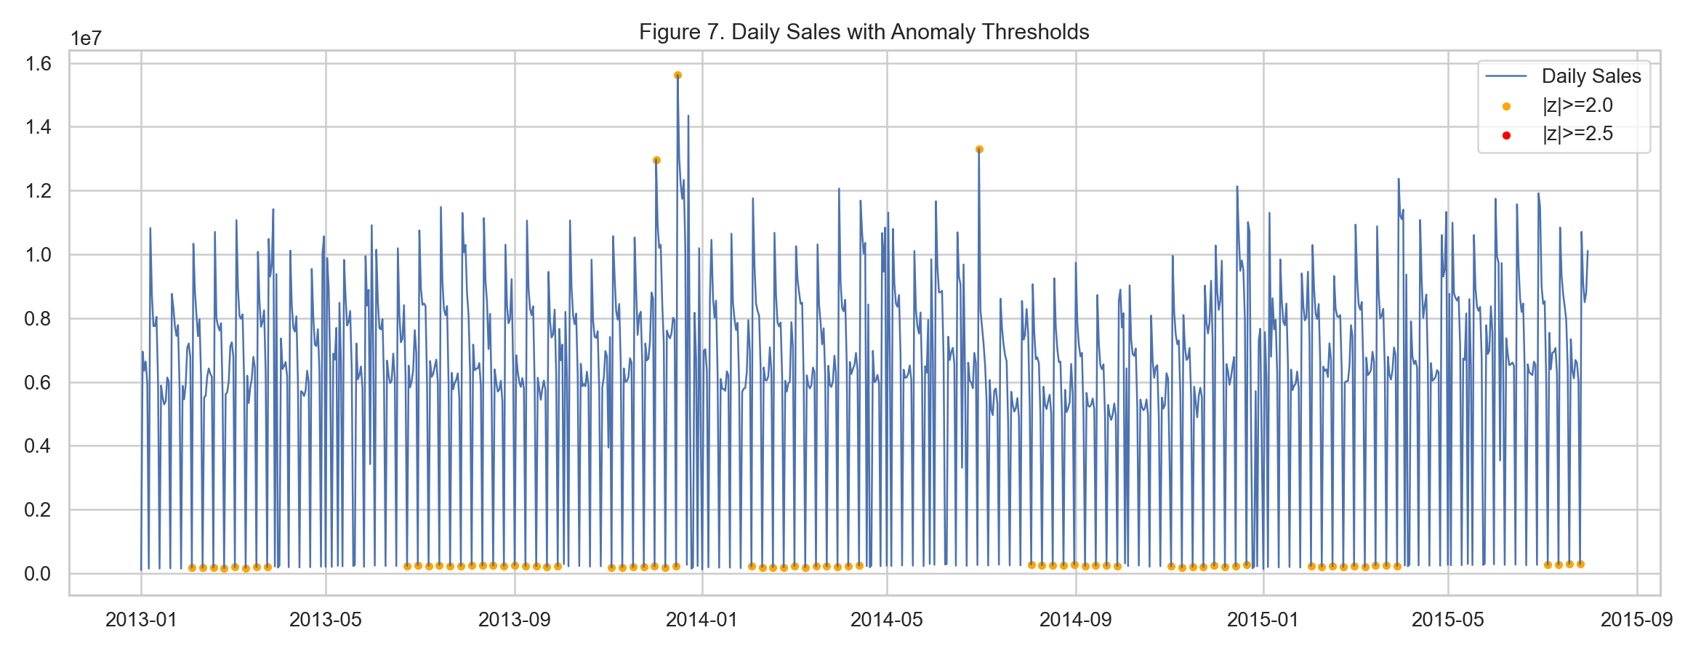
Figure 7. Anomaly detection is sensitive to the threshold chosen: low thresholds flag many events (good for monitoring), high thresholds flag only the extreme tail (appropriate for cleaning training data without discarding seasonal spikes).
We also looked closely at the outlier days. The big sales days happen because a lot more people walk in, not because each person spends more (the sales-per-customer is almost the same on normal and outlier days). Those days show up mostly in December, on Mondays, and at Flagship stores, which is a pattern we can actually turn into features. A few records looked off, like Store 909 on June 22, 2015 selling €41,551 with a basket size that does not make sense for a normal retail day. We treated those as likely data issues and dealt with them using the cleaning rule described in the next section.

4. Methodology
For the modeling part we used both a simple linear model that is easy to interpret and some tree-based models that can pick up more complicated patterns. We tested all of them the same way, always training on earlier dates and testing on later ones. Everything was done in Python with scikit-learn so it can be re-run.

4.1 Target and cleaning
We only kept the days where the store was actually open (Open_Flag = 1 and Sales > 0), which is 844,338 rows, or 83% of the data. Closed days are easy to handle separately since the sales are just zero. Based on the EDA we predict log1p(Sales) instead of the raw sales, because that fixes the right skew (Figure 8). For cleaning we only threw out the most extreme records, the ones above Q3 + 3×IQR (€18,863). That is only 0.71% of the days, and we kept it strict on purpose so we did not accidentally delete the real seasonal spikes that a normal 1.5×IQR cutoff would have removed.
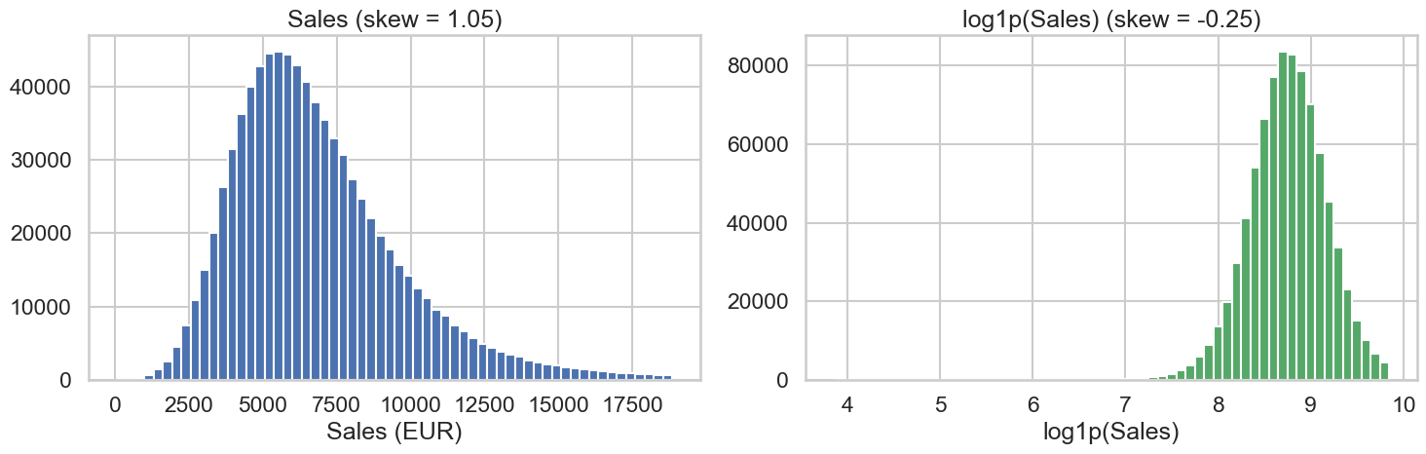
Figure 8. Before and after taking the log of sales. The raw sales are skewed to the right, and the log version is much closer to symmetric, which is what we train on.

4.2 Avoiding data leakage
Deciding what NOT to use turned out to be one of the more important calls we made. Sales and customer count are correlated at 0.89, so it is tempting to feed the customer count straight into the model. The problem is that you would not know that day's customer count when you actually need the forecast, so using it is a form of leakage and the model would not work in practice (Kaufman et al., 2012). We left out the same-day customer count and only used customer traffic from previous days. We also left out the raw StoreID, since it is just a label, and instead gave each store a baseline sales level computed only from the training data.

4.3 Feature engineering
Every feature only uses information from before the day being predicted. The lag and rolling-average features are calculated per store, in date order, and shifted back so a row never accidentally sees its own day or any future day.
Feature group | Examples | Why (EDA link)
Lagged sales | lag-1, lag-7, 7/30-day rolling mean & std | autocorrelation, trend (Fig. 4)
Lagged traffic | customer lag-1, lag-7, 7-day rolling mean | traffic is the key driver (Fig. 3)
Calendar | day of week, month, week, quarter, weekend | seasonality (Fig. 4)
Promotions | daily promo, recurring promo, promo-month active | promo lift by segment (Fig. 5)
Holidays | state-holiday flag & type, school holiday | December peaks (Table 3)
Store metadata | store type, assortment, log competitor distance | monopoly effect (outliers)
Missingness | competitor-open missing, promo-start missing | structural missingness (Fig. 1)
Store baseline | train-only mean log-sales per store | store scale, leak-free

4.4 Time-aware validation
Sales change over time and have strong seasonality, so a random train/test split would basically let the model see the future. Instead we split by date. The model trains on everything up through June 19, 2015 (627,363 rows) and is tested on the last six weeks, June 20 to July 31, 2015 (38,369 rows). This is the same kind of setup as the real Rossmann forecasting task. When we tuned the linear models we used time-series cross validation, not shuffled folds, for the same reason.

4.5 Models and metrics
We compared four models against a simple baseline that just predicts last week's same-day sales:
- Ridge and Lasso: regularized linear models on log-sales, which are easy to interpret.
- HistGradient Boosting: a fast gradient-boosted-tree model, which ended up being our main one.
- Random Forest: an ensemble of deep trees (we trained it on a 200k-row sample so it would not take forever).
We convert predictions back to euros before scoring. We report RMSE and MAE (in euros), MAPE (%), R², and RMSPE. RMSPE is the metric the original Rossmann competition used, so that is the one we focused on when picking the best model.

5. Results
On the held-out final six weeks, all four models beat the baseline, and the tree models did clearly better than the linear ones because they can pick up the interactions we saw in the EDA. HistGradient Boosting came out on top on every metric.
Table 2. Model performance on the held-out test window.
Model | RMSE (€) | MAE (€) | MAPE (%) | RMSPE | R²
HistGradient Boosting | 903 | 647 | 9.66 | 0.131 | 0.896
Random Forest | 1,030 | 706 | 10.43 | 0.146 | 0.864
Ridge (log-sales) | 1,283 | 918 | 14.06 | 0.203 | 0.789
Lasso (log-sales) | 1,288 | 914 | 14.07 | 0.206 | 0.788
Seasonal-naive baseline | 2,944 | 2,364 | 37.46 | 0.483 | -0.11

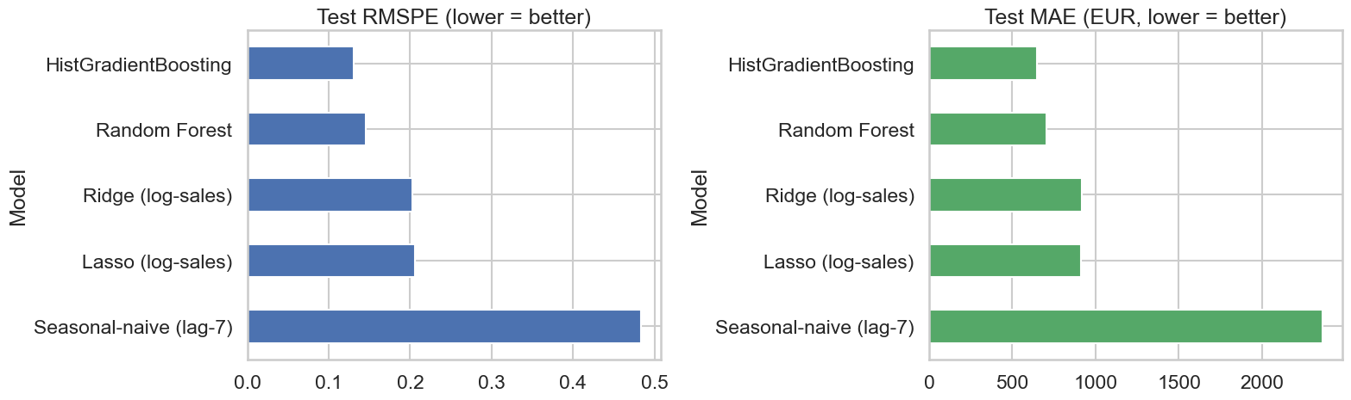
Figure 9. Test-set model comparison on the two headline metrics, RMSPE and MAE. Gradient boosting leads, followed by random forest, then the linear models.
To put that in plain terms, the best model is usually off by about €647 on a day (MAE), or around 10% (MAPE), compared to €2,364 and 37% for the baseline. That works out to a 72.9% drop in RMSPE versus just guessing last week's number.

6. Rolling-Window Backtesting
One split can always get lucky, so we also ran a backtest. The idea is to train on the history up to a certain point, test on the next chunk of time, then move the window forward and do it again. This shows whether the model holds up across different parts of the year.
Table 3. Expanding-window backtest (HistGradient Boosting).
Fold | Train end | Test end | Test rows | RMSPE
1 | 2014-07-05 | 2014-11-12 | 97,898 | 0.128
2 | 2014-11-12 | 2015-03-22 | 107,673 | 0.320
3 | 2015-03-22 | 2015-07-31 | 114,637 | 0.142

The average backtest RMSPE is 0.197 ± 0.107. The spring and summer folds are strong and pretty consistent. The winter fold is worse (0.320), which makes sense because the November and December holiday period is just harder to predict. We see that as something to work on with better holiday features rather than a problem with how we tested.

7. Model Interpretation
We did not just want a model with a good score, we wanted to check that it was using reasonable features. So we looked at it three different ways and confirmed it relies on the same things the EDA pointed to.
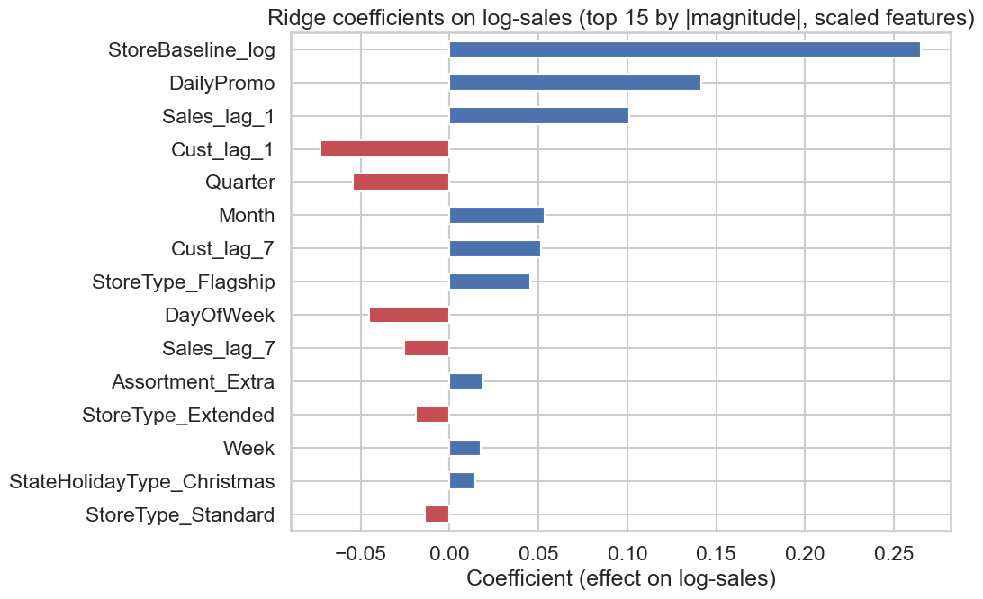
Figure 10. Ridge regression coefficients on log-sales (scaled features). Recent sales history and the store baseline carry the largest positive weights; promotions lift sales; competitor distance and holiday effects appear with sensible signs.
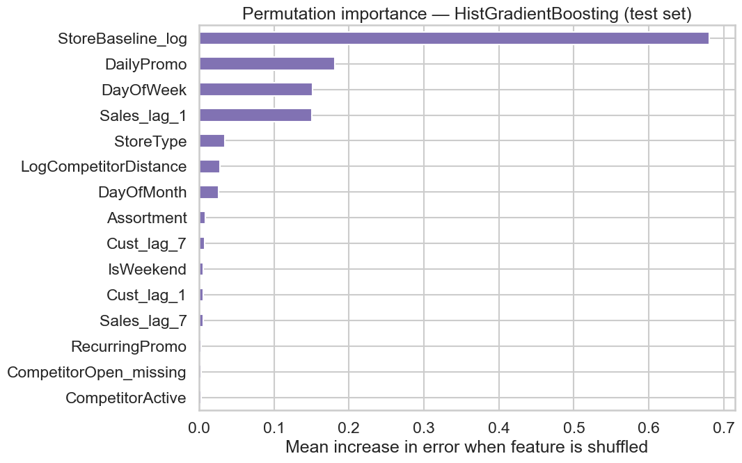
Figure 11. Permutation importance for the best model on the test set: how much test error rises when each feature is shuffled. Lagged sales/traffic, the store baseline, day of week, and promotion flags dominate.
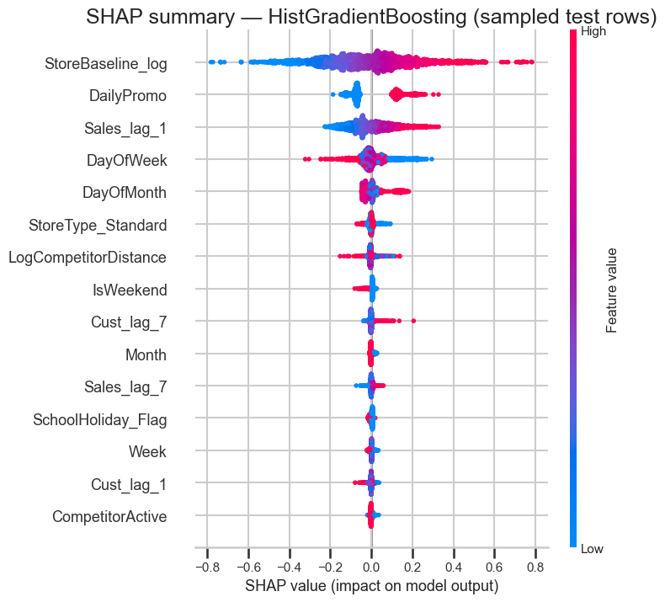
Figure 12. SHAP summary for the gradient-boosting model. Each point is a store-day; color is the feature value. The plot shows both the strength and the direction of each feature's effect — e.g., higher recent sales and active promotions push predicted sales up.
All three methods basically agree. The predictions come mostly from recent sales and traffic, the store's baseline level, the day of week and time of year, and the promotion flags, which are all things the EDA already flagged as important. The tree models beat the linear ones because they can figure out things like the promo effect being different by store type on their own, without us having to spell out every interaction.

8. Forecast Diagnostics
We ran three quick checks to make sure the predictions behave reasonably on the test data.
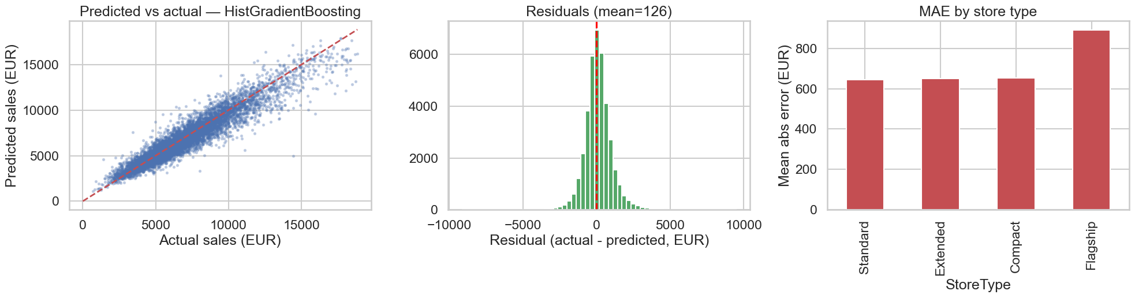
Figure 13. Left: predicted vs. actual sales cluster tightly along the diagonal. Center: residuals are centered near zero with no systematic bias. Right: mean absolute error is comparable across store types, so no segment is systematically mis-forecast.
The predicted-versus-actual points sit close to the 45-degree line, the residuals are roughly centered on zero, and the error is about the same across the different store types. That tells us the model is generalizing and not just memorizing certain stores or dates.

9. Conclusions, Limitations, and Future Work
Overall, we took a real retail dataset all the way through the process and ended up with a model that works. The final gradient-boosting model predicts daily store sales with an RMSPE of 0.131 and an R² of 0.896 on the held-out six weeks, which is about 73% better than the baseline, and the backtest showed it stays solid across seasons. It also uses features that make sense, like recent sales and traffic, the store's usual level, the calendar, and promotions, so we trust what it is doing.
Limitations.
- Subsampling: we trained the Random Forest on a 200k-row sample to keep the runtime reasonable, so training it on all the data would probably close some of the gap with gradient boosting.
- Holidays: the holiday months (November and December) are still the hardest to get right, as the winter backtest fold showed.
- One day ahead: the model predicts one day ahead using the actual recent lags. Predicting further out would need a different setup.
Future work.
- Better models: try a tuned library like XGBoost or LightGBM and train on the full dataset.
- More data: bring in extra data like weather or local events, and more store-level features.
- Uncertainty: add prediction intervals so the staffing decisions can account for how uncertain the forecast is, not just the single number.

References
Haque, M. S., Amin, M. S., & Miah, J. (2023). Retail Demand Forecasting: A Comparative Study for Multivariate Time Series. arXiv:2308.11939.
Januschowski, T., et al. Forecasting with Trees. International Journal of Forecasting.
Hyndman, R. J., & Athanasopoulos, G. (2021). Forecasting: Principles and Practice (3rd ed.). OTexts.
Bandara, K., Bergmeir, C., & Smyl, S. (2020). Forecasting Across Time Series Databases Using Recurrent Neural Networks on Groups of Similar Series. Expert Systems with Applications, 140.
Kaufman, S., Rosset, S., Perlich, C., & Stitelman, O. (2012). Leakage in Data Mining: Formulation, Detection, and Avoidance. ACM TKDD, 6(4).
Gupta, M., Gao, J., Aggarwal, C. C., & Han, J. (2014). Outlier Detection for Temporal Data: A Survey. IEEE TKDE, 26(9), 2250–2267.

