# Interior Design Documentation Example

This is a sample Markdown file that demonstrates how to use image references that will be properly converted to embedded images in the DOCX file.

## Basic Spatial Concepts

When organizing interior spaces, it's important to consider both functionality and aesthetics.

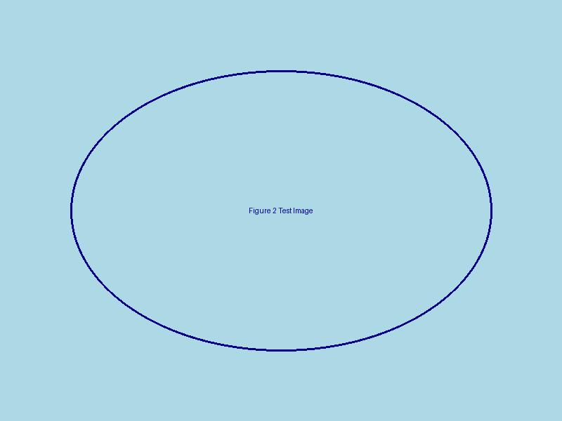

Fig.1 (Unknown on [Pexels](https://www.pexels.com), N.d) Professional space planning demonstrates proper traffic flow and balanced visual weight in this contemporary living room

Good interior design balances several key elements:

1. Functionality
2. Aesthetics
3. Proportion
4. Balance

## Material Selection

Materials play a crucial role in defining the character of a space.

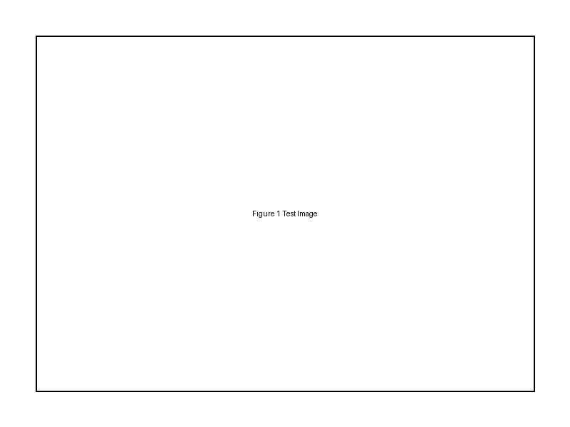

Fig.2 (Unknown on [Pexels](https://www.pexels.com), N.d) Material selection board showing complementary textures and finishes for a cohesive design scheme

## Color Theory

Understanding color relationships is essential for creating harmonious spaces.



Fig.3 (Unknown on [Pexels](https://www.pexels.com), N.d) Monochromatic blue color scheme showing how variations in tone create depth while maintaining harmony

## Final Documentation

Professional documentation ensures that design concepts are properly communicated and executed.



Fig.4 (Unknown on [Pexels](https://www.pexels.com), N.d) Professional documentation setup showing organized presentation of design specifications, samples, and technical drawings