# Interior Design Spatial Concepts Test

This is a test markdown file created from real descriptions and images.

## Design Concept 1

A well-designed living room showing balanced furniture arrangement with clear pathways and proper spacing.

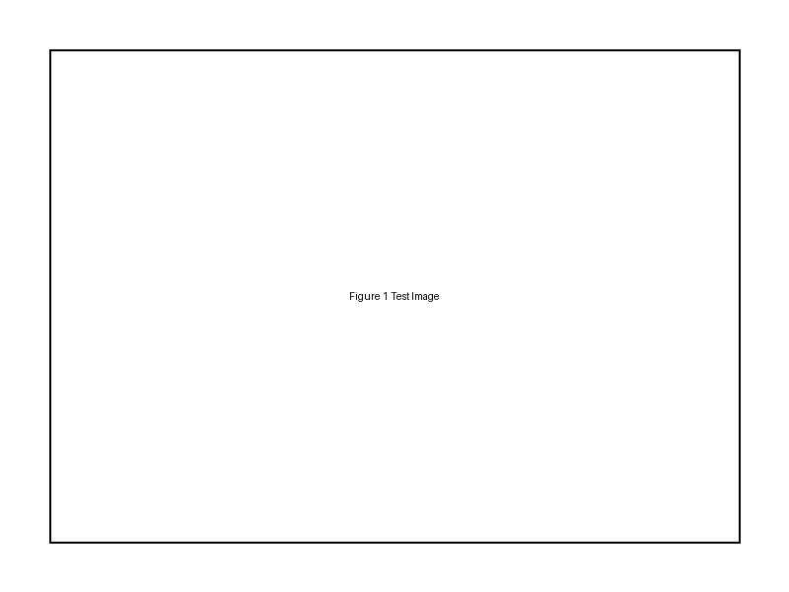

Fig.1 (Unknown on [Pexels](https://www.pexels.com), N.d) Professional interior design showcasing - living room, - furniture arrangement

Key elements in this design:

* - living room
* - furniture arrangement
* - interior design
* - open space
* - natural lighting

## Design Concept 4

Interior space showcasing various geometric shapes and forms in furniture and architectural elements.

[Image: Interior space showcasing various geometric shapes and forms in furniture and architectural elements. Caption: "Fig 4: Professional interior design showcasing - sofa, - coffee table"]

Key elements in this design:

* - sofa
* - coffee table
* - arched doorway
* - geometric patterns
* - minimalist design

## Design Concept 6

Interior space showing varied ceiling heights with pendant lighting creating a middle plane in a high-ceilinged area.

[Image: Interior space showing varied ceiling heights with pendant lighting creating a middle plane in a high-ceilinged area. Caption: "Fig 6: Professional interior design showcasing - pendant lighting, - high ceilings"]

Key elements in this design:

* - pendant lighting
* - high ceilings
* - interior design

## Design Concept 9

Overhead view of a living room arrangement showing furniture groupings that respect different personal space zones.

[Image: Overhead view of a living room arrangement showing furniture groupings that respect different personal space zones. Caption: "Fig 9: Professional interior design showcasing - sofa, - coffee table"]

Key elements in this design:

* - sofa
* - coffee table
* - area rug
* - armchair
* - living room

## Design Concept 10

Open concept living space with clearly defined functional zones for cooking, dining, and relaxing.

[Image: Open concept living space with clearly defined functional zones for cooking, dining, and relaxing. Caption: "Fig 10: Professional interior design showcasing - kitchen, - dining table"]

Key elements in this design:

* - kitchen
* - dining table
* - living room furniture