**Procedure for those seeking Protection**

Originating from Ukraine (S-Status)

individual cases: short interview (SEM)

› With legal protection

further checks

in the ordinary asylum procedure: person remains in the Federal Asylum Center

**Federal Asylum Center**

Ein Bild, das Elektronik, Tastatur enthält.

**Canton**



**SEM**



**registration protection status S**

› Specification of personal data / fingerprints

› Support legal protection

› Pre-appointment registration possible online

› Information on protection status, health and human trafficking

v**erification of personal data**

› Nationality

› Special needs: Vulnerability, individual reasons for asylum

**Application processing**



› Security check

› inspection / decision

S-Status

**Information Canton**

› Delivery of decision S-Status

› Issuance of S-status card by

Canton

› Payment of global lump sum to canton

› Health insurance in the canton

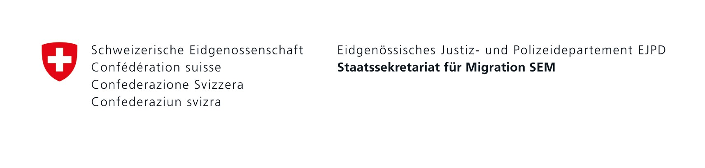

Accommodation available

No accommodation available yet

Private accommodation

**Canton**

Coordination

**SEM**

**Swiss Refugee Council (SRC)**

Canton decides

on the type of accommodation

organizes

Short-term accommodation in the Federal Asylum Center if no suitable accommodation is immediately available in the canton (a few days).

If requested by canton

arranges

Cantonal

Accommodation

Federal Asylum Center

Private accommodation

**As of March 2022**