[watchmovieshd](https://play.google.com/store/apps/details?id=freefullmovies.watchmovies&pcampaignid=web_share)

[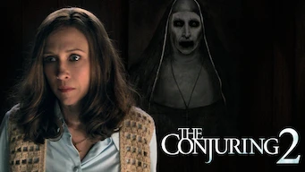](https://play.google.com/store/apps/details?id=freefullmovies.watchmovies&pcampaignid=web_share)Your Go-To App to Watch Movies in HD, Including Adult Movies  
In the ever-evolving world of digital entertainment, having a reliable source for high-quality movie streaming is essential. Whether you're an avid movie lover or just looking to unwind, Movies Hub is your ultimate destination. Our app offers a vast collection of movies and TV shows in stunning HD, including a dedicated selection of [adult movies](https://play.google.com/store/apps/details?id=freefullmovies.watchmovies&pcampaignid=web_share). Dive into this detailed guide to discover why Movies Hub is the perfect choice for all your viewing needs.

[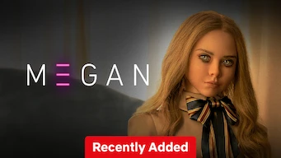](https://play.google.com/store/apps/details?id=freefullmovies.watchmovies&pcampaignid=web_share)What is Movies Hub?  
Movies Hub is a premium streaming platform designed to provide users with seamless access to a diverse library of movies and TV shows in high definition. With its user-friendly interface and a wide range of genres, Movies Hub caters to every taste, including a special category for adult movies for those seeking more mature content.

Why Choose Movies Hub to Watch MoviesHD and Adult Movies?  
Extensive Library: Movies Hub boasts a comprehensive library of films, from the latest blockbusters to timeless classics. Whether you're in the mood for drama, comedy, action, or romance, our app has something for everyone. Additionally, we offer a curated selection of adult movies, ensuring that our [](https://play.google.com/store/apps/details?id=freefullmovies.watchmovies&pcampaignid=web_share)content variety meets all preferences.

High-Quality Streaming: Enjoy [watchmovieshd](https://play.google.com/store/apps/details?id=freefullmovies.watchmovies&pcampaignid=web_share) content with crystal-clear visuals and superb sound quality. Movies Hub ensures that every viewing experience is immersive and satisfying, regardless of the genre you choose.

User-Friendly Interface: Our app is designed with simplicity and ease of use in mind. Finding and streaming movies, including adult movies, is straightforward and hassle-free, making it accessible to users of all ages and tech-savvy levels.

Regular Updates: We constantly update our library with new releases and popular titles. You'll always have fresh content to watch, ensuring your entertainment options are never stale.

Affordable Subscription Plans: Movies Hub offers various subscription plans to fit different budgets. Enjoy premium content without breaking the bank, and take advantage of special offers and discounts.

Key Features of Movies Hub  
Personalised Recommendations: Our advanced algorithm analyses your viewing habits and preferences to suggest movies and TV shows tailored to your tastes. Discover new favourites without the endless

WATCH NOW 👀.

Click here to download: <https://play.google.com/store/apps/details?id=freefullmovies.watchmovies&pcampaignid=web_share>