博客作业：rpm包格式安装配置lamp，提供两个虚拟主机，一个用于wordpress，一个用于phpMyAdmin，为后一个提供ssl访问方式。

作业环境：

操作系统：CentOS 6.7

所需软件：wordpress-4.7.4-zh_CN.tar.gz，phpMyAdmin-4.0.10.20-all-languages.zip, httpd-2.2.15-59.el6.centos.x86_64, php-5.3.3-49.el6.x86_64, php-mysql-5.3.3-49.el6.x86_64 ,mysql-5.1.73-8.el6_8.x86_64

安装wordpress环境要求：PHP 5.2.4或更新版本

MySQL 5.0或更新版本

1、下载所需软件

wget https://files.phpmyadmin.net/phpMyAdmin/4.0.10.20/phpMyAdmin-4.0.10.20-all-languages.zip

wget <https://cn.wordpress.org/wordpress-4.7.4-zh_CN.tar.gz>

2、安装httpd服务

# yum install httpd -y

3、安装php

# yum install php -y

注意yum安装的php是以模块的方式提供给httpd服务的，使用“rpm -ql php”查看会显示一个“libphp5.so”的模块

# rpm -ql php

/etc/httpd/conf.d/php.conf

/usr/lib64/httpd/modules/libphp5.so

/var/lib/php/session

/var/www/icons/php.gif

4、启动httpd服务查看是否加载PHP模块

# service httpd start

# httpd -M

php5_module (shared)

5、设置wordpress虚拟主机

编辑“httpd.conf”配置文件

# vim /etc/httpd/conf/httpd.conf //使用vim编辑配置文件

#DocumentRoot "/var/www/html" //关闭“Main” Server

NameVirtualHost 172.16.227.154:80 //启用NameVirtualHost指令

<VirtualHost 172.16.227.154:80>

DocumentRoot /web/wordpress/

ServerName www.Mywordpress.com

</VirtualHost> //配置www.Mywordpress.com虚拟主机

<VirtualHost 172.16.227.154:80>

DocumentRoot /web/phpMyAdmin

ServerName www.Mypma.com

</VirtualHost> //配置www.Mypma.com虚拟主机

6、创建虚拟主机网站目录

# mkdir /web/{wordpress,phpMyAdmin}/

7、修改网站目录SELinux默认type

# semanage fcontext -a -t httpd_sys_content_t “/web(/.*)?”

# restorecon -Rv /web/

8、测试php

# vim /web/wordpress/index.php

<?php

phpinfo();

?>

9、使用浏览器测试访问“www.mywordpress.com”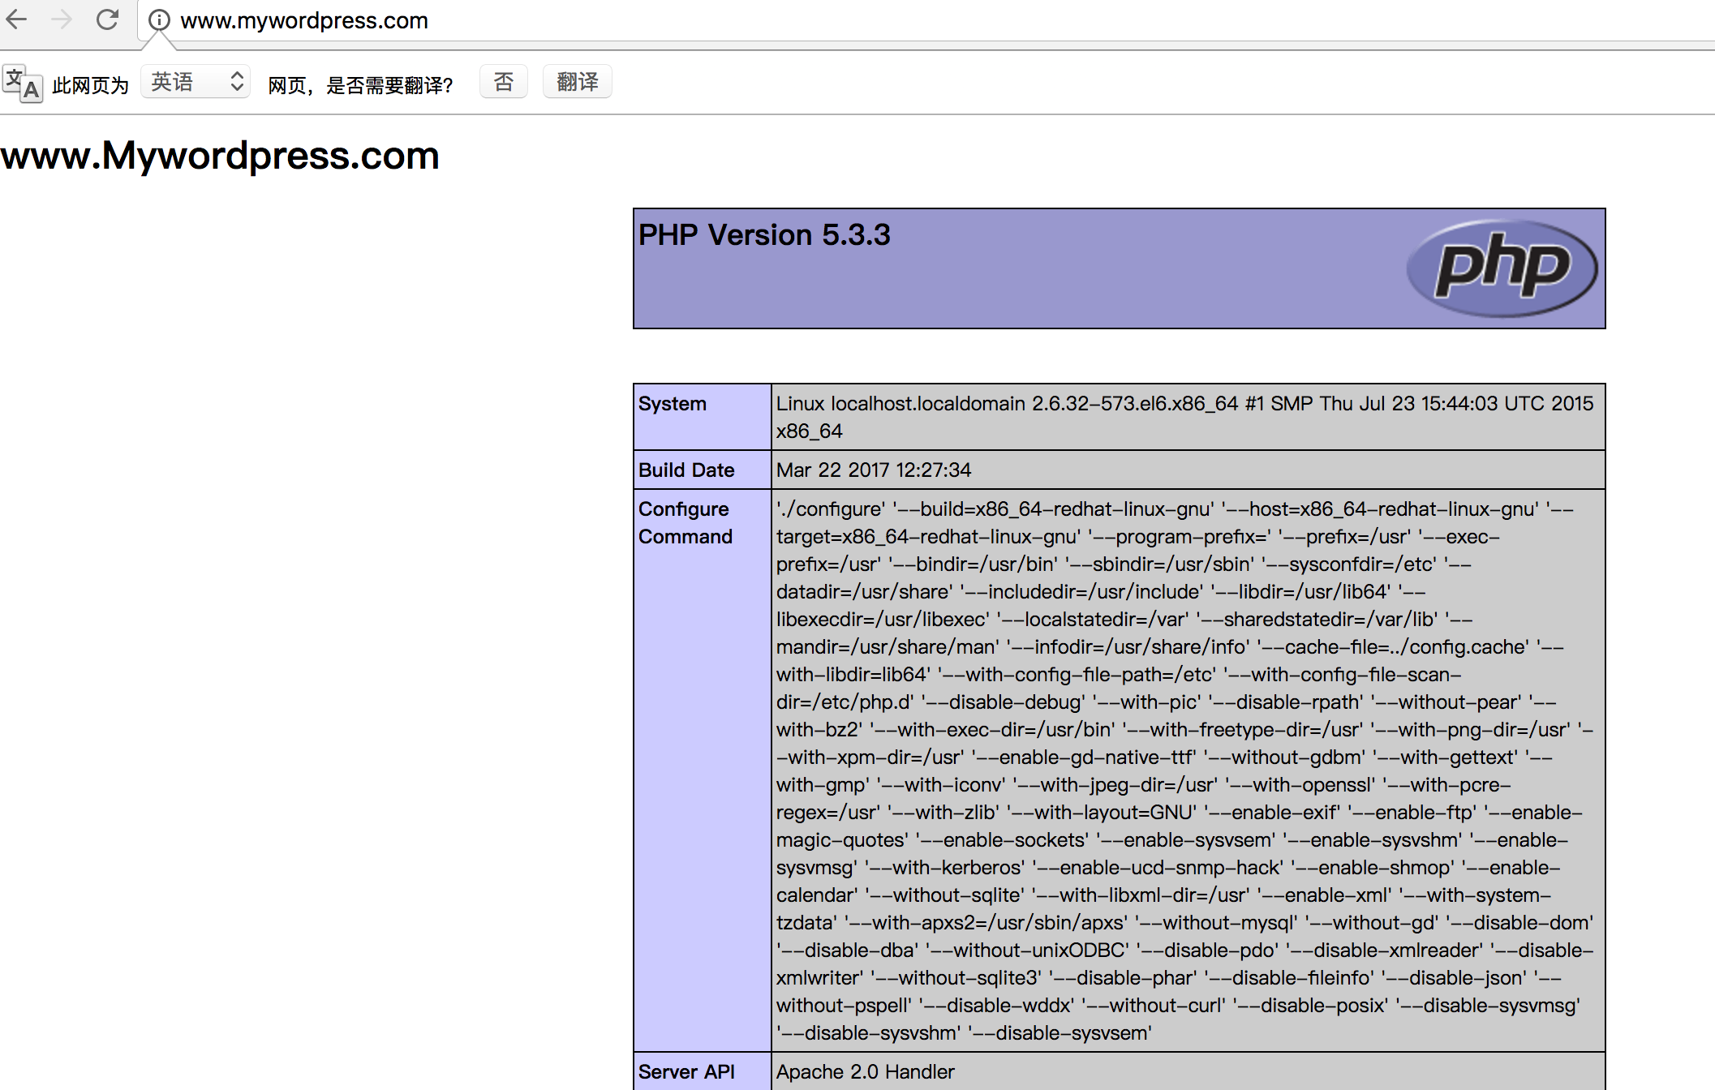

10、安装php-mysql

php-mysql是实现让php代码能够调用mysql数据库的API。

# yum install php-mysql

# service httpd reload

11、编辑一段php连接mysql的代码来测试php-mysql组件安装成功

# vim /web/wordpress/index.php

<?php

$conn = mysql_connect('127.0.0.1','root','');

if ($conn)

echo "OK";

else

echo "Failure";

mysql_close($conn);

?>

a、使用浏览器访问测试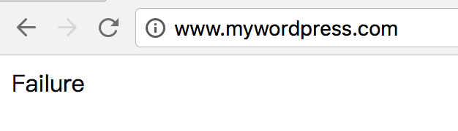

b、查看httpd错误日志

# tail /var/log/httpd/error_log

[Tue Apr 25 14:51:01 2017] [error] [client 172.16.227.1] PHP Warning: mysql_connect(): Can't connect to MySQL server on '127.0.0.1' (13) in /web/wordpress/index.php on line 3

[Tue Apr 25 14:51:01 2017] [error] [client 172.16.227.1] PHP Warning: mysql_close() expects parameter 1 to be resource, boolean given in /web/wordpress/index.php on line 8

c、以上报错说明php-mysql已经安装成功，因为还没有安装mysql-server，所以报错。

12、安装mysql-server，并启动

# yum install mysql-server

启动mysqld服务

# service mysqld start

查看是否监听3306端口

# ss -tnl

13、架设wordpress

a、解压wordpress-4.7.4-zh_CN.tar.gz

# tar xf /usr/local/src/wordpress-4.7.4-zh_CN.tar.gz -C /web/

b、配置wordperess配置文件

# cd /web/wordpress

# cp wp-config-sample.php wp-config.php

# vim wp-config.php

define('DB_NAME', ‘wpdb');

define('DB_USER', ‘wpuser');

define('DB_PASSWORD', ‘wppass');

c、测试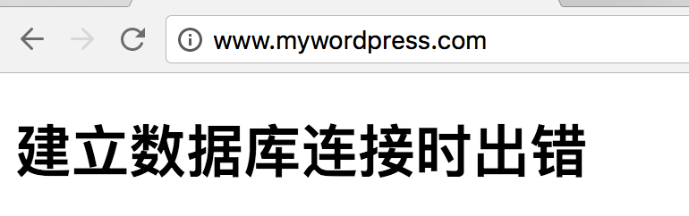

d、创建wpdb数据库

# mysql

mysql> CREATE DATABASE wpdb;

mysql> GRANT ALL ON wpdb.* TO 'wpuser'@'127.0.0.1' IDENTIFIED BY 'wppass';

mysql> GRANT ALL ON wpdb.* TO 'wpuser'@'localhost' IDENTIFIED BY ‘wppass';

mysql> FLUSH PRIVILEGES;

mysql> quit

e、刷新测试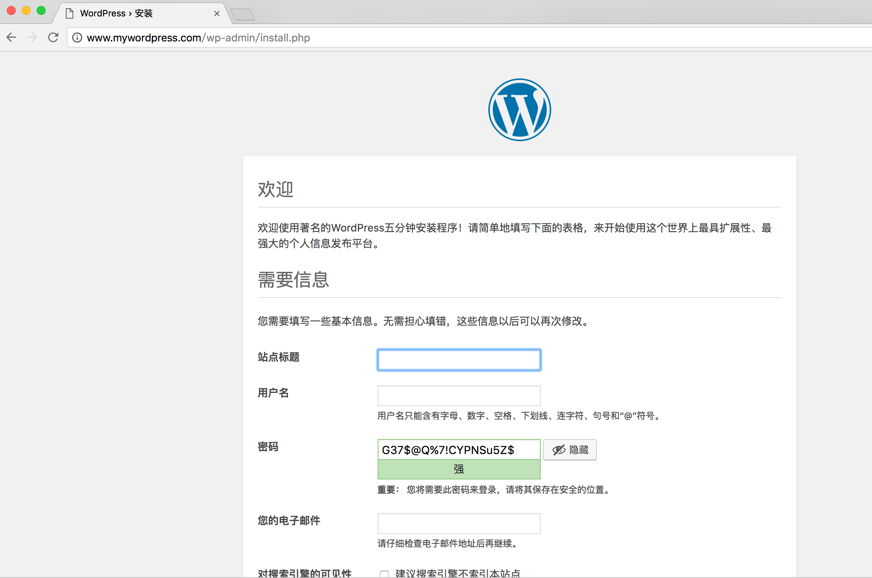

14、安装phpMyAdmin

a、解压phpMyAdmin

# unzip /usr/local/src/phpMyAdmin-4.0.10.20-all-languages.zip -d /web/

b、重命名

# cd /web/

# mv phpMyAdmin-4.0.10.20-all-languages phpMyAdmin

c、网页访问测试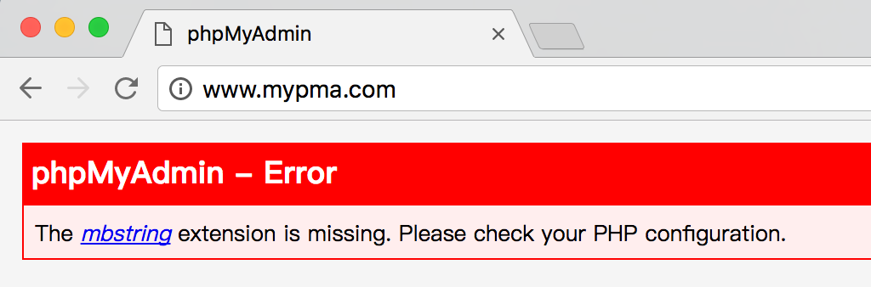

d、安装php-mbstring

# yum install php-mbstring -y

# service httpd reload

e、刷新测试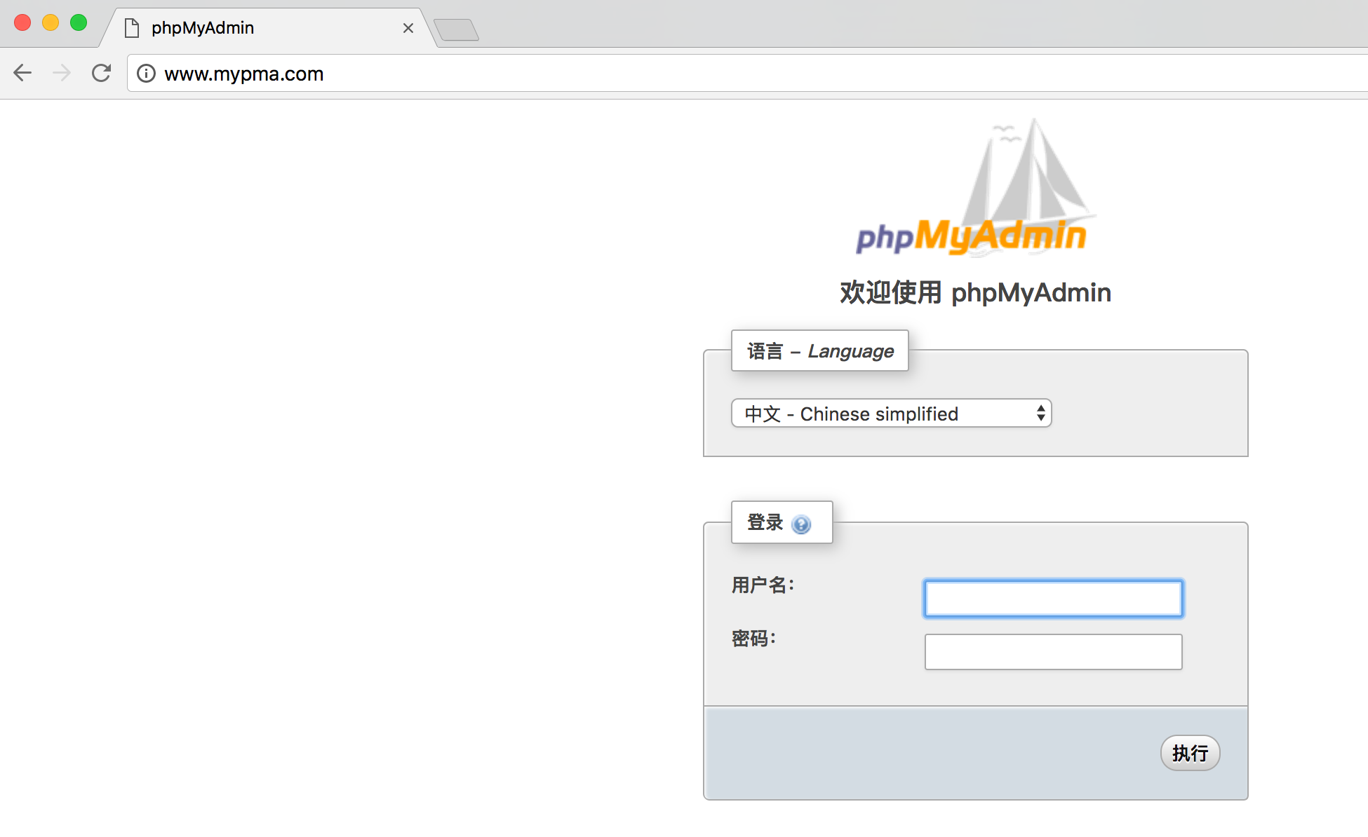

f、给数据库root用户添加密码用以登陆phpMyAdmin

# mysql

mysql> SET PASSWORD FOR 'root'@'localhost'= PASSWORD(‘I&my-zhouna');

mysql> SET PASSWORD FOR 'root'@'127.0.0.1'= PASSWORD('I&my-zhouna');

mysql> FLUSH PRIVILEGES;

mysql> exit

g、使用root用户登陆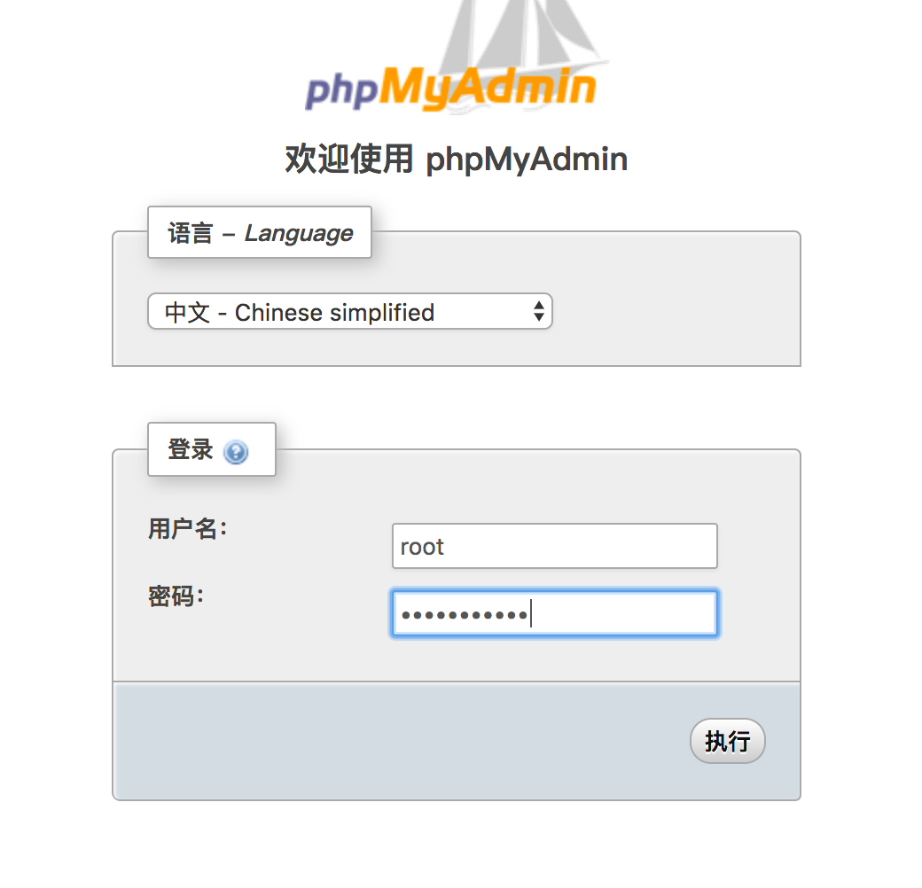

15、为phpMyAdmin虚拟主机配置ssl

a、创建服务器私钥

# cd /etc/httpd/

# mkdir ssl

# cd ssl/

# (umask 077; openssl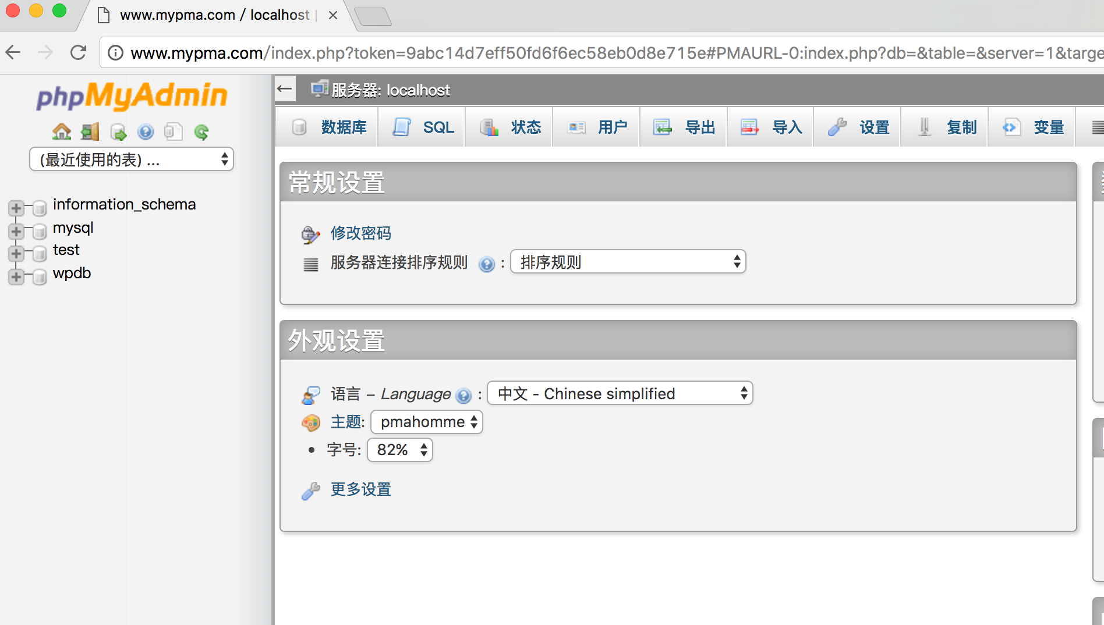 genrsa -out mypma.key 1024)

b、创建证书签署请求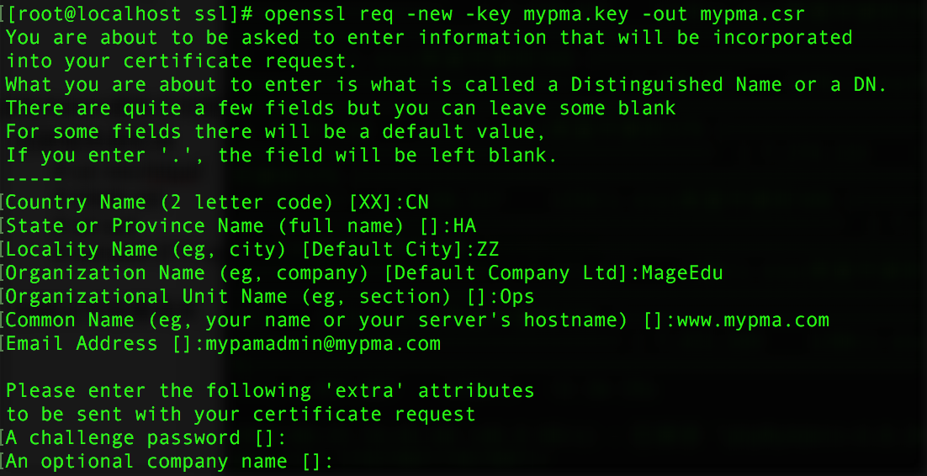

c、把请求发送给CA

# scp mypma.csr [root@172.16.227.130](mailto:root@172.16.227.130):/etc/pki/CA/certs/

d、签署请求

e、发还证书

# scp /etc/pki/CA/newcerts/mypma.crt [root@172.16.227.154](mailto:root@172.16.227.154):/etc/httpd/ssl/

f、配置phpMyAdmin虚拟主机使用ssl

# yum install mod_ssl

# cd /etc/httpd/conf.d/

# cp ssl.conf{,.bak}

# vim ssl.conf

DocumentRoot "/web/phpMyAdmin/"

ServerName www.mypma.com:443

<VirtualHost 172.16.227.153:443>

DocumentRoot “/web/phpMyAdmin"

Serve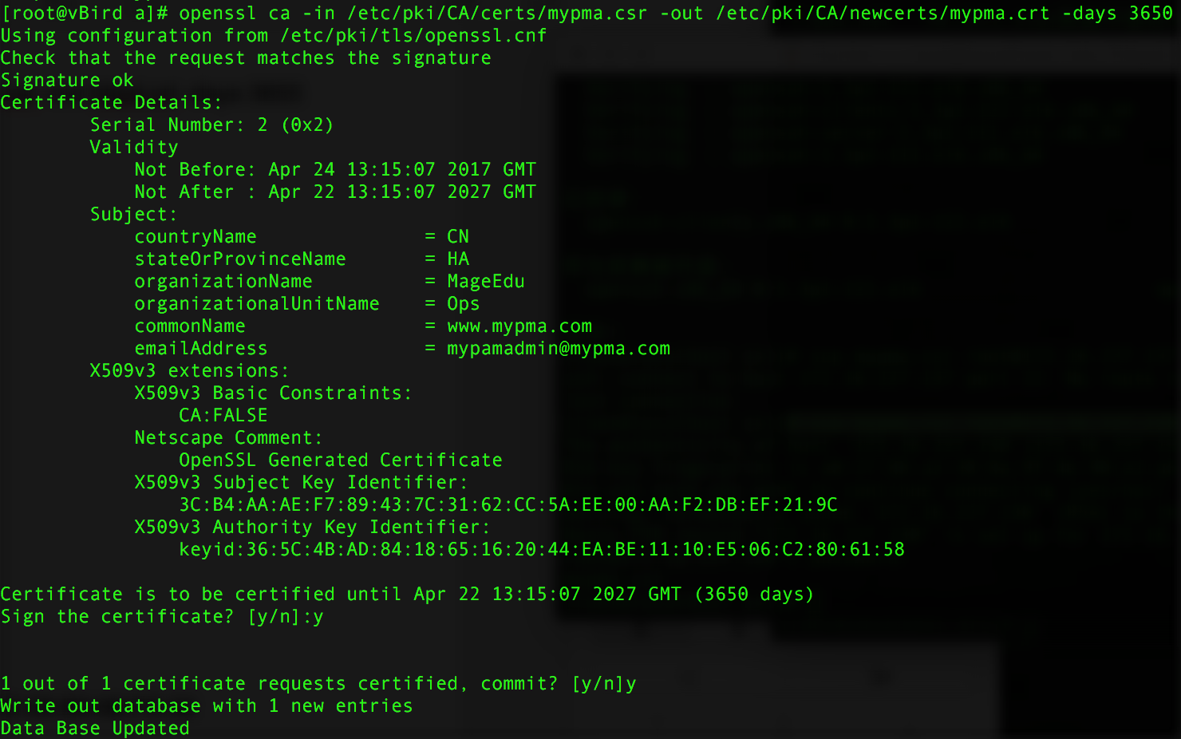rName [www.mypma.com](http://www.mypma.com)

SSLCertificateFile /etc/httpd/ssl/mypma.crt

SSLCertificateKeyFile /etc/httpd/ssl/mypma.key

</VirtualHost>

g、重启httpd服务

# httpd -t

# service httpd restart

# ss -tnl

LISTEN 0 128 :::443 :::*

h、使用浏览器访问测试

