TITLE PAGE

# TABLE OF CONTENTS

1 TABLE OF CONTENTS 2

2 INTRODUCTION 3

2.1 Background 3

2.2 Motivation 3

3 THEORY OF HALO ORBITS 4

3.1 Lagrange Points 4

3.1.1 Periodic stationary orbits around L points 4

3.1.2 Halo orbit 6

3.2 Circular Restricted Three Body Problem (CR3BP) 8

3.2.1 Equations of motion in non-dimensional form 9

3.2.2 Lagrange (or libration) points 11

3.3 N-Body Problem 12

3.3.1 Equations of Motion 12

3.3.2 Difference from CRTBP 12

4 METHODOLOGY OF PRECISE ORBIT SIMULATION 13

4.1 Force Model 16

4.1.1 Space Environment around SEM L2 16

4.1.2 Overview of characteristics 16

4.1.3 Gravitational perturbation sources 17

4.1.4 Solar Radiation Pressure 20

4.1.5 Spacecraft Maneuvers 23

4.2 Numerical Integration 24

4.2.1 Numerical integrators 24

5 SIMULATION AND TESTS 25

5.1 Simulation 25

5.1.1 Orbit Propagation 25

5.1.2 Maneuver Calculation 26

5.2 Test Cases and Results 26

5.2.1 Force Model Simplification 26

6 CONCLUSION 27

7 REFERENCES 28

# INTRODUCTION

* *Description of motivation and research problem (2 paragraphs, min. half a page in total)*

In recent years, the observation of the formation of Earth-like planets has gained particular interest of the scientific society. Current focus of modern astronomy is studying the physical properties and chemical processes which can lead to prebiotic conditions in Earth-like planets, which can open the path to understanding the genesis of our own planet.

Earth-like planets can be originated in circumstellar disks and protoplanetary regions. These regions in space are obscured by clouds of gas and dust such that they are the best observable in far-infrared frequencies. This is, however, not possible to carry out from the ground due to the limitations caused by Earth’s atmosphere.

Thus, a space-based interferometric telescope mission called Infrared Astronomy Satellite Swarm Interferometry (IRASSI) was designed. This mission is a joint project between Menlo Systems GmbH, TU Braunschweig Institut für Flugführung, Max-Planck-Institut für Astronomie, and Universität der Bundeswehr München Institut für Raumfahrttechnik and Institut für Navigation. The projuect is funded by German Aerospace Centre (DLR). UniBw ISTA is conducting a feasibility study for that mission. The aim of the mission is to further develop the understanding of star and thus planet formation, by simultaneously implementing new technologies with regard to observation instruments, ranging detection systems and formation flying. According to the plan, the constellation of five satellites, whose inter-satellite distance will be tracked to an unprecedented precision, will be following Halo orbit around second Lagrange point of Sun-Earth-Moon system.

This mission is of great importance for the future of exo-planets discovery and studies, therefore thorough studies have to be carried out before the mission enters the launch phase. One of the most important among these studies is whether the satellite positions are determined with sufficient accuracy to meet the scientific and operational goals of the mission. The first step for this would be the development of a high precision simulation environment for the satellite motion in the vicinity of SEM L2.

**Main objective of the thesis**

Main objective of this Master Thesis project is to create the aforementioned simulation environment in order to propagate the sufficiently precise orbit around SEM L2 point. The simulation will not include the launch and early orbit phase (LEOP). Only the satellite motion during HALO orbit phase will be taken into account and studied. The simulation environment will be used to test the orbit determination performance of one IRASSI mission satellite.

Many astrodynamical tools exist, which are using simplified models such as Circular-Restricted Three Body problem or consider only Sun, Earth and Moon influences. One of the goals of this work is to find out whether those simplifications affect the orbit propagation precision and to what extent by comparison. This includes determination of the relevant forces in the vicinity of L2 environment and including them in the precise model.

The next objective is to compare certain well-known numerical integrators for orbit propagation and show which one could be the best choice to propagate the HALO-type orbit around L2.

## Background

* *Advantages of L2 orbits and why it is popular for science/exoplanet missions (1 paragraph)*
* *L2 missions (1 small paragraph for each mission)*
* *Irassi mission description (similar to previous in format, but longer – half a page), (Irassi mission specific information: Buinhas, L., Ferrer-Gil, E., & Forstner, R. (2016, March). IRASSI: InfraRed astronomy satellite swarm interferometry—Mission concept and description. In Aerospace Conference, 2016 IEEE (pp. 1-20). IEEE.*

For scientific missions in space L2 point of the Sun-Earth-Moon system is often utilized. This point allows spacecraft to remain relatively stationary with respect to the Sun and Earth/Moon. This results in a low energy expenditure required for station keeping.

The satellite in an orbit around L2 is much closer to the Earth than if it resided at L4 or L5, which results in reducing the time to command a spacecraft. Light will take only 5 seconds to reach the spacecraft, whereas it will take 9 minutes to reach L4/L5. This, in turn, facilitates the ability to do real time commands, which occasionally might be useful.

Since the spacecraft resides at a distance of 1.5 millions kilometers from Earth it is not troubled by any atmospheric absorption. In addition, the spacecraft avoids any problems caused by thermal infrared radiation from the Earth interfering with observations.

The L2 orbit also prevents the occurrence of temperature changes due to the spacecraft moving in and out of eclipse in an Earth orbit, which is a particular problem for infrared instruments requiring extreme thermal stability. Satellites will be shielded against primary radiation sources which protects the onboard equipment.

Furthermore, L2 orbit offers uninterrupted eclipse-free observations, provided the sufficient size of the orbit. Scientific observatories are pointed away from the Sun, Earth and Moon, therefore from L2 the entire celestial sphere can be observed during the course of one year.

Many missions are designed to benefit from the aforementioned advantages of L2 orbits, such as:

**GAIA**

GAIA’s goal is to chart a three-dimensional map of our Galaxy, the Milky Way, in the process revealing the composition, formation and evolution of the Galaxy. Gaia is placed in an orbit around the Sun, at the second Lagrange point L2. The mission utilizes a Lissajous-type orbit. The orbit period is about 180 days and the size of the orbit is typically 340 000 × 90 000 km. An operational lifetime of 5 years is planned. The spacecraft must perform small manoeuvres every month. [18]

**HERSCHEL**

The Herschel Space Observatory is the largest infrared space observatory launched to date. The observatory resides at the Sun-Earth system Lagrange point (L2) and consists of two spacecrafts. Nominal mission lifetime is three years. The spacecraft is at a Lissajous orbit around L2 with an average amplitude of about 700 000 km and an orbital period of about 178 days. Herschel will use its propulsion system to perform orbit maintenance manoeuvres roughly once each month. **2-4 m/s!** [19]

**PLANCK**

**The Planck mission was devised to collect and characterize radiation from the Cosmic Microwave Background (CMB) using sensitive radio receivers operating at extremely low temperatures.**

Planck spacecraft resides in a Lissajous orbit with an average amplitude of about 400 000 km around the L2 point at a distance of around 1.5 million km from Earth in the anti-Sun direction. The station-keeping maneuvers are performed every 23 days [20]

**JAMES WEBB SPACE TELESCOPE**

Also well-known James Webb Space Telescope will be placed at SEM L2 as well, in HALO orbit.

The orbit is similar in size to the Moon's orbit around the Earth. This orbit (which takes JWST about 6 months to complete once) keeps the telescope out of the shadows of both the Earth and Moon. Unlike Hubble, which goes in and out of Earth shadow every 90 minutes, JWST will have an unimpeded view that will allow science operations 24/7. [21]

* *Irassi mission description (similar to previous in format, but longer – half a page), (Irassi mission specific information: Buinhas, L., Ferrer-Gil, E., & Forstner, R. (2016, March). IRASSI: InfraRed astronomy satellite swarm interferometry—Mission concept and description. In Aerospace Conference, 2016 IEEE (pp. 1-20). IEEE.*

**IRASSI MISSION**

As was already mentioned, IRASSI telescopes would be operating in far-infrared radiation spectrum in order to look through the clouds of gas and dust present in protoplanetary regions. Specifically range of 1 to 6 THz, spanning wavelengths from 300 down to 50 μm will be utilized.

Observations in such range requires sophisticated instrumentation. To be able to resolve the processes involved in planets formation, angular resolutions of less than 0.1 arcsec must be provided. The angular resolution has an inverse relation with the diameter of the collecting dish, which means that in order to achieve the required resolution, the dish must be prohibitively large, which, in turn, is not feasible for space-based telescopes. This obstacle can be overcome by employing interferometry. Interferometric systems employ arrays of telescopes to be able to extract information from the radiation source by superimposing electromagnetic wavefronts, which are phase-shifted, in order to measure their interference.

The high angular resolution is achieved by changing the separation between the satellites, also known as baselines. IRASSI mission will use five satellites in free-flying formation. The baselines are foreseen to vary from 7 to 850 meters and each spacecraft ought to be able to measure the baseline relative to the other four spacecrafts. Achieving accurate baseline measurements is a very challenging task and this problem is currently under investigation by Menlo Systems.

It is of great importance to the telescopes that observations are carried out unobstructively and in stable conditions, which has lead to the consideration of putting the space observatory in an orbit around the second Lagrangian (or libration) point.

Libration points are analytical solutions of the Circular-Restricted Three-body Problem (CR3BP), which describes the dynamics of a spacecraft under the gravitational influence of two primary massive bodies revolving around their center of mass in circular orbits, without the spacecraft influencing these primary bodies. CR3BP is an approximation of the real world as no other influencing forces, such as radiation pressure and influences of solar system planets, are taken into account. Libration points are special positions, in which the gravitational forces of the two primaries balance out the centripetal force of the spacecraft, therefore in these positions the spacecraft can maintain stationary position with respect to the primary bodies. In theory, periodic orbits exist for CR3BP, in application however, only quasi-periodic orbits exist around these points. There are five such points, and IRASSI mission will be placed around the second point of Sun/Earth-Moon system, which is approx. 1.5 million kilometers away from Earth in the anti-Sun direction. Earth and Moon in CR3BP are treated as a single massive body by considering their barycenter.

A certain type of orbit, namely Halo, is possible around libration point. Such orbit is quasi-periodic, allows large amplitudes which may allow eclipse-free observations, which makes Halo orbits ideal to carry out observations in the far-infrared spectrum, satisfying scientific requirement of the IRASSI mission. The orbit will be further discussed in more details in later sections.

## Motivation

* Detailed description of motivation with references (1 page)

Motivation for thesis or for IRASSI? Not sure what to put here in the case of motivation for the thesis

Motivation for thesis: motivation for your tests, your research questions

Method of precise orbit propagation: 1-2 sentences.

A lot of studies and methods use approximations like CR3BP or simplified force models. (some example references using CR3BP in orbit propagation). What is the effect of simplification in force model on the orbit?

Which integrator performs better for such an orbit?

# THEORY OF HALO ORBITS

## Circular Restricted Three Body Problem (CR3BP)

* History of the problem, who studied it (1 small paragraph)
* Assumptions (1 small paragraph)
* Rotating reference frame description with figure (1 small paragraph)(figure)
* Equations of motion in non-dimensional form (equations with assumptions)(approx. 1 page)
* How lagrange points are derived from the equation (optional)(half a page)

In order to establish the basis for further explanation of Lagrange points and possible orbits around them, first we have to take a look at the Circular Restricted Three-body problem of orbital mechanics in more details.

In general, Three-body problem doesn’t have analytical solutions unless some restrictions are imposed. Those restrictions were found by Lagrange and published in his “Essai sur le Probleme des Trois Corps”. These restrictions force three bodies to remain in an equilateral triangle or collinear formation. More information about those formations can be found in [2]. With respect to Lagrange points, the CR3BP is of particular interest.

In the CR3BP it is assumed that both primary bodies are very massive objects compared to the third mass. Thus, the Keplerian motion of the first two masses is determined through their respective inverse-square gravitational attraction.

Furthermore, primary bodies are assumed to revolve in circular orbits about their center of mass. This is considered to be a good approximation for celestial couples like Earth-Moon, Sun-Earth and others. [2]

The general equation of motion for the restricted three-body problem in a closed form is shown below: [2]

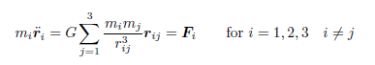(1.1)

where G is the universal gravitational constant, Fi is the net resultant force acting in each mass mi, r ij is the relative position vector defined as rij = rj – ri

Graphical representation of CR3BP is shown on the figure below:

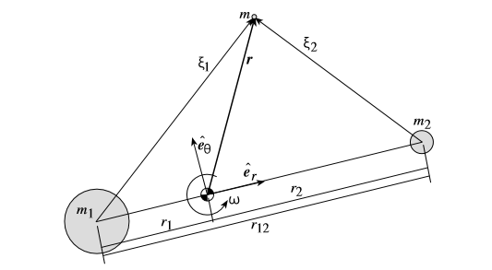

Figure 1.1 Geometry of the CR3BP [3]

**Equations of motion in non-dimensional form**

Lagrangian points, i.e. points of equilibrium are only stationary in the rotating reference frame. Therefore non-dimensionless equations of motion of mass m near the circularly orbiting m1 and m2 should be used. Below, the general principle of deriving the non-dimensional equations of motion is shown. This derivation can be found in Shaub[2]. [1] and [2] provide the detailed derivation with different level of details.

First, the inertial position vector r (figure 1.1) is expressed with components taking in a rotating reference frame F : (er,eteta,e3). The origin is at the system center of mass.

Considering the angular velocity w is assumed to be constant throughout the trajectory, w is given by:

(1.2)

The position vector r in F is expressed as:

(1.3)

Acceleration vector of r is expressed as:

(1.4)

The gravitational force acting on m in F frame components is expressed as:

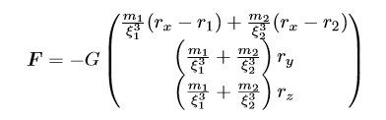(1.5)

Where relative distances of mass m to primary bodies are given as:

(1.6)

Thus, the equations of motion of mass m in a rotating reference frame F can be expressed as three coupled differential equations:

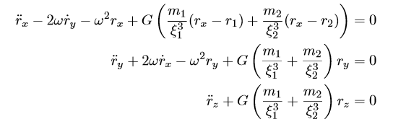(1.7)

These equations of motion can be rewritten in a convenient non-dimensional form. The non-dimensional time variable tau is defined as:

(1.8)

Therefore the non-dimensional time derivative with respect to this time is:

(1.9)

Thus, non-dimensional time derivative is related to previous xdot as:

(1.10)

Scalar distances are non-dimensionalized by dividing them by r12=m1-m2:

(1.11)

Mass quantities are non-dimensionalized by introducing the mass parameter mu defined as:

(1.12)

The center of mass condition was defined as:

m r = -m r1 – m2r2 (1.13)

With the new non-dimensional quantities, the center of mass condition is rewritten as:

 (1.14)

Knowing that the distance between primary bodies is normalized to one and given center of mass condition, the non-dimensional coordinates of primary masses m1 and m2 are now expressed in terms of the mass parameter mu:

(1.15)

Now, the equations of motion in Eq. 1.7 are expressed in non-dimensional form as:

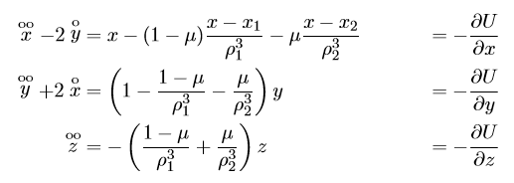(1.16 a b c )

Where non-dimensional relative distances are defined as:

(1.17)

And the corresponding non-dimensional potential function is:

(1.18)

## Lagrange points

* Description of lagrange points (1 paragraph)
* Figure of lagrange points in the sun-earth-moon system (figure)
* Lagrange point stability (1 paragraph)

Lagrange (or libration) points are the natural equilibrium solutions of the restricted three body problem. Setting the relative velocities and accelerations in non-dimensional equations of motion (Eq. 1.16) to zero, the conditions that are satisfied by the stationary points of CR3BP can be found. As mentioned before, these stationary points are exactly the Lagrange points.

All stationary points have z=0 and therefore lie in m1-m2 plane. Eq.1.16b is equal zero either if y=0, which corresponds to the collinear solution, or if ro1 = ro2 which corresponds to equilateral solutions.

Lagrange discovered five distinct formations which are invariant when viewed from the rotating reference frame. So, five possible locations for small mass m, for which the net gravitational force of two primary bodies on this smaller mass m is balanced by the centrifugal force of the rotating primaries themselves. That in turn makes those locations appear stationary as seen from rotating frame.

In other words, these are the five locations around a planet’s orbit where the gravitational forces and the orbital motion of the spacecraft and massive bodies interact to create stable locations from which, for instance, one can make observations. Lagrange points of the 3-body system Sun/Earth-Moon are shown on the figure below:

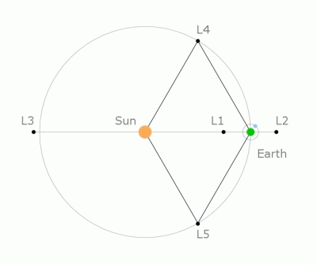

Figure 1.2 Stationary lagrange points [esa]

As seen from the Sun, the L4 and L5 points lie at 60 degrees ahead of and behind Earth, close to its orbit.

**Stability in the vicinity of Lagrange Points**

Unlike the other Lagrange points, L4 and L5 are resistant to perturbations. When a perturbation occurs near L4 or L5, the gravitational force acts to counterbalance the centripetal force and compensates a drift from the nominal orbit. Because of this stability, objects such as dust and asteroids tend to accumulate in these regions.

A spacecraft at L1, L2, or L3 is ‘meta-stable’. A little perturbation forces it to move away, so a spacecraft must use frequent rocket firings to stay in orbits around these Lagrangian point. When a perturbation occurs near meta-stable points, the unbalanced forces contibute to the perturbation and make the drift faster.

### Periodic orbits around L points

* Periodic and quasi-periodic orbits, orbit types (distinguish between L2 and other libration points), short description of orbits other than halo (half a page)
* Halo orbits, characteristics, advantages over other libration orbits (half a page)

Since stationary points of the circular-restricted 3 body problem are of practical interest, much effort has been put into finding periodic stationary orbits of RC3BP. Such orbits form closed three-dimensional curves and remain fixed as seen from the rotating frame.

Thousands such orbits were discovered but not all of them are of practical value. Those orbits can be grouped into certain families, thus helping to explain the more general classes of orbits for this 3body problem. [Shaub 2].

In Hamiltonian systems the presence of a periodic orbit involves the characterization of the whole family as isolated periodic orbits do not exist in such systems. Hence, in order to identify a single orbit belonging to the family, a certain parameter must be introduced. For a halo orbit, which will be discussed further, this parameter is the out-of-plane amplitudes Az; for Lyapunov orbit, this is in-plane Ax. [3]

Before going deeper into these orbits types, linearized non-dimensional equations of motion (Eq. 1.16) should be expressed in a different form:



(1.19)

Thus, we obtain the two equal frequency parameters in xy in-plane (primary bodies plane) and one frequency in the perpendicular plane.

The fact that frequency in z axis is decoupled from frequencies in y and x axes allow for obtaining different kinds of interesting orbits by varying the amplitudes and frequency values.

*In [3] it is shown that* linearized dynamics (Eq. 1.19) around collinear libration points, in particular L1 and L2, with only two of these frequencies (in xy plane) allows obtaining some infinitesimal or **Lyapunov orbits** in a small neighborhood around those points, given an appropriate initial condition. Moreover these planar orbits can be numerically continued until the desired finite size is reached. Different Lyapunov orbits around L1 of the Sun-Earth system are shown on the figure below:

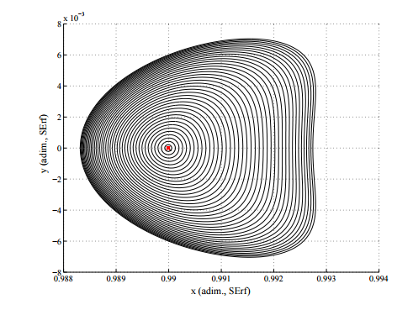

figure 1.3 Finite-size Lyapunov orbits of different amplitudes [3]

As can be seen, in reality these frequencies vary and therefore the orbit changes its shape with growing amplitude. This happens due to the actual non-linearities of the dynamical system.

Such orbits do not allow the out-of-plane motion and therefore not suitable for space application. [3 Mil pages 14-15 answer why]

*Other that [3] see also L2env paper for additional details:*

Adding a frequency in z direction (not equal to that of y and z) one would obtain the quasi-periodic closed form path called Lissajous Trajectory. Depending on the frequency z and the Az amplitude it may take on different shapes. Lissajous orbits can be used in space missions but do not allow big excursions in the out-of-plane direction, which sometimes is requirement in order to meet the mission scientific or operational requirements, which is the case for IRASSI mission.

PICTURE!

However, very interesting and applicable for space missions large periodic Halo-orbit types can be obtained, which allow out-of-plane motion. This is possible, if the amplitudes of in-plane and out-of-plane motions are of sufficient magnitude, so that the non-linear contributions to the system produce eigenfrequencies that are equal, in other words, Eq.1.19 becomes: *[3] p 23*

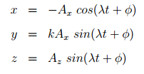(1.20)

Note, that these equations are only a first approximation to the true orbit, and higher order corrections are introduced when nonlinearities, eccentricity and perturbations are taken into account. However, the corrected orbit is still bounded, but only quasi-periodic. [12]

Mention Richardson! Milano p. 22-23

Show the relation between Ax and Az to get a Halo orbit!

### Halo orbit

Orbits’ name speaks for itself, it is a ring or “halo” about the libration point. Aforementioned big excursions in the out-of-plane direction can facilitate satisfying the scientific or operational mission-specific goals.

By varying Az amplitude, it is possible to obtain Halo-orbit with different inclinations and of different size.

Therefore, choosing an appropriate Az is important since through its value the mission-specific constraints can be formulated. For instance, (applies to IRASSI mission) space telescope about the Sun-Earth L2 requires a minimum Az in order to avoid the eclipses and maintain uninterrupted communication link.

On the figure below Halo-orbits with different Az amplitudes around L1 in the Sun-Earth rotating frame are shown:

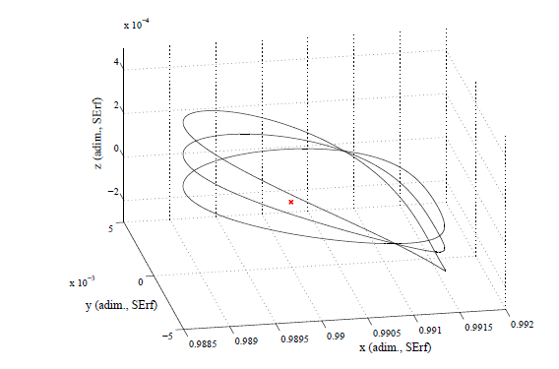

figure 1.4 Halo orbits with Az = 10000, 30000, 50000 km

In the CR3BP model, halo orbits are both periodic and time independent. However, note that if we take all the effects of the full solar system among others into account, halo orbits are in fact quasi-periodic and time dependent.

Any orbit around L2 is dynamically unstable in reality, i.e. over time a spacecraft in its orbit will diverge and escape to the outer space. This is due to the effect of the solar radiation pressure, gravitational attraction of other planets and movement of the Moon.

In order to describe such orbit, in case of IRASSI around L2 point of Sun/Earth-Moon system, the L2-centered reference frame must be defined. The following properties apply: [irassi]

* X-axis is aligned with the Sun-Earth line in the ecliptic plane. Its positive direction points towards outer space
* Z-axis is aligned with the North and South ecliptic poles of the celestial sphere. Positive direction towards the North-Pole
* Y-axis completes the right-handed reference frame

Below is the representation of L2-centered reference frame:

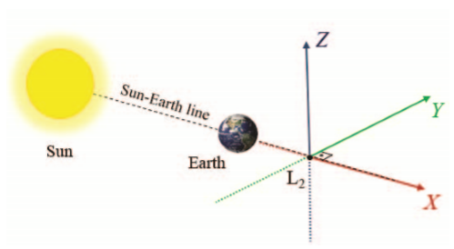

Figure 1.4 L2-centered frame

In general quasi-Halo orbits would be characterized by the following properties: [irassi]

* Quasi-periodic. Frequency in z-axis is nearly the same as in X-Y axes frequencies.
* Large amplitudes in the Y-component
* Spacecraft on such an orbit will not enter the antumbra region, therefore free-of-eclipse observations are possible
* Quasi-free delta-V transfer maneuvers

Therefore, quasi-Halo orbit is chosen for the IRASSI mission as these properties make such orbits ideal for carrying out far-infrared observations and satisfying scientific requirements for the mission.

The spacecraft should not enter the antumbra shadowed region of the Earth at any point during the Nominal Operations phase in order to ensure the constant solar power supply. During the mission analysis study [irassi] it was concluded that the minimum Az to avoid drifting into eclipse within a period of 5 years is 270 000 km. Adequate value of Az is also important in terms of constant direct visibility from the ground stations. As such, an excessive amplitude Az on the negative direction may impair the communications between the satellites and the ground station situated in the Northern Hemisphere. [irassi]

Maximum amplitude Ay was set to 850 000 km but can be altered in future.

The launch periods were selected in accordance with the possibility to satisfy aforementioned conditions and no maximum amplitudes (Ay) lower than 600 000 km were obtained for the selected launch periods.

Illustration of the quasi-Halo orbit around L2 including transfer from the Earth is shown on the figure below:

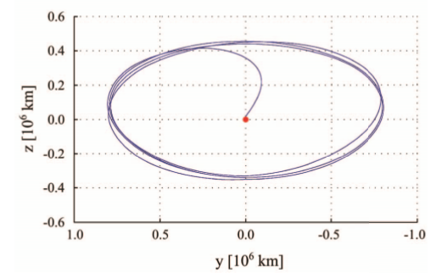

Figure 1.5 Quasi-Halo orbit around L2 SEM [irassi]

As was already mentioned Halo orbits tend to be unstable, therefore station-keeping maneuvers are required to maintain its stability and periodicity. More detailed information about maneuvers calculation and implementation is in chapter 4.1.4 (theory) and 5.1.2 (implementation).

Also worth mentioning, that Halo orbits are difficult to obtain because the problem is highly non-linear and small changes in the initial conditions break the periodicity of the orbits. However, there are some methods allowing for the generation of halo orbits with desired amplitudes. Detailed description of the process goes beyond the scope of this work, but relevant information can be found for instance in Zazzera [3] or in full details in Richardson [7].

## N-Body Problem

* Description (1 paragraph)
* General Equations of Motion (barycentric)
* Difference from CRTBP, why it is more realistic (1 parapraph)

Some work in astrodynamics can be done using standard two-body relations. For more complex analysis, three-body problem with certain restrictions might be used, such as CR3BP discussed before.

But in other cases, the influence of other celestial bodies should be included in the model for more precise modeling of the real world. The further generalization of three body problem is n-body problem. One should, however, consider the influences only to a certain extent. Even though some bodies have a certain influence, but it might be in negligible levels.

In the n-body problem, – for which three body problem is a special case – additional forces arise from the mutual interactions between the bodies.

Vallado [1] has shown that the equations of motion are independent of a particular origin and any particular inertial frame. They depend only on the relative position vectors and the second derivatives, which are, in turn, independent of the inertial frame’s origin.

The generalized barycentric equation of motion is:

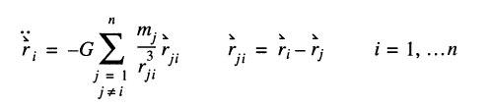 (1.21)

(form Vallado page 118, eq. 2-26)

However, if we want to reference the equations to the Earth’s center, using inertial (relative) form of equation of motion is preferable. Thus, we transform the acceleration to a different origin and it is measured relative to the Earth. Inertial equation of motion for the satellite is shown below [1]:

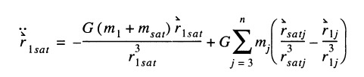(1.22)

The first term in this equation is the two-body acceleration of the Earth acting on a satellite. The second term is divided into two terms – direct and indirect effects. Direct represents the influence of the body on a satellite, whereas indirect represents the influence of the primary body on that body. Altogether, the second term of this equation of motion represents perturbation or the additional force beyond the simple two-body motion. [1]

Unlike CR3BP, there is no assumption about the bodies revolving in circular orbits here. Also, other bodies that have non-negligible influence on the motion of a spacecraft are included. That makes such gravitational force model much more realistic.

# METHODOLOGY OF PRECISE ORBIT SIMULATION

* Description of the methodology (min. 1 page, max. 3 pages)

In Newtonian physics the motion of the satellite under the influence of the force is described by the differential equation



where r an v are the position and velocity of the satellite in a non-rotating geocentric coordinate system and m denotes the satellite’s mass.

In order to perform precise orbit determination one has to include as many acceleration sources as possible within a certain threshold and decide which forces can be neglected in order to achieve desired precision.

Most significant perturbations arise from gravitational attraction of the celestial bodies, especially Sun, Earth and Moon when we are dealing with the Earth-orbiting satellites. Other dominant planetary contributions stem from Venus and Jupiter.

Satellites with altitudes of several hundred kilometers above the Earth’s surface are subject to a drag force, caused by Earth’s atmosphere. Since the atmospheric density decreases exponentially with increasing height, drag effect mainly affect the low-Earth satellites and is the strongest during the perigee of an orbit. While, the acceleration due to gravitational forces is independent of the satellite’s mass and area that is not the case for atmospheric drag as well as for other surface forces. Among these the solar radiation pressure is the most significant. The radiation pressure arises when photons transfer the impulse to the satellite and doesn’t vary with altitude. Its main effect is in slight changes in eccentricity and the longitude of perigee. [7]

For near-Earth orbiting satellites quite significant accelerations arise from the fact that Earth is not a perfect sphere, but has the form of an oblate spheroid with an equatorial diameter that exceeds the polar diameter by 20 km. This perturbation is about three orders of magnitudes smaller that the central gravitational attraction. Due to its angular momentum the orbit behaves like a gyroscope and reacts with a precessional motion of the orbital plane, and a shift of the line of nodes by several degrees per day. [7] The effect of various perturbations as a function of geocentric satellite distance is illustrated on a figure below:

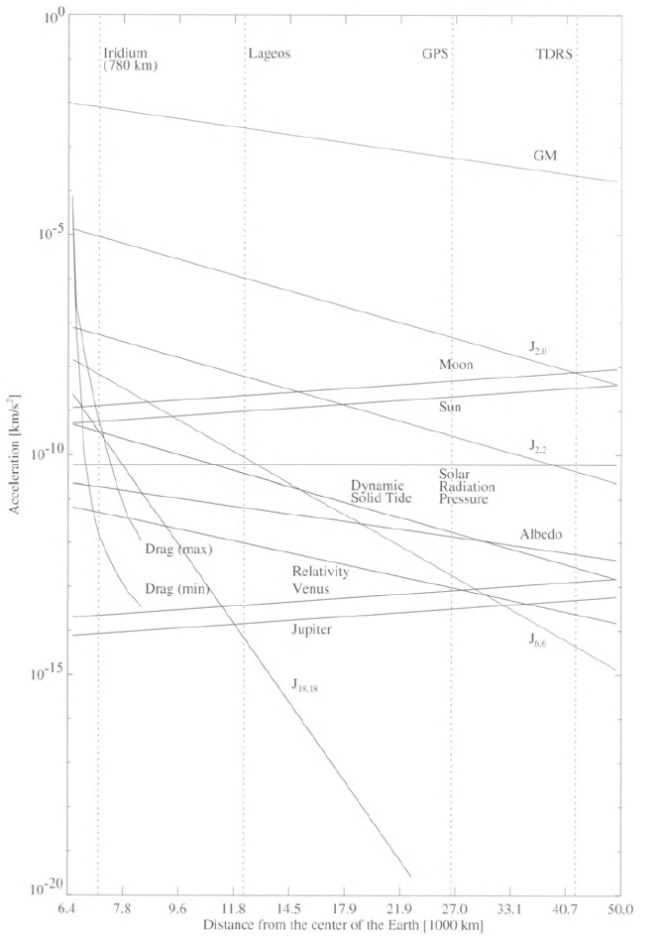

figure 1.5: Order of magnitudes of various perturbation of a satellite orbit. [7]

## Modeling Forces

* Introductory small paragraph

In Fig.1.6 along with major perturbations various minor perturbations are presented, which produce accelerations on the order of 10^-15 – 10^-12 km/s^2.

It is important to determine and consider the relevant forces based on the location of the spacecraft. Therefore we need to study the environment around L2 SEM point in order to create precise force model of the satellite motion.

### Space Environment around SEM L2

* Description of the space environment around L2 and overview of characteristics (min. 1 page, max. 3 pages)
* One big table of the effects with their magnitudes (table)

The environment around L2 point of Sun/Earth-Moon system was studied both for previous L2 missions and for the ones planned for future. Here the results of the analysis from Steven W. Evans [4] for the JWST will be addressed.

The natural environment near the L2 libration point is characterized by many complex, varying and sometimes quite subtle processes. In some cases the characteristics and interactions among these processes are poorly understood. [4]

But we have a general understanding of the processes and forces, occurring at this location in our Solar System and this should be enough to model the forces that have non-negligible influence on the orbit modeling precision.

The L2 libration point is a position if unstable equilibrium in the gravitational system consisting if the Sun and the Earth-Moon system. In general, a spacecraft in an orbit about the Sun whose radius is greater than that of the Earth will move at a slower angular rate compared to that of the Earth. However, at L2 the additional gravitational attraction provided by the Earth and Moon will accelerate the spacecraft’s motion allowing it to keep pace thus keeping its position relative to Earth-Moon system fixed as seen from the Sun.

Of course, this balance of forces is quite subtle. Different perturbations may nudge the spacecraft away from the equilibrium position such as– motion of the Earth and Moon about their barycenter, eccentricity of the Earth-Moon system’s heliocentric orbit, passing celestial planets and solar radiation pressure.

In practice, the spacecraft will be placed into a ‘halo’ orbit about the nominal equilibrium point. There it will be maintained by periodic station-keeping maneuvers to compensate for the perturbations.

A spacecraft in an L2 Halo orbit will be also subjected to the ambiend plasma and ionizing radiation environments due to both the solar wind and the geomagnetic tail. Depending on the size and orientation of halo orbit, the spacecraft may be sometimes immersed in the tail, in the free solar wind and inside the schocked plasma of the magnetosheath between these regions.

The latter have influence only on electronic systems of the spacecraft and therefore will be not be anyhow considered in this work.

The spacecraft will be exposed to the full spectrum of electromagnetic energy produced by the Sun. The intensity of solar electromagnetic emission, the level of production of ionizing radiation, the speed and density of the solar wind and the strength of solar magnetic field all vary more or less cyclically with an average period of 11 years. [4]

The exact level of solar activity cannot be predicted very accurately, but since we are interested only in the effect on the orbit it is enough to consider merely the average solar flux in the Solar System. In this work simplified SRP model will be used for reasons, which will be discussed in more details in the corresponding section.

At L2 the spacecraft may also be subjected to bombardement by meteoroids. We will not take into account possible gravitational perturbations caused by them due to the insignificance of such forces. Meteoroids streams, which are clouds of particles scattered along and near the orbits of their parent bodies having ejected from them should be considered when designing the materials, design geometry and other characteristics of the sunshield, but all these are out of the scope of this work. More information and references can be found in Steven W. Evans [4]

Threshold for neglecting the perturbing accelerations was set to e-13. Thus, for the spacecraft at L2 only gravitational sources and solar radiation pressure will be taken into account without considering Earth’s harmonics, atmospheric drag and relativistic effects.

IRASSI mission satellites will be placed in the vicinity of a point of unstable equilibrium in the Sun/Earth-Moon dynamical system which is modeled by the classical Circular Restricted Three-Body Problem. In this model the Earth and the Moon are considered as a single body taken as a point mass at the Earth-Moon barycenter. Neglecting the Moon would cause great error in Three-Body model Sun-Earth-Spacecraft, whereas treating Sun-Earth-Moon-Spacecraft in a Four-body problem is too complex for analysis.

Here we will consider the perturbations due to various planetary bodies the Solar System.

First of all the motion will be disturbed by the motion of the Moon about the Earth. The orbit of the Moo is inclined to the ecliptic by 5.145 degrees and the orbital plane precesses with respect to the Sun-barycenter line with a period of 18.613 years. [4]. Perturbations vary during this period. The table below shows mean accelerations during a typical 28 day Earth-Moon revolution cycle

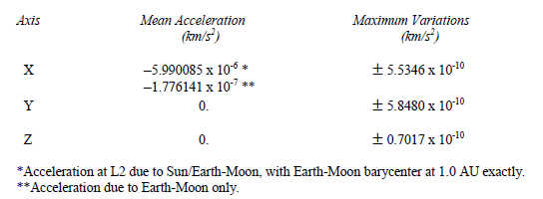

Table 1. Mean accelerations and Variations About the mean from perturbations due to the Earth-Moon system [4]

Other sources of periodic gravitational perturbations are the planets.

Jupiter and Venus are the most important perturbers of a spacecraft at L2. Worth noticing that the maximum possible sum of planetary perturbations is of the same order of magnitude as the maximum Earth-Moon variations about the mean acceleration at L2. The values are shown in the table below:

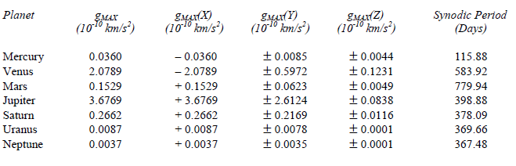

Table 2. Single-Planet Maximum Perturbations and Synodic Periods [4]

A satellite exposed to solar radiation experiences a small force arising from the absorption or reflection of photons.

This acceleration depends on the mass and surface area. The radiation pressure accelerations at different distances from the Sun can vary. It is know that the solar flux at a distance of 1 AU is 1367 W/m2 and this value is often used in SRP calculations. For better precision one can use the flux value around SEM L2 point, which is about 1340 W/m2 [4]. That doesn’t matter that much as for SRP the simplified model will be utilized anyways.

Modeling of solar radiation pressure will be further discussed later, but so far it is necessary to mention the order of magnitude of that perturbation source.

Given the mass of the satellite of 6000 kg and the surface area of 1 m2, one arrives at at the average values for SRP around L2:

gSRP ~ 1.5 * 10^-12 km/s2

### Gravitational perturbation sources (approx. 1 page)

* Description (approx. 1 page)
* Table with the effects of all solar system bodies (table)
* Earth centric equations of motion (newtonian dynamics) (approx. 1 page)

For modeling gravitational effects we will use Earth-centered reference frame. As was mentioned in n-body problem section (3.3) the primary body would be Earth and therefore first term of the equation will represent simple two-body motion whereas influences of other bodies will be treated as perturbations.

Below is the general equation for Earth-centric

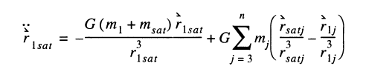 (1.23)

*where 1- is the primary body (Earth), sat is the satellite and j would represent other bodies that will be taken into account.*

Modeling will be performed using simplified and full dynamics. In case of simplified model, only the influences of the Earth, Sun and Moon will be taken into account. For the full dynamics influences of the Earth, Sun, Moon, Jupiter, Venus, Mars and Saturn will be considered. Thus, influences of Mercury, Neptune, Pluto as well as some large asteroids will not be taken into account as their influence is way beyond the threshold that we set and those can be neglected.

### Solar Radiation Pressure

* Description (half a page)
* Equations with the assumptions (max. 2 pages)

The explanation in a simplified form is taken from Montenbruck [5]. For more details please refer to this source.

The size of the solar radiation pressure is determined by the solar flux [



where the energy deltaE passes through an area A in a time interval delta t.

Each photon carries an impulse. The total impulse of an absorbing body that is illuminated by the Sun changes by



and the therefore the satellite experiences a force



that is proportional to the cross-section A or a pressure



provided the flux is totally absorbed.

In a distance of 1 AU, in the vicinity of the Earth, the solar flux amounts to 1367 W/m2, and therefore the solar radiation pressure is P = 4.56*10^-6 N/m2 assuming the complete absorption (i.e. zero reflectivity) or complete reflection (reflectivity is one). The force exerted on the satellite due to solar radiation pressure is shown below:

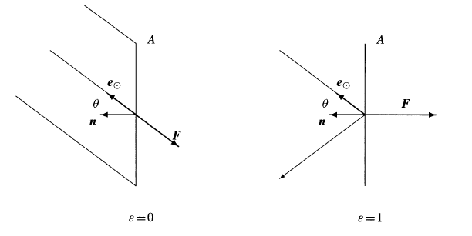

figure 3.1 The force due to solar radiation pressure for absorbitn and reflecting surface elements

The normal vector n gives the orientation of the surface A and is inclined at an angle O to the vector e which points in the direction of the Sun.

From those considerations follows that, for an absorbing surface, the force is:



whereas in case of a reflecting surface, the force is not directed away from the Sun since no impulse is transferred in the direction parallel to the surface. Due to the reflected light rays, the impulse is twice as large. This results in the following formula for the reflecting surface:



In reality, both formulas should be combined as the body reflects a fraction epsilon of the incoming radiation deltaE while absorbing the remaining energy (1-epsilon)*deltaE. Thus the resulting force is:



epsilon is the reflectivity coefficient and for typical materials, used in the constructions of satellites, lies between 0.2 and 0.9

For reference, a table of typical reflectivity coefficients for selected satellite components, is below: [5]

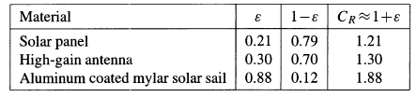

Table 3.1: Typical reflectivity coefficients

The distance between an Earth-orbiting satellite varies between 147*10^6 and 152*10^6 km during the course of a year. This is also the case for the satellite orbiting around SEM L2. This results in an annual variation of solar radiation pressure by +- 3.3% as the flux decreases with the square of the distance from the Sun [5]

This result in the following expression:

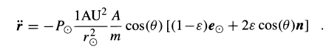

However, for many applications it is sufficient to assume that the surface normal n always points in the direction of the Sun. Which leads to a further simplification of the expression:

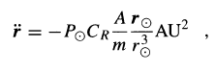

In terms of this work, the simplified model will be used, firstly because the surface normal variations would be in the range of +- 20 deg. Secondly, given the current state of the project, the exact physical parameters or the satellite are not known.

We will assume the surface area of the spacecraft is 1 m2 and mass is 6000 kg. Reflectivity coefficient is 0.8

Even though the model is simplified, such calculations will still be useful and serve as a good first approximation. Solar radiation pressure acceleration is of magnitude e-12 and has notable influence on the satellite orbit.

SRP also should be further studied as it is important for sunshield design and will have an influence on the decision about other spacecraft components construction but this is, obviously, out of the scope of this work.

Moreover, satellites with large solar arrays (such as JWST, having the surface area of 264 m2) can turn SRP perturbation into advantage in maintaining the spacecraft on station. More information on that can be found in [4]

Matlab code for the SRP calculation can be found in srp.m matlab function.

### Spacecraft Maneuvers

* Description (half a page)
* Theory (not the implementation) on how to calculate the manuvers (max. 2 pages)

[farquhar control and use] [12]

Howell [13] <http://adsabs.harvard.edu/full/1984CeMec..32...53H>

[14] http://www.agi.com/downloads/resources/white-papers/AAS-11-480.pdf

As was mentioned before, collinear libration points are unstable. Therefore some form of translation control is required to maintain the satellites position in the vicinity of libration point [12]. Thus thrust control for station keeping will always be necessary in order to maintain quasi-stable quasi-periodic orbit, in our case Halo-orbit.

Different station-keeping strategies can be devised. Burns can be performed, for instance, once per revolution cycle, twice or, every month. Choice of a strategy is usually dictated by operational goals, total delta-V budget for the mission, orbital parameters, etc. In terms of this work, no fuel consumption optimization was made.

Based on the IRASSI mission analysis, without station-keeping maneuvers applied, the spacecraft would escape the orbit around L2 after 1 to 3 months. Total delta-V budget for the mission starting from the launch phase and including formation reconfiguration maneuvers can be found here - [irassi paper].

So, as was said before, our goal is to maintain quasi-periodic orbit around L2. Non-dimensional equations of motion, shown in previous chapter, (Eq.1.16) present the following symmetry:



That means that given a solution x(t) there is guaranteed another orbit x(-t). [Mil 3]

Noting the statement above, the initial conditions demand the initial vector to be:



which is perpendicular to the x-z plane. The solution will also be symmetric with respect to that plane. Therefore if another perpendicular crossing can be found such that



where velocity components in x and z directions are zero, then the orbit will be periodic with period T. [13 Howell]

The transition matrix at T/2 can be used to adjust the initial values of a nearby periodic orbit.

Using integration procedure, the equations are integrated until y changes sign. Then the step size is reduced until y < 10^-11 and the time at this point is defined to be T/2. [13]

The orbit is considered to be periodic if modulus Vx and Vz are < 10^-8 at T/2.

If this is not the case Vz and Vy can be reduced by correcting two of the three initial conditions and integrating again until those conditions are met.

Therefore we have to solve targeting problem (also known as shooting problem), i.e. answer the question: how can the initial conditions and other control variable be adjusted in order to meet specified set of orbital goals? In our case the goal is to have such state at t=T ½ where y=0 and Vx=Vz=0 within some tolerance.

One of the procedures, widely used in a trajectory design and maneuver planning is the differential correction. Using the differential correction procedure, solutions at each half-revolution can be produced.

One of the most popular approaches for differential correction is Newton-Raphson root finding algorithm. It is used to adjust the independent variables, such as time, direction and magnitude of maneuvers, in order to achieve certain desired values of dependent variables (aforementioned set of orbital goals). [14]

Such root-finding algorithms methods solve the problem of type:



where x is a vector of independent variables and y is a vector of dependent variables. The problem can also be written as



in case the desired values are not zero. [14]

Method starts typically with some initial guess X0, compute f(x) and compare the resulting **y** with the desired values. The method then computes a step to take in the independent variables so that the dependent variables move closer to the desired values. [14]

Newton-Raphson method, in particular, uses the first derivative of the function to determine the step to take in the independent variables. [14]

Newton-Raphson for single variable problems:



For multi-variable problems:



where J is the Jacobian matrix defined as:

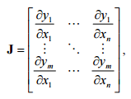

More detailed information regarding shooting technique and differential correctors can be found in [14] as well as in other numerical methods related sources.

### Force model

*Final formula used*

## Numerical Integration

* Describe generic numerical integration process (theory) (1 page)
* Literature search on numerical integrators used in astrodynamics applications (one big paragraph)

Equations of motion in astrodynamics aren’t easy to solve as usually they are coupled systems of nonlinear differential equations that cannot be solved analytically. Solution can be obtained by using numerical methods. A variety of methods has been developed for the numerical integration of ordinary differential equations and many of them have proven to be efficient when solving problems of celestial mechanics. [1]

There are different integration methods based on different principle and it is not possible immediately tell which method would be the best for a particular problem. There are also different criteria to compare them.

Usually, integrators are divided into several types based on the underlying principle: [5]

* Single-step Runge-Kutta methods. Those are particularly easy to use and may be applied to a wide range of problems
* Multi-step, or often referred to as Predictor-Corrector, methods. Provide high efficiency but require a storage of past data points
* Extrapolation methods, famous for their typically high accuracy

Detailed discussion about numerical integration methods can be a topic for the whole work as there is variety of developed numerical integration methods and studying them in details is beyond the scope of this work. To delve deeper into the topic one can refer to Vallado [1] or Montenbruck [5], who provide relatively detailed review of the main numerical methods and further provide references to other sources.

It is assumed that equations would be n-dimensional ordinary differential equations of the form: [5]



with derivatives w r t time. This form can be obtained from the second-order differential equation



by combining position of a satellite r and velocity rdot into the six-dimensional state vector:



which satisfies



**General idea**

The majority of numerical integrators derive from Taylor series integrator. Below is the form of Taylor series: [1]

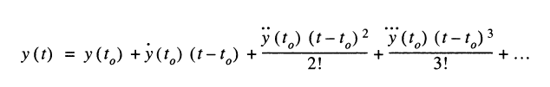

We cannot include an infinite number of terms and it can be not clear where to truncate the series. Also with complex functions one might have a hard time calculating the derivatives. The simplest solution is the basis for an Euler integrator, which takes into account only a first-order term of Taylor series: [1]



When using the Euler method one must carefully approach to choosing the appropriate step size (t-t0), so that it is small enough to handle variations caused by the neglected higher-order terms.

### Numerical integrators

* Introductory paragraph to outline which integrators will be described and if they have types e.g. fixed step, extrapolation etc. Montenbruck’s book. (min. half a page)

**Runge-Kutta Methods**

First we start we one of the most used in astrodynamics integration methods – Runge-Kutta singlestep methods.

These methods derive from Taylor series but instead of deriving for higher derivative terms, the approximation is formed by using the slope at different points within the integration interval.

Runge-Kutta is an often used type of single-step integrators. Such methods combine the state at one time with the rates at several different times based on the single initial state at time tzero. The rates are obtained from the equations of motion and allow to determine the state at t + some stepsize.

For satellite problem, equations of motion are often formulated as a first-order system with initial conditions. Using position and velocity vectors we obtain velocity and acceleration vectors.

For many applications a fourth-order RK is sufficient. RK don’t require a sequence of previous values to start the integration unlike multi-step methods. However they evaluate the function at several intermediate points (the number is determined by the methods’ order) and these values are used only ones. [1]

Below is the example of classical fourth-order RK method, where the weighted mean is calculated: [1]

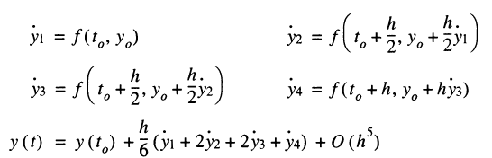

The formula is designed to approximate the exact solution up to terms of order h4 provided that y(t) is sufficiently smooth and differentiable. Its local truncation error is



and bound by a term of order h5.

Graphical representation of the method is shown on the figure below:

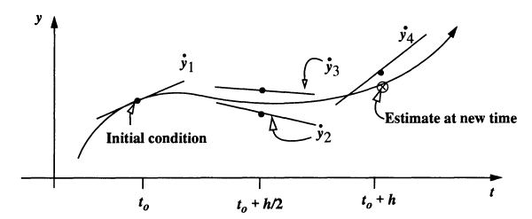

figure: RK algorithm [1]

The derivative (slope) is evaluated at several different points, in this particular example 4 times as the method is of the order of 4, along the estimated trajectory. These intermediate estimates help to find the final estimate at t + h.

There are other forms of this basic method of higher order, for instance fifth, eighth, twelfth and others. The general formula for methods is presented below: [1]

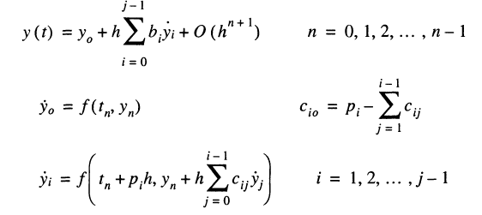

The constants b,c and p in the formula must be determined separately. Nowadays they are available in the respective books. The coefficients are not uniquely determined, therefore various Runge-Kutta methods exist with the same number of stages.

In the example above, the number of evaluations is equal to the order of local truncation error, but this is not generally the case. [5] Butcher [ref] has shown that one additional evaluation is required for methods of orders 5 and 6, two for order 7, 3 for 8 and upwards. Those rules are known as Butcher barriers.

It is possible to construct methods that are based on the same set of evaluations. Such methods are known as embedded Runge-Kutta methods and allow estimation of the local truncation error in each step along with the solution. That is the prerequisite for step-size control, which will be discussed further. [5]

Embedded method of s stages yields two independent approximations of orders p and p+1 within one integration step. Then one is able to get an estimate of the local truncation error of the p-th order formula from the difference between the two solutions. [5]

**Step-size control**

During the numerical integration the stepsize should be chosen in a way that each step contributes uniformly to the total error. Single step cannot be neither too large nor too small as the latter can increase round-off errors due to increased total number of steps.

As was mentioned before, embedded methods provide the error estimate that can be used to in stepsize control technique. Stepsize control tries to limit the local truncation error, an estimate of which is computed each step. [5]

Each step yields an error estimate:



If this value is larger than the set tolerance, then the step has to be repeated with a smaller stepsize h*. The local truncation error for the new stepsize will then be: [5]



Therefore maximum allowed stepsize is:



If the step was successful, then one may use it for the next iteration.

Note however, that there is still the need to supply an adequate initial guess for the step size.

**Multistep methods**

Previously discussed Runge-Kutta methods make no use of previous steps and therefore each step is independent of one another. However, it is possible to apply completely different approach by storing the values from previous steps. Such methods are particularly useful for differential equations defined by complicated functions with a lot of arithmetic operations. [5]

For example, below is the increment function and formula for calculating the solution for the 4th-order Adams-Bashforth formula which contains function value at three previous points: [5]





Note, that multistep methods require the integration for the first value (amount depends on the order). Previous values may be obtained using Runge-Kutta method. However, it is recommended that Runge-Kutta method is of the same order as the multistep method used. [5]

One of the most used multistep method is Adams-Bashforth-Moulton method or Predictor-Corrector (also known as PECE) algorithm, which consists of four steps: [5]

1. In a first step (the predictor) an initial estimate of the solution at t(i+1) is calculated using the Adams-Bashforth formula



1. The result is then used in the Evaluation step to find the corresponding function value



1. Third step is the Corrector. Adams-Moulton implicit formula is applied to find an improved value:



1. Final evaluation step yields the updated function value:



This final value is then used as an initial value for the next integration step. Worth noticing that local truncation error

Such methods have proven to provide great stability at large stepsizes.

Multistep Stoermer and Cowell methods are also well-known methods that are specially designed for the direct integration of second-order differential equations. But they won’t be covered at this work since their usage is not required. More information on that matter can be found in Montenbruck [5].

**Integrators widely used in astrodynamics**

Runge-Kutta methods are widely used for solving astrodynamical problems. Embedded pairs methods of Runge-Kutta methods of orders p and p+1 with a local error estimation as a difference between the higher and lower order solution are of great use. Among them RK5(4)7 (RK might be replaced by some authors by DP or PD), meaning that the solution is advanced with solution y(n+1) of order 5 while the solution of order four is used to obtain the local error estimate. Number 7 means that the method has seven stages, i.e. the function is evaluated 7 times within one step. Following the same notation - RK8(7)13M by Prince & Dormand is offered by Montenbruck [5] as a solution for wide range of astrodynamical problems.

Some authors claim that embedded pair RK method RK9(8)16 would be the best choice in terms of accuracy. Here [16] the author performs analysis of different Runge-kutta pairs methods showing that when severe tolerances are required, pair 9(8) outperforms other numerical methods. However this conclusion is not astrodynamics problems specific.

Multi-step Adams-Bashforth-Moulton predictor corrector is also widely used.

### Methods of comparison

When discussing numerical integrators in terms of different problems, it is good to have a method whereby we can estimate and control the accuracy of the results.

Zadunaisky in his paper [15] mentions several methods (there are more) to estimate the accuracy of integration of equations of motion of the N-body problem:

1. Fixing in advance an upper tolerance limit for the absolute values either of local truncation errors or of the highest differences used in the process
2. Checking deviations in the total energy if theorethically it must be constant
3. Checking deviations from periodicities or constant configurations when they must exist
4. The reverse test. It consists of integrating of motion from initial state to final state. When reached the final state the integration is reversed towards initial state and then the accuracy with which the initial state is reconstructed is checked. For this test it is assumed that a change of sign in the independent variable does not change the differential equations of motion which is the case for N-body problem.
5. The closure test. Almost equivalent to the reverse test but the integration is divided into stages of certain length

None of the methods is entirely reliable but it is possible to obtain a qualitative picture of the behavior of errors. Usage of methods 4 and 5 must be preceded by a careful analysis of the situation at hand. However these are often used in astrodynamics for checking the integrator accuracy (NASA General Mission Analysis Tool software was tested using closure method)

In the table below, a comparison of different integrators in GMAT (NASA General Mission Analysis Tool) for different test cases is shown:

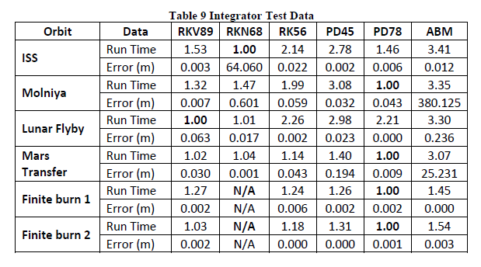

table

As can be seen from this table, integrators show different efficiency for different test cases. However PD78 and RKV89 seem to outperform others in most cases. The same outcome is expected for Halo orbit case. In GMAT testing both run time and final accuracy were checked. Accuracy was checked using closure test.

In this work integrators performance will be checked only in terms of accuracy. The reverse check will be utilized due to its known efficiency and relative simplicity.

### Integrators used

#### Matlab ODE suite. Ode45, Ode113

Two integrators from standard Matlab ODE suite will be used. Particularly, ode45 and ode113.

*ode45* is the Prince-Dormand pair PD5(4)7M that was previously mentioned. This single-step integrator is an embedded explicit Runge-Kutta method of orders 4 and 5 with error control and step-size adaptation.

*ode113* is a variable step and variable order multistep method which uses Adams-Bashforth-Moulton predictor-corrector scheme of order 1 to 13. [17]

Both integrators have event-handling capability which is useful for maneuvers calculation.

#### Embedded Runge-Kutta-Verner 89

Self-written Runge-Kutta-Verner 9(8)16M method is used for integration. It is also an explicit embedded Runge-Kutta method with coefficients derived by Verner (can be found in his publications). Error control and consecutive step-size adaptation are also be implemented along with the event-handling required for maneuvers calculation.

#### Runge-Kutta-Verner 89

For comparison the Runge-Kutta 9(8) is implemented without any error control. This is mostly done to show the effect of the adaptive step-size on the integration accuracy.

#### Prince-Dormand 78

Prince-Dormand pair PD8(7)13M is also used. This single-step integrator is an embedded explicit Runge-Kutta method of orders 7 and 8 with error control and step-size adaptation. Method has 13 stages.

#### Adams-Bashforth-Moulton PECE 8

Multistep Adams-Bashforth-Moulton Predictor-Corrector method of 8th order is used. This method doesn’t include error checking and step-size variation and to some extent is a greatly simplified version of Matlab *ode113*.

# SIMULATION AND TESTS

## Simulation

### Orbit Propagation

* Description of orbit propagation (half a page)

#### Force model

* Describe which model has been used, refer to the equation in theory section and state which values, bodies, libraries, etc. has been used. (approx. 2 pages)
* Describe everything necessary other than theory here for simulation.

Three different force models were used to propagate the orbit.

$\ddot{r} - acceleration of the satellite with respect to the center of the Earth$

$μ_{celestial body}- gravitational constant of the corresponding celestial body$

$r-position vector of the satellite$

**First model** is a simplified case, for which only gravitational forces of the Earth, Sun and Moon were considered.

$$\ddot{r}= -\frac{μ_{E}}{r^{3}}r+μ_{moon}\left(\frac{r_{moon}- r}{{\left|r_{moon}- r\right|}^{3}}- \frac{r_{moon}}{r_{m}^{3}}\right)+ μ_{sun}\left(\frac{r_{sun}}{{\left|r_{sun}- r\right|}^{3}}- \frac{r_{sun}}{r_{s}^{3}}\right)$$

**Second model** considers gravitational forces of the aforementioned bodies plus solar radiation pressure acting on a satellite in the vicinity of L2.

$$\ddot{r}= -\frac{μ_{E}}{r^{3}}r+μ_{moon}\left(\frac{r_{moon}- r}{{\left|r_{moon}- r\right|}^{3}}- \frac{r_{moon}}{r_{m}^{3}}\right)+ μ_{sun}\left(\frac{r_{sun}}{{\left|r_{sun}- r\right|}^{3}}- \frac{r_{sun}}{r_{s}^{3}}\right)+ a_{SRP}$$

**Third model** is a full force model, which incorporates the gravitational forces of the Earth, Sun, Moon, Jupiter, Venus, Saturn and Mars, plus solar radiation pressure.

$$\ddot{r}= -\frac{μ_{E}}{r^{3}}r+μ_{moon}\left(\frac{r_{moon}- r}{{\left|r_{moon}- r\right|}^{3}}- \frac{r_{moon}}{r_{moon}^{3}}\right)+ μ_{sun}\left(\frac{r_{sun}}{{\left|r_{sun}- r\right|}^{3}}- \frac{r_{sun}}{r_{sun}^{3}}\right)+ μ_{jupiter}\left(\frac{r_{jupiter}}{{\left|r_{jupiter}- r\right|}^{3}}- \frac{r_{jupiter}}{r_{jupiter}^{3}}\right)+ μ_{venus}\left(\frac{r_{venus}}{{\left|r_{venus}- r\right|}^{3}}- \frac{r_{venus}}{r_{venus}^{3}}\right)+ μ_{mars}\left(\frac{r_{mars}}{{\left|r_{mars}- r\right|}^{3}}- \frac{r_{mars}}{r_{mars}^{3}}\right) +μ_{saturn}\left(\frac{r_{saturn}}{{\left|r_{saturn}- r\right|}^{3}}- \frac{r_{saturn}}{r_{saturn}^{3}}\right)+ a_{SRP}$$

Thrust forces are not explicitly included in the force model but rather added as an additional velocity vector when a certain event during the integration occurs.

As can be seen from the gravitational acceleration part of the equations, one need to obtain relative distances between the acting bodies at different epochs and the respective products of gravitational constant and masses of the bodies.

All the values required for the force model are measured with respect to the Earth barycenter. That is an adequate choice since the Earth is the closest body that has the biggest influence on a spacecraft orbiting around second Lagranian point, which makes it logical to make the Earth the primary body for the gravitation acceleration part of the force model. Besides, all the operating commands will be sent from the Earth.

To obtain celestial bodies positions, a well-known SPICE Toolkit from NASA will be utilized. The toolkit is offered in different programming languages: C, FORTRAN, IDL and MATLAB. The reference can be found here [22].

The primary SPICE data sets are called “kernels”. Kernels are composed of navigation and other ancillary information that has been structured and formatted for easy access and correct use by the planetary science and engineering communities. Kernels are produced by mission operation centers. [22]

SPK kernels will be used to obtain planets ephemerides, i.e. location of a target body given as a function of time. Specifically, kernel file DE430.bsp comprises all the necessary position and velocity related data needed for simulations.

PCK kernels contain data concerning physical constants, therefore it is utilized for obtaining GM of the bodies.

LSK kernel *naif0012.tls* is used to obtain the ET time required for using the function that outputs positions and velocities of the bodies.

Example of usage of the spice functions:

1. Getting the required epoch in Ephemeris Time

UTC_TIME = '2030 MAY 22 00:03:25.693';

ET_TIME = cspice_str2et (UTC_TIME);

output is the Ephemeris time is seconds

1. Getting the position of the Sun with respect to the Earth at epoch ET_TIME

SUN = cspice_spkezr ( ‘SUN’, ET_TIME, 'J2000', NONE, ‘EARTH’ );

output is a state vector with 3 positions and 3 velocity components.

1. Getting GM for Sun

SUN_GM = cspice_bodvrd( ‘SUN’ 'GM', 1 );

output is the SUN gravitational parameter in *units*

Important thing to note - one should carefully check the units used. SPICE functions output positions in km with respect to the observer body and velocities in km/s2. Ephemeris time is in seconds.

More information about usage of SPICE functions can be found here [22]

Generic kernels are available here [23]

#### Numerical Integration

* Describe which integrators has been used, refer to the theory section (approx. 1 page)
* Describe everything you used other than theory here.

One of the goals of this work is to find out which integrator provides the best accuracy when propagating the Halo-type orbit around second Lagrangian point of Sun/Earth-Moon system. Integrators described in section 4.2.3 are used to propagate the orbit.

As was mentioned before, two integrators from the standard Matlab ODE suite are used – ode45 and ode113. They both provide user with the possibility to employ a certain stopping condition required for correcting the trajectory whereby applying thrust forces.

For that a special event handler function is created which first transforms the Earth-Centered coordinate after each iteration to L2-centered frame and checks if y-coordinate is zero (more detailed process will be further discussed). Once such value is found, the integration stops, respective maneuver is applied and then the next part of the integration starts with the new initial state. Event handler function can be found in the *event_handler.m* file.

Runge-Kutta-Verner 89, embedded Runge-Kutta-Verner 89 and Adams-Bashforth-Moulton of 8th order had to be coded from scratch. Prince-Dormand 78 was found on the MathWorks web-site and was adjusted to the needs of this work.

Self-written integrators can be used for different purposes other than this work but have to be altered first as a lot of adjustments were made specifically to fulfill the goals of the current work. Since that was done mostly in order to implement the station-keeping maneuvers, the process will be discussed in the next section more in details.

### Maneuver Calculation

* Describe methodology of calculating maneuver with a flow chart (min. half a page)(figure: flow chart)
* Describe differential corrector, and the function used (approx.. 1 page)
* Describe event handling, stopping conditions, time frames (approx.. 1 page)

According to a theory discussed in section 4.1.4 quasi-periodic orbit around L2 can be achieved if the spacecraft crosses Y-plane (in L2-centered frame) perpendicularly, i.e. its Vx and Vz velocity components are zero.

The first objective is to transform the coordinates after each iteration from Earth-centered frame to L2-centered.

That is done by first getting the position of L2 point at a given epoch using spice function:

L2point = cspice_spkezr('392', epoch, 'J2000', 'NONE', 'EARTH');

Then the L2 state vector must be subtracted from the Earth-centered state vector. The outcome is then multiplied by the transformation matrix obtained with cspice_sxform function.

xform = cspice_sxform('J2000','L2CENTERED',epoch);

Note, however, that dynamic L2CENTERED frame have to be defined as a kernel file beforehand. The file used in this work is *dynamic_frame_l2.txt*

More information on coordinate transformations with SPICE toolkit can be found here [24]

Now the maneuver calculation is ready to start. The flowchart below shows the main steps of the process.

C:\Users\Alex\Downloads\flowchart.png

figure: Maneuver calculation flowchart

Differential corrector takes a certain initial guess V* (thrust force) and tries to adjust this V* in order to reach the state where Y component of position vector and X and Z components of the velocity equal to zero within some tolerance. The principle behind this idea was discussed in section 4.1.4

As a differential corrector the standard Matlab function *fsolve* is used. This is a powerful instrument to solve non-linear differential equations of the form F(x) = 0.

As an input for *fsolve* one has to provide the evaluation function which comprises ODE. In our case this function contains integrator which solves numerically the equation of motion. Output of the numerical integrator is a state vector where Y=0. *fsolve* adjuststhe V* in order to get Vx and Vz components equal zero at the end of the integration cycle.

As can be seen from the flowchart the integrator must stop at some point in order to give the state vector to the differential corrector for further evaluation.

Standard Matlab integrators have such event handling embedded as was already mentioned in *section 5.1.2.1* and therefore they are not discussed here. However for self-written integrators such event handling has to be implemented from scratch.

The process is relatively straight-forward:

1. After each integration transform the state to L2-centered frame and check if the Y-value has changed its sign compared to that of the previous integration step
2. If the sign changes, then Y=0 is somewhere between these two points. Take the previous and the new point as boundaries
3. Create a function (*FindYzero.m file*) that takes these boundary values and does the integration with the stepsize of 0.1 second (or smaller if needed)
4. Apply binary search principle.

Divide the integrated range of states in the middle and check if the Y value is larger or smaller than zero. That will help do discard the range of values that cannot comprise the sought for value of Y=0 value thus making the next search range two times smaller.

Take this new reduced range and integrate again, check Y value’s sign and further reduce the range.

Perform this procedure until the values are almost zero (within some tolerance, say 1e-8) and just pick the value that is the closest to zero out of the range. Thus the state where Y=0 is found

1. Stop the integration at that point
2. Feed the value to the differential corrector for further adjustments (see flowchart above)

## Test Cases and Results

* Repeat motivation in the introductory paragraph and outline the tests (1 small paragraph)

### Force Model Simplification

#### Test description

* Describe the test, state what we are changing and why, state what remains the same, list the test cases in a table (approx. 1 page) (table)

#### Force Model Simplification Test Results

* Plots of orbits created for each case
* Plots of differences in the coordinates, velocities and calculated maneuvers
* Apply the maneuvers created from simplified case to the full model and show if it is successful or unsuccessful staying in the orbit

#### Comparison of Integrators Test description

* Describe the test, state what we are changing and why, state what remains the same, list the test cases in a table (approx. 1 page) (table)

#### Comparison of Integrators Test Results

* Plots of orbits created for each case
* Plots of differences in the coordinates, velocities and calculated maneuvers
* Apply the maneuvers created from the worst case to the best case and show if it is successful or unsuccessful staying in the orbit

# CONCLUSION

* To be written when chapter 5 is finished.

# REFERENCES

* Make it an automatic table

[1] Vallado

[2] Schaub Analytical mechanics

[3] http://www.esa.int/gsp/ACT/doc/ARI/ARI%20Study%20Report/ACT-RPT-MAD-ARI-03-4103b-InterplanetaryHighways-Milano.pdf

[4] L2 environment for JWST paper

[5] Montenbruck

[6] GMAT paper

[7] D.L. Richardson A Note on a Lagrangian Formulation for Motion about the Collinear Points Celestial Mechanics, Vol. 22, No. 3, pp. 231-235, 1980

[8] SPICE API http://naif.jpl.nasa.gov/pub/naif/toolkit_docs/MATLAB/info/mostused.html

[9] http://www.gg.caltech.edu/~mwl/publications/papers/maneuvers.pdf

[10] Farquhar orbits paper

[11] IRASSI paper

[12] Farquhar

[13] Howell

[14] <http://www.agi.com/downloads/resources/white-papers/AAS-11-480.pdf>

[15] <http://adsabs.harvard.edu/full/1979CeMec..20..209Z>

[16] RK89 paper <https://www.researchgate.net/publication/222246261_Optimized_explicit_Runge-Kutta_pair_of_orders_98>

[17] Matlab ode suite

[18] <http://sci.esa.int/gaia/>

[19] <http://sci.esa.int/herschel/>

[20] <http://sci.esa.int/planck/>

[21] <http://jwst.nasa.gov/orbit.html>

[22] <https://naif.jpl.nasa.gov/naif/spiceconcept.html>

[23] <http://naif.jpl.nasa.gov/pub/naif/generic_kernels/>

[24] coordinate transformations

https://naif.jpl.nasa.gov/pub/naif/toolkit_docs/MATLAB/req/frames.html