|  |  |
| --- | --- |
| Technische Universität München  Ingenieurfakultät Bau Geo Umwelt  Lehrstuhl für Astronomische und Physikalische Geodäsie  Univ.-Prof. Dr.techn. Mag.rer.nat. Roland Pail | |
| **HALO Orbit Simulation around SEM L2 of an IRASSI Mission Satellite** | |
| **Aleksei Petukhov**  Master's Thesis | |
| Master’s Course in Earth Oriented Space Science and Technology | |
| Supervisor(s): | 1. Prof. Dr. Urs Hugentobler  TUM, Institut für Astronomische und Physikalische Geodäsie |
|  | 1. M. Sc. Meltem Eren Çopur Universität der Bundeswehr, Fakultät für Luft- und Raumfahrttechnik |
|  |  |
|  | |
| December, 2016 | |
|  | |

Declaration

This thesis is a presentation of my original research work. Wherever contributions of others are involved, every effort is made to indicate this clearly, with due reference to the literature, and acknowledgement of collaborative research and discussions.

Munich, 19.12.2016 ……………………… Aleksei Petukhov

# ABSTRACT

The aim of this thesis is to study and to demonstrate the effect of the force model simplifications on the precision of the propagation of the Halo orbit around second Lagrangian point of the Sun/Earth-Moon system, and to compare numerical integrators to find out the best one specifically for the Halo orbit propagation.

In the first part, the theoretical basis for Halo orbits is established along with the prerequisites for the force model. Then the space environment around second Lagrangian point is investigated and relevant forces are identified. Afterwards, well-known numerical integrators are discussed and their performances are compared. In the simulation section, the process of maneuvers calculation is demonstrated and explained. Then, the orbit is propagated with three different force models using the best integrator in terms of accuracy.

# LIST OF FIGURES

[Figure 2.1 Geometry of the CR3BP 16](#_Toc469973174)

[Figure 2.2 Stationary lagrange points 20](#_Toc469973175)

[Figure 2.3 Finite-size Lyapunov orbits of different amplitudes. 22](#_Toc469973176)

[Figure 2.4 Halo orbits with = 10000, 30000, 50000 km 24](#_Toc469973177)

[Figure 2.5 L2-centered frame 25](#_Toc469973178)

[Figure 2.6 Quasi-Halo orbit around L2 SEM 26](#_Toc469973179)

[Figure 3.1 Order of magnitudes of various perturbation of a satellite orbit. 30](#_Toc469973180)

[Figure 3.2 Force due to solar radiation pressure for absorption and reflecting surface elements 36](#_Toc469973181)

[Figure 4.1 Runge-Kutta integrator graphical representation 45](#_Toc469973182)

[Figure 5.1 Maneuvers calculation flowchart 56](#_Toc469973183)

[Figure 5.2 Test case 1 - Halo orbit with different integrators 62](#_Toc469973184)

[Figure 5.3 Test case 2 – Propagation with wrong maneuvers. 64](#_Toc469973185)

[Figure 5.4: Test case 2 – Propagation with wrong maneuvers 65](#_Toc469973186)

[Figure 5.5: Test case 2 – Difference in position components 66](#_Toc469973187)

[Figure 5.6: Test case 2 – Difference in velocity components 66](#_Toc469973188)

[Figure 5.7 Test case 3 – Orbits for three force models (1.5 years) 3D View 69](#_Toc469973189)

[Figure 5.8 Test case 3 – Orbits for three force models (1.5 years) X-Y Plane 70](#_Toc469973190)

[Figure 5.9 Test case 3 – Orbits for three force models (1.5 years) X-Z Plane 70](#_Toc469973191)

[Figure 5.10 Test case 3 – Differences. Simplified vs Simplified + SRP 71](#_Toc469973192)

[Figure 5.11 Test case 3 – Differences. Simplified vs Full model 71](#_Toc469973193)

[Figure 5.12 Test case 3 – Differences. Simplified + SRP vs Full model 72](#_Toc469973194)

[Figure 5.13 Test case 4 – Full force model orbit with maneuvers for Simplified model. 6 months 73](#_Toc469973195)

[Figure 5.14 Test case 4 – Full force model orbit with maneuvers for Simplified model. 1.5 years 74](#_Toc469973196)

[Figure 5.15 Halo orbit around SEM L2 point. X-Y / Z-Y planes 75](#_Toc469973197)

[Figure 5.16 Halo orbit around SEM L2 point. X-Z / X-Y planes 76](#_Toc469973198)

[Figure 5.17 Halo orbit around SEM L2 point relative to the Earth (X-Y) 77](#_Toc469973199)

[Figure 5.18 Halo orbit around SEM L2 point relative to the Earth (X-Z) 78](#_Toc469973200)

# LIST OF TABLES

[Table 3.1 Mean accelerations and Variations About the mean from perturbations due to the Earth-Moon system 33](#_Toc469973164)

[Table 3.2 Single-Planet Maximum Perturbations and Synodic Periods 33](#_Toc469973165)

[Table 3.3 Relevant forces at the vicinity of SEM L2 34](#_Toc469973166)

[Table 3.4 Typical reflectivity coefficients 37](#_Toc469973167)

[Table 4.1 GMAT integrators test cases 50](#_Toc469973168)

[Table 4.2 Integrators chosen for comparison 51](#_Toc469973169)

[Table 5.1 Integrators’ settings 60](#_Toc469973170)

[Table 5.2 Maneuvers for integrators 61](#_Toc469973171)

[Table 5.3 Results of the reverse check 63](#_Toc469973172)

[Table 5.4 Maneuvers for three force models 67](#_Toc469973173)

# TABLE OF CONTENTS

[Declaration 2](#_Toc469973256)

[ABSTRACT 3](#_Toc469973257)

[LIST OF FIGURES 4](#_Toc469973258)

[LIST OF TABLES 5](#_Toc469973259)

[TABLE OF CONTENTS 6](#_Toc469973260)

[LIST OF ABBREVIATIONS 8](#_Toc469973261)

[1. INTRODUCTION 9](#_Toc469973262)

[1.1 IRASSI mission background 10](#_Toc469973263)

[1.2 Motivation 13](#_Toc469973264)

[2. THEORY OF HALO ORBITS 15](#_Toc469973265)

[2.1 Circular Restricted Three Body Problem (CR3BP) 15](#_Toc469973268)

[2.1.1 Equations of motion in non-dimensional form 16](#_Toc469973269)

[2.2 Libration points 19](#_Toc469973270)

[2.2.1 Stability in the vicinity of Lagrange Points 21](#_Toc469973271)

[2.2.2 Periodic orbits around L points 21](#_Toc469973272)

[2.2.3 Halo orbit 24](#_Toc469973273)

[2.3 N-Body Problem 27](#_Toc469973274)

[3. METHODOLOGY OF PRECISE ORBIT SIMULATION 29](#_Toc469973275)

[3.1 Modeling Forces 31](#_Toc469973277)

[3.1.1 Space Environment around SEM L2 31](#_Toc469973278)

[3.1.2 Relevant forces at the vicinity of SEM L2 34](#_Toc469973279)

[3.1.3 Gravitational perturbation sources 35](#_Toc469973280)

[3.1.4 Solar Radiation Pressure 35](#_Toc469973281)

[3.1.5 Spacecraft Maneuvers 39](#_Toc469973282)

[4. Numerical Integration 42](#_Toc469973283)

[4.1 Theory 42](#_Toc469973285)

[4.2 Numerical integrators 44](#_Toc469973286)

[4.2.1 Runge-Kutta Methods 44](#_Toc469973287)

[4.2.2 Step-size control 46](#_Toc469973288)

[4.2.3 Multistep methods 47](#_Toc469973289)

[4.2.4 Integrators widely used in astrodynamics 49](#_Toc469973290)

[4.2.5 Methods of comparison 49](#_Toc469973291)

[5. SIMULATION AND TESTS 52](#_Toc469973292)

[5.1 Orbit Propagation 52](#_Toc469973294)

[5.1.1 Force model 52](#_Toc469973295)

[5.1.2 Numerical Integration 54](#_Toc469973296)

[5.1.3 Maneuvers Calculation 55](#_Toc469973297)

[5.2 Test Cases and Results 59](#_Toc469973298)

[5.2.1 Comparison of the integrators 59](#_Toc469973299)

[5.2.2 Force Model Simplification Consequences 67](#_Toc469973300)

[5.2.3 HALO Orbit Propagation Result 75](#_Toc469973301)

[CONCLUSION 79](#_Toc469973302)

[REFERENCES 80](#_Toc469973303)

[APPENDIX 83](#_Toc469973304)

# LIST OF ABBREVIATIONS

**CR3BP** – Circular-Restricted Three Body Problem

**IRASSI** – InfraRed Astronomy Satellite Swarm Interferometry

**SEM** – Sun/Earth-Moon system

**L2** – Second libration (Lagrange) point of SEM system

**AU** – Astronomical Unit

**RK** – Runge-Kutta

**PD** – Prince-Dormand

**RKV** – Runge-Kutta-Verner

**ABM** – Adams-Bashforth-Moulton

# INTRODUCTION

In recent years, the observation of the formation of Earth-like planets has gained particular interest of the scientific society. Current focus of modern astronomy is studying the physical properties and chemical processes which can lead to prebiotic conditions in Earth-like planets, which can open the path to understanding the genesis of our own planet [1].

Earth-like planets can be originated in circumstellar disks and protoplanetary regions. These regions in space are obscured by clouds of gas and dust such that they are the best observable in far-infrared frequencies. This is, however, not possible to carry out from the ground due to the limitations caused by Earth’s atmosphere.

Thus, a space-based interferometric telescope mission called Infrared Astronomy Satellite Swarm Interferometry (IRASSI) was designed. This mission is a joint project between Menlo Systems GmbH, TU Braunschweig Institut für Flugführung, Max-Planck-Institut für Astronomie, and Universität der Bundeswehr München Institut für Raumfahrttechnik and Institut für Navigation. The project is funded by German Aerospace Centre (DLR). Munich University of Armed Forces Institute of Space Technology and Applications is conducting a feasibility study for that mission. The aim of the mission is to further develop the understanding of star and thus planet formation, by simultaneously implementing new technologies with regard to observation instruments, ranging detection systems and formation flying. According to the plan, the constellation of five satellites, whose inter-satellite distance will be tracked to an unprecedented precision, will be following Halo orbit around second Lagrange point of Sun-Earth-Moon system.

This mission is of great importance for the future of exo-planets discovery and studies, therefore thorough studies have to be carried out before the mission enters the launch phase. One of the most important among these studies is whether the satellite positions are determined with sufficient accuracy to meet the scientific and operational goals of the mission. The first step for this would be the development of a high precision simulation environment for the satellite motion in the vicinity of SEM L2.

**Main objective of the thesis**

Main objective of this Master Thesis project is to create the aforementioned simulation environment in order to propagate the sufficiently precise orbit around SEM L2 point. The simulation will not include the launch and early orbit phase (LEOP). Only the satellite motion during HALO orbit phase will be taken into account and studied. The simulation environment will be used to test the orbit determination performance of one IRASSI mission satellite.

Many astrodynamical tools exist, which are using simplified models such as Circular-Restricted Three Body problem or consider only Sun, Earth and Moon influences. One of the goals of this work is to find out whether those simplifications affect the orbit propagation precision and to what extent by comparison. This includes determination of the relevant forces in the vicinity of L2 environment and including them in the precise model.

The next objective is to compare certain well-known numerical integrators for orbit propagation and show which one could be the best choice to propagate the HALO-type orbit around L2.

## IRASSI mission background

For scientific missions in space L2 point of the Sun-Earth-Moon system is often utilized. This point allows spacecraft to remain relatively stationary with respect to the Sun and Earth/Moon. This results in a low energy expenditure required for station keeping.

The satellite in an orbit around L2 is much closer to the Earth than if it resided at L4 or L5, which results in reducing the time to command a spacecraft. Light will take only 5 seconds to reach the spacecraft, whereas it will take 9 minutes to reach L4/L5. This, in turn, facilitates the ability to do real time commands, which occasionally might be useful.

Since the spacecraft resides at a distance of 1.5 millions kilometers from Earth it is not troubled by any atmospheric absorption. In addition, the spacecraft avoids any problems caused by thermal infrared radiation from the Earth interfering with observations [1].

The L2 orbit also prevents the occurrence of temperature changes due to the spacecraft moving in and out of eclipse in an Earth orbit, which is a particular problem for infrared instruments requiring extreme thermal stability. Satellites will be shielded against primary radiation sources which protects the onboard equipment.

Furthermore, L2 orbit offers uninterrupted eclipse-free observations, provided the sufficient size of the orbit. Scientific observatories are pointed away from the Sun, Earth and Moon, therefore from L2 significant part of celestial sphere can be observed during the course of one year.

Many missions are designed to benefit from the aforementioned advantages of L2 orbits, such as:

***GAIA***

GAIA’s goal is to chart a three-dimensional map of our Galaxy, the Milky Way, in the process revealing the composition, formation and evolution of the Galaxy. Gaia is placed in an orbit around the Sun, at the second Lagrange point L2. The mission utilizes a Lissajous-type orbit. The orbit period is about 180 days and the size of the orbit is typically 340 000 × 90 000 km. An operational lifetime of 5 years is planned. The spacecraft must perform small manoeuvres every month [2].

**HERSCHEL**

The Herschel Space Observatory is the largest infrared space observatory launched to date. The observatory resides at the Sun-Earth system Lagrange point (L2) and consists of two spacecrafts. Nominal mission lifetime is three years. The spacecraft is at a Lissajous orbit around L2 with an average amplitude of about 700 000 km and an orbital period of about 178 days. Herschel will use its propulsion system to perform orbit maintenance manoeuvres roughly once each month[3].

**PLANCK**

**The Planck mission was devised to collect and characterize radiation from the Cosmic Microwave Background (CMB) using sensitive radio receivers operating at extremely low temperatures.**

Planck spacecraft resides in a Lissajous orbit with an average amplitude of about 400 000 km around the L2 point at a distance of around 1.5 million km from Earth in the anti-Sun direction. The station-keeping maneuvers are performed every 23 days [4].

**JAMES WEBB SPACE TELESCOPE**

Also well-known James Webb Space Telescope will be placed at SEM L2 as well, in HALO orbit.

The orbit is similar in size to the Moon's orbit around the Earth. This orbit (which takes JWST about 6 months to complete once) keeps the telescope out of the shadows of both the Earth and Moon. Unlike Hubble, which goes in and out of Earth shadow every 90 minutes, JWST will have an unimpeded view that will allow science operations 24/7 [5].

**IRASSI MISSION**

As was already mentioned, IRASSI telescopes would be operating in far-infrared radiation spectrum in order to look through the clouds of gas and dust present in protoplanetary regions. Specifically range of 1 to 6 THz, spanning wavelengths from 300 down to 50 μm will be utilized [1].

Observations in such range requires sophisticated instrumentation. To be able to resolve the processes involved in planets formation, angular resolutions of less than 0.1 arcsec must be provided. The angular resolution has an inverse relation with the diameter of the collecting dish, which means that in order to achieve the required resolution, the dish must be prohibitively large, which, in turn, is not feasible for space-based telescopes. This obstacle can be overcome by employing interferometry. Interferometric systems employ arrays of telescopes to be able to extract information from the radiation source by superimposing electromagnetic wavefronts, which are phase-shifted, in order to measure their interference [1].

The high angular resolution is achieved by changing the separation between the satellites, also known as baselines. IRASSI mission will use five satellites in free-flying formation. The baselines are foreseen to vary from 7 to 850 meters and each spacecraft ought to be able to measure the baseline relative to the other four spacecrafts. Achieving accurate baseline measurements is a very challenging task and this problem is currently under investigation by Menlo Systems.

It is of great importance to the telescopes that observations are carried out unobstructively and in stable conditions, which has lead to the consideration of putting the space observatory in an orbit around the second Lagrangian (or libration) point.

Libration points are analytical solutions of the Circular-Restricted Three-body Problem (CR3BP), which describes the dynamics of a spacecraft under the gravitational influence of two primary massive bodies revolving around their center of mass in circular orbits, without the spacecraft influencing these primary bodies. CR3BP is an approximation of the real world as no other influencing forces, such as radiation pressure and influences of solar system planets, are taken into account. Libration points are special positions, in which the gravitational forces of the two primaries balance out the centripetal force of the spacecraft, therefore in these positions the spacecraft can maintain stationary position with respect to the primary bodies. In theory, periodic orbits exist for CR3BP, in application however, only quasi-periodic orbits exist around these points. There are five such points, and IRASSI mission will be placed around the second point of Sun/Earth-Moon system, which is approx. 1.5 million kilometers away from Earth in the anti-Sun direction. Earth and Moon in CR3BP are treated as a single massive body by considering their barycenter.

A certain type of orbit, namely Halo, is possible around libration point. Such orbit is quasi-periodic, allows large amplitudes which may allow eclipse-free observations, which makes Halo orbits ideal to carry out observations in the far-infrared spectrum, satisfying scientific requirement of the IRASSI mission. The orbit will be further discussed in more details in later sections.

## Motivation

Nowadays, a lot of studies related to astrodynamics use approximations like Circular-Restricted Three Body Problem or highly simplified force models to prove concepts or perform preliminary mission analysis. Such approximations allow for obtaining certain solutions and answer general questions. In terms of orbits around libration points almost all studies are done using aforementioned simplifications, thus making the majority of the problems’ solutions highly theoretical and not applicable in real life.

In this work the effect of such simplifications on the precision of the propagation of the Halo orbit around second Lagrangian point of Sun/Earth-Moon system will be studied. Precise orbit propagation implies taking into account as many relevant forces acting on satellite motion as possible. This especially important in terms of highly unstable orbits like the ones around collinear libration points. Even a small perturbation is enough to break the periodicity of the orbit. Therefore using a highly simplified force model or especially CR3BP in such cases makes analysis too unrealistic.

For orbit propagation, a variety of numerical integrators has been in use. Some of them have proven to provide very high accuracy. However, the accuracy of certain integrators strongly depends on a particular problem, therefore one cannot say which one would be the best choice to propagate Halo orbit around libration points.

In this study, a simulation environment is created to investigate the effects of simplification in the force model and the performance of different integrators on Halo orbit propagation.

# THEORY OF HALO ORBITS



## Circular Restricted Three Body Problem (CR3BP)

In order to establish the basis for further explanation of Lagrange points and possible orbits around them, first we have to take a look at the Circular Restricted Three-body problem of orbital mechanics in more details.

In general, Three-body problem doesn’t have analytical solutions unless some restrictions are imposed. Those restrictions were found by Lagrange and published in his “Essai sur le Probleme des Trois Corps”. These restrictions force three bodies to remain in an equilateral triangle or collinear formation. More information about those formations can be found in [6]. With respect to Lagrange points, the CR3BP is of particular interest.

In the CR3BP it is assumed that both primary bodies are very massive objects compared to the third mass. Thus, the Keplerian motion of the first two masses is determined through their respective inverse-square gravitational attraction.

Furthermore, primary bodies are assumed to revolve in circular orbits about their center of mass. This is considered to be a good approximation for celestial couples like Earth-Moon, Sun-Earth and others [7].

The general equation of motion for the restricted three-body problem in a closed form is shown below [6]:

|  |  |
| --- | --- |
|  | (2.1) |

where is the universal gravitational constant, is the net resultant force acting in each mass , is the relative position vector defined as

Graphical representation of CR3BP is shown on the figure below:

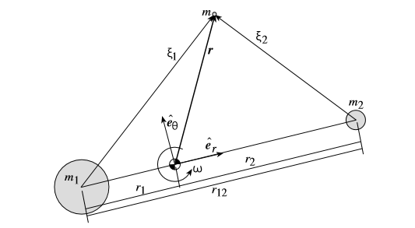

Figure 2.1 Geometry of the CR3BP [7]

### Equations of motion in non-dimensional form

Lagrangian points, i.e. points of equilibrium are only stationary in the rotating reference frame. Therefore non-dimensionless equations of motion of mass near the circularly orbiting and should be used. Below, the general principle of deriving the non-dimensional equations of motion is shown. This derivation can be found in Shaub [7]. Vallado [6] and Schaub [7] provide the detailed derivation with different level of details.

First, the inertial position vector (Fig. 2.1) is expressed with components taking in a rotating reference frame : ). The origin is at the system’s center of mass. Considering the angular velocity is assumed to be constant throughout the trajectory, is given by:

|  |  |
| --- | --- |
|  | (2.2) |

The position vector in is expressed as:

|  |  |
| --- | --- |
|  | (2.3) |

Acceleration vector of is expressed as:

|  |  |
| --- | --- |
|  | (2.4) |

The gravitational force acting on in frame components is expressed as:

|  |  |
| --- | --- |
|  | (2.5) |

Where relative distances of mass to primary bodies are given as:

|  |  |
| --- | --- |
|  | (2.6) |

Thus, the equations of motion of mass in a rotating reference frame can be expressed as three coupled differential equations:

|  |  |
| --- | --- |
|  | (2.7a) |
|  | (2.7b) |
|  | (2.7c) |

These equations of motion can be rewritten in a convenient non-dimensional form. The non-dimensional time variable tau is defined as:

|  |  |
| --- | --- |
|  | (2.8) |

Therefore the non-dimensional time derivative with respect to this time is:

|  |  |
| --- | --- |
|  | (2.9) |

Thus, non-dimensional time derivative is related to previous as:

|  |  |
| --- | --- |
|  | (2.10) |

Scalar distances are non-dimensionalized through dividing them by

|  |  |
| --- | --- |
|  | (2.11) |

Mass quantities are non-dimensionalized by introducing the mass parameter mu defined as:

|  |  |
| --- | --- |
|  | (2.12) |

The center of mass condition was defined as:

|  |  |
| --- | --- |
|  | (2.13) |

With the new non-dimensional quantities, the center of mass condition is rewritten as:

|  |  |
| --- | --- |
|  | (2.14) |

Knowing that the distance between primary bodies is normalized to one and given center of mass condition, the non-dimensional coordinates of primary masses and are now expressed in terms of the mass parameter mu:

|  |  |
| --- | --- |
|  | (2.15) |

Now, the equations of motion in Eq. 1.7 are expressed in non-dimensional form as:

|  |  |
| --- | --- |
|  | (2.16a) |
|  | (2.16b) |
|  | (2.16c) |

Where non-dimensional relative distances are defined as:

|  |  |
| --- | --- |
|  | (2.17) |

And the corresponding non-dimensional potential function is:

|  |  |
| --- | --- |
|  | (2.18) |

## Libration points

Libration (or Lagrange) points are the natural equilibrium solutions of the restricted three body problem. Setting the relative velocities and accelerations in non-dimensional equations of motion (Eq. 2.16) to zero, the conditions that are satisfied by the stationary points of CR3BP can be found. As mentioned before, these stationary points are exactly the Lagrange points.

All stationary points have and therefore lie in plane. Eq. 2.16b is equal zero either in case when , which corresponds to the collinear solution, or if

= which corresponds to equilateral solutions.

Lagrange discovered five distinct formations which are invariant when viewed from the rotating reference frame. So, five possible locations for small mass m, for which the net gravitational force of two primary bodies on this smaller mass m is balanced by the centrifugal force of the rotating primaries themselves. That in turn makes those locations appear stationary as seen from rotating frame.

In other words, these are the five locations around a planet’s orbit where the gravitational forces and the orbital motion of the spacecraft and massive bodies interact to create stable locations from which, for instance, one can make observations. Lagrange points of the 3-body system Sun/Earth-Moon are shown on the figure below:

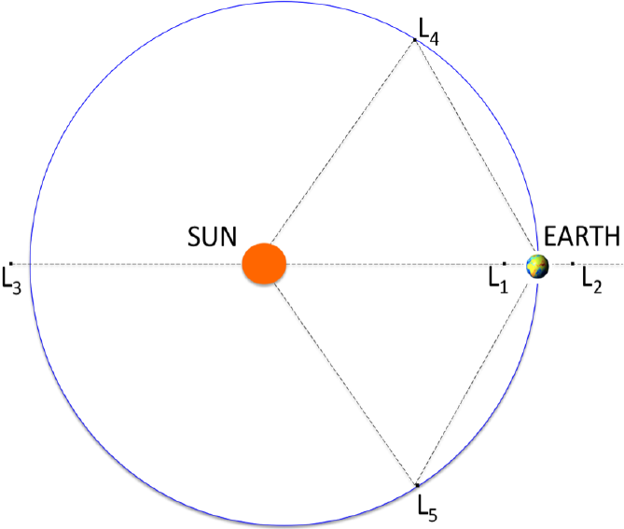

Figure 2.2 Stationary lagrange points [8]

As seen from the Sun, the L4 and L5 points lie at 60 degrees ahead of and behind Earth, close to its orbit.

### Stability in the vicinity of Lagrange Points

Unlike the other Lagrange points, L4 and L5 are resistant to perturbations. When a perturbation occurs near L4 or L5, the gravitational force acts to counterbalance the centripetal force and compensates a drift from the nominal orbit. Because of this stability, objects such as dust and asteroids tend to accumulate in these regions.

A spacecraft at L1, L2, or L3 is ‘meta-stable’. A little perturbation forces it to move away, so a spacecraft must use frequent rocket firings to stay in orbits around these Lagrangian point. When a perturbation occurs near meta-stable points, the unbalanced forces contibute to the perturbation and make the drift faster.

### Periodic orbits around L points

Since stationary points of the circular-restricted 3 body problem are of practical interest, much effort has been put into finding periodic stationary orbits of CR3BP. Such orbits form closed three-dimensional curves and remain fixed as seen from the rotating frame.

Thousands such orbits were discovered but not all of them are of practical value. Those orbits can be grouped into certain families, thus helping to explain the more general classes of orbits for this 3body problem. [7]

In Hamiltonian systems the presence of a periodic orbit involves the characterization of the whole family as isolated periodic orbits do not exist in such systems. Hence, in order to identify a single orbit belonging to the family, a certain parameter must be introduced. For Halo orbit, which will be discussed further, this parameter is the out-of-plane amplitude , whereas for Lyapunov orbit in-plane amplitude . [3]

Before going deeper into these orbits types, linearized non-dimensional equations of motion (Eqs. 2.16) should be expressed in a different form:

|  |  |
| --- | --- |
|  | (2.19a) |
|  | (2.19b) |
|  | (2.19c) |

Thus, we obtain the two equal frequency parameters in in-plane (primary bodies’ plane) and one frequency in the perpendicular plane.

The fact that frequency in is decoupled from frequencies in and axes allows for obtaining different kinds of interesting orbits by varying the amplitudes and frequency values.

Zazzera [9] has shown that linearized dynamics (Eqs. 2.19) around collinear libration points, in particular L1 and L2, with only two of these frequencies (in plane) allows obtaining some infinitesimal or Lyapunov orbits in a small neighborhood around those points, given an appropriate initial condition. Moreover these planar orbits can be numerically continued until the desired finite size is reached. Different Lyapunov orbits around L1 of the Sun-Earth system are shown on the figure below:

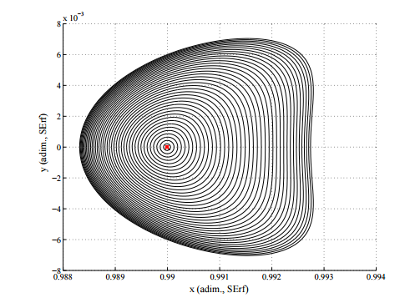

Figure 2.3 Finite-size Lyapunov orbits of different amplitudes. [9]

As can be seen, in reality these frequencies vary and therefore the orbit changes its shape with growing amplitude. This happens due to the actual non-linearities of the dynamical system.

Such orbits do not allow the out-of-plane motion and therefore not suitable for real space applications [9].

Having a frequency in -direction (not equal to that of and ) one would obtain the quasi-periodic closed form path called Lissajous Trajectory. Depending on the -frequency and the amplitude it may take on different shapes. Lissajous orbits can be used in space missions but do not allow big excursions in the out-of-plane direction, which sometimes is necessary in order to meet the mission scientific or operational requirements, which is the case for IRASSI mission.

However, very interesting and applicable for space missions large periodic Halo-orbit types can be obtained, which allow out-of-plane motion. This is possible, if the amplitudes of in-plane and out-of-plane motions are of sufficient magnitude, so that the non-linear contributions to the system produce eigenfrequencies that are equal, in other words, Eqs. 2.19 become [9]:

|  |  |
| --- | --- |
|  | (2.20a) |
|  | (2.20b) |
|  | (2.20c) |

Note however, that these equations are only a first approximation to the true orbit, and higher order corrections are introduced when non-linearities, eccentricity and perturbations are taken into account. However, the corrected orbit is still bounded, but only quasi-periodic [10].

Halo orbits exist above some minimum in-plane amplitude that is dependent on the mass ratio. To match aforementioned eigenfrequencies the in-plane and out-of-plane amplitudes must satisfy the relation [11]

|  |  |
| --- | --- |
|  | (2.21) |

where is the frequency correction needed to match the in-plane and out-of-plane eigenfrequencies and are constants. More details on calculating these parameters can be found in Richardson [12].

### Halo orbit

Orbits’ name speaks for itself, it is a ring or “halo” about the libration point. Aforementioned big excursions in the out-of-plane direction can facilitate satisfying the scientific or operational mission-specific goals.

By varying amplitude, it is possible to obtain Halo-orbit with different inclinations and of different size.

Therefore, choosing an appropriate is important since through its value the mission-specific constraints can be formulated. For instance (applies to IRASSI mission) space telescope about the Sun-Earth L2 requires a minimum in order to avoid the eclipses and maintain uninterrupted communication link.

On the figure below Halo-orbits with different amplitudes around L1 in the Sun-Earth rotating frame are shown:

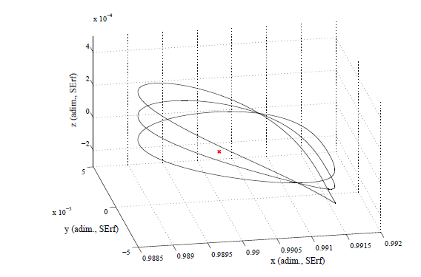

Figure 2.4 Halo orbits with = 10000, 30000, 50000 km [9]

In the CR3BP model, halo orbits are both periodic and time independent. However, note that if we take all the effects of the full solar system among others into account, halo orbits are in fact quasi-periodic and time dependent.

Any orbit around L2 is dynamically unstable in reality, i.e. over time a spacecraft in its orbit will diverge and escape to the outer space. This is due to the effect of the solar radiation pressure, gravitational attraction of other planets and movement of the Moon.

In order to describe such orbit, in case of IRASSI around L2 point of Sun/Earth-Moon system, the L2-centered reference frame must be defined. The following properties apply [1]:

* X-axis is aligned with the Sun-Earth line in the ecliptic plane. Its positive direction points towards outer space
* Z-axis is aligned with the North and South ecliptic poles of the celestial sphere. Positive direction towards the North-Pole
* Y-axis completes the right-handed reference frame

Below is the graphical representation of L2-centered reference frame:

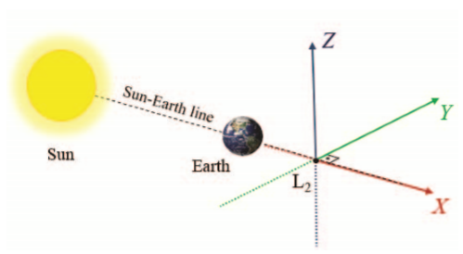

Figure 2.5 L2-centered frame [1]

In general quasi-Halo orbits would be characterized by the following properties [1]:

* Quasi-periodic. Frequency in z-axis is nearly the same as in X-Y axes frequencies.
* Large amplitudes in the Y-component
* Spacecraft on such an orbit will not enter the antumbra region, therefore free-of-eclipse observations are possible
* Quasi-free delta-V transfer maneuvers

Therefore, quasi-Halo orbit is chosen for the IRASSI mission as these properties make such orbits ideal for carrying out far-infrared observations and satisfying scientific requirements for the mission [1].

The spacecraft should not enter the antumbra shadowed region of the Earth at any point during the Nominal Operations phase in order to ensure the constant solar power supply. During the mission analysis study [1] it was concluded that the minimum to avoid drifting into eclipse within a period of 5 years is 270 000 km. Adequate value of is also important in terms of constant direct visibility from the ground stations. As such, an excessive amplitude on the negative direction may impair the communications between the satellites and the ground station situated in the Northern Hemisphere [1].

Maximum amplitude was set to 850 000 km but can be altered in future.

The launch periods were selected in accordance with the possibility to satisfy aforementioned conditions and no maximum amplitudes lower than 600 000 km were obtained for the selected launch periods.

Illustration of the quasi-Halo orbit around L2 including transfer from the Earth is shown on the figure below:

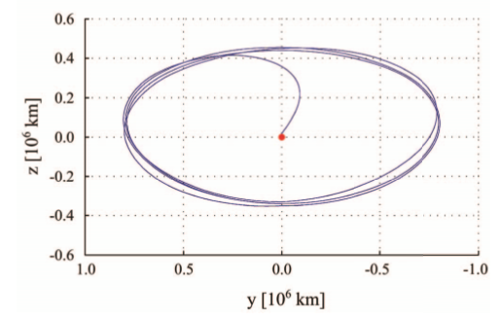

Figure 2.6 Quasi-Halo orbit around L2 SEM [1]

As was already mentioned Halo orbits tend to be unstable, therefore station-keeping maneuvers are required to maintain its stability and periodicity. More detailed information about maneuvers calculation and implementation is in sections 3.1.5 (theory) and 5.1.3 (implementation).

Also worth mentioning, that Halo orbits are difficult to obtain because the problem is highly non-linear and small changes in the initial conditions break the periodicity of the orbits. However, there are some methods allowing for the generation of halo orbits with desired amplitudes. Detailed description of the process goes beyond the scope of this work, but relevant information can be found for instance in Zazzera [9] or in full details in Richardson [13].

## N-Body Problem

Some work in astrodynamics can be done using standard two-body relations. For more complex analysis, three-body problem with certain restrictions might be used, such as CR3BP discussed before.

But in other cases, the influence of other celestial bodies should be included in the model for more precise modeling of the real world. The further generalization of three body problem is N-body problem. One should, however, consider the influences only to a certain extent. Even though some bodies have a certain influence, but it might be in negligible levels.

In the N-body problem, – for which three body problem is a special case, – additional forces arise from the mutual interactions between the bodies.

Vallado [6] has shown that the equations of motion are independent of a particular origin and any particular inertial frame. They depend only on the relative position vectors and the second derivatives, which are, in turn, independent of the inertial frame’s origin.

The generalized barycentric equation of motion is:

|  |  |
| --- | --- |
|  | (2.22) |

However, if one wants to reference the equations to the Earth’s center, using inertial (relative) form of equation of motion is preferable. Thus, one has to transform the acceleration to a different origin and it is measured relative to the Earth. Inertial equation of motion for the satellite is shown below [6]:

|  |  |
| --- | --- |
|  | (2.23) |

The first term in this equation is the two-body acceleration of the Earth acting on a satellite. The second term is divided into two terms – direct and indirect effects. Direct represents the influence of the body on a satellite, whereas indirect represents the influence of the primary body on that body. Altogether, the second term of this equation of motion represents perturbation or the additional force beyond the simple two-body motion [6].

Unlike CR3BP, there is no assumption about the bodies revolving in circular orbits here. Also, other bodies that have non-negligible influence on the motion of a spacecraft are included. That makes such gravitational force model much more realistic.

# METHODOLOGY OF PRECISE ORBIT SIMULATION

In Newtonian physics the motion of the satellite under the influence of the force is described by the differential equation [15]:

|  |  |
| --- | --- |
|  | (3.1) |

where and are the position and velocity of the satellite in a non-rotating coordinate system and m denotes the satellite’s mass.

In order to perform precise orbit propagation one has to include as many acceleration sources as possible within a certain threshold and decide which forces can be neglected in order to achieve the desired precision.

Most significant perturbations arise from gravitational attraction of the celestial bodies, especially Sun, Earth and Moon when the Earth-orbiting satellites are considered. Other dominant planetary contributions stem from Venus and Jupiter.

Satellites with altitudes of several hundred kilometers above the Earth’s surface are subject to a drag force, caused by Earth’s atmosphere. Since the atmospheric density decreases exponentially with increasing height, atmospheric drag mainly affect the low-Earth satellites and has the strongest influence during the perigee of an orbit. While the acceleration due to gravitational forces is independent of the satellite’s mass and area, this is not the case for atmospheric drag as well as for other surface forces. Among these, the solar radiation pressure is the most significant. The radiation pressure arises when photons transfer the impulse to the satellite and does not vary with altitude. Its main effect is in slight changes in eccentricity and the longitude of perigee [15].

For near-Earth orbiting satellites quite significant accelerations arise from the fact that Earth is not a perfect sphere, but has the form of an oblate spheroid with an equatorial diameter that exceeds the polar diameter by 20 km. This perturbation is about three orders of magnitudes smaller than the central gravitational attraction. Due to its angular momentum, the orbit behaves like a gyroscope. It reacts with a precessional motion of the orbital plane and a shift of the line of nodes by several degrees per day [15]. The effect of various perturbations as a function of geocentric satellite distance is illustrated on a figure below:

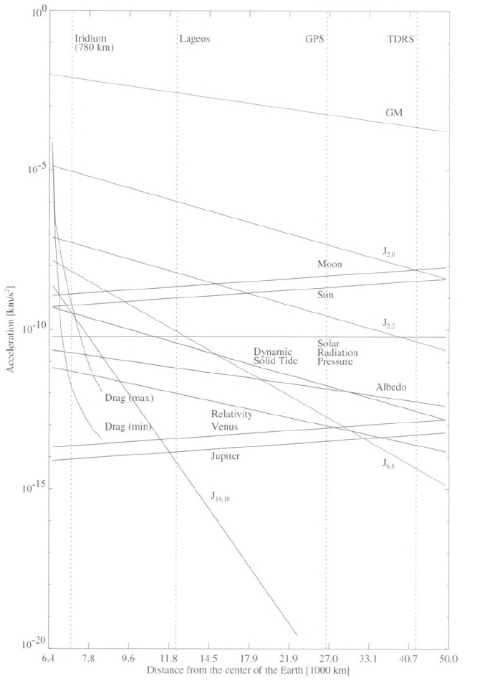

Figure 3.1 Order of magnitudes of various perturbation of a satellite orbit. [15]



## Modeling Forces

Along with major perturbations various minor perturbations are presented in Fig.3.1, which produce accelerations on the order of – .

It is important to determine and consider the relevant forces based on the location of the spacecraft. Therefore we need to study the environment around L2 SEM point in order to create a precise model of the forces governing satellite motion.

### Space Environment around SEM L2

The environment around L2 point of Sun/Earth-Moon system was studied both for previous L2 missions and for the ones planned for future. Here the results of the analysis from Steven W. Evans [14] for the JWST will be addressed.

The natural environment near the L2 libration point is characterized by many complex, varying and sometimes quite subtle processes. In some cases, the characteristics and interactions among these processes are poorly understood [14]. However, a general understanding of the processes and forces existing at this location in our Solar System should be enough to model the forces that have non-negligible influence on the orbit propagation precision.

The L2 libration point is one of the unstable equilibriums in the Sun- Earth/Moon gravitational system. In general, a spacecraft with a radius greater than that of the Earth around the Sun will move at a slower angular rate compared to that of the Earth. However, additional gravitational attraction provided by the Earth allows a spacecraft to keep up with the Earth’s motion, thus maintaining its position stationary relative to Earth as seen from the Sun-centered system.

Of course, this balance of forces is quite sensitive. Different perturbations may nudge the spacecraft away from the equilibrium position such as– motion of the Earth and Moon about their barycenter, eccentricity of the Earth-Moon system’s heliocentric orbit, passing celestial planets and solar radiation pressure.

In practice, the spacecraft will be placed into a ‘halo’ orbit around the nominal equilibrium point. The orbit will be maintained by periodic station-keeping maneuvers to compensate for the perturbations.

A spacecraft in an L2 Halo orbit will be also subjected to the ambient plasma and ionizing radiation environments due to both the solar wind and the geomagnetic tail. Depending on the size and orientation of a Halo orbit, the spacecraft might be immersed in the tail, in the free solar wind and inside the shocked plasma of the magnetosheath between these regions. The latter has influence only on the electronic systems of the spacecraft and therefore will be not be considered in this work.

The spacecraft will be exposed to the full spectrum of electromagnetic energy produced by the Sun. The intensity of solar electromagnetic emission, the level of production of ionizing radiation, the speed and density of the solar wind and the strength of solar magnetic field all vary almost cyclically with an average period of 11 years [14].

The exact level of solar activity cannot be predicted very accurately, but since we are interested only in the effect on the orbit it is enough to consider merely the average solar flux in the Solar System. In this work, a simplified SRP model will be used for reasons that will be discussed in more details in the corresponding section.

At L2, the spacecraft may also be subjected to bombardement by meteoroids. We will not take possible gravitational perturbations caused by them into account due to the insignificance of such forces. Meteoroids streams, which are clouds of particles scattered along and near the orbits of their parent bodies having ejected from them should be considered when designing the materials, design geometry and other characteristics of the sunshield, but all these are out of the scope of this work. More information and references can be found in Evans [14].

Threshold for neglecting the perturbing accelerations was set to 10-13 km/s2. Thus, for the spacecraft at L2 only gravitational sources and solar radiation pressure will be taken into account without considering Earth’s harmonics, atmospheric drag and relativistic effects.

IRASSI mission satellites will be placed in the vicinity of L2 in the Sun/Earth-Moon dynamical system. First of all the satellite trajectory will be disturbed by the motion of the Moon about the Earth. The orbit of the Moon is inclined to the ecliptic by 5.145 degrees and the orbital plane precesses with respect to the Sun-barycenter line with a period of 18.613 years [14]. Perturbations vary during this period. The table below shows mean accelerations during a typical 28 day Earth-Moon revolution cycle.

**Table 3.1 Mean accelerations and Variations About the mean from perturbations due to the Earth-Moon system [14]**

|  |  |  |
| --- | --- | --- |
| *Axis* | *Mean Acceleration, (km/s2)* | *Maximum Variations, (km/s2)* |
| X | \*  \*\* |  |
| Y | 0 |  |
| Z | 0 |  |
| *\* Acceleration at L2 due to Sun/Earth-Moon, with Earth-Moon barycenter at 1.0 AU exactly; \*\* Acceleration due to Earth-Moon only* | | |

Other sources of periodic gravitational perturbations originate from the planets.

Jupiter and Venus are the most important planetary perturbers of a spacecraft at L2. Worth noticing that the maximum possible sum of planetary perturbations is of the same order of magnitude as the maximum Earth-Moon variations about the mean acceleration at L2. The influence of planetary perturbations are shown in the table below:

Table 3.2 Single-Planet Maximum Perturbations and Synodic Periods [4]

|  |  |  |  |  |  |
| --- | --- | --- | --- | --- | --- |
| *Planet* | *gmax*  *(10-10 km/s2)* | *gmax (X)*  *(10-10 km/s2)* | *gmax (Y)*  *(10-10 km/s2)* | *gmax (Z)*  *(10-10 km/s2)* | *Synodic Period*  *(Days)* |
| Mercury |  |  |  |  |  |
| Venus |  |  |  |  |  |
| Mars |  |  |  |  |  |
| Jupiter |  |  |  |  |  |
| Saturn |  |  |  |  |  |
| Uranus |  |  |  |  |  |
| Neptune |  |  |  |  |  |

When a satellite is exposed to solar radiation, it experiences a small acceleration arising from the absorption or reflection of photons. This acceleration depends on the mass and surface area. The radiation pressure accelerations vary at different distances from the Sun. It is known that the solar flux is approx. 1367 W/m2 at a distance of 1 AU. Given the mass of the satellite of 6000 kg and the surface area of 1 m2, one arrives at the average values for SRP around L2 is ~1.5 \* 10-12 km/s2. The solar radiation pressure model will be provided in detail in the *section 3.1.4.*

### Relevant forces at the vicinity of SEM L2

After review or the environmental characteristics around L2 point the following forces will be taken into account with the following approximate magnitudes:

Table 3.3 Relevant forces at the vicinity of SEM L2

|  |  |
| --- | --- |
| *Source* | *Expected max. acceleration (approx), km/s2. Scalar value* |
| **Gravitational Perturbations** | |
| Sun/Earth/Moon |  |
| Jupiter |  |
| Venus |  |
| Saturn |  |
| Mars |  |
| **Solar Radiation Pressure** | |
| SRP |  |
| **Thrust Forces** | |
| Maneuvers |  |

### Gravitational perturbation sources

For modeling gravitational effects we will use Earth-centered reference frame. As mentioned in N-body problem *section 2.3*, the primary body would be the Earth and therefore, the first term of the equation will represent simple two-body motion whereas influences of other bodies will be treated as perturbations.

Below is the general equation for Earth-centric coordinates:

|  |  |
| --- | --- |
|  | (3.2) |

*where - Earth as the primary body, is the satellite and represents other bodies that will be taken into account.*

Modeling will be performed using simplified and full dynamics. In case of simplified model, only the influences of the Earth, Sun and Moon will be taken into account. For the full dynamics influences of the Earth, Sun, Moon, Jupiter, Venus, Mars and Saturn will be considered. Thus, influences of Mercury, Neptune, Pluto as well as some large asteroids will not be taken into account as their influence is way beyond the threshold that we set and those can be neglected.

### Solar Radiation Pressure

The explanation in a simplified form is taken from Montenbruck [15]. For more details please refer to this source.

The size of the solar radiation pressure is determined by the solar flux [15]

|  |  |
| --- | --- |
|  | (3.4) |

where the energy passes through an area in a time interval .

Each photon carries an impulse. The total impulse of an absorbing body that is illuminated by the Sun changes by

|  |  |
| --- | --- |
|  | (3.5) |

and the therefore the satellite experiences a force

|  |  |
| --- | --- |
|  | (3.6) |

that is proportional to the cross-section or a pressure

|  |  |
| --- | --- |
|  | (3.7) |

provided the flux is totally absorbed.

At a distance of 1 , in the vicinity of the Earth, the solar flux amounts to and therefore the solar radiation pressure is assuming the complete absorption (i.e. zero reflectivity) or complete reflection (reflectivity is one). The force exerted on the satellite due to solar radiation pressure is shown below:

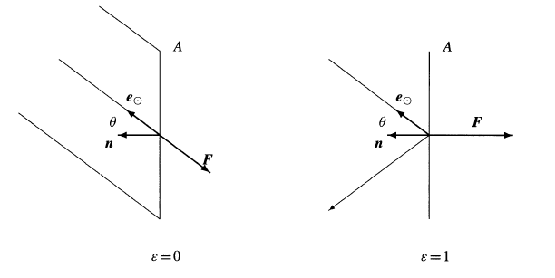

Figure 3.2 Force due to solar radiation pressure for absorption and reflecting surface elements [15]

The normal vector n gives the orientation of the surface and is inclined at an angle to the vector e which points in the direction of the Sun.

Thus for an absorbing surface, the force is:

|  |  |
| --- | --- |
|  | (3.8) |

whereas in case of a reflecting surface, the force is not directed away from the Sun since no impulse is transferred in the direction parallel to the surface. Due to the reflected light rays, the impulse is twice as large. This results in the following formula for the reflecting surface:

|  |  |
| --- | --- |
|  | (3.9) |

In reality, both formulas should be combined as the body reflects a fraction epsilon of the incoming radiation while absorbing the remaining energy . Thus the resulting force is:

|  |  |
| --- | --- |
|  | (3.10) |

is the reflectivity coefficient and for typical materials, used in the constructions of satellites, lies between 0.2 and 0.9

For reference, a table of typical reflectivity coefficients for selected satellite components, is below [15]:

Table 3.4 Typical reflectivity coefficients

|  |  |  |  |
| --- | --- | --- | --- |
| Material |  |  |  |
| Solar panel  High-gain antenna  Aluminium coated mylar solarsail | 0.21  0.30  0.88 | 0.79  0.70  0.12 | 1.21  1.30  1.88 |

The distance between the satellite and the Sun varies during the course of a year. This results in an annual variation of solar radiation pressure as the flux decreases with the square of the distance from the Sun [15].

This result in the following expression:

|  |  |
| --- | --- |
|  | (3.11) |

However, for many applications it is sufficient to assume that the surface normal always points in the direction of the Sun. That leads to a further simplification of the expression:

|  |  |
| --- | --- |
|  | (3.12) |

In terms of this work, the simplified model will be used, firstly because the surface normal variations would be in the range of . Secondly, given the current state of the project, the exact physical parameters or the satellite attitude are not known. Therefore, it is assumed that the reflective surface of the spacecraft has area, the satellite has mass and the reflectivity coefficient of the surface is .

Even though the model is simplified, such calculations will still be useful and serve as a good first approximation. Solar radiation pressure acceleration is of magnitude and has notable influence on the satellite orbit.

SRP also should be further studied as it is important for sunshield design and will have an influence on the decision about other spacecraft components construction but this is out of the scope of this work.

Moreover, satellites with large solar arrays (such as JWST, having the surface area of ) can turn SRP perturbation into advantage in maintaining the spacecraft on station. More information on that can be found in [14].

### Spacecraft Maneuvers

As mentioned before, since collinear libration points are unstable, translational control is required to maintain the satellite in the orbit [10]. Thus, thrust control for station keeping will always be necessary in order to maintain a quasi-stable quasi-periodic orbit, in our case Halo-orbit.

Different station-keeping strategies can be devised. Burns can be performed, for instance, once per revolution cycle, twice or, every month. Choice of a strategy is usually dictated by operational goals, total delta-V budget for the mission, orbital parameters, etc. In terms of this work, no fuel consumption optimization was made.

Based on the IRASSI mission analysis, without applying station-keeping maneuvers, the spacecraft would escape the orbit around L2 after 1 to 3 months. Total delta-V budget for the mission starting from the launch phase and including formation reconfiguration maneuvers can be found in Buinhas [1].

To maintain a quasi-periodic orbit around L2, one of the conditions has to be satisfied is symmetry. Non-dimensional equations of motion, shown in previous chapter, (Eqs. 2.16) present the following symmetry:

|  |  |
| --- | --- |
|  | (3.13) |

That means for a given solution there exists another orbit [9].

Noting the statement above, the initial conditions demand the initial vector to be:

|  |  |
| --- | --- |
|  | (3.14) |

which means that orbit must cross the plane orthogonally. The solution will be symmetric with respect to that plane. Therefore if another orthogonal crossing can be found such that

|  |  |
| --- | --- |
|  | (3.15) |

where velocity components in and directions are zero, then the orbit will be periodic with period [16].

If this is not the case and can be reduced by correcting two of the three initial conditions and integrating again until those conditions are met.

Therefore, we have to solve a targeting problem (also known as shooting problem) to answer the question: “How can the initial conditions and other control variable be adjusted in order to meet specified set of orbital goals?” In this case, the goal is to have such state where and with a predefined tolerance.

One of the procedures widely used in a trajectory design and maneuver planning is the differential correction. Using the differential correction procedure, solutions at each half-revolution can be produced.

One of the most popular approaches for differential correction is Newton-Raphson root finding algorithm. It is used to adjust the independent variables, such as time, direction and magnitude of maneuvers, in order to achieve certain desired values of dependent variables (aforementioned set of orbital goals) [17].

Such root-finding algorithms methods solve the problem of type:

|  |  |
| --- | --- |
|  | (3.16) |

where x is a vector of independent variables and y is a vector of dependent variables. The problem can also be written as

|  |  |
| --- | --- |
|  | (3.17) |

in case the desired values are not zero [17]

Method starts typically with some initial guess , computing and comparing the resulting y with the desired values. The method then computes a step to take in the independent variables so that the dependent variables move closer to the desired values [17].

Newton-Raphson method, in particular, uses the first derivative of the function to determine the step to take in the independent variables [14].

Newton-Raphson for single variable problems:

|  |  |
| --- | --- |
|  | (3.18) |

For multi-variable problems:

|  |  |
| --- | --- |
|  | (3.19) |

where J is the Jacobian matrix defined as:

|  |  |
| --- | --- |
|  | (3.20) |

More detailed information regarding shooting technique and differential correctors can be found in Berry [14] as well as in other numerical methods related sources.

Important to note, that the station-keeping costs in terms of delta-V can be prohibitively high if the orbit was calculated with the model that does not represent the actual dynamics, i.e. if relevant perturbative accelerations such as Solar Radiation Pressure and celestial bodies’ gravitational effects are not included in the force model [11].

# Numerical Integration



## Theory

Equations of motion in astrodynamics are coupled systems of nonlinear differential equations that cannot be solved analytically. Solution can be obtained by using numerical methods. A variety of methods has been developed for the numerical integration of ordinary differential equations and many of them have proven to be efficient when solving problems of celestial mechanics [6].

There are different integration methods based on different principles and it is not possible to tell immediately which method would be the best for a particular problem. There are also different criteria to compare them.

In general, integrators are divided into several types based on the underlying principle [15]:

* Single-step Runge-Kutta methods, which are particularly easy to use and may be applied to a wide range of problems
* Multi-step, or often referred to as Predictor-Corrector, methods to provide high efficiency but they require a storage of past data points
* Extrapolation methods, which are famous for their typically high accuracy

Detailed discussion about numerical integration methods can be a topic for the whole work as there is variety of developed numerical integration methods and studying them in details is beyond the scope of this work. To delve deeper into the topic one can refer to Vallado [6] or Montenbruck [15], which provide relatively detailed review of the main numerical methods and further provide references to other sources.

It is assumed that equations would be n-dimensional ordinary differential equations of the form [15]:

|  |  |
| --- | --- |
|  | (4.1) |

with derivatives with respect to time. This form can be obtained from the second-order differential equation

|  |  |
| --- | --- |
|  | (4.2) |

by combining position of a satellite  and velocity into the six-dimensional state vector

|  |  |
| --- | --- |
|  | (4.3) |

which satisfies

|  |  |
| --- | --- |
|  | (4.4) |

The majority of numerical integrators derive from Taylor series integrator. Below is the form of Taylor series: [1]

|  |  |
| --- | --- |
|  | (4.5) |

In Taylor series expansion, an infinite number of terms cannot be included and it can be unclear where to truncate the series. In addition, calculating the derivatives with complex functions might be difficult. The simplest solution is the basis for an Euler integrator, which takes only a first-order term of Taylor series into account [6]:

|  |  |
| --- | --- |
|  | (4.6) |

When using the Euler method one must carefully approach to choosing the appropriate step size so that it is small enough to handle variations caused by the neglected higher-order terms.

## Numerical integrators

### Runge-Kutta Methods

Runge-Kutta singlestep methods are the most common methods of integration. These methods are derived from Taylor series but instead of deriving for higher derivative terms, the approximation is formed by using the slope at different points within the integration interval.

Runge-Kutta is an often used type of single-step integrators. Such methods combine the state at one time with the rates at several different times based on the single initial state at time. The rates are obtained from the equations of motion and allow to determine the state at the next point.

For satellite trajectories, equations of motion are often formulated as a first-order differential equation system with initial conditions. Using initial position and velocity vectors we obtain velocity and acceleration vectors.

For many applications a fourth-order RK is sufficient. RK don’t require a sequence of previous values to start the integration unlike multi-step methods. However they evaluate the function at several intermediate points (the number is determined by the methods’ order) and these values are used only once [6].

Below is the example of classical fourth-order RK method, where the weighted mean is calculated [6]:

|  |  |  |
| --- | --- | --- |
|  |  | (4.7) |
|  |  |  |
| ( ) + ) | |  |

The formula is designed to approximate the exact solution up to terms of order provided that is sufficiently smooth and differentiable. Its local truncation error is

|  |  |
| --- | --- |
|  | (4.8) |

and bound by a term of order . That means that the accuracy of such method is comparable to that of 4th order Taylor series [15].

Graphical representation of the method is shown on the figure below:

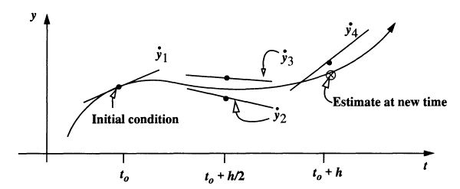

Figure 4.1 Runge-Kutta integrator graphical representation [6]

The derivative (slope) is evaluated at several different points (in this particular example 4 times as the method is of 4th order) along the estimated trajectory. These intermediate estimates help to find the final estimate at whereby obtaining the average slope within the integration step.

There are other forms of this basic method of higher order, for instance fifth, eighth, twelfth and others. The general formula for methods is presented below [6]:

|  |  |  |
| --- | --- | --- |
| ) |  | (4.9) |
|  |  |  |
| *(* | |  |

The constants and in the formula must be determined separately. The coefficients are not uniquely determined, therefore various Runge-Kutta methods exist with the same number of stages.

In the example above, the number of evaluations is equal to the order of local truncation error, but this is not generally the case [15]. Butcher [18] has shown that one additional evaluation is required for methods of orders 5 and 6, 2 for order 7, 3 for 8 and upwards. Those rules are known as Butcher barriers.

It is possible to construct methods that are based on the same set of evaluations. Such methods are known as embedded Runge-Kutta methods and allow estimation of the local truncation error in each step along with the solution. That is the prerequisite for step size control, which will be discussed further [15].

Embedded Runge-Kutta method yields two independent approximations of orders and within one integration step, obtained using the same auxiliary functions but with different linear combination of these functions. Thus it is possible to get an estimate of the local truncation error of the order formula from the difference between the two solutions [15].

### Step-size control

During the numerical integration the step size should be chosen in a way that each step contributes uniformly to the total error. Single step cannot be either too large or too small as the latter can increase round-off errors due to the increased total number of steps.

As mentioned before, embedded methods provide the error estimate that can be used for the step size control. Step size control technique tries to limit the local truncation error, an estimate of which is computed at each step [15].

Each step yields an error estimate:

|  |  |
| --- | --- |
|  | (4.10) |

If this value is larger than the set tolerance, then the step has to be repeated with a smaller step size The local truncation error for the new step size will then be [15]:

|  |  |
| --- | --- |
|  | (4.11) |

Therefore the maximum allowed step size is:

|  |  |
| --- | --- |
|  | (4.12) |

If the step was successful, then it is allowed to be used for the next iteration.

However, note that there is still the need to supply an adequate initial guess for the step size.

### Multistep methods

Previously discussed Runge-Kutta methods make no use of previous steps and therefore, each step is independent of one another. However, it is possible to apply a completely different approach by storing the values from previous steps. Such methods are particularly useful for differential equations defined by complicated functions with a lot of arithmetic operations [15].

For example, below is the increment function and formula for calculating the solution for the 4th-order Adams-Bashforth formula which contains function value at three previous points [15]:

|  |  |
| --- | --- |
|  | (4.13) |
|  | (4.14) |

Note that the multistep methods require the integration for the first value. Previous values may be obtained using Runge-Kutta method. However, it is recommended that Runge-Kutta method is of the same order as the multistep method used [15].

One of the most used multistep method is Adams-Bashforth-Moulton method or Predictor-Corrector (also known as PECE) algorithm, which consists of four steps: [15]

1. In a first step (the predictor) an initial estimate of the solution at is calculated using the Adams-Bashforth formula
2. The result is then used in the Evaluation step to find the corresponding function value
3. Third step is the Corrector. Adams-Moulton implicit formula is applied to find an improved value:
4. Final evaluation step yields the updated function value:

This final value is then used as an initial value for the next integration step. Such methods have proven to provide great stability at large step-sizes [15].

Multistep Stoermer and Cowell methods are also well-known methods that are specially designed for the direct integration of second-order differential equations. However, they will not be covered in this study since their usage is not required. Further information on this methods can be found in Montenbruck [15].

### Integrators widely used in astrodynamics

Runge-Kutta methods are widely used in astrodynamical problems. Embedded pairs methods of Runge-Kutta methods of orders and with a local error estimation as a difference between the higher and lower order solution are of great use. Among them, RK5(4)7, - meaning that the solution is advanced with solution y(n+1) of order 5 while the solution of order 4 is used to obtain the local error estimate. Number 7 means that the method has seven stages, i.e. the function is evaluated 7 times within one step. Following the same notation - RK8(7)13M by Prince & Dormand is offered by Montenbruck [15] as a solution for wide range of astrodynamical problems.

Some authors claim that embedded pair RK method RK9(8)16 would be the best choice in terms of accuracy. In [26], the author performs analysis of different Runge-kutta pairs methods showing that when severe tolerances are required, pair 9(8) outperforms other numerical methods. Worth mentioning that this conclusion is not specific to astrodynamics problems.

Multi-step Adams-Bashforth-Moulton predictor corrector is also widely used.

The motivation to use a specific integrator for a specific astrodynamics problem is not mentioned in the reviewed literature.

### Methods of comparison

When comparing numerical integrators in the frame of astrodynamics problems, it is required to have a method whereby the accuracy of the results is estimated and controlled. Zadunaisky [19] mentions several methods among others available in literature to estimate the accuracy of the integration in terms of the N-body problem:

1. Fixing in advance an upper tolerance limit for the absolute values either of local truncation errors or of the highest differences used in the process
2. Checking deviations in the total energy if theoretically it must be constant
3. Checking deviations from periodicities or constant configurations when they must exist
4. The reverse test. It consists of integrating of motion from initial state to final state. When reached the final state the integration is reversed towards initial state and then the accuracy with which the initial state is reconstructed is checked. For this test it is assumed that a change of sign in the independent variable does not change the differential equations of motion which is the case for N-body problem.
5. The closure test. Almost equivalent to the reverse test but the integration is divided into stages of certain length

None of the methods is entirely reliable but it is possible to obtain a qualitative picture of the behavior of errors. Usage of methods 4 and 5 must be preceded by a careful analysis of the situation at hand. However, these are often used in astrodynamics for checking the integrator accuracy. For instance, NASA General Mission Analysis Tool (GMAT) software integrators were tested using the closure method. In the table below, a comparison of different integrators in GMAT for different test cases is shown:

Table 4.1 GMAT integrators test cases [20]

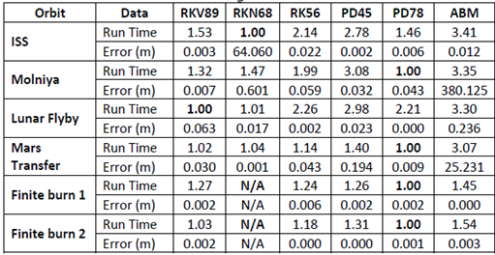

This table shows both the runtime and the accuracy of the integrators. As can be seen from this table, integrators show different efficiency for different test cases. However PD78 and RKV89 seem to outperform others in most cases.

In this thesis performance of integrators will be compared only in terms of accuracy. The reverse check will be utilized due to its known efficiency and relative simplicity.

Table 4.2 Integrators chosen for comparison

|  |  |  |
| --- | --- | --- |
| *Integrator* | *Source* | *Description or features* |
| ODE45 | Matlab ODE Suite | Prince-Dormand pair RK-PD5(4)7M. This Single-step embedded explicit Runge-Kutta method of orders 4 and 5 with error control and step-size adaptation. Event-handling capability provided |
| ODE113 | Matlab ODE Suite | Variable step and variable order multistep method which uses Adams-Bashforth-Moulton predictor-corrector scheme of order 1 to 13. Event-handling capability provided |
| Embedded Runge-Kutta-Verner 8(9) – *RKV89* | Written for Matlab based on the following sources: [24] [25] | Runge-Kutta-Verner 9(8)16M method. Single-step explicit embedded Runge-Kutta method with coefficients derived by Verner. 16 function evaluations per step. Error control and consecutive step-size adaptation are implemented along with the event-handling required for maneuvers calculation. |
| Runge-Kutta-Verner 8 – *RKV8* | Written for Matlab based on the following sources: [24] [25] | The simplified version of Runge-Kutta-Verner 8(9)-16M method without error control and step-size adaptation. |
| Prince-Dormand 78 – *PD78* | MathWorks web-site. Modified. Reference: [23] | Prince-Dormand pair RK-PD8(7)13M Embedded single-step explicit Runge-Kutta method of orders 7 and 8 with error control and step-size adaptation. The method performs 13 function evaluations per step. Event-handling is implemented. |

# SIMULATION AND TESTS



## Orbit Propagation

Before proceeding with the simulation itself, utilized force models will be shown and the maneuvers calculation procedure will be explained.

Important to note, that the initial conditions to start the Halo orbit are provided by ISTA. Therefore the simulation considered here does not involve the LEOP and the transfer to L2 mission phases. In Buinhas [1] the orbit complying with mission requirements was found. Transfer to libration points and calculating Halo orbits of different sizes is outside the scope of the thesis, however relevant information can be found in Farquhar [10], Mahajan [11] and Richardson [12].

### Force model

Three different force models were used to propagate the orbit.

**First model** is a simplified case, for which only gravitational forces of the Earth, Sun and Moon were considered.

|  |  |
| --- | --- |
|  | (5.1) |

**Second model** considers gravitational forces of the aforementioned bodies plus solar radiation pressure acting on a satellite in the vicinity of L2.

|  |  |
| --- | --- |
|  | (5.2) |

**Third model** is a full force model, which incorporates the gravitational forces of the Earth, Sun, Moon, Jupiter, Venus, Saturn and Mars, plus solar radiation pressure.

|  |  |
| --- | --- |
|  | (5.2) |

Thrust forces are not explicitly included in the force model but rather added as an additional velocity vector when a certain event during the integration occurs.

As can be seen from the gravitational acceleration part of the equations, one need to obtain relative distances between the acting bodies at different epochs and the respective products of gravitational constant and masses of the bodies.

All the values required for the force model are obtained with respect to the Earth. That is an adequate choice since the Earth is the closest body that has the biggest influence on a spacecraft orbiting around second Lagranian point, which makes it logical to make the Earth the primary body for the gravitational acceleration part of the force model. Besides, the positioning of the satellite will be carried out from the Earth with measurements relative to the tracking stations. Since the positions of the tracking stations are accurately known relative to Earth (i.e. with respect to Geocenter), coordinate transformations are eliminated by this choice.

To obtain celestial bodies’ positions, a well-known SPICE Toolkit from NASA will be utilized. The toolkit is offered in different programming languages: C, FORTRAN, IDL and MATLAB. The reference can be found here [25].

The primary SPICE data sets are called “kernels”. Kernels are composed of navigation and other ancillary information that has been structured and formatted for easy access and correct use by the planetary science and engineering communities. Kernels are produced by mission operation centers [25].

SPK kernels will be used to obtain planets ephemerides, i.e. location of a target body given as a function of time. Specifically, kernel file DE430.bsp comprises all the necessary position and velocity related data needed for simulations.

PCK kernels contain data concerning physical constants, therefore it is utilized for obtaining GM of the bodies.

LSK kernel *naif0012.tls* is used to obtain the ET time required for using the function that outputs positions and velocities of the bodies.

Example of usage of the spice functions:

1. Obtaining the required epoch in Ephemeris Time

UTC\_TIME = '2030 MAY 22 00:03:25.693';

ET\_TIME = cspice\_str2et(UTC\_TIME);

Output ET\_TIME is the Ephemeris time is seconds

1. Obtaining the position of the Sun with respect to the Earth at epoch ET\_TIME

SUN\_POS = cspice\_spkezr(‘SUN’,ET\_TIME,'J2000',NONE,‘EARTH’);

Inputs: position of the desired body, epoch in seconds, reference frame, aberration type, observer body

Output SUN\_POS is a state vector with 3 positions and 3 velocity components of the SUN with respect to the Earth (observer)

1. Obtaining GM for Sun

SUN\_GM = cspice\_bodvrd( ‘SUN’ 'GM', 1 );

Output is the Sun’s gravitational parameter

SPICE functions output positions in with respect to the observer body and velocities in . Ephemeris time is in seconds.

More information about usage of SPICE functions can be found on a NASA SPICE’s official web-site [25]. Generic kernels are available on NASA SPICE’s ftp server [27].

### Numerical Integration

One of the goals of this work is to find out which integrator provides the best accuracy when propagating the Halo-type orbit around second Lagrangian point of Sun/Earth-Moon system. Integrators described in *section 4.2.6* are used to propagate the orbit.

As was mentioned before, two integrators from the standard Matlab ODE suite are used – ODE45 and ODE113. They both provide user with the possibility to employ a certain stopping condition required for correcting the trajectory whereby applying thrust forces.

Runge-Kutta-Verner 8 and Embedded Runge-Kutta-Verner 8(9) had to be coded from scratch based on existing implementations written in C. Prince-Dormand 87 was found on the MathWorks web-site and was adjusted to the needs of this work.

These integrators can be used for different purposes other than this work but have to be altered first as a lot of adjustments were made specifically to fulfill the goals of the current work. Since that was done mostly in order to implement the station-keeping maneuvers, the process will be discussed in the next section more in details.

### Maneuvers Calculation

According to the theory discussed in section 3.1.5, quasi-periodic orbit around L2 can be achieved if the spacecraft crosses plane twice within one revolution (in L2-centered frame) and its and velocity components are zero at these moments. Figure 5.1 below shows the main steps of the maneuver calculation process.

The first task is the transformation of the coordinates from Earth-centered frame to L2-centered after each iteration.

This is done by first obtaining the position of L2 point at a given epoch using SPICE function:

L2point = cspice\_spkezr('392',epoch,'J2000','NONE', 'EARTH');

Then the L2 point state vector is subtracted from the satellite’s state vector in Earth-centered frame so that the center of the frame is translated from Earth to L2 point. The outcome is then multiplied by the transformation matrix obtained with cspice\_sxform function so as to rotate the frame.

xform = cspice\_sxform('J2000','L2CENTERED',epoch);

Note, however, that dynamic L2-centered frame ‘L2CENTERED’ must be defined as a frame kernel file beforehand. The file used in this work is *dynamic\_frame\_l2.txt*

More information on coordinate transformations with SPICE toolkit can be found on SPICE’s web-manuals [26]

C:\Users\Alex\Desktop\MASTER THESIS\RESULTS\man_flowchart.png

Figure 5.1 Maneuvers calculation flowchart

#### Differential corrector

Differential corrector takes a certain initial guess of (thrust force) as an input and tries to adjust this in a way, that adding as a velocity vector to the initial state helps to reach the final state where component of the position vector and and components of the velocity vector are equal to zero within some predefined tolerance. The principle behind this idea was discussed in section 3.1.5

As a differential corrector the well-known Newton-Raphson method, described in section 3.1.5. This is a powerful instrument to solve non-linear differential equations of the form . Working version of Newton-Raphson method is available on the MathWorks web-site. For the code refer to file *newtonraphson.m*

As an input for that functionone has to provide the evaluation function which comprises ODE. In our case this function contains integrator which propagates the orbit up to a stopping condition. Output of the numerical integrator is a state vector where . Newton-Raphson function adjust in order to get and components equal zero at the end of the integration cycle.

Interesting to note, that similar performance can be achieved using Matlab’s standard function

#### Event handling

As can be seen from the flowchart the integrator must stop at some point in order to give the state vector to the differential corrector for further evaluation.

Standard Matlab integrators have such event handling mechanism already embedded. It is only required to create a special event handler function which first transforms the Earth-Centered coordinate after each iteration to L2-centered frame and checks if y-coordinate is zero. Event handler function can be found in the *event\_handler.m* file.

For custom integrators such event handling has to be implemented from scratch.

The process is relatively straight-forward:

1. After each integration it transforms the state to L2-centered frame and checks if y-coordinate has changed its sign compared to that of the previous integration step
2. If the sign changes, then is somewhere between these two points. These two points are considered as the new boundaries
3. Then, it calls a function (*FindYzero.m file*) that takes these boundary values and does the integration with the stepsize of 0.1 second (or smaller if needed)
4. Afterwards, it applies the binary search principle. Following this principle, the integrated range is divided in the middle and the sign of value is checked. This will help in discarding the range of values that cannot comprise Thus, the next search range becomes smaller.

It takes this new reduced range and integrates again, checks value’s sign and further reduces the range. This procedure is performed until the values are almost zero (within some tolerance, e.g. 1e-8). Thus, the state where is found

1. Integration stops at that point since the stopping condition has been reached.
2. The state vector at the stopping condition is delivered to the differential corrector for further adjustments (see flowchart above)

During one orbit two such events will be detected and therefore 2 maneuvers are applied in the course of one orbit revolution, i.e. each maneuver occurs approximately every 3 months.

## Test Cases and Results

The first goal of this work is to study the influence of the force model simplification on the orbit propagation process. Three full revolutions for Halo orbit for different force models were presented and the results were compared in terms of difference between the position and velocity components. In addition, the required maneuvers were calculated and compared for each force model. Significant difference was observed when the maneuvers calculated for simplified model was applied to a trajectory integrated using the full model. In the latter case, the result will be shown for 1 revolution and for 3 revolutions, i.e. for time period of 6 months and 1.5 years respectively.

The second goal is to compare the performance of the selected integrators for the Halo orbit propagation. To this end, the reverse test was carried out (section 4.2.5) for each integrator and the resulting accuracy values were compared. The tests were carried out using the full force model as it reflects the reality in a better way than other models and it makes the test of more practical value.

To study the influence of force model simplification, only the best integrator in terms of accuracy were used. Therefore, the first part of tests is related to the integrators comparison.

### Comparison of the integrators

As was stated before the integrators are compared whereby the reverse check method, i.e. the orbit will be propagated from the initial conditions until the full revolution is achieved. Then the achieved final state is made the initial state and the orbit is propagated backwards. In the end the accuracy of the initial state’s reconstruction is checked. The closer the result to the initial condition – the better the integrator suits the Halo orbit propagation. For such check it is enough to propagate one orbit rather than propagating the whole cycle as the main goal here is to study the general performance of the integrator for Halo orbit and to find out how the integrator reacts for events such as adding thrust forces. Two maneuvers applied are enough for such purpose. The following settings were set for integrators:

Table 5.1 Integrators’ settings

|  |  |
| --- | --- |
| *Integrator* | *Settings* |
| ODE45 | Initial step: 60 seconds  Max step: 2700 seconds  Error tolerance: 1e-11 for each state component |
| ODE113 | Initial step: 60 seconds  Max step: 2700 seconds  Error tolerance: 1e-11 for each state component |
| Runge-Kutta-Verner 8 | Fixed step size: 2700 seconds |
| Embedded Runge-Kutta-Verner 89 | Initial step: 60 seconds  Min step: 1e-13 seconds  Max step: 2700 seconds  Error tolerance: 1e-11 for each state component |
| Prince-Dormand 78 | Initial step: 60 seconds  Min step: 1e-13 seconds  Max step: 2700 seconds  Error tolerance: 1e-11 for each state component |

Values of maneuvers calculated for different integrators:

Table 5.2 Maneuvers for integrators

|  |  |
| --- | --- |
| *Integrator* | *Thrust, km/s2 ; Vx Vy Vz* |
| ODE45 | * deltaV\_1 = 0.01326248 -0.0162513 0.0040461 * deltaV\_2 = -0.0007805 0.0018552 -0.00724845 |
| ODE113 | * deltaV\_1 = 0.01326248 -0.0162513 0.0040461 * deltaV\_2 = -0.0007805 0.0018552 -0.00724846 |
| Runge-Kutta-Verner 8 | * deltaV\_1 = 0.0133256 -0.016216 0.0040405 * deltaV\_2 = -0.0007808 0.00185419 -0.0072468 |
| Embedded Runge-Kutta-Verner 89 | * deltaV\_1 = 0.0133256 -0.016216 0.0040405 * deltaV\_2 = -0.0007808 0.00185419 -0.0072468 |
| Prince-Dormand 87 | * deltaV\_1 = 0.01322567 -0.0162161 0.0040405 * deltaV\_2 = -0.0007804 0.00185525 -0.0072464 |

#### Test case 1 – Orbit propagation with different integrators

One full revolution of Halo orbit using full force model was carried out for five chosen integrators. After propagation the reverse check was performed and the best integrator was defined.

Results of *Test case 1* are shown in Fig. 5.2 and Table 5.3

*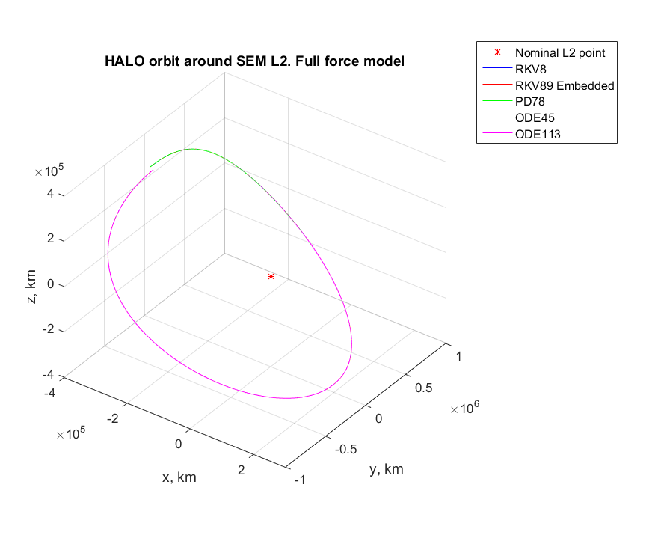*

Figure 5.2 Test case 1 - Halo orbit with different integrators

The table below shows results of the reverse test:

Table 5.3 Results of the reverse check

|  |  |  |
| --- | --- | --- |
| *Integrator* | *Final position difference, km* | *Final velocity difference, km/s2* |
| ODE45 | 2.8394e-06 | 2.0950e-06 |
| ODE113 | 2.5423e-05 | 1.4303e-11 |
| Runge-Kutta-Verner 8 | 4.8587e-06 | 3.6480e-12 |
| Embedded Runge-Kutta-Verner 89 | **5.1323e-07** | **3.6811e-13** |
| Prince-Dormand 87 | 1,2013e-05 | 9.2644e-12 |

As expected the best performance was shown by Runge-Kutta-Verner 8(9) integrator. First of all it is high-order integrator and therefore is able to provide the best precision (in theory). Second reason is the implementation of error control and step-size adaptation – the influence on that can be spotted when RKV8 without error control and RKV89 with error control are compared.

In general, one can observe that all integrators performed quite well. Therefore, for applications where extreme accuracy is not required, one can go with standard *ODE45* integrator keeping in mind, however, that there is a better solution in terms of accuracy – Embedded Runge-Kutta-Verner 9(8)16M.

#### Test case 2 – Propagation with wrong maneuver

RKV89 has shown the best accuracy. Integrator ODE113 on the contrary has shown the poorest performance. Now, let’s find out what happens if maneuvers calculated for ODE113 are applied when integrating using RKV89. The orbit propagated with correct maneuvers is compared to the one propagated with wrong maneuvers.

The results are shown in Fig. 5.3 – Fig.5.6

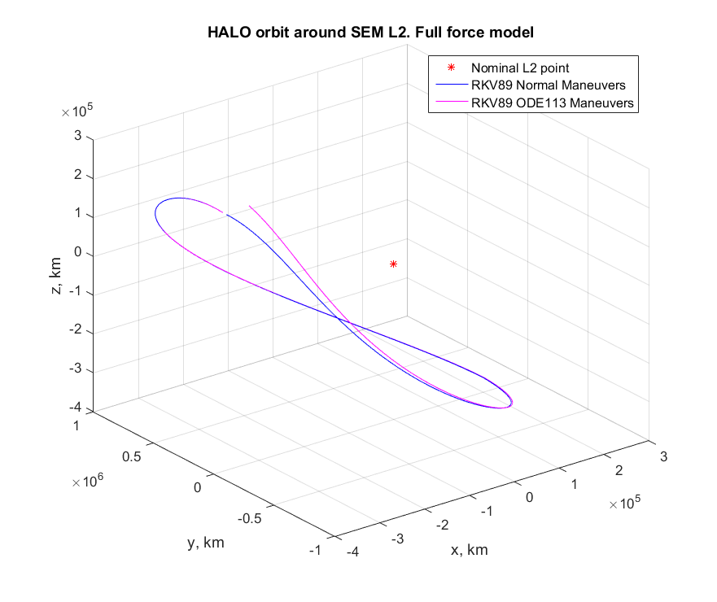

Figure 5.3 Test case 2 – Propagation with wrong maneuvers.

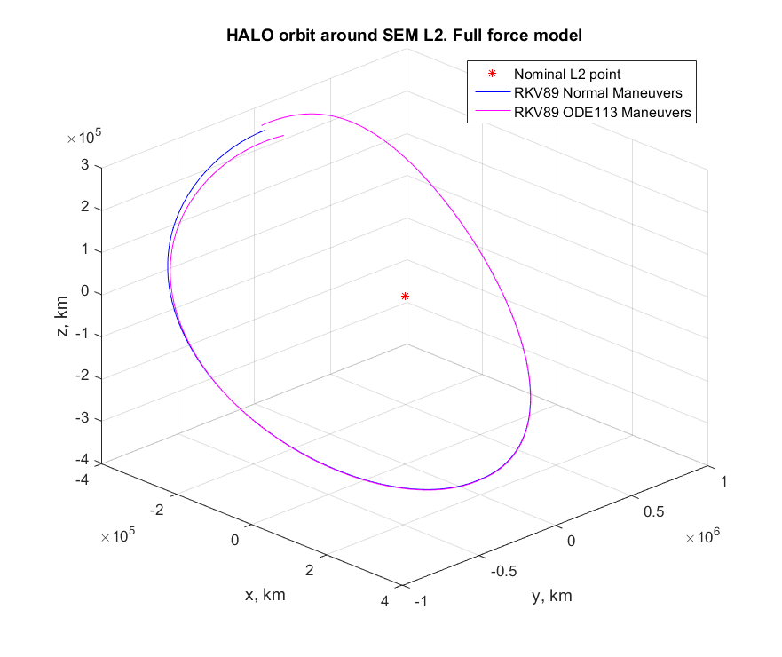

Figure 5.4: Test case 2 – Propagation with wrong maneuvers

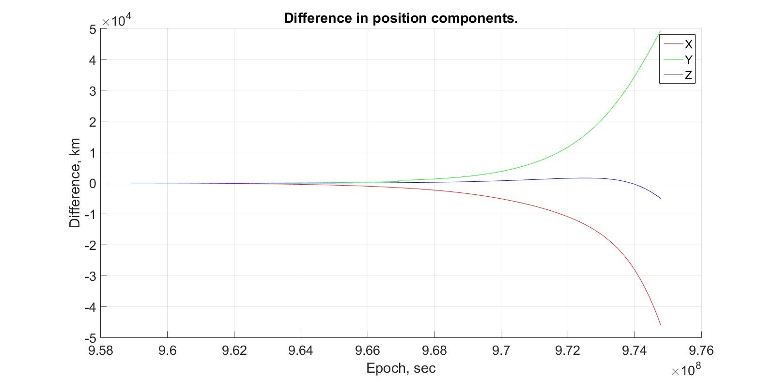

Figure 5.5: Test case 2 – Difference in position components

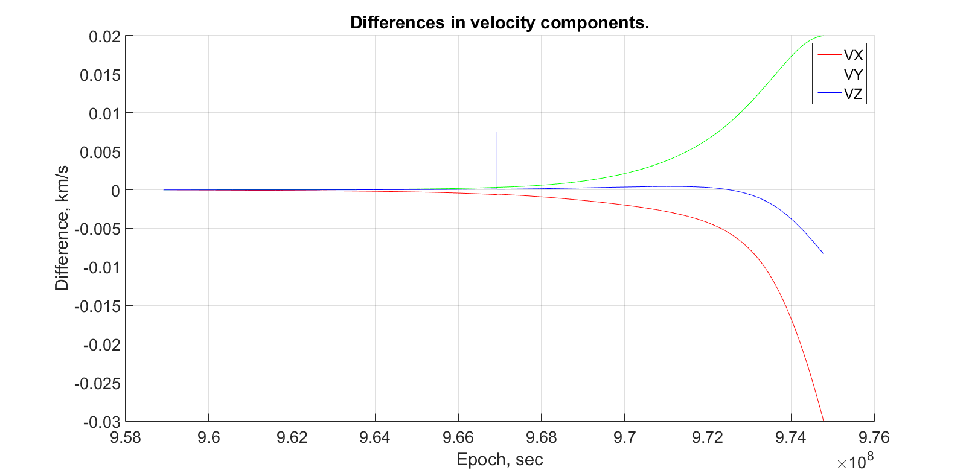

Figure 5.6: Test case 2 – Difference in velocity components

Results have shown that even though after the first half of one revolution the orbits almost matched, however by the end of the whole revolution the difference has grown quite significantly.

### Force Model Simplification Consequences

#### Test case 3 – Orbit propagation with different force models

In the previous section the best integrator was chosen and will be utilized to propagate the orbit and carry out further tests. Now the orbit is propagated using three different force models – Simplified, Simplified + Solar Radiation Pressure, Full Force Model (see section 5.1.1). Duration: 1.5 years, i.e. 3 full revolutions

Maneuvers calculated for force model are presented in Table 5.4

Table 5.4 Maneuvers for three force models

|  |  |
| --- | --- |
| *Force model* | *Maneuvers, km/s2 [Vx Vy Vz]* |
| Simplified | 21.3331795290059e-003 |
| 7.52165859729875e-003 |
| 8.62273463624437e-003 |
| 8.82241443583290e-003 |
| 9.45629340080896e-003 |
| 9.35526094301974e-003 |
| Simplified + SRP | 21.3317503713134e-003 |
| 7.52165063873953e-003 |
| 8.62270829108934e-003 |
| 8.82238326568006e-003 |
| 9.45629692406849e-003 |
| 9.35529276244947e-003 |
| Full force model | 21.3317489108646e-003 |
| 7.52089774170539e-003 |
| 8.62179050305927e-003 |
| 8.82264543751856e-003 |
| 9.47478696018164e-003 |
| 9.36306263651982e-003 |

The resulting orbits are shown in Fig. 5.7 – Fig.5.12

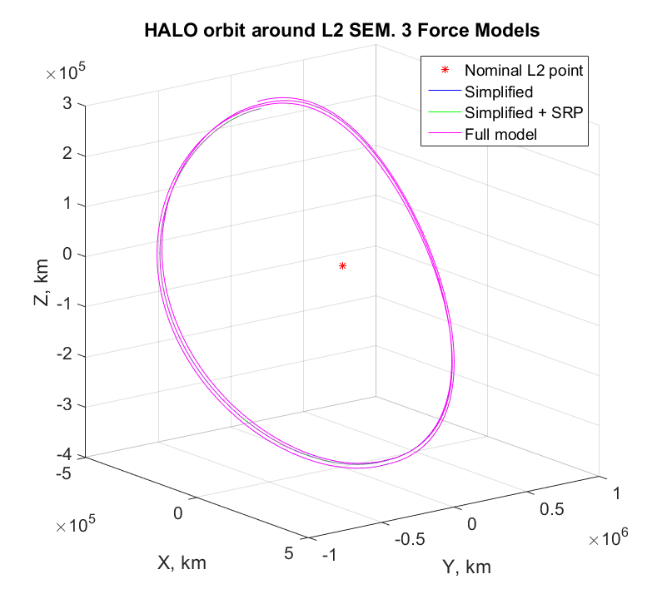

Figure 5.7 Test case 3 – Orbits for three force models (1.5 years) 3D View

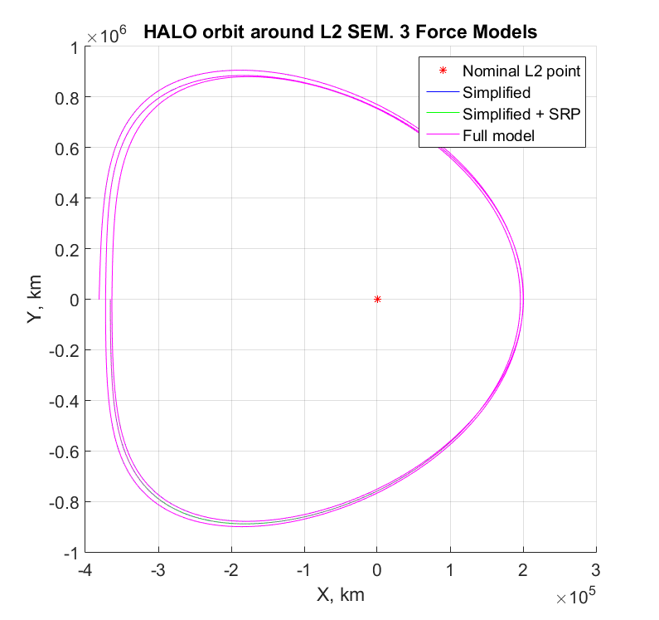

Figure 5.8 Test case 3 – Orbits for three force models (1.5 years) X-Y Plane

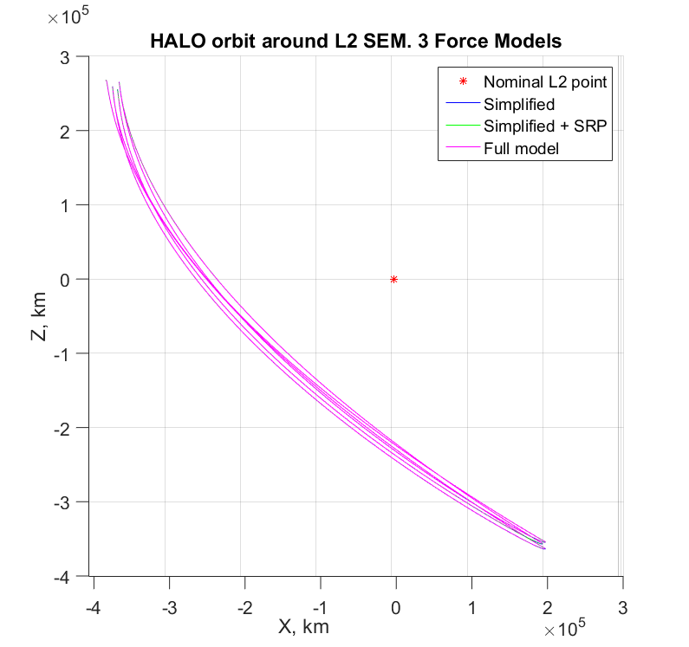

Figure 5.9 Test case 3 – Orbits for three force models (1.5 years) X-Z Plane

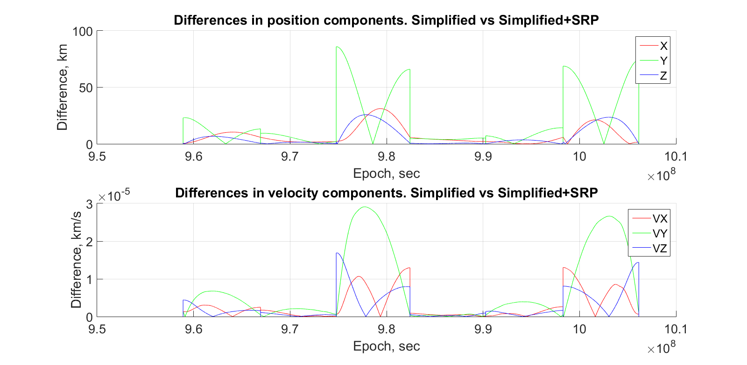

Figure 5.10 Test case 3 – Differences. Simplified vs Simplified + SRP

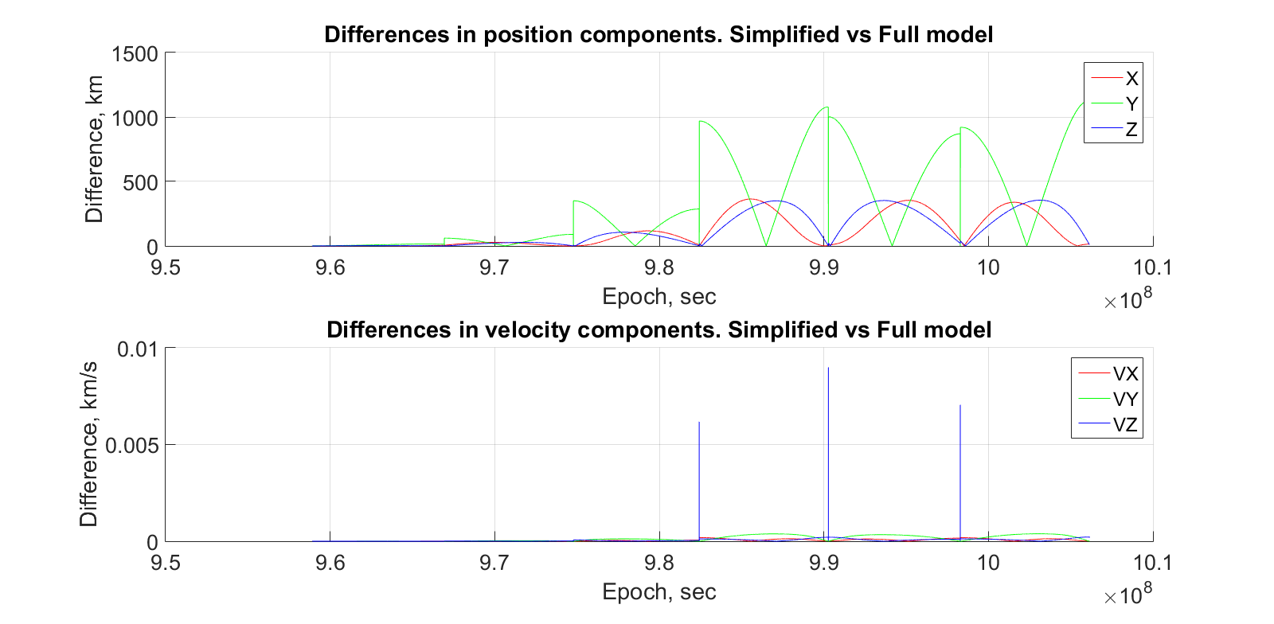

Figure 5.11 Test case 3 – Differences. Simplified vs Full model

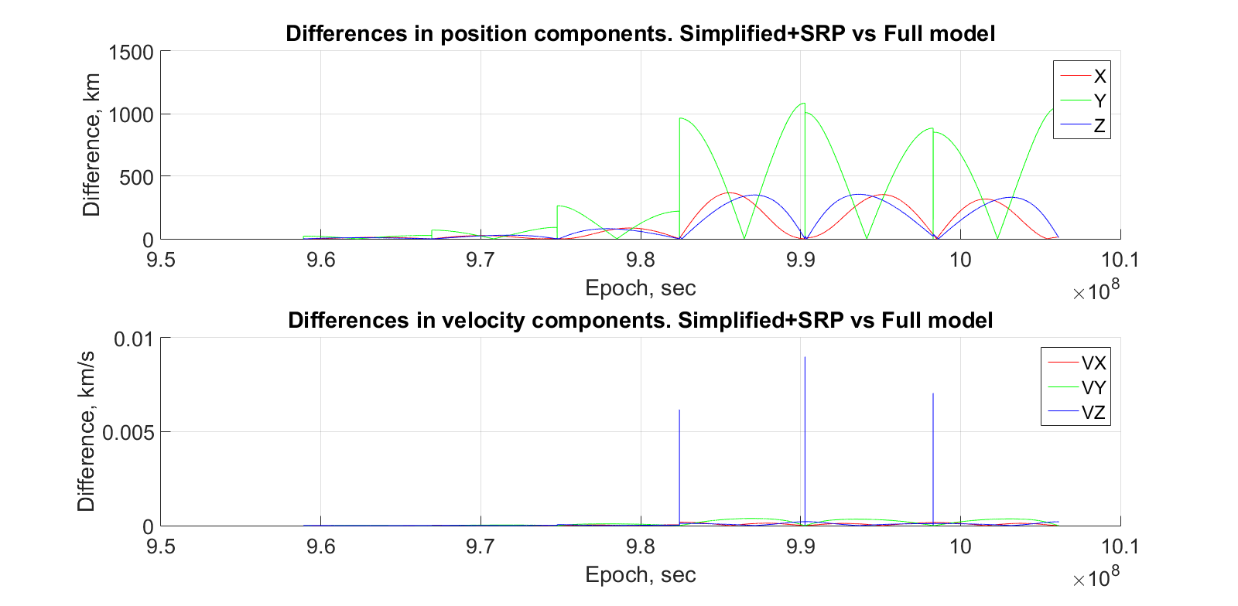

Figure 5.12 Test case 3 – Differences. Simplified + SRP vs Full model

As can be seen the difference is notable. But this test does not show the influence of the simplification of the model on the total orbit propagation to the full extent since all maneuvers were calculated for each case specifically and therefore some differences might have been compensated by the correct maneuvers.

#### Test case 4 – Applying wrong maneuvers for propagation with full force model

To show the significance of force model simplification effect, the maneuvers calculated for *Simplified model + SRP* will be applied for the *Full force model.* For the best representation this will be done for one revolution (6 months) with 2 maneuvers and for three revolutions (1.5 years) with 6 maneuvers applied.

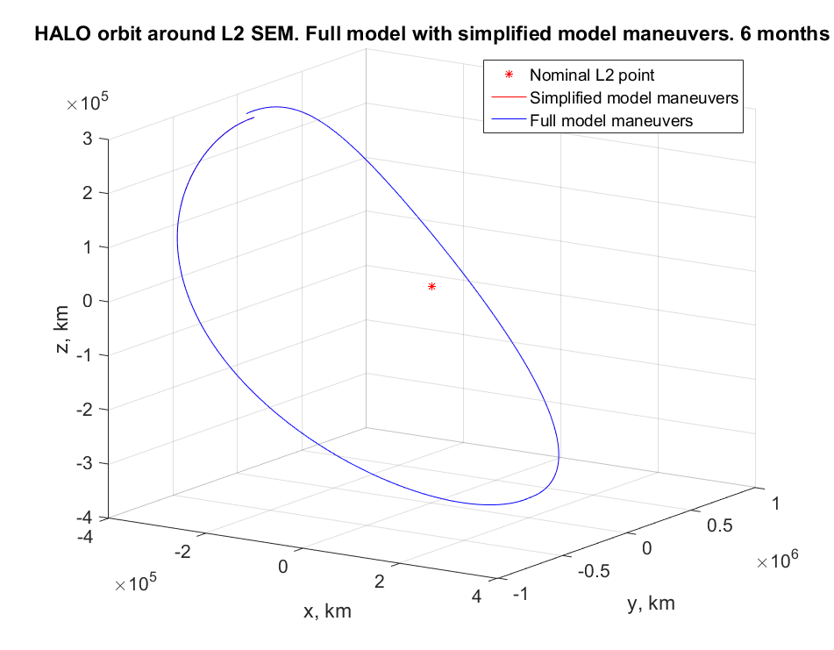

Figure 5.13 Test case 4 – Full force model orbit with maneuvers for Simplified model. 6 months

For one revolution it is hard to make conclusions about the influence of incorrect maneuver. One revolution is successfully completed.

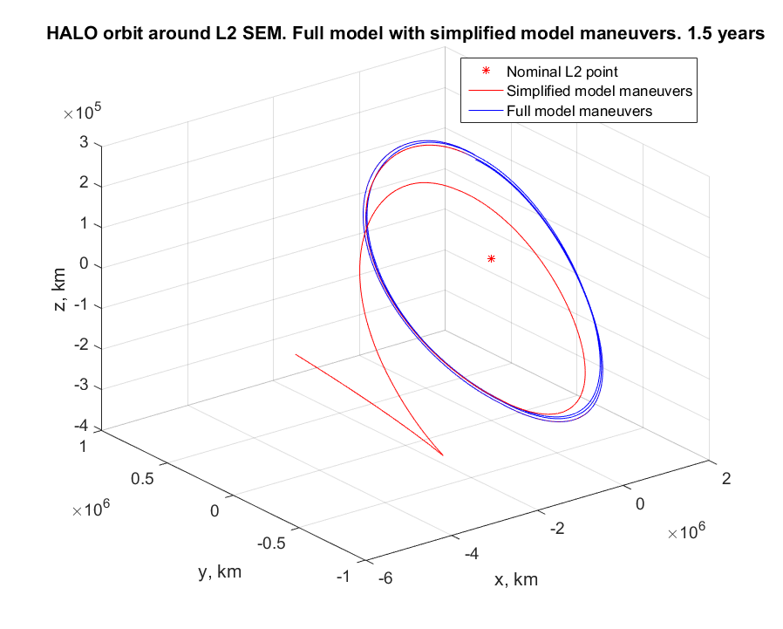

Figure 5.14 Test case 4 – Full force model orbit with maneuvers for Simplified model. 1.5 years

As can be seen, after 1.5 years the spacecraft has left the Halo orbit and entered heliocentric orbit. The environment around second Lagrange point is highly unstable and therefore small errors in maneuvers calculation can lead to the satellite escaping the orbit.

Therefore, it can be concluded that, despite that simplified force models can serve as good first approximations of the real dynamics, they do not reflect the reality with sufficient accuracy. For real applications one has employ full model dynamics in order to adequately represent the real world conditions.

### HALO Orbit Propagation Result

Performed tests have proved the significant effect of a force model simplification on the precision of Halo orbit propagation and helped to identify the most suitable numerical integrator for such purpose.

As a final result, propagated with RKV89 integrator Halo orbit is shown in Fig.5.15-Fig. 5.18

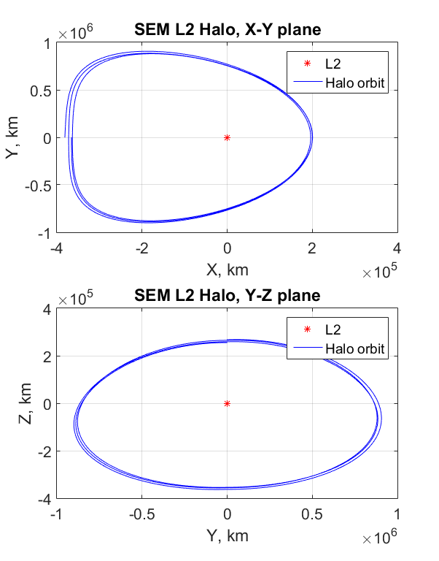

Figure 5.15 Halo orbit around SEM L2 point. X-Y / Z-Y planes

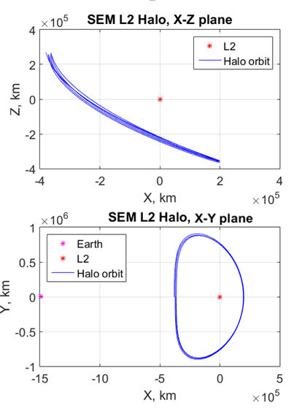

Figure 5.16 Halo orbit around SEM L2 point. X-Z / X-Y planes

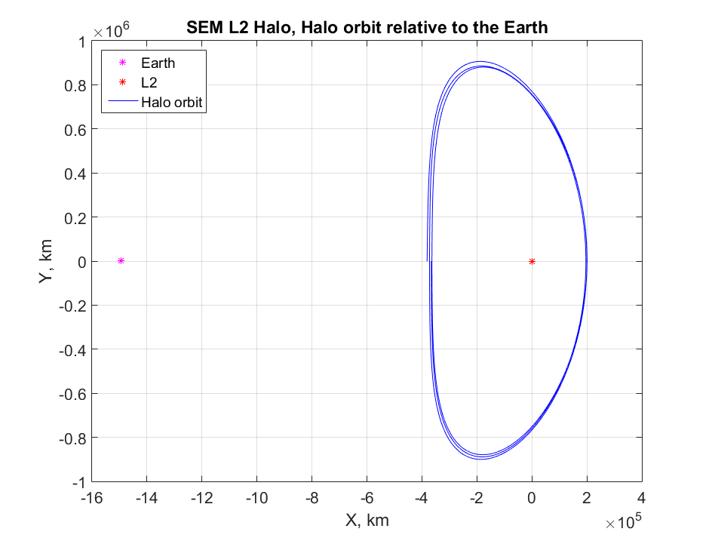

Figure 5.17 Halo orbit around SEM L2 point relative to the Earth (X-Y)

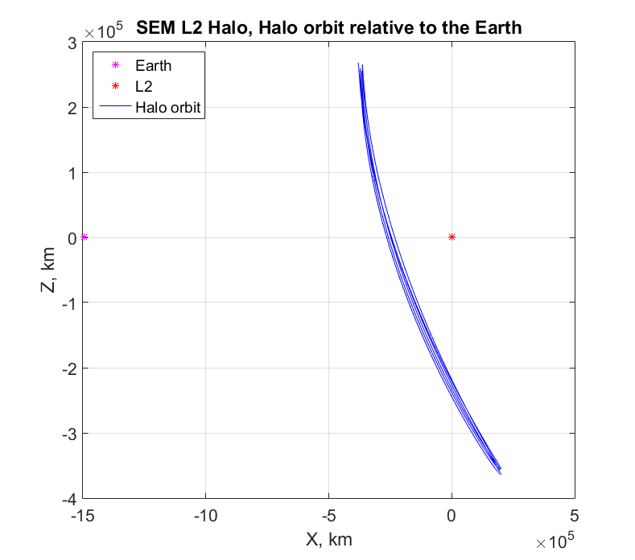

Figure 5.18 Halo orbit around SEM L2 point relative to the Earth (X-Z)

# CONCLUSION

Working Matlab environment for maneuvers calculation and Halo orbits propagation was successfully created. Test procedures for simulation and verification were implemented and can be used in future work.

Importance of including all relevant perturbations in the force model has been demonstrated. Full force model represents the real world conditions much better and therefore should be used in mission analysis. Including all relevant forces does not increase the complexity too much, but can be really beneficial. More realistic dynamical model can facilitate calculation of required station-keeping maneuvers and preliminary estimation of mission’s deltaV budget.

Furthermore, the most suitable for the Halo orbit propagation numerical integrator – Runge-Kutta-Verner 8(9)-16M – was determined.

Results of this work can be used in further investigations of IRASSI mission. However, some additional work needs to be done. First of all, the simulation should be expanded to LEOP and transfer to the orbit phases. Also, the simulation should be adjusted for formation of satellites.

# REFERENCES

[1]Buinhas L, Ferrer-Gil E, Forstner R. (2016). „IRASSI: InfraRed astronomy satellite swarm interferometry—Mission concept and description.” In Aerospace Conference, 2016 IEEE (pp. 1-20). IEEE

[2] ESA Gaia Mission Summary <http://sci.esa.int/gaia/>

[3] ESA Herschel Mission Summary <http://sci.esa.int/herschel/>

[4] ESA Planck Mission Summary <http://sci.esa.int/planck/>

[5] NASA James Webb Space Telescope Orbit information <http://jwst.nasa.gov/orbit.html>

[6] Vallado D.A., McClain W.D. (1997). “Fundamentals of Astrodynamics and Applications”

[7] Schaub H., Junkins J.L., (2002). „Analytical Mechanics of Aerospace Systems”

[8] https://www.researchgate.net/figure/265207632\_fig1\_Figure-1-The-5-libration-points-in-the-Sun-Earth-System-in-normalized-rotating

[9] Zazzera F.B., Topputo F., Massari M., “Assesment of Mission Design Including Utilization of Libration Points and Weak Stability Boundaries.” Dipartimento di Ingegneria Aerospaziale, Politecnico di Milano

[10] Farquhar R.W. (1970). “The control and use of libration-point satellites.” National Aeronautics and Space Administration, Goddard Space Flight Center, Greenbelt, Md. 20771

[11] Mahajan B., (2013) “Libration point orbits near small bodies in the elliptic restricted-three-body problem”. Masters Theses. Paper 7200

[12] Richardson D. L. (1979) “Analytic construction of periodic orbits about the collinear points.” Department of Aerospace Engineering, University of Cincinnati, U.S.A.

[13] Richardson D. L. (1980) “A note on a Lagrangian formulation for motion about the collinear points.” Celestial Mechanics, vol. 22, Oct. 1980, p. 231-236.

[14] Evans S.W., “Natural environment near the Sun/Earth-Moon L2 libration point.” Marschall Space Flight Center

[15] Montenbruck O., Gill E. (2005) “Satellite Orbits. Models, Methods and Applications“ Deutsches Zentrum für Luft- und Raumfahrt (DLR) e.V.

[16] Pavlak T.A., Howell K.C. “Strategy for Optimal, Ling-Term Stationkeeping of Libration Point Orbits in the Earth-Moon System.” Purdue University, West Lafayette, IN, 47907 – 2045, USA

[17] Berry M.M., “COMPARISONS BETWEEN NEWTON-RAPHSON AND BROYDEN’S METHODS FOR TRAJECTORY DESIGN PROBLEMS.” AAS 11-480

[18] Butcher J.C. (1964) “On Runge-Kutta processes of high order.”, J. Austral. Math. Soc., IV/2, 179-194

[19] Zadunaisky P. E. (1979) “ON THE ACCURACY IN THE NUMERICAL SOLUTION OF THE N-BODY PROBLEM.” C.N.I.E., Observatorip Nacional de Fisica Cosmica, Av. Mitre 3100 – San Miguel (B.Aires), Argentina

[20] Hughes S.P., Qureshi R.H., Cooley S.D., Parker. J.J.K., Grubb T.G. (2014) “Verification and Validation of the General Mission Analysis Tool (GMAT)” NASA Goddard Space Flight Center, Greenbelt, MD, 20771, USA

[21] ode87 Integrator. Author: Govorukhin Vasiliy (2003) <https://de.mathworks.com/matlabcentral/fileexchange/3616-ode87-integrator>

[22] Verner’s 8th and 9th Order Embedded Runge-Kutta Method, Mathematics Source Library C & ASM, <http://www.mymathlib.com/diffeq/embedded_runge_kutta/embedded_verner_8_9.html>

[23] NASA General Mission Analysis Tool, Source code, https://sourceforge.net/p/gmat/git/ci/1ef56c2ab38c1385ed08b0613c34c580371db441/tree/src/base/propagator/

[24] Tsitouras C. “Optimized explicit Runge-Kutta pair of orders 9(8).”, Department of Mathematics, National Technical University, Zografou Campus, GR15780 Athens, Greece

[25] NASA, The SPICE Toolkit official web-site, <https://naif.jpl.nasa.gov/naif/toolkit.html>

[26] Dynamic reference frames. NASA SPICE Toolkit tutorial, <http://naif.jpl.nasa.gov/pub/naif/toolkit_docs/Tutorials/pdf/individual_docs/24_dynamic_frames.pdf>

[27] Generic SPICE kernels, <http://naif.jpl.nasa.gov/pub/naif/generic_kernels/>

# APPENDIX

All the software developed for this work can be found in a GitHub repository:

**https://github.com/pekkipo/OrbitDeterminationIRASSI**