Instructions to Authors Preparing Their
Camera Ready Papers for AECE Journal

Abstract—These instructions provide basic guidelines to help authors prepare their final camera-ready papers for submission to Advances in Electrical and Computer Engineering. The abstract, with a maximum of 200 words, should be self-explanatory and summarize the essential qualities of the paper. The abstract must clearly state the novelty of the work regarding the journal fields. Do not use more than 200 words in the abstract, as it will be included in the on-line version of the journal and sent for indexing to international databases, in different formats. Also, try to use only English characters in the abstract. Other characters, like special symbols, Greek alphabet letters, subscript and superscript styles, could not be included in the text-only on-line abstract. Do not cite references in the abstract. Do not delete the character immediately before the Abstract; it sets the footnote at the bottom of this column. Very careful wording should be used in the title and in the abstract. Without a proper title and abstract, a great paper might never be downloaded and/or read. Before starting a new submission you are kindly invited to read all the information on the "For Authors" page from the journal website and on the HelpDesk.
First Author^{1,2}, Second Author¹, Third Author² - No abbreviations allowed
¹Stefan cel Mare University of Suceava, 720229, Romania
²Institute of Computer Science, Romanian Academy, Iaşi, 700054, Romania
corresponding.author@mailserver.com

Index Terms—five key words or phrases arranged alphabetically and separated by commas, the same you declared in OpenConf. A list of key words may be found on the website. Use only the key words defined there.

Introduction
Prospective authors are invited to submit papers that fit within the scope of the journal. Papers should be written in English and submitted in final camera-ready form. All text has to be edited by using the styles defined in this document.
It is mandatory to submit your original work in Microsoft Word format (.DOC) by using our online manuscript submission system at http://www.aece.ro/openconf. We will do only minor corrections and the final formatting of your paper.
Papers must have an even number of pages: 6, 8 or 10. If your paper is longer than 10 pages (12 pages and more), please contact us before uploading it in the interface. We do not publish short papers.
You have to create a "New Submission" and upload your paper file by using the on-line interface. All subsequent versions should be uploaded by using the same paper ID and your defined password. We are unable to process files sent by E-mail or by any other method.
Do not use blank lines for spacing. Re-arrange the text in order to fit all the blanks. Do not use blank lines for spacing. Re-arrange the text in order to fit all the blanks.

Copyright Form
An AECE copyright form should accompany your submission. You can get the .PDF form version on-line. Authors are responsible for obtaining any security clearances.
All authors have to personally sign the copyright transfer form - with no exceptions. The signed copyright form has to be scanned and uploaded by using the corresponding interface on the website. There are some restrictions regarding the length of the copyright file, so please read carefully the instruction provided in the copyright file uploading interface.

Paper and Text Format
When you open this document, select “Page Layout” from the “View” menu in the menu bar (View | Page Layout), which allows you to see the footnotes. Then type over sections or cut and paste from another document and then use markup styles. The pull-down style menu is at the left of the Formatting Toolbar at the top of your Word window (for example, the style at this point in the document is “Text”). Highlight a section that you want to designate with a certain style, and then select the appropriate name on the style menu. The style will adjust your fonts and line spacing. Do not change the font sizes or line spacing to squeeze more text into a limited number of pages. Use italics for emphasis; do not underline.
To insert images in Word, position the cursor at the insertion point and either use Insert | Picture | From File or copy the image to the Windows clipboard and then Edit | Paste Special | Picture (with “Float over text” unchecked).
You are kindly advised to use this template for editing your submission, as you have nothing to change in terms of paper and text format. Simply applying the styles defined here will be sufficient - it should take no more than 5 to 10 minutes per page.
Author name, affiliation and complete address are to be placed underneath the title. In case of multiple authorship of a submitted paper, the affiliation and complete address of each author must be specified.

Tables, Figures, Equations
Illustrations and tables should be progressively numbered, following the order cited in the text; they may be organized in one or two columns. Tables must be accompanied by a caption placed at the top. Figures (abbreviated Figure X in the caption and Fig. X in the text) must be accompanied by a caption placed underneath ("Figure Caption" style). References made to tables in text will not be abbreviated e.g. “in Table I, TN Roman means Times New Roman”.

Table I. The Recommended Fonts
Item | Style (from "Style and Formatting")
Title of paper | Title
Authors' names | Authors
Authors' address | Authors + Italic
Abstract | Abstract
Title of sections | Heading 1
Text, Formulae | Text
Algorithms | Text + Courier New 8
Figure captions | Figure Caption
References Head | References Head
References | References

When inserting figures, they should be as clear as possible. Figures must be centered. Do not use font sizes smaller than 8 TNRoman, as they will be difficult to be read.
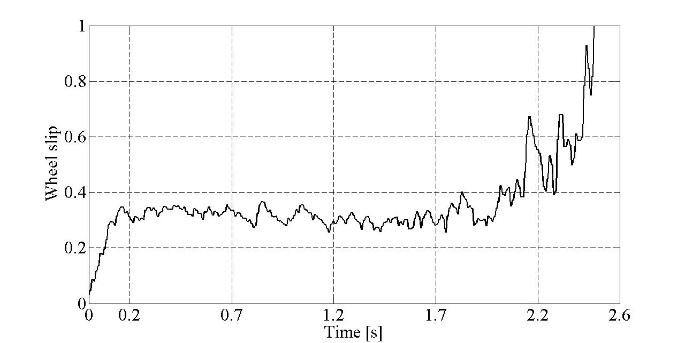 Figure 1. Wheel slip response with the proposed control algorithm
Color pictures are also acceptable, but you have to be sure they will be also visible on grayscale printing. In the online version of your paper they will be in color version.

Math
Use either the Microsoft Equation Editor or the MathType add-on (http://www.mathtype.com) for equations in your paper (Insert | Object | Create New | Microsoft Equation or MathType Equation). “Float over text” should not be selected.
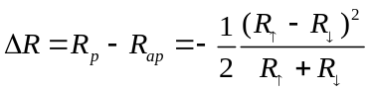 (1)
Each formula should occupy one line. Consecutive numbers should be marked in brackets. All equations should be numbered (the numbers should be aligned at the right), and cited (1) in the text.

References Section
Number the citations consecutively, in square brackets [1]. The sentence punctuation follows the brackets [2]. Multiple references [1], [2] and [3], should be cited [1-3]. Also, use [4],[6-8] and not [4],[6],[7],[8]. When citing a section in a book, please give the relevant page numbers [2-3]. You should avoid citing books but, if mandatory, indicate the page numbers. In sentences, refer simply to the reference number, as in [3]. Do not use “Ref. [3]” or “reference [3]” except at the beginning of a sentence: “Reference [3] shows ....” Please do not use automatic endnotes in Word, rather, type the reference list at the end of the paper using the “References” style.
Give all authors’ names; do not use “et al.” unless there are six authors or more. Use a space after authors’ initials. Papers that have not been published should be cited only if they have a DOI number assigned and should be referenced as “to be published” [4]. Papers that have been submitted for publication or have been accepted for publication - but not yet specified for an issue and they have no DOI assigned, should not be cited.
Capitalize only the first word in a paper title, except for proper nouns and element symbols. For papers published in translation journals, please give the English citation first, followed by the original foreign-language citation.
As all papers of AECE are published on-line, including the references, it is mandatory to include permanent links for all references available on-line. References linking to temporary on-line resources (for example links to sites like http://www.somejournal.org/papers/down/thispaper043.pdf, https://www.abigcompany.com/datasheets/thebestoap.html, or any other similar) are not acceptable. Only permanent links to on-line resources are accepted (CrossRef, PubMed, PermaLink, Handle, or similar).
For every reference try to find out (this is not mandatory and not always possible) a permanent on-line link and include it at the end of the respective reference. You may use some free tools for this task: http://refassist.ieee.org or http://www.crossref.org/SimpleTextQuery (please do a search on the web if you get invalid 404 pages on the links above to find out the new ones). Updated addresses are always available on our website in the "Author Guidelines" section.
We developed an online tool for authors to check the References keywords. Please try it and compare your declared keywords with the keywords extracted from the references: https://www.aece.ro/openconf/author/references_check.php

Some Common Mistakes
The word “data” is plural, not singular. The subscript for the permeability of vacuum µ₀ is zero, not a lowercase letter “o.” Use the word “micrometer” instead of “micron.” A graph within a graph is an “inset,” not an “insert.” The word “alternatively” is preferred to the word “alternately” (unless you really mean something that alternates). Use the word “whereas” instead of “while” (unless you are referring to simultaneous events). Do not use the word “essentially” to mean “approximately” or “effectively.” Do not use the word “issue” as a euphemism for “problem.” Be aware of the different meanings of the homophones “affect” (usually a verb) and “effect” (usually a noun), “complement” and “compliment,” “discreet” and “discrete,” “principal” (e.g., “principal investigator”) and “principle” (e.g., “principle of measurement”). Do not confuse “imply” and “infer”.
Prefixes such as “non,” “sub,” “micro,” “multi,” and “ultra” are not independent words; they should be joined to the words they modify, usually without a hyphen. There is no period after the “et” in the Latin abbreviation “et al.” (it is also italicized). The abbreviation “i.e.,” means “that is,” and the abbreviation “e.g.,” means “for example” (these abbreviations are not italicized).

Paper Status
You may always see the status of your submission on the website by accessing the "Submission Status" page.

Conclusion
A conclusion section is not compulsory, but we recommend it. Although a conclusion may review the main points of the paper, do not replicate the abstract as the conclusion. A conclusion might elaborate on the importance of the work or suggest applications and extensions. Try to emphasize your scientific contribution and the differences from previous works in the literature. The conclusion is a text only section - do not use equations, graphs or cite references in this section. Make sure that the whole text of your paper observes the textual arrangement on this page.
Appendix A
Appendices, if present, must be marked A, B, C, and placed before the Acknowledgment section.
Acknowledgment
Place your acknowledgments before References. Do not mention the sponsors and/or financial support obtained in this section, as they must be included in an unnumbered footnote on the first page of the paper. You have to delete de footnote on the first page if there is no sponsorship information to add.
References
- J. U. Duncombe, “Infrared navigation Part I: An assessment of feasibility (Periodical style),” IEEE Trans. Electron Devices, vol. ED-11, pp. 3439, Jan. 1959. doi:10.4316/ieee.1959.3422
- M. Young, The Technical Writers Handbook. Mill Valley, CA: University Science, pp. 1023-1045, 1989.
- D. Knuth. The Art of Programming. Addison-Wesley, pp. 82-86, 1973.
- E. H. Miller, “A note on reflector arrays (Periodical style-Accepted for publication, but the doi number has been assigned),” IEEE Trans. Antennas Propagat., doi:10.4316/ieee.1959.3422, to be published.
- S. P. Binguac, “On the compatibility of adaptive controllers (Published Conference Proceedings style),” in Proc. 4th Annu. Allerton Conf. Circuits and Systems Theory, New York, 1994, pp. 8–16. doi:10.1011/sp.1994.312
- At least 20-25 quality references should be cited

IMPORTANT
You may always find updated instructions on the HelpDesk:

http://www.aece.ro/helpdesk

This work was supported in part by the E.U. Commission under Grant EUV13/20160727/AE (sponsor and financial support acknowledgment goes here - modify or delete this note if it is not the case).

