**Exercise 1: ceil_log2 function**

1. **VHDL code**

**LIBRARY** ieee;

**USE** ieee.std_logic_1164.**all**;

**USE** ieee.numeric_std.**all**;

**use** ieee.math_real.**all**;

**PACKAGE** lab4 **IS**

**FUNCTION** count_leading_zeros(*x* : UNSIGNED) **return** UNSIGNED;

**FUNCTION** ceil_log2(*x* : UNSIGNED) **return** UNSIGNED;

**END** **PACKAGE** lab4;

**package** **body** lab4 **is**

**FUNCTION** count_leading_zeros(*x* : UNSIGNED) **return** UNSIGNED **IS**

**VARIABLE** count : UNSIGNED(*x*'*RANGE*) := to_unsigned(0, *x*'*LENGTH*);

**BEGIN**

**FOR** i **IN** *x*'*RANGE* **LOOP**

**CASE** *x*(i) **IS**

**WHEN** *'0'* => count := count + 1;

**WHEN** **OTHERS** => **EXIT**;

**END** **CASE**;

**END** **LOOP**;

**RETURN** count;

**END** **FUNCTION** count_leading_zeros;

**FUNCTION** ceil_log2(*x* : UNSIGNED) **return** UNSIGNED **IS**

-- as it turns out this can be done with a count leading zeros procedure which is

-- very close to our count leading ones procedure

**VARIABLE** temp : UNSIGNED(*x*'*RANGE*) := to_unsigned(0, *x*'*LENGTH*);

**begin**

**IF** *x* = to_unsigned(0, *x*'*LENGTH*) **THEN**

**return** to_unsigned(0, *x*'*LENGTH*);

**ELSE**

temp := count_leading_zeros(*x* - to_unsigned(1, *x*'*LENGTH*));

**return** to_unsigned(*x*'*HIGH*, *x*'*LENGTH*) - temp + to_unsigned(1, *x*'*LENGTH*);

**END** **IF**;

**end** **FUNCTION** ceil_log2;

**end** lab4;

1. **Simulation results**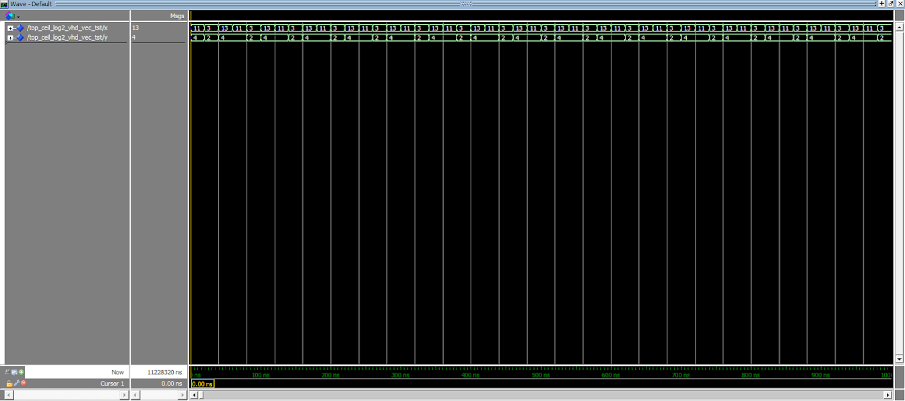

**Exercise 2: natural_to_thermometer converter**

1. **VHDL code**

**LIBRARY** ieee;

**USE** ieee.std_logic_1164.**ALL**;

**USE** ieee.numeric_std.**ALL**;

**USE** ieee.math_real.**ALL**;

**PACKAGE** lab4 **IS**

**FUNCTION** natural_to_thermometer (*x*: UNSIGNED) **RETURN** BIT_VECTOR;

**END** **PACKAGE** lab4;

**PACKAGE** **BODY** lab4 **IS**

**FUNCTION** natural_to_thermometer(*x*: UNSIGNED) **RETURN** BIT_VECTOR **IS**

**VARIABLE** temp: BIT_VECTOR((2\*\**x*'*LENGTH* - 1) **DOWNTO** 0) := (**OTHERS** => *'0'*);

**BEGIN**

**FOR** i **IN** 0 **TO** temp'*left* **LOOP**

**IF** i < *x* **THEN**

temp(i) := *'1'*;

**ELSE**

**EXIT**;

**END** **IF**;

**END** **LOOP**;

**RETURN** temp;

**END** **FUNCTION** natural_to_thermometer;

**END** **PACKAGE** **BODY** lab4;

**LIBRARY** ieee;

**USE** ieee.std_logic_1164.**ALL**;

**USE** ieee.numeric_std.**ALL**;

**USE** ieee.math_real.**ALL**;

**USE** work.lab4.**all**;

**ENTITY** top_natural_to_thermometer **IS**

**GENERIC**(

-- number of input bits

*BITS* : INTEGER := 7

);

**PORT**(

-- input in stl format

x : **IN** STD_LOGIC_VECTOR(*BITS* - 1 **DOWNTO** 0) := (**OTHERS** => *'0'*);

--num of bits, take the log base 2, then convert to an int. we redefine this because vhdl sucks

y : **OUT** STD_LOGIC_VECTOR((2 ** *BITS*) - 1 **DOWNTO** 0) := (**OTHERS** => *'0'*)

);

**END** **ENTITY** top_natural_to_thermometer;

**ARCHITECTURE** arch **OF** top_natural_to_thermometer **IS**

**BEGIN**

y <= to_stdlogicvector(natural_to_thermometer(UNSIGNED(x)));

**END** **ARCHITECTURE** arch;

1. Simulation results

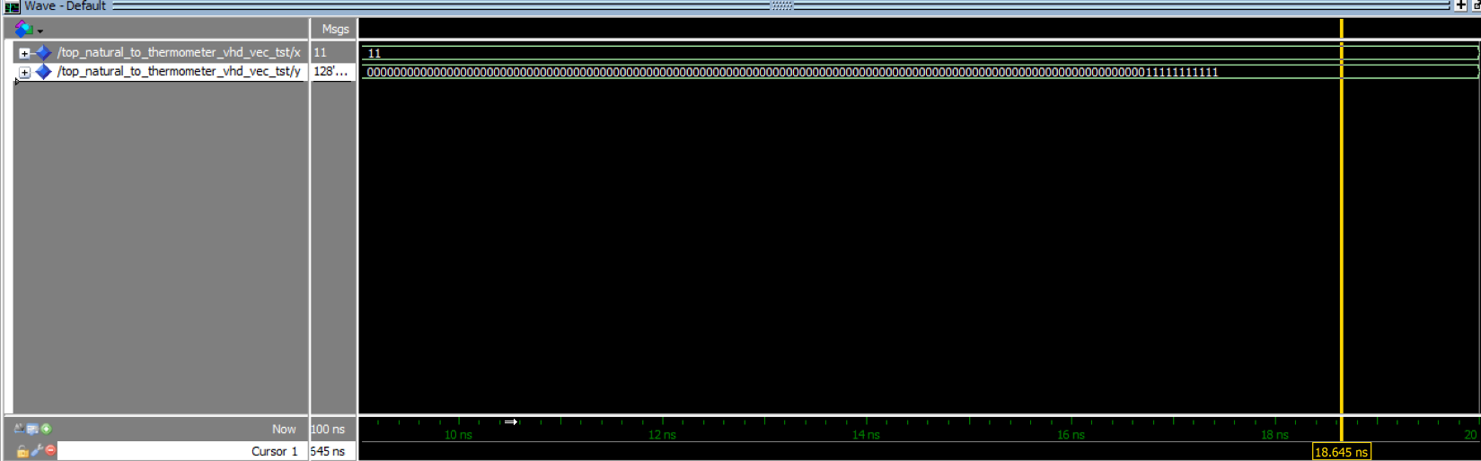



**Exercise 3: Synchronous Counter**

1. **VHDL code**
2. **Simulation Results**

**Exercise 4: Pulse Width Modulator**

1. VHDL code

d) Simulation results (N = 8)