

**Register**

Enter information for register.

Address

Number:

Frist Credit:

Name:

Receive information to database.

Input fingerprint

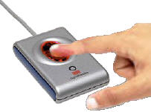



Receive information to database.

Create Account for prison



+

5000 $



**Deposit**

-Family deposit to prisoner by give money to officer at the counter.

-Officer will make 3 bills for depositor, prisoner and get one in office for used as evidence.

-officer will increase credit for that prisoner.



+

10,000

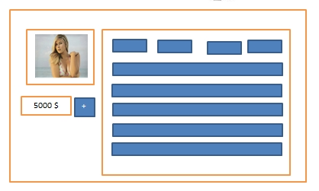



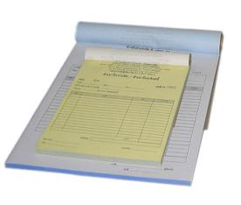

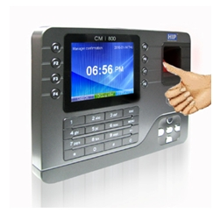

**Dealing**

Provide fingerprint scanner to user and user scan for call credit information.

Prisoners go to the store.

Program show information detail and list product.

-Sell product not more 200$

Stock

Member

Sell

Report

Account

Log out

ID

Name

Address

500

Total

Sell

Cancel

Add

Stock

Member

Sell

Report

Account

Log out

ID

Name

Address

400

Total

Sell

Cancel

Add



When finish dealing program will calculate total price and credit.

|  |  |  |  |
| --- | --- | --- | --- |
| No | Product list | Number | Price |
| 1 | Milk | 5 | 100 |

|  |  |  |  |
| --- | --- | --- | --- |
| No | Product list | Number | Price |
|  |  |  |  |





**Withdrawal**

* Prisoner request withdrawal
* Prisoner get the document to officer
* Prison calculate withdrawal money in prisoner account
* Officer give the cash to the prisoner











**Interface Design**

Log out

Account

Report

Sell

Member

Stock



Add

Add new Product

Edit

|  |  |  |  |  |
| --- | --- | --- | --- | --- |
| Product Id | Product list | Product type | Product price | Number  Of product |
| 1 |  |  |  |  |
| 2 |  |  |  |  |
| 3 |  |  |  |  |

Password

Username

Extit

Login

Delete Product







-Can add Product.

-Can add new Product.

-Can delete product

-Can edit detail.

-Show the detail of product





-Number of product will reduce follow the number that product sell.

**Interface Design**

Log out

Account

Report

Sell

Member

Stock

Log out

Account

Report

Sell

Member

Stock

Remove member

Add new member

Search

ID

|  |  |  |  |  |
| --- | --- | --- | --- | --- |
| ID | Name | Tel | Address | credit |
| 552115007 |  |  |  |  |
| 552115053 | Champ | 0826962132 | Fang | 5000 |

Name

Tel

Credit

Address

Deposit

Back

Withdrawal

Financial

Stock

Member

Sell

Report

Account

Log out

Stock

Member

Sell

Report

Account

Log out

Medicine

Drink

Snack

Wares

Other

|  |  |  |  |  |  |  |
| --- | --- | --- | --- | --- | --- | --- |
| No | Product list | Number | Price | Buyer | seller | time |
|  |  |  |  |  |  |  |

|  |  |  |  |
| --- | --- | --- | --- |
| No | Product list | Product type | Product price |
| 1 |  |  |  |
| 2 |  |  |  |
| 3 |  |  |  |

ID

Name

Address

Back

Add

Add

Sell

Cancel

Total

Credit

**Interface Design**

Date

Account of Admin

Account of Financial

Stock

Member

Sell

Report

Account

Log out

Search

DATE

Stock

Member

Sell

Report

Account

Log out

Send

Import report

|  |  |  |  |  |  |  |
| --- | --- | --- | --- | --- | --- | --- |
| No | Product list | Price | number | Buyer | seller | time |
|  |  |  |  |  |  |  |

Send

Deposit

Send

Withdrawal

Total

Reporting Financial

Stock

Member

Sell

Report

Account

Log out

Account of Admin

Account of Financial

|  |  |  |  |  |
| --- | --- | --- | --- | --- |
| ID | NAME | USER NAME | Position | Add to account by |
|  |  |  |  |  |

Change Information

Black list

Band

**Stock database Sell One List database**

**Database Design**

|  |  |  |  |  |  |  |
| --- | --- | --- | --- | --- | --- | --- |
| Product ID | Product list | Number | Price | Buyer | seller | time |
| 0001 |  |  |  |  |  |  |
| 0002 |  |  |  |  |  |  |

|  |  |  |  |  |
| --- | --- | --- | --- | --- |
| Product Id | Product list | Product type | Product price | Number Of product |
| 1 |  |  |  |  |
| 2 |  |  |  |  |

**Prisoner database**

|  |  |  |  |  |  |  |
| --- | --- | --- | --- | --- | --- | --- |
| ID | Name | Tel | Address | credit | Picture | Fingerprint |
| 552115007 | Ting | 0812345678 | Chaingrai | 200 |  |  |
| 552115053 | Champ | 0826962132 | Fang | 5000 |  |  |

**Financial database**

|  |  |  |  |  |  |  |  |
| --- | --- | --- | --- | --- | --- | --- | --- |
| ID | Name | Tel | Withdrawal | Deposit | Buy list | Buy price | Date |
| 552115007 |  |  |  |  |  |  |  |
| 552115053 | Champ | 0826962132 | Fang | 5000 |  |  |  |

**Report selling database Report list database**

|  |  |  |  |
| --- | --- | --- | --- |
| No | Product list | Product type | Product price |
| 1 |  |  |  |
| 2 |  |  |  |

|  |  |  |  |  |  |  |
| --- | --- | --- | --- | --- | --- | --- |
| No | Product list | Price | number | Buyer | seller | time |
|  |  |  |  |  |  |  |

**Financial database Admin database**

|  |  |  |  |  |  |
| --- | --- | --- | --- | --- | --- |
| Date | Input | Selling | Deposit | Withdrawal | total |
|  |  |  |  |  |  |
|  |  |  |  |  |  |

|  |  |  |  |  |
| --- | --- | --- | --- | --- |
| ID | NAME | USER NAME | Position | Add to account by |
|  |  |  |  |  |
|  |  |  |  |  |

**Stock database Sell One List database**

|  |  |  |  |  |  |  |
| --- | --- | --- | --- | --- | --- | --- |
| Product ID | Product list | Number | Price | Buyer | seller | time |
| 0001 |  |  |  |  |  |  |
| 0002 |  |  |  |  |  |  |

|  |  |  |  |  |
| --- | --- | --- | --- | --- |
| Product Id | Product list | Product type | Product price | Number Of product |
| 1 |  |  |  |  |
| 2 |  |  |  |  |

**Prisoner database**

|  |  |  |  |  |  |  |
| --- | --- | --- | --- | --- | --- | --- |
| ID | Name | Tel | Address | credit | Picture | Fingerprint |
| 552115007 | Ting | 0812345678 | Chaingrai | 200 |  |  |
| 552115053 | Champ | 0826962132 | Fang | 5000 |  |  |

**Financial database**

|  |  |  |  |  |  |  |  |
| --- | --- | --- | --- | --- | --- | --- | --- |
| ID | Name | Tel | Withdrawal | Deposit | Buy list | Buy price | Date |
| 552115007 |  |  |  |  |  |  |  |
| 552115053 | Champ | 0826962132 | Fang | 5000 |  |  |  |

**Report selling database Report list database**

|  |  |  |  |
| --- | --- | --- | --- |
| No | Product list | Product type | Product price |
| 1 |  |  |  |
| 2 |  |  |  |

|  |  |  |  |  |  |  |
| --- | --- | --- | --- | --- | --- | --- |
| No | Product list | Price | number | Buyer | seller | time |
|  |  |  |  |  |  |  |

**Financial database Admin database**

|  |  |  |  |  |  |
| --- | --- | --- | --- | --- | --- |
| Date | Input | Selling | Deposit | Withdrawal | total |
|  |  |  |  |  |  |
|  |  |  |  |  |  |

|  |  |  |  |  |
| --- | --- | --- | --- | --- |
| ID | NAME | USER NAME | Position | Add to account by |
|  |  |  |  |  |
|  |  |  |  |  |

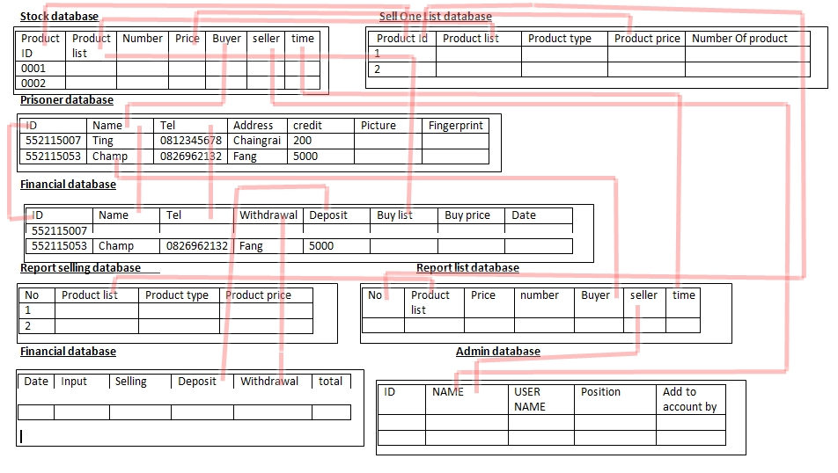



Bills

Account

Prison

**Over view**

Officer Account

Prisoner Account

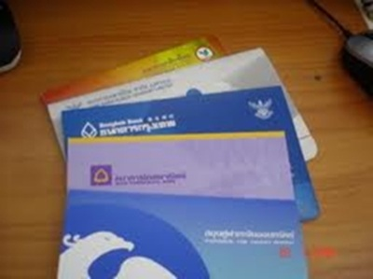

Make bills

Request

Get bill



Request





Request

Scan

Deposit

Family





Total price

Officer



Scan finger

Finger print

Transporter



Buy

BUY

Store

|  |  |  |  |  |  |  |  |  |
| --- | --- | --- | --- | --- | --- | --- | --- | --- |
|  | Stock database | Sell One List database | Prisoner database | Prisoner Financial database | Report selling database | Report list database | Financial account database | Admin database |
| Product ID |  |  |  |  |  |  |  |  |
| Product list |  |  |  |  |  |  |  |  |
| Product type |  |  |  |  |  |  |  |  |
| Product Price |  |  |  |  |  |  |  |  |
| Number of Product |  |  |  |  |  |  |  |  |
| Prisoner ID |  |  |  |  |  |  |  |  |
| Prisoner Name |  |  |  |  |  |  |  |  |
| Prisoner tell |  |  |  |  |  |  |  |  |
| Prisoner Address |  |  |  |  |  |  |  |  |
| Prisoner Credit |  |  |  |  |  |  |  |  |
| Prisoner picture |  |  |  |  |  |  |  |  |
| Prisoner Fingerprint |  |  |  |  |  |  |  |  |
| Prisoner withdrawal |  |  |  |  |  |  |  |  |
| Prisoner deposit |  |  |  |  |  |  |  |  |
| Prisoner buy list |  |  |  |  |  |  |  |  |
| Prisoner buy price |  |  |  |  |  |  |  |  |
| Date buy |  |  |  |  |  |  |  |  |
| Sell ID |  |  |  |  |  |  |  |  |
| Number that buy |  |  |  |  |  |  |  |  |
| Date |  |  |  |  |  |  |  |  |
| Time |  |  |  |  |  |  |  |  |
| Import |  |  |  |  |  |  |  |  |
| Total balanced |  |  |  |  |  |  |  |  |
| Officer ID |  |  |  |  |  |  |  |  |
| Officer Name |  |  |  |  |  |  |  |  |
| User name |  |  |  |  |  |  |  |  |
| Officer position |  |  |  |  |  |  |  |  |
| Add tot account by |  |  |  |  |  |  |  |  |

w