

PROJECT PROPOSAL

By

**Mr.Kullawat Cotanon 552115007**

**Mr.Peeraphut Punsuwan 552115053**

Department of Software Engineering

College of Arts, Media and Technology

Chiang Mai University

Project Advisor

**Dr. Noppon Choosri**

**Document History**

|  |  |  |  |  |  |  |
| --- | --- | --- | --- | --- | --- | --- |
| **Document Name** | **Version** | **Status** | **Date** | **Viewable** | **Reviewer** | **Responsible** |
| Documents | | | | | | |
| SIMPLY BUY  -Project Proposal -V.0.1.docx | - Abstract  - Add chapter 1 - Add chapter 2  - Business review  - Business tools and software review  - Technology review  - Development tool review - Add chapter 3 - Add chapter 4 - Add chapter 5 | Draft | May 9 ,2015 | KC,PP,NC | KC,PP | KC,PP |
| SIMPLY BUY  -Project Proposal -V.0.2.docx | - Abstract  - Add chapter 1  - Introduction and background - Add chapter 2  - Business review  - Business tools and software review  - Technology review  - Development tool review  - Add chapter 3  - ISO29110 - Add chapter 4  - Motivation  - Aim and Objective  - Deliverable and Limit  - Schedule and Milestone - Add chapter 5  - Reference | Draft | May 19 ,2015 | KC,PP,NC | KC,PP | KC,PP |

KC = Kullawat Cotanon  
PP = Peeraphut Punsuwan  
NC = Noppon Choosri

**Abstract**

Prison is still using coupon as paper which is high risk of lost and damage. It also takes a lot of process to withdrawal the coupon. And the coupon has expiration date. So the officer and prisoners is not satisfied in the services.

Thus, Dealing using fingerprint system has developed a new system to support dealing. The result is that fewer coupons are lost and the usage of paper is also being decreased.

The simply buy is a dealing program of using fingerprints system instead coupon system that have the same result but reduce some process that not necessary. Moreover, the system has managed product in stock. The programmer uses eclipse program to create and develop, SQLserver program to create database and Arduino to help connect the fingerprint scanner.

**Chapter One | Introduction and Background**

Nowadays, there are many ways in payment. The payment via ATM, credit card, including the Internet. These ways are also paying for the convenience a buyer. But in the prison the prisoner cannot use the cash money, no credit card and cannot pay via ATM. The system that the prison using is the coupon system is made up through account passbook that there are complex, multi-step processes, the prisoner have to withdrawal coupon to using in dealing. Moreover, the coupon which high risk of lost and damaged.

The simply buy will manage about financial and dealing in prison, the prisoners are required to fingerprint identification first. The system displays the information of prisoners such as balance, name and profile picture. Officer can check the history payment and withdrawal-deposits of the prisoners. Therefore, the dealing in the prison using the database to keep all history information. In addition, the officer can manage the stock by adding new products, edit and delete products. They can record sales adjust the amount of products in stock, makes note the amount of products sold, sales of products and remaining products in stock.

The Simply Buy has benefits and must to develop the database of dealing in prison for store the data and treatment history. There are little step to make dealing faster and convenient. Reduce operational costs such as paper coupons and toner or reduce waste time.

**Chapter Two | Literature Review**

**2.1 Business Review**

**Overview**

Simply BUY is a software application invented by a leading Arduino hardware. It designs to be able to get the fingerprint from user to the database for the convenience of buying. The program can save information, balance and print into the database. The user uses the print to confirm the account for the purchase. The system is suitable exclusive stores in the organization. There are programs for manage the stock and depositing-withdrawal.

**Target**

The main goal of this software is management dealing of the prisoner. Help to convenient and faster dealing. Manage the depositing of the prisoner by simplify the process.Also manage the stock and account sales.

**Benefit**

1. Easy dealing

Buying without coupon in the system that use in the present, User uses the fingerprint to retrieve the account to buying the products.

2. Simplify the depositing process

The money earned from the depositing will be added to the system by check amount from actual data.

3. Management dealing

Can manage the stock and check the account sales.

**2.2 Business Tools/Software Review**

**2.2.1 Dealing in the prison using the coupons system.**

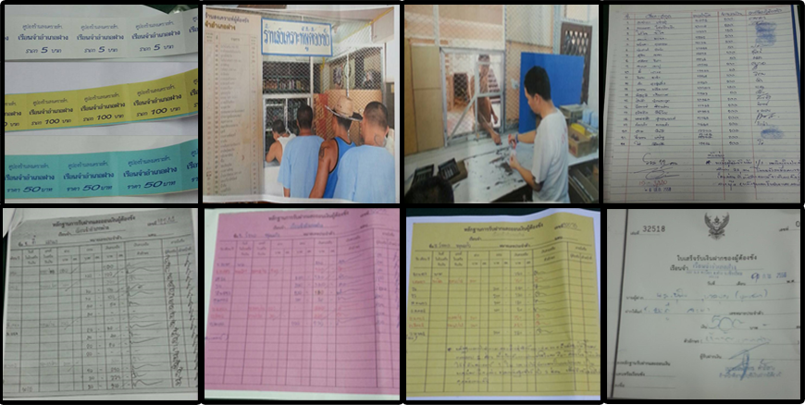

**Figure 2.2.1: Dealing using coupons review**

Firmly of prisoners deposit by paying cash to officer, the officer record to the prisoner’s book and then Issue three receipts for the relatives, prisoners, and prison apiece for one. When the prison wants to use the coupon them must withdrawals the coupon. The withdrawal is not more than 200 baht per day as coupons. The coupons available day to day if unused it will be expires.In the dealing prisoner use the coupon for pay to officer (the coupon that has 5, 10, 20 and 100 bath). The officer will record about list of product that sells.

Pro

- There is evidence supporting the approval.

- Do not waste electricity bill.

Cons  
 - Coupon which high risk of lost and damaged.

- A lot of process when prisoner want to withdrawals the coupon.

- Resource consumption the paper coupons and toner.

- Resource consumption the book account of prisoner.

- Maybe some mistake that form human.

- Cannot change the amount paid fairly.

- Resource consumption human when record or manage in the store.

**2.3 Technology Review**

**2.3.1 Database**

 **Figure 2.3.1: Database**

**Technology Detail**

A database is a collection of files or information that is organized in a computer system so that it can easily be accessed, managed, and updated.   
 **The selection of this technology** - Data duplication

- Data independence  
 - Data integrity

**2.3.2 Fingerprint**

**  
Figure 2.3.2: Fingerprint**

**Technology Detail**

Fingerprint system is a system that requires the fingerprint of the authorized person or a people who has recorded fingerprint in the fingerprint scanner. If a person does not have record the fingerprint, they will not be able to use the system requires fingerprint.  
 **The selection of this technology** - So fast and convenient

- Reduce operational

- Reduce waste time.

**2.3.3 Java**

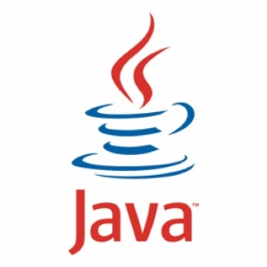

**Figure 2.3.3: Java**

**Technology Detail**

Java is the object oriented programming language that has been designed for develop programs for multiple platforms

**Alternative Technology** - Java**Script**

- C#

- C++

**The selection of this technology**

- Object-oriented language allows contacting with SQL

- Excellent performance.

- Excellent specification

- Great memory

- Clear error messages

  - Powerful for development tools such as Eclipse

**2.4 Development Tool Review**

**2.4.1 Eclipse**



**Figure 2.4.1: Eclipse Logo**

**Development Tool Description**

Eclipse is a program that used for developing Java, Computer language. Eclipse program is the program which used to develop Application Server effectively since Eclipse is Open source software to develop for using by developer. It made develop and progress continuously.

**Alternative Tools** - none

**The selection of this tool**

- Provides reconciled set of possibilities for most of the platforms

- Eclipse support for many plug-in and there are many tools for develop project.

- Many flexible frameworks for building various types of applications

- It is really Enlarge and configurable

- Development of the industrial

**2.4.2** **SQL Server**

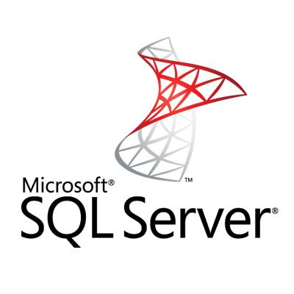  
**Figure 2.4.2: SQL Server Logo**

**Development Tool Description**

SQL Server offers on Microsoft’s Data Platform vision by helping your organization manage any data, any place, anytime from anywhere. Store data from structured, semi-structured and unstructured documents. SQL Server offers a complete set of integrated services that enable you to do more with your data.

**Alternative Tools** - MySQL

**The selection of this tool**

- Access each client reads and writes directly to the raw data tables

- SQL server support for a large database, work efficiently and Microsoft Windows server by processing queries in parallel and minimizing additional memory requirements when more users are added easy to administer complex security schemes, reduces network traffic by processing database queries on the server before sending results to the client.

**2.4.3** **ARDUINO IDE**



**Figure 2.4.3: Arduino Logo**

**Development Tool Description**

An integrated development environment (IDE) based on the Processing project, which includes support for C and C++ programming languages.

**Alternative Tools**

- none

**The selection of this tool**

- Easier to write a command of Arduino

- Code templates help to develop standard app features.

- Large-scale layout editor with support for drag and drop theme editing.

**Chapter Three | Quality Standard**

**3.1** **ISO29110 for Very Small Entity (VSE)**

ISO/IEC 29110 Systems and Software Life Cycle Profiles and Guidelines for Very Small Entity (VSE). A Very Small Entity (VSE) is an enterprise, organization, department or project having up to 25 people. The target of VSE involved in the development or maintenance of software has been published by ISO. The guide provides project management and software implementation processes.

**3.1.1 Project Management process**

The purpose of the Project Management process is to establish and carry out in a systematic way the tasks of the software implementation project, which allows complying with the project’s objectives in the expected quality, time and cost.

**Selected process**

3.1.1. Progress of the project is monitored against the project plan and recorded in the progress status record.

3.1.2. The change requests are addressed through their reception and analysis. Changes to software requirements are evaluated for cost, schedule and technical impact.

3.1.3. Review meetings with the developer and the customer are held. Agreements are registered and tracked.

3.1.4. Risks are identified as they develop and during the conduct of the project.

3.1.5. A software version control strategy is developed. Items of software configuration are identified, defined and baseline. Modifications and releases of the items are controlled and made available to the customer and developer.

3.1.6. Software Quality Assurance is performed to provide assurance that work products and processes comply with the project plan and requirements specification

**3.1.2 Software Implementation process**

The purpose of the Software Implementation process is the systematic performance of the analysis, design, construction, integration and tests activities for new or modified software products according to the specified requirements.

**Selected process**

3.2.1 Software Implementation Initiation Process.

3.2.2 Software Requirements Analysis Process.

3.2.3 Software Architectural Design Process.

3.2.4 Software Construction Process.

3.2.5 Software Integration and Test Process.

3.2.6 Software Delivery Process.

**Chapter Four | Project Plan**

**4.1 Motivation**

SIMPLY BUY is a system that help store in organization manage about dealing. Customer must input information to the system. The system will get detail as name, picture, address and fingerprint. About highlights of this system is customer just touch a finger to finger scan for buy. System will use the money in credit for dealing. SIMPLY BUY can manage about stock of product in the store in design for the organization that people who do not carry cash in that place.

**4.2 Aims and Objectives**

· **Aims**

Manage system financial transactions of prisoners by use technology connect all information into system. The system can work by itself form depositing to dealing.

· **Objectives**

- Reduce old process system that uses many methods.

- Save the human resource and costs.

- Manage all products in the store.

- Manage system financial transactions of prisoner.

**4.3 Deliverables and Limits**

**4.3.1 Annotations**

**Simply buy -** The System that manages financial transactions in the prison organization.

**4.3.2 Deliverables**

**1) progress I**

1. Feature#1: Consist of store management system.

2. Feature#9: Consist of product information in database.

3. Feature#8: Consist of financial store management.

4. Feature#4: Consist of administrator system.

5. Feature#5: Consist of registration administrator system.

**2) progress II**

6. Feature#2: Consist of prisoner information in database.

7. Feature#3: Consist of financial prisoner management.

8. Feature#7: Consist of deposits between prisoner accounts.

9. Feature#6: Consist of connect device to system.

10. Feature#10: Consist of withdrawal between prisoner accounts.

**3) The document and other material**

· Proposal

· Project plan

· Quality plan

· Software requirement specification

· Traceability record

· Software design document

· Testing document

- Test plan

- Unit test report

- System Test report

· 1 DVD stores client source code, relate file, all documents and poster files in PDF format.

· 1 project poster.

**4.3.3 Limits**

· Limits of size of information depend on database server.

· The accuracy of the fingerprint scan depends on device.

## 

## 4.4 Budget

The equipment needed to do the project.

|  |  |
| --- | --- |
| **Category** | **Budget in TH฿** |
| Fingerprint scan module | 1700 ฿ |
| Arduino (Arduino UNO) | 500 ฿ |
| Miscellaneous equipment | 200 ฿ |
| **Total** | **2,400 ฿** |

**4.5 Schedule & Milestones**

**Feature list:**

Feature#1: Consist of store management system.

Feature#2: Consist of product information in database.

Feature#3: Consist of financial store management.

Feature#4: Consist of administrator system.

Feature#5: Consist of registration administrator system.

Feature#6: Consist of prisoner information in database.

Feature#7: Consist of financial prisoner management.

Feature#8: Consist of deposits between prisoner accounts.

Feature#6: Consist of connect device to system.

Feature#10: Consist of withdrawal between prisoner accounts.

**Schedule plan:**

Proposal phase: Create proposal document.

Progress I: Create Development plan, Quality plan, Software requirement specification, Software design document and some part of Test document. Start creates feature# 1, 2, 3,4,5 of system (related with store management system and administrator system.).

Progress II: Create feature# 4, 5, 6, 7, 8,9,10 of the system, software system will connect with device and testing. And integrate all features.

Overall of the system should be complete or nearly.

Final progress (before show pro): Integrate and review all document. Make sure all system and document are complet.

**Figure 4.5.1 Proposal Milestone.**

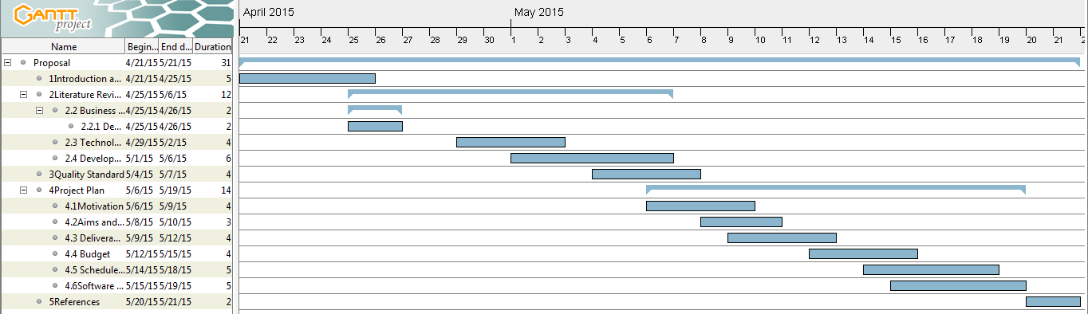

**Figure 4.5.2 Progress1 Milestone.**

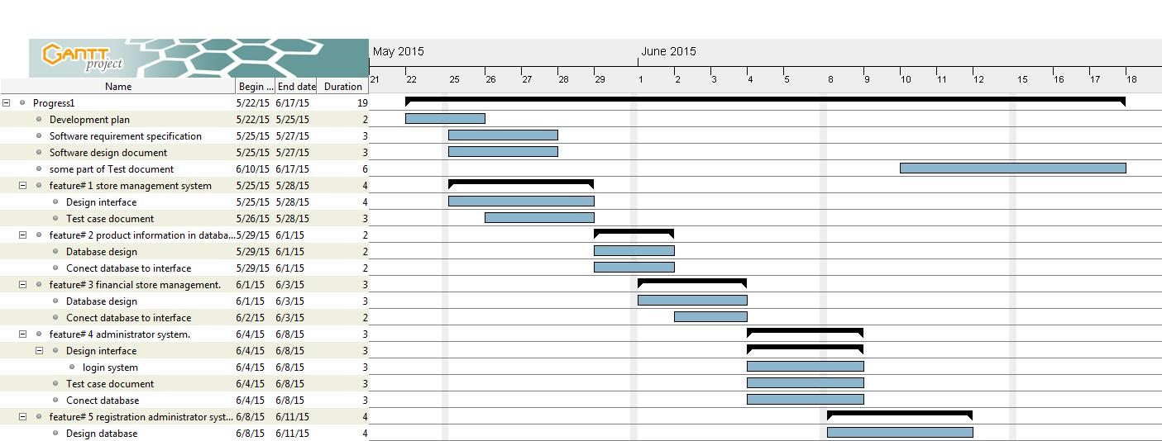

**Figure 4.5.3 Progress2 Milestone.**

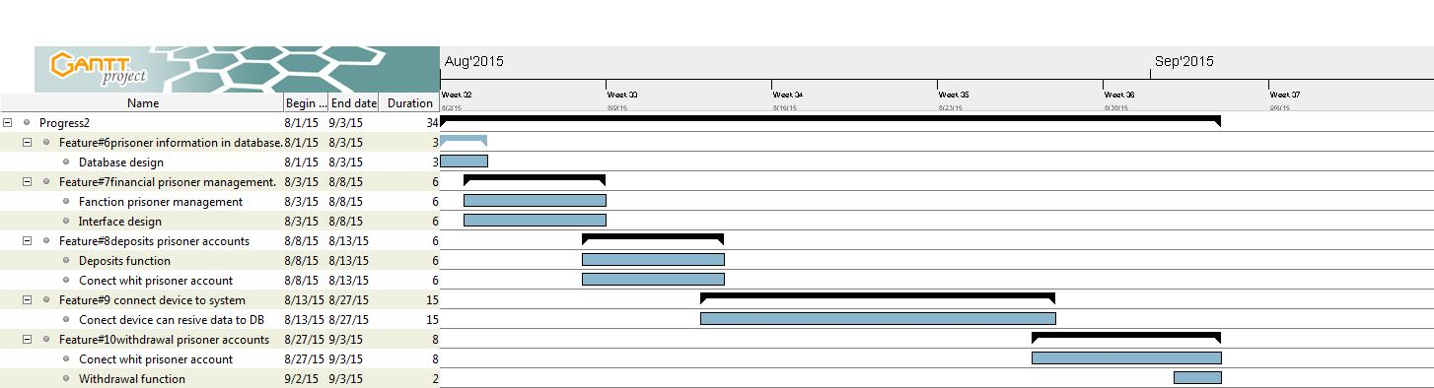

**Chapter Five | References**

[1]Arduino. Retrieved May 9, 2015.

<http://www.arduino.in.th/>

[2]reference fingerprint. Retrieved May 9, 2015.  
<http://www.bioelectronix.com/what_is_biometrics.html>

[3]How to connect Arduino. Retrieved May 9, 2015.

<http://www.instructables.com/id/Arduino-Fingerprint-Lock/?ALLSTEPS>

[4]How to get fingerprint form device. Retrieved May 9, 2015.

<https://www.sparkfun.com/products/11792>

[5]How to connect device to computer. Retrieved May 9, 2015.

<https://www.youtube.com/watch?v=1diFaa5OsFg>