1com.android.build.api.transform.TransformException: com.android.builder.packaging.DuplicateFileException: Duplicate files copied in APK META-INF/maven/com.belerweb/pinyin4j/pom.properties
添加
android {
compileSdkVersion 25
buildToolsVersion "25.0.0"
//为了解决部分第三方库重复打包了META-INF的问题
packagingOptions {
exclude 'META-INF/LICENSE.txt'
exclude 'META-INF/NOTICE.txt'
exclude 'META-INF/license.txt'
exclude 'META-INF/LICENSE'
exclude 'META-INF/notice.txt'
exclude 'META-INF/NOTICE'
exclude 'META-INF/DEPENDENCIES.txt'
exclude 'META-INF/DEPENDENCIES'
exclude 'META-INF/maven/com.belerweb/pinyin4j/pom.properties'
exclude 'META-INF/maven/com.belerweb/pinyin4j/pom.xml'
}
｝

strings.xml
Error:Error: ' ' is not a valid resource name character
string文件中命名有带空格的，去掉就行

java.lang.RuntimeException: Manifest merger failed with multiple errors, see logs
合并Manifest.xml文件错误。查看哪个Manifest.xml文件出错

编译成功。运行的时候报错
Error:Execution failed for task ':transformClassesWithDexForDebug'.
> com.android.build.api.transform.TransformException: com.android.ide.common.process.ProcessException: org.gradle.process.internal.ExecException: Process 'command 'C:\Java\jdk1.8\bin\java.exe'' finished with non-zero exit value 2
往前查看错误信息
UNEXPECTED TOP-LEVEL ERROR:
java.lang.OutOfMemoryError: Java heap space
在android标签下添加
dexOptions {
incremental true
javaMaxHeapSize "4g"
}
多lib包时,编译出错，
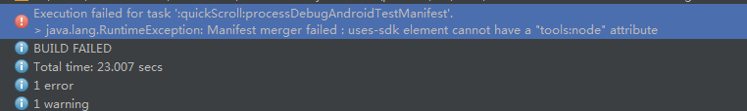

在AndroidManifest.xml里面添加如下
<uses-sdk
tools:node="replace"
android:minSdkVersion="14"
android:targetSdkVersion="19" />

更新Android Studio 3.0之后，出现Cannot set the value of read-only property ‘outputFile’报错，也就是用来打包后重命名的gradle出现了问题

//在apk文件后边生成版本号信息
applicationVariants.all {
variant ->
variant.outputs.each {
output -> output.outputFile = new File(output.outputFile.parent, "VeryFitPro_" + "V" + defaultConfig.versionName + ".apk");
}
}

Error:(44, 0) Cannot set the value of read-only property 'outputFile' for ApkVariantOutputImpl_Decorated{apkData=Main{type=MAIN, fullName=debug, filters=[]}} of type com.android.build.gradle.internal.api.ApkVariantOutputImpl.

更改后
//在apk文件后边生成版本号信息
android.applicationVariants.all {
variant ->
variant.outputs.add {
outputFileName = new File(output.outputFile.parent, "VeryFitPro_" + "V" + defaultConfig.versionName + ".apk");
}
}

No service of type Factory available in ProjectScopeServices.

解决方案更新maven-plugin的依赖
classpath ‘com.github.dcendents:android-maven-gradle-plugin:1.5’

