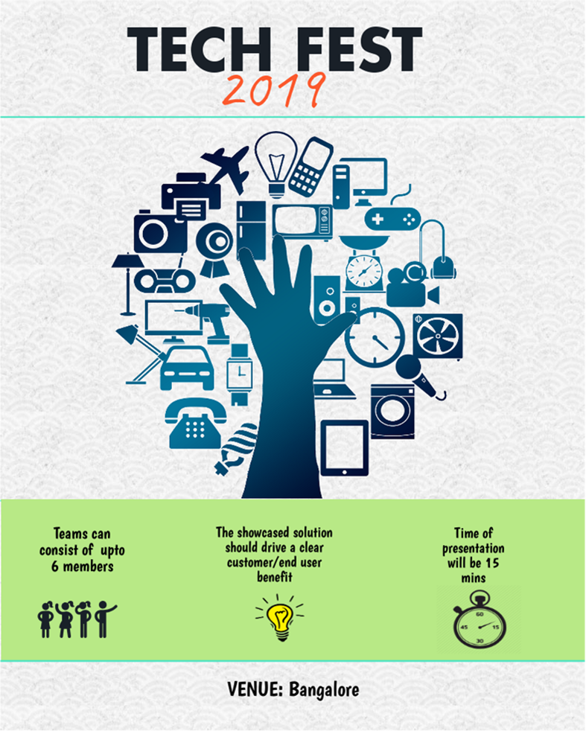

|  |  |
| --- | --- |
| **Who can register?**  This Tech Fest is open to all Capgemini Employees of **Apps Europe** **BU**.  **What is the allowed team size?**  Your team can have maximum 6 people.  Only one person is required to register on behalf of their team.  **Where can I register my team details?**  You can register your team [**here**](https://builders.capgemini.com/event/takeevent?content_id=3ABFA37C-45C5-D235-0392-D677C40CA12E)  **What deadlines should I keep in mind ?**  April 3rd: Submission of ideas/topics by participants (refer **Topics**)  April 8th: Finalization of topic by event organizers. The final selected ideas will move to implementation phase.  April 10th : Finalized Ideas conveyed to teams  April 11th to April 18th: Idea implementation by teams  April 19th: Presentation at **Tech Fest** Venue (maximum 15 mins). All teams will gather at the venue during the half day event (2nd Half)  April 22nd: Winners announcement. | **What *Topics* can I choose from?**  Below is the list of topics that you can choose from for themes around **Manufacturing /Automotive /Aerospace** domains   1. Artificial Intelligence 2. Internet of Things 3. DevOps 4. Blockchain 5. Automation (RPA) 6. Springboot 7. Microservices 8. Dockers   **How will the assessment be done?**   * Solution should showcase tangible customer/end user benefit * It showcases solutions to real time problems * Completeness of the solution provided * Mode of presentation (working demo) * Complexity of the solution and ecosystem   **Register** [**Here**](https://builders.capgemini.com/event/takeevent?content_id=3ABFA37C-45C5-D235-0392-D677C40CA12E)  **Have Questions: Write to** [**khusboo.khusboo@capgemini.com**](mailto:khusboo.khusboo@capgemini.com) |