**Investment**

There are 2 kind of investment.

1. Financial
2. Non-financial

Financial asset can be divided into 2 types

1. Market Linked products( Like mutual fund or stocks)
2. Fixed income products(Like FD or public provident fund)

Non-financial can be like Gold or Real estate.

My Rule: 50:50

50-> fixed income assets

50-> volatile assets (Equity mutual fund, Real estate, gold)

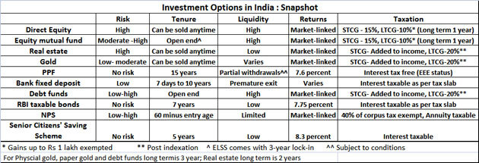

So investment options can be categorized in 4 different category –

1. Mutual fund
2. Different Pension schemes or Government schemes
3. Bank FD, Recurring Deposit, RBI bonds
4. Real Estate, Gold

**Mutual Fund:** [**http://qr.ae/TUNKIA**](http://qr.ae/TUNKIA)

**Mutual Fund KYC:** [**https://economictimes.indiatimes.com/mf/analysis/how-to-get-your-kyc-done/why-should-you-need-a-kyc-done/slideshow/64659076.cms**](https://economictimes.indiatimes.com/mf/analysis/how-to-get-your-kyc-done/why-should-you-need-a-kyc-done/slideshow/64659076.cms)

**Bank RD (Recurring Deposit):** it is like SIP. Every month certain amount deducted and interest paid at the end of maturity**.**

**Bank FD:** It is like lumpsum. Interest can be paid quarterly or annually.

**Prematurity exit charge apply in both cases.**

**Gold:** Not to good option to invest because of very low return even less than FD.

**Real Estate:** Land, Flats…etc. Procedure of buy Real-estate is complicated because no online work here and each state has its different procedure. Other expert person required.

**Different Pension Schemes –**

1. EPF(Employee provident Fund)
2. PPF(public provident Fund)
3. NPS(National Pension Schemes)

**Different Government Schemes like:**

1. Sukanya Samriddhi Yojana (SSY)
2. National Savings Certificate (NSC)

These are basically investment schemes for retirement and tax saving I will go through this after having stable job.

**To do:**

1. **Activate online FD service on your account.**
2. **Do mutual fund KYC.**