### 变更信息

20200407 10:00 文档新建

20200407 16:00 io信息修改，多个硬盘结果合并。

20200408 14:00 硬盘信息_明细，硬盘信息_汇总返回结果去掉%,以kb为单位，不显示G、M

20200410 16:00 新增内存历史查询、io历史查询、硬盘历史查询、cpu历史查询、cpu信息-明细新增字段niCpuRate（改变过优先级的进程占用CPU的百分比）

20200414 17:00 硬盘明细新增挂载点字段

### 定时任务

定时任务控制类名 com.pactera.monitoring.quartz.QuartzJob

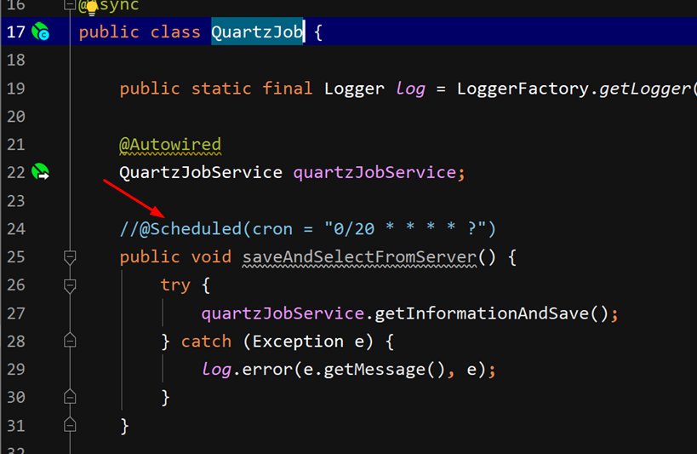

如图：开启时只需要打开@Scheduled注释，配置需要的cron表达式即可

### 1、内存信息

http://localhost:8080/memInfo/summary?ip=127.0.0.1

{

"code": "200",

"message": "成功",

"data": {

"serviceNm": "f667ef11850c", //服务器名称

"memTotal": "1.943", //内存总大小

"memUseTotal": "1.396", //内存已使用大小

"freeMemTotal": "0.547", //空闲内存大小

"sharedMemTotal": "0.297", //进程共享内存总额

"bufferCacheUseMemTotal": "0.986", //缓存使用大小

"swapMemTotal": "1.000", //交换区总大小

"swapUseMemTotal": "0.000", //交换区使用大小

"swapFreeMemTotal": "1.000", //交换区空闲大小

"memUsedRate": "71.845" //服务器使用内存占比

}

}

### 2、服务器基本信息

http://localhost:8080/serverInfo/summary?ip=127.0.0.1

{

"code": "200",

"message": "成功",

"data": {

"serviceNm": "f667ef11850c", //服务器名称

"serviceIp": "127.0.0.1", //服务器ip

"dataDt": "2020-04-07T01:24:58.547+0000", //当前时间

"serviceVersion": "Ubuntu 14.04.1 LTS", //服务器系统版本

"serviceActive": "1", //服务器运行状态1正常0死亡

"serviceCoreVersion": "4.19.76-linuxkit" //服务器内核版本信息

}

}

### 3、cpu信息—明细

http://localhost:8080/cpuInfo/detail?ip=127.0.0.1

{

"code": "200",

"message": "成功",

"data": {

"serviceNm": "f667ef11850c", //服务器名称

"serviceIp": "127.0.0.1", //服务器ip

"dataDt": "2020-04-07T01:28:10.854+0000", //当前时间

"usCpuRate": "0", //用户空间占用CPU百分比

"syCpuRate": "0", //内核空间占用CPU的百分比

"idCpuRate": "100", //空闲CPU百分比

"waCpuRate": "0" //IO等待占用CPU的百分比

"niCpuRate": "0" //改变过优先级的进程占用CPU的百分比

}

}

### 4、cpu信息——汇总

http://localhost:8080/cpuInfo/summary?ip=127.0.0.1

{

"code": "200",

"message": "成功",

"data": {

"serviceNm": "f667ef11850c", //服务器名称

"dataDt": "2020-04-07T01:31:49.032+0000", //当前时间

"cpuType": "Intel(R) Core(TM) i7-4710MQ CPU @ 2.50GHz", //CPU型号

"cpuNum": "1", //CPU个数

"cpuThread": "2" //CPU线程数

}

}

### 5、硬盘信息-明细

http://localhost:8080/diskInfo/detail?ip=127.0.0.1

{

"msg": "操作成功",

"code": 0,

"data": [

{

"serviceNm": "c53dccbfd2f7", //服务器名称

"serviceIp": "127.0.0.1", //服务器ip

"dataDt": "2020-04-15T00:46:08.403+0000", //当前时间

"filesystemNm": "overlay", //文件系统名称

"diskTotalSize": "61255652", //所在磁盘大小

"diskUsedSize": "16192700", //所在磁盘使用大小

"diskUsedRate": "28", //所在磁盘使用率

"diskAvailSize": "41921620", //磁盘剩余容量

"mountedOn": "/"

},

{

"serviceNm": "c53dccbfd2f7",

"serviceIp": "127.0.0.1",

"dataDt": "2020-04-15T00:46:08.403+0000",

"filesystemNm": "tmpfs",

"diskTotalSize": "65536",

"diskUsedSize": "0",

"diskUsedRate": "0",

"diskAvailSize": "65536",

"mountedOn": "/dev"

},

{

"serviceNm": "c53dccbfd2f7",

"serviceIp": "127.0.0.1",

"dataDt": "2020-04-15T00:46:08.403+0000",

"filesystemNm": "tmpfs",

"diskTotalSize": "1018508",

"diskUsedSize": "0",

"diskUsedRate": "0",

"diskAvailSize": "1018508",

"mountedOn": "/sys/fs/cgroup"

},

{

"serviceNm": "c53dccbfd2f7",

"serviceIp": "127.0.0.1",

"dataDt": "2020-04-15T00:46:08.403+0000",

"filesystemNm": "shm",

"diskTotalSize": "65536",

"diskUsedSize": "0",

"diskUsedRate": "0",

"diskAvailSize": "65536",

"mountedOn": "/dev/shm"

},

{

"serviceNm": "c53dccbfd2f7",

"serviceIp": "127.0.0.1",

"dataDt": "2020-04-15T00:46:08.403+0000",

"filesystemNm": "/dev/sda1",

"diskTotalSize": "61255652",

"diskUsedSize": "16192700",

"diskUsedRate": "28",

"diskAvailSize": "41921620",

"mountedOn": "/etc/hosts"

},

{

"serviceNm": "c53dccbfd2f7",

"serviceIp": "127.0.0.1",

"dataDt": "2020-04-15T00:46:08.403+0000",

"filesystemNm": "tmpfs",

"diskTotalSize": "1018508",

"diskUsedSize": "8456",

"diskUsedRate": "1",

"diskAvailSize": "1010052",

"mountedOn": "/run"

}

]

}

### 6、硬盘信息-汇总

http://localhost:8080/diskInfo/summary?ip=127.0.0.1

{

"code": "200",

"message": "成功",

"data": {

"serviceNm": "c53dccbfd2f7", //服务器名称

"serviceIp": "127.0.0.1", //服务器IP

"dataDt": "2020-04-08T06:29:31.429+0000", //当前时间

"diskTotalSize": "124679392", //磁盘总大小

"diskUsedSize": "32380040", //磁盘使用大小

"diskUsedRate": "28", //磁盘使用率

"diskAvailSize": "86016688" //磁盘剩余容量

}

}

### 7、io信息-汇总

http://localhost:8080/ioInfo/summary?ip=127.0.0.1

{

"code": "200",

"message": "成功",

"data": {

"serviceNm": "f667ef11850c", //服务器名称

"serviceIp": "127.0.0.1", //服务器IP

"dataDt": "2020-04-07T09:00:21.111+0000", //当前时间

"diskTrans": "4.650", //磁盘每秒传输速度

"diskRead": "0.580", //磁盘每秒读取数

"diskWrite": "4.070", //磁盘每秒写入数

"diskUseRate": "25.155", //磁盘使用率

"diskAvgRespond": "0.293" //磁盘平均响应时间

}

### 内存历史查询

|  |  |
| --- | --- |
| 网络请求类型 | post |
| 请求地址 | <http://localhost:8080/memInfo/list> |
| 参数 | |
| ip | 查询服务器信息的ip |
| startTime | 查询开始时间(格式：2020-04-10) |
| endTime | 查询结束时间(格式：2020-04-10) |
| pageSize | 每条条数 |
| pageNum | 页数 |

结果集字段含义

|  |  |
| --- | --- |
| dataDt | 时间 |
| memTotal | 内存总大小 |
| memUseTotal | 内存已使用大小 |
| freeMemTotal | 空闲内存大小 |
| bufferCacheUseMemTotal | 缓存使用大小 |
| swapMemTotal | 交换区总大小 |

结果集：

{

"total": 54,

"rows": [

{

"dataDt": "2020-04-10T05:20:20.000+0000",

"memTotal": "1.943",

"memUseTotal": "0.403",

"freeMemTotal": "0.564",

"bufferCacheUseMemTotal": "0.976",

"swapMemTotal": "1.000"

},

{

"dataDt": "2020-04-10T05:20:00.000+0000",

"memTotal": "1.943",

"memUseTotal": "0.398",

"freeMemTotal": "0.569",

"bufferCacheUseMemTotal": "0.976",

"swapMemTotal": "1.000"

}

],

"code": 0,

"msg": 0

}

### IO历史查询

|  |  |
| --- | --- |
| 网络请求类型 | post |
| 请求地址 | http://localhost:8080/ioInfo/list |
| 参数 | |
| ip | 查询服务器信息的ip |
| startTime | 查询开始时间(格式：2020-04-10) |
| endTime | 查询结束时间(格式：2020-04-10) |
| pageSize | 每条条数 |
| pageNum | 页数 |

结果集字段含义

|  |  |
| --- | --- |
| dataDt | 时间 |
| diskTrans | 磁盘每秒传输速度 |
| diskRead | 磁盘每秒读取数 |
| diskWrite | 磁盘每秒写入数 |
| diskUseRate | 磁盘使用率 |
| diskAvgRespond | 磁盘平均响应时间 |

结果集：

{

"total": 54,

"rows": [

{

"dataDt": "2020-04-10T05:20:31.000+0000",

"diskTrans": "50.420",

"diskRead": "41.960",

"diskWrite": "8.460",

"diskUseRate": "25.972",

"diskAvgRespond": "3.026"

},

{

"dataDt": "2020-04-10T05:20:00.000+0000",

"diskTrans": "50.510",

"diskRead": "42.050",

"diskWrite": "8.460",

"diskUseRate": "25.972",

"diskAvgRespond": "3.026"

}

],

"code": 0,

"msg": 0

}

### 硬盘历史查询

|  |  |
| --- | --- |
| 网络请求类型 | post |
| 请求地址 | http://localhost:8080/diskInfo/list |
| 参数 | |
| ip | 查询服务器信息的ip |
| startTime | 查询开始时间(格式：2020-04-10) |
| endTime | 查询结束时间(格式：2020-04-10) |
| pageSize | 每条条数 |
| pageNum | 页数 |

结果集字段含义

|  |  |
| --- | --- |
| dataDt | 时间 |
| filesystemNm | 文件系统名称 |
| diskTotalSize | 所在磁盘大小 |
| diskUsedSize | 所在磁盘使用大小 |
| diskUsedRate | 所在磁盘使用率 |
| mountedOn | 挂载点 |

结果集：

{

"total": 3,

"rows": [

{

"dataDt": "2020-04-15T00:50:00.000+0000",

"filesystemNm": "tmpfs",

"diskTotalSize": "1018508",

"diskUsedSize": "0",

"diskUsedRate": "0",

"mountedOn": "/sys/fs/cgroup"

},

{

"dataDt": "2020-04-15T00:50:00.000+0000",

"filesystemNm": "tmpfs",

"diskTotalSize": "1018508",

"diskUsedSize": "8456",

"diskUsedRate": "1",

"mountedOn": "/run"

},

{

"dataDt": "2020-04-15T00:50:00.000+0000",

"filesystemNm": "tmpfs",

"diskTotalSize": "65536",

"diskUsedSize": "0",

"diskUsedRate": "0",

"mountedOn": "/dev"

}

],

"code": 0,

"msg": 0

}

### cpu历史查询

|  |  |
| --- | --- |
| 网络请求类型 | post |
| 请求地址 | http://localhost:8080/cpuInfo/list |
| 参数 | |
| ip | 查询服务器信息的ip |
| startTime | 查询开始时间(格式：2020-04-10) |
| endTime | 查询结束时间(格式：2020-04-10) |
| pageSize | 每条条数 |
| pageNum | 页数 |

结果集字段含义

|  |  |
| --- | --- |
| dataDt | 时间 |
| usCpuRate | 用户空间占用CPU百分比 |
| syCpuRate | 内核空间占用CPU的百分比 |
| niCpuRate | 改变过优先级的进程占用CPU的百分比 |
| idCpuRate | 空闲CPU百分比 |
| waCpuRate | IO等待占用CPU的百分比 |

结果集：

{

"total": 54,

"rows": [

{

"dataDt": "2020-04-10T05:20:32.000+0000",

"usCpuRate": "0.00",

"syCpuRate": "0.50",

"niCpuRate": "0.00",

"idCpuRate": "99.50",

"waCpuRate": "0.00"

},

{

"dataDt": "2020-04-10T05:20:00.000+0000",

"usCpuRate": "0.00",

"syCpuRate": "0.50",

"niCpuRate": "0.00",

"idCpuRate": "99.50",

"waCpuRate": "0.00"

}

],

"code": 0,

"msg": 0

}