Enterprise Service Intake
Architecture & Design Brief
Candidate | Forrest Zhang
Role | Power Platform Senior Developer - Take-Home Case
Prepared For | Mitacs technical review team
Environment | https://mitacs.crm.dynamics.com/
Portal | https://enterprise-service-intake-hellox.powerappsportals.com
Status | Interview submission artifact

Executive Summary
This solution implements an enterprise-grade external service request intake process using Power Pages, Dataverse, Power Automate, C# plugins, and PCF. External customers submit authenticated multi-step requests, receive real-time routing and SLA feedback, and upload supporting documentation. Dataverse holds the system of record while server-side plugins apply non-bypassable routing and close-validation rules. Power Automate handles manager approval, mock ERP synchronization, and resilient error logging.

End-to-End Outcome
- Customer submits a portal request and receives a formatted confirmation number.
- Dataverse plugin applies the matching routing/SLA rule and flags approval or documentation requirements.
- Internal coordinator reviews the request in the model-driven app with a PCF status indicator.
- Critical or high-priority items route to manager approval.
- Approved requests are posted to a mock REST endpoint and the external system ID is written back to Dataverse.
- Failures in approval or integration are captured in a custom System Error Log table.

Reviewer Access
The environment, portal, and repository are prepared so reviewers can walk through the complete vertical slice.
Area | Value | Reviewer Use
Environment | https://mitacs.crm.dynamics.com/ | Open Dataverse tables, model-driven app, flow runs, and solution components.
Maker Solution | https://make.powerapps.com/environments/99dd50ed-a753-e37f-912c-78a022b12b09/solutions | Review solution-aware components and exports.
Model-driven App | https://mitacs.crm.dynamics.com/main.aspx?appid=3de4f813-b454-f111-bec7-000d3a3aca8f | Review request queue, form fields, and PCF/internal user experience.
Power Pages Site | https://enterprise-service-intake-hellox.powerappsportals.com | Submit a customer request and verify dynamic SLA/routing preview.
Cloud Flow | ESI - Approval and ERP Sync | Review approval, HTTP sync, run history, and Try/Catch error handling.

Reviewer Accounts
Account | Purpose
forrest@hellosmart.ca | Admin/customizer reviewer
agent@hellosmart.ca | Internal service coordinator
manager@hellosmart.ca | Approval manager
Credential handling: passwords are intentionally not stored in Git or in this document. The system administrator should share them out of band and rotate them after the interview.

Architecture Overview
The solution keeps Dataverse as the authority for state while placing business logic in the component that best enforces the requirement.
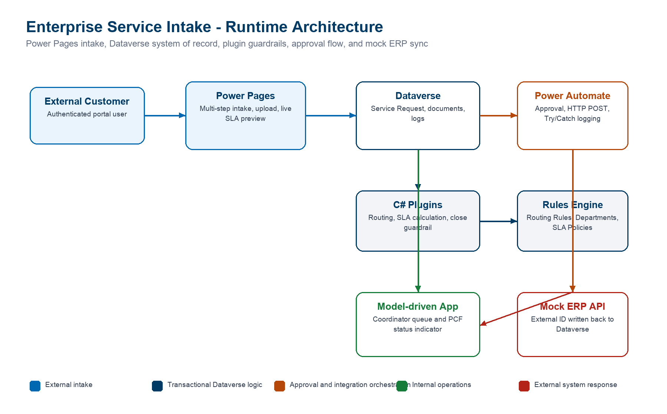

Component Placement
Requirement | Component | Reason
External intake | Power Pages | Provides authenticated customer access, contact-scoped data permissions, multi-step forms, upload support, and Liquid/Web API extensibility.
System of record | Dataverse | Central relational model, security roles, ownership, auditing, solution packaging, and consistency across portal, app, flow, and APIs.
Routing and SLA | C# plugin | Runs transactionally when rows are created or updated and cannot be bypassed through imports, API calls, flows, or alternate clients.
Close guardrail | C# plugin | Enforces critical-request documentation requirements at the server boundary, which is stronger than form scripts or flow validation.
Approval and ERP sync | Power Automate | Human approval, HTTP action, connector run history, retry behavior, and clear Try/Catch observability belong in orchestration.
Internal coordinator UX | Model-driven app + PCF | Model-driven app gives secure operational CRUD; PCF adds concise visual severity/SLA/approval status.

Dataverse Data Strategy
The data model separates request state, rule configuration, documents, integration telemetry, and operational error records.
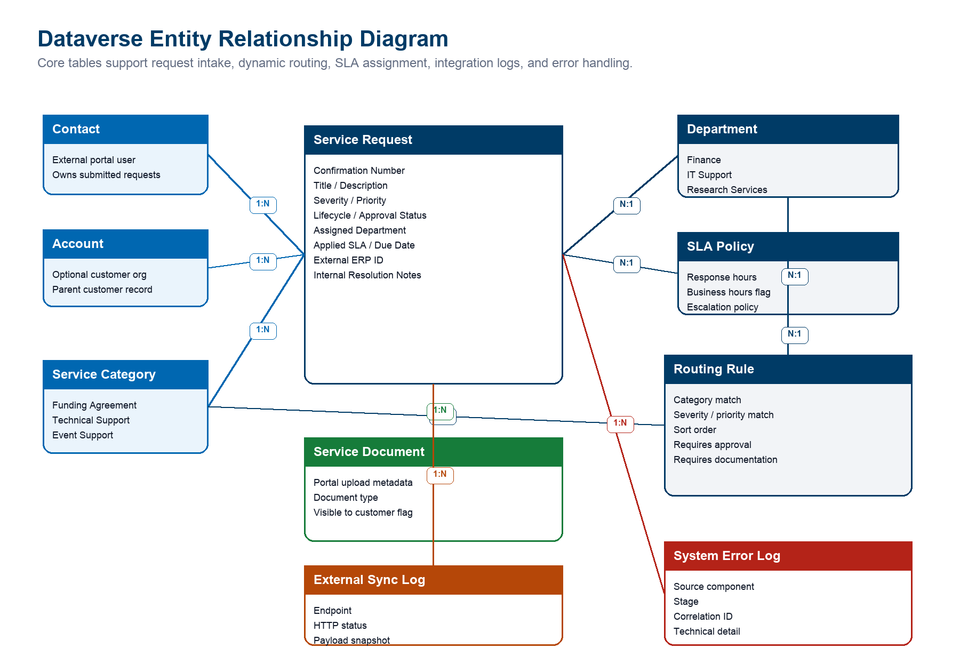

Core Tables
Table | Purpose | Key Relationships
Service Request | Primary intake and work-management row. Stores confirmation number, status, priority, SLA, assigned department, approval state, integration state, external ERP ID, and internal notes. | Contact, Account, Service Category, Department, SLA Policy, Service Document, External Sync Log, System Error Log
Routing Rule | Configurable rules engine row. Matches category/severity/priority and supplies department, SLA, approval requirement, and documentation requirement. | Service Category, Department, SLA Policy
Department | Internal routing destination for operational ownership. | Service Request, Routing Rule
SLA Policy | Response target and escalation policy assigned by routing. | Service Request, Routing Rule
Service Document | Supporting documentation metadata for portal uploads. | Service Request
External Sync Log | Integration audit trail for outbound ERP calls. | Service Request
System Error Log | Structured error capture for plugin, flow, and integration failures. | Service Request optional

Confirmation Number
- Service Request uses a Dataverse autonumber format: SR-{yyyyMMdd}-{SEQNUM}.
- The number is generated server-side, remains stable after creation, and is safe to show externally.
- The formatted value gives customers a readable reference while preserving Dataverse row IDs for integration and support work.

Security Strategy
The design assumes least privilege across external portal users, internal coordinators, managers, and administrators.

Power Pages Access
- External users authenticate to Power Pages and are associated to Contact rows.
- Table permissions are contact-scoped so users can create requests and view only requests tied to their contact.
- Reference data needed for dynamic preview, such as active service categories and routing outcomes, is exposed read-only.
- Portal forms exclude internal-only fields, integration payloads, internal notes, sync logs, and system error logs.

Internal Dataverse Access
- Coordinators use the model-driven app for operational request triage.
- Managers review approvals and can inspect high-priority items.
- Sensitive internal resolution notes are kept off the portal and should be protected with role and column-level security in production.
- Error and sync telemetry tables are intended for managers, admins, and support owners rather than broad staff access.

Security Tradeoffs
Area | Lean Demo Choice | Production Hardening
Portal identity | Authenticated Power Pages users in the interview tenant. | Use Entra External ID or a configured B2C provider, lifecycle controls, and conditional access where appropriate.
Uploads | Portal upload step captures supporting documentation metadata. | Apply file type limits, malware scanning, retention rules, and DLP review.
Secrets | No tenant passwords or tokens committed to Git. | Use connection references, environment variables, Key Vault-backed custom connectors, and managed identities where available.

External User Experience
The portal is scoped as a clean customer intake experience rather than an internal operations surface.

Submission Flow
- User signs in to the Power Pages site.
- User starts a new service request and enters request details.
- User selects category, severity, and priority.
- Portal dynamically previews expected department, SLA target, approval requirement, and documentation requirement before final submission.
- User uploads supporting documentation where needed.
- User reviews and submits the request, then receives a confirmation number.

Dynamic Preview Implementation
- The portal reads eligible routing/SLA data through Power Pages Web API and/or Liquid-rendered data.
- Client-side JavaScript recalculates the displayed routing destination and expected SLA when the user changes category, severity, or priority.
- The preview avoids a full page reload and mirrors the server-side plugin rule result, while the plugin remains the authoritative enforcement layer.

Automation And Integration
The cloud flow handles long-running human approval and integration work that should remain visible in run history.

Flow: ESI - Approval and ERP Sync
Stage | Implementation
Trigger | Dataverse row added or modified for Service Request where approval is required, approval is pending, and integration is unsynced.
Try scope | Start and wait for approval assigned to manager@hellosmart.ca, branch on decision, call mock ERP API, update request, and write External Sync Log.
HTTP sync | POST approved request details to https://api.restful-api.dev/objects and store the returned external id in Dataverse.
Reject branch | Mark approval rejected and skip ERP sync.
Catch scope | Runs after failure, timeout, or skipped Try scope; writes System Error Log with flow run correlation details and marks the request failed.

Resiliency Pattern
- Try/Catch scopes make failures observable and reviewable during the live demo.
- The custom System Error Log captures source component, stage, message, technical detail, correlation ID, and related request.
- Request integration status is updated to failed when the integration path cannot complete.
- Flow run history and Approval records provide proof if tenant email delivery is restricted.

Pro-Code Extensibility
The pro-code pieces are intentionally placed where low-code would either be bypassable or less effective.
Component | Location | Responsibility | Why Here
ServiceRequestRoutingPlugin | src/plugins/ServiceIntake.Plugins/ServiceRequestRoutingPlugin.cs | Evaluates routing rules, assigns department/SLA, sets due date, approval requirement, documentation requirement, and lifecycle defaults. | PreOperation server-side plugin keeps routing transactional and consistent across all entry points.
ServiceRequestClosureGuardPlugin | src/plugins/ServiceIntake.Plugins/ServiceRequestClosureGuardPlugin.cs | Blocks closure of critical requests unless internal resolution notes and documentation evidence are present. | Server-side validation prevents bypass from forms, imports, flows, and APIs.
SlaStatusIndicator PCF | src/pcf/SlaStatusIndicator/ | Displays severity, SLA, approval, and sync status as a compact coordinator-facing visual. | PCF improves internal model-driven usability without duplicating authoritative business logic.
Provisioning Utility | src/scripts/ServiceIntake.Provisioning/ | Creates metadata, registers plugins, provisions app/forms/views, sample data, and flow definition patching. | Makes the environment build repeatable and keeps ALM steps reviewable.

ALM, Verification, And Demo Evidence
The repository contains both deployable solution packages and unpacked source so reviewers can inspect the implementation.

Deliverables
Artifact | Location
Managed solution | solution/export/Enterprise_ServiceIntake_ForrestZhang_managed.zip
Unmanaged solution | solution/export/Enterprise_ServiceIntake_ForrestZhang_unmanaged.zip
Unpacked solution source | solution/unpacked/managed/ and solution/unpacked/unmanaged/
C# plugin source | src/plugins/ServiceIntake.Plugins/
PCF source | src/pcf/SlaStatusIndicator/
Power Pages source | src/powerpages/ and powerpages-live/
Demo script | docs/demo/demo-script.md
Verification notes | docs/evidence/verification.md

Verified Behavior
Check | Evidence
Plugin build | Passed.
Provisioning utility | Builds and runs, with upstream SDK NU1903 warnings from Microsoft.PowerPlatform.Dataverse.Client dependency.
PCF | Build and pac pcf push passed.
Power Pages | Dynamic preview shows Finance, 4 hour SLA, approval required, and documentation required for critical funding requests.
Portal submission | Portal demo request created with formatted confirmation SR-20260521-001004.
Closure guard | Smoke test blocked undocumented critical closure and allowed documented closure.
Flow | Active, solution-aware, and includes approval, HTTP sync, reject branch, External Sync Log, and Catch error-log scope.
Solution export/unpack | Managed and unmanaged exports and unpacked source generated successfully.

Known Demo Notes
- If email delivery is restricted, use Approval records and Flow run history as evidence.
- reqres.in currently requires an API key for POST, so the mock ERP endpoint uses api.restful-api.dev to keep the demo self-contained.
- If a target environment does not automatically bind the PCF control on import, add the PCF control to the coordinator form field in the form designer.

Live Demonstration Path
The demo is designed to show the full lifecycle and then drill into implementation decisions.
- Walk through the ERD and architecture choices.
- Submit a critical funding request from the portal and show dynamic preview before submit.
- Open the request in the model-driven app and review routing, SLA, approval, sync status, and internal fields.
- Open the cloud flow and explain approval, HTTP POST, writeback, sync log, reject branch, and Catch scope.
- Demonstrate or explain failure handling through System Error Log rows.
- Demonstrate the critical close guardrail through the smoke test or form behavior.
- Show managed solution, unpacked source, PCF, plugin source, Power Pages source, and GitHub repository.

Prepared Q&A
Question | Answer
Why plugin over flow for routing? | Routing must be transactional and consistent for every entry point, including portal, model app, imports, flows, and APIs.
Why plugin for close validation? | The requirement says agents cannot bypass documentation requirements; server-side PreOperation validation is the correct enforcement point.
Why flow for approvals and ERP sync? | Approvals and integration orchestration need human workflow, connector history, retry visibility, and run evidence.
How do customers only see their data? | Power Pages users are tied to Contacts, and contact-scoped table permissions restrict request visibility to owned rows.
How is this deployable? | Components are solution-aware, exported as managed/unmanaged zips, unpacked with PAC, and source-controlled with raw plugin and PCF code.

