尚硅谷大数据技术之Kafka（外部系统集成）
（作者：尚硅谷研究院）

版本：V3.3

第1章 集成Flume
Flume是一个在大数据开发中非常常用的组件。可以用于Kafka的生产者，也可以用于Flume的消费者。
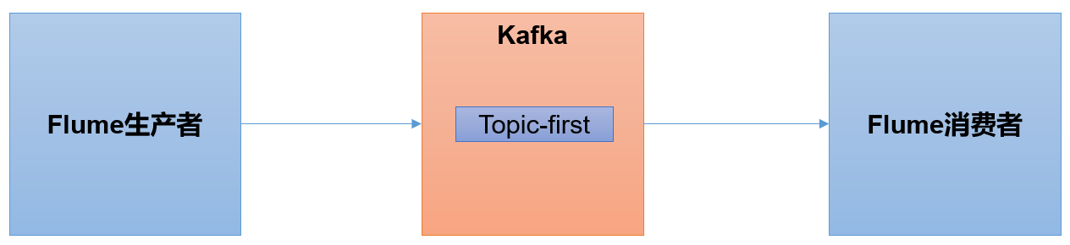

1.1 Flume生产者
（1）启动kafka集群
[atguigu@hadoop102 ~]$ zk.sh start
[atguigu@hadoop102 ~]$ kf.sh start
（2）启动kafka消费者
[atguigu@hadoop103 kafka]$ bin/kafka-console-consumer.sh --bootstrap-server hadoop102:9092 --topic first
（3）Flume安装步骤
在hadoop102主机上安装Flume。
详见：尚硅谷大数据技术之Flume
（4）配置Flume
在hadoop102节点的Flume的job目录下创建file_to_kafka.conf
[atguigu@hadoop102 flume]$ mkdir jobs
[atguigu@hadoop102 flume]$ vim jobs/file_to_kafka.conf
配置文件内容如下
# 1 组件定义
a1.sources = r1
a1.sinks = k1
a1.channels = c1

# 2 配置source
a1.sources.r1.type = TAILDIR
a1.sources.r1.filegroups = f1
a1.sources.r1.filegroups.f1 = /opt/module/applog/app.*
a1.sources.r1.positionFile = /opt/module/flume/taildir_position.json

# 3 配置channel
a1.channels.c1.type = memory
a1.channels.c1.capacity = 1000
a1.channels.c1.transactionCapacity = 100

# 4 配置sink
a1.sinks.k1.type = org.apache.flume.sink.kafka.KafkaSink
a1.sinks.k1.kafka.bootstrap.servers = hadoop102:9092,hadoop103:9092,hadoop104:9092
a1.sinks.k1.kafka.topic = first
a1.sinks.k1.kafka.flumeBatchSize = 20
a1.sinks.k1.kafka.producer.acks = 1
a1.sinks.k1.kafka.producer.linger.ms = 1

# 5 拼接组件
a1.sources.r1.channels = c1
a1.sinks.k1.channel = c1
（5）启动Flume
[atguigu@hadoop102 flume]$ bin/flume-ng agent -c conf/ -n a1 -f jobs/file_to_kafka.conf &
（6）向/opt/module/applog/app.log里追加数据，查看kafka消费者消费情况
[atguigu@hadoop102 module]$ mkdir applog
[atguigu@hadoop102 applog]$ echo hello >> /opt/module/applog/app.log
（7）观察kafka消费者，能够看到消费的hello数据

1.2 Flume消费者
（1）配置Flume
在hadoop102节点的Flume的/opt/module/flume/jobs目录下创建kafka_to_file.conf
[atguigu@hadoop102 jobs]$ vim kafka_to_file.conf
配置文件内容如下
# 1 组件定义
a1.sources = r1
a1.sinks = k1
a1.channels = c1

# 2 配置source
a1.sources.r1.type = org.apache.flume.source.kafka.KafkaSource
a1.sources.r1.batchSize = 50
a1.sources.r1.batchDurationMillis = 200
a1.sources.r1.kafka.bootstrap.servers = hadoop102:9092
a1.sources.r1.kafka.topics = first
a1.sources.r1.kafka.consumer.group.id = custom.g.id

# 3 配置channel
a1.channels.c1.type = memory
a1.channels.c1.capacity = 1000
a1.channels.c1.transactionCapacity = 100

# 4 配置sink
a1.sinks.k1.type = logger

# 5 拼接组件
a1.sources.r1.channels = c1
a1.sinks.k1.channel = c1
（2）启动Flume
[atguigu@hadoop102 flume]$ bin/flume-ng agent -c conf/ -n a1 -f jobs/kafka_to_file.conf -Dflume.root.logger=INFO,console
（3）启动kafka生产者
[atguigu@hadoop103 kafka]$ bin/kafka-console-producer.sh --bootstrap-server hadoop102:9092 --topic first
并输入数据，例如：hello world
（4）观察控制台输出的日志

第2章 集成Flink
Flink是一个在大数据开发中非常常用的组件。可以用于Kafka的生产者，也可以用于Flink的消费者。
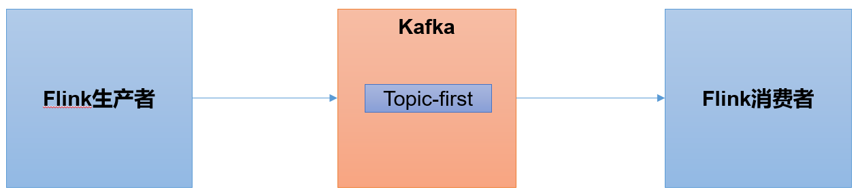
1）Flink环境准备
（1）创建一个maven项目flink-kafka
（2）添加配置文件
<dependencies>
<dependency>
<groupId>org.apache.flink</groupId>
<artifactId>flink-java</artifactId>
<version>1.13.0</version>
</dependency>

<dependency>
<groupId>org.apache.flink</groupId>
<artifactId>flink-streaming-java_2.12</artifactId>
<version>1.13.0</version>
</dependency>

<dependency>
<groupId>org.apache.flink</groupId>
<artifactId>flink-clients_2.12</artifactId>
<version>1.13.0</version>
</dependency>

<dependency>
<groupId>org.apache.flink</groupId>
<artifactId>flink-connector-kafka_2.12</artifactId>
<version>1.13.0</version>
</dependency>
</dependencies>
（3）将log4j.properties文件添加到resources里面，就能更改打印日志的级别为error
log4j.rootLogger=error, stdout,R
log4j.appender.stdout=org.apache.log4j.ConsoleAppender
log4j.appender.stdout.layout=org.apache.log4j.PatternLayout
log4j.appender.stdout.layout.ConversionPattern=%d{yyyy-MM-dd HH:mm:ss,SSS} %5p --- [%50t] %-80c(line:%5L) : %m%n

log4j.appender.R=org.apache.log4j.RollingFileAppender
log4j.appender.R.File=../log/agent.log
log4j.appender.R.MaxFileSize=1024KB
log4j.appender.R.MaxBackupIndex=1

log4j.appender.R.layout=org.apache.log4j.PatternLayout
log4j.appender.R.layout.ConversionPattern=%d{yyyy-MM-dd HH:mm:ss,SSS} %5p --- [%50t] %-80c(line:%6L) : %m%n
（4）在java文件夹下创建包名为com.atguigu.flink

2.1 Flink生产者
（1）在com.atguigu.flink包下创建java类：FlinkKafkaProducer1
package com.atguigu.flink;

import org.apache.flink.api.common.serialization.SimpleStringSchema;
import org.apache.flink.streaming.api.datastream.DataStream;
import org.apache.flink.streaming.api.environment.StreamExecutionEnvironment;
import org.apache.flink.streaming.connectors.kafka.FlinkKafkaProducer;
import org.apache.kafka.clients.producer.ProducerConfig;

import java.util.ArrayList;
import java.util.Properties;

public class FlinkKafkaProducer1 {

public static void main(String[] args) throws Exception {
// 0 初始化flink环境
StreamExecutionEnvironment env = StreamExecutionEnvironment.getExecutionEnvironment();
env.setParallelism(3);

// 1 读取集合中数据
ArrayList<String> wordsList = new ArrayList<>();
wordsList.add("hello");
wordsList.add("world");

DataStream<String> stream = env.fromCollection(wordsList);

// 2 kafka生产者配置信息
Properties properties = new Properties();
properties.put(ProducerConfig.BOOTSTRAP_SERVERS_CONFIG, "hadoop102:9092");

// 3 创建kafka生产者
FlinkKafkaProducer<String> kafkaProducer = new FlinkKafkaProducer<>(
"first",
new SimpleStringSchema(),
properties
);

// 4 生产者和flink流关联
stream.addSink(kafkaProducer);

// 5 执行
env.execute();
}
}
（2）启动Kafka消费者
[atguigu@hadoop104 kafka]$ bin/kafka-console-consumer.sh --bootstrap-server hadoop102:9092 --topic first
（3）执行FlinkKafkaProducer1程序，观察kafka消费者控制台情况

2.2 Flink消费者
（1）在com.atguigu.flink包下创建java类：FlinkKafkaConsumer1
package com.atguigu.flink;

import org.apache.flink.api.common.serialization.SimpleStringSchema;
import org.apache.flink.streaming.api.environment.StreamExecutionEnvironment;
import org.apache.flink.streaming.connectors.kafka.FlinkKafkaConsumer;
import org.apache.kafka.clients.consumer.ConsumerConfig;
import org.apache.kafka.common.serialization.StringDeserializer;

import java.util.Properties;

public class FlinkKafkaConsumer1 {
public static void main(String[] args) throws Exception {

// 0 初始化flink环境
StreamExecutionEnvironment env = StreamExecutionEnvironment.getExecutionEnvironment();
env.setParallelism(3);

// 1 kafka消费者配置信息
Properties properties = new Properties();
properties.setProperty(ConsumerConfig.BOOTSTRAP_SERVERS_CONFIG, "hadoop102:9092");

// 2 创建kafka消费者
FlinkKafkaConsumer<String> kafkaConsumer = new FlinkKafkaConsumer<>(
"first",
new SimpleStringSchema(),
properties
);

// 3 消费者和flink流关联
env.addSource(kafkaConsumer).print();

// 4 执行
env.execute();
}
}
（2）启动FlinkKafkaConsumer1消费者
（3）启动kafka生产者
[atguigu@hadoop103 kafka]$ bin/kafka-console-producer.sh --bootstrap-server hadoop102:9092 --topic first
（4）观察IDEA控制台数据打印

第3章 集成SpringBoot
SpringBoot是一个在JavaEE开发中非常常用的组件。可以用于Kafka的生产者，也可以用于SpringBoot的消费者。
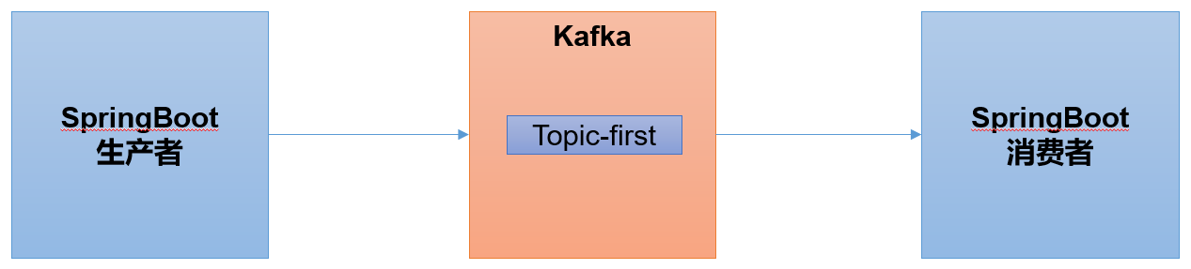
1）在IDEA中安装lombok插件
在Plugins下搜索lombok然后在线安装即可，安装后注意重启
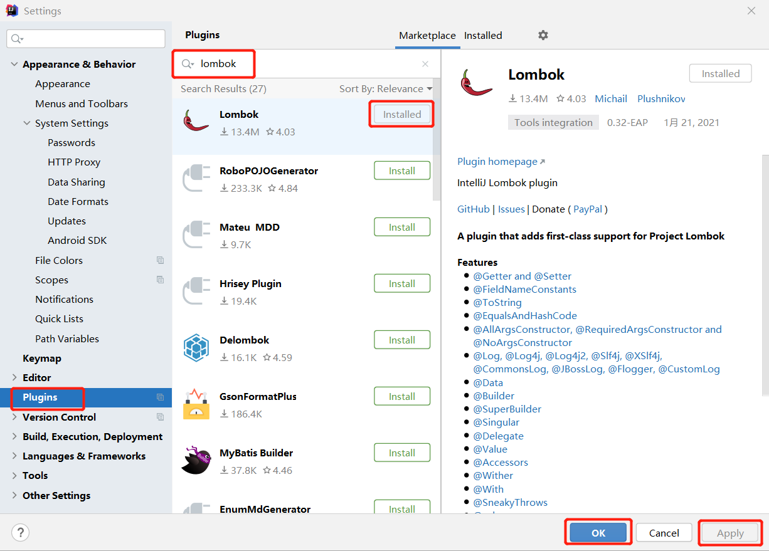
2）SpringBoot环境准备
（1）创建一个Spring Initializr
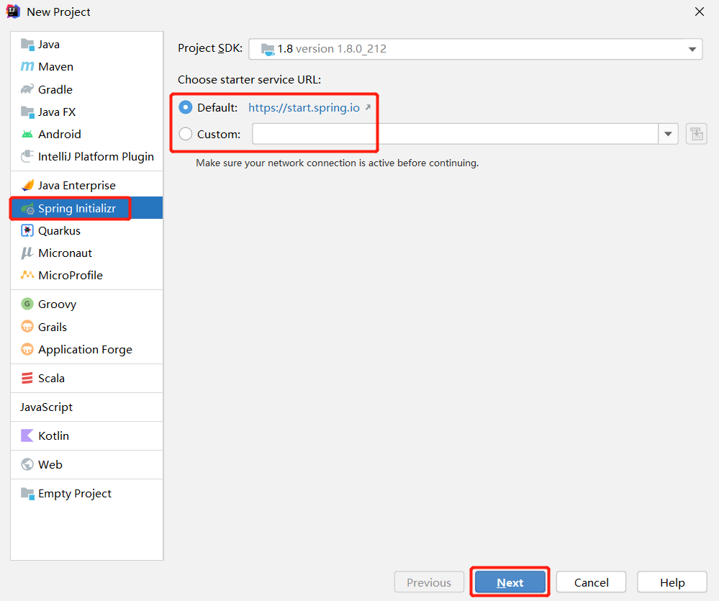
注意：有时候SpringBoot官方脚手架不稳定，我们切换国内地址https://start.aliyun.com
（2）项目名称springboot
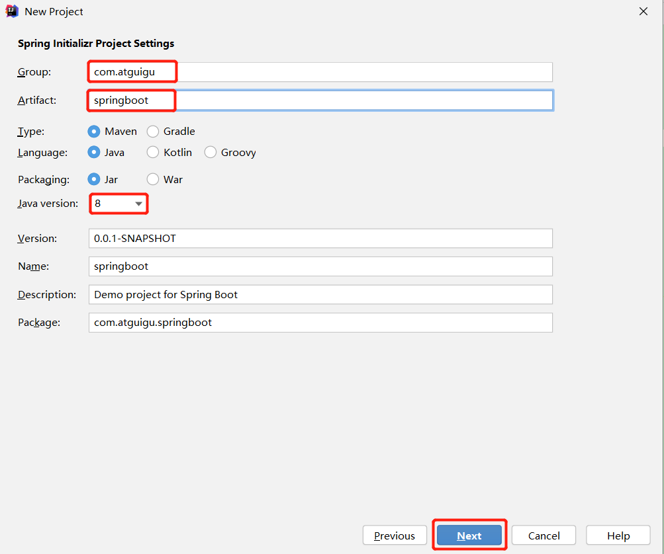
（3）添加项目依赖
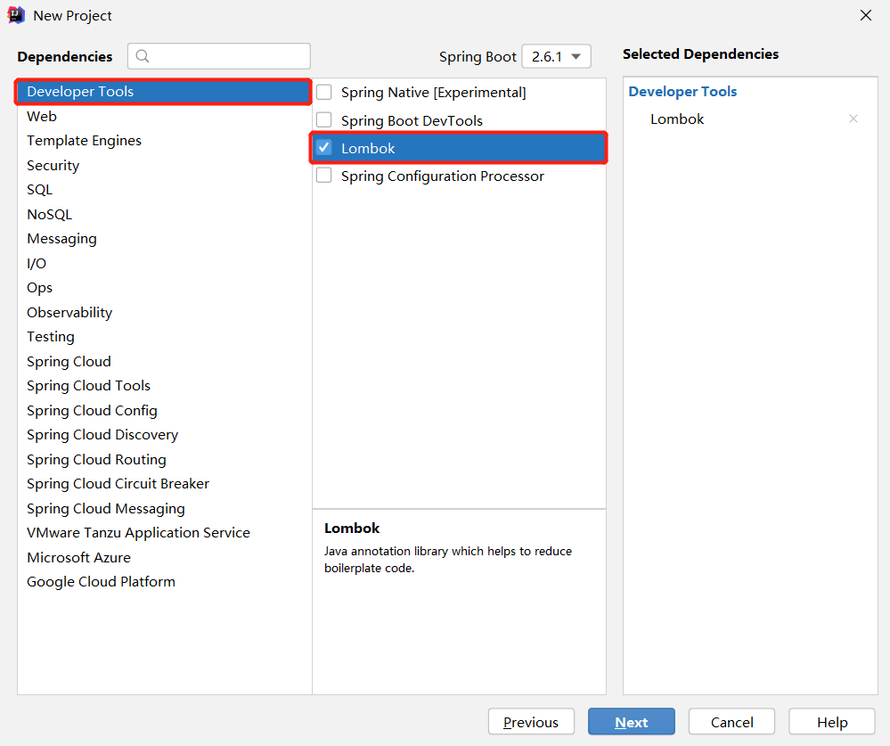
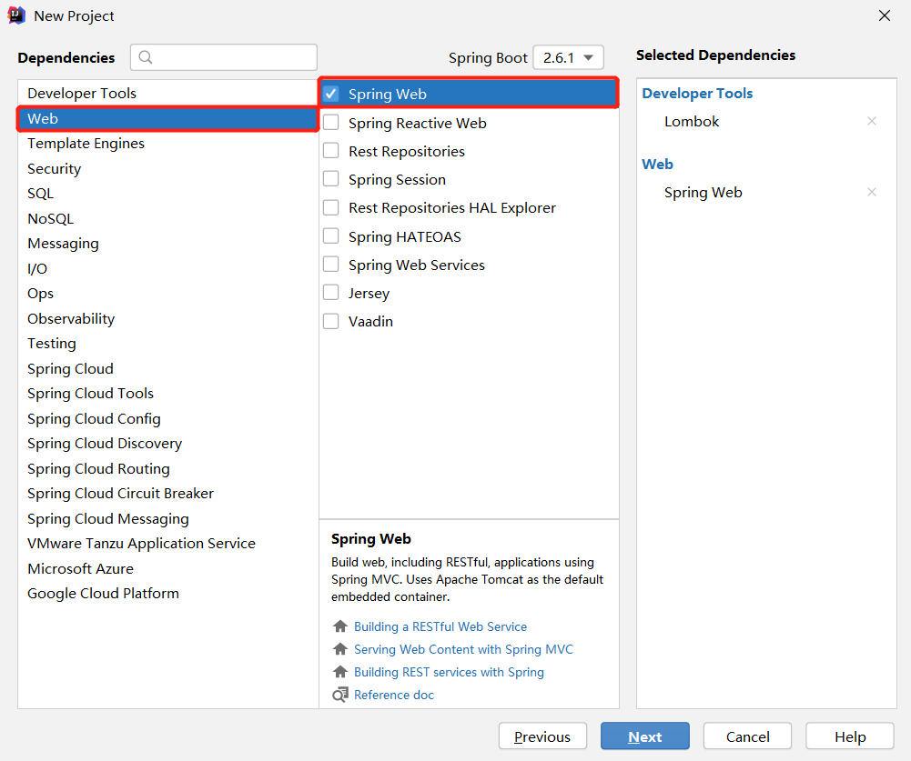
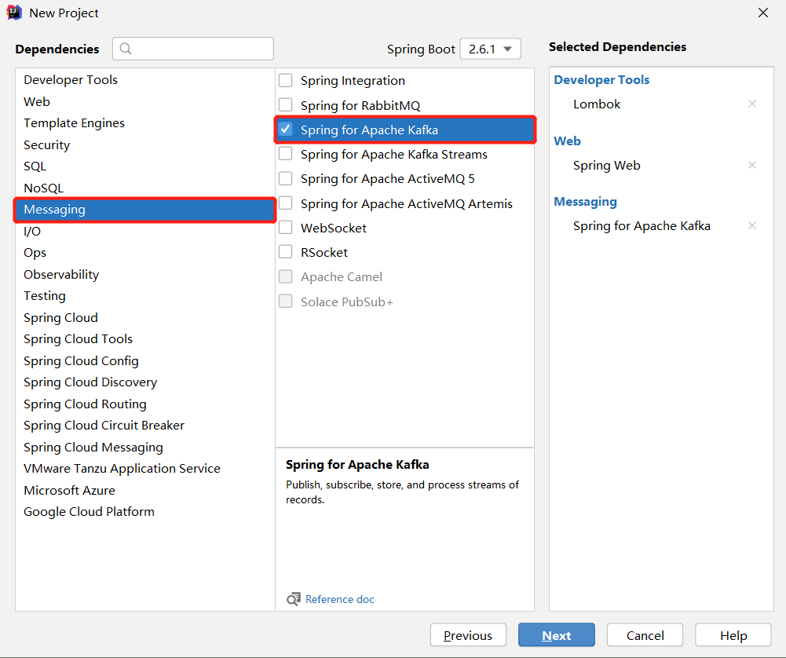
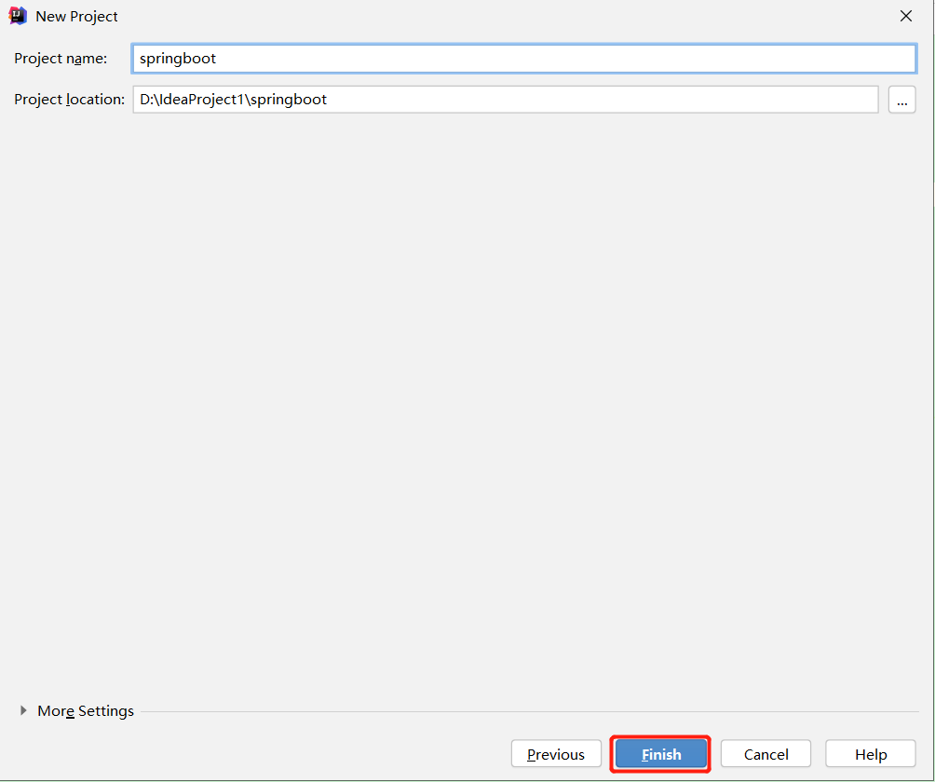
（4）检查自动生成的配置文件
<?xml version="1.0" encoding="UTF-8"?>
<project xmlns="http://maven.apache.org/POM/4.0.0" xmlns:xsi="http://www.w3.org/2001/XMLSchema-instance"
xsi:schemaLocation="http://maven.apache.org/POM/4.0.0 https://maven.apache.org/xsd/maven-4.0.0.xsd">
<modelVersion>4.0.0</modelVersion>
<parent>
<groupId>org.springframework.boot</groupId>
<artifactId>spring-boot-starter-parent</artifactId>
<version>2.6.1</version>
<relativePath/> <!-- lookup parent from repository -->
</parent>
<groupId>com.atguigu</groupId>
<artifactId>springboot</artifactId>
<version>0.0.1-SNAPSHOT</version>
<name>springboot</name>
<description>Demo project for Spring Boot</description>
<properties>
<java.version>1.8</java.version>
</properties>
<dependencies>
<dependency>
<groupId>org.springframework.boot</groupId>
<artifactId>spring-boot-starter-web</artifactId>
</dependency>
<dependency>
<groupId>org.springframework.kafka</groupId>
<artifactId>spring-kafka</artifactId>
</dependency>

<dependency>
<groupId>org.projectlombok</groupId>
<artifactId>lombok</artifactId>
<optional>true</optional>
</dependency>
<dependency>
<groupId>org.springframework.boot</groupId>
<artifactId>spring-boot-starter-test</artifactId>
<scope>test</scope>
</dependency>
<dependency>
<groupId>org.springframework.kafka</groupId>
<artifactId>spring-kafka-test</artifactId>
<scope>test</scope>
</dependency>
</dependencies>

<build>
<plugins>
<plugin>
<groupId>org.springframework.boot</groupId>
<artifactId>spring-boot-maven-plugin</artifactId>
<configuration>
<excludes>
<exclude>
<groupId>org.projectlombok</groupId>
<artifactId>lombok</artifactId>
</exclude>
</excludes>
</configuration>
</plugin>
</plugins>
</build>

</project>

3.1 SpringBoot生产者
（1）修改SpringBoot核心配置文件application.propeties, 添加生产者相关信息
# 应用名称
spring.application.name=atguigu_springboot_kafka

# 指定kafka的地址
spring.kafka.bootstrap-servers=hadoop102:9092,hadoop103:9092,hadoop104:9092

#指定key和value的序列化器
spring.kafka.producer.key-serializer=org.apache.kafka.common.serialization.StringSerializer
spring.kafka.producer.value-serializer=org.apache.kafka.common.serialization.StringSerializer
（2）创建controller从浏览器接收数据, 并写入指定的topic
package com.atguigu.springboot;
import org.springframework.beans.factory.annotation.Autowired;
import org.springframework.kafka.core.KafkaTemplate;
import org.springframework.web.bind.annotation.RequestMapping;
import org.springframework.web.bind.annotation.RestController;
@RestController
public class ProducerController {
// Kafka模板用来向kafka发送数据
@Autowired
KafkaTemplate<String, String> kafka;
@RequestMapping("/atguigu")
public String data(String msg) {
kafka.send("first", msg);
return "ok";
}
}
（3）在浏览器中给/atguigu接口发送数据
http://localhost:8080/atguigu?msg=hello

3.2 SpringBoot消费者
（1）修改SpringBoot核心配置文件application.propeties
# =========消费者配置开始=========
# 指定kafka的地址
spring.kafka.bootstrap-servers=hadoop102:9092,hadoop103:9092,hadoop104:9092
# 指定key和value的反序列化器
spring.kafka.consumer.key-deserializer=org.apache.kafka.common.serialization.StringDeserializer
spring.kafka.consumer.value-deserializer=org.apache.kafka.common.serialization.StringDeserializer

#指定消费者组的group_id
spring.kafka.consumer.group-id=atguigu
# =========消费者配置结束=========
（2）创建类消费Kafka中指定topic的数据
package com.atguigu.springboot;
import org.springframework.context.annotation.Configuration;
import org.springframework.kafka.annotation.KafkaListener;
@Configuration
public class KafkaConsumer {
// 指定要监听的topic
@KafkaListener(topics = "first")
public void consumeTopic(String msg) { // 参数: 收到的value
System.out.println("收到的信息: " + msg);
}
}
（3）向first主题发送数据
[atguigu@hadoop102 kafka]$ bin/kafka-console-producer.sh --bootstrap-server hadoop102:9092 --topic first
>

第4章 集成Spark
Spark是一个在大数据开发中非常常用的组件。可以用于Kafka的生产者，也可以用于Spark的消费者。
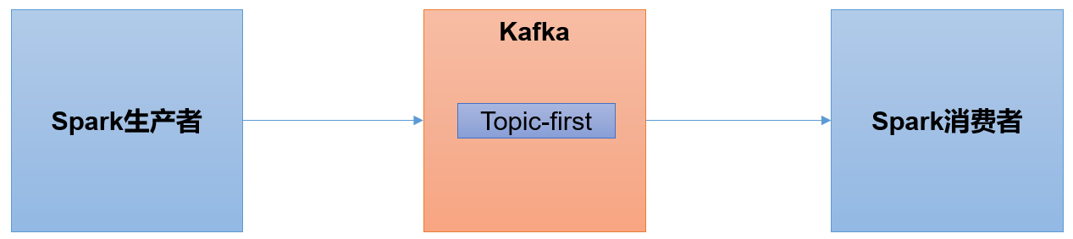
1）Scala环境准备
2）Spark环境准备
（1）创建一个maven项目spark-kafka
（2）在项目spark-kafka上点击右键，Add Framework Support=》勾选scala
（3）在main下创建scala文件夹，并右键Mark Directory as Sources Root=>在scala下创建包名为com.atguigu.spark
（4）添加配置文件
<dependencies>
<dependency>
<groupId>org.apache.spark</groupId>
<artifactId>spark-streaming-kafka-0-10_2.12</artifactId>
<version>3.0.0</version>
</dependency>
</dependencies>
（5）将log4j.properties文件添加到resources里面，就能更改打印日志的级别为error
log4j.rootLogger=error, stdout,R
log4j.appender.stdout=org.apache.log4j.ConsoleAppender
log4j.appender.stdout.layout=org.apache.log4j.PatternLayout
log4j.appender.stdout.layout.ConversionPattern=%d{yyyy-MM-dd HH:mm:ss,SSS} %5p --- [%50t] %-80c(line:%5L) : %m%n

log4j.appender.R=org.apache.log4j.RollingFileAppender
log4j.appender.R.File=../log/agent.log
log4j.appender.R.MaxFileSize=1024KB
log4j.appender.R.MaxBackupIndex=1

log4j.appender.R.layout=org.apache.log4j.PatternLayout
log4j.appender.R.layout.ConversionPattern=%d{yyyy-MM-dd HH:mm:ss,SSS} %5p --- [%50t] %-80c(line:%6L) : %m%n

4.1 Spark生产者
（1）在com.atguigu.spark包下创建scala Object：SparkKafkaProducer
package com.atguigu.spark

import java.util.Properties
import org.apache.kafka.clients.producer.{KafkaProducer, ProducerRecord}

object SparkKafkaProducer {

def main(args: Array[String]): Unit = {

// 0 kafka配置信息
val properties = new Properties()
properties.put(ProducerConfig.BOOTSTRAP_SERVERS_CONFIG, "hadoop102:9092,hadoop103:9092,hadoop104:9092")
properties.put(ProducerConfig.KEY_SERIALIZER_CLASS_CONFIG, classOf[StringSerializer])
properties.put(ProducerConfig.VALUE_SERIALIZER_CLASS_CONFIG, classOf[StringSerializer])

// 1 创建kafka生产者
var producer = new KafkaProducer[String, String](properties)

// 2 发送数据
for (i <- 1 to 5){
producer.send(new ProducerRecord[String,String]("first","atguigu" + i))
}

// 3 关闭资源
producer.close()
}
}
（2）启动Kafka消费者
[atguigu@hadoop104 kafka]$ bin/kafka-console-consumer.sh --bootstrap-server hadoop102:9092 --topic first
（3）执行SparkKafkaProducer程序，观察kafka消费者控制台情况

4.2 Spark消费者
（1）添加配置文件
<dependencies>
<dependency>
<groupId>org.apache.spark</groupId>
<artifactId>spark-streaming-kafka-0-10_2.12</artifactId>
<version>3.0.0</version>
</dependency>
<dependency>
<groupId>org.apache.spark</groupId>
<artifactId>spark-core_2.12</artifactId>
<version>3.0.0</version>
</dependency>
<dependency>
<groupId>org.apache.spark</groupId>
<artifactId>spark-streaming_2.12</artifactId>
<version>3.0.0</version>
</dependency>
</dependencies>
（2）在com.atguigu.spark包下创建scala Object：SparkKafkaConsumer
package com.atguigu.spark

import org.apache.kafka.clients.consumer.{ConsumerConfig, ConsumerRecord}
import org.apache.kafka.common.serialization.StringDeserializer
import org.apache.spark.SparkConf
import org.apache.spark.streaming.dstream.{DStream, InputDStream}
import org.apache.spark.streaming.{Seconds, StreamingContext}
import org.apache.spark.streaming.kafka010.{ConsumerStrategies, KafkaUtils, LocationStrategies}

object SparkKafkaConsumer {

def main(args: Array[String]): Unit = {

//1.创建SparkConf
val sparkConf: SparkConf = new SparkConf().setAppName("sparkstreaming").setMaster("local[*]")

//2.创建StreamingContext
val ssc = new StreamingContext(sparkConf, Seconds(3))

//3.定义Kafka参数：kafka集群地址、消费者组名称、key序列化、value序列化
val kafkaPara: Map[String, Object] = Map[String, Object](
ConsumerConfig.BOOTSTRAP_SERVERS_CONFIG -> "hadoop102:9092,hadoop103:9092,hadoop104:9092",
ConsumerConfig.GROUP_ID_CONFIG -> "atguiguGroup",
ConsumerConfig.KEY_DESERIALIZER_CLASS_CONFIG -> classOf[StringDeserializer],
ConsumerConfig.VALUE_DESERIALIZER_CLASS_CONFIG -> classOf[StringDeserializer]
)

//4.读取Kafka数据创建DStream
val kafkaDStream: InputDStream[ConsumerRecord[String, String]] = KafkaUtils.createDirectStream[String, String](
ssc,
LocationStrategies.PreferConsistent, //优先位置
ConsumerStrategies.Subscribe[String, String](Set("first"), kafkaPara)// 消费策略：（订阅多个主题，配置参数）
)

//5.将每条消息的KV取出
val valueDStream: DStream[String] = kafkaDStream.map(record => record.value())

//6.计算WordCount
valueDStream.print()

//7.开启任务
ssc.start()
ssc.awaitTermination()
}
}
（3）启动SparkKafkaConsumer消费者
（4）启动kafka生产者
[atguigu@hadoop103 kafka]$ bin/kafka-console-producer.sh --bootstrap-server hadoop102:9092 --topic first
（5）观察IDEA控制台数据打印

