
Project Report on:
Pyrates- A Platformer Game

Submitted by:
Aaryan Fatnani
Semester VI
TY BBA(CA)

Under the guidance of:
Prof. Deepak Singh

Submitted to:
SURYADATTA COLLEGE OF MANAGEMENT INFORMATION RESEARCH & TECHNOLOGY
(SCMIRT)
In fulfilment of:
Bachelors of Business Administration (Computer Application)
2024-2025



Declaration

I hereby declare that the project report entitled “Platformer game” is original work done by me & not submitted at any other purpose earlier. It is my own contribution in fulfilment of the requirement for the award of Degree BBA(CA).

Place: Pune
Date:

(Sign)

ACKNOWLEDGEMENT

I am grateful to Suryadatta College of Management, Information, Research and Technology for providing me this opportunity to work on this topic I have taken efforts on this project. However, it would not have been possible without the kind support of Faculties, Teachers, Management. I also Extent My Gratitude to SPPU for Designing this Course. My sincere Thanks to project guide Prof. Deepak Singh Who not only encouraged me through his venture but also took great efforts, giving valuable suggestions and correction which improved the quality of the project. Sincere Thanks to all the teachers for their support guidance and ideas during the field work.

Place: Pune
Date:

(Sign)

Index
Sr. No. | Title | Description | Page Number
1 | Introduction | Brief introduction to the project | 1
2 | Synopsis | Project Topic, Objective, Key Features, Entities: User/Player, Game Levels, Leaderboard | 3
3 | Diagrams | ER Diagram, DFDs (Level 0, Level 1), UML Diagrams (Class, Activity, Sequence, Use Case) | 4
4 | Technology Stack | Front-End (Pygame, Tiled), Back-End (PHP, SQL, XAMPP) | 14
5 | Test Plan | Unit Testing, Integration Testing, System Testing, UAT, Performance Testing | 14
6 | Execution | Initialization, Window Creation, Game Loop, Event Handling, Logic Update, Rendering, Exit | 15
7 | Deployment | Local Deployment, Future Production Deployment | 15
8 | Scope | Core Gameplay Mechanics, Level Design, HUD, Leaderboard System, Abandoned Features | 16
9 | Limitations | Platform Constraints, Time Constraints, Simplistic Art, Limited Gameplay, Leaderboard Connectivity | 18
10 | Screenshots | Main Menu, Leaderboard, Name Input, Pause Menu, Gameplay, Level Completed, Game Over, Game Completed | 21
11 | Conclusion | Summary of the project outcome and future improvements | 26

Introduction:
Pyrates is a nostalgic, PC-only platformer inspired by the classic games of the SNES era. The game’s primary objective is to complete each level by reaching the flag – the finish line – which represents a triumph over a variety of challenges designed to test the player’s skills in jumping, wall jumping, attacking, and even deflecting enemy projectiles. With its retro art style, Pyrates is intended to evoke memories of early platform games for adult gamers while remaining accessible to children and newcomers, who may have little or no prior gaming experience.

The gameplay is built around straightforward, intuitive mechanics that emphasize precision and timing. Players must navigate levels filled with dynamic obstacles and enemies while using an assortment of moves to overcome challenges. Special emphasis has been placed on ensuring that each level offers a balanced mix of action and strategy, rewarding players who master the mechanics with smoother progress through the game. Furthermore, the inclusion of both an overall high score leaderboard and individual level high scores adds a competitive edge, encouraging players to replay levels in pursuit of higher scores.

Pyrates deliberately keeps its HUD and interface minimalistic, allowing the gameplay and retro art style to take center stage. The simplistic design not only contributes to the nostalgic feel but also makes the game easy to learn and play, ensuring that even individuals with zero prior gaming experience can quickly get into the action. Throughout the development process, the focus was maintained on preserving the spirit of the classic platformers, with a particular emphasis on smooth controls, engaging level design, and authentic pixel art that pays homage to the beloved titles of the past.

In addition to its core gameplay, Pyrates features a username-only login system that reinforces the nostalgic, laid-back vibe of the game while simplifying the user experience. The decision to use a username-only system – instead of a full login mechanism – supports a more streamlined approach and aligns with the game’s overall design philosophy. Although there was initial interest in developing an overworld for level selection, time constraints led to a more focused design that emphasizes immediate action and replayability.

Overall, Pyrates blends classic platforming action with modern development techniques to create a game that is both a tribute to and a reinvention of the classics. It is designed to appeal to a wide range of players: from nostalgic adults longing for the simplicity and charm of yesteryear’s games to younger players experiencing retro-style gameplay for the first time. With its carefully tuned mechanics, accessible controls, and emphasis on both skill and speed, Pyrates stands as a testament to the enduring appeal of the platforming genre.

Synopsis:
Project Topic:
The project is titled "Pyrates: Conquer the Seas!"
Objective:
The primary objective of this project is to create a fun and engaging 2D platformer game with a robust backend system for user management and score storage, and in the process, learning about game development and back end integration.
The project aims to:
- Create an entertaining and visually appealing gaming experience by implementing responsive controls, engaging level designs, and interactive elements.
- Provide a secure system for user data storage and retrieval, ensuring data privacy and integrity.
- Display dynamic leaderboards to foster competition and encourage players to improve their performance.
- Enable scalability for future enhancements, such as adding new levels, features, or multiplayer capabilities.
The end product is a fun and engaging game that combines simple controls, creative level design and robust backend systems
Key Features:
The platformer game includes the following key features:
Nostalgic Feel: A feel similar to platformers from the Nintendo era. The game will feel fresh, yet familiar thanks to its inspirations.
Leaderboards: Dynamic leaderboards displaying top scores to encourage competition among players.

Entities:
The main entities of the game are as follows:
I) User/Player: Represents users playing the game. Attributes include username, password, and high score. Players can register, log in, and view their previous scores.
II) Game Levels: Stores information about each level, including level ID, high score for that level as well as the user who have set the high score. Levels are designed to offer progressive challenges to players.
III) Leaderboard: Stores information about player's aggregate scores and ranks them on basis of the highest score first.

Entity relationship diagram:
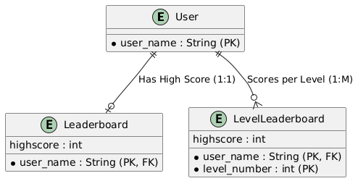

Fig 1.1 Entity relationship diagram
This figure shows an Entity Relationship Diagram(ERD), which shows the relationship between various entities i.e. User, Level, Scores and Totals.
User has a 1:M relationship with scores, User has a M:M relationship with Level, User has a 1:1 relationship with totals and Scores has a M:1 relationship with totals.
Data Flow Diagram:

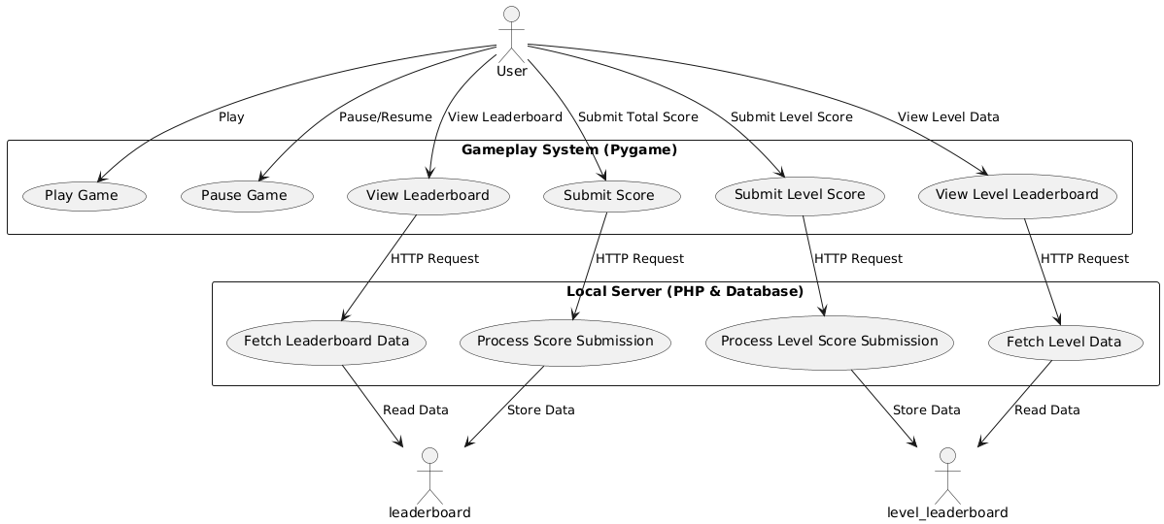

Figure 1.2 Level 1 DFD
UML:
Following are some UML diagrams showcasing various UML diagrams for the project, which represent the structure and behavior of the systems through various diagrams.
I) Class Diagram:

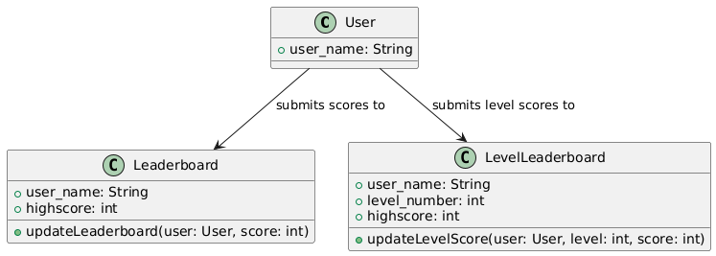

Fig 1.3 Class diagram

II) Object Diagram:
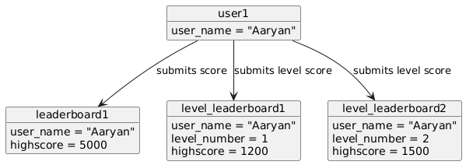

Fig 1.4 Object Diagram
III) Use Case diagram:
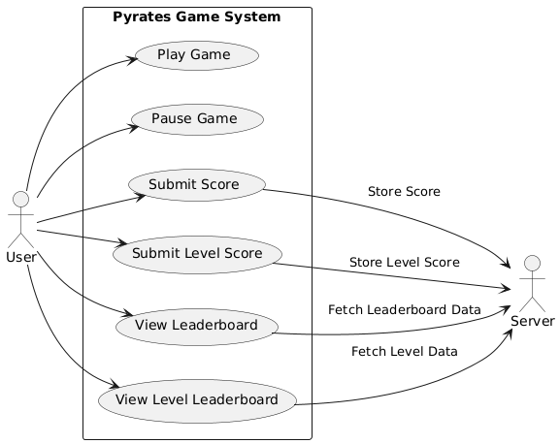

Fig 1.5 Use Case diagram
IV) Sequence Diagram:
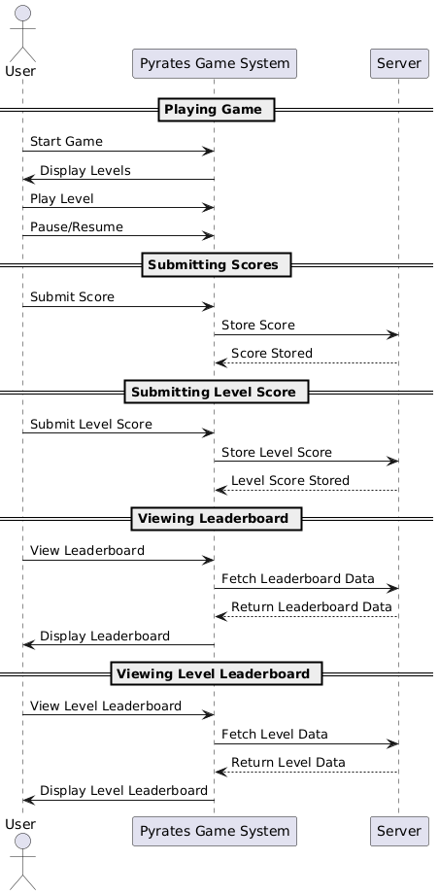

Fig 1.6 Sequence Diagram
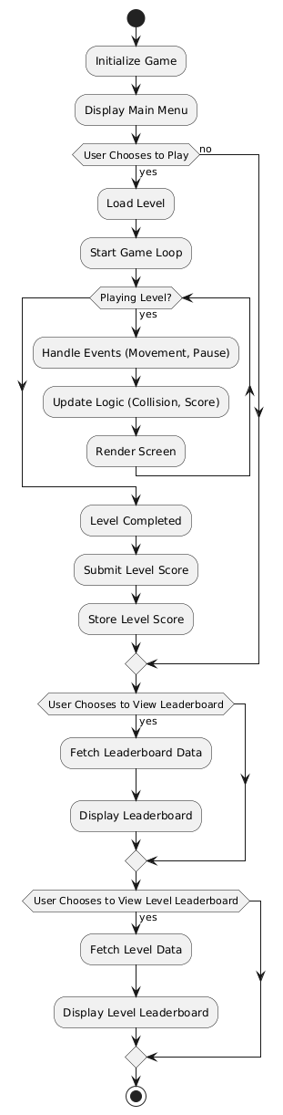
V) Activity diagram:

Figure 1.7 Activity Diagram

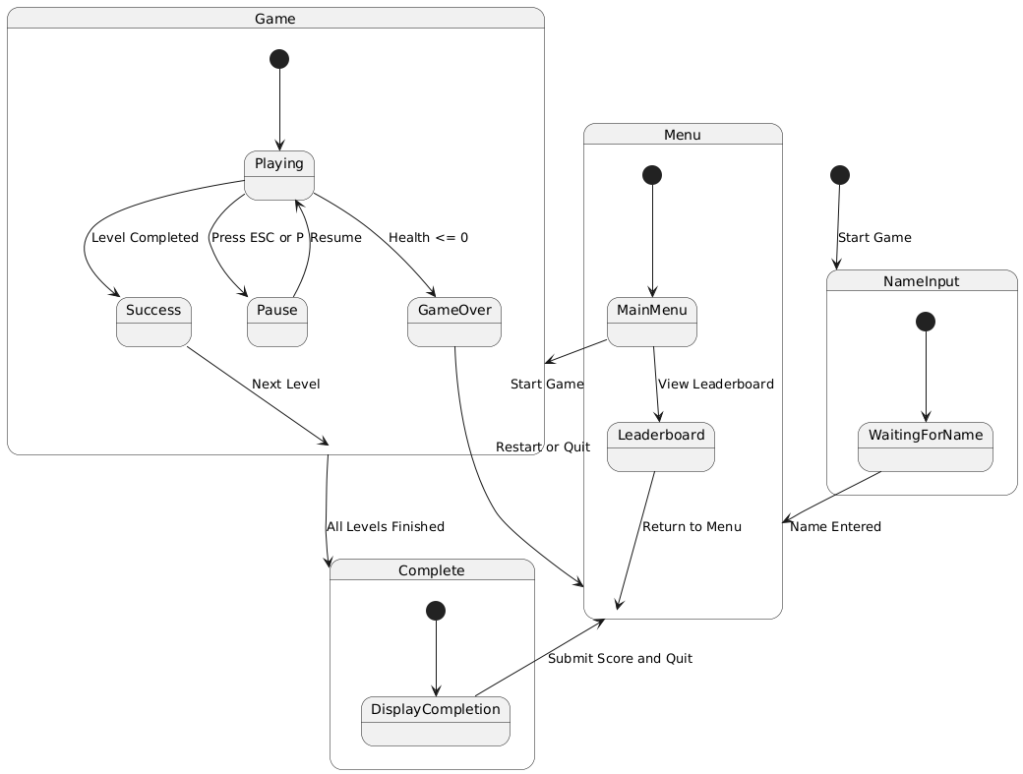
VI) State Chart Diagram:

Fig 1.8 State Chart Diagram
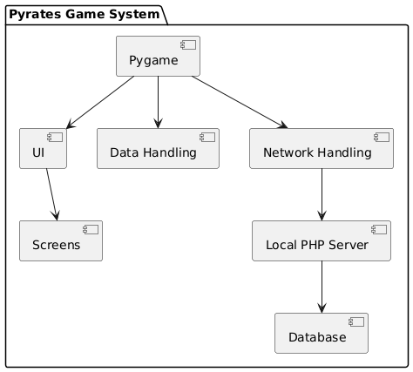
VII) Component diagram:

Fig 1.9 Component Diagram
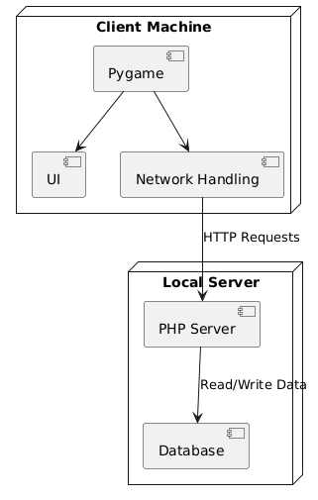
VII) Deployment Diagram:

Fig 1.10 Deployment Diagram
Technology Stack (Front-end and Back-end used):
Front-End technologies:
I) Pygame- a Python Library
II) Tiled.
Back-End technologies:
I) PHP, Hosted through Xampp.
II) SQL

The game is primarily built using Pygame, a Python library. It handles all the logic for the game such as player movement, collision detection, etc. Tiled, an open source level editor is used to create and design the various levels for the game.
As for the back-end, the server-side scripting is handled through PHP and the server is hosted through Xampp, and the queries are written using Structured Query Language (SQL).

Test Plan:
The test plan consists of:
- Unit Testing: Validate individual components, such as player movement, collision detection, scoring logic, and database queries.
- Integration Testing: Ensure seamless interaction between Pygame frontend and PHP backend, including data flow and API functionality.
- System Testing: Test the game as a whole to identify and resolve any bugs or inconsistencies across components.
- User Acceptance Testing (UAT): Conduct testing with a group of players, consisting of fellow students from TY BBA(CA), to gather feedback on gameplay, difficulty balance, and overall experience.
- Performance Testing: Evaluate the game's responsiveness and backend performance under different loads.

Execution:
On execution, the following steps take place:
I) Initialization: Pygame is initialized through pygame.init() method.
II) Window creation: Using the pygame.display.set_mode(), a window is created.
III) Game Loop start: The event loop starts, which is responsible for checking events, updating the game state, etc.
IV) Event handling: The program handles various events like user input etc.
V) Logic update: The game state i.e. position of the player, objects are updated.
VI) Rendering: All game objects and graphics are drawn or rendered after each frame.
VII) Exit: the loop continues till there is an exit event, after which the game ends.

Deployment:
Currently, the project is deployed locally i.e. it is hosted on a local server on the developer's device.
In order for the project to be deployed for production, the database will have to be hosted on a cloud server or a web hosting platform. Also, using pyInstaller, an executable file should be created to make it convenient for the user.

Scope
The scope of the Pyrates project was defined early on with the intention of developing a basic yet engaging platformer that remains true to the SNES era’s aesthetics and gameplay while incorporating modern enhancements. The project was conceived to include the following core components:

Core Gameplay Mechanics:
Pyrates centers on classic platforming skills such as running, jumping, wall jumping, and attacking. The game introduces mechanics like bullet deflection to add a layer of depth, allowing skilled players to execute advanced maneuvers during combat. Each level is designed to test these abilities and to encourage mastery through progressively challenging obstacles and enemy patterns.

Level Design and Progression:
Initially, the plan called for the creation of 4–5 levels. Each level was to be carefully crafted with unique layouts, environmental hazards, and enemy placements to create a varied experience. The levels are linear, culminating in a flag that players must reach to complete the stage. The level design emphasizes replayability, inviting players to return and refine their technique to improve their score.

User Interface and HUD:
The game’s user interface is kept deliberately simple. The minimalistic HUD displays key information such as the player’s health and coin count, allowing players to focus on gameplay without distraction. This design choice reinforces the retro aesthetic and ensures that the overall experience remains uncluttered.

Score and Leaderboard System:
Pyrates incorporates a dual leaderboard system. One leaderboard tracks the total score across the entire game, while a secondary leaderboard records the best scores for each individual level. This dual system not only motivates players to improve their overall performance but also provides an incentive to perfect their play on each stage. The scoring mechanism is straightforward – coins collected and actions executed during a level contribute to the overall score, and high scores are uploaded via a username-only system to maintain simplicity.

Username-Only Login System:
In order to keep the game accessible and maintain a nostalgic feel, a full-scale login system was deemed unnecessary. Instead, players are prompted to enter a username before starting the game. This lightweight approach removes barriers to entry while still allowing players to have their achievements recorded in the leaderboards.

Abandoned Features and Future Possibilities:
One significant feature that was considered but ultimately abandoned was the implementation of an overworld map. Originally, the overworld would have served as a hub for navigating between levels, adding an extra layer of exploration. However, due to time constraints and a desire to maintain focus on the core gameplay, the idea was shelved. Similarly, while mobile and console versions were contemplated, the project was ultimately constrained to PC development due to technical expertise limitations.

This scope ensured that the project remained manageable while still delivering a complete and engaging gameplay experience. The decision to focus on core mechanics and level design allowed for rapid prototyping and iterative improvements, ensuring that Pyrates could capture the spirit of classic platformers while integrating contemporary enhancements.

Limitations
Despite its strengths and thoughtful design, Pyrates has several limitations that have influenced its final implementation:

Platform Constraints:
One of the most significant limitations encountered during development was platform expertise. The game is built exclusively for PC, as the development team had little to no experience with mobile or console platforms. This limitation not only affected the potential audience but also restricted the implementation of platform-specific features such as touch controls or optimized performance for various devices. As a result, while Pyrates might have broader appeal on multiple platforms, it remains a PC-only experience.

Time Constraints and Feature Cuts:
Time constraints played a crucial role in shaping the final product. Several ideas that were part of the initial vision had to be scaled back or eliminated entirely. The most notable of these was the concept of an overworld for level selection. Originally planned as a hub where players could navigate between levels, the overworld was abandoned in favor of a more linear and focused level progression. This decision, while practical, reduced the overall scope of exploration and world-building that could have enriched the game’s experience.

Simplistic Art Style and User Interface:
The art style of Pyrates is intentionally simplistic, aiming to evoke nostalgia while remaining accessible. However, this minimalism comes with trade-offs. The limited graphical complexity may not appeal to all modern gamers who expect more detailed visuals or advanced animations. Similarly, the user interface, while effective and uncluttered, lacks the polish or dynamic elements that could further enhance user engagement. This simplicity is both a design choice and a limitation imposed by the scope and resources available during development.

Limited Gameplay Depth:
While the game features core platforming mechanics such as jumping, wall jumping, and bullet deflection, it does not venture into more complex gameplay systems that could offer additional layers of strategy or narrative depth. The focus was on delivering a straightforward, nostalgic experience. Consequently, players seeking deep storylines, extensive character progression, or complex enemy AI may find Pyrates lacking in these areas. The game is designed primarily as a tribute to classic platformers, and as such, prioritizes simple, enjoyable mechanics over intricate systems.

Leaderboard and Online Connectivity:
The leaderboard system in Pyrates is implemented using a username-only system, which simplifies user interaction but may raise concerns regarding security and data integrity. The lack of a comprehensive login system limits the ability to personalize the experience or track detailed player statistics over time. Additionally, reliance on a simple PHP backend means that the leaderboard functionality is basic and may not scale well or offer the robustness expected from more modern, cloud-based systems.

Development Team Limitations:
Finally, the limitations in programming expertise and resources influenced many design decisions. The development team focused on achieving a playable and nostalgic experience within the constraints of their skills and available time. This pragmatic approach ensured that the game was completed but also meant that certain ambitious features had to be deferred or omitted entirely.

In summary, while Pyrates succeeds in delivering a nostalgic, enjoyable platforming experience for PC, its development was bounded by several key limitations. These include platform constraints, time pressures, a simplistic art style and UI, and limitations in gameplay depth and online functionality. Each of these limitations represents an area for potential future improvement, whether through expanded development resources, broader platform support, or enhanced design elements. Despite these constraints, Pyrates remains a focused tribute to the classic platformers of the past, offering players a straightforward yet engaging journey through its levels.

Screenshots:
Main menu:

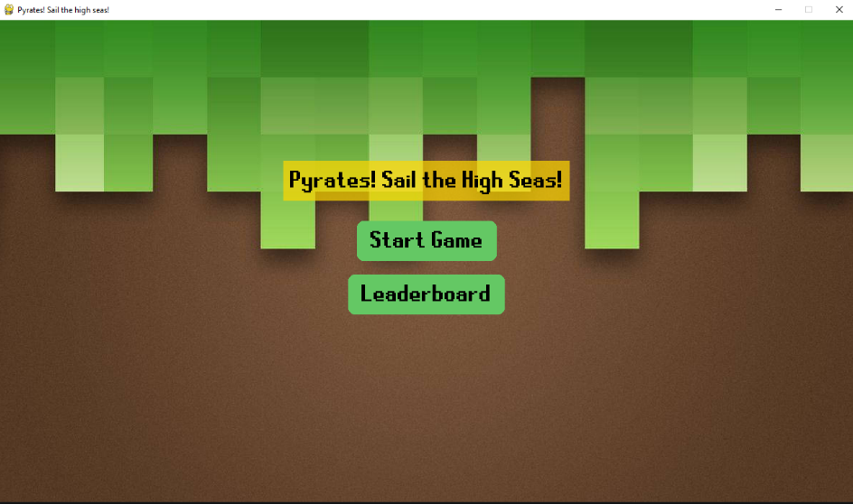

Leader-Board:
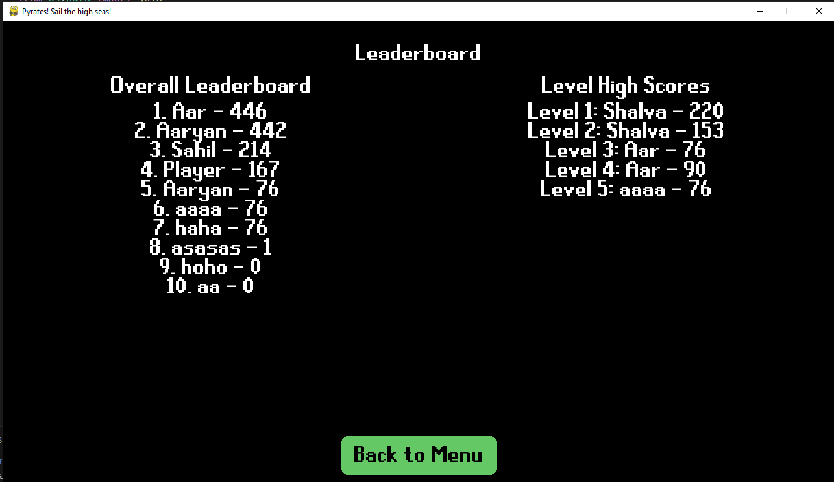
Name Input:

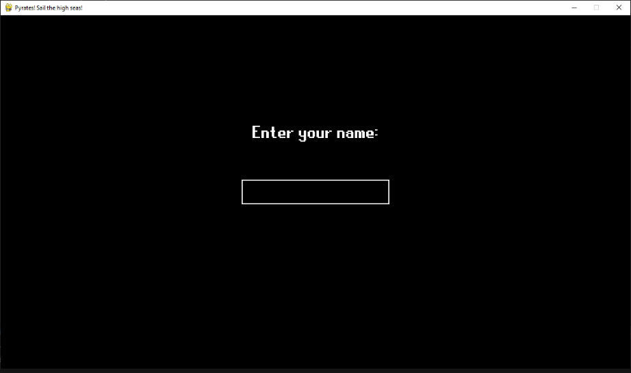
'

Pause menu:

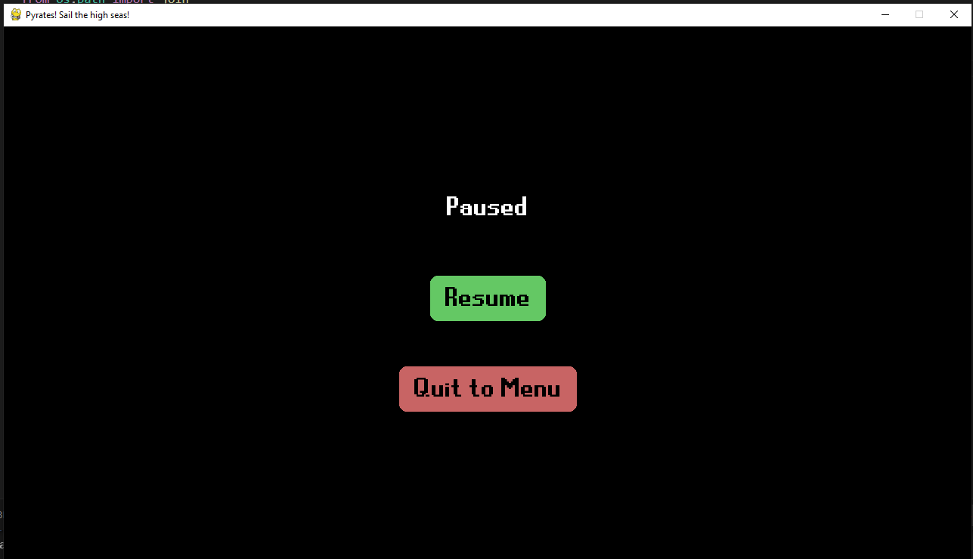

Gameplay images:

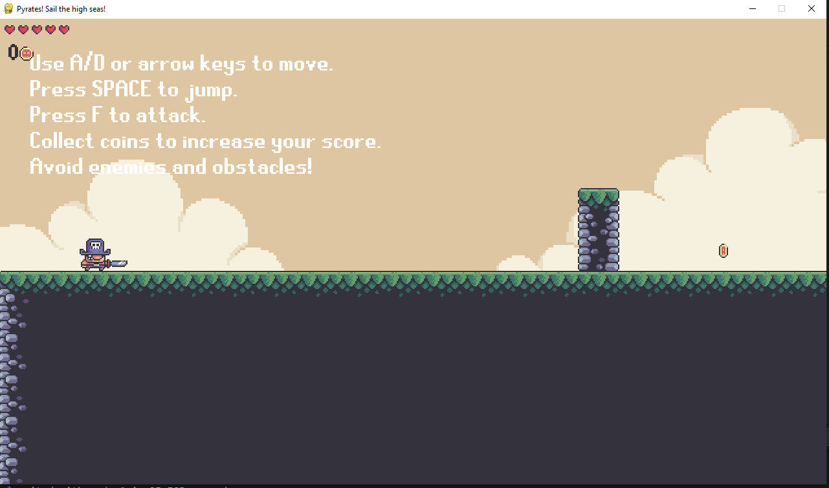
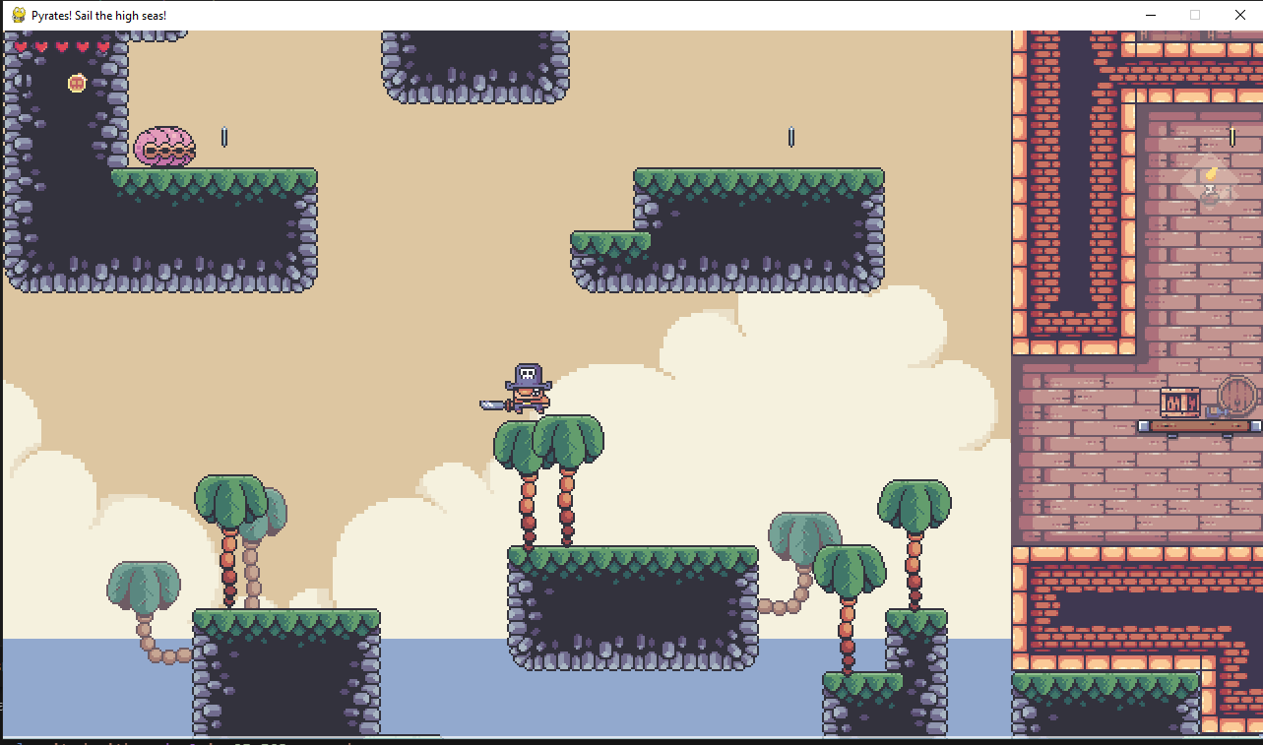
Level Completed:

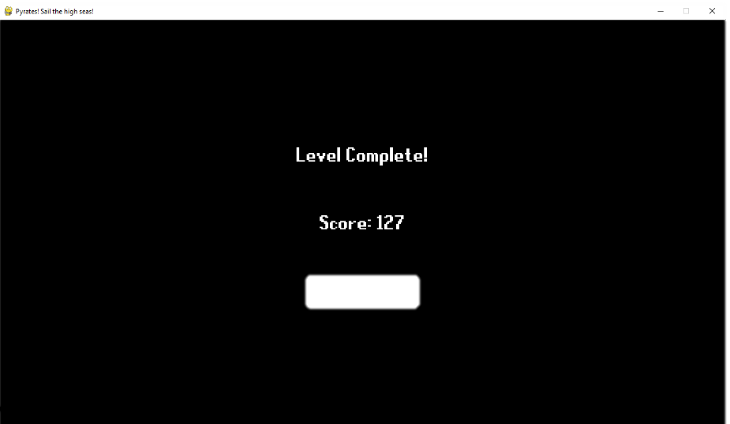

Game over Screen:

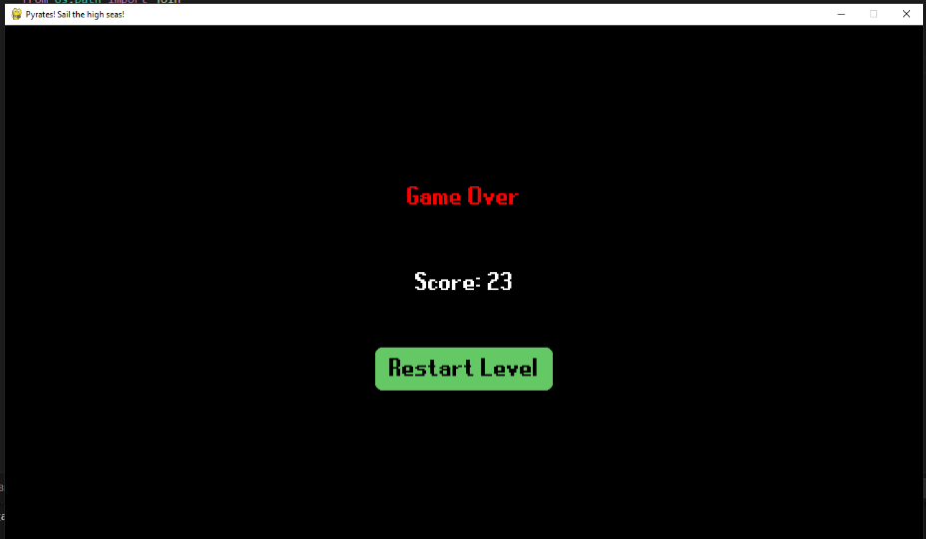

Game Completed:

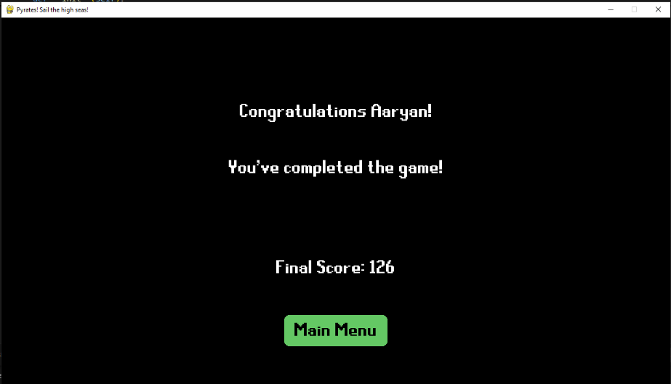
Conclusion:
Pyrates successfully captures the essence of classic platformers while incorporating subtle enhancements to create a satisfying, nostalgic experience. By focusing on simple yet refined gameplay mechanics, including jumping, wall jumping, attacking, and bullet deflection, the game presents a straightforward but engaging challenge to players of all ages and skill levels. The retro-inspired art style, paired with a minimalistic HUD, ensures that the gameplay remains the central focus, evoking the charm of the SNES era while appealing to both children and adults.

Throughout the development process, the core objective of providing a fun, accessible platformer was consistently prioritized. The decision to build the game exclusively for PC was made to accommodate technical expertise limitations, but this constraint also allowed for a more concentrated development effort. As a result, Pyrates delivers a polished experience within its intended scope, offering players a series of levels that grow progressively more challenging while encouraging replayability through a well-implemented leaderboard system. The use of a username-only system for score tracking further reinforces the nostalgic feel, simplifying user interaction and allowing players to focus purely on gameplay.

However, the limitations encountered during development also shaped the final product. The absence of an overworld, initially envisioned as a central hub for level selection, stands as a testament to the compromises made to ensure a manageable scope. Additionally, while the simplistic art style and user interface effectively evoke the desired aesthetic, they lack the polish that might be expected from a modern release. Moreover, the leaderboard system, though functional, remains basic and may not provide the robustness required for more extensive online competition.

Despite these limitations, Pyrates achieves its primary goal of providing an enjoyable platforming experience that honors the design principles of classic games. The project demonstrates a successful application of core gameplay mechanics, intuitive controls, and replayability features that enhance the player's experience. The leaderboard system, while modest in scope, adds a competitive aspect that encourages players to improve their scores and perfect their runs.

Looking forward, Pyrates presents numerous opportunities for further enhancement. Expanding the game to other platforms, refining the visuals and UI, adding more complex gameplay mechanics, and enhancing the leaderboard system to include features such as player authentication and more detailed statistical tracking could all contribute to a richer experience. Additionally, revisiting the idea of an overworld or integrating new gameplay elements could greatly enhance the game's depth and appeal.

In conclusion, Pyrates stands as a testament to the timeless appeal of the platforming genre. By embracing the simplicity and charm of classic games while incorporating modern development techniques, the project has achieved its goal of delivering a nostalgic experience that remains engaging for players of all skill levels. With room for future growth and improvement, Pyrates has laid a strong foundation that can be built upon to create an even more immersive and enjoyable game.

