Assignment 1
Software Design 2026
Course: Data Mining and Machine Learning (Autumn 2026)
Group 10
Esraa Hassan Burghle | esrb@itu.dk
Hans Hornbek | haho@itu.dk
Bastian Smith-Sivertsen | bsmi@itu.dk
Johan Krøyer Thomsen | jokt@itu.dk

Preprocessing
The very first step of our preprocessing consisted of transforming the four data files to a shared file format: .csv-format and combining them into one file. This was done to have all rows gathered in one dataframe.
During the data cleaning, we detected discrepancies and standardized units and format so values in a column are comparable. Heights were converted to cm by classifying each value by magnitude (cm, metres, decimal feet or inches) and parsing feet and inches notation. Heights that could not be parsed were median imputed. Timestamps were parsed and converted to Copenhagen time using each file's recorded timezone, although 2023 had none and was assumed to be local already. We also fixed misspellings and have deleted a row that we judged unreliable. One outlier in height was kept to stay true to the population.
We integrated daily rainfall data from DMI’s weather API into our dataset by fetching rainfall per unique date and saving it in a separate CSV. The datasets can then be joined by date, reducing API calls and adding weather information to answer question 2.
For free_choice we used binary encoding, to create a column that could indicate whether a row belongs to cohorts that could choose the course freely or not. The “why” column is feature engineered by multilabel encoding each response into motive columns (exciting, mandatory, commercial_skills, uncertain, less_attractive). It is multilabel because a student can tick several reasons, so a row can have zero or several 1s. Days_after_open is also feature engineered, and time_of_day has been feature engineered using binning into these variables: (Morning, Afternoon, Evening, Night).
The final dataset has 222 rows and 15 columns.
We haven’t followed preprocessing workflow steps in order, because we have revised our questions after cleaning the data the first time, e.g. data integrating happened after encoding and feature engineering. We also haven’t done scaling or resampling because it wasn’t relevant for this project.

Question 1:
Can we predict whether a student has chosen mandatory based on other survey answers?

Approach
We treated this question as a binary classification problem: the label (y) is ‘mandatory’, and the features (X) are the four other motives (‘exciting’, ‘commercial skills’, ‘uncertain’, ‘less attractive’). As further preprocessing we kept only Software Design students from 2020–2025; 2026 was left out because the course no longer can be mandatory. Students from other programmes can only take the course as an elective, so it is never mandatory for them. We split the data 80/20 (106 train, 27 test) and used logistic regression and k-NN with a baseline that always predicts “not mandatory”.

Results / Evaluations
Both models beat the baseline only slightly. k-NN was always right when it predicted mandatory, but the confusion matrix shows it found only 5 of the 11 truly mandatory students (see Figure A1 in the appendix). Changing the value of k made almost no difference.
 | Accuracy | Precision | Recall | F1
Baseline | 0.59 | 0.0 | 0.0 | 0.0
Logistic Regression | 0.67 | 0.60 | 0.55 | 0.57
k-NN (k=5) | 0.78 | 1.00 | 0.45 | 0.62

Conclusion / Reflections
The form requires at least one reason, so a student with no other motive must be mandatory. This applies to 27 of the 55 mandatory students, about half (see Figure A2 in the appendix).
Our theory is that the models learn this: every student with only zeros in X is always mandatory, so they always get those students right, but they learn little about the others. The other motives themselves are therefore only a weak predictor, and most of what the models find probably comes from the form itself.
What we can conclude, however, is that mandatory students are less likely than most other groups to choose more than one motive: 51%, compared with 65% for exciting and 74% for commercial skills (see Figure A3 in the appendix).
In hindsight, we could have approached this question differently. The fact that the form forces at least one reason is something we should have noticed at the start, before choosing the label and the features.

Question 2: Weather and response rates.
Is it possible to find a correlation between the accumulated precipitation and the amount of survey responses on a given day?
With this part of the report we intend to explore how we can extend the existing data set by performing data integration.
We discussed in which ways we can integrate new data in a meaningful way and decided to take the point of departure in the timestamps of the responses to the survey. We integrated one new data point and feature engineered another one:
- Daily accumulated precip (from the Danish Metrological Institute’s Open Data API).
- Number of entries per day.
These two new data points allow us to investigate if there is a correlation between the amount of rain (accumulated precip, measured in millimeters/per day rounded to the nearest integer) and the amount of survey responses on a given day.
Using linear regression: ${Sum}_{answer}({mm}_{rain})=b_{0}+b_{1}*{mm}_{rain}$, where $b_{0}$, $b_{1}$ are the coefficients discovered performing linear regression on X="millimeters of rain on a whole day” and y=”number of entries in the survey” (using the values of the already-cleaned dataset). Our hypothesis was that on a rainy day a student is more likely to fill out the survey since they cannot go to the beach.
Performing linear regression we got these results:
Equation | y=5.537-0.00817x
R²_{training} | 0.0013
R²_{test} | -1.0087
MAE_{test} | 2.609323
MSE_{test} | 9.2749
The equation says that on a day with 0 mm rain there were 5.537 daily responses to the survey and the amount of daily responses would decline by 8% percent for each mm of rain.

Conclusion/reflection
If our model is to be trusted our hypothesis does not hold true since this is a negative coefficient. It shows that on a sunny day a student is most likely to fill the survey (and that must stem from a love for data mining!). That is if we wish to trust our model, and the values given do not prescribe us a reason to do so. The mean square error (MAE) tells that the mean absolute distance to the regression line is 2.6 and thus the model is averagely off by 2.6 survey answers per day. Considering the starting point, y(0)=5.537, our MAE says that the model is almost off by 50%. And either the MSE or R² suggests anything better. Especially the negative R-squared for the test set suggests (fairly) that the model cannot be used at all for predicting the correlation between the amount of rain and the number of answers for that given day.
Some things to consider that might have changed the output: We only took days with survey responses into account, excluding all other days. There may have been days with perfect weather where every single student went outside, but that is not taken into account. The model could be improved by gathering data (acc. precip and response rates) for all the dates where the questionnaire was ‘open’ (each year), however then we would have more API-calls than allowed. Perhaps, we can conclude that there are more important factors that make a student fill out a survey than the amount of rain.

Appendix
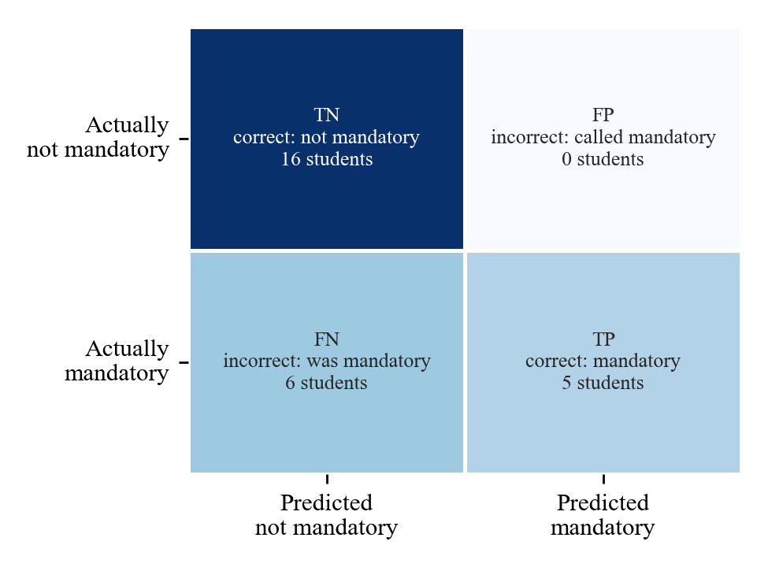
Figure A1: Confusion matrix for k-NN (k=5) on the 27 test students. It finds 5 of the 11 truly mandatory students and never calls a non-mandatory student mandatory.
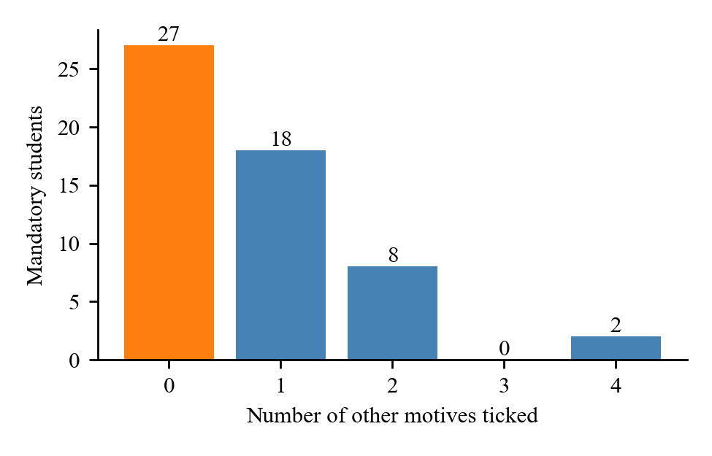
Figure A2: The 55 mandatory students by the number of other motives they ticked. The orange bar is the 27 students who ticked no other motive.
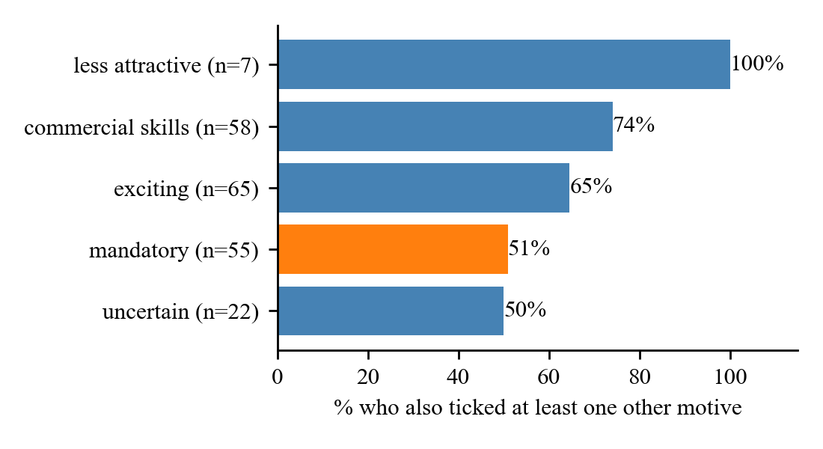
Figure A3: Share of students who ticked each motive and also ticked at least one other motive (Software Design students before 2026, number of students per motive in brackets). Mandatory is highlighted.

