Tugas pendahuluan modul 15

Nama : Helmi Efendi Lubis

NIM : 1301223338

Kelas : IF-46-08

Link Github : <https://github.com/helmiel/StrukturDataTP/tree/main/TP15>

Header

Source

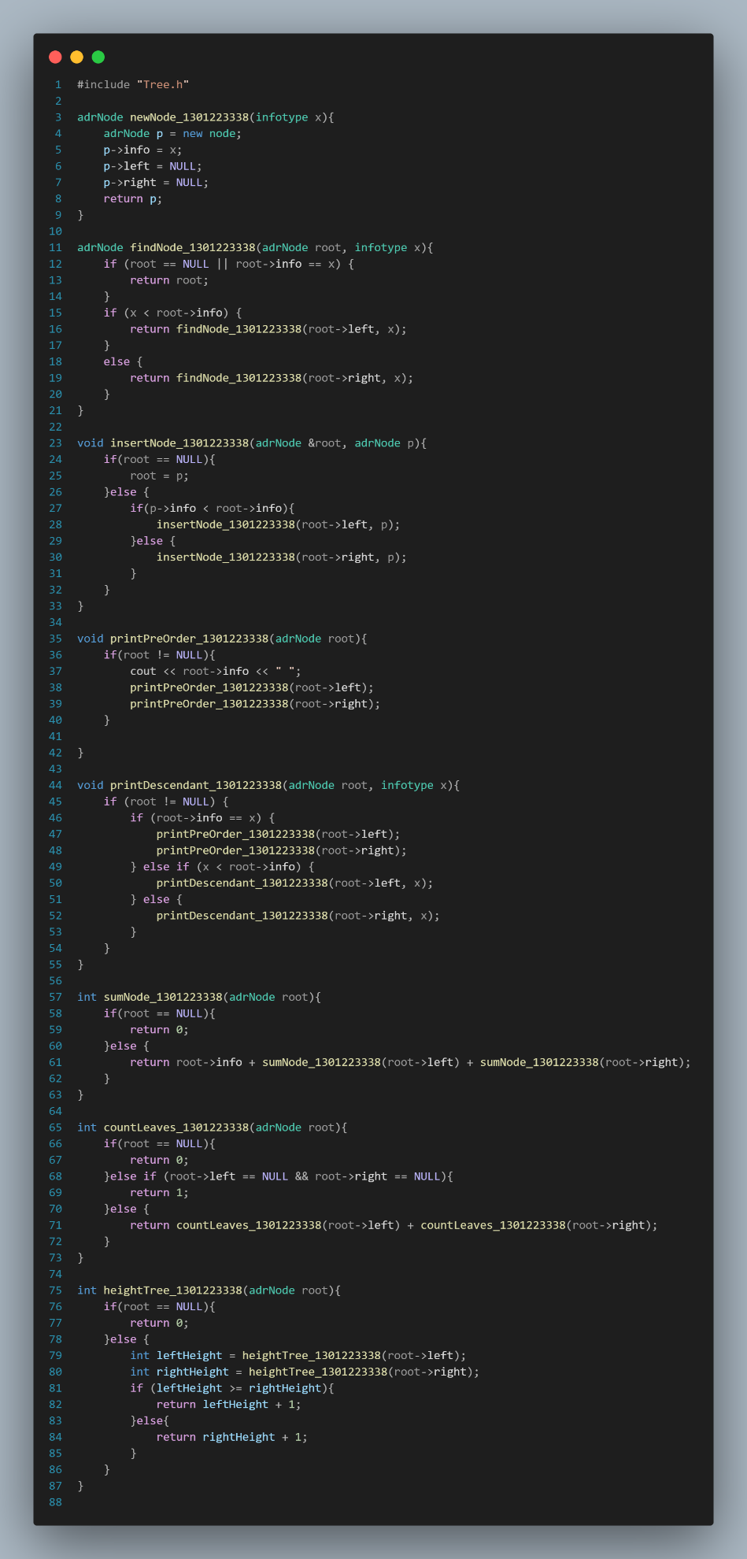

Main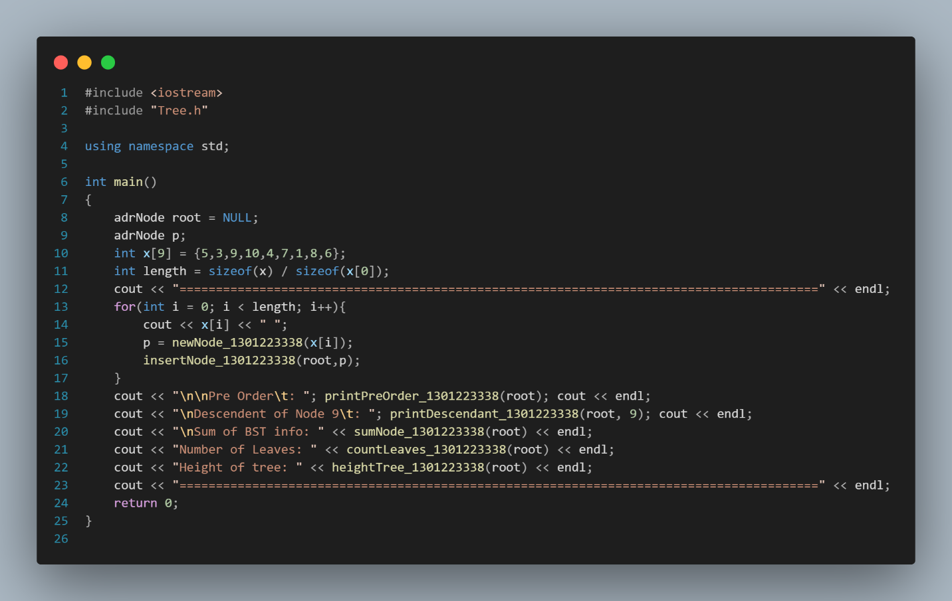

Output

