

Functional Safety Concept Lane Assistance

**Document Version: [Version]**

**Template Version 1.0, Released on 2017-06-21**



# Document history

|  |  |  |  |
| --- | --- | --- | --- |
| Date | Version | Editor | Description |
| 2017-10-22 | 0.1 | Wilhelm Nagel | Initial Version |
|  |  |  |  |
|  |  |  |  |
|  |  |  |  |
|  |  |  |  |

# Table of Contents

Document history

Table of Contents

Purpose of the Functional Safety Concept

Inputs to the Functional Safety Analysis

Safety goals from the Hazard Analysis and Risk Assessment

Preliminary Architecture

Description of architecture elements

Functional Safety Concept

Functional Safety Analysis

Functional Safety Requirements

Refinement of the System Architecture

Allocation of Functional Safety Requirements to Architecture Elements

Warning and Degradation Concept

# Purpose of the Functional Safety Concept

The Functional Safety Concept describes the general functionality of the item in terms of high-level performance requirements. Based on the Safety Goals from Hazard Analysis and Risk Assessment, items are identified that need to be adjusted in order to achieve a safe system. The Functional Safety Concept is not concerned with technical details of sub systems – these will be addressed later in the Technical Safety Concept.

# Inputs to the Functional Safety Concept

## Safety goals from the Hazard Analysis and Risk Assessment

|  |  |
| --- | --- |
| **ID** | **Safety Goal** |
| Safety_Goal_01 | The oscillating steering torque from the lane departure warning function shall be limited. |
| Safety_Goal_02 | The LKA function shall be time limited and the additional torque shall end after a given time interval so that the driver cannot misuse the system for autonomous driving. |

## Preliminary Architecture

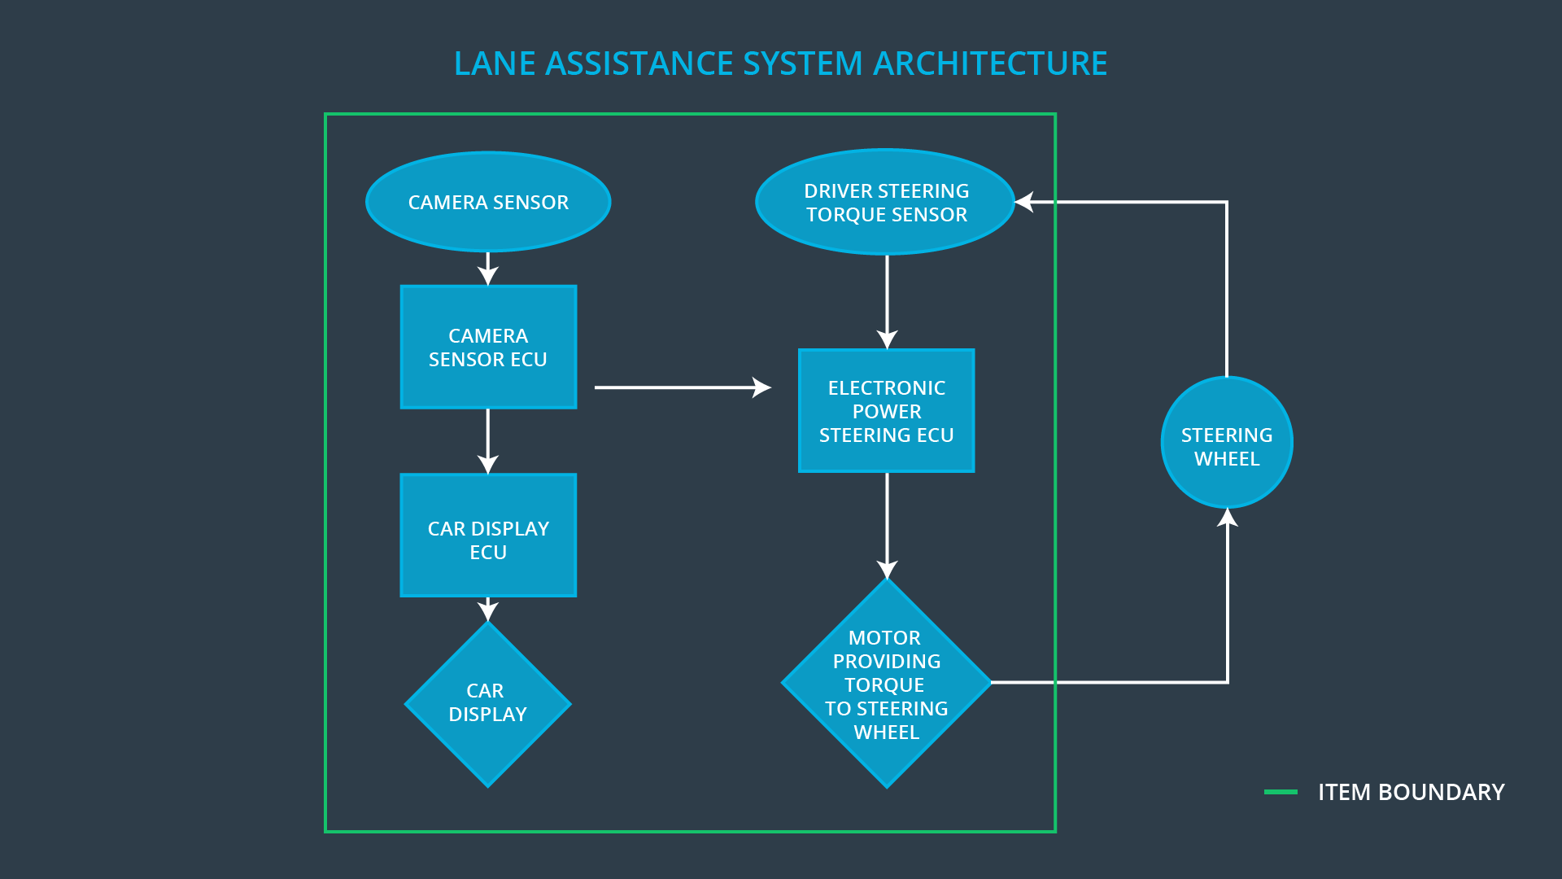

Figure 1: Preliminary System Architecture of the Lane Assistance System

### Description of architecture elements

|  |  |
| --- | --- |
| **Element** | **Description** |
| Camera Sensor | Provide images of the road for the Camera Sensor ECU. |
| Camera Sensor ECU | Process the provided images to detect lane boundaries. |
| Car Display | Display the current state of the Lane Assistance System, e.g. availability and corrective actions. |
| Car Display ECU | Process incoming signals from Camera Sensor ECU and control the Car Display. |
| Driver Steering Torque Sensor | Sense the torque provided by the driver to make sure that driver has not both hands off the steering wheel. |
| Electronic Power Steering ECU | Process inputs from Driver Steering Torque Sensor and Camera Sensor ECU and control the steering Motor |
| Motor | Process inputs from Electronic Steering ECU to provide steering torque for steering wheel. |

# Functional Safety Concept

The functional safety concept consists of:

* Functional safety analysis
* Functional safety requirements
* Functional safety architecture
* Warning and degradation concept

## Functional Safety Analysis

|  |  |  |  |
| --- | --- | --- | --- |
| **Malfunction ID** | **Main Function of the Item Related to Safety Goal Violations** | **Guidewords (NO, WRONG, EARLY, LATE, MORE, LESS)** | **Resulting Malfunction** |
| Malfunction_01 | Lane Departure Warning (LDW) function shall apply an oscillating steering torque to provide the driver a haptic feedback | MORE | The LDW function applies an oscillating torque with very high torque amplitude (above limit). |
| Malfunction_02 | Lane Departure Warning (LDW) function shall apply an oscillating steering torque to provide the driver a haptic feedback | MORE | The LDW function applies an oscillating torque with very high torque frequency (above limit). |
| Malfunction_03 | Lane Keeping Assistance (LKA) function shall apply the steering torque when active in order to stay in ego lane | NO | The LKA function is not limited in time duration which leads to misuse as an autonomous driving function. |

## Functional Safety Requirements

Lane Departure Warning (LDW) Requirements:

|  |  |  |  |  |
| --- | --- | --- | --- | --- |
| **ID** | **Functional Safety Requirement** | **ASIL** | **Fault Tolerant Time Interval** | **Safe State** |
| Functional  Safety  Requirement  01-01 | The electronic power steering ECU shall ensure that the lane departure oscillating torque amplitude is below Max_Torque_Amplitude | C | 50 ms | Off |
| Functional  Safety  Requirement  01-02 | The electronic power steering ECU shall ensure that the lane departure oscillating torque frequency is below Max_Torque_Frequency | C | 50 ms | Off |

Lane Departure Warning (LDW) Verification and Validation Acceptance Criteria:

|  |  |  |
| --- | --- | --- |
| **ID** | **Validation Acceptance**  **Criteria and Method** | **Verification Acceptance**  **Criteria and Method** |
| Functional  Safety  Requirement  01-01 | Determine a maximum amount of Max_Torque_Amplitude by testing with human drivers. It should be proven that human drivers are comfortable with the chosen value and are able to control the car while steering wheel is vibrating. | When torque amplitude exceeds Max_Torque_Amplitude, LKA system’s output is set to zero within the specified 50 ms fault tolerant time interval. |
| Functional  Safety  Requirement  01-02 | Determine a maximum amount of Max_Torque_Frequency by testing with human drivers. It should be proven that human drivers are comfortable with the chosen value and are able to control the car while steering wheel is vibrating. | When torque frequency exceeds Max_Torque_Frequency, LKA system’s output is set to zero within the specified 50 ms fault tolerant time interval. |

Lane Keeping Assistance (LKA) Requirements:

|  |  |  |  |  |
| --- | --- | --- | --- | --- |
| **ID** | **Functional Safety Requirement** | **ASIL** | **Fault Tolerant Time Interval** | **Safe State** |
| Functional  Safety  Requirement  02-01 | The electronic power steering ECU shall ensure that the LKA torque is applied only for Max_Duration. | B | 500 ms | Off |

Lane Keeping Assistance (LKA) Verification and Validation Acceptance Criteria:

|  |  |  |
| --- | --- | --- |
| **ID** | **Validation Acceptance**  **Criteria and Method** | **Verification Acceptance**  **Criteria and Method** |
| Functional  Safety  Requirement  02-01 | By testing with human drivers it should be proven, that the specified deactivation duration of 500 ms is short enough to keep the drivers from taking both hands off the steering wheel. | Verify that electronic power steering ECU provides no more torque after the specified duration of 500 ms. |

## Refinement of the System Architecture

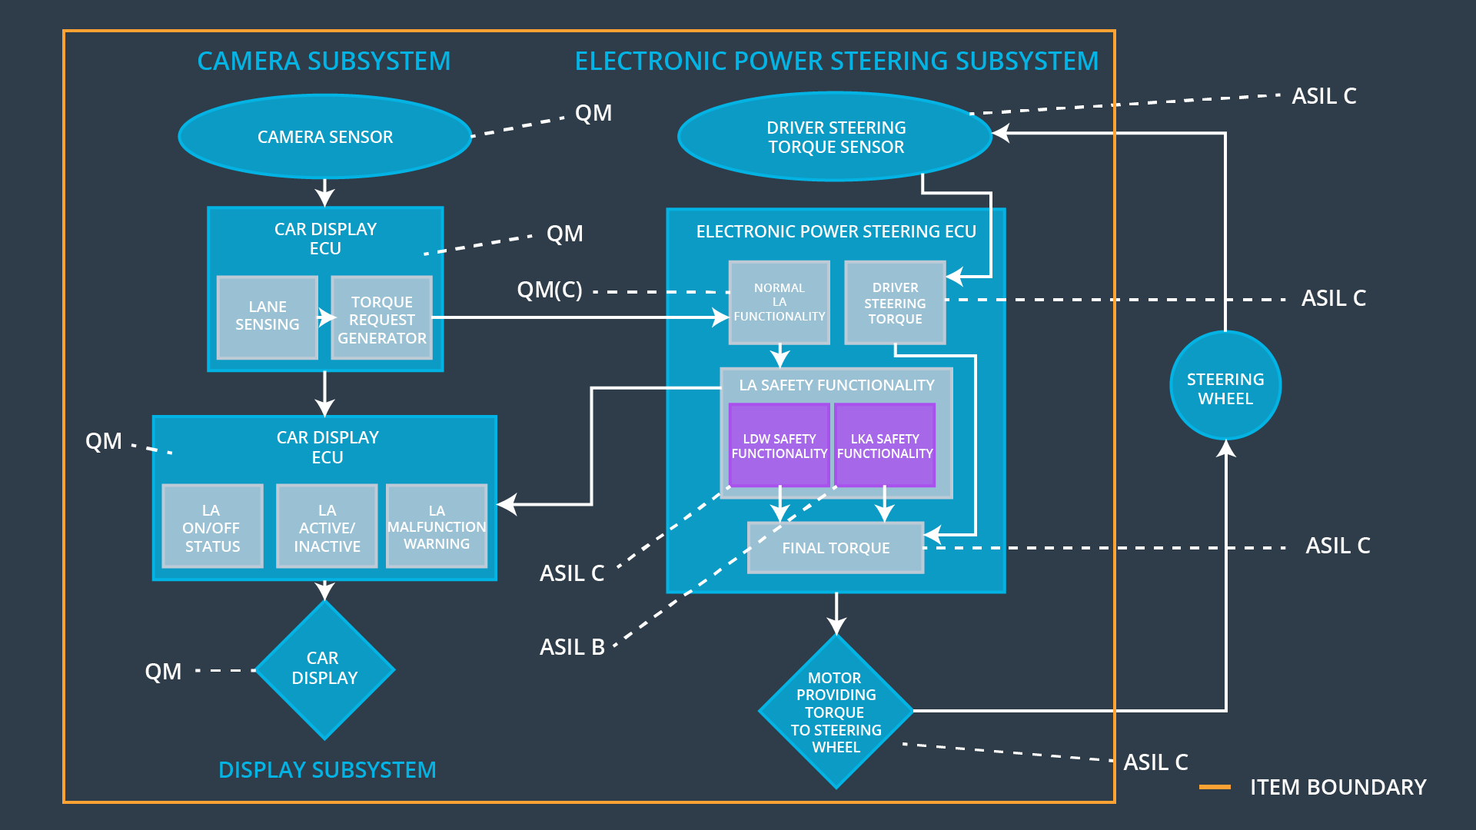

Figure 2: Refined System Architecture of the Lane Assistance System

## Allocation of Functional Safety Requirements to Architecture Elements

|  |  |  |  |  |
| --- | --- | --- | --- | --- |
| **ID** | **Functional Safety Requirement** | **Electronic Power Steering ECU** | **Camera ECU** | **Car Display ECU** |
| Functional  Safety  Requirement  01-01 | The electronic power steering ECU shall ensure that the lane departure oscillating torque amplitude is below Max_Torque_Amplitude | **X** |  |  |
| Functional  Safety  Requirement  01-02 | The electronic power steering ECU shall ensure that the lane departure oscillating torque frequency is below Max_Torque_Frequency | **X** |  |  |
| Functional  Safety  Requirement  02-01 | The electronic power steering ECU shall ensure that the LKA torque is applied only for Max_Duration. | **X** |  |  |

## Warning and Degradation Concept

|  |  |  |  |  |
| --- | --- | --- | --- | --- |
| **ID** | **Degradation Mode** | **Trigger for Degradation Mode** | **Safe State invoked?** | **Driver Warning** |
| WDC-01 | Off | LDW torque or frequency exceeds defined maximum values for Max_Torque_Amplitude or Max_Torque_Frequency | Yes | Visual warning in Car Display, e.g. by a flashing LED |
| WDC-02 | Off | LKA torque is applied longer than Max_Duration | Yes | Visual warning in Car Display, e.g. by a flashing LED |