

Technical Safety Concept Lane Assistance

**Document Version: [Version]**

**Template Version 1.0, Released on 2017-06-21**



# Document history

|  |  |  |  |
| --- | --- | --- | --- |
| Date | Version | Editor | Description |
| 2017-10-24 | 0.1 | Wilhelm Nagel | Initial Version |
|  |  |  |  |
|  |  |  |  |
|  |  |  |  |
|  |  |  |  |

# 

# Table of Contents

Document history

Table of Contents

Purpose of the Technical Safety Concept

Inputs to the Technical Safety Concept

Functional Safety Requirements

Refined System Architecture from Functional Safety Concept

Functional overview of architecture elements

Technical Safety Concept

Technical Safety Requirements

Refinement of the System Architecture

Allocation of Technical Safety Requirements to Architecture Elements

Warning and Degradation Concept

# Purpose of the Technical Safety Concept

The Technical Safety Concept details the high-level requirements from the Functional Safety Concept. It describes how the desired functionality will be achieved on a technical level by defining requirements for sensors, control units and actuators. The Technical Safety Concept defines which component is responsible for a function, the electronic signals that are exchanged between ECUs and how the ECUs will behave on the reception of the signals. Technical Safety Concepts are often divided in System Level Technical Concepts and Sub System Level Technical Concepts.

# Inputs to the Technical Safety Concept

## Functional Safety Requirements

|  |  |  |  |  |
| --- | --- | --- | --- | --- |
| **ID** | **Functional Safety Requirement** | **ASIL** | **Fault Tolerant Time Interval** | **Safe State** |
| Functional  Safety  Requirement  01-01 | The electronic power steering ECU shall ensure that the lane departure warning oscillating torque amplitude is below Max_Torque_Amplitude | C | 50 ms | Off |
| Functional  Safety  Requirement  01-02 | The electronic power steering ECU shall ensure that the lane departure warning oscillating torque frequency is below Max_Torque_Frequency | C | 50 ms | Off |
| Functional  Safety  Requirement  02-01 | The lane keeping assistance function shall be time limited and the additional steering torque shall end after a given timer interval so that the driver cannot misuse the system for autonomous driving | B | 500 ms | Off |

## Refined System Architecture from Functional Safety Concept

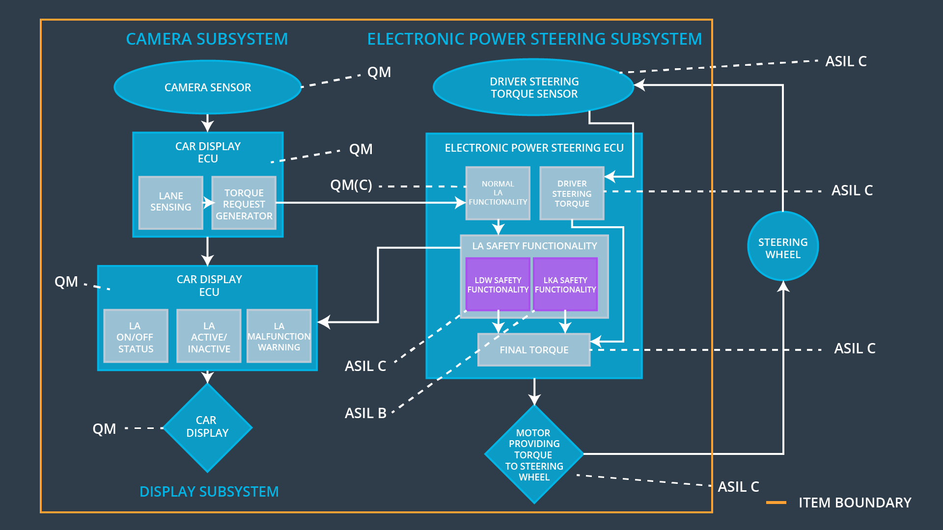

Figure 1: Refined System Architecture for Lane Assistance System

### Functional overview of architecture elements

|  |  |
| --- | --- |
| **Element** | **Description** |
| Camera Sensor | Capture images of the road and provide them to the Camera Sensor ECU |
| Camera Sensor ECU - Lane Sensing | Process the received images to detect drifts from the center of the lane and signal necessity for corrective action to Torque request generator |
| Camera Sensor ECU - Torque request generator | Translate the received corrective action into signals for the Electronic Power Steering ECU |
| Car Display | Display the state information provided by the Car Display ECU, e.g. activation of assistance function, warnings or malfunctions |
| Car Display ECU - Lane Assistance On/Off Status | Displays state of Lane Assistance, i.e. on or off |
| Car Display ECU - Lane Assistant Active/Inactive | Displays if the Lane Assistance function is performing corrective actions, e.g. steering towards lane center |
| Car Display ECU - Lane Assistance malfunction warning | Displays a warning if an error has been detected in the Lane Assistance function |
| Driver Steering Torque Sensor | Senses the torque at the steering wheel that is applied by the driver |
| Electronic Power Steering (EPS) ECU - Driver Steering Torque | Processes signals from Driver Steering Torque Sensor and calculates required torque for EPS ECU |
| EPS ECU - Normal Lane Assistance Functionality | Process signals from Camera Sensor ECU and generate torque requests for LDW and LKA |
| EPS ECU - Lane Departure Warning Safety Functionality | Check that torque amplitude and oscillation are below the thresholds Max_Torque_Amplitude and Max_Torque_Frequency |
| EPS ECU - Lane Keeping Assistant Safety Functionality | Check that duration in which torque is applied does not exceed the threshold of Max_Duration |
| EPS ECU - Final Torque | Sends required torque value to motor |
| Motor | Receives input from EPS ECU and applies torque to steering wheel |

# Technical Safety Concept

## Technical Safety Requirements

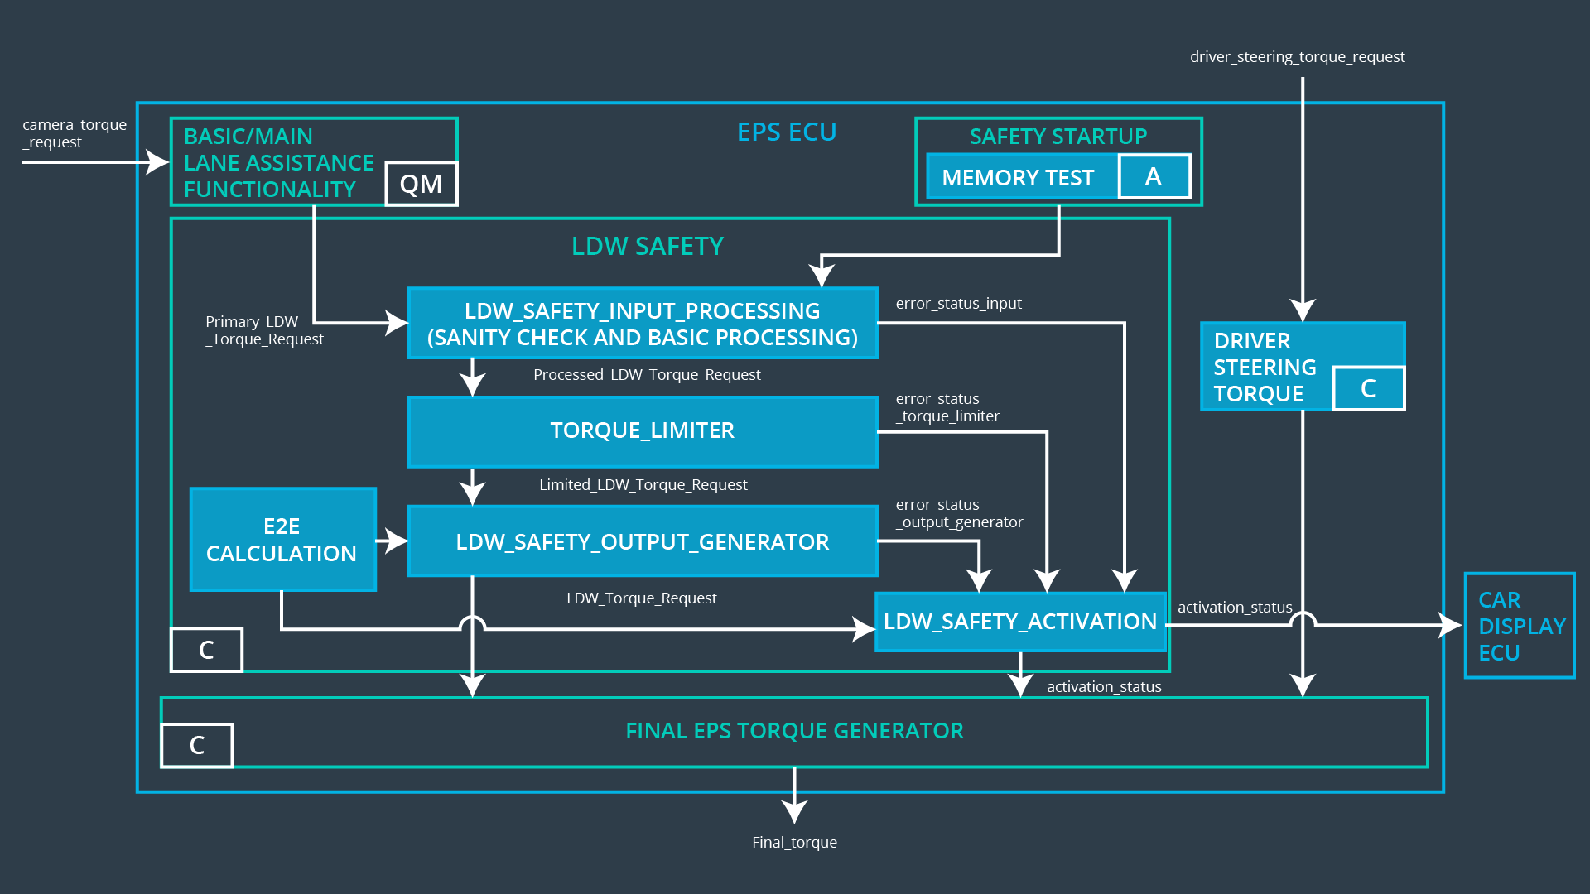

Figure 2: Lane Departure Warning component of the EPS ECU

**Lane Departure Warning (LDW) Requirements:**

Functional Safety Requirement 01-01 with its associated system elements

(derived in the functional safety concept)

|  |  |  |  |  |
| --- | --- | --- | --- | --- |
| **ID** | **Functional Safety Requirement** | **Electronic Power Steering ECU** | **Camera ECU** | **Car Display ECU** |
| Functional  Safety  Requirement  01-01 | The lane keeping item shall ensure that the lane departure oscillating torque amplitude is below Max_Torque_Amplitude | X |  |  |

Technical Safety Requirements related to Functional Safety Requirement 01-01 are:

|  |  |  |  |  |  |
| --- | --- | --- | --- | --- | --- |
| **ID** | **Technical Safety Requirement** | **ASIL** | **Fault Tolerant Time Interval** | **Architecture Allocation** | **Safe State** |
| Technical  Safety  Requirement  01 | The LDW safety component shall ensure that the amplitude of the ‘LDW_Torque_Request’ sent to the ‘Final electronic power steering Torque’ component is below ‘Max_Torque_Amplitude’ | C | 50 ms | LDW Safety Functionality | Off |
| Technical  Safety  Requirement  02 | As soon as a failure is detected by the LDW function, it shall deactivate the LDW feature and the ‘LDW_Torque_Request’ shall be set to zero | C | 50 ms | LDW Safety Functionality | Off |
| Technical  Safety  Requirement  03 | As soon as a failure is detected by the LDW function, it shall deactivate the LDW feature and the ‘LDW_Torque_Request’ shall be set to zero. | C | 50 ms | LDW Safety Functionality | Off |
| Technical  Safety  Requirement  04 | The validity and integrity of the data transmission for ‘LDW_Torque_Request’ signal shall be ensured | C | 50 ms | Data Transmission Integrity Check | Off |
| Technical  Safety  Requirement  05 | Memory test shall be conducted at startup of the EPS ECU to check for any faults in memory. | A | ignition cycle | Safety startup | Off |

Functional Safety Requirement 01-2 with its associated system elements

(derived in the functional safety concept)

|  |  |  |  |  |
| --- | --- | --- | --- | --- |
| **ID** | **Functional Safety Requirement** | **Electronic Power Steering ECU** | **Camera ECU** | **Car Display ECU** |
| Functional  Safety  Requirement  01-02 | The lane keeping item shall ensure that the lane departure oscillating torque frequency is below Max_Torque_Frequency | X |  |  |

Technical Safety Requirements related to Functional Safety Requirement 01-02 are:

|  |  |  |  |  |  |
| --- | --- | --- | --- | --- | --- |
| **ID** | **Technical Safety Requirement** | **ASIL** | **Fault Tolerant Time Interval** | **Architecture Allocation** | **Safe State** |
| Technical  Safety  Requirement  01 | The LDW safety component shall ensure that the amplitude of the LDW_Torque_Request sent to the ‘final electronic power steering Torque’ component is below Max_Torque_Frequency | C | 50 ms | LDW Safety Functionality | Off |
| Technical  Safety  Requirement  02 | As soon as a failure is detected by the LDW function, it shall deactivate the LDW feature and the LDW_Torque_Request shall be set to zero | C | 50 ms | LDW Safety Functionality | Off |
| Technical  Safety  Requirement  03 | As soon as the LDW function deactivates the LDW feature, the LDW Safety software block shall send a signal to the car display ECU to turn on a warning light | C | 50 ms | LDW Safety Functionality | Off |
| Technical  Safety  Requirement  04 | The validity and integrity of the data transmission for LDW_Torque_Request signal shall be ensured | C | 50 ms | Data Transmission integrity check | Off |
| Technical  Safety  Requirement  05 | Memory test shall be conducted at start up of EPS ECU to check for any faults in memory | A | Ignition cycle | Safety startup | Off |

**Lane Keeping Assistance (LKA) Requirements:**

Functional Safety Requirement 02-1 with its associated system elements

(derived in the functional safety concept)

|  |  |  |  |  |
| --- | --- | --- | --- | --- |
| **ID** | **Functional Safety Requirement** | **Electronic Power Steering ECU** | **Camera ECU** | **Car Display ECU** |
| Functional  Safety  Requirement  02-01 | The lane keeping item shall ensure that the lane keeping assistance torque is applied for only Max_Duration | X |  |  |

Technical Safety Requirements related to Functional Safety Requirement 02-01 are:

|  |  |  |  |  |  |
| --- | --- | --- | --- | --- | --- |
| **ID** | **Technical Safety Requirement** | **ASIL** | **Fault Tolerant Time Interval** | **Allocation to Architecture** | **Safe State** |
| Technical  Safety  Requirement  01 | The LKA safety component shall ensure that the LKA_Torque_Request sent to the ‘Final electronic power steering Torque’ component is applied for only Max_Duration | B | 500 ms | LKA Safety Functionality | Off |
| Technical  Safety  Requirement  02 | As soon as the LKA function deactivates the LKA feature, the LKA Safety software block shall send a signal to the car display ECU to turn on a warning light | B | 500 ms | LKA Safety Functionality | Off |
| Technical  Safety  Requirement  03 | As soon as a failure is detected by the LKA function, it shall deactivate the LKA feature and the LKA_Torque_Request shall be set to zero | B | 500 ms | LKA Safety Functionality | Off |
| Technical  Safety  Requirement  04 | The validity and integrity of the data transmission for LKA_Torque_Request signal shall be ensured | B | 500 ms | Data Transmission integrity check | Off |
| Technical  Safety  Requirement  05 | Memory test shall be conducted at start up of the EPS ECU to check for any faults in memory | A | Ignition cycle | Safety startup | Off |

## Refinement of the System Architecture

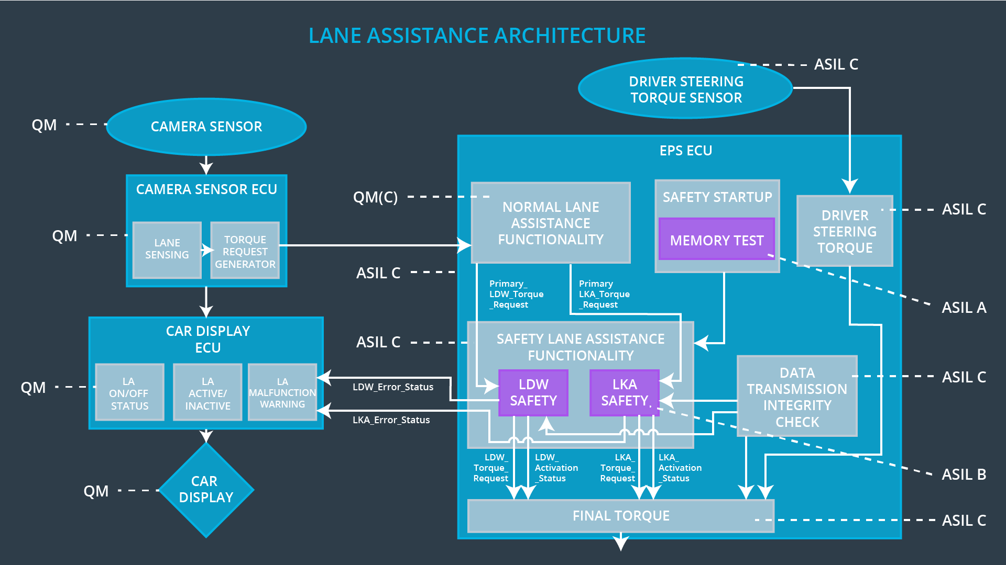

Figure 3: Refined System Architecture of Lane Assistance

## Allocation of Technical Safety Requirements to Architecture Elements

All technical safety requirements of the Lane Assistance system are allocated to the Electronic Power Steering ECU.

## Warning and Degradation Concept

|  |  |  |  |  |
| --- | --- | --- | --- | --- |
| **ID** | **Degradation Mode** | **Trigger for Degradation Mode** | **Safe State invoked?** | **Driver Warning** |
| WDC-01 | Off | LDW torque or frequency exceeds defined maximum values for Max_Torque_Amplitude or Max_Torque_Frequency | Yes | Visual warning in Car Display, e.g. by a flashing LED |
| WDC-02 | Off | LKA torque is applied longer than Max_Duration | Yes | Visual warning in Car Display, e.g. by a flashing LED |