1. What is the benefit of using master-slave architecture rather than building on master only?

-work with master and slave faster than work on master only.

-master-slave don’t need to install denseness for many time it will install one time.

-master-slave can work on big number of projects .

## 2- What is different between authorization and authentication ?

Authentication: is the process of verifying the identity of a user or system.

Authorization :is the process of determining whether an authenticated user or system has the necessary permissions to access a specific resource or perform a certain operation.

## 3-Make jenkins-shared-library and make your jenkinsfile which you used in lab2 to point to this library

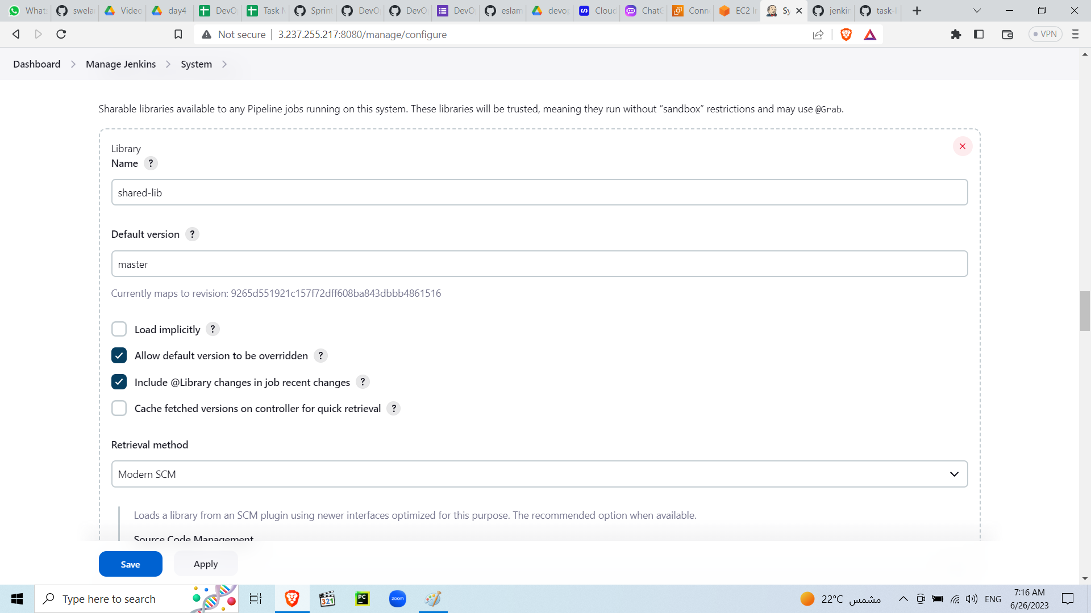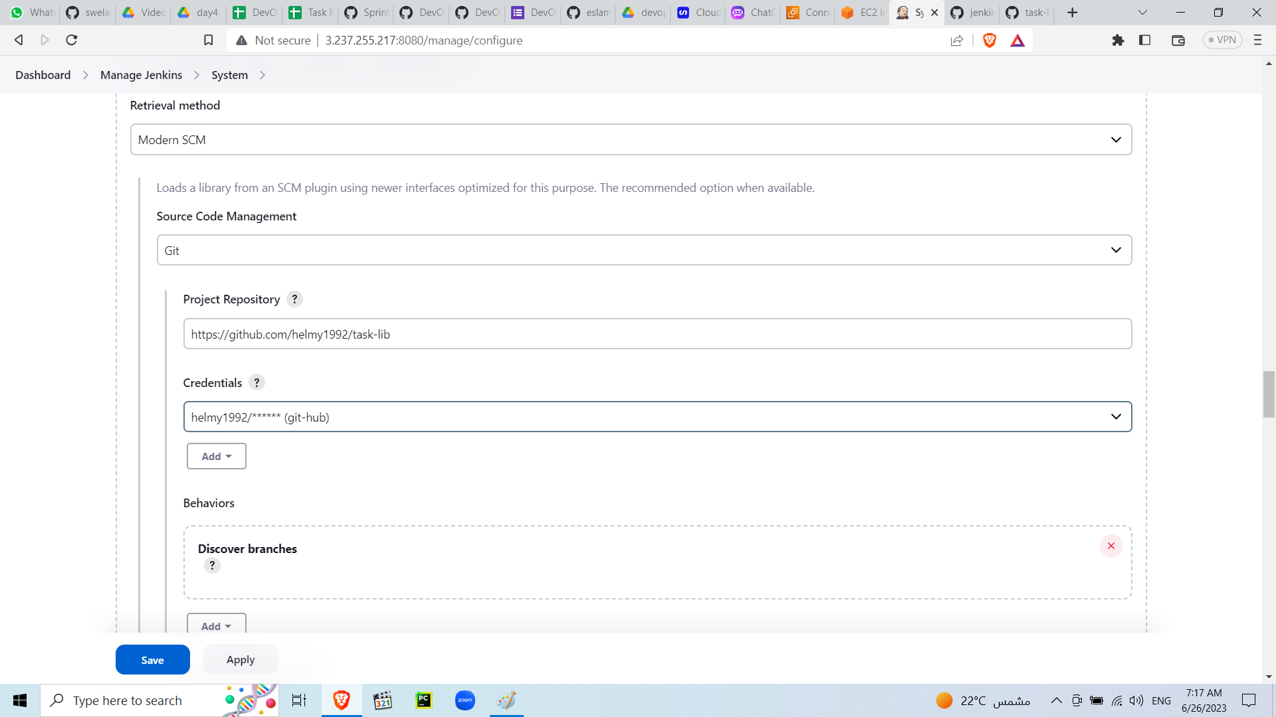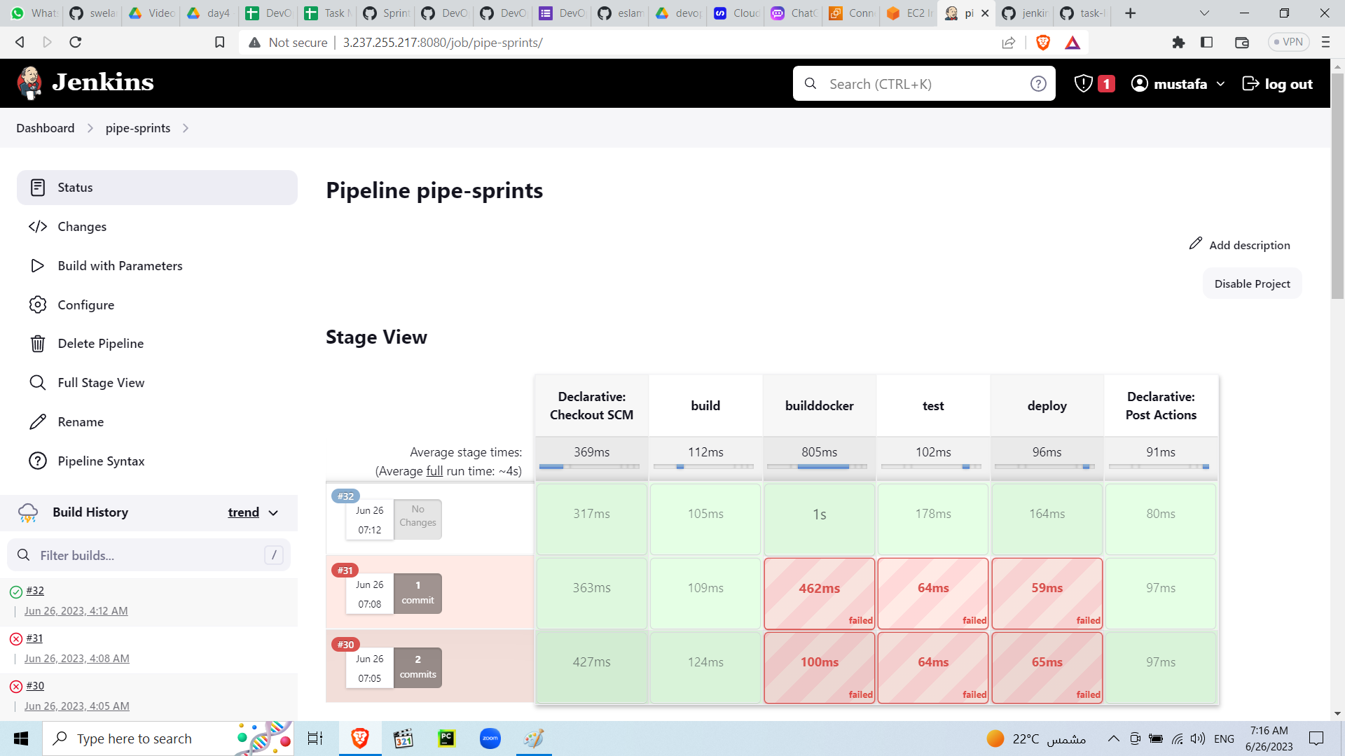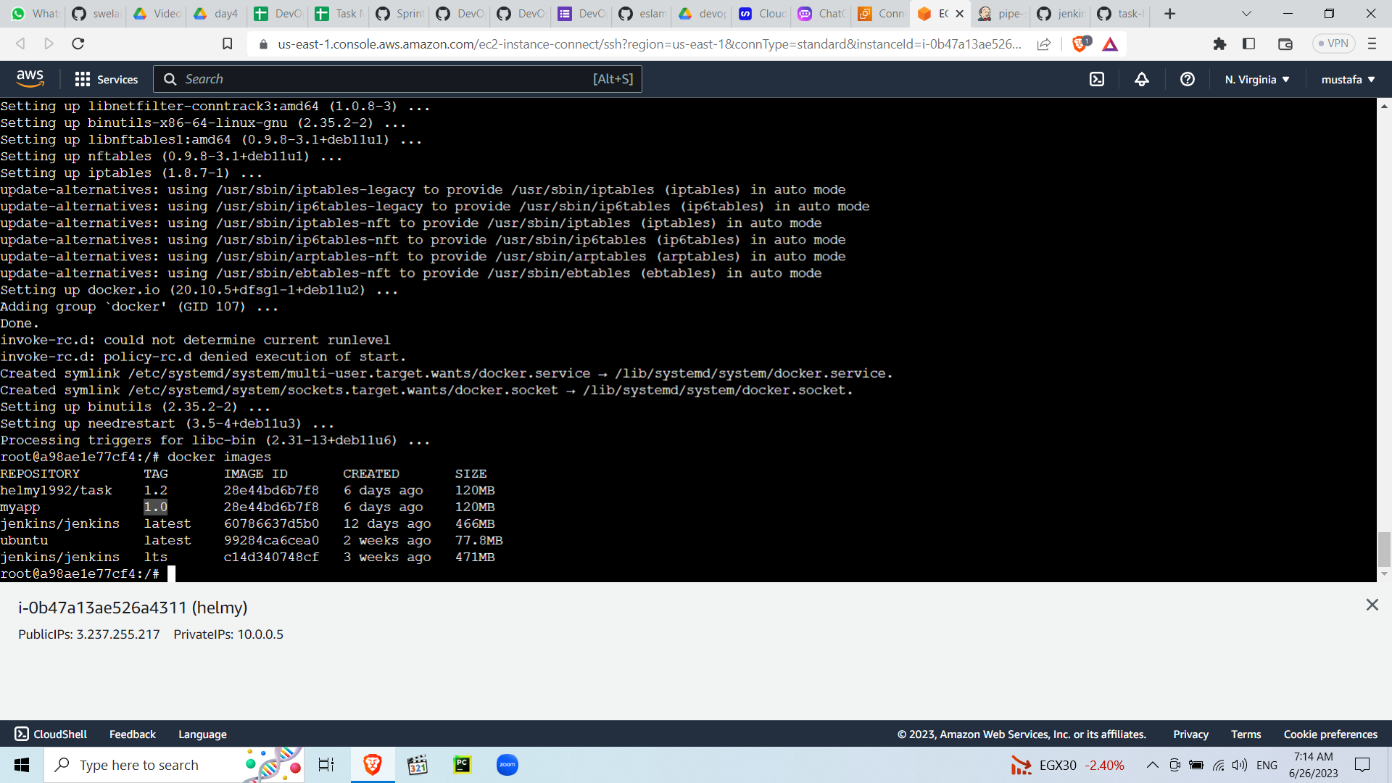

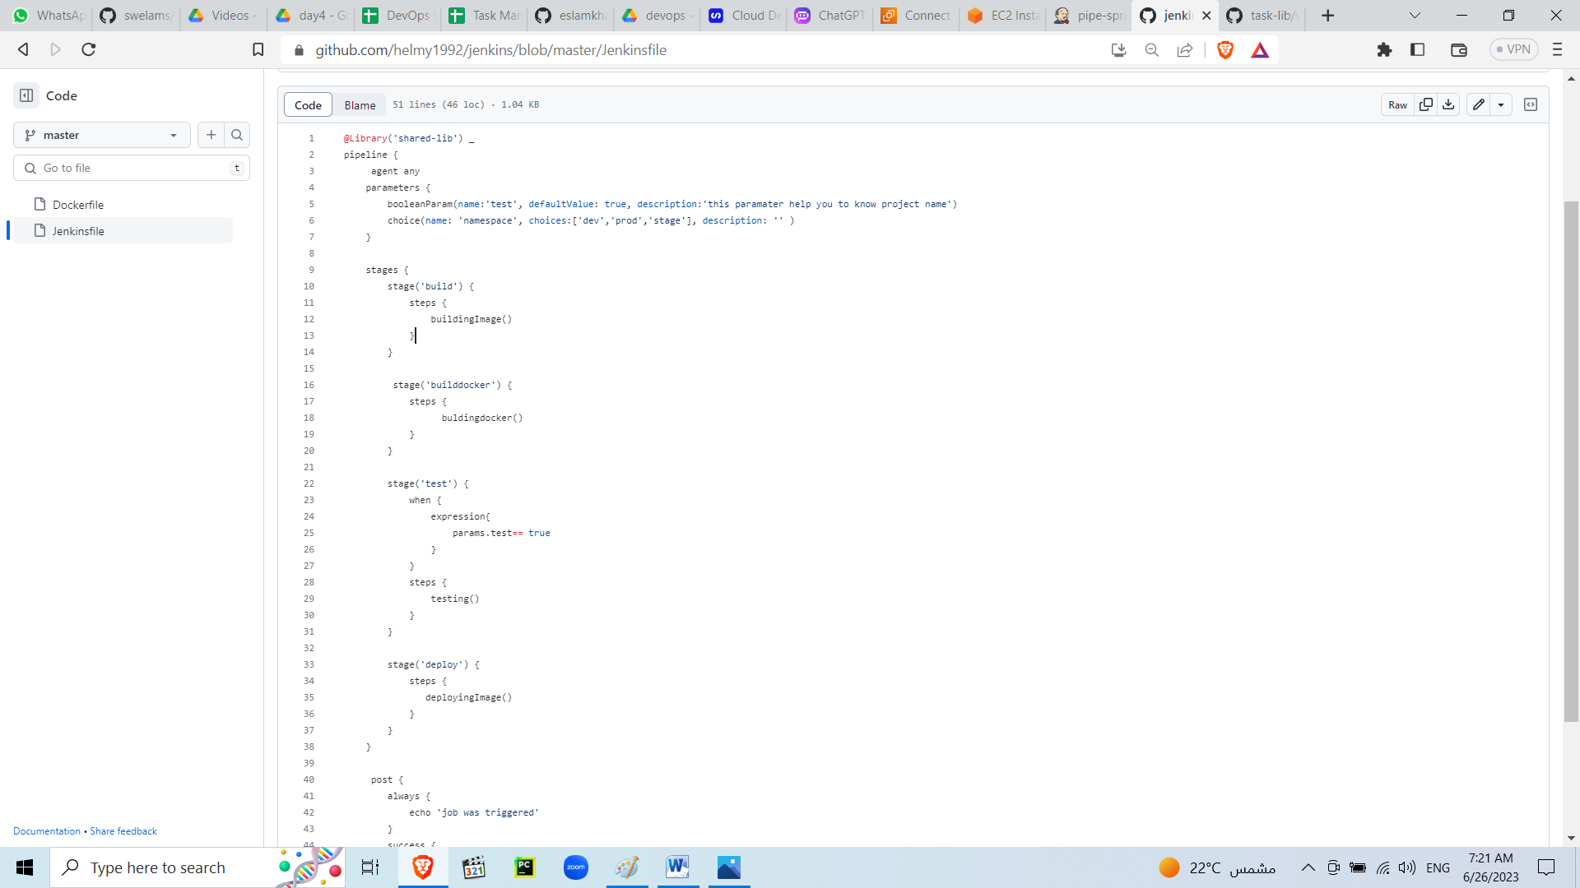

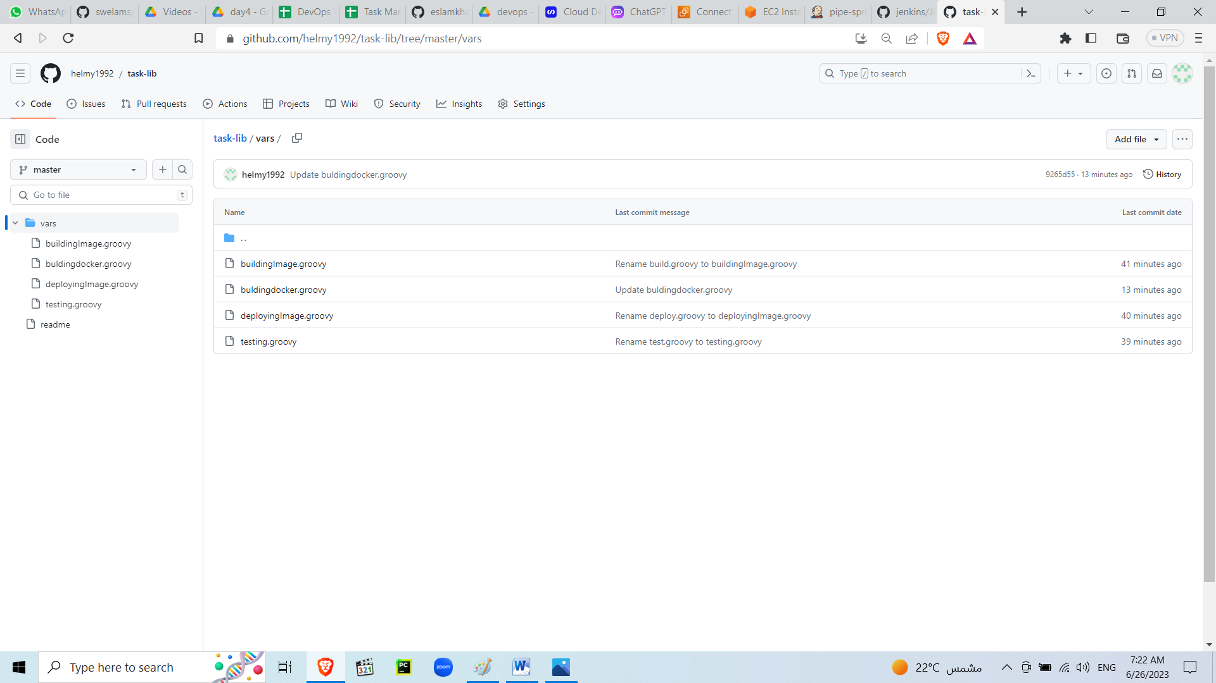

## 4- Try to make new slave as container or ec2 server and configure master to use it

