**Helen Natalia**

**51019010**

**Prak.Cloud Computing**

**LATIHAN 1**

**Create a Cloud Datastore database**

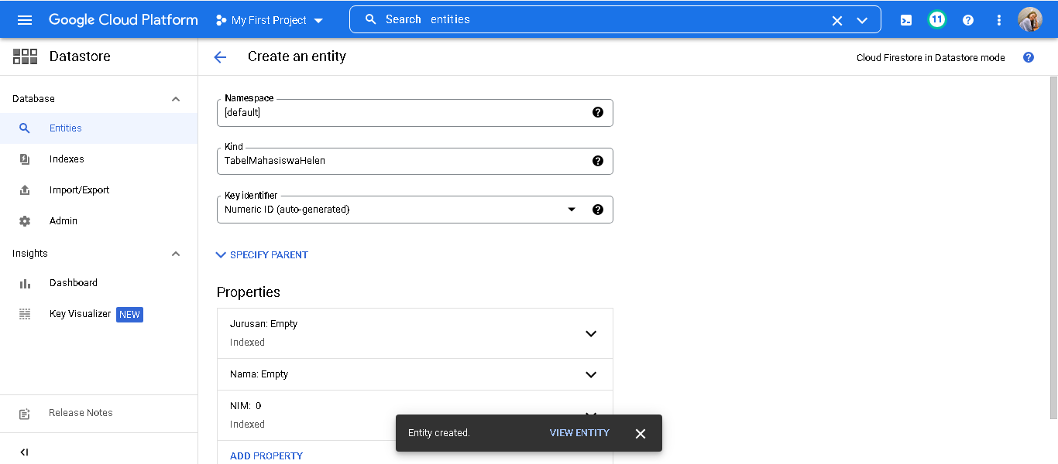

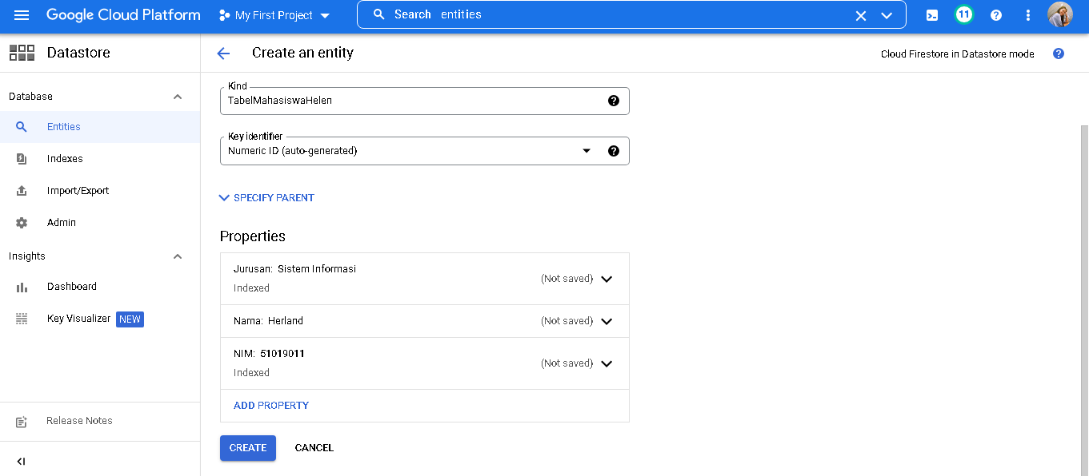

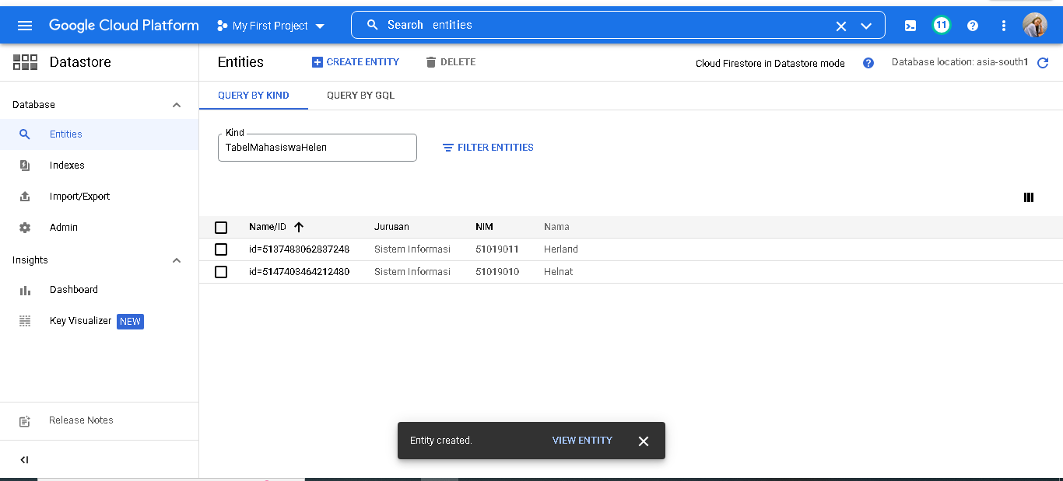

**LATIHAN 2**

**Menggunakan Filter Entities**

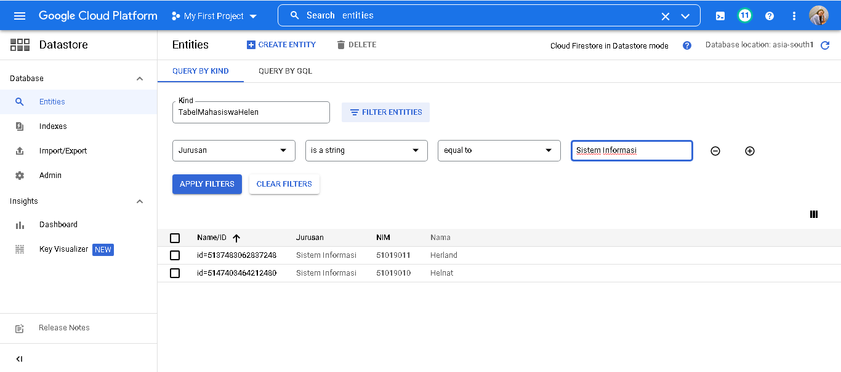

**LATIHAN 3**

**Menggunakan QUERY BY GQL**

