**Installation Documentation for Implementing Jar**

**Step#1:IntelliJ IDEA Installation Guide**

**Table of Contents**

IntelliJ Overview

Downloading and Installing IntelliJ

Step 1: Downloading IntelliJ

Step 2: Installing IntelliJ

Step 1: Launching IntelliJ

Step 2: Customize IntelliJ

Step 3: Creating the Project

Step 4: Running the Project

Exporting a Project for Submission

Step 1: Exporting the Project

Optional Step 2: Viewing the File

**IntelliJ Overview**

IntelliJ is one of the most popular Java application development environments for desktop and Android applications. IntelliJ runs under Windows, Linux, and Mac OS. It supports advanced Java development from a default install, and can be further extended with a variety of plugins to suit particular environments. IntelliJ supports basic and advanced debugging, as well as a host of application creation tools. By learning to use IntelliJ, you’ll have experience with an industry standard Java development environment.

Note that the proper name of this tool is “IntelliJ IDEA”, but the tool is often referred to as just “IntelliJ”. This document refers to it as such. IntelliJ is created and maintained by JetBrains, an organization that develops various code development software with an eye towards making the tools both powerful and intelligent

**Downloading and Installing IntelliJ**

## Step 1: Downloading IntelliJ

**Visit Website** Go to [https://www.jetbrains.com/idea/download/](http://www.jetbrains.com/idea/download/) to get started downloading IntelliJ. JetBrains regularly updates their website, so what you see may be different than the following.

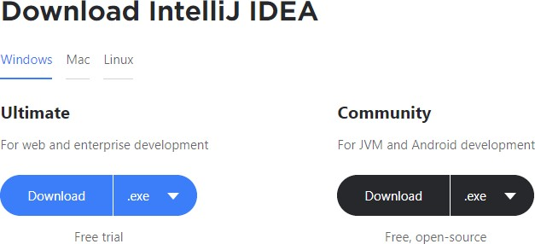

**Download and Execute**

Click the “Download” link under the “Community” option to get started.

## Step 2: Installing IntelliJ

**Execute Installer**

Your browser will now give you the option to run the executable it downloaded. Go ahead and run it. You’ll see a screen like the following.

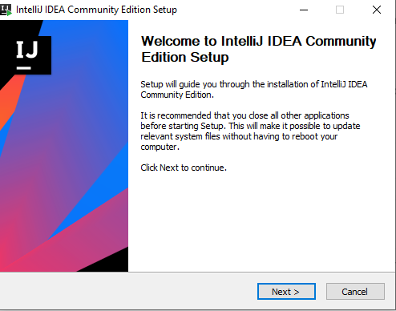

**Accept Destination Folder**

After clicking the Next button, the installer will show you the directory it pre‐selected for installation. There is no need to change the default. The screen will look like the following.

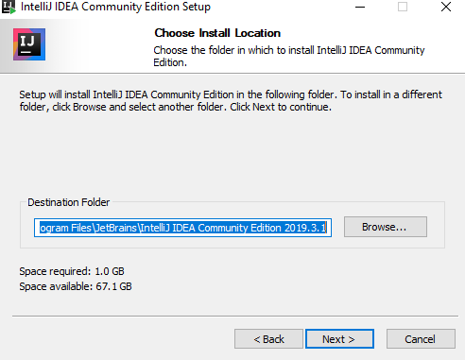

**Select Other Options**

After clicking the Next button, you’ll be presented with other options. Check all the boxes mentioned in attachment and click on Next.

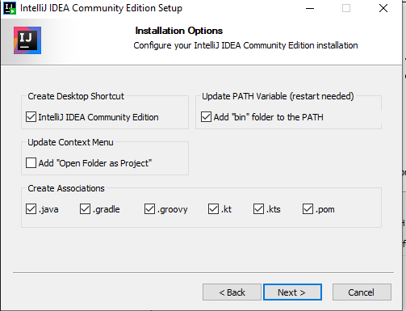

**Accept Start Menu Option**

After clicking the Next button, you’ll be shown the default Start Menu folder the program will be placed into. There is no need to change it so you can accept the default. The screen will look like the following.

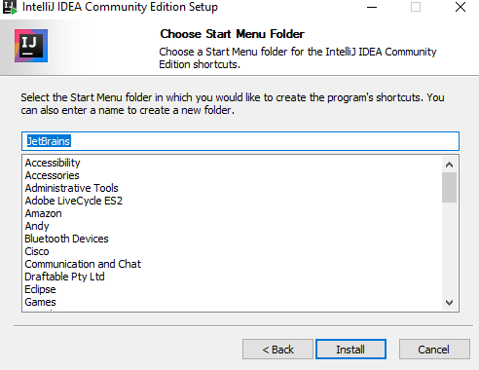

**Start the Install**

Click the Install button to start the install. You’ll see a progress bar for a while, followed by a screen indicating installation is completed, similar to the below.

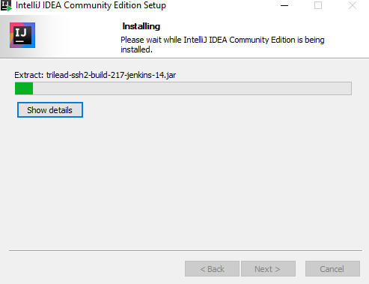

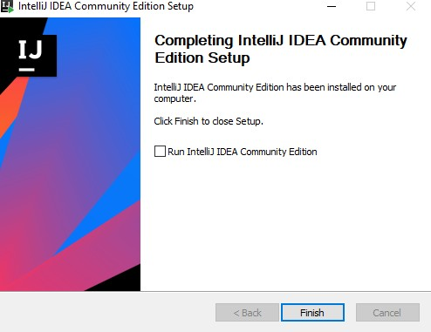

Congratulations! IntelliJ is now installed on your machine and is ready to use.

## Step 1: Launching IntelliJ

**Launching from Installer**

After the installation is completed, you can launch IntelliJ for the first time by selecting the “Run IntelliJ IDEA Community Edition” checkbox and clicking the “Finish” button.

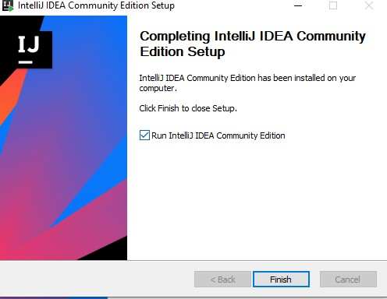

**Launch from Windows**

Going forward, you can launch IntelliJ from Windows, either from the Start Menu, or from the shortcut on the desktop.

### Start Menu

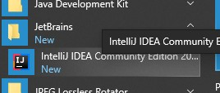

### Desktop

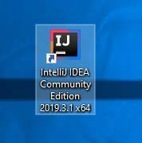

## Step 2: Customize IntelliJ

Upon first launch, several screens will appear asking you to customize your IntelliJ. We guide you through these step‐by‐step. You will only see the screens on the first launch.

**Accept Import Settings**

The first screen is about whether or not you want to import anything. You have nothing to import, so just accept the default of not importing anything.

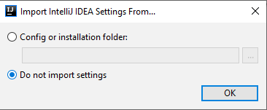

**Accept Privacy Policy**

Next, you’ll be ask to accept the Privacy Policy. Check the “I confirm…” checkbox and hit “Continue” to continue.

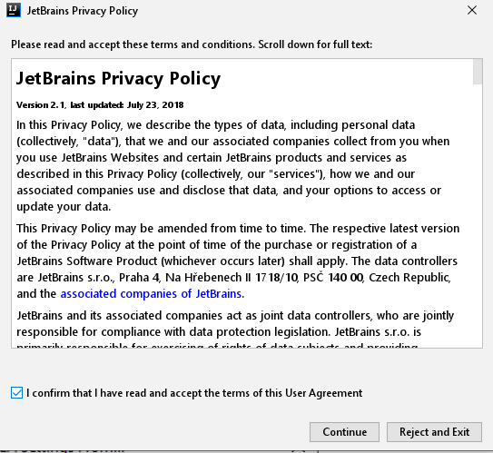

**Decide About Data Sharing**

**Choose UI Theme**

Next, you’ll be asked to decide whether or not you want to send anonymous usage statistics to JetBrains. This is your choice so you can choose whichever option you feel comfortable with.

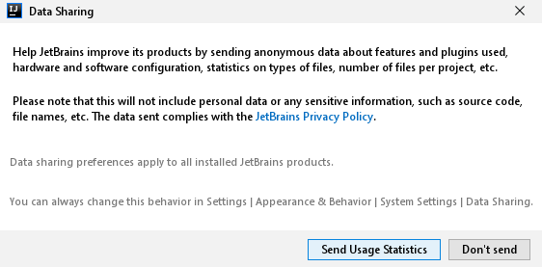

Next, you’ll be asked to choose your UI them, light or dark. Light has a white background and dark has a dark background. You can choose whichever you prefer.

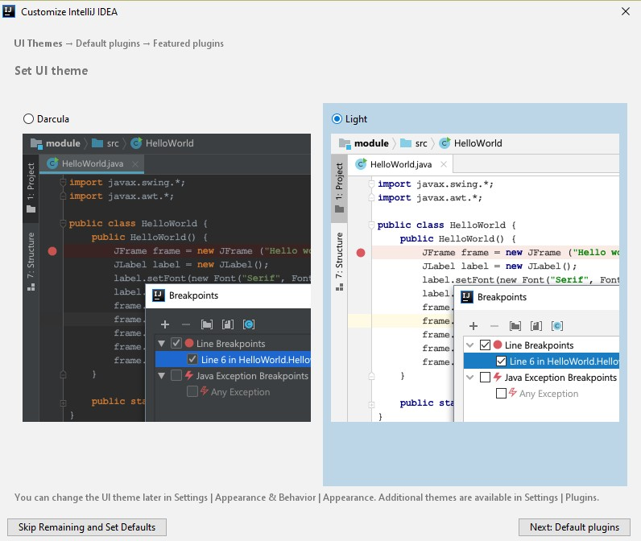

**Accept Default Tools**

After clicking the “Next: Default plugins” button, you’ll be presented with several other options. You don’t need to change anything. Just accept the defaults.

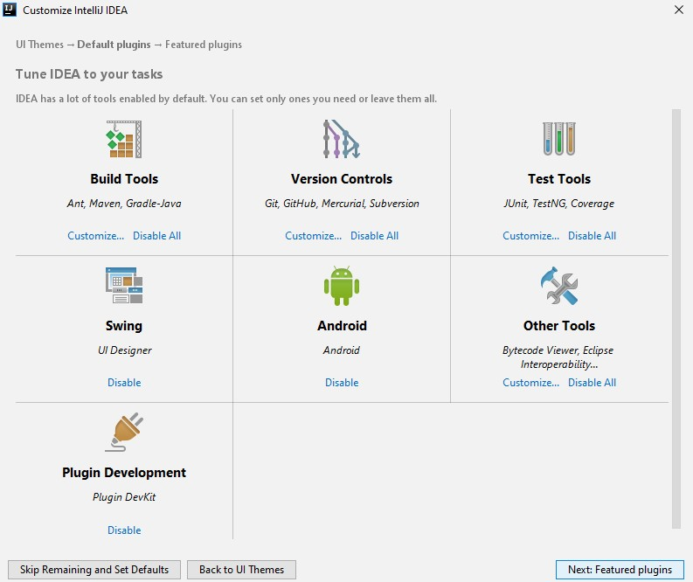

**Accept Default Plugins**

After clicking the “Next: Feature plugins” button, you’ll be asked to choose additional plugins. You don’t need them, so you can just accept the defaults.

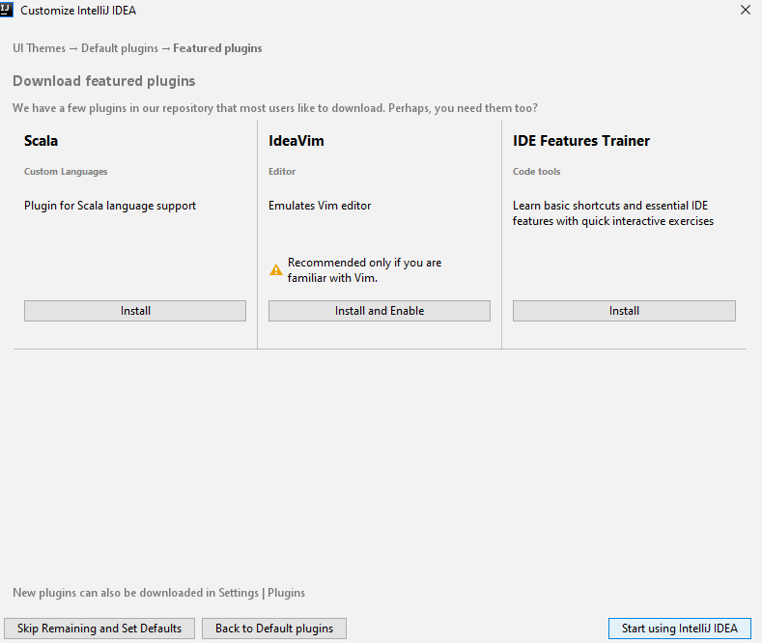

## Step 3: Creating the Project

**Splash Screen**

After clicking the “Start using IntelliJ IDEA” button, you’ll first see a splash screen with a progress bar.



**Create a Project**

After this, the initial IntelliJ screen appears with a few options; only one is needed for us right now. Click the “Create New Project” option to get started creating your project.

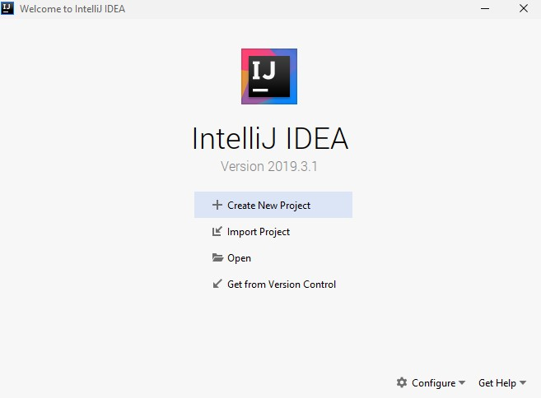

**Choose Project Type**

Your next step is to choose the “Java” project type. There are other types of projects you can create, but a typical project is a Java project which allows you type Java code and execute it. The Java project type is selected by default, so just click the Next button to continue. Make sure maven is selected also in Build system and simply click on create.

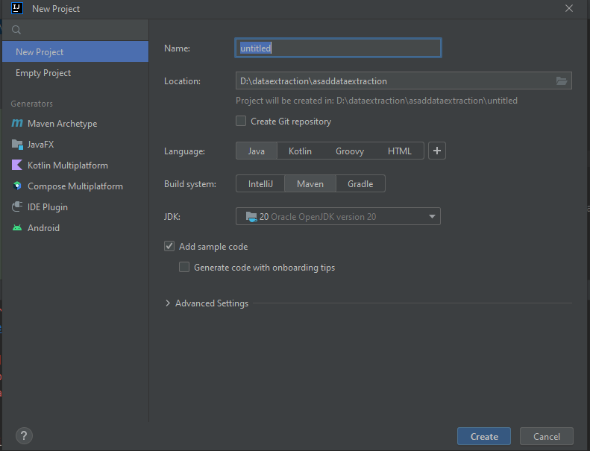

**Step#1:JDK Installation Guide**

**Table of Contents**

JDK Overview

Downloading and Installing JDK

Step 1: Downloading JDK

Step 2: Installing JDK

Step 3: Launching JDK

Step 4: Setting up Environment variables for JDK

**JDK Overview**

JDK (Java Development Kit) is a software development environment that provides the necessary tools and libraries for developing, debugging, and running Java applications. It includes the Java Runtime Environment (JRE), the Java compiler (javac), various utilities, and additional libraries.

**Downloading and Installing JDK**

## Step 1: Downloading JDK

**Visit Website** Go to  [https://www.oracle.com/java/technologies/downloads/](http://www.jetbrains.com/idea/download/) to get started downloading JDK. Oracle regularly updates their website, so what you see may be different than the following.

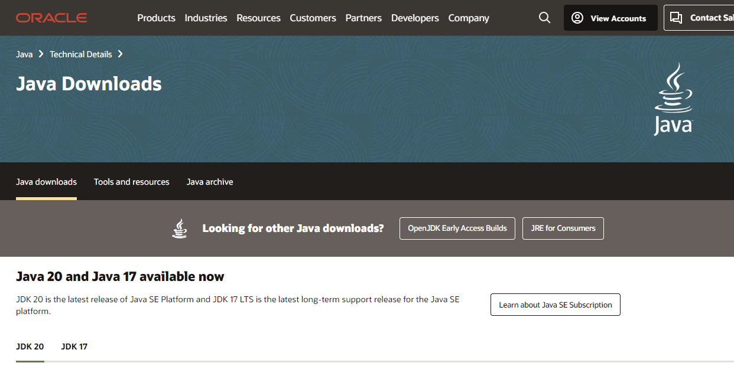

**Download JDK** Go Scroll down to some extent, you will see JDK’s version also red highlighted in attachment. Make sure if you are windows user window is selected, if you are Mac user macOS is selected.

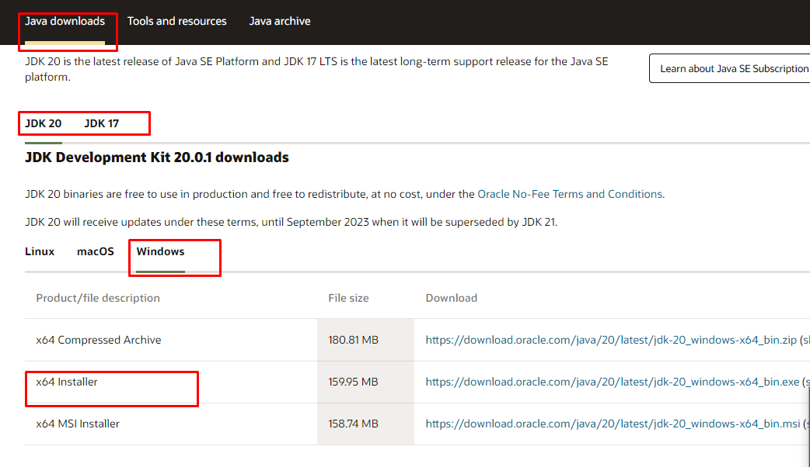

***When you click on Link for download it will start downloading.***

**Execute Installer** Your browser will now give you the option to run the executable it downloaded. Go ahead and run it. You’ll see a screen like the following.

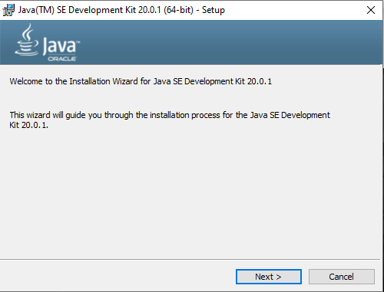

**Accept Destination Folder**

After clicking the Next button, the installer will show you the directory it pre‐selected for installation. There is no need to change the default. The screen will look like the following.

.

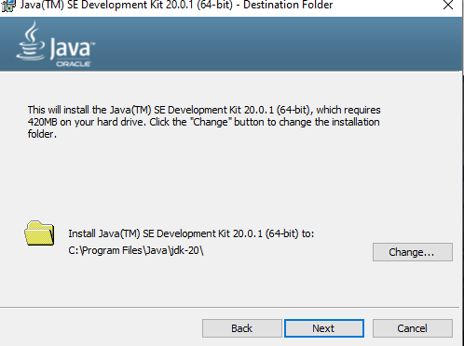

**Start the Install** Click the Install button to start the install. You’ll see a progress bar for a while, followed by a screen indicating installation is completed, similar to the below.



**JDK Folder Visibility** Check in program files for jdk-version folder .

