**ATM Transaction Options**

**1. Just after logging**

Here on, she is presented with the following options:

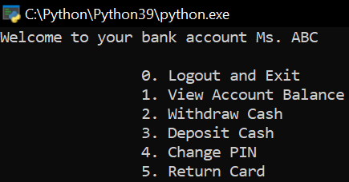

Let’s see what pressing the buttons for all these options does, as well as pressing an invalid button:

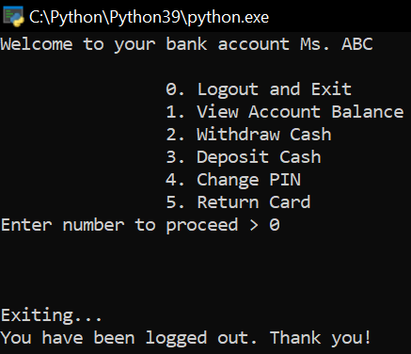

**2. Pressing 0 in Simple Atm Program in Python**

Pressing 0 will simply “log us out” of the ATM.

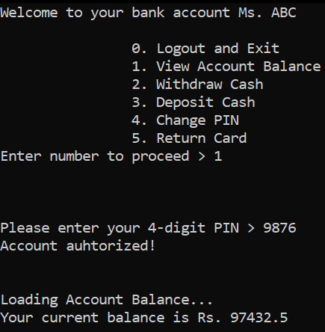

**3. Pressing 1**

Pressing 1 takes us to the “View Account Balance” option, where, after we’ve entered the correct PIN for our bank account, we are able to see how much money is in our bank account.

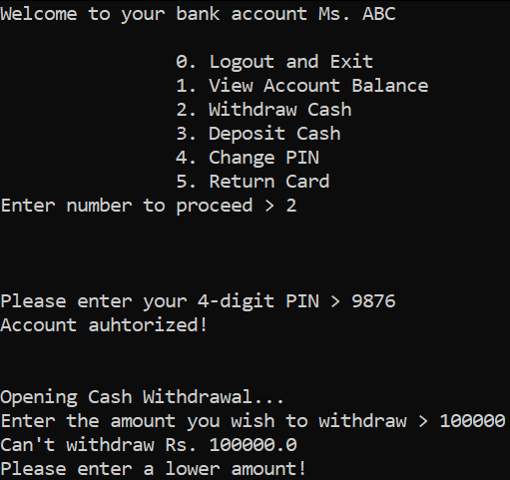

**4. Pressing 2 in Simple Atm Program in Python**

Pressing 2 will load up the cash withdrawal screen, wherein after we have entered the right PIN for our bank account, we will be able to enter an amount to withdraw from our account. Here, in the above screenshot, I have entered an extra 0 in 10000 by mistake, which is where the code tells me that I won’t be able to withdraw an amount that is greater than my account balance and is giving me an error message.

Immediately after that, as seen in the next screenshot, I am being prompted to enter the amount again, where I have put in 10000, and after getting a confirmation from me, it deducts the amount entered, that is 10 thousand rupees in this example, and shows us the updated balance of money in our account.

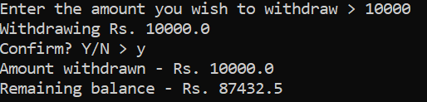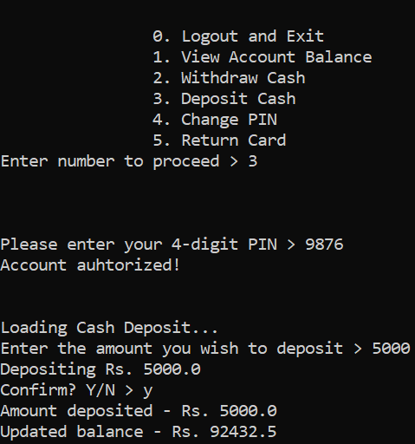

**5. Pressing 3**

On entering 3, we are taken to the cash deposit option of the ATM, where we’ll be able to deposit an amount into our bank account. Here, I have entered 5000 as the deposit amount, which is then immediately added to the bank balance after I validate that 5000 is indeed the amount I wish to deposit into my account.

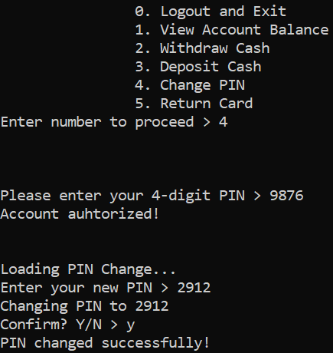

**6. Pressing 4 in Simple Atm Program in Python**

Pressing 4 allows me to change my ATM PIN. Here, I am prompted to enter my old PIN, after which the program allows me to enter the new PIN I want, which I have chosen at 2912.

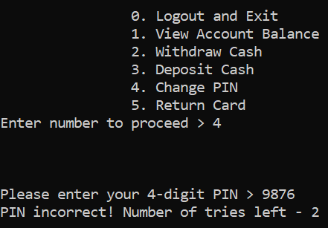

So after the PIN update, I will not be able to use my old PIN for any processes or transactions as long as my program is running this time.

Further, I will only be able to enter an incorrect PIN a total of 3 times, after which I will be logged out of the account and will be exited from the code execution.

Also, if I enter n or N after the “Confirm? Y/N”, the entire process will be canceled and no changes will be made to the PIN or account balance.

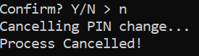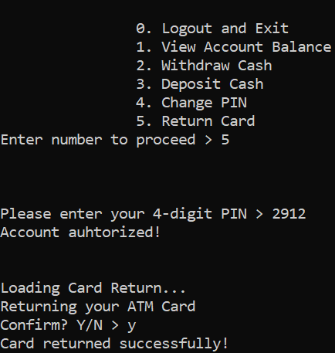

**7. Pressing 5**

The last option, 5, is for returning the ATM card, as seen above.

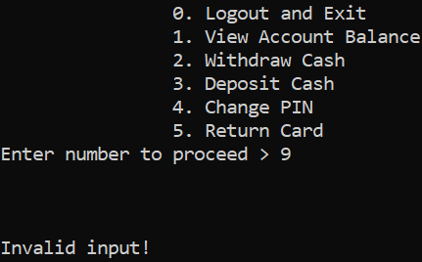

Inputting a number that is not in the range of 0 to 6 will give me an “Invalid Input!” message.

**Code explanation for Simple Atm Program in Python**

Now that we have seen and understood how the entire program works, let’s take a look at the code for each of the above options, as well as for the entry and exit messages –

import time as t

I am using the time module with the alias t for its sleep function. I have used the sleep function simply for the realistic effect it gives to an application, and will explain its implementation as we encounter it further along in the code.

Here, I have hard-coded the user’s PIN and account balance as so:

user_pin = 9876

user_balance = 97432.50

user_name = "Ms. ABC"

print("Welcome to your bank account", user_name, end = "\n\n")

choice = 9

I have also initialized the value of the choice variable.

while (True):

print("\t\t0. Logout and Exit")

print("\t\t1. View Account Balance")

print("\t\t2. Withdraw Cash")

print("\t\t3. Deposit Cash")

print("\t\t4. Change PIN")

print("\t\t5. Return Card")

choice = int(input("Enter number to proceed > "))

print("\n\n")

if choice == 0:

print("Exiting...")

t.sleep(2)

print("You have been logged out. Thank you!\n\n")

break

Now here, after Exiting… is printed, I have added t.sleep(2), where 2 is indicative is the number of seconds the program execution is supposed to wait before going forward with the code.

elif choice in (1,2,3,4,5):

num_of_tries = 3

while (num_of_tries!=0):

input_pin = int(input("Please enter your 4-digit PIN > "))

if input_pin == user_pin:

print("Account auhtorized!\n\n")

if choice == 1:

print("Loading Account Balance...")

t.sleep(1.5)

print("Your current balance is Rs.", user_balance, end = "\n\n\n")

break

elif choice == 2:

print("Opening Cash Withdrawal...")

t.sleep(1.5)

while(True):

withdraw_amt = float(input("Enter the amount you wish to withdraw > "))

if withdraw_amt>user_balance:

print("Can't withdraw Rs.", withdraw_amt)

print("Please enter a lower amount!")

continue

else:

print("Withdrawing Rs.", withdraw_amt)

confirm = input("Confirm? Y/N > ")

if confirm in ('Y', 'y'):

user_balance-=withdraw_amt

print("Amount withdrawn - Rs.", withdraw_amt)

print("Remaining balance - Rs.", user_balance, end = "\n\n\n")

break

else:

print("Cancelling transaction...")

t.sleep(1)

print("Transaction Cancelled!\n\n")

break

break

elif choice == 3:

print("Loading Cash Deposit...")

t.sleep(1.5)

deposit_amt = float(input("Enter the amount you wish to deposit > "))

print("Depositing Rs.", deposit_amt)

confirm = input("Confirm? Y/N > ")

if confirm in ('Y', 'y'):

user_balance+=deposit_amt

print("Amount deposited - Rs.", deposit_amt)

print("Updated balance - Rs.", user_balance, end = "\n\n\n")

else:

print("Cancelling transaction...")

t.sleep(1)

print("Transaction Cancelled!\n\n")

break

elif choice == 4:

print("Loading PIN Change...")

t.sleep(1.5)

pin_new = int(input("Enter your new PIN > "))

print("Changing PIN to", pin_new)

confirm = input("Confirm? Y/N > ")

if confirm in ('Y', 'y'):

user_pin = pin_new

print("PIN changed successfully! \n\n")

else:

print("Cancelling PIN change...")

t.sleep(1)

print("Process Cancelled!\n\n")

break

else:

print("Loading Card Return...")

t.sleep(1.5)

print("Returning your ATM Card")

confirm = input("Confirm? Y/N > ")

if confirm in ('Y', 'y'):

print("Card returned successfully! \n\n")

else:

print("Cancelling process...")

t.sleep(1)

print("Process Cancelled!\n\n")

break

else:

num_of_tries-=1

print("PIN incorrect! Number of tries left -", num_of_tries, end = "\n\n")

else:

print("Exiting...")

t.sleep(2)

print("You have been logged out. Thank you!\n\n")

break

else:

print("Invalid input!")

print("\t\t0. Enter 0 to Logout and Exit!")

continue