Bootstrap Starter Template

<html>

<head>

<meta charset="utf-8">

<meta name="viewport" content="width=device-width, initial-scale=1">

<title></title>

<link rel="stylesheet" type="text/css" href="css/bootstrap.css">

</head>

<body>

<h1>Hello World..</h1>

<button type="button" class="btn btn-primary">

Notifications <span class="badge bg-secondary">4</span>

</button>

<script type="text/javascript" src="js/bootstrap.js"></script>

</body>

</html>

**Components:**

Url: https://getbootstrap.co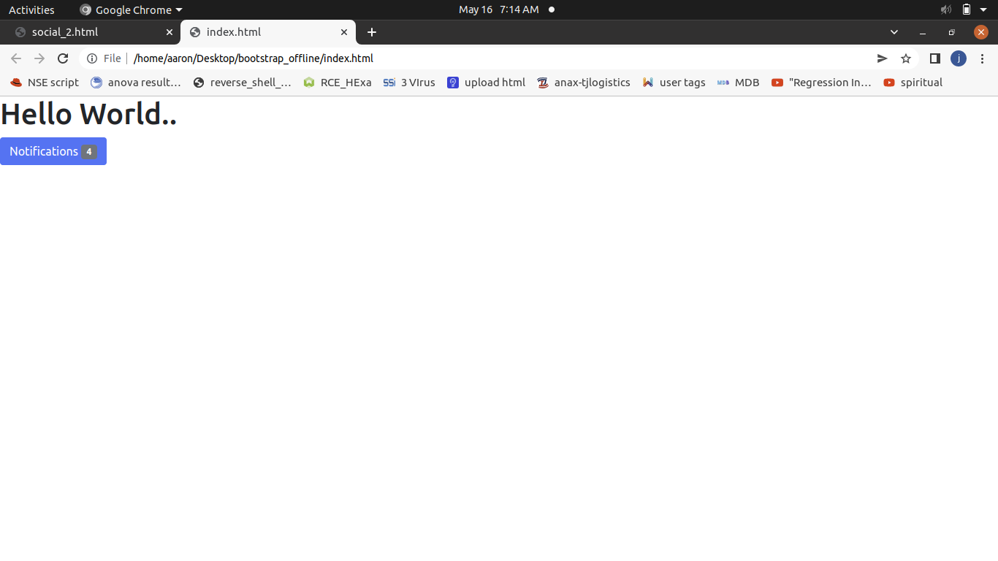m/docs/5.1/components/alerts/