Subnetting explained

**Subnetting** is the practice of dividing a network into two or more smaller networks. It increases routing efficiency, enhances the security of the network and reduces the size of the broadcast domain.

Consider the following example:

[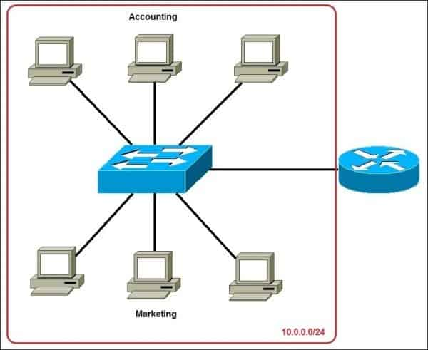](https://study-ccna.com/wp-content/uploads/2016/03/subnetting_example.jpg)

In the picture above we have one huge network: **10.0.0.0/24**. All hosts on the network are in the same subnet, which has the following disadvantages:

* **a single broadcast domain** – all hosts are in the same broadcast domain. A broadcast sent by any device on the network will be processed by all hosts, creating lots of unnecessary traffic.
* **network security** – each device can reach any other device on the network, which can present security problems. For example, a server containing sensitive information shouldn’t be in the same network as user’s workstations.
* **organizational problems** – in a large networks, different departments are usually grouped into different subnets. For example, you can group all devices from the **Accounting** department in the same subnet and then give access to sensitive financial data only to hosts from that subnet.

The network above could be subnetted like this:

[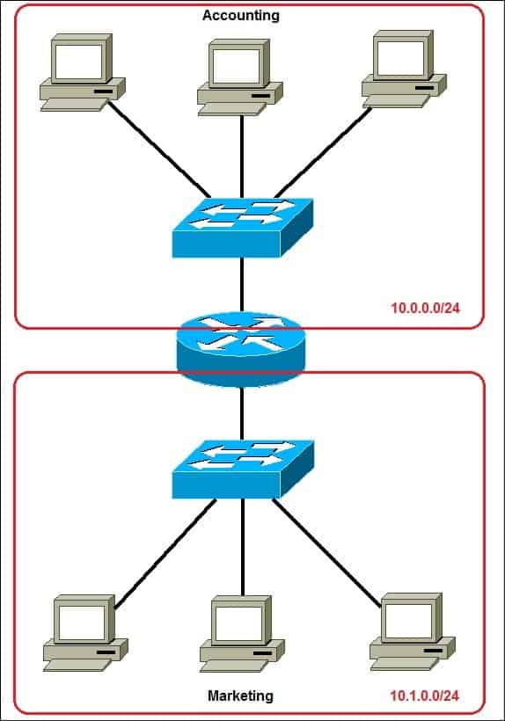](https://study-ccna.com/wp-content/uploads/2016/03/subnetting_example_2.jpg)

Now, two subnets were created for different departments: **10.0.0.0/24** for Accounting and **10.1.0.0/24** for Marketing. Devices in each subnet are now in a different broadcast domain. This will reduce the amount of traffic flowing on the network and allow us to implement packet filtering on the router