Bottom of Form

Installing XAMPP

Our XAMPP tutorial will take you through the installation process for the software package on Windows. If you’re using Linux or Mac OS X, then the steps listed below for the installation process may differ.

Step 1: Download

XAMPP is a release made available by the non-profit project Apache Friends. Versions with PHP 5.5, 5.6, or 7 are available for download on the [Apache Friends](http://www.apachefriends.org/de/download.html) website.

Step 2: Run .exe file

Once the software bundle has been downloaded, you can start the installation by double clicking on the file with the ending [.exe](https://www.ionos.com/digitalguide/server/know-how/exe-file/).

Step 3: Deactivate any antivirus software

Since an active antivirus program can negatively affect the installation process, it’s recommended to temporarily pause any antivirus software until all XAMPP components have successfully been installed.

[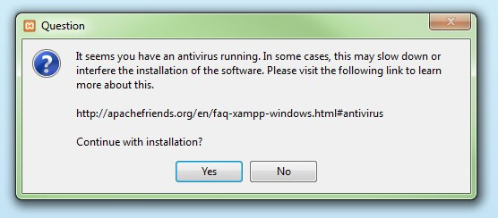](https://www.ionos.com/digitalguide/fileadmin/DigitalGuide/Screenshots/XAMPP_01.jpg)Before installing XAMPP, it is advisable to disable the anti-virus program temporarily

Step 4: Deactivate UAC

User Account Control (UAC) can interfere with the XAMPP installation because it limits writing access to the C: drive, so we recommend you deactivate this too for the duration of the installation process. To find out how to turn off your UAC, head to the [Microsoft Windows support pages](https://support.microsoft.com/en-us/help/17228/windows-protect-my-pc-from-viruses).

[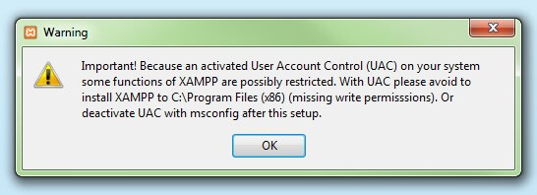](https://www.ionos.com/digitalguide/fileadmin/DigitalGuide/Screenshots/XAMPP_02.jpg)User account control can affect the installation of XAMPP

Step 5: Start the setup wizard

After you’ve opened the .exe file (after deactivating your antivirus program(s) and taken note of the User Account Control, the start screen of the XAMPP setup wizard should appear automatically. Click on ‘Next’ to configure the installation settings.

[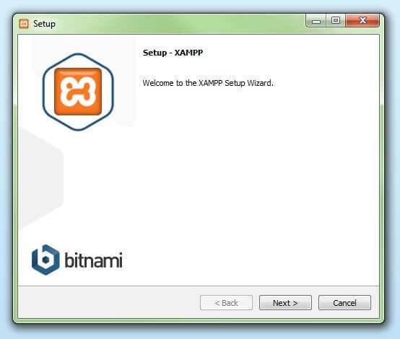](https://www.ionos.com/digitalguide/fileadmin/DigitalGuide/Screenshots/XAMPP_03.jpg)You can start the setup on the startup screen

Step 6: Choose software components

Under ‘Select Components’, you have the option to exclude individual components of the XAMPP software bundle from the installation. But for a full local test server, we recommend you install using the standard setup and all available components. After making your choice, click ‘Next’.

[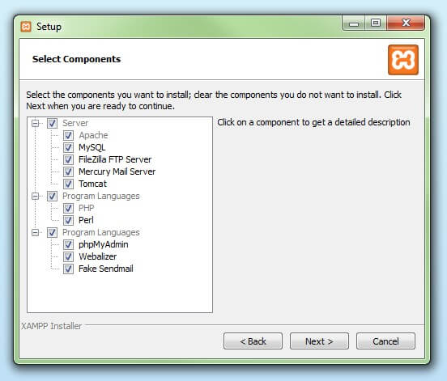](https://www.ionos.com/digitalguide/fileadmin/DigitalGuide/Screenshots/XAMPP_04.jpg)In the dialog window entitled 'select components', you can choose the software components before installation

Step 7: Choose the installation directory

In this next step, you have the chance to choose where you’d like the XAMPP software packet to be installed. If you opt for the standard setup, then a folder with the name XAMPP will be created under C:\ for you. After you’ve chosen a location, click ‘Next’.

[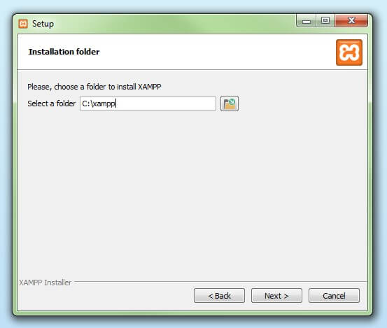](https://www.ionos.com/digitalguide/fileadmin/DigitalGuide/Screenshots/XAMPP_05.jpg)For the next step, you need to select the directory where XAMPP should be installed

Step 8: Start the installation process

Once all the aforementioned preferences have been decided, click to start the installation. The setup wizard will unpack and install the selected components and save them to the designated directory. This process can take several minutes in total. You can follow the progress of this installation by keeping an eye on the green loading bar in the middle of the screen.

[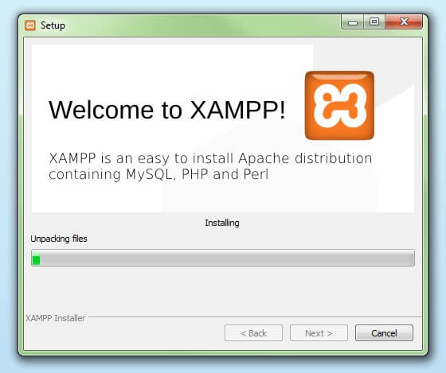](https://www.ionos.com/digitalguide/fileadmin/DigitalGuide/Screenshots/XAMPP_06.jpg)According to the default settings, the selected software components are unpacked and installed in the target folder

Step 9: Windows Firewall blocking

Your Firewall may interrupt the installation process to block the some components of the XAMPP. Use the corresponding check box to enable communication between the Apache server and your private network or work network. Remember that making your XAMPP server available for public networks isn’t recommended.

Step 10: Complete installation

Once all the components are unpacked and installed, you can close the setup wizard by clicking on ‘Finish’. Click to tick the corresponding check box and open the XAMPP Control Panel once the installation process is finished.

[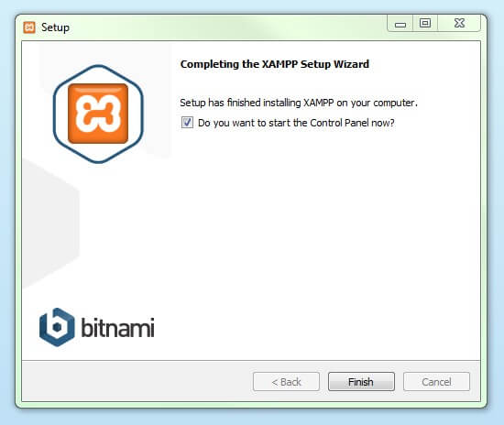](https://www.ionos.com/digitalguide/fileadmin/DigitalGuide/Screenshots/XAMPP_08.jpg)By clicking on 'finish', the XAMPP Setup Wizard is completed

The XAMPP Control Panel

Controls for the individual components of your test server can be reached through the XAMPP Control Panel. **The clear user interface**logs all actions and allows you to start or stop individual modules with a single. The XAMPP Control Panel also offers you various other buttons, including:

* **Config:** allows you to configure the XAMPP as well as the individual components
* [Netstat](https://www.ionos.com/digitalguide/server/tools/introduction-to-netstat/)**:** shows all running processes on the local computer
* **Shell:** opens a UNIX shell
* **Explorer:** opens the XAMPP folder in Windows Explorer
* **Services:** shows all services currently running in the background
* **Help:**offers links to user forums
* **Quit:**closes the XAMPP Control Panel

[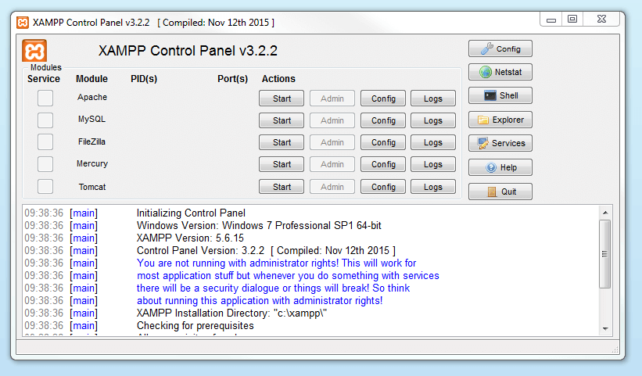](https://www.ionos.com/digitalguide/fileadmin/DigitalGuide/Screenshots/EN_XAMPP_Control_Panel_1.PNG)In the Control Panel, you can start and stop individual modules

Starting modules

Individual modules can be started or stopped on the XAMPP Control Panel through the corresponding buttons under ‘Actions’. You can see which modules have been started because their names are highlighted green under the ‘Module’ title.

[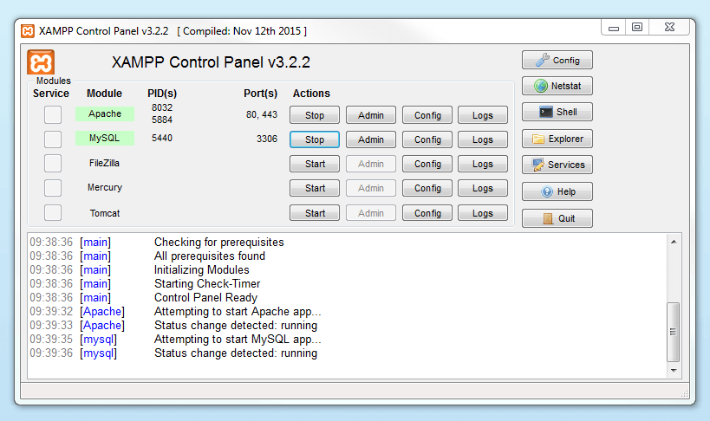](https://www.ionos.com/digitalguide/fileadmin/DigitalGuide/Screenshots/EN_XAMPP_Control_Panel_2.PNG)An active module is marked in green in the Control Panel

If a module can’t be started as a result of an error, you’ll be informed of this straight away in red font. A **detailed error report** can help you identify the cause of the issue.

Setting up XAMPP

A common source of error connected with Apache is **blocked ports**. If you’re using the standard setup, then XAMPP will assign the web server to main port 80 and the SSL port 443. The latter of these particularly is often blocked by other programs. In the example above, it’s likely that the Tomcat port is being blocked, meaning the web server can’t be started. There are three ways to solve this issue:

* **Change the conflicting port:**Let’s assume for the sake of example that the instant messenger program Skype is blocking SSL port 443 (this is a common problem). One way to deal with this issue is to change Skype’s port settings. To do this, open the program and navigate via ‘Actions’, ‘Options’, and ‘Advanced’, until you reach the ‘Connections’ menu. You should find a box checked to allow Skype access to ports 80 and 443. Deselect this checkbox now.
* **Change the XAMPP module port settings**: Click the Config button for the module in question and open the files *httpd.conf* and *httpd-ssl.conf*. Replace port number 80 in *httpd.conf* and port number 443 in *httpd-ssl.conf*with any free ports, before saving the file data. Now click on the general Config button on the right-hand side and select ‘Services and Ports Settings’. Customize the ports for the module server to reflect the changes in the *conf* files.
* **End the conflicting program:**The simplest way to avoid port conflicts in the short term is to end the conflicting program (Skype in this case). If you restart Skype after your XAMPP module servers are already running, it will select a different port and your issue will be resolved.

[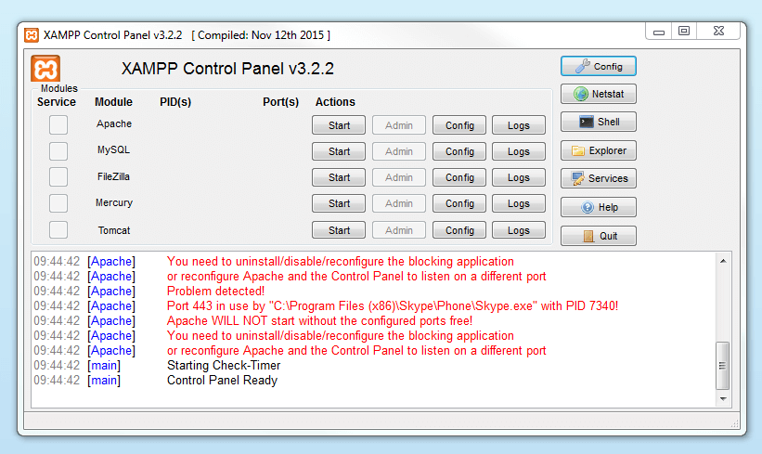](https://www.ionos.com/digitalguide/fileadmin/DigitalGuide/Screenshots/EN_XAMPP_Control_Panel_3.PNG)Modules that can’t be started will be shown in red. The user will also receive an error report to help solve the problem

Module administration

You have an ‘Admin’ option located on the Control Panel for every module in your XAMPP.

* Click on the Admin button of your Apache server to go to the web address of your web server. The Control Panel will now start in your standard browser, and you’ll be led to the **dashboard of your XAMPP’s local host**. The dashboard features numerous links to websites for useful information as well as the open source project [BitNami](https://bitnami.com/stack/xampp" \o "Link to homepage for BitNami" \t "_blank), which offers you many different applications for your XAMPP, like WordPress or other content management systems. Alternatively, you can reach the dashboard through *localhost/dashboard/*.

[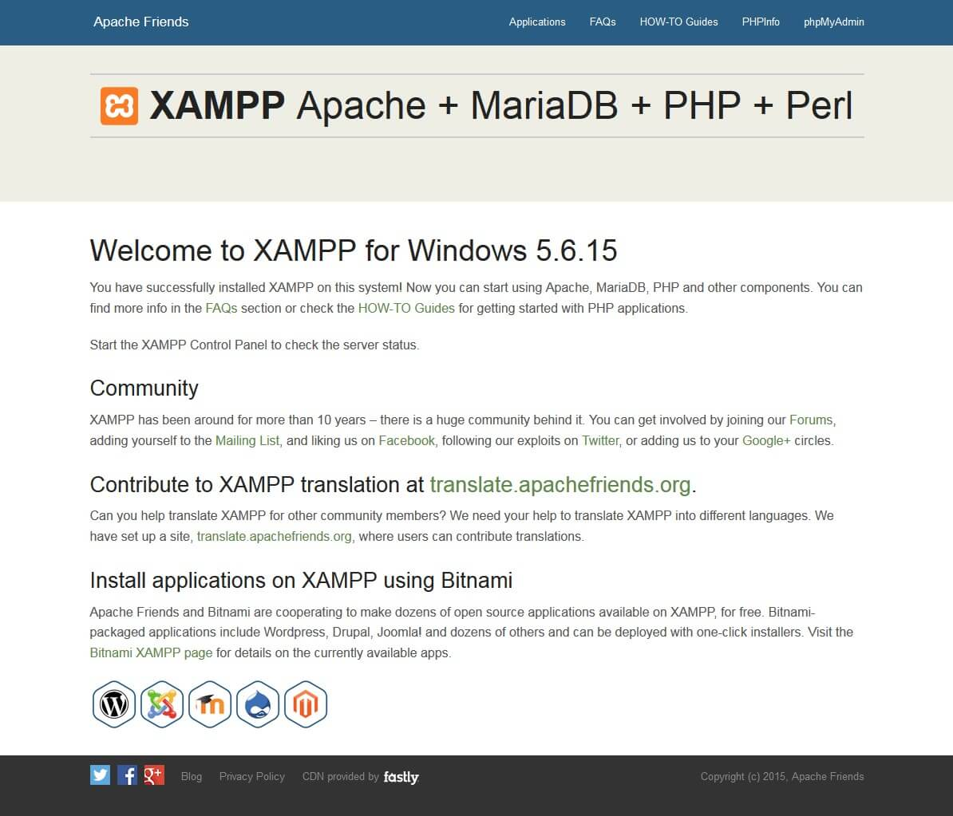](https://www.ionos.com/digitalguide/fileadmin/DigitalGuide/Screenshots/XAMPP_12.jpg)By clicking on the 'admin' button of the Apache module, the user will be redirected to the local dashboard of XAMPP

* You can use the Admin button of your database module to open **phpMyAdmin**. Here, you can manage the databases of your web projects that you’re testing on your XAMPP. Alternatively, you can reach the administration section of your MySQL database via [localhost](https://www.ionos.com/digitalguide/server/know-how/localhost/)*/phpmyadmin/*.

[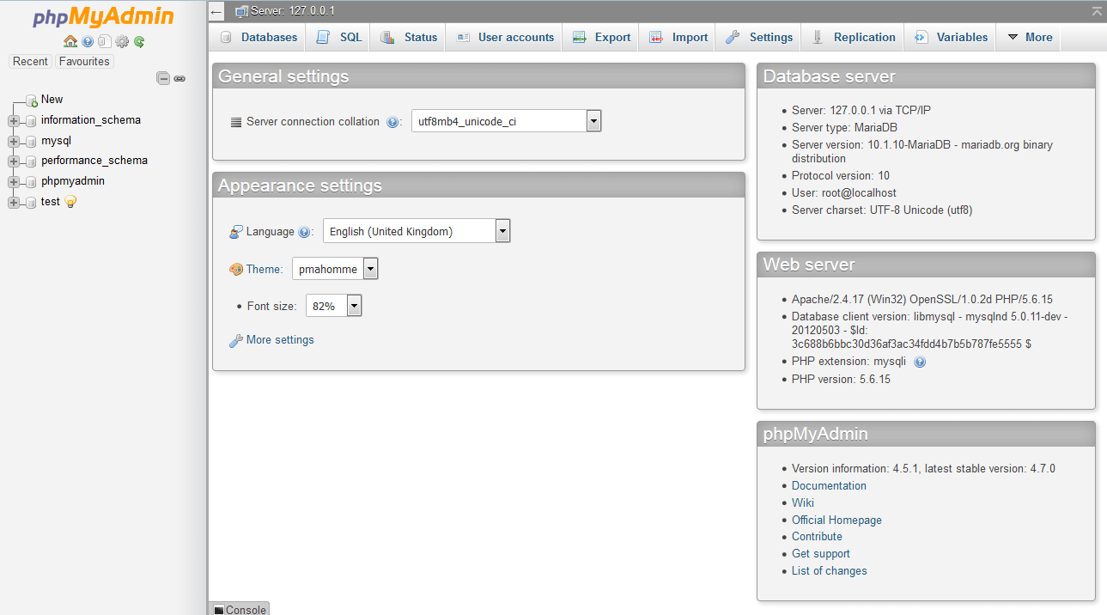](https://www.ionos.com/digitalguide/fileadmin/DigitalGuide/Screenshots/EN_XAMPP_phpMyAdmin.PNG)The web project’s databases are managed by the user in phpMyAdmin (accessible via the 'Admin' button in the database module)

Testing your XAMPP installation

To check whether your test server is installed and configured correctly, you have the option to create a **PHP test page**, store them on your XAMPP’s local host, and retrieve them via the web browser.

* Open the XAMPP directory through the ‘Explorer’ button in the Control Panel and choose the folder *htdocs* (C:\xampp\htdocs for standard installations)*.*This directory will store file data collected for web pages that you test on your XAMPP server. The *htdocs*folder should already contain data to help configuration of the web server. But you should store your own projects in a new folder (like ‘Test Folder’ for example).
* You can create a new PHP page easily by using the following content in your editor and storing it as *test.php* in your ‘ *test’*folder (C:\xampp\htdocs\test):

<html>

<head>

<title>PHP-Test</title>

</head>

<body>

<?php echo '<p>Hello World</p>'; ?>

</body>

</html>

* The last step now is to open your web browser and load your PHP page via *localhost/test/test.php*. If your browser window displays the words ‘Hello World’, then you’ve successfully installed and configured your XAMPP.