**The Oxford Polytechnic**

**J.P. Nagar 1st Phase Bangalore-78**

The Oxford Polytechnic organized a **Health Awareness Program** aimed at promoting the well-being of students and staff. The initiative focused on various health aspects. Including **physical fitness, mental health,** nutrition, and **preventive healthcare.**

The Health Awareness Program organized by the ISTE Student Chapter at The Oxford Polytechnic, under the leadership of Dr**. Geetha** and with the guidance of ISTE Faculty Adviser **Mrs.Priyanka** **Joshi,** successfully met its objectives. **Dr. Geetha’s** session was engaged in activities such as **fitness challenges, and mental health support sessions, all aimed at promoting a healthier lifestyle** and educated them on Preventive Healthcare and distributed an **ALBENDAZOLE**tablets to students under the health program, offering participants valuable insights into managing their health responsibly. The positive outcomes highlight the significance of health awareness initiatives in educational institutions.

The event was witnessed by **Sri Mallesh B.Y,** **Principal** **The Oxford Polytechnic** andHOD’s**, Faculty members and Students** of various departments of **The Oxford Polytechnic.**

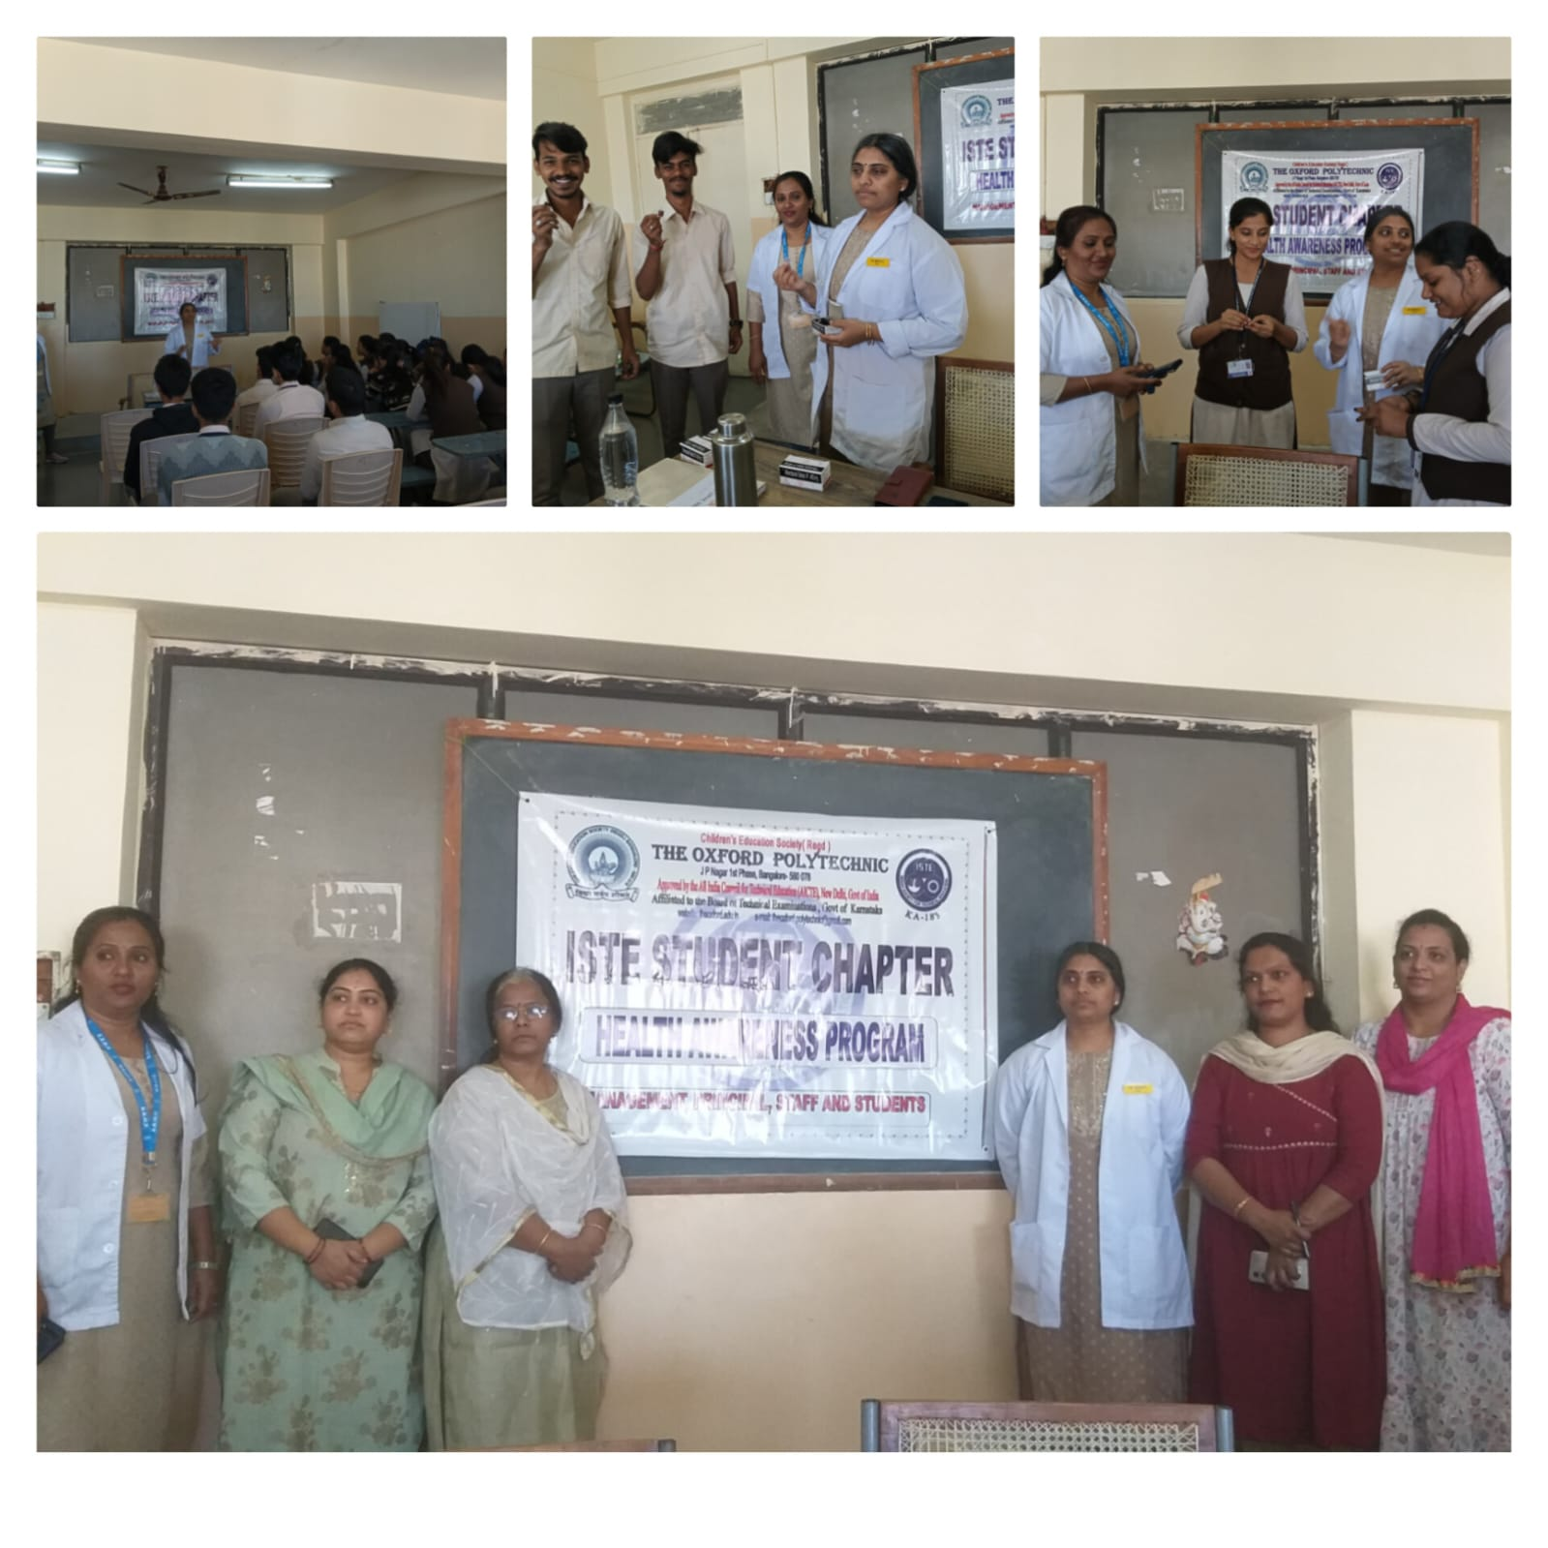

A singing competition was held at Oxford Polytechnic, providing a platform for students to showcase their musical talents. The event was organized with the aim of promoting creativity and enhancing cultural engagement within the institution.

**Organizers and Guidance:**

The competition was successfully coordinated by **Divya Girish**, who led the event with enthusiasm and professionalism. The program was conducted under the expert guidance of **Faculty Advisor Priyanka Kulkarni**, whose mentorship played a crucial role in the event's seamless execution.

**Event Hosting:**

The event was hosted by **Gun Gun Biswas**, who ensured that the proceedings ran smoothly and kept the audience engaged throughout the competition. Gun Gun's energy and presence contributed significantly to the success of the event.

**Judging Panel:**

The competition was judged by two esteemed individuals:

* **Arundhathi**, a respected judge in the field, brought a wealth of experience and knowledge to the panel.
* **Professor Dasthgiri**, a distinguished faculty member, provided valuable insights and constructive feedback to the participants.

The judges played a pivotal role in assessing the performances and ensuring that the competition maintained high standards.

**Conclusion of the Event:**

The event concluded with a closing address by **Divya Girish**, who expressed gratitude to the participants, judges, and attendees for making the event a success. The competition not only highlighted the immense talent within the student body but also fostered a spirit of camaraderie and cultural appreciation among all involved.

**Acknowledgments:**

The success of this event is attributed to the collaborative effort of the organizers, host, judges, and participants. Special thanks to **Priyanka Kulkarni** for her guidance and to everyone who contributed to the smooth execution of this event.

This report captures the essence of the competition in a formal manner. Let me know if you need any modifications or additional details!