1. General Project Information
Project Name: |  |  | Help Us (Android App)

2. Project Team
 | Name |  |  | ID |  | Department
Project Manager | Dr Sherif Elshafie
Team Members: | El-Shaymaa Sayed |  |  | 4141183 |  | Software Engineering
 | Sama Taha |  |  | 4141107 |  | Software Engineering
 | Fatema Ali |  |  | 4141260 |  | Software Engineering
 | Hazem Samir |  |  | 4141259 |  | Software Engineering
 | Kholoud Muhamad |  |  | 4141159 |  | Computer Networks
 | Hady Muhammad |  |  | 4141248 |  | Software Engineering

3. Overview
Help-Us App
It is a native mobile application for helping people to find their lost children/adults or items. Finding lost children/adults is done using face recognition technology which provides ease of finding the lost person instead of using social media.
Actors
- User
- Admin
- System
OBJECTIVES
Develop an intelligent helper Application system to help people to get their children using face recognition technology OR to get their lost items using communication.
Purpose
The purpose of this document is to present a detailed description of the Mobile Application System. It will explain the purpose and features of the system, the interfaces of the system, what the system will do, the constraints under which it must operate and how the system will react to external stimuli. Also provide a good understanding of how the application will work.
Deliverables
At the end of Semester One, we will deliver the software requirement specification of the Application. Then at the end of second semester we will deliver the implementation of the Help-Us application that finds any lost child using face recognition technology, and it helps people to find their lost items using communication instead of suffering in looking for a social media solutions.
Out of Scope
Not Specified yet.
Project Milestones
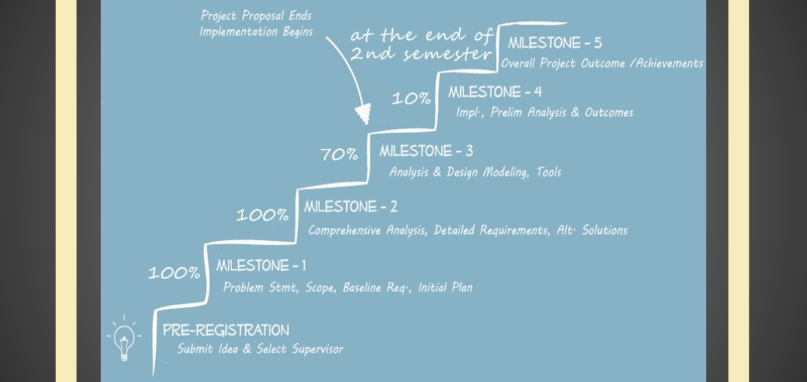

Constraints
Safety Constraints
- Developers shall consider safety of the information that this system will process.
- The System shall be free of bugs.
Assumptions
- An assumption might be that a GPS-Navigator would be available on the hardware designated to detect the location.
- It is assumed that all people involved in the use of this system have internet access.
- This system depends on reliable databases, so facial recognition accuracy depends on the size and quality of the databases used to recognize a face. You have to be able to compare it to something. The challenge is to establish matching points between the new image and the source image. In other words, photos of known individuals.

5. Sign-of
 |  | Name |  |  | Signature |  | Date (06th/Dec/2017)
Project Manager |  | Dr Sheriff Elshafie

