User manual

for
Madhya Pradesh
WAREHOUSE STORAGE MODULE
A software developed under the project
“Extension of IISFM to DCP States”

Version 2.0- Mar 2010


Food and Consumer Affairs Infosys Division
National Informatics Centre
Department of Information Technology
Ministry of Communication and Information Technology
Government of India

No part of this document shall be reproduced without prior Permission of Director General, National Informatics Centre

Food and Consumer Affairs Infosys Division
National Informatics Centre
A Block, C. G. O. Complex, Lodi Road
New Delhi – 110 092
Tel. : 24392167

INDEX
Pre – requisite 4
Purpose 5
Scope 5
Definitions, acronyms, and abbreviations 5
Login 6
1. MASTERS 8
1.1 Godown Master 12
1.1.1 Adding new Godown 12
1.1.2 Updating Godown 13
1.1.3 Deleting Godown 13
1.2 Stack Master 14
1.2.1 Adding new stack 14
1.2.2 Updating Stack 16
1.2.3. Deleting Stack 17
1.3 Transpoter Master 21
1.3.1 Adding New Transporter 22
1.3.2 Updating the record 23
1.3.3 Deleting the Transporter 23
1.4 Depositor Master 24
1.4.1 Adding New Depositor 24
1.4.2 Updating the Depositor 25
1.4.3 Deleing the Depositor 26
1.5 Miller Master 26
1.5.1 Adding New Miller 26
1.5.2 Updating Miller 27
1.5.3 Deleting Miller 28
1.6 Depot Master 26
1.6.1 Adding New Depot 26
1.6.2 Updating Depot Profile 27
2. Initialization
2.1 Opening Balance
3. Warehouse Operations 31
3.1 A-(a) Reciept Details 31
3.1 A.(b) Edit Reciept Details 35
3.2 Depositor Form(WHR) 36
3.3.A.(a).7 Delivery GatePass Details 38
3.3.A.(a).8 Searching the existing records 39
3.3.A.(a).9 Adding new record 40
3.3.A.(b).1 Pending Delivery GatePass List 42
3.3.A.(b).2 Searching the existing records 43
3.4.A.(b).2 Searching the existing records
3.4.A.(b).3 Print Gate Pass of the existing records
3.4.A.(b).4 Cancelling Gate Pass of the existing records
3.4.A.(b).5 Editing the existing records
3.4.A.(c) Delivery Order 44
3.4.A.(c).1 Searching the existing records 44
3.4.A.(c).2 Adding new record 45
3.5 Quality Control 47
3.5.1 Searching the existing records 47
3.5.2 Adding new record 47
3.6 Made Up Bags 48

Pre – requisite

1. JavaScript should be enabled in the browser.
Steps to be followed to enable JavaScript:
a. Click tools menu >> Internet Options.
b.Then select the Security tab. It will show the Security Settings window.
c.Select the enable radio button for Active Scripting, Allow paste operations via script and Scripting of Java applets. It will prompt a dialog box asking ‘Are you sure you want to change the security settings for this zone?’ Click Yes.
d.Then select the Advanced tab. In the Browsing option check the options:
- Disable Script Debugging (Internet Explorer).
- Disable Script Debugging (Other).
- Display a notification about every script error.
Then click ok.
2. It is best viewed on Internet Explorer 6.0 and above.

Purpose

This document specifies requirements for the customisation of IISFM Software for Madhya Pradesh State Civil Supplies Corporation (MPSCSC) and State Warehouse Corporation.
The Main objective is to interlink state level agency like MPSCSC & SWC with FCI, to get clear & fair picture in terms of PDS. Secondly it will also help state level agency to provide information on food grain storage and distribution in the State.
The requirements analysis contained in this document defines the specific functionality that must be met in order to successfully deploy a system. The requirements of the user have been translated into measurable and definable business rules and functions to allow for successful development of a comprehensive process tracking system.
The intended audience for this document includes technical professionals from NIC involved in the design, coding and testing of the system as well as management of MPSCSC and (issue centre) SWC.

Scope:
The software to be produced from these requirements is a customized Depot Module and reports. The objective the client wants to achieve in acquiring a new system is to reduce time spent to track and process records by hand. Specifically, the new system must achieve the following goals:
Provide timely and accurate information to management
Provide greater reporting capability
Be easy to use and learn
Be reliable and require little maintenance
The monitoring system should be able to generate reports in all desired format and assist in various decision-making requirements of the organization.

Definitions, acronyms, and abbreviations
SRS: Software Requirements Specification (this document)
NIC: National Informatics center
IISFM: Integrated Information system for Food grain Management
MPSCSC : Madhya Pradesh State Civil Supplies Corporation
SWC: State Warehouse Co-oporation
UC: USE CASES
WHR: Ware House Receipt
WCM: Weight cash memo
DO: Delivery Order

Login

To use the benefits of the application enter User Name and Password and click Login button as shown in the screen below:

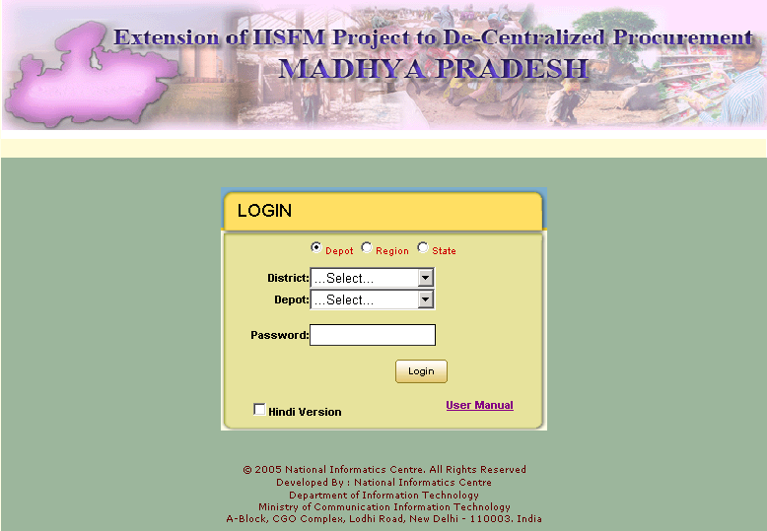

Password can be maximum 20 characters long and minimum of 6 character, it should contain at-least 1 numeric value, 1alphabets and 1 special symbols. Password field is mandatory. Without which it will show a red star against it.
Then system checks for the password. If password is incorrect then it returns to the same login window with the message “Your login attempt was not successful. Please try again.”

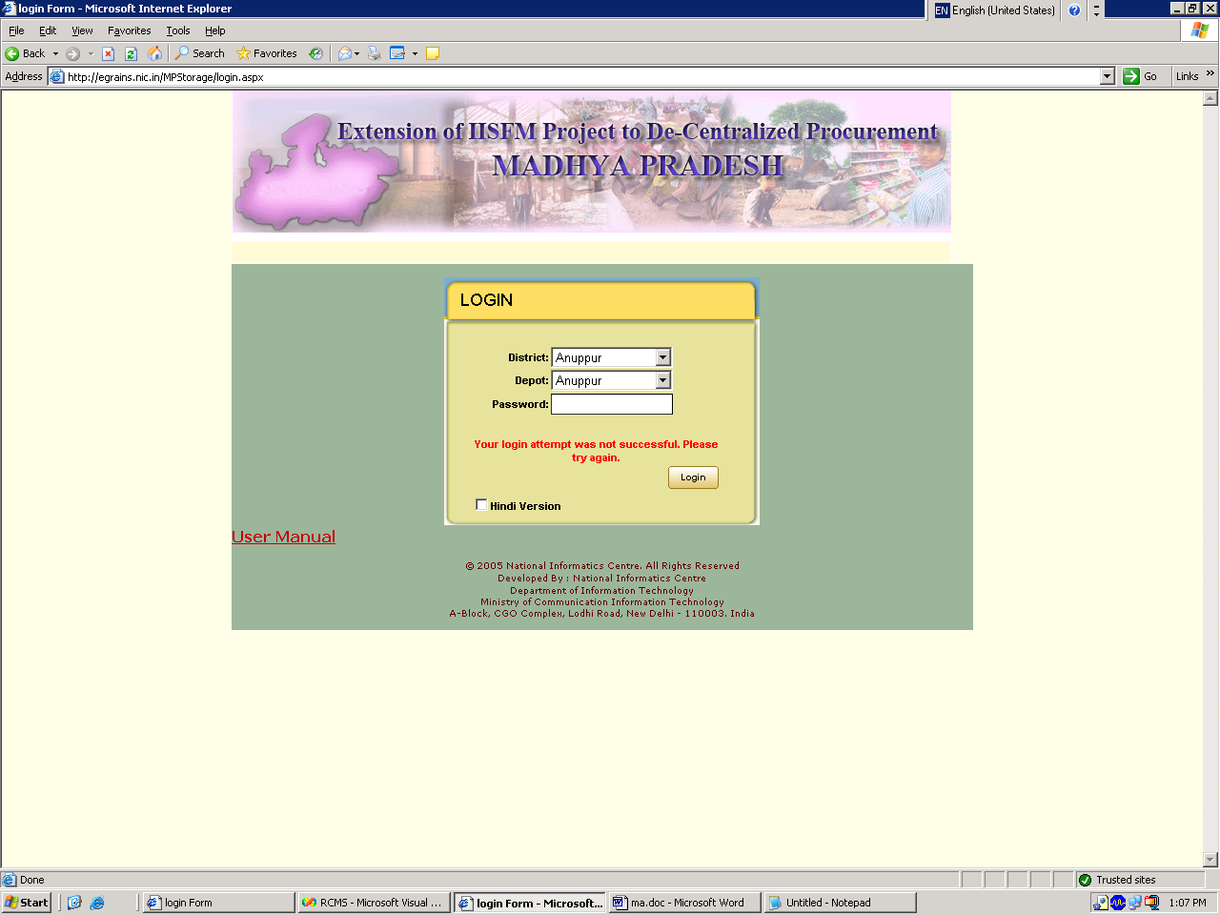

If the password is correct then you can see the welcome page:

MASTERS

There are in all six Masters-
- Godown Master,
- Stack Master,
- Transporter Master.
- Depositor Master
- Miller Master
- Depot Master (profile for Depot user and new addition facility for MPWLC)

The following screen is to update all masters.

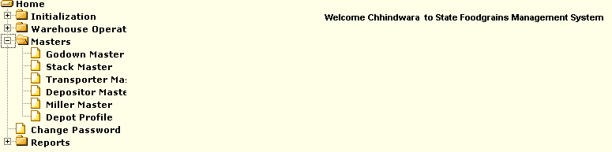

Godown Master

Purpose:
The Purpose of Godwon Masters is to maintain all the related records like Add new ,update existing one ,delete of commodity(for example rice , wheat).

Adding new Godown

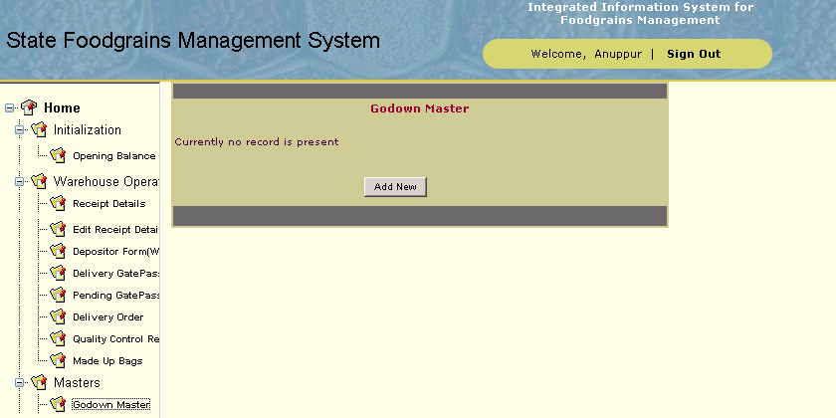

1. Click to the Add New Button to fill your record like Godown name, capacity its Hired Type & Storage Type.

2. Enter all the relevant information i.e. stack number, Godown name, capacity its Hired Type & Storage Type for adding the Commodity then click Insert button.

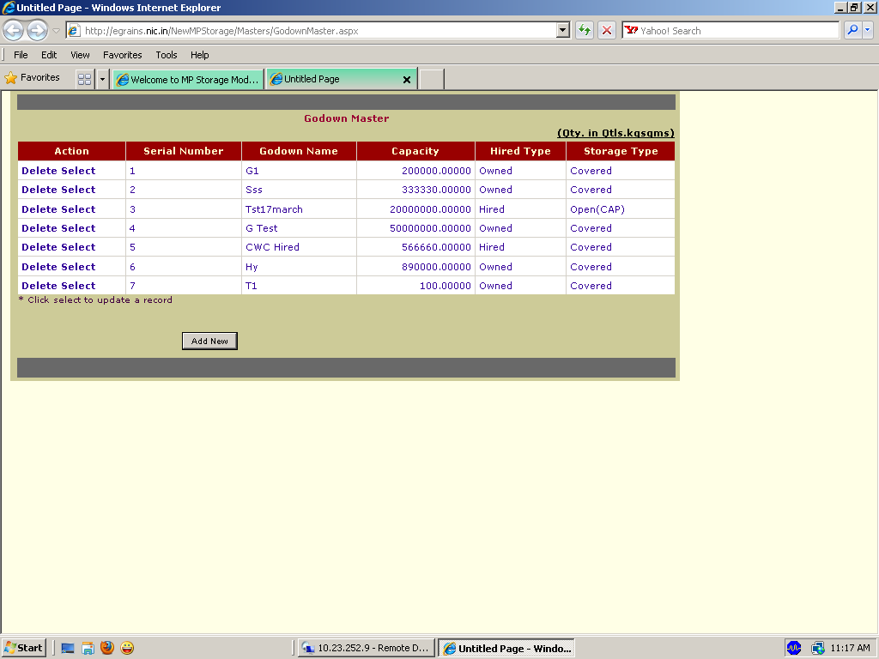

Updating Godown

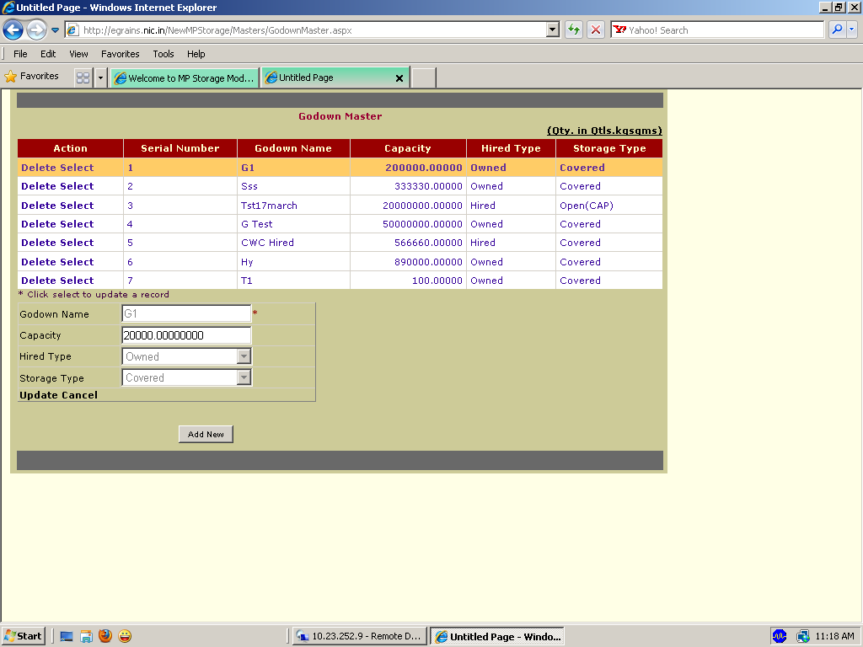

- For Updating the Godown information click Select link of the corresponding Godown name.
2. Select the any record which existing one you want to update .And click the update button and insert the Godown name, capacity it’s Hired Type & Storage Type.

Deleting Godown

- Click the delete button and it will ask for sure deletion Click ok for deleting the records
- If donot want to delete records then click cancel.

Stack Master

Purpose:
The Purpose of Stack Masters is to maintain all the related records like Add new ,update existing one ,delete of commodity(for example rice , wheat).

Adding new stack

Click to the masters it will expand into six masters.
Click to the Stack masters.

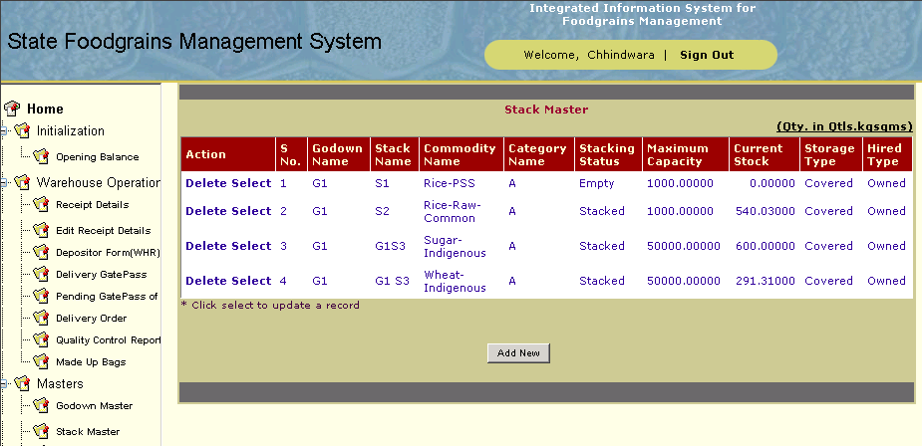

1.Click to the Add New Button to fill your record like stack number , Godown number .
2. Enter all the relevant information i.e. stack number,godown number ,commodity number ,category name for adding the Commodity, Hired type and Storage type then click Insert button.
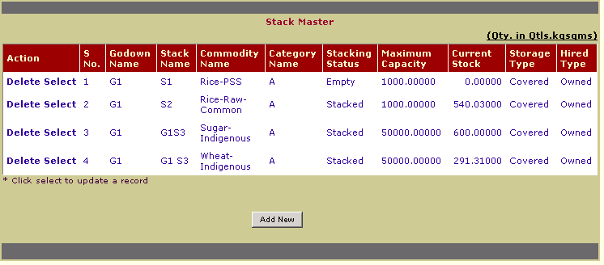

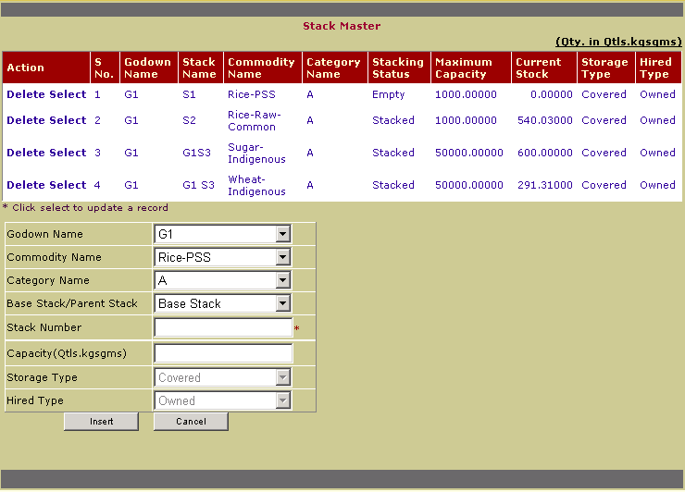

3. If Stack Number is already exists then it will show message ‘Stack Number already exist’.
4. If you don’t want to insert Stack number click on cancel button.

Updating Stack

1. For Updating the Stack information click Select link of the corresponding Stack name.
2. Select the any record which existing one you want to update .And click the update button.

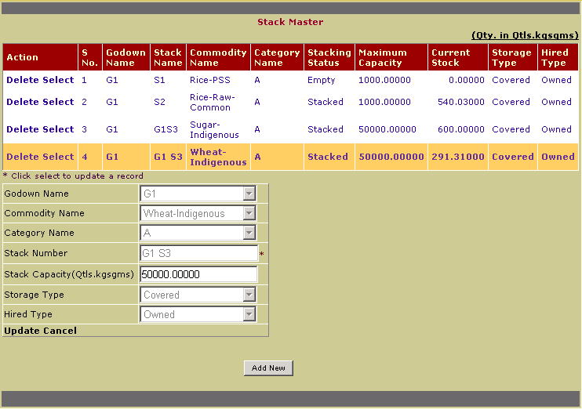

Deleting Stack

- For deleting the existing record click the Delete Button corresponding Stack name and it will ask ‘Are you sure want to delete the Record’ Click ok If you want to delete record.
- If you donot want to delete records click cancle button.

Transporter Master

Purpose:
The Purpose of Transporter Masters is to maintain all the related records like Add new ,update existing one ,delete the previous one.

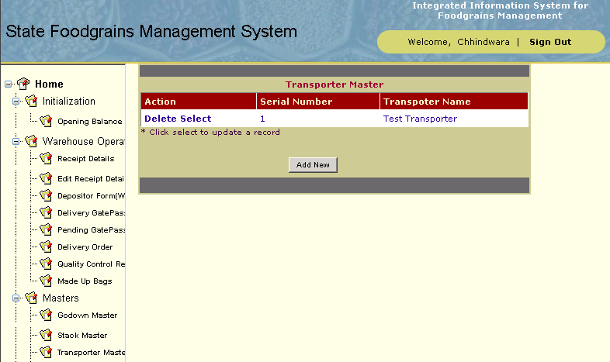

Adding New Transporter

1.Click to the Add New Button to fill your record like Transporter Name .
2. Enter all the relevant information i.e. Transporter Name for adding the Transporter then click Insert button.

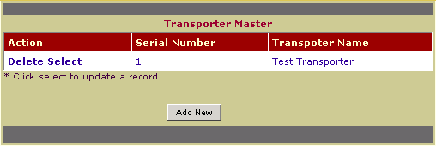

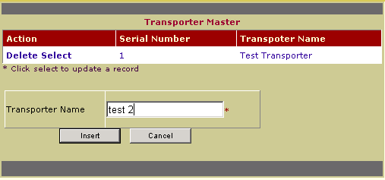

Updating the record

1. For Updating the Transporter information click Select link of the corresponding Transporter Name
2. Now enter the new information in place of old information, and then click Update button. If you don’t want to change anything then click Cancel button.
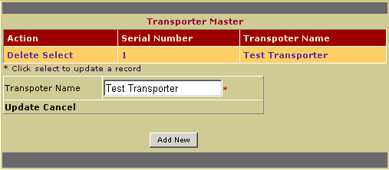

- Click the Update button to update the records which are existing.

Deleting the Transporter
- To delete the Transporter Name click Delete link of the corresponding Transporter Names

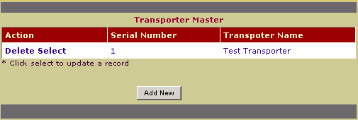

- Then it will show message ‘Are you sure want to delete’. If you click on ‘ok’ button then it will show
- message ‘Record Deleted Successfully’.

Depositor Master

Purpose:
The Purpose of Depositor Masters is to maintain all the related records like Add new ,update existing one ,delete the previous one.
- MPSCSC/FCI/MPWLC are under Institution and are not deletable or updatble which is common to all Depot.
- Other than this any local depot related depositor to be created by the individual Depots.

Adding New Depositor

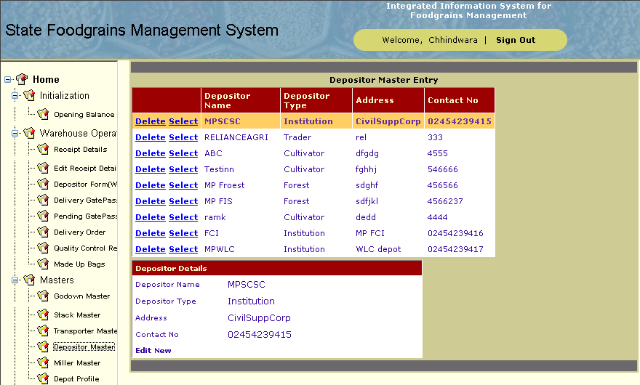

- Click the new button to fill your records like Depositor Name, Depositor Type.
- Enter all the relevant information i.e. Depositor Name, Depositor Type, Address, Contact No. for adding the depositor, then click Insert button.

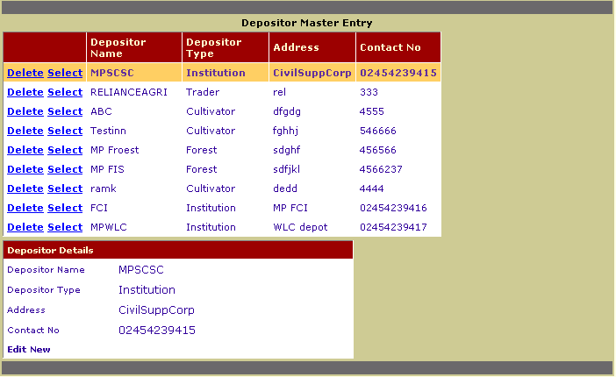

Updating the Depositor

For updating the Depositor information, Click on the Select link of the corresponding Depositor Name

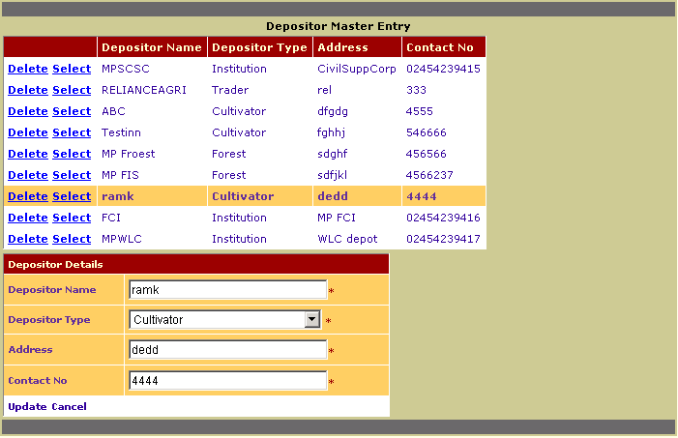

- For updating the Depositor information, click edit link of the corresponding depositor name.
- Now enter the new information in place of the old information, and then click Update button. If you don’t want to change anything then click Cancel button.

Deleing the Depositor
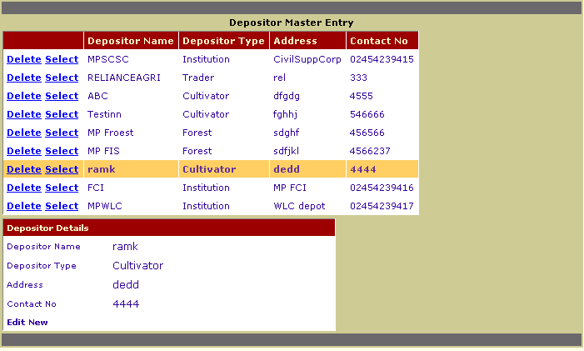

- Click the delete button and it will ask for sure deletion, Click OK for deleting the records.
- If you do no want to delete records, click Cancel.

Miller Master

Purpose:
The Purpose of Miller Masters is to maintain all the related records like Add new ,update existing one ,delete the previous one.

Adding New Miller
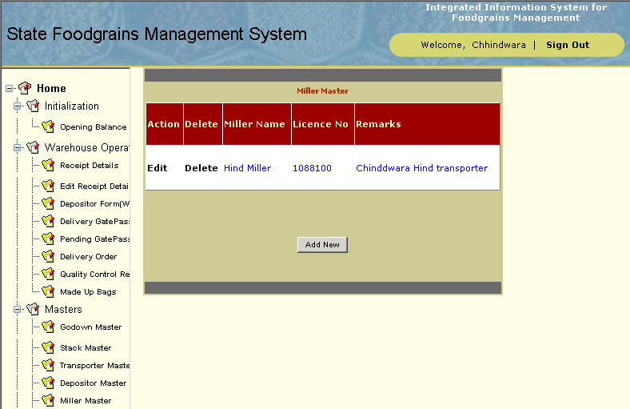

- Click on Add New button to fill your records like Miller Name.
- Enter all the relevant information i.e. Miller Name, License No., Remarks for adding the Miller and then click Insert button.

Updating Miller

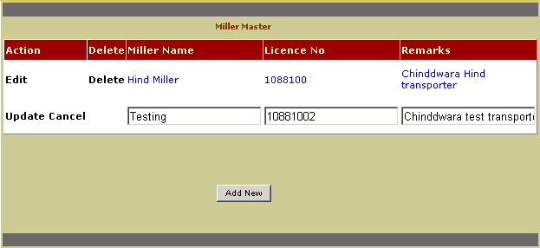

- For updating the Miller Information, Click on edit link of the corresponding Miller Name.
- Now enter the new information in place of the old information, and click Update button. If you don’t want to change anything then click on Cancel button.

Deleting Miller

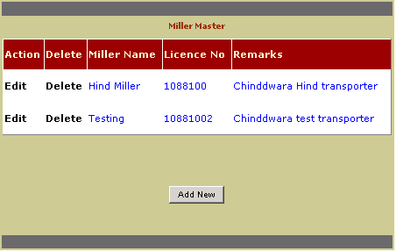

- Click the delete button and it will ask for sure deletion, Click OK for deleting the records.
- If you do no want to delete records, click Cancel.

Depot Master(under MPWLC login)

Purpose:
The Purpose of Depot Masters is to Add new depot my MPWLC user or to update Depot Profile my Logged inn depot.

Adding New Depot (MPWLC Login)

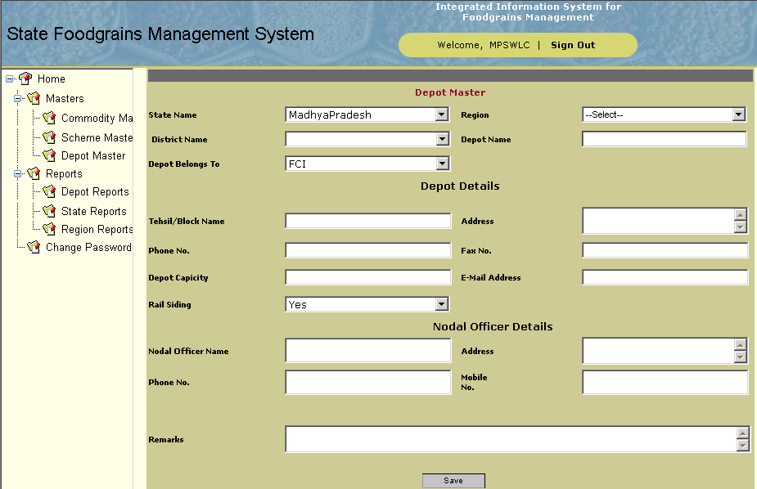

- Fill and select the data and click save button.
- Enter all the relevant information i.e. Depot Name, Tehsil/Block Name, Address and Remarks for adding the new Depot and then click Save button.

Updating Depot Profile (Logged in Depot)

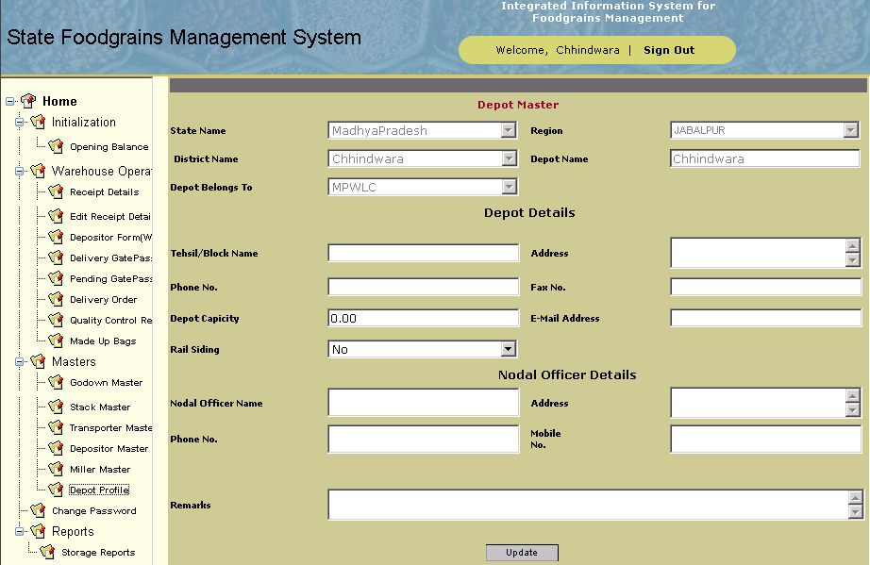

1 For updating the Depot Profile Information, The Logged in Depot will be shown with some disabled fields and rest enabled fields.
- Now enter the new information in enabled(Enterable) fields , and click Update button.

WORK FLOW STARTS

Initialization

Opening Balance
Purpose:
The Purpose of Opening Balance is to enter all existing WHR No with WHR Date aand its balance left on stack, maintain all the related basic records of Type of Depositor, name of depositor ,Date Disitric extra.
You will have to select the Type of Depositor and Name of the Depositor from the drop down list box. If there is no Depositor, it can be added from the Depositor Masters.

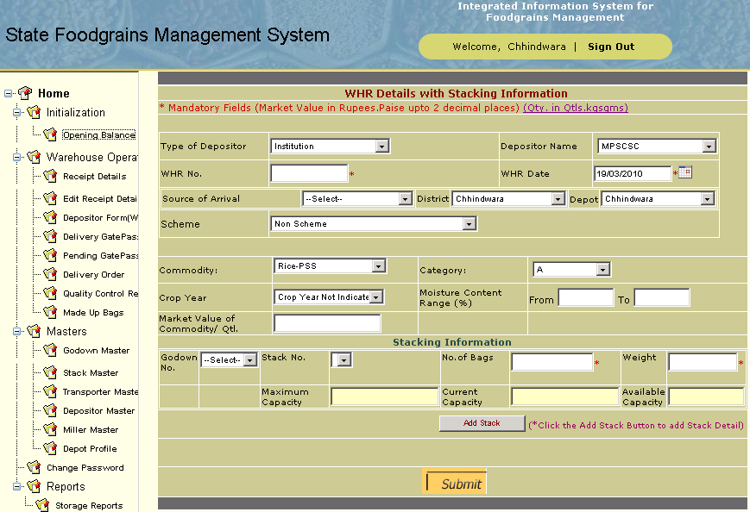

Warehouse Operations

A-(a) Receipt Details

Purpose:
The Purpose of Reciept Details is to search records of Type of Depositor, name of depositor and Source i.e. Deposit at issue center from drop down, on selection of that the records from MPSCSC database will be visible under a grid as per selection criterion.

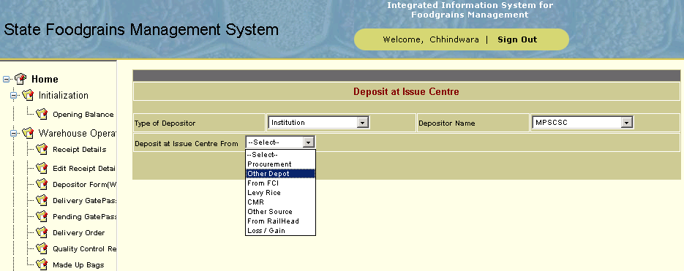

3.1 A-(a)1 Searching the existing records

Select the Depositor Type, Depositor and Deposit at issue center.
If there is no record for selected Depositor Type,Depositor and Deposit at issue center criterion then message of no record found will appear After the grid appers You will have to select a record from grid of which you want to deposit at issue center.

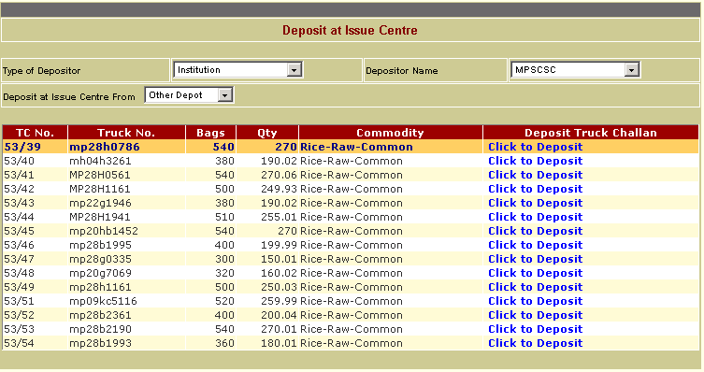

After you select a record the data on a form will appear with some of details that come from MPSCSC data base will be populated and disabled, now for that you need to Deposit by giving Moisture Content, WCM No and Stack details.

3.1 .A-(a)2 Adding new record

- Enter all the relevant information of Moisture, WCM No and date of deposit.

- Then Add Stacking details are added by selecting the related Godown and Stack for shown commodity and adding the No of Bags & Weight Such that the Deposited No of Bags and Qty Deposited should be equal to sum of stacked No of Bags & Weight.
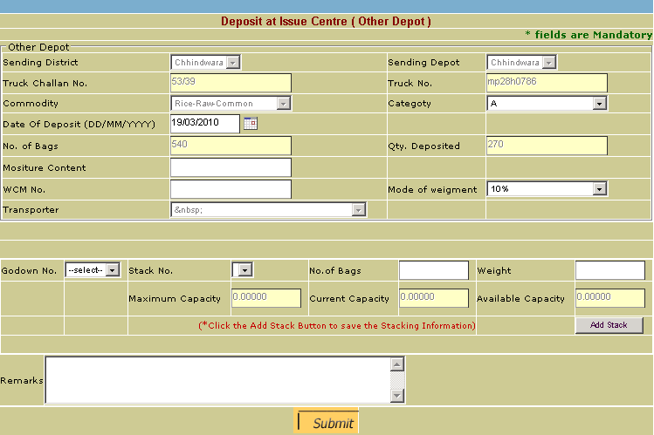

- After you add all the details click Submit button to save the record.
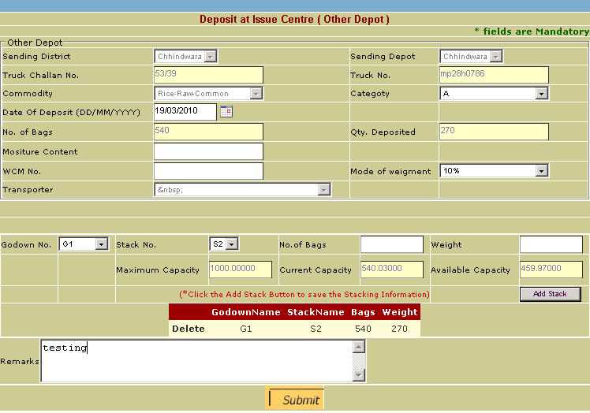

When the record id saved successfully a gate Pass will be generated and popped up in front of the form.

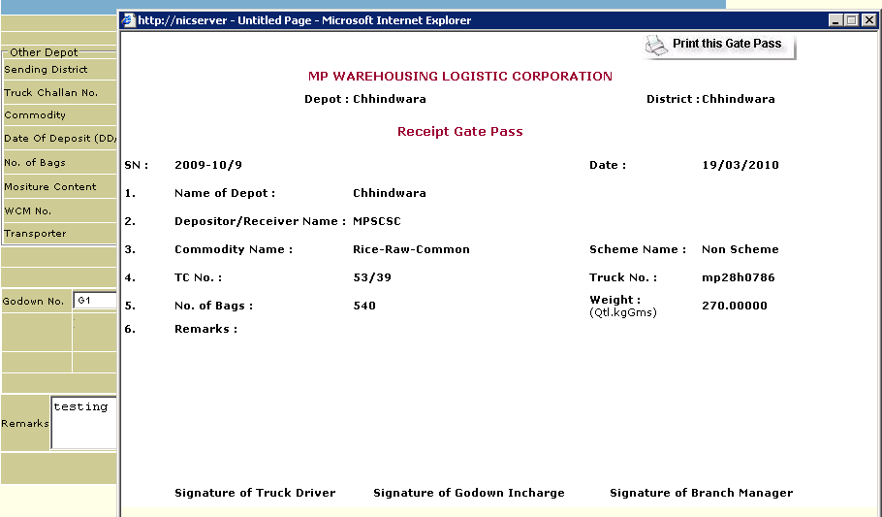

A.(b) Edit Reciept Details

3.1 A-(b) 1 Searching the existing records

Select the Depositor Type, Depositor and Deposit at issue center.
If there is no record for selected Depositor Type,Depositor and Deposit at issue center criterion then message of no record found will appear After the grid appers You will have to select a record from grid of which you want to deposit at issue center.

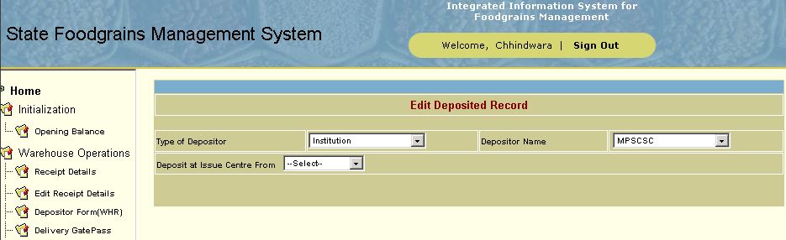

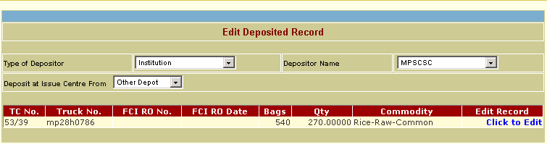

Select the record from the grid you want to edit.

3.1 A. (b).2 Updating selected record

1.You can either change only the Moisture and WCM No. or can Edit/delete the existing stacking information or add new stack to Deposit the Food grain in any case the total Qty Deposited cann’t be changed only stacking information will change.
2. Make the necessary changes and then click Update button.

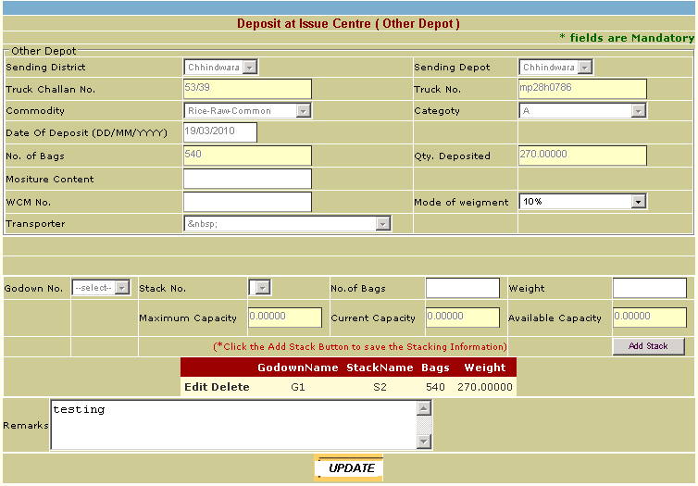

Depositor Form(WHR)

Purpose:
The Purpose of Depositor Form is to maintain all the related records like Depositor name, Category, Date of deposit, No of quantity received, total weight etc.

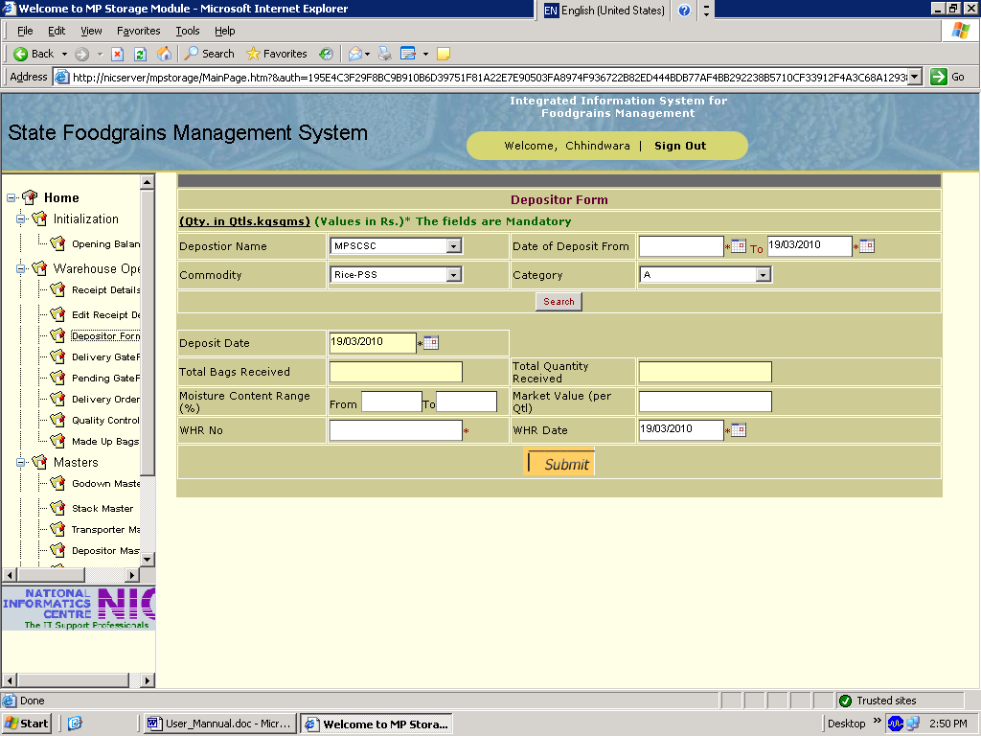

3.2 (A) Searching the existing records

In the above screen fill Depositor Name,Date of deposite,category,Commodity and click to the Search Button as marked in the next Screeen to find the searching records.

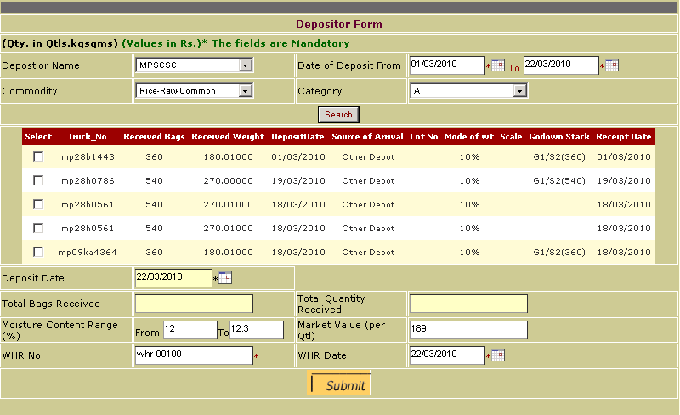

(B) Adding new record

1.when you check any of the Truck details the total Bags and Qty received will get automaticall filled with the record of bags and qty of truck
2. insert your data like total bags received ,Moisture contain range ,market value, WHR No and WHR Date .
2.Enter all the relevant information and then click Submit button.

OUT FLOW :

For adding the records click the Submit Button as marked in the Third Screen.

Delivery GatePass Details

Purpose:
The Purpose of Delivery Gatepass Details is to maintain all the related records like multiple Release order number and its release order date, Truck details, Payment mode, Average moisture, Issued bags, Issued Weight ,Validity date etc.
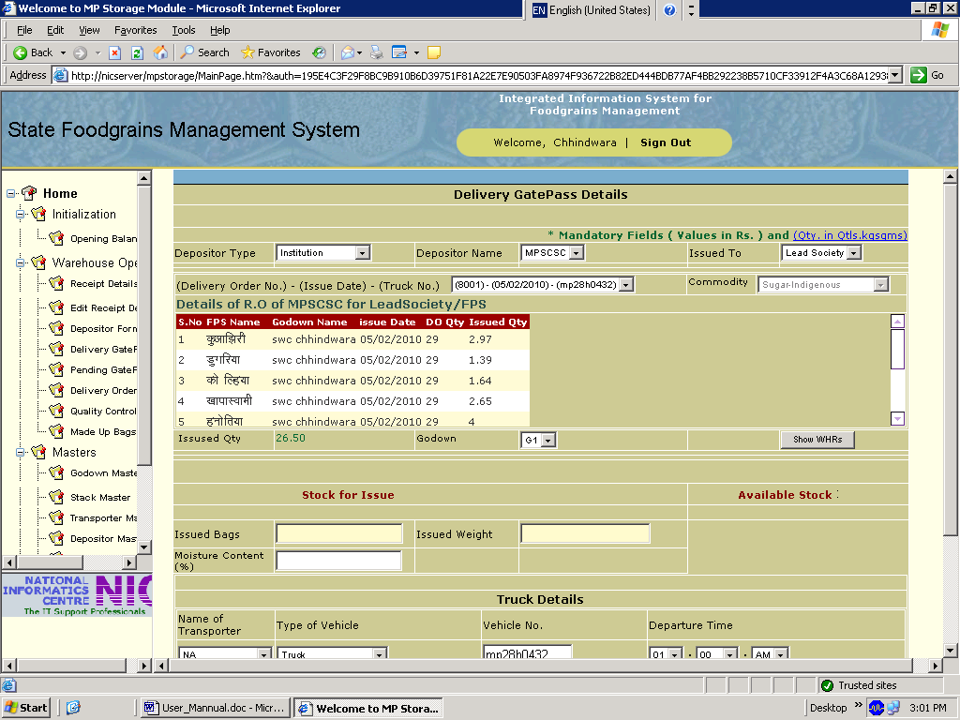

Searching the existing records

1. Fill the relevant record like Depositor Type, Depositor Name, Commodity, Godown and then search for WHR No’s.

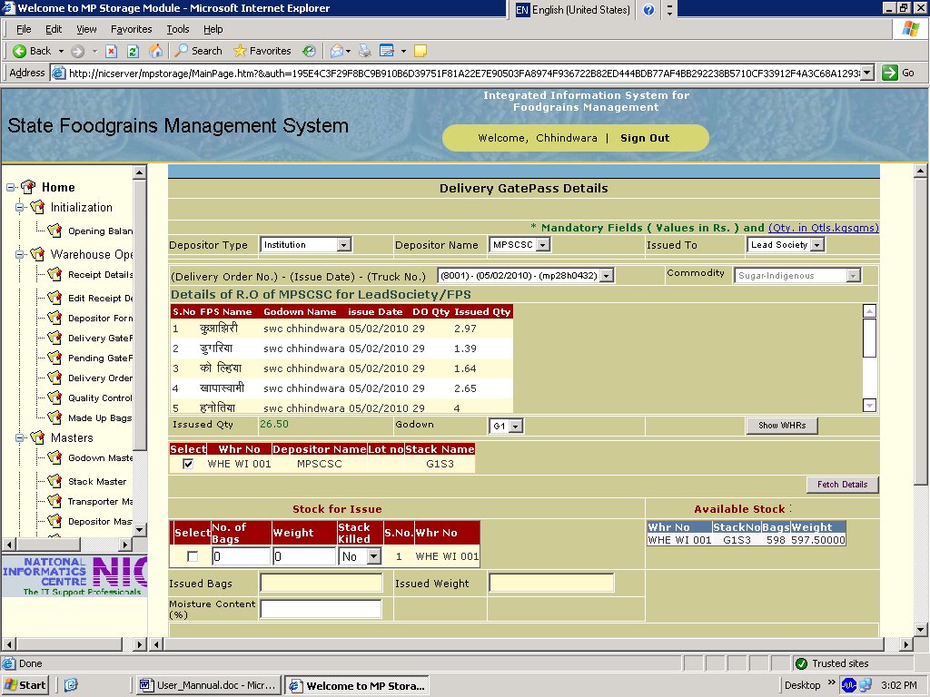
ss

2.Click to Show WHR No’s Button to get the previous records and then Click Fetch Details to fill the values like issued,Moisture,Commodity Sample NO etc the multiple Release order with their respective dates of issued

Adding new record

1.Click to the Submit button to insert your record like Avg Moisture contain ,Rental amout received,quantity,validity,DD number,Date,Gate pass.Truck No.
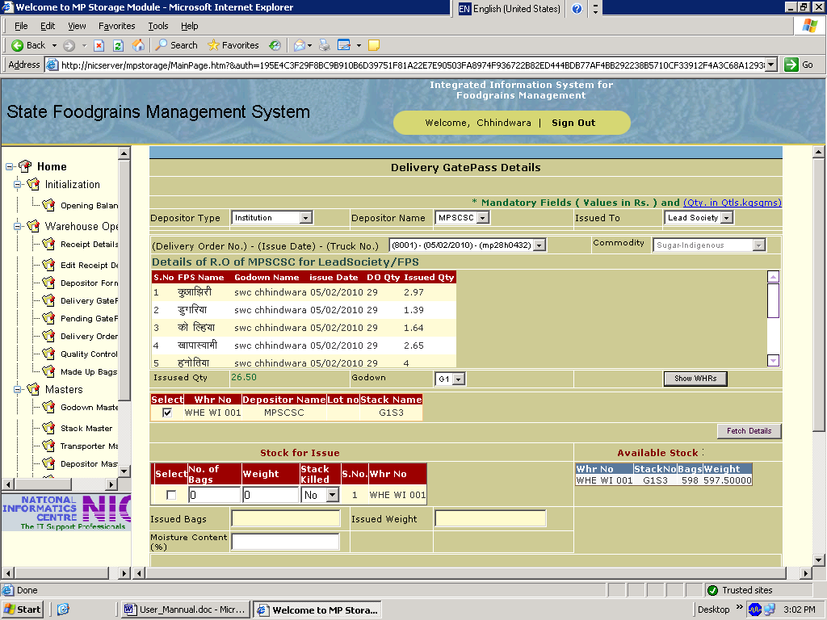

2.Enter all the relevant information and then click Submitt button.

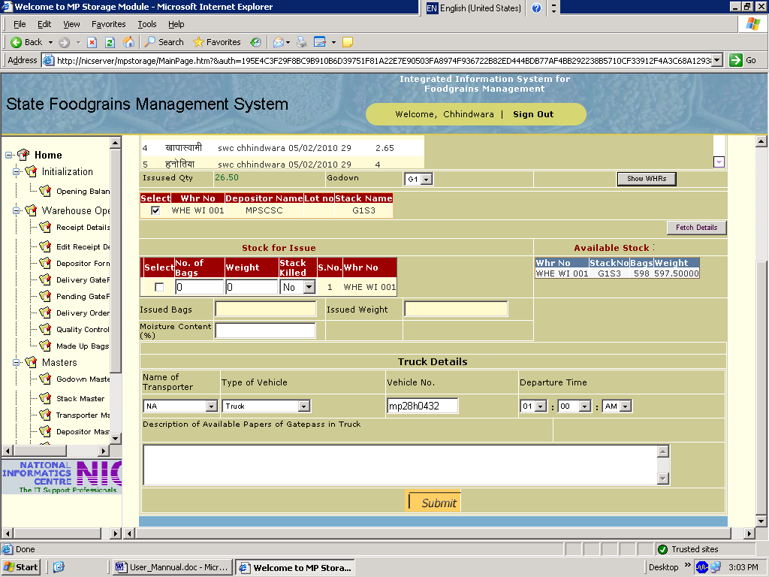

Pending Delivery GatePass List

Purpose:
The Purpose of Pending Delivery Gatepass List is to maintain all the releated records Depositor Type,Depositor Name,Depositor Date (To and From) .

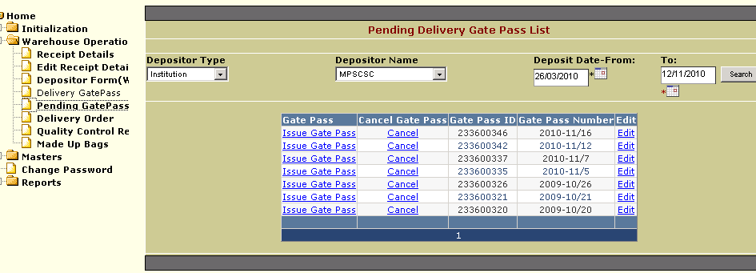

Searching the existing records

Select the Depositor Type first .
On the basis of this Select the Depositor name and then From date and To date
It will fecth the all the gatepasses.

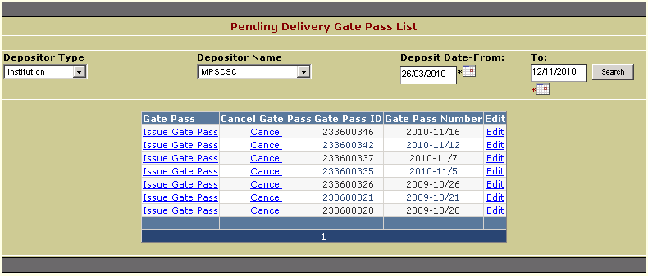

2.4.A.(b).3 Print Gate Pass of the existing records

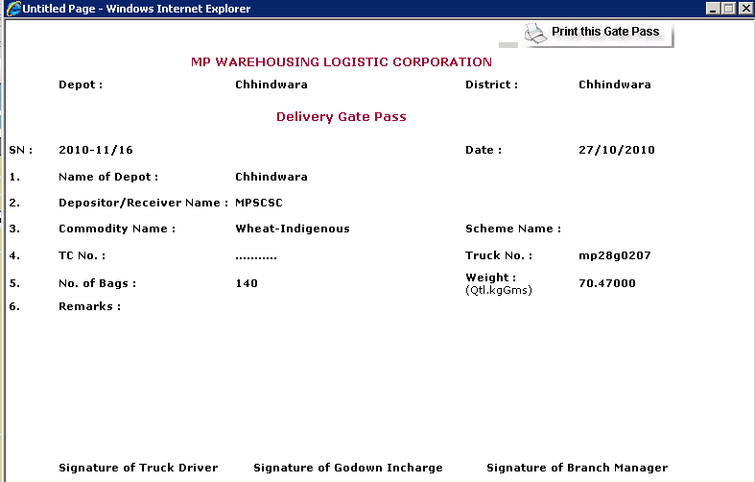

2.4.A.(b).4 Cancelling Gate Pass of the existing records

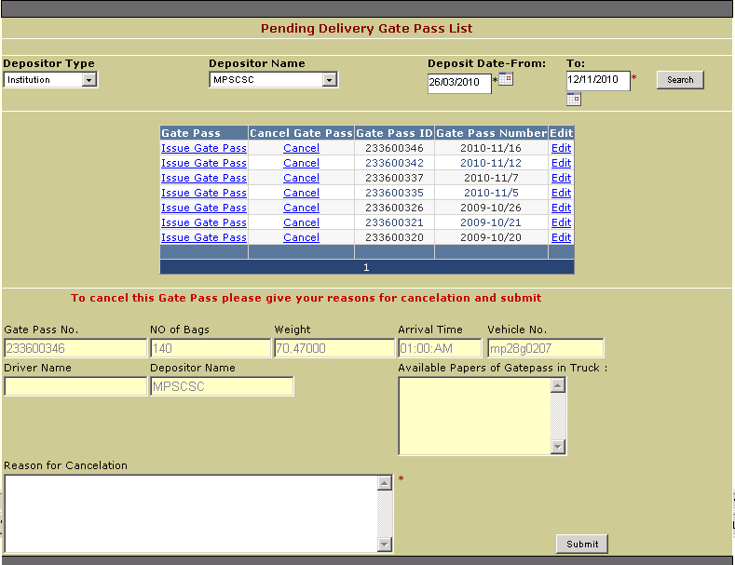

2.4.A.(b).5 Editing the existing records

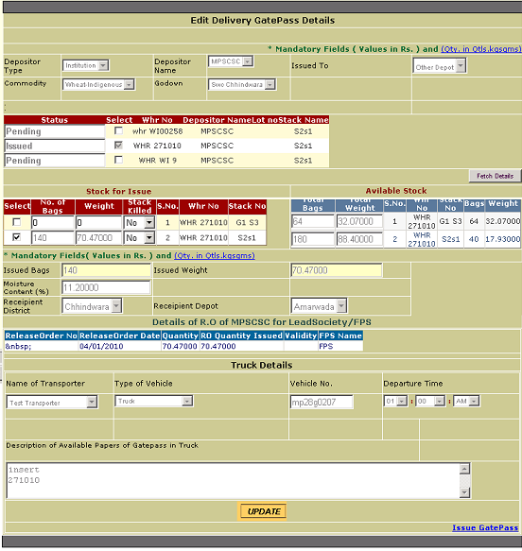

Delivery Order

Purpose:
The Purpose of Delivery Order(CSC) is to maintain all the releated records GatepassNo,Vechcle no,No of bags,Weights which has to be issued.

Searching the existing records

Select the Depositor Type first Then
On the basis of that select Depositor Name and Commodity ,Godown,Date
Click Show Gatepass button.
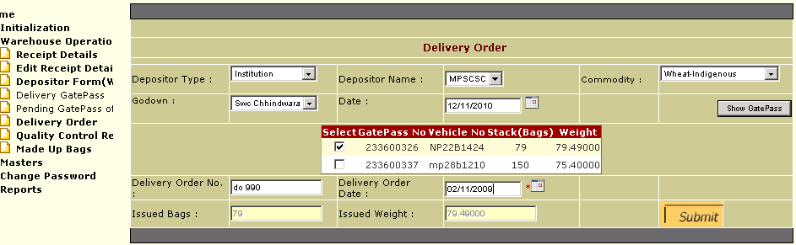

Adding new record

1.Click to the Submit button to insert your record like Delivery Order No,Delivery Order Date
2.Enter all the relevant information and then click Submit button.

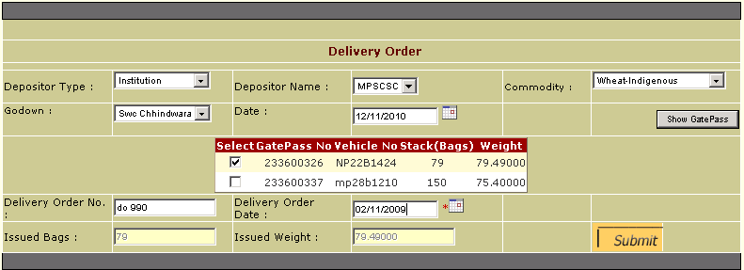

Quality Control

Purpose:
The Purpose of Quality Control is to maintain all the releated records like Godown number,Stack number,Date of Inspection,Moisture of the stack.

Searching the existing records

Click to the masters it will expand into ten masters.
Click to the Stack masters.

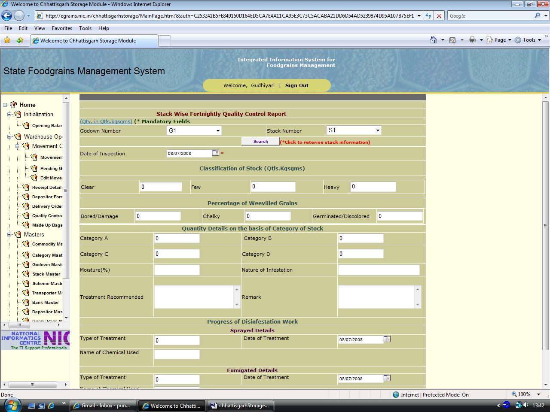
In the above screen fill Godown Number,Stack Number and click to the Search Button as marked in the Second Screeen to find the searching records.

Adding new record

1.Click to the Submit button to insert your record like Moisture contain ,CategaryA,CategaryB,CategaryC,CategaryD
2.Enter all the relevant information and then click Submit button.

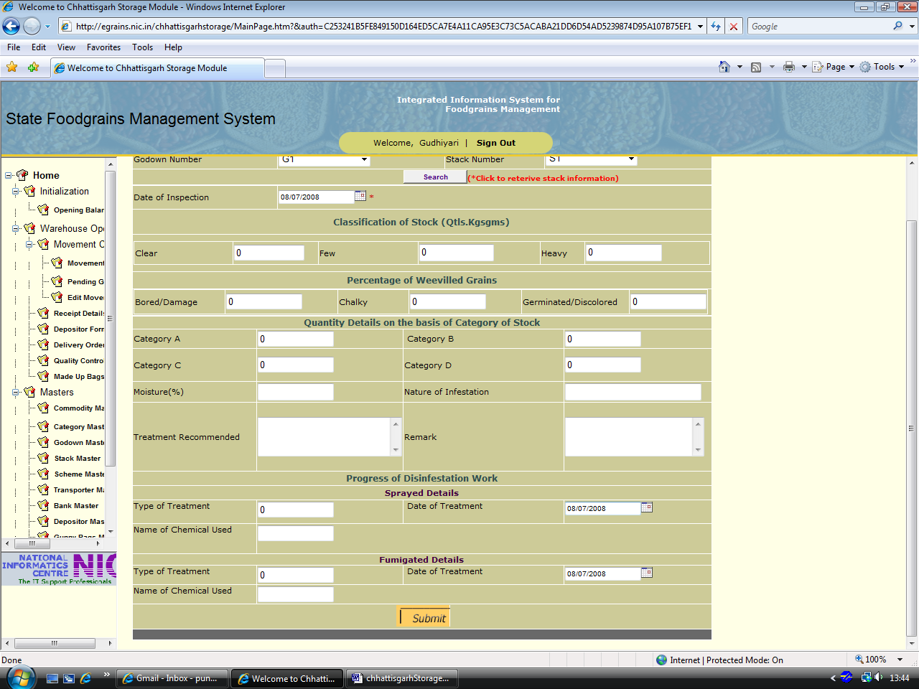

For adding the records click the Submit Button as marked in the Third Screen.

Note- Godown Number comes from the Godown master and stack number comes from the Stack Master

Made Up Bags

Purpose:
The Purpose of Made up bags Form is to maintain all the releated records like Commodity ,Godown Number,Stack no,Date of collection,Number of madeup bags

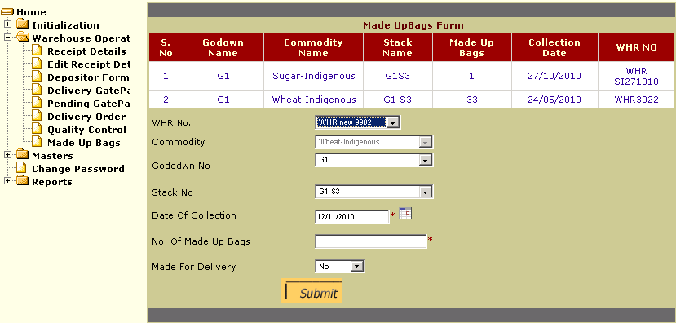
Fill the records like Date of collection ,No. of Made up Bages,Stack no,Godown No,Stack no and Press Submit to add the records into Databases.

Reports :

