CLARITAS HR ONBOARDING SYSTEM
Complete System Architecture Documentation

Version 2.0 | April 2026

Document Type | System Architecture Documentation
System Name | Claritas HR Onboarding & HRM System
Version | 2.0
Date | April 2026
Framework | Laravel 12 (PHP 8.3)
Database | MySQL 8.4 (62 tables)
Frontend | Blade + Tailwind CSS v4 + Bootstrap 5
Classification | Internal / Confidential

Table of Contents
1. Executive Summary
2. System Context & Overview
3. Technology Stack
4. Application Architecture
5. Module Architecture
5.1 Onboarding Module
5.2 Employee Management Module
5.3 Offboarding Module
5.4 IT Asset Management Module
5.5 Leave Management Module
5.6 Payroll & Statutory Module
5.7 Attendance & Overtime Module
5.8 Expense Claims (eClaim) Module
5.9 Announcements Module
6. Database Architecture
7. Authentication & Authorization
8. Security Architecture
9. Email & Notification System
10. Scheduled Tasks & Automation
11. File Storage Architecture
12. Frontend Architecture
13. API & Route Architecture
14. Role Hierarchy & Access Matrix
15. Deployment Architecture
16. Appendix: Full Database Schema

1. Executive Summary
Claritas HR Onboarding System is a comprehensive multi-role Human Resource Management (HRM) platform built for Malaysian companies. It manages the entire employee lifecycle from pre-hire onboarding through active employment services (payroll, leave, attendance, expense claims) to exit offboarding and archival.
The system serves four distinct user role groups — HR, IT, SuperAdmin, and Employee — with granular sub-roles providing fine-grained access control. It fully complies with Malaysian statutory requirements including EPF, SOCSO, EIS, PCB tax deductions, and Employment Act 1955 provisions.

Key System Metrics:
Total Database Tables | 62
Total Models | 45
Total Controllers | 20
Total Routes | 150+
Total Mail Classes | 23
Total Blade Views | 80+
Scheduled Commands | 7 (5 automated, 2 manual)
Security Score | 89/100 (OWASP Top 10 compliant)

2. System Context & Overview
The system context diagram shows how Claritas HRM interacts with external actors and systems. Five distinct user groups access the web application through role-based authentication. The application communicates with MySQL for data persistence, local file storage for documents, SMTP for automated email delivery, and a task scheduler for background automation.

Figure 2.1 — System Context Diagram
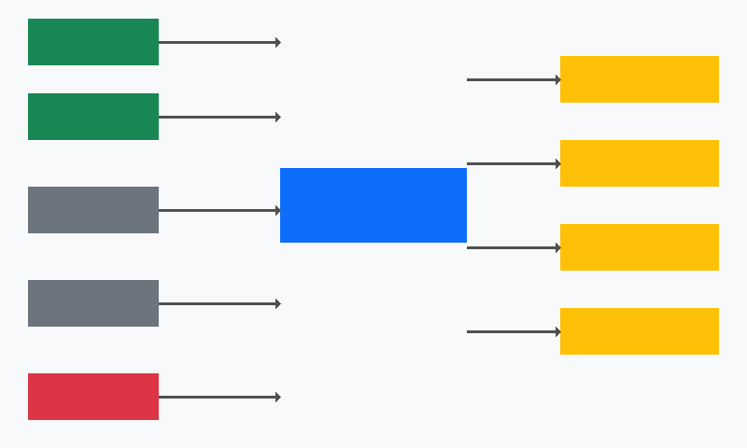
■ HR / IT Staff | ■ Application | ■ Users | ■ External Systems | ■ SuperAdmin

All interactions flow through the Laravel web application which enforces authentication, authorization, and security middleware on every request. The SMTP integration powers 23 distinct automated email workflows covering the entire employee lifecycle.

3. Technology Stack
Layer | Technology | Version | Purpose
Backend Framework | Laravel | 12.x | MVC web framework with Eloquent ORM
Language | PHP | 8.3 | Server-side scripting
Database | MySQL | 8.4 | Primary relational data store (62 tables)
Test Database | SQLite | In-memory | Fast isolated test execution
CSS Framework (1) | Tailwind CSS | v4 | Utility-first CSS via Vite plugin
CSS Framework (2) | Bootstrap | 5.3 | Component library (grid, forms, modals)
Build Tool | Vite | 7.x | Asset bundling with HMR
JavaScript | Vanilla JS + Alpine.js | - | Progressive enhancement
HTTP Client | Axios | 1.11 | AJAX requests
Icons | Bootstrap Icons | 1.x | Iconography via CDN
Dev Server | Laragon | - | Local WAMP stack (Windows)
Mail | SMTP | - | 23 Mailable classes, hr@claritas.com
Timezone | Asia/Kuala_Lumpur | UTC+8 | Malaysian timezone
Testing | PHPUnit | 11.x | Unit + Feature test suites

4. Application Architecture
Claritas follows a classic Model-View-Controller (MVC) pattern within a modular monolith. The application is structured as a single deployable Laravel application with clear module boundaries enforced through controller grouping, model relationships, and route prefixing.

4.1 Architecture Pattern
Pattern | Modular Monolith (MVC)
Communication | Synchronous HTTP (server-rendered Blade views)
Data Access | Eloquent ORM with eager loading
Authentication | Session-based with custom provider (work_email)
Authorization | Role-based (8 roles) + capability methods + custom permissions
File Serving | SecureFileController with DIRECTORY_PERMISSIONS map
Background Tasks | Laravel Scheduler (cron-based, 7 commands)
Email | Laravel Mail with 23 Mailable classes

Figure 4.1 — Module Overview Diagram

■ Core Modules | ■ HRM Modules | ■ Leave | ■ Payroll | ■ Claims/Offboarding | ■ Infrastructure

5. Module Architecture

5.1 Onboarding Module
The onboarding module manages the pre-hire process from HR creating an onboarding record through to a new hire completing a multi-step self-service form via a secure tokenized invite link.

Flow: HR Creates Record → Invite Email → New Hire Form → Registration → Employee Activation

Models | Onboarding, PersonalDetail, WorkDetail, AssetProvisioning, ItTask, OnboardingEditLog
Controllers | OnboardingController (12 methods), OnboardingInviteController (6 methods)
Views | hr/onboarding/ (page, show, edit), onboarding/ (form, success)
Mail | OnboardingInviteMail, OnboardingEditNotificationMail, OnboardingConsentRequestMail, WelcomeNewHire
Key Feature | invite_staging_json — Sections F-I stored as JSON until activation date
Automation | ActivateEmployees command runs every minute, transitions on start_date

Figure 5.1 — Employee Lifecycle Flow
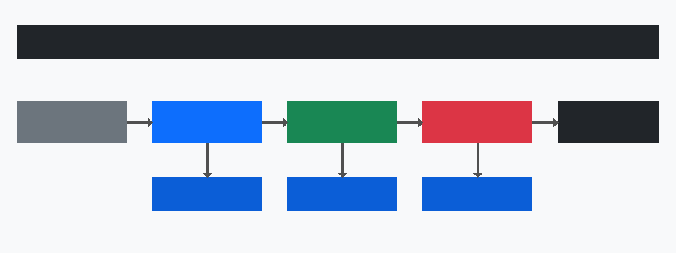
■ Invite/Register | ■ Registration | ■ Active Employee | ■ Offboarding | ■ Header/Archived | ■ Sub-Processes

5.2 Employee Management Module
The employee module is the central entity of the system. It manages personal details, work details, education history, spouse information, emergency contacts, child registrations, and employment contracts. It supports HR editing with a full re-consent flow and tracks all changes via EmployeeEditLog.
Central Model | Employee — 50+ fields, 15+ relationships
Sub-Models | EmployeeEducationHistory, EmployeeSpouseDetail, EmployeeEmergencyContact, EmployeeChildRegistration, EmployeeContract
Audit | EmployeeEditLog with consent token flow, EmployeeHistory for archival snapshots
Controller | EmployeeController (25+ methods), ProfileController (15 methods)
Views | hr/employees/ (page, show, edit), user/profile.blade.php
File Storage | NRIC files (JSON array), education certificates (JSON array, max 5), contracts
Consent Flow | HR edits Sections A/F/G/H/I → token generated → email sent → employee re-acknowledges

5.3 Offboarding Module
The offboarding module manages the employee exit process with automated email reminders, IT asset return tracking, and HR/IT task coordination. Two distinct view paths serve HR and IT staff.
Model | Offboarding — tracks 10+ status fields for each exit step
Controller | OffboardingController (7 methods for HR + IT)
HR View | hr/offboarding/ (index, show, edit) — full edit access
IT View | it/offboarding-show — read-only with "HR only" badges
Mail | OffboardingNoticeMail, OffboardingReminderMail, OffboardingWeekReminderMail, OffboardingSendoffMail
Automation | OffboardingNotifications command runs every minute (notice → reminder → week → sendoff)
Calendar | ICS calendar attachments sent with offboarding emails

5.4 IT Asset Management Module
Complete IT asset lifecycle tracking from procurement through assignment, provisioning, and disposal. Includes AARF (Annual Asset Record Form) with dual acknowledgement by employee and IT manager via tokenized email links.

Figure 5.4 — IT Asset Lifecycle Flow
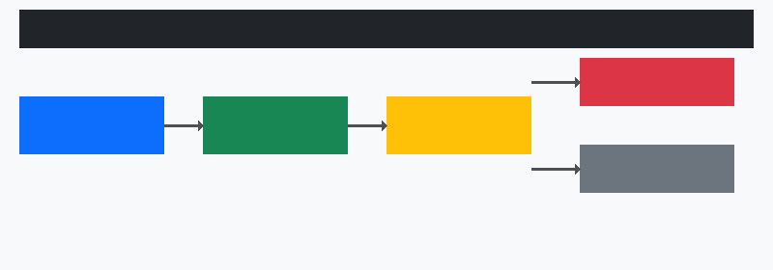
■ Inventory | ■ Assignment | ■ Provisioning | ■ Disposed | ■ Returned

Models | AssetInventory, AssetAssignment, AssetProvisioning, Aarf, DisposedAsset
Controller | AssetController (13 methods), AarfController (3 methods)
Views | it/assets/ (page, show, edit), aarf/ (acknowledge)
AARF Flow | Email with token → Employee acknowledges → IT Manager acknowledges → Locked
Features | Asset photos (JSON array), rental tracking, warranty tracking, CSV import/export

5.5 Leave Management Module
Full leave management with 9 Malaysian statutory leave types, tenure-based entitlements, two-tier approval workflow (Manager → HR), balance tracking with carry-forward, and public holiday management per company.

Figure 5.5 — Leave Application Flow
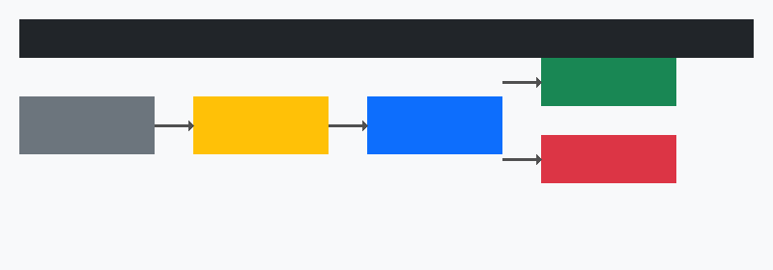
■ Employee | ■ Manager Review | ■ HR Review | ■ Approved | ■ Rejected

Models | LeaveApplication, LeaveType, LeaveBalance, LeaveEntitlement, PublicHoliday
Controller | LeaveController (20 methods)
Leave Types (default) | Annual, Medical, Hospitalization, Maternity, Paternity, Marriage, Compassionate, Unpaid, Emergency
Approval Flow | Employee → Manager Approve/Reject → HR Approve/Reject (two-tier)
Mail | LeaveApplicationNotifyMail, LeaveApprovalNotifyMail, PendingLeaveReminderMail
Automation | LeaveReminder: daily @09:00 — reminds managers of pending approvals

5.6 Payroll & Statutory Module
Comprehensive payroll processing with Malaysian statutory deductions (EPF, SOCSO, EIS, PCB), salary management, pay run workflow, payslip generation, and Borang EA / CP.8D tax form generation.

Figure 5.6 — Payroll Processing Flow
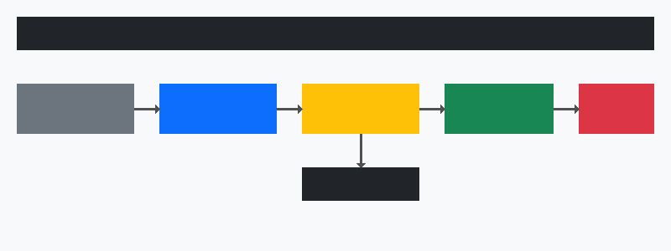
■ Salary Setup | ■ Draft | ■ Generate | ■ Approve | ■ Paid | ■ Statutory

Models | PayRun, Payslip, PayslipItem, PayrollItem, EmployeeSalary, EmployeeSalaryItem, EaForm, SalaryAdjustment, PayrollConfig
Controller | PayrollController (22 methods)
Statutory | EPF (employee/employer), SOCSO (employee/employer), EIS (employee/employer), PCB, HRDF (employer)
EPF Categories | A (below 60, Malaysian), B (60+, Malaysian), C (below 60, non-Malaysian), D (60+, non-Malaysian)
EA Form | Borang EA / CP.8D annual tax summary — auto-generated from payslip data
Mail | PayslipReadyMail, EaFormReadyMail
Integration | Approved expense claims auto-linked as reimbursement line items in payslips

5.7 Attendance & Overtime Module
Employee attendance tracking with clock-in/out, work schedule management, overtime requests, and IP-based location logging. Supports multiple work schedules per company.
Models | AttendanceRecord, WorkSchedule, OvertimeRequest
Controller | AttendanceController (11 methods)
Clock In/Out | IP address recorded, work hours auto-calculated, break deduction
Overtime | Request → Approval flow with multiplier-based calculation
Status Types | present, absent, late, half_day, on_leave, holiday
Work Schedules | Configurable per company: start/end time, break, working days (JSON array)

5.8 Expense Claims (eClaim) Module
Monthly expense claim submission with auto-categorization, GST handling, receipt management, two-tier approval (Manager → HR), bulk approve, CSV export, and payroll integration.

Figure 5.8 — Expense Claim Flow
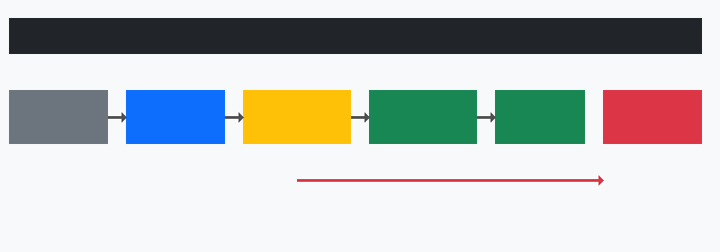
■ Draft | ■ Submitted | ■ Mgr Approved | ■ HR Approved / Paid | ■ Rejected

Models | ExpenseClaim, ExpenseClaimItem, ExpenseCategory, ExpenseClaimPolicy
Controller | ExpenseClaimController (20 methods)
Categories | 13 default categories with keyword-based auto-detection
GST | Configurable rate (default 8%), per-item GST calculation
Two-Tier Approval | Employee → Manager → HR (or bulk HR approve)
Security | CSV formula injection protection, total integrity validation, audit logging
Mail | ClaimSubmittedMail, ClaimApprovedMail, ClaimRejectedMail, ClaimReminderMail
Payroll Integration | HR-approved claims auto-linked as payslip reimbursement line items

5.9 Announcements Module
Company-wide or targeted announcements with file attachments. Visible by company filter (null = all companies). Created by HR Manager/SuperAdmin.

6. Database Architecture
The system uses MySQL 8.4 with 62 tables organized into 10 logical groups. All tables follow Laravel conventions with auto-incrementing IDs, timestamps, and soft deletes where appropriate. Foreign keys enforce referential integrity across the schema.

Figure 6.1 — Database Entity-Relationship Overview
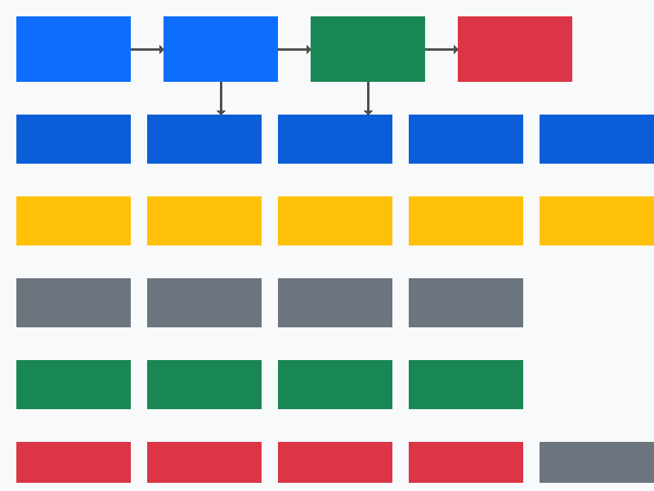
■ Core (users, employees, onboarding, offboarding) | ■ Sub-tables (personal, work, education, spouse, emergency) | ■ Assets (inventory, assignments, aarfs, tasks, disposed) | ■ Leave (types, applications, balances, holidays) | ■ Payroll (pay_runs, payslips, items, ea_forms) | ■ Claims & Attendance

6.1 Table Groups
Core & Auth (4) | users, employees, password_reset_tokens, companies
Onboarding (5) | onboardings, personal_details, work_details, onboarding_edit_logs, announcements
Employee Sub-tables (7) | employee_education_histories, employee_spouse_details, employee_emergency_contacts, employee_child_registrations, employee_contracts, employee_histories, employee_edit_logs
Offboarding (1) | offboardings
Assets (5) | asset_inventories, asset_assignments, asset_provisionings, aarfs, dispose_assets
IT Tasks (1) | it_tasks
Leave (5) | leave_types, leave_entitlements, leave_balances, leave_applications, public_holidays
Payroll (9) | pay_runs, payslips, payslip_items, payroll_items, employee_salaries, employee_salary_items, salary_adjustments, payroll_configs, ea_forms
Attendance (3) | attendance_records, work_schedules, overtime_requests
Claims (4) | expense_claims, expense_claim_items, expense_categories, expense_claim_policies
Admin (3) | user_permissions, security_audit_logs, cache/cache_locks

7. Authentication & Authorization

Figure 7.1 — Authentication & Security Flow
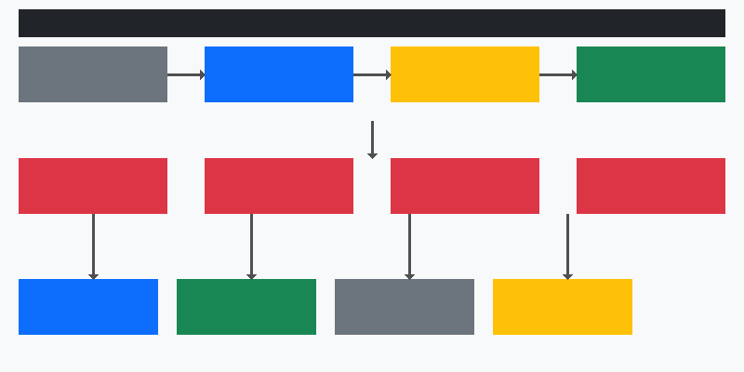
■ User Input | ■ Auth Provider | ■ Validation | ■ Session | ■ Security Middleware

7.1 Custom Authentication
Auth Provider | WorkEmailUserProvider — authenticates via work_email (not personal email)
Guard | Session-based (web guard)
Login Lockout | 5 failed attempts → account locked, security event logged
Session Enforcement | EnforceSingleSession — unique token per login, concurrent sessions blocked
Password Reset | 60-minute token expiry, 3-hour session timeout
Timing Safety | Constant-time hash comparison prevents enumeration attacks

7.2 Role-Based Access Control

Figure 7.2 — Role Hierarchy
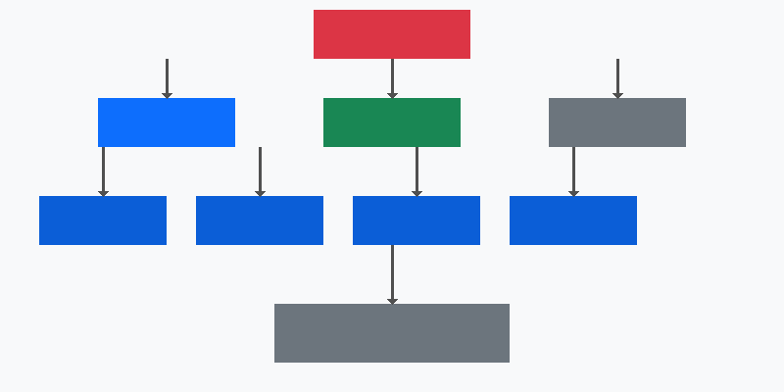
■ SuperAdmin | ■ HR Group | ■ IT Group | ■ System Admin / Employee | ■ Junior Roles

Role | Description | Module Access
superadmin | Full system access, company management, role assignment | All modules
system_admin | Internal admin, treated like HR Manager | HR + Admin modules
hr_manager | Full HR operations, edit records, download documents | HR + HRM modules
hr_executive | View-only HR operations, some Leave/Payroll actions | HR modules (restricted)
hr_intern | Limited HR view access | HR modules (view-only)
it_manager | Full IT operations, asset management, task assignment | IT + Asset modules
it_executive | IT operations, asset management | IT modules
it_intern | Limited IT view access | IT modules (view-only)
employee | Self-service profile, leave, payslips, attendance, claims | User modules

8. Security Architecture
The system implements defense-in-depth with 6 security layers, achieving an 89/100 security score against OWASP Top 10 assessment. All layers work together to protect against common web vulnerabilities.

Figure 8.1 — Defense-in-Depth Security Layers

■ Layer 1: Network Security (HSTS, CSP, Security Headers) | ■ Layer 2: Rate Limiting (login 30/min, reset 5/min, uploads 10/min) | ■ Layer 3: Authentication (WorkEmail, SingleSession) | ■ Layer 4: Authorization (RBAC + Capabilities) | ■ Layer 5: Data Validation (Input sanitization, parameterized queries) | ■ Layer 6: Audit Trail (SecurityAuditLog)

Security Headers | X-Frame-Options: DENY, X-Content-Type-Options: nosniff, CSP, HSTS (1 year), Referrer-Policy, Permissions-Policy
Rate Limiting | Login: 30/min, Password Reset: 5/min, File Uploads: 10/min, Bulk Approve: 30/min
CSRF Protection | Global CSRF middleware (exceptions: AARF token-based acknowledgement)
XSS Prevention | Blade {{ }} escaping (no {!! !!} for user data), strip_tags() on inputs
SQL Injection | Eloquent ORM with parameterized queries throughout
File Validation | Custom valid_file_content validator (magic-byte MIME verification)
Session Security | Unique session_token per login, single-session enforcement, session hijack detection
Audit Logging | SecurityAuditLog for failed logins, lockouts, unauthorized access, session hijacks
CSV Injection | sanitizeForCsv() helper prefixes formula characters in exports
Secrets | All secrets in .env, no hardcoded credentials

9. Email & Notification System
The system uses 23 Laravel Mailable classes covering every stage of the employee lifecycle. Emails are sent via SMTP from hr@claritas.com. Each mailable has a dedicated Blade template in resources/views/emails/.

Figure 9.1 — Email System Architecture
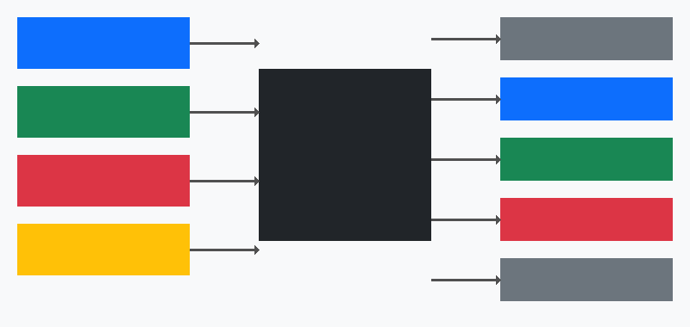
■ Onboarding Events | ■ Employee Events | ■ Offboarding Events | ■ Scheduled Tasks | ■ 23 Mailable Classes | ■ Recipients

Onboarding (4) | OnboardingInviteMail, OnboardingEditNotificationMail, OnboardingConsentRequestMail, WelcomeNewHire
Employee (3) | EmployeeConsentRequestMail, ConsentRequestMail, AnnouncementMail
Offboarding (5) | OffboardingNoticeMail, OffboardingReminderMail, OffboardingWeekReminderMail, OffboardingSendoffMail, CalendarInvite
Assets (1) | AarfAcknowledgementMail
Leave (3) | LeaveApplicationNotifyMail, LeaveApprovalNotifyMail, PendingLeaveReminderMail
Payroll (2) | PayslipReadyMail, EaFormReadyMail
Claims (4) | ClaimSubmittedMail, ClaimApprovedMail, ClaimRejectedMail, ClaimReminderMail
Security (1) | SecurityAuditMail

10. Scheduled Tasks & Automation
Command | Frequency | Purpose
employees:activate | Every minute | Activate employees on start_date, send welcome email, create offboarding on exit_date
offboarding:notify | Every minute | Send scheduled offboarding emails (notice, reminder, week, sendoff)
leave:remind-managers | Daily @ 09:00 | Remind managers of pending leave approvals
claims:remind | Daily @ 09:00 | Remind employees of upcoming claim deadlines
security:audit-report | Hourly | Generate security audit report from event logs
backfill:preferred-name | Manual | One-time: populate preferred_name if empty
backfill:offboarding | Manual | One-time: create offboarding records for employees with exit_date

11. File Storage Architecture
All sensitive files are stored in private storage (storage/app/) and served through SecureFileController which enforces role-based access via DIRECTORY_PERMISSIONS mapping.
Directory | Contents | Allowed Roles
nric_files | NRIC/Passport scans | hr_manager, superadmin, system_admin, self
contracts | Employment contracts | hr_manager, superadmin, system_admin
handbooks | Employee handbooks | hr_manager, superadmin, system_admin, self
orientation | Orientation documents | hr_manager, superadmin, system_admin, self
aarf_files | AARF documents | hr_manager, it_manager, superadmin, system_admin, self
asset_photos | Asset photographs | hr_manager, it_manager, it_executive, superadmin
leave_attachments | Leave supporting docs | hr_manager, hr_executive, superadmin, system_admin, self
claim_receipts | Expense claim receipts | hr_manager, hr_executive, superadmin, system_admin, self

12. Frontend Architecture
Rendering | Server-Side Rendering (SSR) via Laravel Blade templates
CSS | Tailwind CSS v4 (utilities) + Bootstrap 5 (components)
JavaScript | Vanilla JS + Alpine.js (progressive enhancement, no SPA)
Build Tool | Vite 7 with @tailwindcss/vite plugin and laravel-vite-plugin
Icons | Bootstrap Icons via CDN
Layout | Single shared layout (layouts/app.blade.php) with collapsible sidebar
Responsive | Mobile-responsive via Bootstrap grid + Tailwind breakpoints
Themes | Dark-mode gradient blue sidebar with light content area
File Handling | DataTransfer API for multi-file management (NRIC, certificates)
Interactivity | Axios for AJAX (category detection, email validation, etc.)

13. API & Route Architecture
All routes are defined in routes/web.php with 150+ endpoints grouped by role prefix. Authentication is enforced via middleware groups. The system uses RESTful conventions.
Group | Count | Prefixes
Guest (Public) | ~15 | /login, /register, /forgot-password, /reset-password, /aarf/{token}, /onboarding-invite/{token}
HR Routes | ~50 | /onboarding/*, /hr/employees/*, /hr/offboarding/*, /hr/leave/*, /hr/payroll/*, /hr/attendance/*, /hr/claims/*, /announcements/*
IT Routes | ~20 | /assets/*, /it/tasks, /it/offboarding/*
SuperAdmin Routes | ~10 | /superadmin/roles/*, /superadmin/accounts/*, /superadmin/companies/*
User Routes | ~40 | /dashboard, /profile, /my/leave/*, /my/payslips/*, /my/attendance/*, /my/claims/*, /my/team-*
Shared/Utility | ~15 | /account/*, /secure-file/*, /hr/aarf/*, /logout

14. Role Hierarchy & Access Matrix
The access matrix shows which modules and capabilities are available to each role group. Capability methods on the User model provide fine-grained authorization checks.
Module | SuperAdmin | HR Manager | IT Manager | HR/IT Intern | Employee
Onboarding | ✓ Full | ✓ Full | ✓ View | ✗ | ✗
Employees | ✓ Full | ✓ Full | ✓ View | ✗ | ✓ Self
Offboarding | ✓ Full | ✓ Full | ✓ IT View | ✗ | ✗
Assets | ✓ Full | ✓ View | ✓ Full | ✗ | ✗
Leave Config | ✓ Full | ✓ Full | ✗ | ✗ | ✗
Leave Apply | ✗ | ✗ | ✗ | ✗ | ✓
Leave Approve | ✓ | ✓ | ✗ | ✗ | ✓ Manager
Payroll | ✓ Full | ✓ Full | ✗ | ✗ | ✓ View
Attendance Config | ✓ Full | ✓ Full | ✗ | ✗ | ✗
Attendance Self | ✗ | ✗ | ✗ | ✗ | ✓
Claims Config | ✓ Full | ✓ Full | ✗ | ✗ | ✗
Claims Submit | ✗ | ✗ | ✗ | ✗ | ✓
Claims Approve | ✓ HR | ✓ HR | ✗ | ✗ | ✓ Manager
Announcements | ✓ | ✓ Full | ✗ | ✗ | ✗
Companies | ✓ | ✗ | ✗ | ✗ | ✗
Roles | ✓ | ✗ | ✗ | ✗ | ✗
Accounts | ✓ | ✗ | ✗ | ✗ | ✗

15. Deployment Architecture
Environment | Laravel application on LAMP/WAMP stack
Web Server | Apache or Nginx with PHP-FPM
PHP Version | 8.3.x with required extensions (mbstring, openssl, pdo_mysql, gd, zip)
Database | MySQL 8.4 with InnoDB engine
File Storage | Local private storage (storage/app/) with symlink for public assets
Cron | Laravel scheduler via system cron: * * * * * php artisan schedule:run
Queue | Sync driver (configurable for Redis/database queue)
Mail | SMTP transport (configurable: Mailgun, SES, Postmark)
SSL | Required for production (HSTS enforced via SecurityHeaders middleware)
Backup Strategy | Database dumps + file storage snapshots (recommended: daily)

16. Appendix: Full Database Schema

Core Tables
Table: users
id, name, work_email, password, role, is_active, profile_picture, login_attempts, deactivation_reason, deactivated_at, session_token, timestamps
Table: employees
id, onboarding_id, user_id, active_from, active_until, full_name, preferred_name, official_document_id, date_of_birth, sex, marital_status, religion, race, is_disabled, residential_address, personal_contact_number, house_tel_no, personal_email, bank_account_number, bank_name, epf_no, income_tax_no, socso_no, epf_category, is_resident, nationality, nric_file_path, nric_file_paths, consent_given_at, consent_ip, designation, department, company, office_location, reporting_manager, manager_id, reporting_manager_email, company_email, start_date, exit_date, last_salary_date, employment_type, work_role, google_id, aarf_file_path, handbook_path, orientation_path, employment_status, resignation_reason, remarks, timestamps
Table: onboardings
id, status, is_expired, hr_email, it_email, hr_emails, it_emails, manual_aarf_path, calendar_invite_sent, welcome_email_sent, assigned_pic_user_id, asset_preparation_status, work_email_status, invite_token, invite_email, invite_expires_at, invite_submitted, timestamps
Table: offboardings
id, onboarding_id, employee_id, full_name, company, department, designation, company_email, reporting_manager_email, personal_email, exit_date, reason, remarks, calendar_reminder_status, exiting_email_status, aarf_status, notice_email_status, reminder_email_status, week_reminder_email_status, sendoff_email_status, asset_cleaning_status, deactivation_status, assigned_pic_user_id, timestamps

Employee Sub-Tables
Table: personal_details
id, onboarding_id, full_name, preferred_name, official_document_id, date_of_birth, sex, marital_status, religion, race, is_disabled, residential_address, personal_contact_number, house_tel_no, personal_email, bank_account_number, bank_name, epf_no, income_tax_no, socso_no, nric_file_path, nric_file_paths, consent_given_at, consent_ip, invite_staging_json, timestamps
Table: work_details
id, onboarding_id, employee_status, staff_status, employment_type, designation, company, office_location, reporting_manager, reporting_manager_email, start_date, exit_date, last_salary_date, company_email, google_id, department, role, timestamps
Table: employee_education_histories
id, employee_id, qualification, institution, year_graduated, years_experience, certificate_path, certificate_paths, timestamps
Table: employee_spouse_details
id, employee_id, name, address, nric_no, tel_no, occupation, income_tax_no, is_working, is_disabled, timestamps
Table: employee_emergency_contacts
id, employee_id, contact_order, name, tel_no, relationship, timestamps
Table: employee_child_registrations
id, employee_id, cat_a_100 through cat_e_50 (10 columns), timestamps
Table: employee_contracts
id, employee_id, uploaded_by, original_filename, file_path, file_size, notes, timestamps
Table: employee_histories
id, onboarding_id, employee_id, user_id, full personal and work fields, exit_reason, exit_remarks, archived_at, timestamps
Table: employee_edit_logs
id, employee_id, edited_by_user_id, edited_by_name, edited_by_role, sections_changed, change_notes, consent_token, consent_token_expires_at, consent fields, acknowledgement fields, timestamps

Asset & IT Tables
Table: asset_inventories
id + 30 fields covering: identification, specifications, procurement, assignment, condition
Table: asset_assignments
id, onboarding_id, employee_id, asset_inventory_id, assigned_date, returned_date, status
Table: asset_provisionings
id, onboarding_id, laptop_provision, monitor_set, converter, company_phone, sim_card, access_card_request, office_keys, others
Table: aarfs
id, onboarding_id, employee_id, aarf_reference, acknowledged, acknowledged_at, acknowledgement_token, it_manager fields, it_notes, asset_changes, pending_asset_ids
Table: dispose_assets
id, asset_inventory_id, asset_tag, asset_type, brand, model, serial_number, asset_condition, reason, disposed_by, disposed_at, remarks
Table: it_tasks
id, onboarding_id, offboarding_id, assigned_to, assigned_by, task_type, title, description, status, completed_at

HRM Module Tables
Table: leave_types
id, company, name, code, description, is_paid, requires_attachment, is_active, sort_order
Table: leave_applications
id, employee_id, leave_type_id, dates, total_days, half_day fields, reason, attachment, status, approval fields, manager approval fields
Table: leave_balances
id, employee_id, leave_type_id, year, entitled, taken, carry_forward, adjustment
Table: leave_entitlements
id, leave_type_id, company, tenure range, entitled_days, carry_forward_limit
Table: public_holidays
id, company, name, date, year, is_recurring
Table: pay_runs
id, company, reference, title, year, month, dates, status, approval fields, totals, notes
Table: payslips
id, pay_run_id, employee_id, payslip_number, salary components, statutory deductions, status
Table: payslip_items
id, payslip_id, payroll_item_id, item_name, amount
Table: payroll_items
id, company, name, code, type (earning/deduction), is_statutory, is_recurring, is_active
Table: employee_salaries
id, employee_id, basic_salary, payment_method, bank fields, effective dates, is_active
Table: ea_forms
id, employee_id, year, employer info, employee info, remuneration, deductions, statutory, status
Table: expense_claims
id, employee_id, claim_number, title, year, month, totals, status, submission/approval fields
Table: expense_claim_items
id, expense_claim_id, category_id, date, description, amounts, receipt_path, is_locked
Table: expense_categories
id, company, name, code, description, is_active
Table: attendance_records
id, employee_id, date, clock times, hours, status, IP addresses, schedule_id
Table: work_schedules
id, company, name, times, working_days (JSON), is_default
Table: overtime_requests
id, employee_id, date, times, hours, multiplier, reason, status, approval fields

Document Information
This document was auto-generated from the live codebase of the Claritas HR Onboarding System. All diagrams represent the current production architecture as of April 2026. The system comprises 62 database tables, 45 models, 20 controllers, 150+ routes, 23 mail classes, and 80+ Blade views.

