Statement of Work (SOW)
IT Issue Tracking Platform

Phase 1 – Core Ticket Intake & Lifecycle Management

1. Project Overview
The City of Rancho Cordova requires a modern, secure, and scalable IT Issue Tracking Platform built on Microsoft 365. This Statement of Work defines Phase 1 of a multi-phase initiative designed to standardize how IT requests are submitted, tracked, processed, and reported across the organization.
Phase 1 focuses on delivering the foundational capabilities of the IT Issue Tracking Platform, including ticket intake, secure ticket storage, workflow automation, lifecycle management, notifications, and baseline reporting. The architecture is intentionally designed to support future phases without rework, data migration, or structural changes.

2. Objectives
The objectives of Phase 1 – Core Ticket Intake & Lifecycle Management are to:
- Establish a single, standardized method for submitting IT support requests
- Centralize all ticket-related data, files, and communications in a secure system of record
- Automate ticket creation, routing, notifications, and lifecycle transitions
- Enforce role-based visibility and data access controls
- Track ticket status, time spent in each lifecycle stage, and SLA performance
- Provide operational reporting for IT leadership and IT Issue Tracking agents
- Lay a scalable foundation for future enhancements such as customer satisfaction surveys and knowledge discovery

3. Phase 1 Solution Architecture
Phase 1 will be implemented using native Microsoft 365 services to minimize custom development, reduce long-term support overhead, and align with existing IT governance.

Architecture Overview
- Intake Layer
  - Microsoft Forms used as the primary ticket submission interface
  - Support for structured data entry, Category/Subcategory logic, and attachments
- Process Layer
  - Power Automate cloud flows (using the modern/new designer UI)
  - Automated ticket creation, routing, notifications, and SLA tracking
  - Status-driven workflow engine
- Data & Storage Layer
  - SharePoint Online Document Library
  - One Document Set per ticket acting as the system of record
  - Metadata-driven filtering, views, and reporting
  - PDF snapshot of each ticket request
- Communication Layer
  - Outlook shared mailbox for notifications and email-to-ticket follow-up
  - Microsoft Teams notifications sent directly to users via chat
- Security Layer
  - SharePoint security groups
  - Content approval enabled
  - Visibility restricted to ticket creator and approvers

4. Phase 1 Scope of Work

4.1 Ticket Intake (Phase 1)
Phase 1 includes the following ticket submission channels:
- Microsoft Forms
  - Primary intake mechanism
  - Master-detail logic for Category and Subcategory
  - Attachment support for screenshots, photos, and PDFs
- Email-to-Ticket
  - Emails sent or replied to the shared mailbox are associated with existing tickets as long the subject of the emails contains a certain text structure
- Teams Entry Point
  - Link-based access to the ticket submission form
Microsoft Forms will serve as the front-door experience, ensuring a consistent and user-friendly submission process without exposing SharePoint libraries directly to requesters.

4.2 Ticket Data Model & Storage (Phase 1)
Phase 1 will implement a dedicated SharePoint Online Document Library configured to store IT tickets as Document Sets.
Document Set Design
- Each Document Set represents one IT ticket
- A unique Ticket Number is generated automatically
- All related files and communications are stored within the Document Set
Metadata (Phase 1)
- Ticket Number
- Issue Title
- Requested By
- Assigned To
- Priority (High / Normal / Low)
- Category
- Subcategory
- Status (New, In Progress, Waiting on User, Closed)
- Created Date
- Current Status Start Date
- SLA Due Date (calculated)
- Time in Current Status (tracked via automation)
Stored Content
- PDF version of the original ticket request
- Attachments submitted via the form
- Email replies and related files
- Manual uploads by IT Issue Tracking agents and requesters

4.3 Security & Governance (Phase 1)
Phase 1 will enforce data visibility and access controls using SharePoint-native features.
Security Model
- SharePoint Security Groups:
  - Requesters
  - IT Issue Tracking Agents
  - IT Issue Tracking Managers
- Content Approval enabled on the library
- Library configured so that:
  - Only the ticket creator and approvers can view ticket content
  - IT Issue Tracking managers have full visibility
  - Requesters can update and add files to their own tickets
This approach avoids per-item permission complexity while maintaining strict data isolation.

4.4 Workflow Automation (Phase 1)
Phase 1 includes multiple Power Automate cloud flows built using the modern designer interface and deployed within a Solution.
Flow 1 – Ticket Intake & Creation
- Trigger: Microsoft Forms submission
- Actions:
  - Generate Ticket Number
  - Create Document Set
  - Apply metadata
  - Save form attachments
  - Generate PDF snapshot of the request
  - Set initial Status to “New”
  - Route ticket based on Category/Subcategory
  - Send confirmation notifications (email + Teams)
Flow 2 – Email-to-Ticket Association
- Trigger: New email in shared mailbox
- Actions:
  - Identify related Ticket Number
  - Store email body and attachments in the corresponding Document Set
  - Notify assigned agent if applicable
Flow 3 – Status & Assignment Updates
- Trigger: Metadata change on Document Set
- Actions:
  - Detect status or assignment changes
  - Record status transition timestamps
  - Send targeted notifications explaining why the message was sent

Flow 4 – SLA, Reminders & Escalation
- Trigger: Scheduled (recurring)
- Logic:
- Business hours enforcement (Monday–Friday, 7:00 AM–5:00 PM)
- Pause SLA timers while status is “Waiting on User”
- Send reminder notifications to agents
- Escalate overdue tickets
- Auto-close tickets after defined inactivity period
- Support ticket reopen by requester or agent

Phase 1 Reporting
Phase 1 provides foundational operational reporting using SharePoint views and metadata.
KPIs Supported
- SLAs met vs missed
- Tickets closed per agent
- Weekly and monthly ticket volumes
- Tickets by category and priority
The data model is designed to support future Power BI dashboards without restructuring.

6. Testing, Rollout & Training (Phase 1)

Testing
End-to-end test cases for:
- Ticket submission
- Routing accuracy
- Security enforcement
- Notifications
- SLA logic
- Auto-close and reopen scenarios
Rollout
- Pilot deployment with IT Issue Tracking agents
- Controlled go-live following validation
Training
- Requester quick-start guide
- IT Issue Tracking agent operational guide
- Manager overview of reporting and escalation
- Administrator handoff documentation
- Training and handoff documentation

5. Deliverables
Description
Microsoft Forms ticket intake configuration
SharePoint Document Library and Document Set configuration
Power Automate flows (intake, routing, SLA, notifications)
Operational views and metadata model
Testing checklist and rollout plan

6. Project Timeline
Estimated duration: 2 weeks
Description
Intake & Data Foundation Build
Workflow Automation Development
Testing & Refinement
Rollout, Training & Go-Live

6. Project COST
Cost of the project is: $4990 USD

7. Assumptions
- Microsoft Forms is approved as the primary intake mechanism
- Document Sets are enabled in the tenant
- Shared mailbox is available and configured
- Business hours and holidays are confirmed
- Premium connectors are permitted if required

8. Out of Scope (Optional Enhancements)
The following capabilities are intentionally excluded from Phase 1 and may be delivered under separate Statements of Work:
- Customer Satisfaction Surveys (CSAT)
- Knowledge base and faceted search experience
- Self-service ticket resolution
- Advanced analytics and trend analysis
- Asset and configuration management
- Extended ITSM processes (problem/change management)

10. Future Phase Alignment
Phase 1 establishes the foundation for future enhancements, including:
- Phase 2: Customer feedback and satisfaction measurement
- Phase 3: Knowledge classification, discovery and faceted search experiences
No re-architecture or data migration is expected to support these future phases.

Reference Implementation

Proven Architecture: Modern Complaint MANAGEMENT SYSTEM (Production Use)
The proposed ITIT Issue Tracking Automation Solution approach is based on an existing, production-proven implementation currently used at California Dairies for customer complaint -style tracking.
This section describes each component of the Modern Complaint Management System solution and explains how the same technical approach applies directly to the ITIT Issue Tracking Program.

1. COMPLAINT FORM – Microsoft Forms
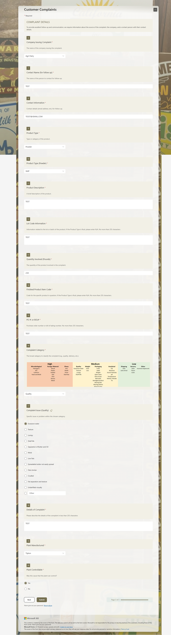 | Current Use in Complaint Management:  - Captures complaints from users in a structured manner.  - Includes fields with conditional logic, subtitles, sections, and a master-detail experience for categories and issues.  - Device-agnostic; supports tablet, mobile, and desktop usage.  IT Issue Tracking Platform:  - Capture IT tickets from employees with standardized fields like Issue Category, Urgency, Impact, and Subsystem.  - Conditional fields guide users based on issue type (e.g., “If Network Issue → ask for location”).  - Master-detail relationships allow capturing parent tickets (main system affected) and child issues (specific error codes, applications, devices).  - Improves data quality, reduces back-and-forth clarification, and ensures all necessary info is collected for quick resolution.

Workflow Automation – Power Automate
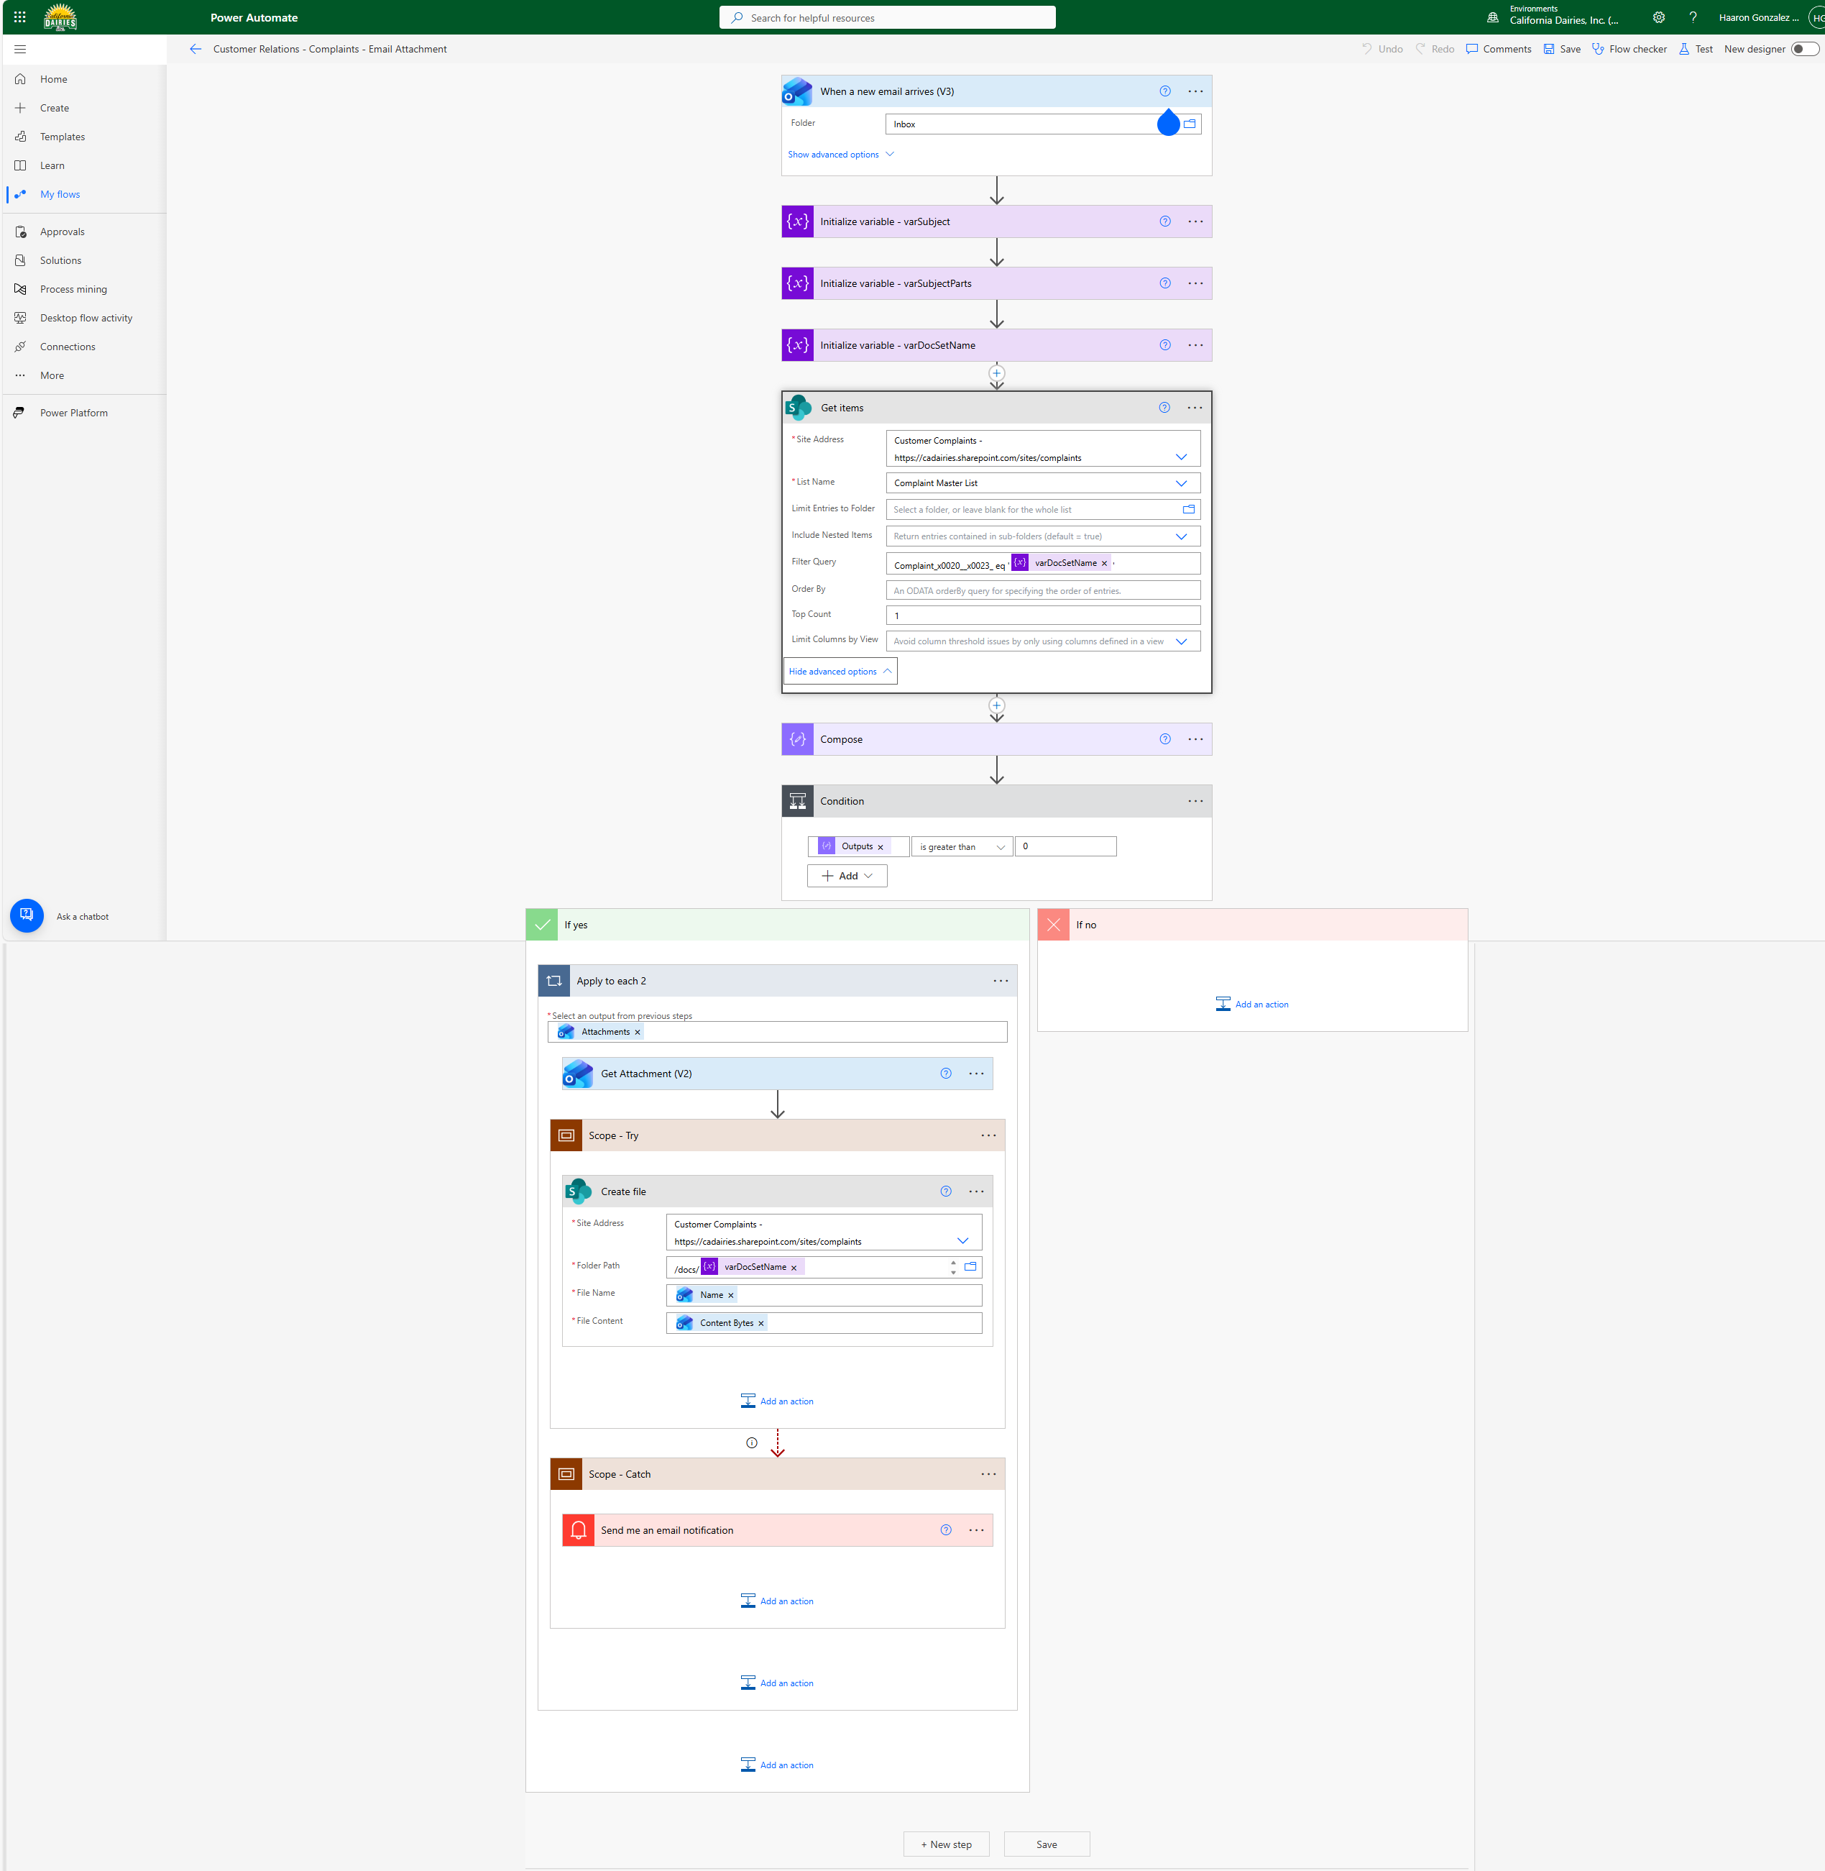 | Current Use in Complaint Management:  - Maps data from Microsoft Forms to SharePoint libraries and lists.  - Evaluates types of complaints and based on that define SLA.  - Sends email assignments and notifications.  - Drives lifecycle workflow (assignment, approval, escalation, reminders).  - Listens to incoming emails and extract attachments, locate the complaint and insert the attached files in the complaint document set.  IT Issue Tracking Platform:  - Automates ticket routing to the correct technician based on category, priority, and department.  - Sends alerts for overdue tickets or escalations.  - Implements SLA-based reminders and escalation rules.  - Enables approvals for special requests (e.g., software installation or elevated access requests).  - Reduces manual administrative work and ensures consistent follow-up.

Reporting & Visibility – SharePoint Views
2. SharePoint Online (or Document & Data Repository)  Current Use in Complaint Management:  - Dedicated SharePoint Online communication site.  - Document libraries with content types and templates.  - Site columns and metadata for filtering and reporting.  - Storage of all complaint documentation and attachments.  IT Issue Tracking Platform:  - Centralized repository for IT tickets and associated documentation (screenshots, logs, emails).  - Templates for common ticket types (Hardware, Software, Access Requests) to standardize submissions.  - Metadata (Priority, Status, Department, Assigned Technician) supports dynamic filtering and reporting.  - Facilitates audit and compliance reporting for IT service management.  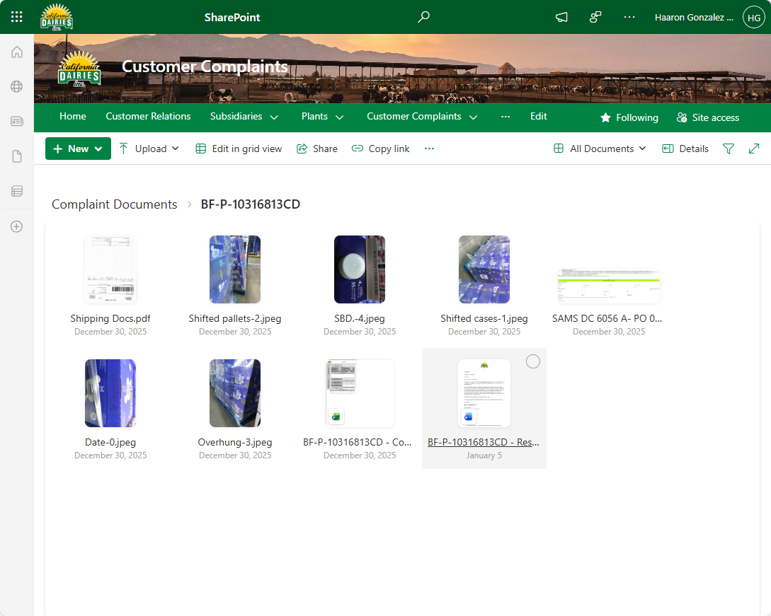 | 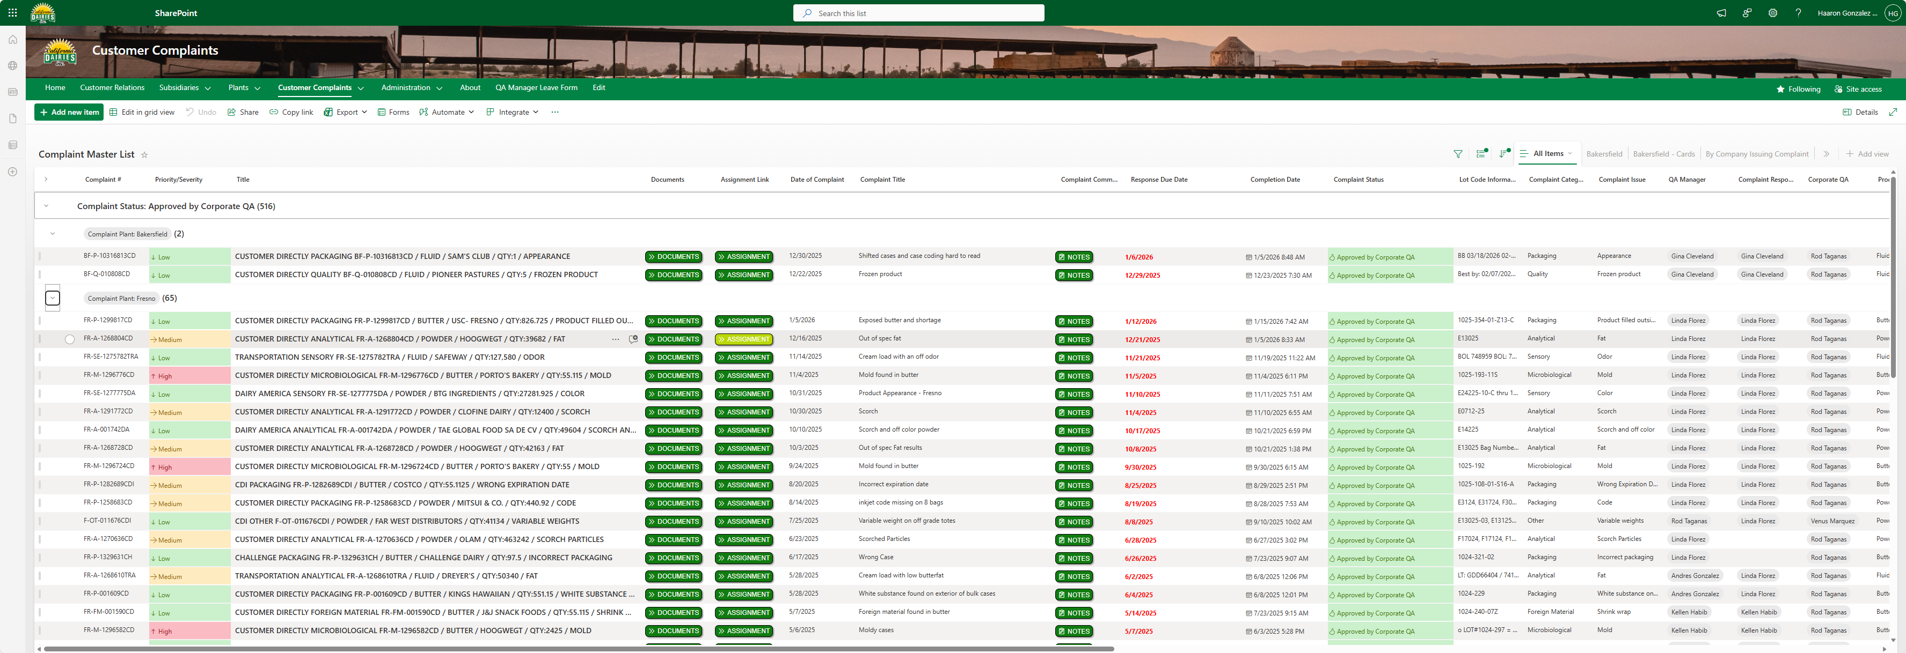

Why This Matters for Rancho Cordova
This is not a prototype or concept.
✔ Used in production
✔ Scales to hundreds or thousands of records
✔ Mobile-ready
✔ Built entirely on Microsoft 365
✔ Low maintenance
✔ Auditable and compliant
The ITIT Issue Tracking Automation Solution is a direct evolution of this architecture, adapted for municipal inspection workflows and compliance enforcement.

