MACHINE LEARNING PROJECT REPORT · UNSUPERVISED LEARNING
District Development Profiling from NFHS-5
Clustering India's districts by the shape of their development, and testing the result against the ways districts are normally grouped
Data | NFHS-5 (2019-21) district factsheets, IIPS
Districts analysed | 704
Features used | 88 candidates, 10 domains (76 of 77 separate the profiles)
Outcomes held out | 9 (child stunting, wasting, severe wasting, underweight, overweight; anaemia in children, women 15-19, women 15-49, non-pregnant women)
Final model | K-means on 30 PCA components
Profiles found | 8

Abstract
India's districts are normally ranked on a single composite development score. That score reports how far behind a district is, but not what is wrong with it: two districts with the same score can require opposite interventions. This project clusters 704 districts on 77 NFHS-5 indicators of living conditions, service use and health behaviour, and evaluates the result against four traditional groupings using nine nutrition and anaemia outcomes withheld from every model. The final model - K-means on 30 principal components with k = 8 - explains 0.233 of the variance in those hidden outcomes, against 0.034 for the composite index cut into the same number of groups. A permutation test confirms the structure is not an artefact of the method, and per-district label margins identify which assignments are reliable and which are borderline.

1. Problem and objectives
NFHS-5 publishes roughly 100 health and development indicators for every district in India. Policy instruments such as the Aspirational Districts Programme and SDG district indices average these into one score and rank districts on it. The ranking is not wrong, but it is one-dimensional: it cannot distinguish a district short of sanitation and cooking fuel from one short of antenatal care, even when both sit at the same score.
- Objective 1 — group districts by the shape of their development rather than its level;
- Objective 2 — demonstrate that the grouping outperforms a single-score ranking and state-based grouping on evidence none of them was allowed to see;
- Objective 3 — deliver an interactive tool that assigns any district, including one not present in NFHS-5, to a profile and reports how confident that assignment is.

2. Data and preprocessing

2.1 Sources and their alignment
Two public mirrors of the same IIPS factsheets were used, each for what it does better. The jvargh7 mirror supplies values: they are already numeric, and it preserves the reliability marks NFHS prints - 5,042 cells based on 25-49 respondents, and 4,113 cells suppressed entirely because fewer than 25 respondents were available. The SaiSiddhardhaKalla mirror supplies Census 2011 district codes and clean indicator names.
The two could not be joined on indicator names. In the factsheet mirror the names are extracted from the source PDFs, and the gender of the non-communicable disease indicators survives only in the factsheet item number: items 86-88 are women's blood sugar and 89-91 are men's, with identical printed names. The mirrors were therefore aligned by value fingerprint - each item matched to the indicator whose values are closest across all 695 shared districts. Because both files derive from the same PDFs, the correct match agrees to approximately 0.001 while the runner-up differs by three orders of magnitude; the code asserts this margin rather than assuming the match. All 104 indicators aligned unambiguously.

2.2 Cleaning decisions
- Completeness — indicators missing in more than 10% of districts were dropped (nine, all small-denominator measures such as diarrhoea treatment); districts missing more than 20% of indicators were dropped (one).
- Consequence — consistent flagging revealed that anaemia in pregnant women is suppressed in 19% of districts, so it was removed from the held-out set, leaving nine outcomes.
- Imputation — remaining gaps were filled with KNN imputation (k = 5) on standardised values. Features and outcomes were imputed separately so that no information could leak from the held-out set into the model inputs.
- Winsorising — 1.8% of feature cells were clipped to the 1st/99th percentile. Without this, single extreme values from very small districts claimed entire clusters.
- Redundancy — two indicators correlating above |r| = 0.95 with a retained indicator were removed, to stop one concept being counted twice in every distance.

2.3 Exploratory analysis
Mean absolute correlation between features is 0.22, with 124 pairs above |r| = 0.6 - heavy redundancy, and the direct justification for PCA. Separately, 42% of the variance in a typical indicator lies within states rather than between them, which is the justification for clustering at district level rather than using the state as the unit.
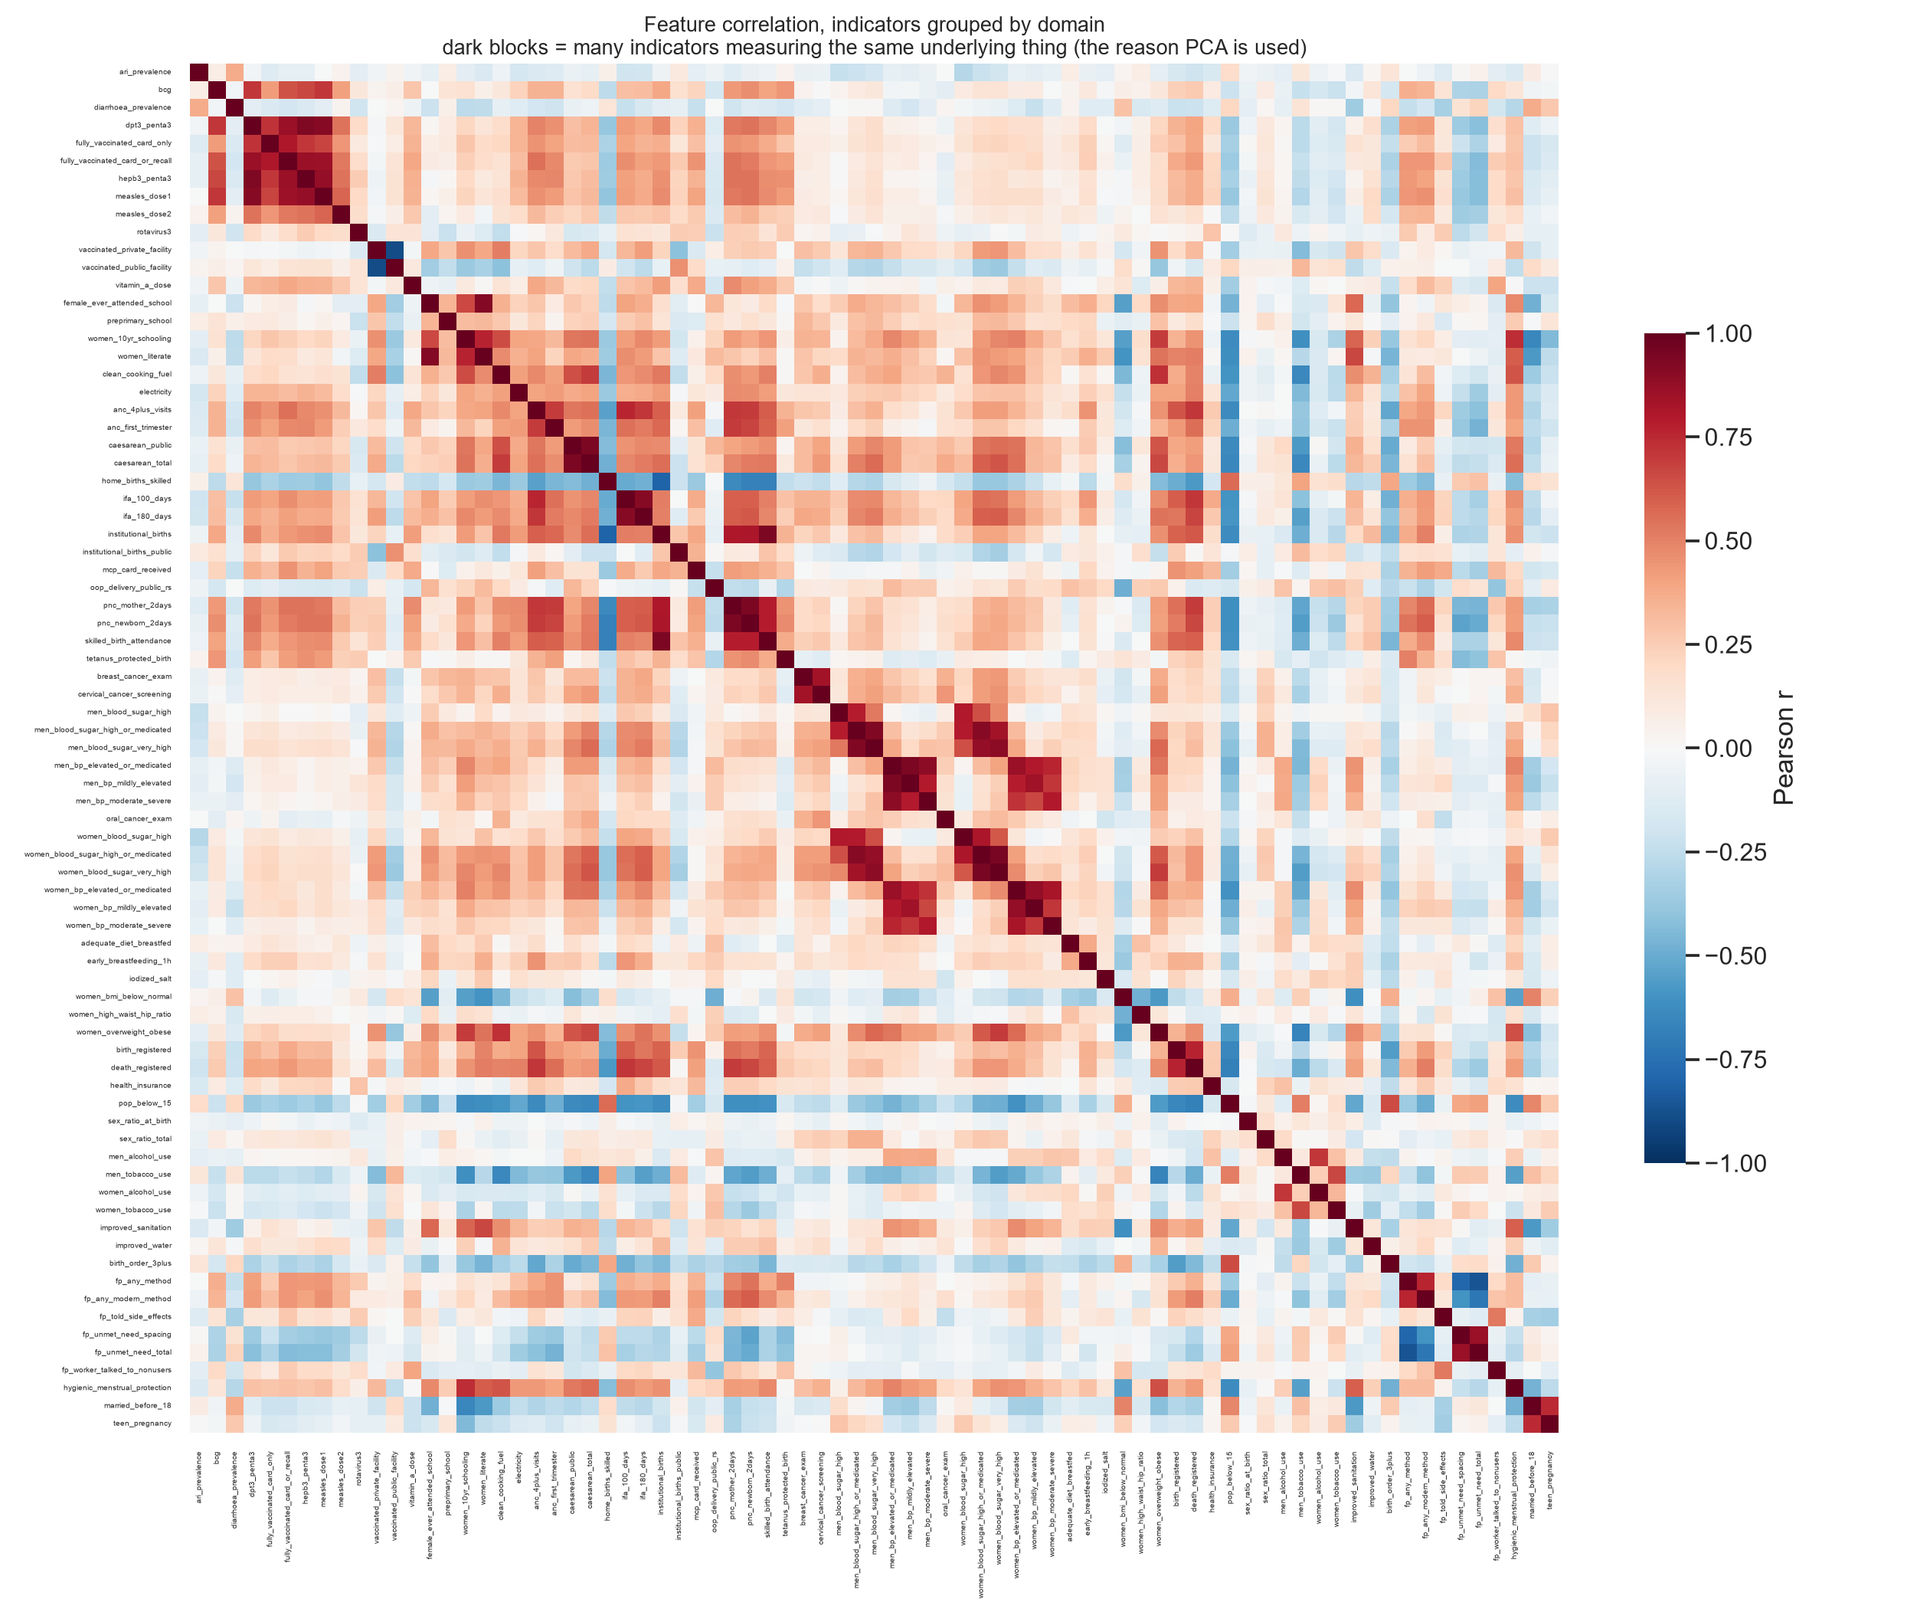
Figure 1. Feature correlations, ordered by domain. The dark blocks are groups of indicators measuring the same underlying construct.

3. Method

3.1 Dimensionality reduction
Features were standardised, then rotated by PCA. The first component explains 25.3% of total variance and represents the reach of maternal care; the second (11.1%) separates districts with strong public immunisation from those with a costlier, more privatised system. Reaching 80 / 90 / 95% of variance requires 18 / 30 / 41 components; all three were carried forward and compared.

3.2 Algorithms compared
Algorithm | Assumption | Role here
K-means | roughly spherical, similar-sized groups | final model
Ward (agglomerative) | merge whichever pair adds least within-cluster variance | hierarchy and dendrogram
Gaussian Mixture | data is a blend of Gaussian components; soft membership | soft alternative
DBSCAN | clusters are dense regions separated by sparse ones | control: tests whether density gaps exist at all

Each was fitted on both the standardised features and the principal components.

3.3 Choosing the number of profiles
Silhouette could not decide: every k from 3 to 10 scores between 0.092 and 0.110, because districts form a continuum rather than separated groups. Selecting on differences of 0.01 would fit noise. The criterion used instead, fixed in advance and using no outcome data, was reproducibility: every cluster must contain at least 15 districts, and the solution must achieve a mean bootstrap Adjusted Rand Index of at least 0.60 across 30 subsamples of 80% of districts. Values k = 3 to 8 satisfy this and k = 9 fails, giving k = 8.
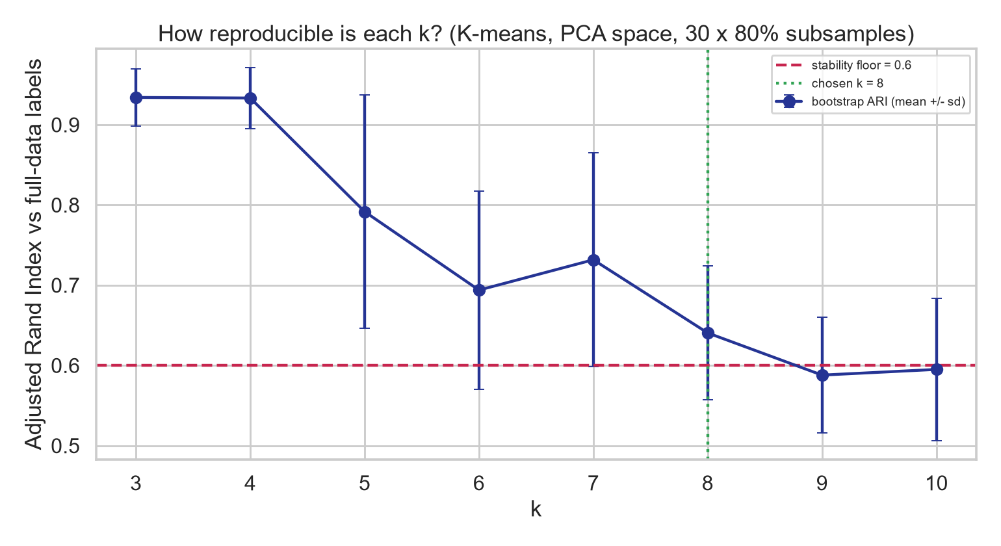
Figure 2. Reproducibility by number of profiles. The chosen k is the last value before stability falls below the pre-set floor.

3.4 Baselines
Four traditional groupings of the same districts were scored identically: an equal-weight composite index; a domain-weighted index that averages within each of the 11 domains before averaging across them; grouping by state; and grouping by region. Both indices were cut into the same number of quantile groups as the clustering, because eta-squared increases mechanically with the number of groups and only an equal-group comparison is fair.

4. Results

4.1 Comparison of all groupings
Grouping | Groups | Held-out eta2 | Silhouette | Features separated | Stability | Note
State grouping | 34 | 0.512 | 0.113 | 77/77 | 1.0 | not like-for-like (34 groups)
Ward, 77 features | 8 | 0.272 | 0.078 | 76/77 | 0.49 | excluded: unstable
GMM, 77 features | 8 | 0.265 | 0.088 | 76/77 | 0.5 | excluded: unstable
K-means, 77 features | 8 | 0.248 | 0.099 | 76/77 | 0.62
K-means, 30 PCA components | 8 | 0.233 | 0.097 | 76/77 | 0.64 | final model
Region grouping | 6 | 0.206 | 0.049 | 75/77 | 1.0
Domain-weighted index | 8 | 0.086 | -0.004 | 64/77 | 0.17
K-means, k = 3 | 3 | 0.071 | 0.11 | 70/77 | 0.93
Composite index | 8 | 0.034 | -0.009 | 53/77 | 0.9
DBSCAN | 2 | 0.008 | 0.275 | 14/77 | 0.72

Table 1. Every grouping scored identically. Eta-squared is the share of the nine held-out outcomes' variance explained; stability is the Adjusted Rand Index against the full-data grouping when 20% of districts are removed. State and region grouping are fixed by geography, so their stability of 1.00 is true by construction rather than a result.
Against the like-for-like baseline, clustering explains 0.233 of held-out outcome variance against 0.034 for the composite index - approximately 7 times more. State grouping scores higher (0.512), and this is reported rather than omitted: it uses 34 groups against 8, and eta-squared rises with the number of groups. States also share diets, policies and health systems. However, the state label carries no interpretation of what a district needs, and 42% of indicator variance lies within states.
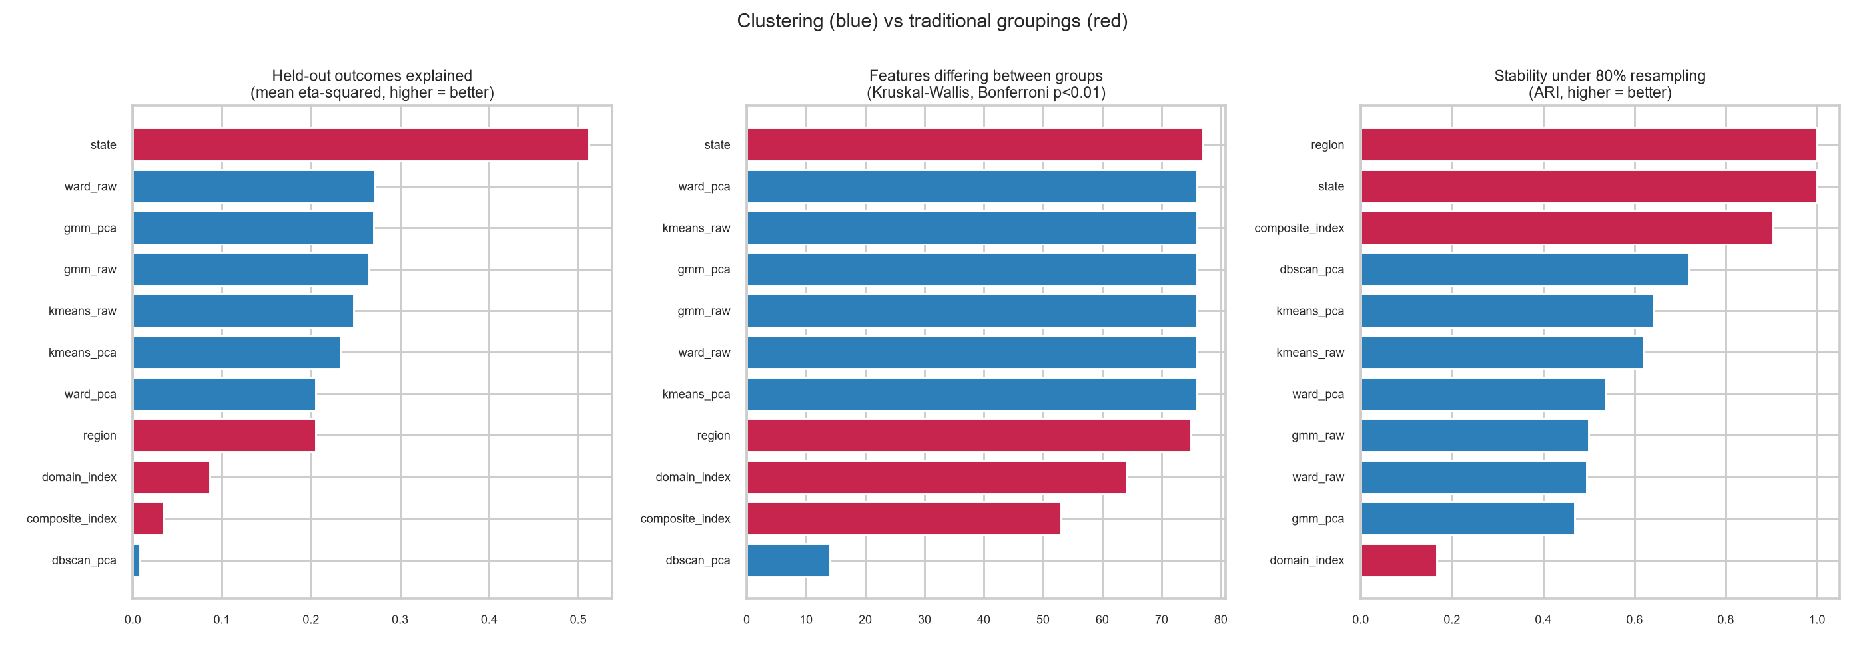
Figure 3. Clustering (blue) against traditional groupings (red) on the three evaluation criteria.

4.2 Is the structure genuine?
Each feature column was shuffled independently 20 times - preserving every indicator's own distribution while destroying the relationships between them - and the entire pipeline was re-run on each shuffle.
Measure | Real data | Shuffled (mean) | Shuffled (best of 20) | p
Silhouette | 0.097 | 0.009 | 0.013 | 0.048
Held-out outcome eta-squared | 0.233 | 0.012 | 0.026 | 0.048

Table 2. Permutation test. Both p-values sit at the floor achievable with 20 permutations (1/21). The second row is the stronger result: the outcome columns were never shuffled, so a grouping built on scrambled features has no mechanism by which to predict them.
A related check answers the objection that a silhouette of 0.10 is low. The composite index's eight bands score -0.009 and the domain-weighted index -0.004 - both negative, meaning a typical district in those bands sits closer to another band's districts than to its own. A slice of a ranking is not a group of similar districts.

4.3 The eight profiles
# | Profile | Districts | Policy focus
0 | Middle development, strong clean energy | 42 | girls' schooling and adult literacy; then blood pressure / blood sugar screening.
1 | Low development, high tobacco & alcohol use and weak maternal care | 53 | tobacco and alcohol control; then antenatal care and institutional delivery.
2 | High development, strong clean energy | 101 | blood pressure / blood sugar screening; then child feeding and supplementary nutrition.
3 | High development, strong schooling | 51 | blood pressure / blood sugar screening.
4 | Middle development, weak schooling | 149 | girls' schooling and adult literacy; then clean cooking fuel and electrification.
5 | Middle development, no standout gap | 104 | No domain is significantly below the national average - maintain services.
6 | Low development, weak clean energy and weak civil registration | 116 | clean cooking fuel and electrification; then civil registration and health insurance enrolment.
7 | Middle development, weak women's agency | 88 | family planning access and delaying marriage; then routine immunisation and sick-child care.

Table 3. Profile names are generated mechanically from each cluster's domain scores - a development level plus the domains more than 0.4 standard deviations below average - so they follow the data rather than expectation. NCD burden is excluded from the naming logic because it rises with development.
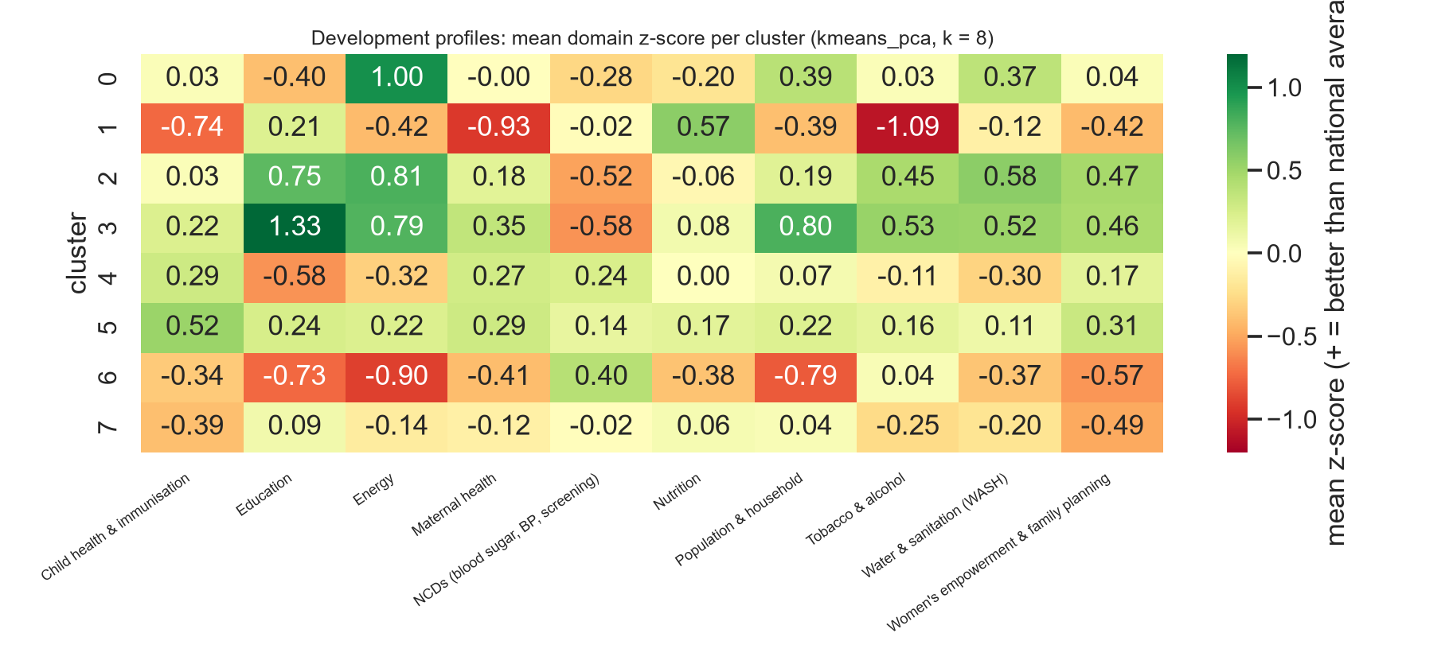
Figure 4. Mean domain score per profile. Green is better than the national average, red worse. Reading across a row gives a profile's shape.

4.4 Same score, different problems
5,632 pairs of districts lie within 0.02 of each other on the composite index yet fall into different profiles. Ernakulam (Kerala) scores 0.646 and Koraput (Odisha) 0.647. Ernakulam stands +2.5 standard deviations on education and +1.2 on sanitation, with its principal deficit in non-communicable disease. Koraput stands -1.7 on education and -1.4 on sanitation, yet above average on child health, maternal care and nutrition: its health services reach people, its households are unserved. Identical scores, opposite deficits, opposite interventions.
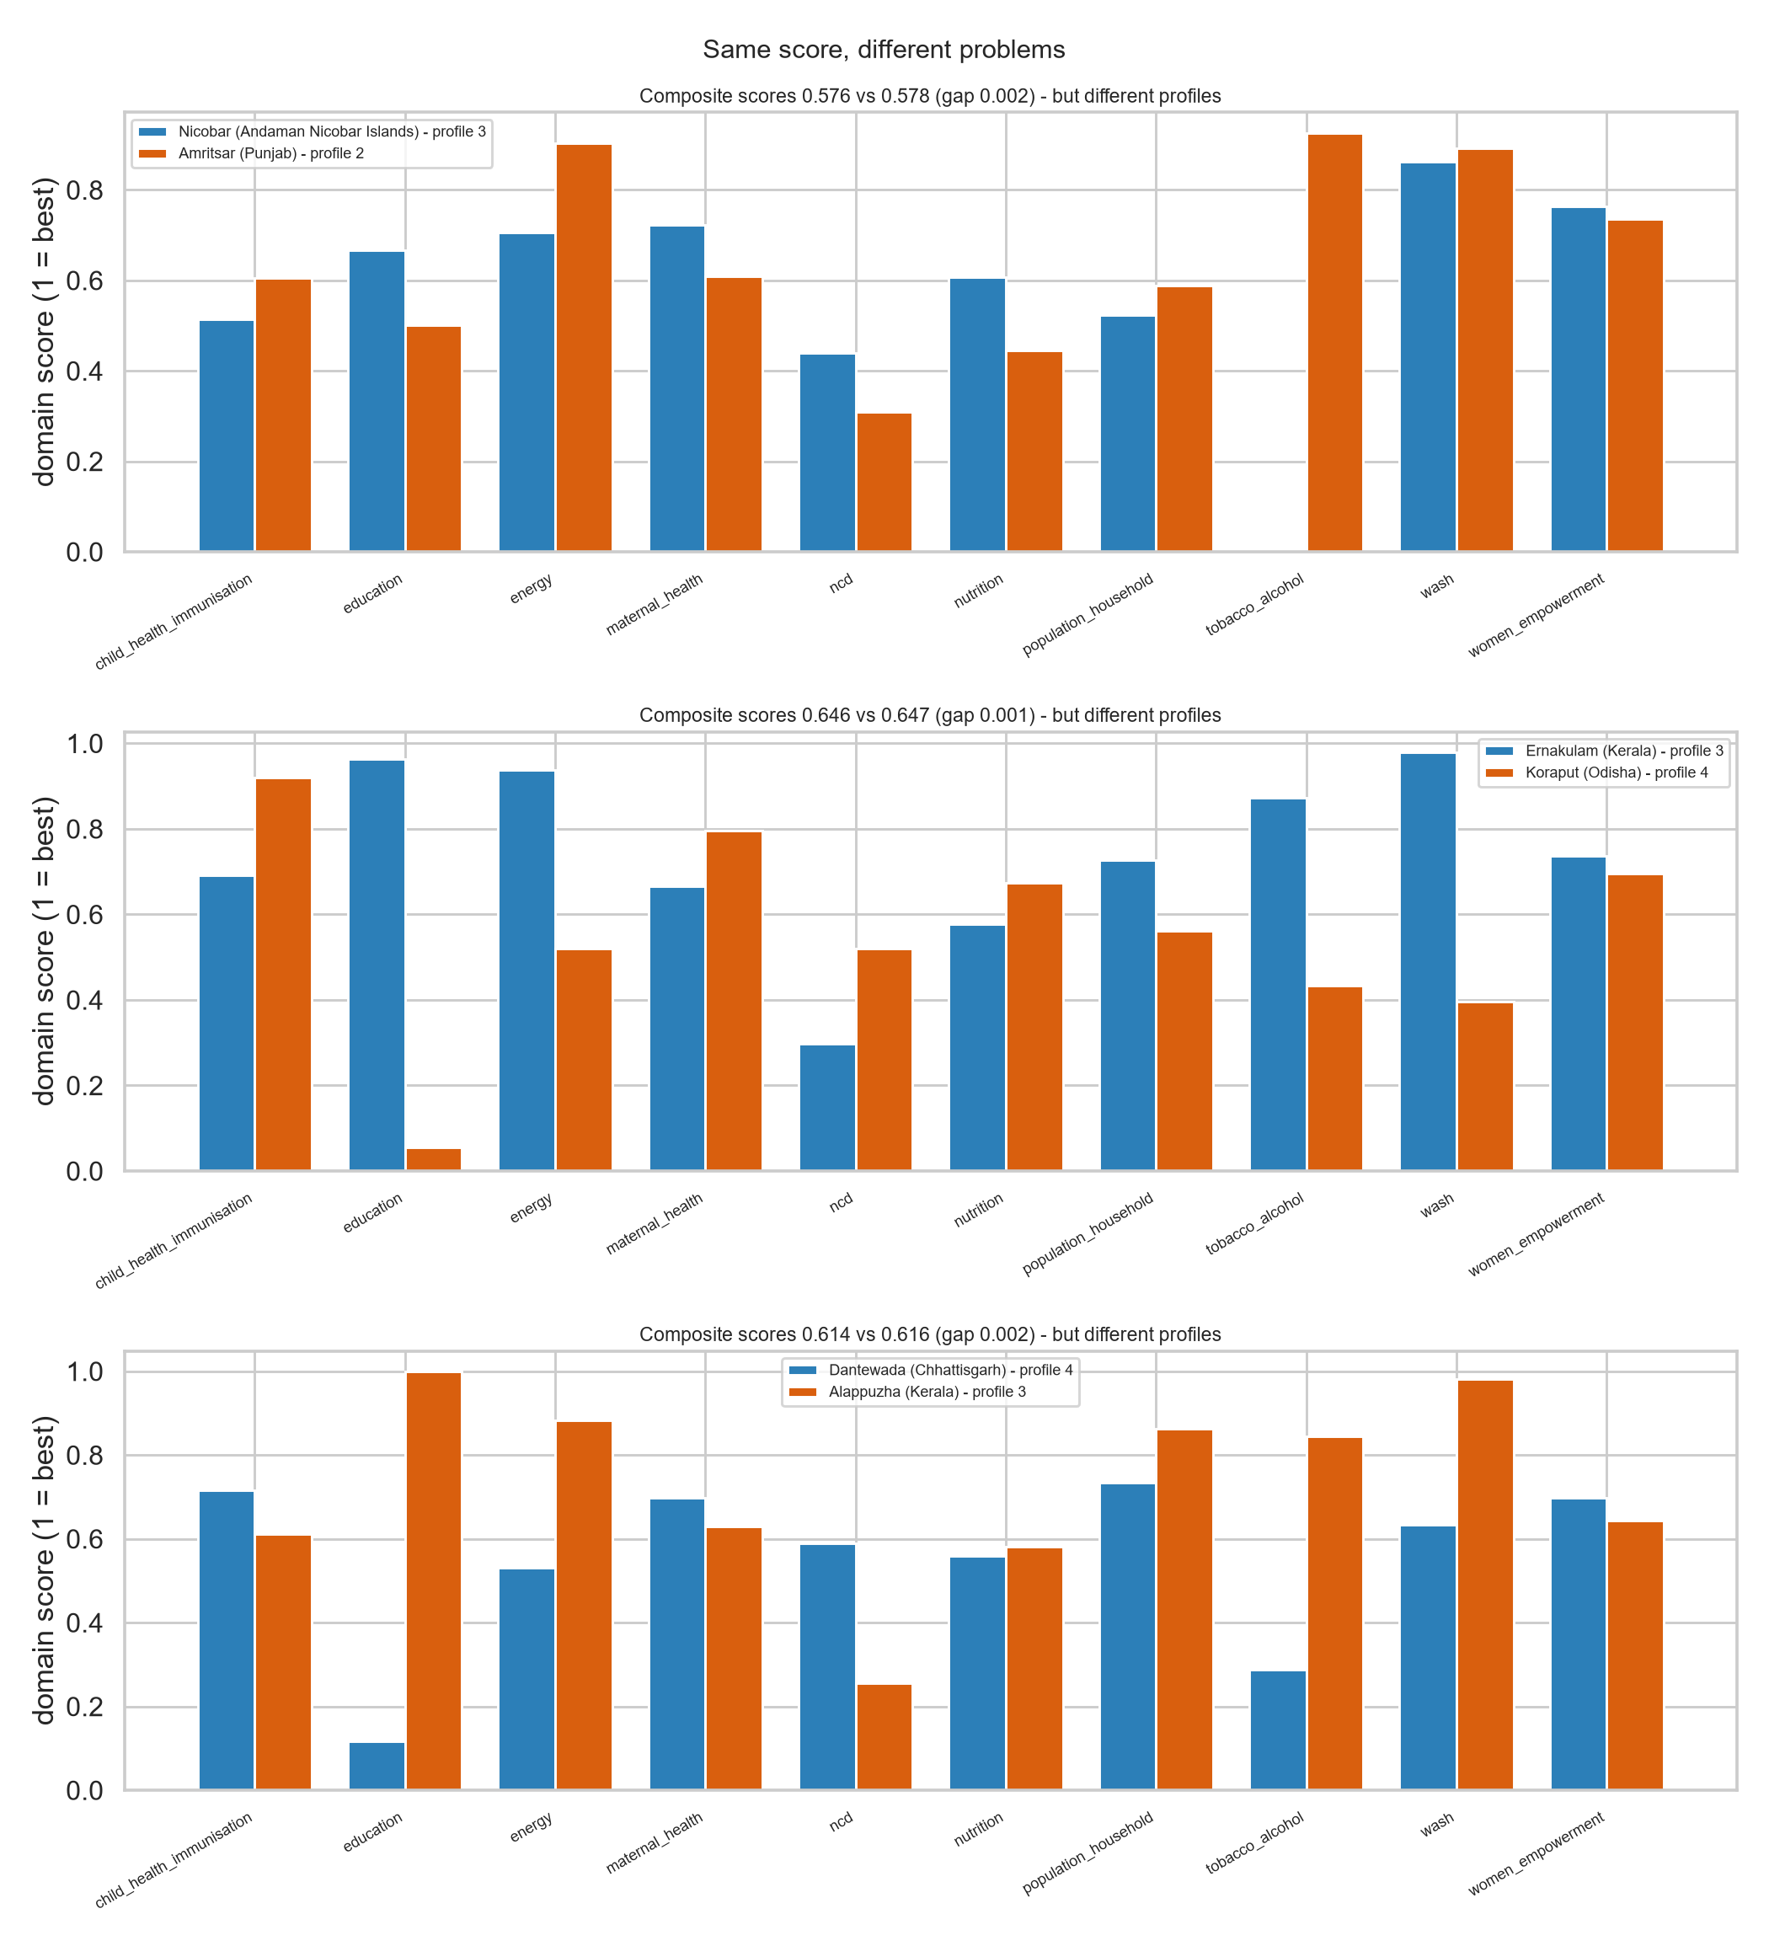
Figure 5. Three pairs of districts the composite index treats as equivalent.

4.5 Reliability of individual assignments
Each profile has a centre, and a district takes the label of the nearest. The label margin - the distance to the second-nearest centre divided by the distance to the nearest - measures how firmly a district belongs. The national median is 1.24; 240 of 704 districts fall below 1.15, and 74 have a negative silhouette, sitting closer to another profile's centre than to their own.
This measure predicts the project's most demanding test. The scaler, PCA rotation and clustering were rebuilt from scratch with one state removed, and that state's districts were then assigned by the reduced pipeline:
State held out | Districts | Median label margin | Borderline | Agreement (ARI) | Pairs preserved
Karnataka | 30 | 1.16 | 12/30 | 0.303 | 67%
Bihar | 38 | 1.46 | 3/38 | 1.0 | 100%
Assam | 33 | 1.14 | 18/33 | 0.169 | 59%

Table 4. Leave-one-state-out test. The confidence columns explain the agreement column: Bihar's districts sit deep inside their profiles and reproduce exactly, while Assam's and Karnataka's sit on boundaries and move as a block when the boundary shifts.

5. Conclusions
- 1. Clustering districts by the shape of their development explains several times more variance in withheld nutrition and anaemia outcomes than a composite index with the same number of groups.
- 2. The structure is not an artefact: shuffled data reproduces neither the geometry nor the predictive power.
- 3. Districts nevertheless form a continuum, not discrete types. Silhouette near 0.10, DBSCAN's single dense region, and 240 boundary districts all indicate this. The profiles are a practical partition of a continuous space.
- 4. Consequently every assignment is reported with its margin. Labels are dependable in the interior of a profile and provisional at its edges - which is precisely what the leave-one-state-out results demonstrate.

6. Limitations
- Measurement — NFHS values are survey estimates subject to sampling error; 5,042 cells rest on 25-49 respondents.
- Processing — 173 feature cells were imputed and 1.8% were winsorised; both introduce uncertainty that the reported metrics do not capture.
- Inference — profiles describe co-occurrence, not causation. The what-if simulator reclassifies a district; it does not predict the effect of an intervention.
- Scope — data covers 2019-21, partly during COVID disruption, and district boundaries have changed since Census 2011 (632 of 704 districts carry a 2011 code).
- Judgement — the assignment of indicators to features, outcomes, directions and domains is our judgement, recorded in src/indicator_meta.py so it can be contested and the analysis re-run.

7. Reproducibility
All results regenerate from the raw factsheets with fixed random seeds:
pip install -r requirements.txt
python src/run_all.py # download, clean, cluster, evaluate
streamlit run app.py # the interactive profiler
Code and data: github.com/helperfn/nfhs-district-clusters. A self-contained notebook, notebooks/NFHS_District_Clustering.ipynb, reproduces the analysis in Google Colab without any local setup.

8. Sources and credit
- Data — IIPS, National Family Health Survey 5 (2019-21), district factsheets.
- Mirrors — jvargh7/nfhs5_factsheets (values and reliability flags) and SaiSiddhardhaKalla/NFHS (indicator names and Census 2011 codes).
- Prior work — kalyaninagaraj/NFHS5 applied PCA and K-means to this dataset. This project adds the baseline comparison, the held-out outcome test, algorithm and stability comparison, permutation testing, label margins and the interactive tool.

