Density Drives Demand
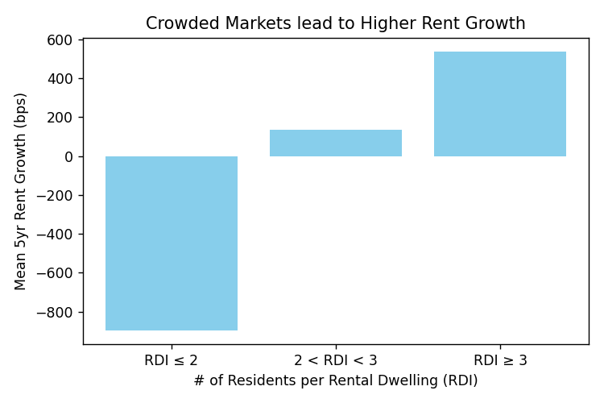
Our research indicates that density serves as a simple but powerful measure of demand in a market. In fact, over the last 20 years, markets with the largest household size (people-er-rental) experience the sharpest rent-growth. More interesting is how long-lasting this effect is. Markets with more than three people per rental tend to see sharply higher rent growth for the next five years. What follows is a list of the most and least dense markets in the 50-largest US markets, suggesting where rent is most likely to grow for in the future.

