Received: Added at production Revised: Added at production Accepted: Added at production
DOI: xxx/xxxx

O R I G I N A L A R T I C L E

Rental Household Size as a Novel Measure of Demand

Matt Larriva, CFA

¹Department of Real Estate Investments, Brookﬁeld Asset Management, New York, United States

Correspondence
Email: matt.larriva@brookﬁeld.com

Present address
250 Vesey Street, New York NY 10281

Abstract
We introduce the Rental Density Index (RDI)—a metric that captures the household size of rented dwellings—as a scalable and behaviorally grounded proxy for latent rental housing demand. Traditional demand indicators like occupancy or absorption are bounded by supply and often fail to reﬂect underlying crowding pressure. In contrast, changes in RDI (∆RDI) reveal when renters are consolidating space, signal- ing excess demand, or spreading out, signaling slack. Using panel data for the 200 largest U.S. metropolitan areas from 2005 to 2023, we show that ∆RDI robustly predicts future rent growth. A two-stage least squares model, instrumenting for RDI growth with plausibly exogenous births in the MSA 20 years prior, reveals a positive and statistically signiﬁcant causal effect on next-year relative rent growth. Out-of-sample tests fur- ther show that RDI-based forecasts outperform ARIMA and naïve models across three-, ﬁve-, and ten-year horizons. Event studies and regime classiﬁcations conﬁrm that reversal of RDI direction signals future rent changes. The Rental Density Index provides a simple yet powerful tool for identifying rental housing mar- ket tightness, classifying supply-demand regimes, and forecasting rent performance. It is especially useful in contexts where traditional demand indicators are constrained or unavailable.

K E Y W O R D S
density, supply and demand, multifamily rent-growth, apartment markets

INTRODUCTION
Housing shortages and affordability concerns have risen to the forefront of policy debates in major urban markets. In the United States, housing production has consistently lagged population growth for decades, contributing to an estimated national shortfall of 4.4 million housing units (Betancourt, 2022). Nearly half of U.S. renter households now spend over 30% of their income on housing (Bureau, 2022), and from 2000 to 2024, the consumer price index (CPI) for shelter exceeded the CPI for all other items by 30% (of St. Louis, 2024). At the same time, select high-growth regions have recently experienced rent declines due to a glut of new supply (Mott, 2024). This juxtaposition of chronic national undersupply with localized oversupply underscores a deeper issue: the lack of a reliable metric to measure consumer housing demand.
Traditional indicators of demand in multifamily real estate, such as occupancy rates and net absorption, are informative but fundamentally supply-constrained. Occupancy rates are naturally bounded at 100%, and absorption cannot exceed the rate of new deliveries (Mueller & Laposa, 1999). These constraints obscure excess demand: when all available and affordable units are occupied, latent demand becomes invisible to market participants and researchers alike (Gabriel & Nothaft, 2001; Sirmans, Sirmans, & Benjamin, 1991; Pyhrr, Cooper, & Wofford, 1999). This problem inhibits clear attribution of rent increases to supply versus demand dynamics (Pennington, 2021; Molloy, 2022). Moreover, ongoing academic debate persists around whether rising rents in constrained markets result more from supply-side limitations (Saiz, 2010) or from heightened demand for desirable locations (Davidoff, 2015). Without a transparent, consistent demand-side metric, attempts to assess equilibrium conditions remain incomplete.
In this paper, we introduce a novel empirical measure of rental housing demand: the rental density index (RDI), deﬁned as the average number of occupants per rental unit in a given metropolitan area. Unlike occupancy or absorption, RDI is not inherently bounded and therefore can reﬂect intensifying demand even in fully occupied markets. The conceptual foundation

Abbreviations: MSA, Metropolitan Statistical Area; RDI, relative density index;

2025;00:1–18
wileyonlinelibrary.com/journal/
© 2025 Copyright Holder Name
1

is straightforward: as rents rise, renters economize on space—whether by delaying household formation, taking on roommates, or crowding—thus increasing the ratio of people per rental unit and signaling pent-up demand. By observing shifts in RDI over time, we capture underlying demand pressures that traditional metrics obscure.
Present trends support this reframing of demand, as density, rental prices, and rental preferences have all shifted meaningfully. For most of its history, the U.S. was less densely populated than its high-income peers, but in 1992 this changed. In that year, the US grew to 28 people per square kilometer, outpacing the High Income Nations whose average was 23 people per square kilometer (Bank, 2025). The most recent ﬁgures report the US with a density of 36 and the High Income Nations with an average density of 27. Over this same period, rental prices have outpaced both wages and non-shelter inﬂation (Feiveson et al., 2024; of St. Louis, 2024), with younger cohorts increasingly preferring rental housing (Mae, 2023).
Prior literature in urban economics and real estate has studied density extensively, often linking increased geographic density to higher wages, rents, and productivity due to agglomeration effects (Titman, Wang, & Yildirmaz, 2024; Liu, Pan, & Li, 2018). However, these studies generally deﬁne density in terms of spatial density: people per square mile or apartments per square mile. Our focus differs: we deﬁne density as the quotient of population over rental units, which provides a clearer window into the number of people actively competing for housing. Unlike geographic density, this measure is directly responsive to shifts in demand, especially during periods of supply constraint or shocks.
Our framework builds on the standard assumption that, all else equal, households derive higher utility from larger living spaces (Muth, 1969; Molloy, 2022). In high-rent markets, however, the extra price per square foot may eventually exceed the marginal beneﬁt of additional space. To economize, renters may respond by sharing units (adding roommates), downsizing to smaller apartments, or relocating to less expensive regions. Conversely, when real rents fall or new supply comes online, the marginal cost of extra space might drop below its marginal utility, enticing households to spread out, move to larger units, or reduce unitshare.The aggregate effect of these choices combined with the new supply additions or subtractions determines the direction of the Rental Density Index change. Because the RDI directly captures these space–consumption margins, year–over– year changes in RDI are proxies for shifts in aggregate housing demand at prevailing prices.

Mean Change in RDI vs. Mean Real Rent Growth Anually

0.06
Line of Best Fit (R2=0.12)
2012
0.04
0.03
0.02
0.01
0.00
0.01
0.02
9
200
2008
2023
2022
2010
2011
2013
2007
2014
2006

2016

2017
2018
2019
2020
2015
Interval
95% Confidence
2021
= -0.53
R2 = 0.12
P = 1.63e-01

0.04

0.02

0.00
Real Rent Growth

0.02

0.04

ExPanding RDI Crowding

F I G U R E 1 Relationship between average annual change in Rental Density Index (horizontal) and average annual relative real rent growth (vertical) in the 200 largest MSAs for each year between 2005 and 2023.

Focusing on a panel of the 200 largest metropolitan statistical areas (MSA) between 2005 and 2023, we calculate the RDI. It ranges from 1.79 occupants—per–rental to 3.87. The value itself is telling. MSAs with RDI greater than the median experience signiﬁcantly higher next—year real rent growth than those with RDI values below the median.

And while the RDI is useful as a spot metric, so too is the change in RDI. A positive change in RDI (densiﬁcation) means that the number of occupants—per—rental is increasing; conversely a negative change in RDI (de-densiﬁcation) corresponds to a decrease in occupants—per—rental. The reasons for an increasing RDI are, in most cases, population growth in excess of supply growth. However, it could be possible that housing units declined as population remained static. Although the RDI does not explicitly factor in the count of households, because household count grows almost monotonically, the variable is still robust.
This empirical strategy corresponds with consistent rent growth differences across multiple time horizons. Over the one-year horizon, positive RDI growth markets signiﬁcantly underperform negative RDI growth markets. That is, the densifying markets underperform the de-densifying markets: as renters consolidate households, rent declines. The RDI value itself /( not the year- over-year change) has the opposite dynamic: markets with higher RDI values signiﬁcantly outperform markets with lower RDI values. While this appears contradictory, it is consistent: a city that densiﬁes has is willing to pay for fewer housing units per person that year, but demand is building, as cities cannot densify forever. And a city that has greater-than-average renters— per–unit has greater demand, and tends in the long-run toward a lower density, consuming more housing units as it unwinds. Akron is an illustrative example: from 2005 to 2011 it increased its occupants-per-rental from 2.06 to 2.32; during this time its real rent declined by 12.4%. In 2012 it began unwinding its pent-up demand, and in the years between 2013 and 2021 its rent increased by 9.9% as its RDI declined to 2.01.
Combining these two metrics: RDI and its change provides further insights. Taken together, they reveal when supply will be accretive to rent versus dillutive. When markets experience supply spikes, those with high RDI and negative RDI growth see rent grow in the following years. Conversely, markets with low RDI and positive RDI growth experience negative rent growth in times of high supply. These ﬁndings suggest that density-based classiﬁcations have predictive power and reﬂect latent demand more accurately than traditional indicators alone.
Our paper makes three principal contributions. First, we introduce the Rental Density Index (RDI), a novel, supply- unbounded metric of housing demand that can be computed at scale from readily available population and unitstock data. Second, we show the RDI is a signiﬁcant indicator of latent demand, using a two-stage least squares model and a very broad panel of foreign in-migration data to measure demand shocks. Finally, we demonstrate RDIs empirical value using a suite of use-cases applicable to investors, renters, developers, and policy-makers.
These ﬁndings carry immediate applications for all housing—market stakeholders. For policymakers, RDI functions as an early-warning gauge of emerging shortages, enabling targeted zoning reforms, calibrated subsidy programs, or expedited per- mitting in precisely those submarkets under the greatest pressure. Institutional investors and residential developers can embed RDI trends into feasibility and risk models, avoiding the twin hazards of overbuilding in cooling metros or underbuilding in tightening ones. Finally, RDI sharpens the housingaffordability debate by identifying the locales where rent increases are most likely to outstrip income growth, thereby guiding tenant–protection policies, rent–assistance programs, and other affordability interventions to the communities that need them most.
In the next section we discuss research on other measures of demand before presenting details on our proposed variable. The Data and Descriptive Statistics section describes and analyzes the density data we used, while the Empirical Strategy section presents evidence and illustrates statistical tests performed to evaluate the validity of the econometric model. In the Forecasting and Validation section, we evaluate the RDI in ﬁve different scenarios, showing its power in rent-growth forecasting. The ﬁnal sections discuss the results of our tests before concluding with implications and further research suggestions.

BACKGROUND AND LITERATURE REVIEW
A substantial literature in urban and housing economics has sought to measure rental demand using structural modeling, hedonic estimation, and affordability thresholds. Price elasticity estimates, often based on income and housing cost shares, provide insight into how demand responds to price movements under equilibrium assumptions (Green, Malpezzi, & Mayo, 2002a; Malpezzi & Green, 1996b). Hedonic models explain rent levels as a function of unit characteristics and neighborhood amenities, while housing affordability metrics attempt to measure stress via cost-to-income ratios. Though valuable, these approaches often require microdata that are unavailable across time and space or assume frictionless adjustment, limiting their utility in settings with short-run disequilibrium or constrained inventory.
The multifamily housing sector has traditionally relied on indicators such as occupancy rates and net absorption to charac- terize demand. These measures are intuitive and operationally convenient but are constrained by the size of the existing rental stock. Occupancy, by deﬁnition, cannot exceed 100 percent, and absorption is mechanically bounded by the number of new

units delivered (Mueller & Laposa, 1999; Gabriel & Nothaft, 2001). As a result, such metrics are poorly equipped to detect latent demand, speciﬁcally periods in which prospective renters are unable to form households or must cohabitate due to lim- ited supply or rising costs (Sirmans et al., 1991; Pyhrr et al., 1999). This limitation has become more acute in recent years as algorithmic revenue management systems increasingly target stabilized occupancy thresholds (for example, 95 to 96 percent), further muting variation and diminishing their informational content (CalderWang & Kim, 2024).
While these indicators retain short-run forecasting value, they offer limited theoretical insight into renter behavior under constraint. Several studies have documented rent growth during periods of high occupancy but tend to attribute this to restricted supply rather than suppressed household formation (Goodman, 1992; Wheaton, 1991). Structural models, including utility- based choice models (Rosenthal, 1997a) or equilibrium migration frameworks, provide more detailed behavioral inference but require data on preferences, incomes, or location-speciﬁc amenities that are rarely standardized across markets.
Parallel literature in urban economics has studied density, typically deﬁned as people or dwellings per square mile, as a proxy for agglomeration or spatial efﬁciency. Seminal work by (Glaeser et al., 2001) and (Duranton & Puga, 2004) links higher density to economic productivity, while more recent studies explore the dual role of densiﬁcation in shaping housing affordability and urban form (Ahlfeldt & Pietrostefani, 2019; Albouy et al., 2015). Yet geographic density is primarily a land-use metric; it does not directly reﬂect household formation or space consumption behavior.
Our work reframes density through a behavioral lens by deﬁning it as the number of people per occupied rental unit: the Rental Density Index (RDI). This metric captures demand pressure more directly than geographic density by tracking how renters adjust their living arrangements under price or supply stress. If renters prefer more space but are observed to cohabitate as rents rise or supply tightens, an increase in RDI reﬂects a behavioral response to constrained conditions. Conversely, declines in RDI suggest slack: households can afford to spread out. Unlike traditional metrics, RDI growth (∆RDI) enables analysts to detect crowding pressures even in fully occupied markets.
RDIs strength lies in its scalability and interpretability. Constructed from widely available data — population, and rental inventory — it offers a transparent, repeatable measure of latent demand across markets and over time. This approach is especially valuable in contexts where elasticity models fail to identify pressure due to equilibrium assumptions or unavailable microdata. While elasticity studies estimate how much demand shifts in response to price, RDI captures whether pressure exists at current prices through observed space consumption.
In sum, our contribution is to reinterpret a familiar spatial concept as a dynamic, renter-centered metric that reﬂects real-time demand conditions. By linking changes in RDI to rent performance, we introduce a new tool for housing market analysis that complements traditional models and offers practical value for forecasting, segmentation, and policy design.

DATA AND DESCRIPTIVE STATISTICS
The data used to calculate RDI is from the Public Use Microdata Statistics (PUMS). The PUMS data is an extremely valuable offering of the U.S. Census in conjunction with the American Community Survey. The data allow for visibility into myriad aspects of a respondent’s life (including the number of people in their household and whether they rent or own their home), annonymized for privacy and standardized to create a comprehensive view of the entire country. Our market rent data and inventory growth data is sourced from Costar. This includes nominal rent per square foot and inventory units. Our inﬂation measures come from the U.S. Bureau of Labor Statistics. And our foreign immigration data at the market level comes from the US Census. We restrict our analysis to the 200 largest U.S. metropolitan statistical areas (MSAs) by multifamily inventory as of 2005, ensuring robust sample representation and consistency over time.
To normalize pricing data across time, we convert all nominal rent ﬁgures into real terms using the Consumer Price Index for All Urban Consumers (CPI-U), all-items, provided by the BLS. We convert nominal rent-growth ﬁgures into real rent- growth ﬁgures by subtracting the annual CPI-U change from the annual rent per square foot change. Although MSA-level inﬂation indices excluding rent would be ideal, such data are unavailable at a consistent and granular level for our study period. Therefore, real effective rent per square foot and rent growth metrics are adjusted using national CPI.
Importantly, we standardize rent-growth subtracting each year’s median rent growth. We do this to remove the impact of national macroeconomic shocks (i.e., COVID-19). This also serves to stationarize the data and remove the autoregressive tendencies of timeseries data.
Our novel demand variable, the Rental Density Index (RDI), is calculated by summing the number of people living in rental units within an MSA, and dividing that by the sum of rental units within an MSA. It does not include vacant dwellings or seasonal dwellings. We compute its year-over-year percentage change—∆RDI—to reﬂect demand dynamics more accurately.

This measure avoids the bounded structure of traditional demand indicators like occupancy and absorption, which are upper bounded by 100%.
We exclude New Orleans, LA from our analysis because of its dynamics around the unfortunate aftermath of Hurricane Katrina. Within two years, this MSA had the greatest and least values of RDI growth as well as the greatest and least values of real rent change.

T A B L E 1 Key variables used in the empirical analysis.

Variable Description

CPI Consumer Price Index for All Urban Consumers: All Items in U.S. City Average
real_rentpsf Costar’s Rent Per Square Foot divided by indexed CPI
real_rent_growth Costar’s Effective Rent Growth 12M less Annual percent change in CPI
relative_real_rent_growth real_rent_growth less that year’s median real_rent_growth
inventory Costar’s total number of rental units in an MSA
rental_households Dwellings that are being rented within an MSA
rental_population The number of people living in rental dwellings within an MSA
pop Total MSA population
RDI rental_population divided by rental_households
delta_RDI Yearoveryear percentage change in RDI
supply_growth Yearoveryear percentage change in inventory
foreign_migration Foreign net migration divided by the area’s population

Rental Density Index Construction
The PUMS data is large, and complex, though very well documented. The output of the raw data requires parsing to aggregate to the MSA level. This section describes that aggregation process.

Grouping Records
Records are grouped by survey year (YEAR), household identiﬁer (SERIAL), metropolitan area name (MET_NAME), group quarters status (GQ), and ownership status (OWNERSHP). For each group i, we compute:

POPULATION_{i} = P PERWT_{j} (1)
j∈i
HOUSEHOLDS_{i} = HHWT_{j}∗ (2)
where PERWT_{j} is the person weight for individual j, and HHWT_{j}∗ is the household weight taken from the ﬁrst individual in the group.

Ownership Label Mapping
Ownership status is translated from numeric codes to descriptive labels as follows:
"OWNED" if code = 1 OWNERSHP = "RENTED" if code = 2

"OTHER" otherwise

(3)

Aggregation by Metro and Year
We then re-aggregate the grouped data by year y, metro area m, and ownership category o:

POPULATION_{y,m,o} = P
i∈(y,m,o)
HOUSEHOLDS_{y,m,o} = P
i∈(y,m,o)

POPULATION_{i} (4)

HOUSEHOLDS_{i} (5)

Pivoting and Computing Totals
We pivot the data to obtain separate columns for each ownership category and compute totals:

TOTAL_POPULATION_{y,m} = POP_OWNED_{y,m} + POP_RENTED_{y,m} + POP_OTHER_{y,m} (6) TOTAL_HOUSEHOLDS_{y,m} = HH_OWNED_{y,m} + HH_RENTED_{y,m} + HH_OTHER_{y,m} (7)

Density Calculation
Finally, population-to-household densities are calculated per ownership type:

DENSITY_OWNED_{y,m} = POP_OWNEDy,m
HH_OWNED_{y,m}
DENSITY_RENTED_{y,m} = POP_RENTEDy,m
HH_RENTED_{y,m}
DENSITY_OTHER_{y,m} = POP_OTHERy,m
HH_OTHER_{y,m}
The variable DENSITY_RENTED becomes our so-called Rental Density Index.

(8)

(9)

(10)

Although we do not use the OWNED or OTHER variables, we compute them for thoroughness and for future use and make them available with our code.
Within the 200 MSAs in the study,the RDI ranges from 1.68 (Bloomington, IN; 2023) to 3.74 (Provo, UT; 2009).
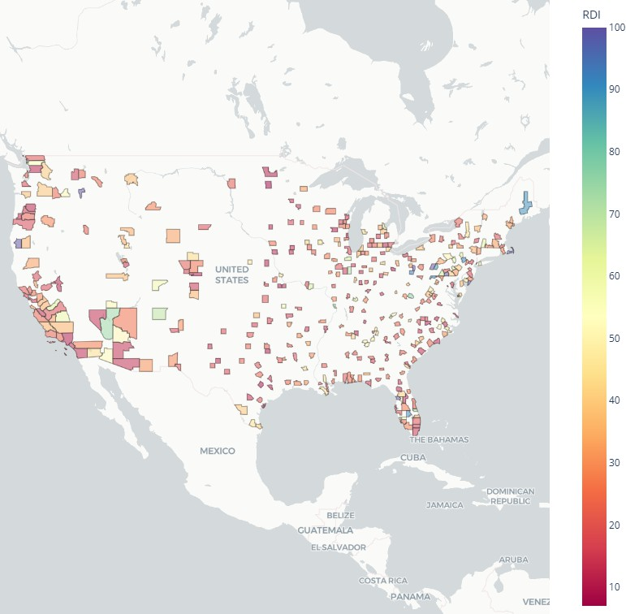
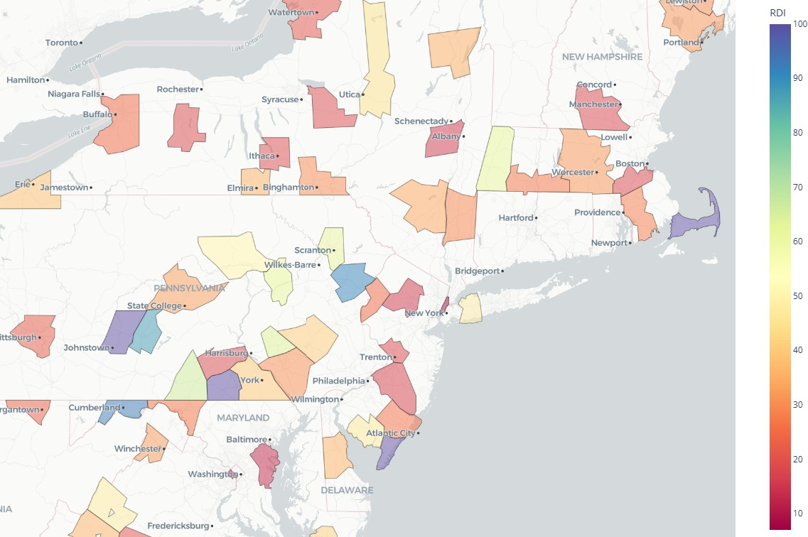
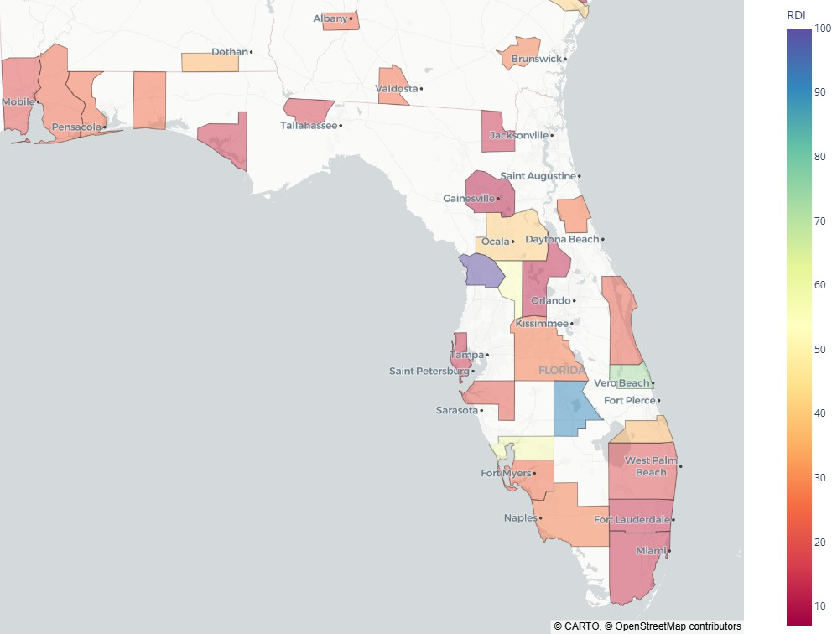
(a) United States (b) Tri-State area (c) Florida

F I G U R E 2 Rental-Density-Index (RDI) choropleths at three spatial scales.

The RDI itself is useful for identifying how tight a market is at a given point in time, and its absolute level is shaped by long- run demographic and structural trends in rentership and household formation. It is rare for a market to shift more than one half of one person-per-rental-dwelling, even over 20 years. To aid in short-term insight and allow comparability across markets, we use the year-over-year change in RDI:

∆RDI_{it} = RDI_{it} − RDI_{it−1}.
The change in RDI (∆RDI) offers several advantages. First, it mitigates issues of nonstationarity in the level RDI, enabling cross-market comparison. Second, it reduces the impact of varying rentership percentages across cities. Most importantly,
∆RDI captures demand pressure on housing stock: when it rises, it indicates more people are consolidating into fewer rental units, signaling a preference for cohabitation over paying prevailing rents. When it falls, it implies renters are spreading out and absorbing more space, suggesting household formation and rents below-or-at utility value.
It is useful to distinguish between two sources of crowding pressure captured by ∆RDI: price-induced and supply- induced. Price-induced crowding occurs when rising rents outpace incomes, forcing renters to share space or delay household formation—behavioral responses that directly elevate RDI. Supply-induced crowding, by contrast, may arise even without rent escalation if housing stock fails to expand alongside population, resulting in more residents per unit out of sheer constraint. While these mechanisms are observationally similar, our framework implicitly captures both, interpreting ∆RDI as the revealed outcome of frictions between housing availability and household spatial preferences. In this way, a high (but not growing) RDI reﬂects pent-up demand pressures regardless of whether they arise from affordability shocks or constrained supply.

Summary Statistics
Table 2 provides descriptive statistics for the key variables across the full panel. On average, the RDI across all MSAs and years is 2.4 persons per rental unit, with a standard deviation of 0.3. The average real rent per square foot is $0.85, and the average annual growth in rental supply is 1.78%. The missing records exist only in the beginning or ending years as the prior period and next-period values do not exist. Note the mean value of real_rent_growth is zero. Nationally, the Consumer Price Index for rent-of-shelter has exceeded the Consumer Price Index excluding shetler, thus the mean national real rent growth is not zero. The reason the mean is zero in these summary statistics owes to weighting. The CPI is weighted to be representitive of the US population. Our summary statistics are not weighted, and thus a high-population metro has the same weight (in calculating this mean) as the smallest metro. This is not a concern, as the data is accurate, and our analyses are focused on the MSA-level metrics.

T A B L E 2 Summary Statistics

Variable | Count | Mean | Std | Min | 25% | 50% | 75% | Max | Missing
pop | 3800 | 1,113,385.26 | 1,778,446.92 | 106,878.20 | 254,907.63 | 487,778.16 | 1,067,312 | 14,897,850 | 0
inventory | 3800 | 68,983.91 | 149,873.18 | 3,038 | 8,363 | 20,479.50 | 54,043.75 | 1,550,003 | 0
supply_growth | 3600 | 0.0178 | 0.0252 | -0.0978 | 0.00044 | 0.0104 | 0.0251 | 0.3211 | 200
RDI | 3800 | 2.4432 | 0.3337 | 1.6857 | 2.2175 | 2.3810 | 2.5832 | 3.7417 | 0
RDI_growth | 3600 | -0.0012 | 0.0539 | -0.2611 | -0.0288 | -0.0012 | 0.0251 | 0.2789 | 200
real_rentpsf | 3800 | 0.8532 | 0.3102 | 0.4061 | 0.6589 | 0.7625 | 0.9485 | 2.7119 | 0
real_rent_growth | 3800 | 0.0000 | 0.0295 | -0.2744 | -0.0180 | -0.0012 | 0.0156 | 0.2738 | 0

Coverage and Representativeness
The sample includes 3,600 MSA-year observations, covering a mix of large coastal cities, fast-growing Sun Belt metros, and slower-growing Midwestern regions. Together, these MSAs account for over 35 million rental dwellings, housing over 81 million residents, providing a true representative snapshot of national rental dynamics.

Preliminary Observations
Figure 3 traces the national Rental Density Index (RDI) from 2006 to 2023. The average RDI over these 200 samples begins at
2.4 people per rental, rises to 2.5 in 2012, then declines toward 2.25 in 2023. A companion histogram of RDI is stationary but skewed slightly right, conﬁrming the slow decline in RDI.

700
0.2
0.1
0.0
Change in RDI ( RDI)
0.1
0.2
0.3

Histogram of Change in RDI: All MSAs (2001-2024)

3.75
ge RDI
Avera

City - IA ord - OR o - TX
MSA
Iowa Medf Lared
RDI Values Over Years for Selected MSAs and Average

600

3.50

3.25
500

3.00

400
Frequency
2.75
RDI

300
2.50

200 2.25

2.00
100

1.75

0
2007.5 2010.0 2012.5 2015.0 2017.5 2020.0 2022.5
Year

- A histogram of the annual change in RDI across 100 MSAs in the years 2001-2023. The outlier to the left is New Orleans in 2004, due to Huricane Katrina.
F I G U R E 3 Histogram of Change in RDI, and Line Graph of RDI
- A line graph showing the RDI values (population divided by apartment units) for the MSAs that were the min, max, and median in year 2001

This pattern illustrates the need for a different demand metric, otherwise the concern for housing shortage seems to be contradicted by a monotonically decreasing housing density. Said differently, occupancy simply reports that units are full– it cannot distinguish whether they are full by choice (everyone prefers roommates) or by necessity (everyone must share). By contrast, year-over-year changes in RDI isolate the relative pace of new people versus new units. In the next section we investigate that property to reveal RDI as a proxy for latent demand.

EMPIRICAL STRATEGY AND RESULTS
We estimate the causal effect of crowding, measured by the Rental Density Index (RDI), on future rent growth using a two- stage least squares (2SLS) instrumental variables (IV) approach. This strategy addresses the potential endogeneity of RDI, which may arise from reverse causality or omitted variable bias. For instance, higher rents may lead households to double up, mechanically increasing RDI, or unobserved local demand shocks could simultaneously drive both rent growth and household density.

Instrumental Variable Justiﬁcation: Share of Population Born in the MSA 20 Years Ago
To address potential endogeneity in the Rental Density Index (RDI), we instrument for RDI using the share of the MSA population that was born in the same MSA 20 years earlier. This variable reﬂects historical birth cohorts that are now reaching the typical age of independent household formation. Crucially, it is a historically anchored and plausibly exogenous proxy for future rental housing demand pressure.
Individuals typically begin to form independent rental households in their early 20s. Therefore, the size of the birth cohort from 20 years ago directly inﬂuences the intensity of household formation pressure today. A larger cohort implies that more individuals are approaching rental household formation age at time t, potentially increasing rental crowding if housing supply has not grown proportionately. As such, this instrument captures anticipated demographic-driven demand shocks that affect how many people are likely to seek housing relative to available rental stock.

While other approaches might use the contemporaneous share of 20-year-olds, that measure is potentially endogenous to current local conditions due to migration and reverse causality. In contrast, our measure is based on historical demo- graphic eventsspeciﬁcally, the size of the cohort born in the MSA 20 years priorwhich are predetermined and unaffected by current-period shocks to rent or housing demand. This strengthens the instruments predictive validity for RDI while avoiding simultaneity bias.
By construction, the share of people born in an MSA 20 years ago is not inﬂuenced by current rental market conditions, as it depends on birth events and migration patterns two decades prior. These historical demographic dynamics are unlikely to be correlated with unobserved contemporary shocks to rent growth, satisfying the exclusion restriction. Importantly, we are not using the current presence of 20-year-olds (which may reﬂect selective migration), but rather the proportion of individuals currently living in the MSA who were born there two decades earlierthus minimizing concerns about endogenous responses to recent housing affordability or labor market conditions.
We bolster the validity of this instrument with two additional tests. First, a placebo test using contemporaneous rent growth as the outcome variable ﬁnds no signiﬁcant effect, suggesting that the instrument inﬂuences rents primarily through its effect on RDI rather than through unobserved confounders. Second, a lagged instrument (based on the cohort born 21 years ago) produces consistent results, further reinforcing the temporal separation and the robustness of the causal identiﬁcation.

Two Stage Speciﬁcation
The model is estimated on a panel of MSA-year observations, and includes MSA and year ﬁxed effects to absorb time-invariant heterogeneity and national trends, respectively. The estimation equations are:

Where:
Stage 1: RDI_{i,t} = γ₀ + γ₁ · Pct20yoi,t + γ₂ · X_{i,t} + µ_{i} + δ_{t} + u_{i,t}

Stage 2: RentGrowth_{i,t+1} = α₀ + β · R DI_{i,t} + α₁ · X_{i,t} + µ_{i} + δ_{t} + ε_{i,t}

    - RentGrowth_{i,t+1} is next-year real relative rent growth in MSA i,
    - RDI_{i,t} is average household size among renters,
    - Pct20yoi,t is the instrument: percent of population age 20,
    - X_{i,t} includes population growth and housing starts as controls,
    - µ_{i} and δ_{t} are MSA and year ﬁxed effects.

Main Results
Table 3 presents the main 2SLS estimates using Pct20yo as the instrument. The coefﬁcient on RDI is negative and statistically signiﬁcant at the 1% level, consistent with the interpretation that increased crowdingvia larger households per rental unitexerts upward pressure on rents through constrained housing demand.

T A B L E 3 Main IV Estimates: RDI and Next-Year Rent Growth
 | Coef. | Std. Err. | p-value | 95% CI
RDI | -0.0246 | 0.0091 | 0.0066 | [-0.0424, -0.0069]
Population Growth | 0.0096 | 0.0017 | 0.0000 | [0.0063, 0.0130]
Housing Starts (%) | -0.2558 | 0.0608 | 0.0000 | [-0.3750, -0.1366]
Constant | 0.0608 | 0.0212 | 0.0040 | [0.0194, 0.1023]
Observations | 792
F-statistic (ﬁrst stage) | 36.21

Placebo and Lagged Instrument Robustness
To test the exclusion restriction, we perform a placebo test using contemporaneous rent growth as the outcome. As shown in Table 4, the estimated effect of instrumented RDI on same-year rent growth is negative but statistically insigniﬁcant (p = 0.155). This supports the causal interpretation that household formation pressure primarily impacts rent growth with a lag, consistent with slow-moving supply constraints and lease adjustments.

T A B L E 4 Placebo Test: RDI and Same-Year Rent Growth
 | Coef. | Std. Err. | p-value | 95% CI
RDI | -0.0122 | 0.0086 | 0.1554 | [-0.0291, 0.0046]
Population Growth | 0.0118 | 0.0020 | 0.0000 | [0.0080, 0.0157]
Housing Starts (%) | -0.1777 | 0.0407 | 0.0000 | [-0.2575, -0.0979]
Constant | 0.0287 | 0.0201 | 0.1526 | [-0.0106, 0.0680]
Observations | 792
F-statistic (ﬁrst stage) | 48.18

We also implement a robustness check using a lagged version of the instrument: percent of 20-year-olds in year t − 1. Results, presented in Table 5, are nearly identical in sign and magnitude to the main speciﬁcation, with the RDI coefﬁcient remaining negative and signiﬁcant at the 1% level. This helps rule out concerns of simultaneity and supports the argument that the instrument captures anticipated household formation shocks.

T A B L E 5 Robustness: Lagged IV for RDI
 | Coef. | Std. Err. | p-value | 95% CI
RDI | -0.0288 | 0.0103 | 0.0050 | [-0.0489, -0.0087]
Population Growth | 0.0098 | 0.0019 | 0.0000 | [0.0061, 0.0135]
Housing Starts (%) | -0.2529 | 0.0669 | 0.0002 | [-0.3840, -0.1219]
Constant | 0.0705 | 0.0239 | 0.0031 | [0.0238, 0.1173]
Observations | 693
F-statistic (ﬁrst stage) | 30.27

Interpretation
Together, these results provide strong evidence that exogenous variation in household crowding pressureproxied by the size of the 20-year-old cohortcausally increases future rent growth. The absence of an effect on contemporaneous rents, and the consistency of estimates across lagged speciﬁcations, reinforce the temporal logic of the identiﬁcation strategy and support the claim of a one-directional, crowding-to-rent causal channel.
While the IV model provides a causal estimate of the effect of crowding pressure on rent growth, the subsequent tests in Section 5 evaluate whether RDI and its change ∆RDI can serve as a useful predictive signals. These forecasting models do not claim to identify structural relationships, but rather assess the practical value of RDI for anticipating future market conditions.

FORECASTING VALIDATION AND REAL-WORLD PERFORMANCE
This section evaluates whether RDI functions as a useful predictive signal for rent growth, independent of causal identiﬁcation. We organize the analysis into ﬁve complementary tests: (1) a simple group-wise ANOVA showing forward rent segmentation by RDI level and movement; (2) an event study evaluating rent dynamics before and after regime shifts in RDI; (3) a top-vs- bottom quintile spread comparison across forecasting models; (4) a long-horizon signal using count-based RDI persistence;

and (5) a diagnostic of supply growth in context, showing how RDI mediates the impact of new supply. Together, these tests examine the predictive performance, durability, and explanatory clarity of RDI across diverse empirical contexts.

Predictive Segment Testing: ANOVA of RDI
We test whether RDI and its delta can segment markets into meaningful groups in terms of future rent performance. Speciﬁcally, we split the samples into four regimes based on the two variables (greater/less-than-median RDI and positive/negative ∆RDI). We then examine whether average next-year relative real rent growth differs signiﬁcantly across these groups.
Table 6 shows that dense markets have higher rent growth. Speciﬁcally, markets with RDI above the national median (2.4) experience average next-year real rent growth of 30 basis points, while markets with RDI below the median exhibit an average decline of 23 basis points. The difference is statistically signiﬁcant (p≤ 3.07⁻⁷), as conﬁrmed by a one-way ANOVA.
Table 7 shows that as markets densify, their rent growth declines. Speciﬁcally, markets and years that have an increase in RDI (representing a growth in number of people per renter household) also have declines in rent of, on average, 31 basis points. This is signiﬁcantly different (p≤ 7.75⁻¹¹) from markets that are de-densifying, which have rent growth, on average, of positive 37 basis points.
Grouped together, table 8 the difference between dense-but-dedensifying markets and sparse-but-densifying markets is 144 basis points.

T A B L E 6 ANOVA: Real Rent Growth Next Year by RDI Level

Source | Sum of Squares | df | F | p-value | Mean Rent Growth
RDI Level  Residual | 2,410,140  311,308,300 | 1.0  3398 | 26.31 | 3.07e-07 | RDI≥median: 30 bps  RDI<median: -23 bps

T A B L E 7 ANOVA: Real Rent Growth Next Year by ∆RDI

Source | Sum of Squares | df | F p-value | Mean Rent Growth
RDI Growth Direction | 3,883,449 | 1.0 | 42.59 7.75e-11 | ∆RDI < 0: 37 bps  ∆RDI ≥ 0: -31 bps
Residual 309,835,000 3398

T A B L E 8 ANVA and Group Means: Real Rent Growth Next Year by Combined RDI Level and Growth

Source | Sum of Squares | df | F p-value | Mean Rent Growth
Combined Group | 7,536,939 | 3.0 | 27.87 8.52e-18 | RDI ≥ median ∩ ∆RDI < 0 : 73bps RDI ≥ median ∩ ∆RDI ≥ 0 : -2bps RDI < median ∩ ∆RDI < 0 : 10bps RDI < median ∩ ∆RDI ≥ 0 : -71bps
Residual 306,181,500 3396

These results show that even without instrumentation, RDI and RDI growth serve as a powerful signals for forward rent performance. Practitioners can use RDI segmentation as a lightweight, interpretable classiﬁcation rule for identifying tight rental markets.

Event Study of RDI Regime Transitions
We next evaluate how rent growth responds dynamically to transitions into and out of RDI-growth regimes. Speciﬁcally, we examine rent growth before and after a market switches into a state of positive ∆RDI (increasing crowding) or negative ∆RDI (declining crowding). Here we examine results in terms of real rent growth relative to the mean rent growth of that year, to avoid capturing rent changes due to macro conditions.
Figure 4 illustrates rent growth over the two years ante and post regime-change. The green bars represent markets and periods where RDI switched from at least 3 years of consolidation to expansion (densiﬁcation shifting to de-densiﬁcation). The blue bars represent occasions when RDI switched from at least 3 years of densiﬁcation to de-densiﬁcation (from crowding to spreading).

Real Relative Rent Growth Before and After RDI Switch Events

0.4%
0.17%
-0.09%
0.22%
-0.19%
RDI reverses positive trend; market begins to de-densify; more rental households are formed
RDI reverses downward trend; market begins to densify; rental households consolidate

0.2%
Avg. Real Relative Rent Growth (3 Year Avg.)

0.0%

0.2%

0.4%

Before After

F I G U R E 4 Real Relative Rent Growth Before and After a Market Switches From/To Positive/Negative ∆RDI

When markets reverse their positive RDI trend (crowding) and begin to form households, real relative rent growth shifts from negative to positive. The markets, on average, shift from a three year stretch of underperformance to a three year stretch of outperformance. The difference of 31 basis points per year is statistically signﬁcant (p < 0.013). Conversely, when markets reverse their negative RDI trend (household formation) and begin to consolidate, real relative rent growth shifts from positive to negative. This shift however is not statistically signiﬁcant (p < 0.066). These dynamics conﬁrm that the onset of renter de- densiﬁcation, as measured by RDI change, precedes statistically and economically meaningful changes in rent performance. RDI transitions can therefore serve as timely indicators of shifts in market pricing power.

Forecast Spread Comparison: RDI vs ARIMA vs Naïve
We compare the predictive strength of the RDI against ARIMA-based and naive trailing average models in forecasting real rent growth across multiple time horizons. For each method, for each year, we group MSAs into quartiles based on their predicted growth (predicted by the RDI value, ARIMA, or naive method). We then compute the realized top-minus-bottom quartile spread. Here we limit the data set to the top 100 markets, as the ARIMA estimators did not converge on a large number of smaller markets. Figure 5 displays forecast accuracy over one-year, three-year, ﬁve-year, and ten-year windows. The RDI-based approach delivers stronger spread segmentation, particularly at longer horizons where traditional time-series methods tend to

degrade. Forecasting one year forward based on the RDI of the prior year, the RDI method underperforms the Naive method slightly ( 30 basis points). In three-year forecasts, the RDI spread outperforms the next closest predictor by 60 basis points. At 5 years, the RDI outperforms by over 500 basis points. At ten years it outperforms by nearly 800 basis points.

Forecast Performance: Difference in I-Year Real Rent Growth in Top Quartile - Bottom Quartile Forecast Performance: Difference in 3-Year Real Rent Growth in Top Quartile - Bottom Quartile

5.0%

4.0%
Difference in I-Year Real Rent Growth (Top Quartile - Bottom Quartile)
RDI Spread ARIMA Spread Naive Spread

6.0%
Difference in 3-Year Real Rent Growth (Top Quartile - Bottom Quartile)
RDI Spread ARIMA Spread Naive Spread

3.0%

4.0%
2.0%

I.0%

0.0%

I.0%

Total Average: 0.34%

2.0%

0.0%

Total Average: 1.41%

Total Average: 2.02%

Total Average: 0.27%

Total Average: 0.49%
2.0%

3.0%

Total Average: 0.76%

2.0%

2006 2008 20I0 20I2 20I4 20I6 20I8 2020 2022
Year
2006 2008 2010 2012 2014 2016 2018 2020
Year

(a) 1-Year Forecast (b) 3-Year Forecast
Forecast Performance: Difference in 10-Year Real Rent Growth in Top Quartile - Bottom Quartile
Forecast Performance: Difference in 5-Year Real Rent Growth in Top Quartile - Bottom Quartile 10.0%
RDI Spread
ARIMA Spread Naive Spread
Difference in 10-Year Real Rent Growth (Top Quartile - Bottom Quartile)

8.0%
RDI Spread
ARIMA Spread Naive Spread
8.0%
Total Average: 9.19%

6.0%
Difference in 5-Year Real Rent Growth (Top Quartile - Bottom Quartile)
6.0%

4.0%
4.0%
2.0%

2.0%
Total Average: 4.10%
0.0%
Total Average: 1.38%

0.0%
2.0%
2008 2010 2012 2014 2016 2018
Year
Total Average: 0.59%
Total Average: -0.36%
2.0%
4.0%
2012 2013
Year
Total Average: -3.09%

(c) 5-Year Forecast (d) 10-Year Forecast
F I G U R E 5 Top-minus-Bottom Quintile Rent Growth Spread by Forecast Method and Horizon

These results reinforce the value of RDI as a forward-looking, long lived predictive signal. Forecasting long-term rent growth is notoriously difﬁcult; most models lose power beyond a few years. That the RDI-based approach maintains signal strength across one-, three-, ﬁve-, and ten-year periods underscores its robustness. While time series models rely on trailing trends, RDI captures forward-looking, structural occupancy pressuremaking it an effective long-horizon indicator of underlying demand.

RDI Positivity and National Rent Growth
To this point, we have examined the effects of RDI and RDI growth on an MSA level. Here, we consider the impact of RDI change on national rent growth. For each year we calculate the percent of markets (out of 200) that have positive RDI growth. The values range from a low of 21% in 2006, to 67.5% in 2022. For each of those years we calculate the mean real rent growth of the following year.
Figure 6 shows a consistent, robust, inverse relationship between number of RDI-increase markets and rent growth. Even with the effects of COVID (2020, 2021) the RDI-positive percent explains 32% of the variance in annual, national, real rent growth. Noteworthy is the 50th percentile on the x-axis, above which rent tends to be negative (5 of 8 years), and above which rent tends to be positive (7 of 9 years). Said differently, when most markets have renters who are crowding (experiencing positive RDI change) the national rent growth is likely to fall in the following year. Conversely, when most markets have renters who are forming households (experiencing negative RDI change), then the demand for rentals is likely to put upward pressure on national real rents.

Percent of MSAs with Positive RDI Growth vs. Avg. Real Rent Growth Next Year by Year Year over Year Change in Percent of MSAs with Positive RDI Growth vs. Avg. Real Rent Growth Next Year by Year

0.04
2020
R² = 0.32
= -0.10
p = 1.87e-02
2014
2019
2018
2015
2017
2016
2012
2013
2006

2011
2009
2022
2010
2008
2021
2007
0.04
2
0.03

0.02

0.01

0.00

0.01

0.02

0.03
10%
0%
10%
20%
30%
2007

2021

2008
2022

2010

2009
2011

2013
2012
2016
2019 2018
2015
2017

2014
R = 0.19
= -0.10
p = 8.88e-02
2020

0.03
Average Real Rent Growth Next Year(All MSAs)
Average Real Rent Growth Next Year(All MSAs)

0.02

0.01

0.00

0.01

0.02

0.03

20% 30% 40% 50% 60%
Percent of MSAs with Positive RDI Growth

Year over Year Change in Percent of MSAs with Positive RDI Growth

F I G U R E 6 Impact of Positive RDI Percentage, and Change in Positive RDI Percentage, on the following year’s real rent growth

Although the residuals are not autocorrelated and the regressors are stationary, to reduce the risk of spurious correlation, we take the ﬁrst difference of the x variable and regress it against the real rent growth in the next year. The result is an an equally signed relationship with statistical signiﬁcance. These results extend naturally from the evidence shown at the MSA level, and they reinforce the practical utility of RDI: even without complex forecasting models, the simple count of positive RDI signals—interpreted as consistent crowding pressure—can help periods of national demand pressure.

Supply Growth in Context: RDI as a Mediating Lens
It is often assumed that elevated supply growth should depress rents in subsequent years. To test this assumption, we identify each MSA’s year of maximum supply growth and examine the subsequent years real rent growth. Here we opt for real rent growth because the years of maximum supply are not the same across MSAs. Figure 7a shows that the relationship between supply growth and rent growth in the next yearis weak: 52% of markets experienced positive rent growth after their peak-supply year.
In contrast, when we introduce RDI in those same years, we gain valuable insight. We compute a simple measure of demand relative to supply of the form

Where: i is an MSA in year t

RDI_of_Supplyi,t

= ∆RDI

i,t
+ ∆Supplyi,t
RDI_{i,t}

Intuitively, this converts supply growth to a population-applicable ﬁgure, to which we add RDI-growth (negative in times of expansion; positive in times of crowding). As (Figure 7b) shows, when this value is greater than zero, rent in the following year is, on average, negative. When this value is less than zero, the next year’s rent, on average, is positive. The difference between the two segments is 142 basis points, and the means are signiﬁcantly different (p < 0.0095). This suggests that crowding pressures, not raw supply levels, capture more of the variance in subsequent rent performance. Even in high-supply environments, strong demand (captured by RDI) can offset what might otherwise appear to be oversupply conditions.
These results challenge the assumption that supply growth alone determines rent dynamics. Without considering how supply is absorbed relative to household formation, analysts risk misclassifying healthy markets as oversupplied. RDI offers a more reliable, demand-sensitive lens.

Summary: RDI as a Practically Useful, Predictively Durable Demand Metric
The empirical tests in this section demonstrate that RDI—a simple, observable measure of rental household crowding—delivers meaningful insight into rental market behavior. Across multiple frameworks, RDI consistently outperforms:

Real Rent Growth the year after each MSA experiences its max supply growth (2001-2023)
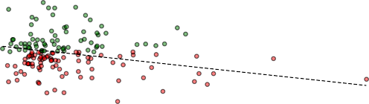
0.050
R² = 0.06
Atlantic City - NJ 2019
State College - PA 2006
Daphne-Fairhope-Foley - AL 2007
Midland - TX 2014

Average Rent Growth by Group with 95% Confidence Intervals

0.025
Real Relative Rent Growth Year After Max Supply Growth
200

0.000
Average Real Rent Growth Next Year (basis points)
150

0.025
100
0.050

50
0.075

0.100
0

0.125
50

0.150
0.00 0.05 0.10 0.15 0.20 0.25 0.30
Supply Growth as a Percentage of Inventory
rdi_x_supply > 0 rdi_x_supply <= 0 Supply Growth > ledian Supply Growth <= ledian

- Supply Growth vs. Subsequent Rent Growth
F I G U R E 7 Crowding Absorption During Maximum Supply Years
- Supply Growth vs. RDI Growth

- RDI group (above/below median) combined with RDI growth (positive/negative)classify markets into rent-growth and rent-decline groups, with a symmetric and signiﬁcant difference of 144 basis points.
- RDI reversal signals periods of coming rent-growth change
- RDI value forecasts 3, 5, and 10-year future rent growth signiﬁcantly better than ARIMA and Naive models.
- RDI values at the national level forecast next year explain a high percentage of the next year’s real rent growth
- When RDI is compared with supply growth ﬁgures it effectively classiﬁes over supplied markets

These results complement the causal identiﬁcation strategy in Section ??, where instrumented RDI growth was shown to drive future rent increases. Here, we show that RDI also performs well in practice without instrumentation, making it suitable for real-time forecasting, benchmarking, and investment decisions.
While RDI is not without limits—its precision may weaken in data-sparse MSAs or highly regulated rent environments—it stands out as a behaviorally grounded, interpretable, and statistically durable signal of latent rental housing demand.

DISCUSSION
This paper demonstrates that crowding pressure, as measured by the Rental Density Index, serve as a robust and forward- looking indicator of rental market tightness. Our empirical analyses show that RDI reliably predicts future rent growth, highlighting the hidden intensity of rental housing demand even when traditional market metrics such as occupancy rates re- main stable. By distinguishing between the causal role of RDI in driving rent growth and its practical forecasting utility, we establish the broad applicability and effectiveness of this indicator. The ﬁndings underscore its versatility as both a rigorous economic indicator of underlying market dynamics and a practical forecasting tool for diverse market participants.

Advantages
Unlike traditional, static metrics such as occupancy and absorption, RDI dynamically captures behavioral adjustments by households responding to housing constraints, such as increased roommate formation or delayed household formation. These early behavioral signals often precede rent increases, positioning RDI as a valuable leading indicator.
Signiﬁcantly, RDI retains predictive strength across various forecasting horizons, consistently outperforming traditional ARIMA and naive trailing-average models, even in out-of-sample tests. Its predictive accuracy, particularly notable in forecasting rent trends over longer periods (such as ten-year horizons), underscores its robustness and practical applicability.
The clear implications for policy-makers, investors, and renters make the variable particularly valuable. For policymakers, it offers an early warning signal of emerging housing shortages or surpluses, facilitating timely and targeted interventions such as zoning reforms, targeted subsidies, and expedited permitting processes. Investors and developers can integrate RDI into their

risk management and feasibility analyses, enhancing strategic decisions about market entry, asset allocation, and development timing. Renters beneﬁt from clearer market signals about impending rent increases, enabling better-informed housing decisions and advocacy efforts. Thus, RDI provides a structurally sound, scalable, and practical framework for anticipating and managing market dynamics across multiple contexts.

Limitations: Spatial Spillovers
The current analysis treats each metropolitan statistical area (MSA) as an independent unit. In practice, however, housing market conditions are rarely contained by administrative boundaries. Migration, affordability spillovers, and commuting patterns often link neighboring MSAs, meaning that crowding pressures in one region may affect rental markets in adjacent areas. Ignoring these spillover dynamics may understate the correlated nature of demand shifts, especially in highly integrated urban corridors. Incorporating spatial dependence structures or spatially lagged RDI variables in future work may enhance model precision and improve detection of regional displacement or diffusion effects.
While we do not formally estimate a spatial lag model, we assess geographic clustering by examining pairwise correlations in
∆RDI across neighboring MSAs. We ﬁnd strong co-movement among regionally linked marketse.g., New York and Northern New Jersey (r = 0.70), San Francisco and San Jose (r = 0.69), and DallasFort Worth and Austin (r = 0.77). More details can be found in Appendix A. These results suggest that crowding pressures often evolve in tandem across proximate metros, reﬂecting regional migration ﬂows, shared housing constraints, or price spillovers. Future work could formalize these relationships using spatial dependence structures or migration-network adjacency matrices.

CONCLUSION
We propose the Rental Density Index (RDI) as a demand-centric metric for measuring latent pressure in multifamily rental markets. By tracking changes in population per occupied unit, RDI captures household-level crowding dynamics that precede and predict future rent movement. Our empirical results, validated across causal models, forecasting tests, and event studies, establish RDI as both a leading indicator and a practical classiﬁcation tool.
The simplicity of RDI is a strength. While traditional demand estimation often requires detailed demographic or income data, RDI can be computed with widely available population and housing stock data. Yet it performs comparablyif not betterthan more complex models, especially over long forecast horizons. It is also behaviorally grounded: renters adjust space usage when pricing becomes constrained, and this adjustment leaves measurable traces in the data.
Future research may extend this work in several directions. RDI could be evaluated alongside migration ﬂows, income segmentation, or micro-level leasing data to reﬁne its predictive speciﬁcity. It may also prove useful in pricing models, rent control policy evaluation, or early-warning systems for affordability crises.
In sum, this paper offers both a new way to quantify housing demand and a practical framework for translating that signal into market insight. RDI helps bridge the gap between structural economics and applied decision-makingand in doing so, offers analysts, policymakers, and investors a grounded, interpretable, and scalable tool for anticipating market behavior.

APPENDIX A: SPILLOVER EFFECT CORRELATION MATRIX

T A B L E 9 Cross-MSA Correlation in ∆RDI Among Regional Pairs

MSA 1 | MSA 2 | Correlation (r)
New York, NY | Northern New Jersey, NJ | 0.70
San Francisco, CA | San Jose, CA | 0.69
DallasFort Worth, TX | Austin, TX | 0.77
Los Angeles, CA | Inland Empire, CA | 0.52
Miami, FL | Palm Beach, FL | 0.54

AUTHOR CONTRIBUTIONS
All authors contributed equally

ACKNOWLEDGMENTS FINANCIAL DISCLOSURE CONFLICT OF INTEREST DATA DISCLOSURE

References
Ahlfeldt, G. M., & Pietrostefani, E. (2019). The economic effects of density: A synthesis. Journal of Regional Science, 59(1), 3–26.
Albouy, D., et al. (2015). Driving to opportunity: Understanding the long-run decline in american mobility. AEA Papers and Proceedings, 105(5), 132–136.
Bank, T. W. (2025). Population density (people per sq. km of land area). https://data.worldbank.org/ indicator/EN.POP.DNST?most_recent_value_desc=true&locations=XD.
Betancourt, L. (2022). The us needs 4.3 million more apartments by 2035. National Multifamily Housing Coun- cil. https://www.nmhc.org/research-insight/research-reports/us-needs-4.3-million
-more-apartments-by-2035/.
Bureau, U. C. (2022). Nearly half of renters are cost-burdened. https://www.census.gov/library/stories/ 2022/03/nearly-half-of-renter-households-are-cost-burdened.html.
CalderWang, S., & Kim, G. H. (2024). Coordinated vs efﬁcient prices: The impact of algorithmic pricing on multifam- ily rental markets . Cowles Foundation for Research in Economics, Yale University. Retrieved from https:// cowles.yale.edu/sites/default/files/2024-05/Calder-Wang-main.pdf Working paper. Shows that RMS adoption drives occupancy toward a ﬁxed 9597% target, rendering occupancy a blunt demand metric.
Davidoff, T. (2015). Supply constraints are not valid in high-cost areas. Critical Housing Analysis, 2(1).
Duranton, G., & Puga, D. (2004). Micro-foundations of urban agglomeration economies. Handbook of Regional and Urban Economics, 4, 2063–2117.
Feiveson, L., et al. (2024). Rent inﬂation and the role of demand. Board of Governors of the Federal Reserve System.
Gabriel, S. A., & Nothaft, F. E. (2001). Rental housing markets, the incidence and duration of vacancy, and the natural vacancy rate. Journal of Urban Economics, 49(1), 121–149.
Glaeser, E. L., & Gyourko, J. (2019). Rethinking housing supply elasticity. Journal of Economic Perspectives, 33(1), 29–50. Glaeser, E. L., et al. (2001). Cities and skills. Journal of Labor Economics, 19(2), 316–342.
Goodman, A. C. (1992). Rental market adjustment and the natural vacancy rate. Journal of Urban Economics, 31(1), 1–16. Green, R. K., Malpezzi, S., & Mayo, S. K. (2002a). Measuring the elasticity of demand for housing services. Journal of Urban
Economics, 52(2), 210–227.
Green, R. K., Malpezzi, S., & Mayo, S. K. (2002b). Metropolitan housing prices and the demand for housing. Urban Studies, 39(3), 455–467. doi: 10.1080/00420980220112799
in Data, O. W. (2024). Population density by country, 1961 to 2021. https://ourworldindata.org/grapher/ population-density.
Liu, S., Pan, Q., & Li, Y. (2018). Vertical cities: The price of tall buildings. Regional Science and Urban Economics, 72, 58–73.
Mae, F. (2023). Consumers feel renting is more affordable than homeownership. https://www.fanniemae.com/ research-and-insights/surveys/national-housing-survey.
Malpezzi, S., & Green, R. K. (1996a). Measuring the price elasticity of demand for housing services. Journal of Housing Economics, 5(4), 369–398.
Malpezzi, S., & Green, R. K. (1996b). Rent control and rental housing quality: A note on the effects of new york citys 1971 law. Journal of Housing Economics, 5(2), 190–206.
Molloy, R. (2022). Housing demand and supply: The need for more data and better policy. Brookings Papers on Economic Activity.
Mott, Z. (2024). This region is ﬁnally seeing rent drop after a supply boom. Apartment List Research. https://www
.apartmentlist.com/research.
Mueller, G. R., & Laposa, S. P. (1999). Real estate rental markets: What rental data can and cannot tell us. Journal of Real Estate Portfolio Management, 5(2), 135–144.

Muth, R. F. (1969). Cities and housing. University of Chicago Press.
of St. Louis, F. R. B. (2024). Consumer price index for all urban consumers: Shelter vs all items less shelter. https:// fred.stlouisfed.org/series/CUSR0000SA0L2.
Pennington, K. (2021). Does building new housing cause displacement? the supply and demand effects of construction in san francisco. Working Paper. https://papers.ssrn.com/sol3/papers.cfm?abstract_id=3902950.
Pyhrr, S. A., Cooper, J. L., & Wofford, M. L. (1999). Real estate investment: Strategies, structures, decisions. Wiley.
Rosenthal, S. S. (1997a). Housing demand and expenditures: evidence from the consumer expenditure survey. Review of Economics and Statistics, 79(2), 330–335.
Rosenthal, S. S. (1997b). Housing services and the investment aspect of homeownership. Journal of Urban Economics, 41(3), 324–350. doi: 10.1006/juec.1996.2013
Saiz, A. (2010). The geographic determinants of housing supply. Quarterly Journal of Economics, 125(3), 1253–1296. Sirmans, C., Sirmans, G., & Benjamin, J. (1991). Determinants of apartment rent. Journal of Real Estate Research, 6(3),
357–379.
Titman, S., Wang, K., & Yildirmaz, M. (2024). City size and vertical development. Journal of Urban Economics, 142, 103519. Wheaton, W. C. (1991). Real estate cycles: Some fundamentals. Real Estate Economics, 19(2), 209–230.

SUPPORTING INFORMATION
Additional supporting information may be found in the online version of the article at the publishers website.

