**Lesson 06 Demo 04**

**Publishing Test Cases Reports in Jenkins**

**Objective:** To publish test case reports in Jenkins to enhance transparency, accountability, and quality in the software development process

**Tools required:** Jenkins

**Prerequisites:** You need to have a Jenkins up and running.

Steps to be followed:

1. Log in to the Jenkins CI tool and publish test case reports

**Step 1:** **Log in to the Jenkins CI tool and publish test case reports**

1.1 Log in to Jenkins using your credentials

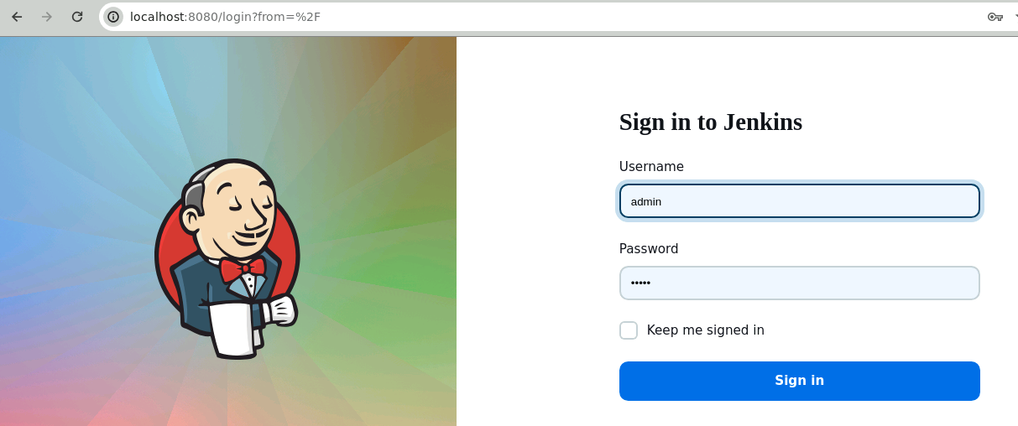

**Note**: The credentials for accessing Jenkins in the lab are Username: **admin** and Password: **admin**.

* 1. In the Jenkins dashboard, click on **New Item**

* 1. Select the **Freestyle project** while creating a Jenkins job, provide a custom job name, and click on **OK**

* 1. Now, in the Configure page, navigate to **Source Code Management** from the left navigation bar, select **Git**, and then provide the Git repository URL

**Note:** Here, the repository URL is **https://github.com/github-simplilearn-net/Maven-Build.git.**

* 1. Now, navigate to **Build Steps,** click on **Add build step**, and then select **Involve top-level Maven targets**

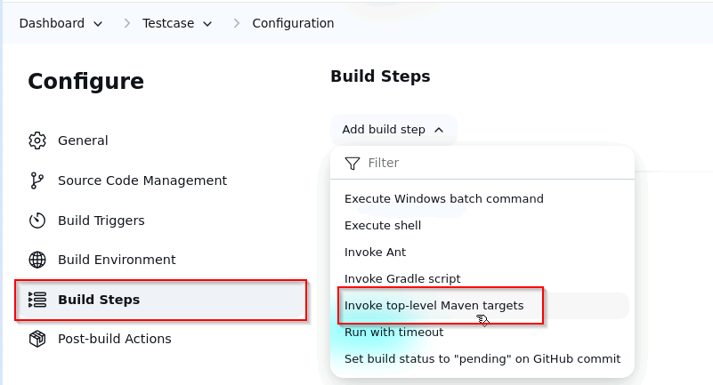

* 1. Now, provide **clean install** in the **Goals** section and click on **Save**

* 1. Then, click on **Build Now** to configure a build

* 1. Now, navigate back to the **Testcase** job configuration page, click on **Post-build Actions**, then choose **Publish Junit test result report** under the **Add post-build action**

* 1. Provide **target/surefire-reports/*.xml** in the **Test report XMLs** section and then click on **Save**

* 1. Now, click on **Build Now** to trigger new build, and build logs will show you build process

logs

You can see that the build is configured successfully.

* 1. Now, click on **Test Result** to check the test reports

You can see that the test cases have been successfully passed.

By following these steps, you have successfully published test case reports in Jenkins to ensure transparency, accountability, and quality in the software development process.