作业2

任务1.1：根据附件1中的数据，提取每台售货机对应的销售数据，保存在CSV文件中，文件名分别为"task1-1A.csv”、“task1-1B.csv”“task1-1E.csv”

保存代码如下图所示：

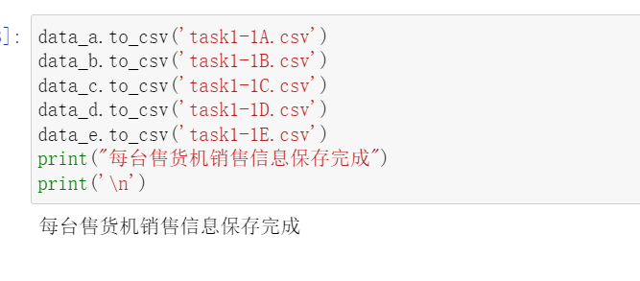

文件显示如下图所示：

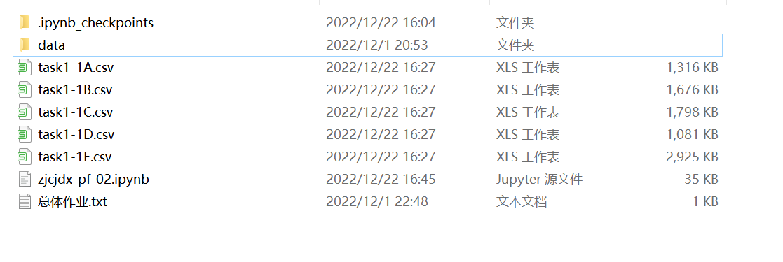

任务1.2：计算每台售货机2017年5月份的交易额、订单量及所有售货机交易总额和订单总量，以表格形式体现在报告中

表格如下：

|  |  |  |  |  |  |  |
| --- | --- | --- | --- | --- | --- | --- |
|  | A | B | C | D | E | 总计 |
| 销售额 | 3385.1 | 3681.2 | 3729.4 | 2392.1 | 5699 | 18886.8 |
| 订单量 | 756 | 869 | 789 | 564 | 1292 | 4270 |

任务1.3：计算每台售货机每月的每单平均交易额与日均订单量，以表格形式体现在报告中

每台每单平均交易额：

|  |  |  |  |  |  |  |
| --- | --- | --- | --- | --- | --- | --- |
| 地点 | 1 | 2 | 3 | 4 | 5 | 6 |
| A | 0.092537313 | 0.245614035 | 0.121568627 | 0.067114094 | 0.041005291 | 0.017974835 |
| B | 0.084699454 | 0.151351351 | 0.116981132 | 0.049751244 | 0.035673188 | 0.016163793 |
| C | 0.081794195 | 0.134615385 | 0.117870722 | 0.040871935 | 0.039290241 | 0.015940489 |
| D | 0.11969112 | 0.19858156 | 0.161458333 | 0.06772009 | 0.054964539 | 0.028846154 |
| E | 0.087570621 | 0.108527132 | 0.088571429 | 0.033519553 | 0.023993808 | 0.01156961 |

|  |  |  |  |  |  |
| --- | --- | --- | --- | --- | --- |
| 7 | 8 | 9 | 10 | 11 | 12 |
| 0.06512605 | 0.046546547 | 0.028846154 | 0.019808307 | 0.025862069 | 0.015476785 |
| 0.089855072 | 0.031600408 | 0.017191977 | 0.015301086 | 0.014771049 | 0.014027149 |
| 0.040575916 | 0.024622716 | 0.017878427 | 0.01398917 | 0.015440041 | 0.013030685 |
| 0.097791798 | 0.043356643 | 0.03051882 | 0.02613828 | 0.024793388 | 0.01864101 |
| 0.038130381 | 0.01754386 | 0.007256894 | 0.011163126 | 0.005976096 | 0.009532595 |

每台日均订单量：

|  |  |  |  |  |  |  |
| --- | --- | --- | --- | --- | --- | --- |
| 地点 | 1 | 2 | 3 | 4 | 5 | 6 |
| A | 10.80645161 | 4.071428571 | 8.225806452 | 14.9 | 24.38709677 | 55.63333333 |
| B | 11.80645161 | 6.607142857 | 8.548387097 | 20.1 | 28.03225806 | 61.86666667 |
| C | 12.22580645 | 7.428571429 | 8.483870968 | 24.46666667 | 25.4516129 | 62.73333333 |
| D | 8.35483871 | 5.035714286 | 6.193548387 | 14.76666667 | 18.19354839 | 34.66666667 |
| E | 11.41935484 | 9.214285714 | 11.29032258 | 29.83333333 | 41.67741935 | 86.43333333 |

|  |  |  |  |  |  |
| --- | --- | --- | --- | --- | --- |
| 7 | 8 | 9 | 10 | 11 | 12 |
| 15.35483871 | 21.48387097 | 34.66666667 | 50.48387097 | 38.66666667 | 64.61290323 |
| 11.12903226 | 31.64516129 | 58.16666667 | 65.35483871 | 67.7 | 71.29032258 |
| 24.64516129 | 40.61290323 | 55.93333333 | 71.48387097 | 64.76666667 | 76.74193548 |
| 10.22580645 | 23.06451613 | 32.76666667 | 38.25806452 | 40.33333333 | 53.64516129 |
| 26.22580645 | 57 | 137.8 | 89.58064516 | 167.3333333 | 104.9032258 |