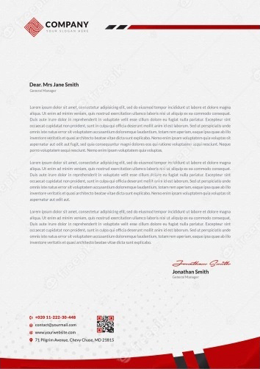
Alana Camille
WWW.HELPSHARED.COM
Software Engineer
September 8, 2026
Dear Mr. Bryan,
I'm sending in my resume for the summer application design internship programme at Simple Corporation. I believe I can be a valuable addition to your team through my skills, experience and expertise as listed in my attached resume.
During my two years at Simple University, I took a lot of classes on cutting-edge design trends and best practices, such as Mobile Application Design and Principles of User Experience Design, where I learned and practised skills like user journey mapping, application wireframing and software design for various mobile devices and operating systems.
On top of that, I volunteered with a local non-profit that collects donated clothing and furniture and redistributes it to needy families throughout the last semester. I assisted the web team in updating and re-launching an application that allows residents to discover nearby drop-off sites and schedule pick-ups. From this experience, I've learned to manage web designs and assist with troubleshooting, as well as cultivated my time management and organisational skills.
Finally, my two years as a barista at the student centre taught me the value of creating a convenient and memorable consumer experience that is consistent with the brand image. It also helped me improve my teamwork, verbal communication, interpersonal and project management abilities.
I believe I can be a valuable asset to Simple Corporation. This internship would allow me to gain real-world and hands-on experience in the technology sector, while also developing and refining my application design abilities.
Feel free to reach me through my email at amylim@email.com or through my mobile at +1 234-567-8900 should you need any more information. I look forward to hearing from you!
Best regards,
Helpshared.Com
Alana Camille

