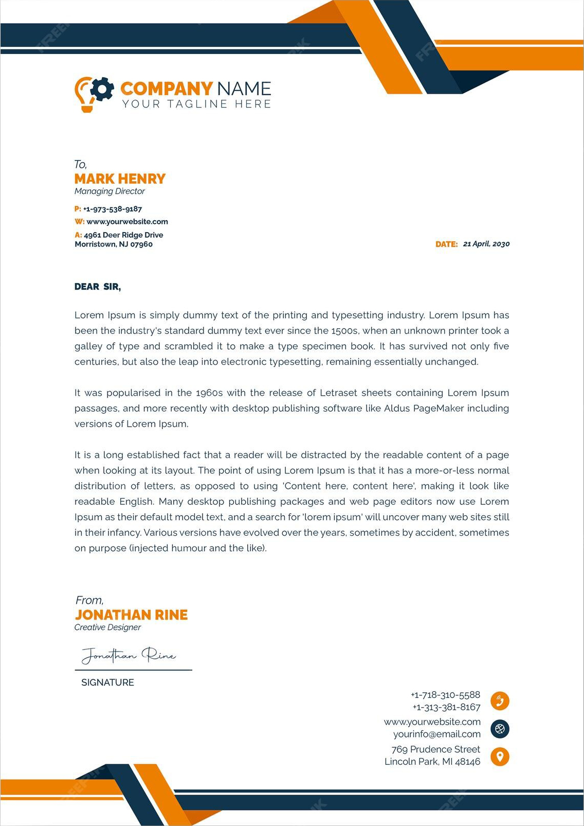
HARRY GRAYSON
WWW.HELPSHARED.COM
The Dispatcher
14 Ferry St, Newark, NJ
+1 234 800 6789
harrygrayson@email.com
October 20, 2026
Dear Hiring Manager,
I'm writing in response to the open Dispatcher position for the Williams County Sheriff's Department. I have four years of experience working for Saint Joseph's Hospital in Pittsburg, where I was responsible for managing the facility's emergency response communications. During my time at Saint Joseph's, I organized emergency communications by urgency and coordinated assistance services for patients. I feel my ability to respond to emergency communications quickly, and my exceptional attention to detail can be an asset to the emergency team and public services of Williams County.
I understand your department requires experience coordinating emergency services through its updated calling software, and I have the skills and proficiency with similar technology that I can contribute to the role. I'm also currently pursuing my bachelor's degree in telecommunications, which further supports my ability to take on the responsibilities of the position.
My proven ability to record call metrics, monitor response times and plan emergency protocols with hospital staff are sure to contribute to the Dispatcher role and further support Williams County's law enforcement personnel. As a highly dedicated professional, I'm motivated to help the department and assist the community by providing guidance in emergency situations.
I appreciate your consideration and look forward to learning more about the role and discussing how my talents can add to your team.
Kind regards,
Helpshared.Com
david_carter123@ gmail.com
+1 234-567-8900
148 Charlotte Area , North Carolina

Harry Grayson

