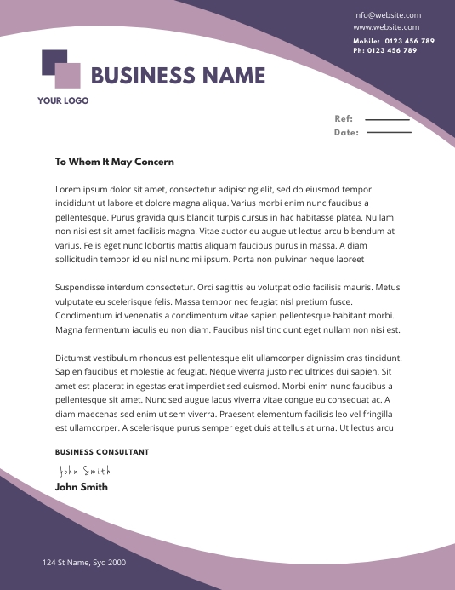

Sophie Allison
WWW.HELPSHARED.COM
THE BUDTENDER
October 20, 2026
Liam Rogers
Hiring Manager
NewLeaf Dispensary
Dear Liam Rogers,
My name is Sophie Allison, and with over eight years in the marijuana industry and a passion for cannabis education, I am excited to apply for the position of budtender with NewLeaf Dispensary. With a Bachelor of Science in botany degree from North Valley College in Providence, Rhode Island, I am eager to spread valuable and scientifically accurate information about medical and recreational marijuana use to customers. After visiting NewLeaf Dispensary and experiencing your commitment to customer service and quality products, I would be a dedicated and enthusiastic member of your team.
I have been working as a budtender for eight years. After exploring my love of nature and plant life in college, I became a budtender because it's a profession where I see the ability to continuously learn and develop throughout the duration of my career. I currently work for Elite Flower Dispensary and have received exceptional on-the-job training over the past four years I have spent there. This means I am familiar with standard handling and distribution protocols.
I routinely dedicate my free time to learning more about CBD, THC and the impacts our products may have on our customers, and I pride myself on my ability to patiently and accurately address client's questions and concerns. I rely on my interpersonal communication skills to understand other's requests and accommodate their medical requirements or recreational preferences. This industry allows me to pursue something I'm interested in while teaching others about a topic I'm passionate about, which is why I would like to continue my career as a budtender with NewLeaf dispensary.
Thank you for your time and consideration. I look forward to hearing from you soon.
Sincerely,
Helpshared.Com
148 Pittsburgh, PA 15243, USA
+1 412-479-3530
Shopie_alllison@email.com
Sophie Allison

