April 27, 2026
Heri Mulyadi
HM
Dear Hiring Manager,
I'm writing today to express my interest in applying for the Barista position available at Cornelia Cafe. As an experienced Barista, I'm excited about the opportunity to work at this well-respected cafe. With my passion for the art of coffee and experience working at many busy commercial coffee chains, I believe this position would allow me to grow my understanding of coffee and help the cafe succeed.
I began working as a Barista more than five years ago at Moonwalk Coffee, and this helped me master the basics of preparing a large menu of beverages. I was responsible for preparing made-to-order beverages and recommending food and drink items to customers, including quickly learning about rotating seasonal menu items. Working as a Barista at Moonwalk Coffee allowed me to develop excellent attention to detail, multitasking and teamwork skills. I've advanced to working as a Barista Trainer and a shift leader, but I'm interested in working as a barista at a cafe with a stronger artisanal approach to coffee.
I recently completed the Certified Roast Master program with Central Coffee Company, and I earned my official barista designation from the National Barista Organization. Both of these credentials provided me with thorough training in the process of growing and harvesting coffee beans, grinding them properly and using them to make different beverages. It expanded my understanding of coffee, and I'm excited about the opportunity to apply my knowledge at your cafe.
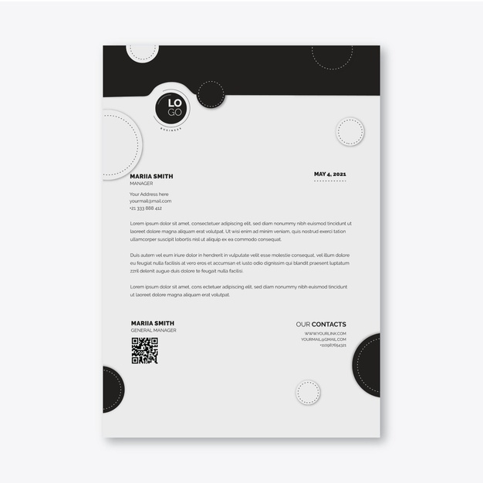
Thank you for considering my application. I'm available at your convenience for an interview, and I'm happy to answer any questions you may have. I look forward to speaking with you soon.
Sincerely,
Helpshared.Com

Heri Mulyadi

48 Lake Park Rd, Colonial, VA 23834 +1 804-385-1928 herimulyadi@email.com

