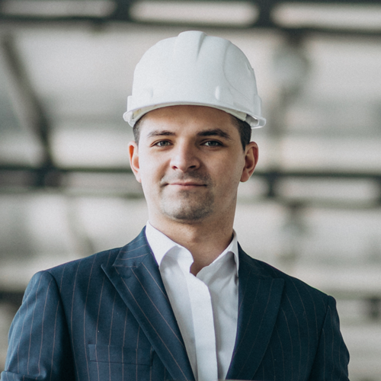
ADRIAN RAFAEL
Mechanical engineer

CONTACT

adrianrafa@gmail.com
+971 3 888 7679
54nd St - Al Jimi - Al Ameriya - Abu Dhabi - UEA
www.helpshared.com
SKILLS
Teamwork
Technical
Communication
Problem-solving
Creativity
LANGUAGES
English
Arabic
HOBIES


WWW.HELPSHARED.COM
SUMMARY
A highly motivated and creative mechanical engineer with three years of experience in research and development facilities. I am determined to work on construction projects that focus on housing estates, ventilation systems and transport infrastructure. Working in the construction sector allows me to use technical, communication, problem-solving and teamwork skills.
EDUCATION

Green Industries, Mechanical Engineer | 2024-2026
- Design 2-3 electric generators in a week, which boosts team performance by 20%.
- Test new computer programs for complex machine designs.
- Write two reports each day regarding progress and machinery failures.
Green Industries, Mechanical Engineer | 2022-2024
- Helped senior engineers plan 10-15 construction projects.
- Documented progress reports on Microsoft Office packages and reported this research to the manager.
- Communicated with team members about replacement parts and what tools were available for creating them.
WORK EXPERIENCE

Sunfield University – Brisbane
Bachelor of Mechanical Engineering | 2017-2021
High Distinction

