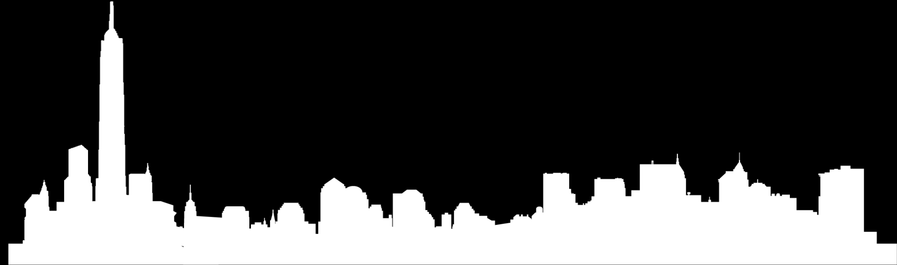

Joseph William
WriteR AND JURNALISM

RESUME



KEY POINTS

Education
Atlanta University
Bachelor of Arts, Journalism
Seaside College
Bachelor of Arts in English literature

Certification
Expert Flexo Press Operator (Level IV), Technical Association
2024
Press Operator Certification, Flexographic Technical Association
2025

Awards
Dean's List, September 2020-May 2025. Received special communication regarding my placement on the Dean's List due to a high GPA
Published writer in the Illinois Star-News, April 2023. Submitted opinion piece titled 'Hazy Outlook' regarding smog level and what students can do to reduce their carbon footprint.

CONTACT
48 Birmingham Rd, South Penrith NSW 2350, AU
josephwilliam@email.com
+61 888 709 123
Established career journalist with 10 years of writing and copy editing experience in the newsroom. Seeking to bring storytelling and investigative skills to the Grizzle Gazette. Experienced in community, health, sports and environmental reporting as well as opinion writing.
WORK EXPERIENCE
Echo Times, Journalist  2025 – 2026  Edited and revised stories to meet the newspaper's standards for reporting and followed AP style guidelines . |  |  | Tree News, Staff reporter  2024– 2025  Proofread articles from peers to ensure they were grammatically correct and included the necessary information .
ABC Press, Reporter  2023– 2024  Collaborate with other writers to create original, newsworthy articles. | Research interesting topics related to local news |  |  | ABC Media, Assistant  2022 – 2023  Generated content for online community calendar | Called local businesses to verify seasonal information .
SKILLS |  |  | LANGUAGES
Journalism  AP style  Collaborative  Public speaking |  |  | English  France  Mandarin  Spain



WWW.HELPSHARED.COM

